Supplementary Figure 1
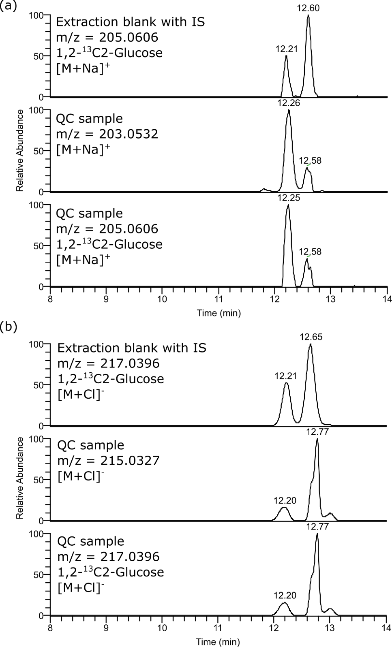
Figure S1: Annotation of glucose peak measured by ESI+ (a) and ESI- (b). Two peaks were eluted at 12.2 and 12.6 minutes respectively, confirmed by internal standard 1,2-¹³C2-Glucose added in extraction solvent.

Supplementary Figure 2
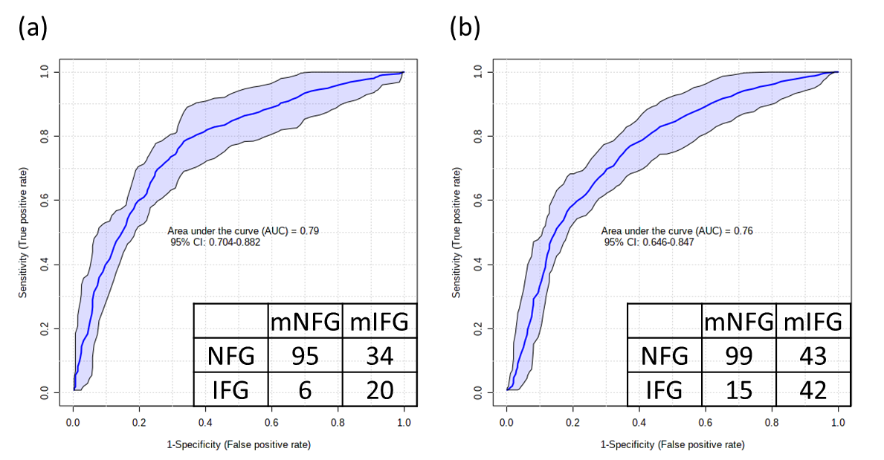
Figure S2: Receiver operating characteristic (ROC) curve of RF performed 100 most important variables among the pooled list of those associated with FPG or %VAT_{TBF} in (a) Caucasian and (b) Asian Chinese.

