Figure S1. Flow diagram of sampling strategy with exclusion criteria.
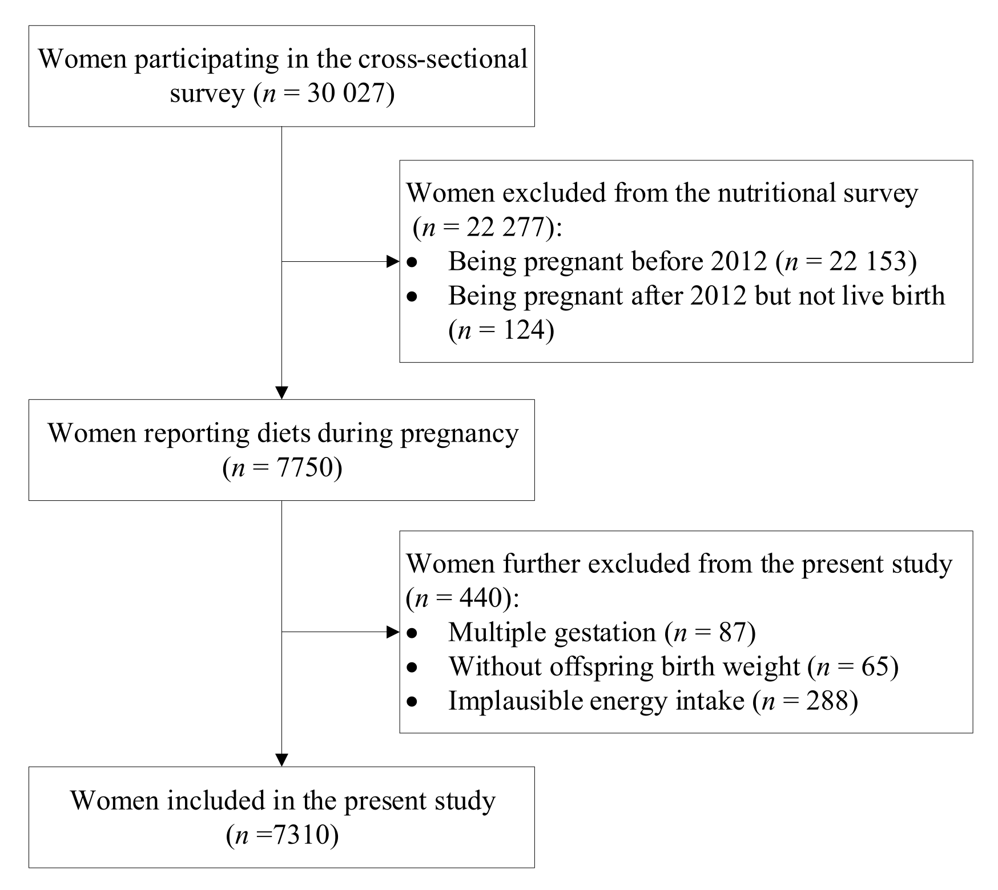
Table S1. Birth weight and the related adverse birth outcomes associated with isocaloric substitution of 3% energy from dietary protein intake during pregnancy.
 | Birth weight, g |  | Low birth weight |  | Small for gestational age |  | Intrauterine growth retardation
 | Change (95%CI) | P | OR (95%CI) | P | OR (95%CI) | P | OR (95%CI) | P
Total protein
Substitution for carbohydrate | 18.9 (4.7, 33.2) | 0.009 | 0.74 (0.59, 0.92) | 0.008 | 0.87 (0.77, 0.98) | 0.025 | 0.81 (0.68, 0.98) | 0.028
Substitution for fat | 19.3 (5.7, 32.9) | 0.005 | 0.75 (0.61, 0.93) | 0.007 | 0.88 (0.78, 0.98) | 0.026 | 0.83 (0.70, 0.98) | 0.035
Animal protein
Substitution for carbohydrate | 20.6 (4.8, 36.5) | 0.011 | 0.72 (0.56, 0.93) | 0.013 | 0.86 (0.75, 0.98) | 0.033 | 0.84 (0.72, 0.98) | 0.019
Substitution for fat | 21.1 (4.9, 37.3) | 0.011 | 0.74 (0.57, 0.96) | 0.021 | 0.86 (0.75, 0.99) | 0.043 | 0.84 (0.71, 0.99) | 0.021
Plant protein
Substitution for carbohydrate | 11.6 (-15.1, 38.4) | 0.393 | 0.71 (0.48, 1.04) | 0.079 | 0.88 (0.71, 1.09) | 0.261 | 0.87 (0.69, 1.07) | 0.242
Substitution for fat | 14.3 (-10.6, 39.2) | 0.262 | 0.69 (0.47, 1.02) | 0.066 | 0.88 (0.72, 1.08) | 0.211 | 0.85 (0.68, 1.06) | 0.132
Dairy protein
Substitution for carbohydrate | 19.3 (5.9, 32.7) | 0.013 | 0.79 (0.63, 0.99) | 0.016 | 0.85 (0.73, 0.99) | 0.037 | 0.76 (0.64, 0.90) | 0.021
Substitution for fat | 19.4 (5.7, 33.1) | 0.012 | 0.81 (0.65, 1.00) | 0.019 | 0.86 (0.77, 0.96) | 0.033 | 0.76 (0.65, 0.89) | 0.017
Multilevel linear regression models were used to estimated changes and the related 95%CIs, and logistic regression models were used to estimate ORs and the related 95%CIs. Models were adjusted for total energy intake, socio-demographic characteristics (including geographic area, residence, childbearing age, education, occupation, household wealth index, and parity), health-related characteristics (including passive smoking, alcohol drinking, antenatal check visit frequency, folate/iron supplements use, anemia, and medication use), principal component score based on the nutrient intakes, and mutually adjusted for animal protein and plant protein. Further adjustment for other major dietary protein sources was performed in the analysis of dairy protein. Models for birth weight and low birth weight were additionally adjusted for offspring sex and gestational age.

