Online Supplementary Information
Impact of Very Low Carbohydrate Ketogenic Diets on Cardiovascular Risk Factors among Patients with Type 2 Diabetes; GRADE-assessed Systematic Review and Meta-Analysis of Clinical Trials
Parisa Ghasemi¹, Malihe Jafari², Saber Jafari Maskouni³, Seyed Ahmad Hosseini⁴, Roksaneh Amiri⁵, Jalal Hejazi⁶, Mahla Chambari⁷, Ronia Tavasolian⁶, Mehran Rahimlou^{6*}
- Research Committee, Medical School, Arak University of Medical Sciences, Arak, Iran
- Department of Exercise physiology, Faculty of Physical Education and Sports Sciences, Allameh Tabataba'i University, Tehran, Iran
- Department of nutrition, School of Public health, Jiroft University of Medical Sciences, Jiroft, Iran
- Department of Nutrition, School of Allied Medical Sciences, Ahvaz Jundishapur University of Medical Sciences, Ahvaz, Iran
- Mofid Childrens Hospital Clinical Research Development Unit, Shahid Beheshti University of Medical Science, Tehran, Iran
- Department of Nutrition, School of Public Health, Zanjan University of Medical Sciences, Zanjan, Iran
- Noncommunicable Diseases Research Center, Neyshabur University of Medical Sciences, Neyshabur, Iran

*Correspondence to: Mehran Rahimlou
Mehran Rahimlou, PhD, Central Office of Zanjan University of Medical Sciences, Azadi Sq. Zanjan, Iran. Tel: 0098-24-33420651, Email: Rahimlum@gmail.com
Running Title: Very Low Carbohydrate Ketogenic Diets and Diabetes

Search Strategies
- Search strategy in Pubmed

("Diabetes Mellitus"[Title/Abstract] OR ("Noninsulin-Dependent"[Title/Abstract] AND "Diabetes Mellitus"[Title/Abstract]) OR ("Diabetes Mellitus"[Title/Abstract] AND "Ketosis-Resistant"[Title/Abstract]) OR "Ketosis-Resistant Diabetes Mellitus"[Title/Abstract] OR ("Diabetes Mellitus"[Title/Abstract] AND "Non-Insulin-Dependent"[Title/Abstract]) OR "Non-Insulin-Dependent Diabetes Mellitus"[Title/Abstract] OR ("Diabetes Mellitus"[Title/Abstract] AND "stable"[Title/Abstract]) OR ("Diabetes Mellitus"[Title/Abstract] AND "Type II"[Title/Abstract]) OR "NIDDM"[Title/Abstract] OR "Type 2 Diabetes Mellitus"[Title/Abstract] OR "Noninsulin-Dependent Diabetes Mellitus"[Title/Abstract] OR "Type 2 Diabetes"[Title/Abstract] OR ("diabetes"[Title/Abstract] AND "Type 2"[Title/Abstract]) OR "Adult-Onset Diabetes Mellitus"[Title/Abstract] OR "Diabetes Mellitus"[Title/Abstract] OR ("Diabetes Mellitus"[Title/Abstract] AND "Insulin Dependent"[Title/Abstract]) OR "Insulin-Dependent Diabetes Mellitus"[Title/Abstract] OR "T2DM"[Title/Abstract]) AND ("ketogenic"[Title/Abstract] OR "Ketogenic Diet"[Title/Abstract] OR ("diet"[Title/Abstract] AND "ketogenic"[Title/Abstract]) OR "keto diet"[Title/Abstract] OR "ketotic diet"[Title/Abstract])

- Search strategy in Scopus
( ( TITLE-ABS-KEY ( "Diabetes Mellitus" ) OR TITLE-ABS-KEY ( ( "Noninsulin-Dependent" AND "Diabetes Mellitus" ) ) OR TITLE-ABS-KEY ( ( "Diabetes Mellitus" AND "Ketosis-Resistant" ) ) OR TITLE-ABS-KEY ( "Ketosis-Resistant Diabetes Mellitus" ) OR TITLE-ABS-KEY ( ( "Diabetes Mellitus" AND "Non-Insulin-Dependent" ) ) OR TITLE-ABS-KEY ( "Non-Insulin-Dependent Diabetes Mellitus" ) OR TITLE-ABS-KEY ( ( "Diabetes Mellitus" AND stable ) ) OR TITLE-ABS-KEY ( ( "Diabetes Mellitus" AND "Type II" ) ) OR TITLE-ABS-KEY ( niddm ) OR TITLE-ABS-KEY ( "Type 2 Diabetes Mellitus" ) OR TITLE-ABS-KEY ( "Noninsulin-Dependent Diabetes Mellitus" ) OR TITLE-ABS-KEY ( "Type 2 Diabetes" ) OR TITLE-ABS-KEY ( ( diabetes AND "Type 2" ) ) OR TITLE-ABS-KEY ( "Adult-Onset Diabetes Mellitus" ) OR TITLE-ABS-KEY ( ( "Diabetes Mellitus" AND "Insulin-Dependent" ) ) OR TITLE-ABS-KEY ( ( "Diabetes Mellitus" AND "Insulin Dependent" ) ) OR TITLE-ABS-KEY ( ( "Insulin-Dependent Diabetes Mellitus" ) ) OR TITLE-ABS-KEY ( iddm ) OR TITLE-ABS-KEY ( t2dm ) ) ) AND ( ( TITLE-ABS-KEY ( ketogenic ) OR TITLE-ABS-KEY ( "Ketogenic Diet" ) OR TITLE-ABS-KEY ( ( diet AND ketogenic ) ) OR TITLE-ABS-KEY ( "keto diet" ) OR TITLE-ABS-KEY ( "ketogenous diet" ) OR TITLE-ABS-KEY ( "ketotic diet" ) ) )
- Search strategy in Web of Science

"Diabetes Mellitus" (Topic) or ( "Noninsulin-Dependent" AND "Diabetes Mellitus" ) (Topic) or ("Diabetes Mellitus" AND "Ketosis-Resistant") (Topic) or "Ketosis-Resistant Diabetes Mellitus" (Topic) or ("Diabetes Mellitus" AND "Non-Insulin-Dependent") (Topic) or "Non-Insulin-Dependent Diabetes Mellitus" (Topic) or ("Diabetes Mellitus" AND stable) (Topic) or ("Diabetes Mellitus" AND "Type II") (Topic) or NIDDM (Topic) or "Type 2 Diabetes Mellitus" (Topic) or "Noninsulin-Dependent Diabetes Mellitus" (Topic) or "Type 2 Diabetes" (Topic) or T2DM (Topic) AND ketogenic (Topic) or "Ketogenic Diet" (Topic) or (diet AND ketogenic) (Topic) or "keto diet" (Topic) or "ketogenous diet" (Topic) or "ketotic diet" (Topic)
- Search strategy in Embase

'diabetes mellitus'/exp OR 'diabetes mellitus' OR 'diabetes mellitus':ti,ab,kw OR ('noninsulin-dependent':ti,ab,kw AND 'diabetes mellitus':ti,ab,kw) OR ('diabetes mellitus':ti,ab,kw AND 'ketosis-resistant':ti,ab,kw) OR 'ketosis-resistant diabetes mellitus':ti,ab,kw OR ('diabetes mellitus':ti,ab,kw AND 'non-insulin-dependent':ti,ab,kw) OR 'non-insulin-dependent diabetes mellitus':ti,ab,kw OR ('diabetes mellitus':ti,ab,kw AND stable:ti,ab,kw) OR ('diabetes mellitus':ti,ab,kw AND 'type ii':ti,ab,kw) OR niddm:ti,ab,kw OR 'type 2 diabetes mellitus':ti,ab,kw OR t2dm:ti,ab,kw OR 'noninsulin-dependent diabetes mellitus':ti,ab,kw OR 'type 2 diabetes':ti,ab,kw OR 'adult-onset diabetes mellitus':ti,ab,kw OR ('diabetes mellitus':ti,ab,kw AND 'insulin-dependent':ti,ab,kw) OR ('diabetes mellitus':ti,ab,kw AND 'insulin dependent':ti,ab,kw) OR 'insulin-dependent diabetes mellitus':ti,ab,kw AND 'ketogenic diet'/exp OR 'ketogenic diet' OR (diet:ti,ab,kw AND ketogenic:ti,ab,kw) OR 'keto diet':ti,ab,kw OR 'ketogenous diet':ti,ab,kw OR 'ketotic diet':ti,ab,kw

Figure 1S: Forest plot detailing weighted mean difference and 95% confidence intervals for the impact of VLCKD on HOMAIR.
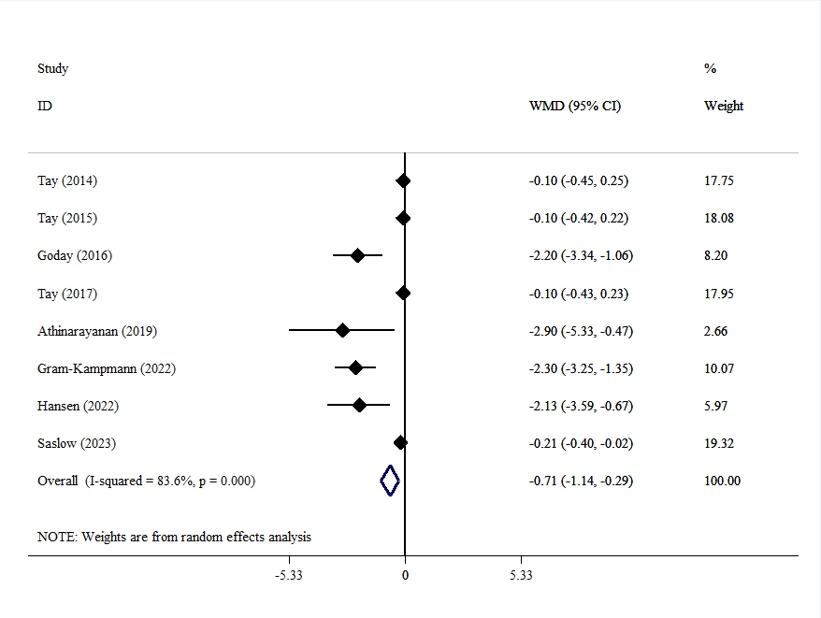
Figure2s: Forest plot detailing weighted mean difference and 95% confidence intervals for the impact of VLCKD on insulin.

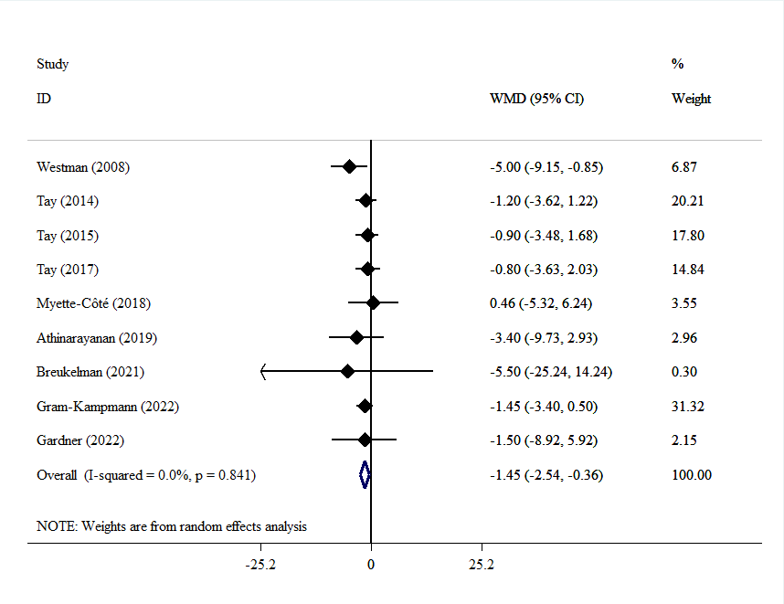
Figure 3S: Funnel plots detailing publication bias in the studies selected for TC
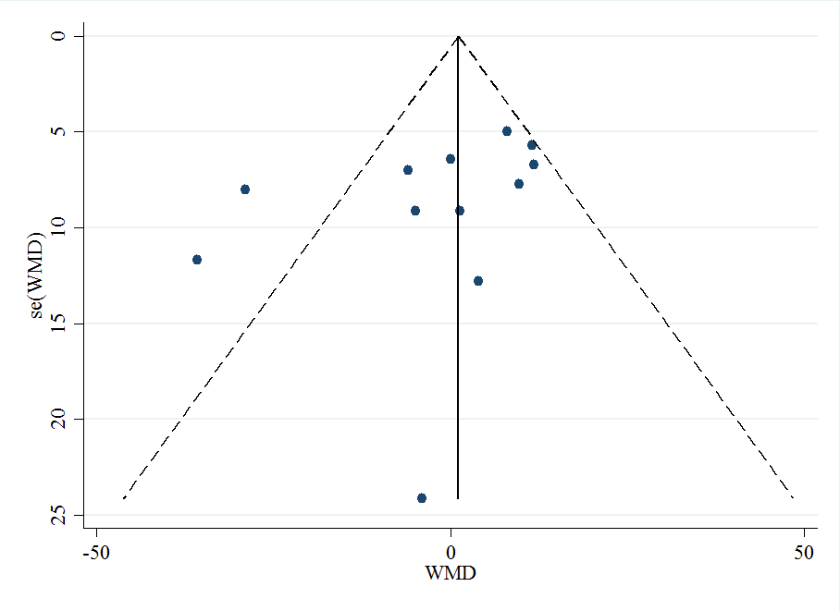

Figure 4S: Forest plot detailing weighted mean difference and 95% confidence intervals for the impact of VLCKD on LDL.
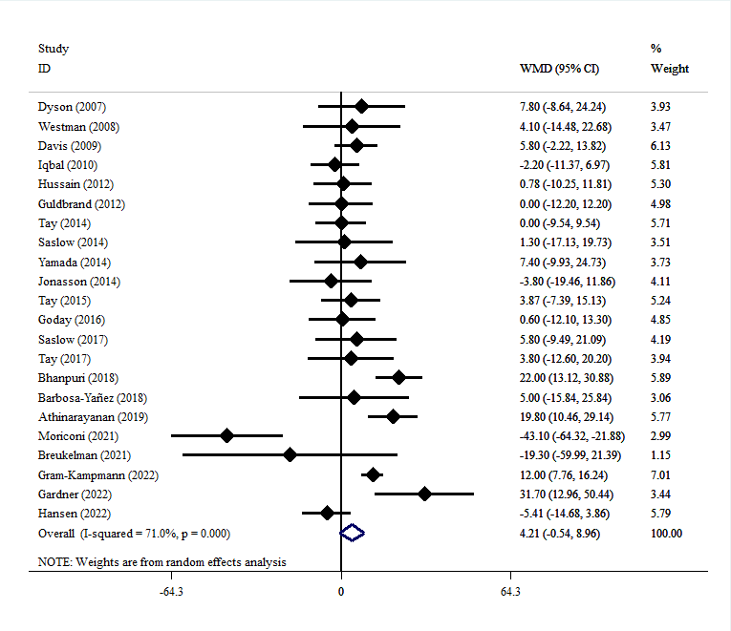
Figure 5S: Forest plot detailing weighted mean difference and 95% confidence intervals for the impact of VLCKD on HDL.
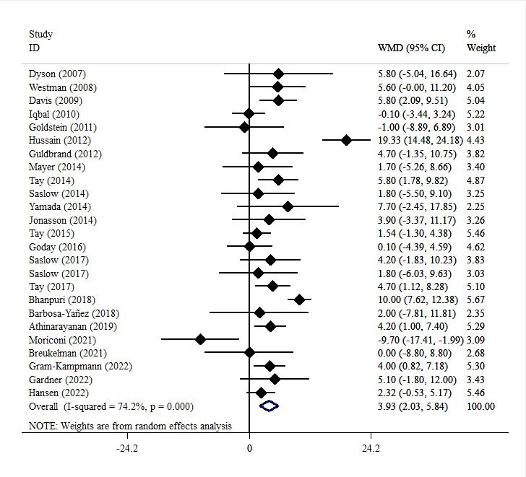

Figure 6S: Forest plot detailing weighted mean difference and 95% confidence intervals for the impact of VLCKD on DBP.
