Supplementary Materials

Query words:
Chia:
“chia” OR “salba” OR “salvia” OR “salba-chia”
Cardiometabolic:
“cardiometabolic” OR “metabolic” OR “metabolism” OR “Lipid” OR “Lipemia*” OR “Lipidemia*” OR “Hyperlipemia*” OR “Hyperlipidemia” OR “Hypolipemia” OR “Hypolipidemia” OR “Cholesterol” OR “Triglyceride*” OR “Triacylglycerol*” OR “lipoprotein*” OR “HDL” OR “High-density Lipoprotein” OR “LDL” OR “low-density lipoprotein” OR “Hypercholesteremia*” OR “Dyslipidem*” OR “Dyslipoproteinemia*” OR “hyperlipoproteinemia” OR “hyperlipidemic agents” OR “Apolipoprotein*” “alpha Lipoprotein” OR “Circulating Lipoprotein” OR “Lipid metabolism disorder” OR “Glycemic” OR “glycemia” OR “glucose” OR “blood sugar” OR “FBS” OR “FBG” OR “HbA1C” OR “hemoglobin A1C” OR “Glycohemoglobin*” OR “Glycated hemoglobin*” OR “Glycosylated Hemoglobin A1c” OR “Hyperglycemia” OR “Hypoglycemia” OR “inflammatory marker” OR “C-reactive protein” OR “CRP”

Table. Ris of Bias (RoB2)
Ris of Bias (RoB2)
Author/Year | D1 | D2 | D3 | D4 | D5 | Overall
Quaresma et al. 2023 | L | Some concerns | L | L | Some concerns | Some concerns
Alwosais et al. 2021 | L | L | L | L | Some concerns | Some concerns
C. S.da Silva et al. 2020 | L | L | L | L | Some concerns | Some concerns
Vuksan et al. 2017 | L | L | L | L | Some concerns | Some concerns
Toscano et al. 2015 | L | L | L | L | Some concerns | Some concerns
Toscano et al. 2014 | L | L | L | L | Some concerns | Some concerns
Brissette et al. 2013 | L | L | L | L | L | L
Nieman et al. 2012 | L | L | L | L | Some concerns | Some concerns
Nieman et al. 2009 | L | L | L | L | Some concerns | Some concerns
Vuksan et al. 2007 | L | Some concerns | L | L | Some concerns | Some concerns
L: low risk

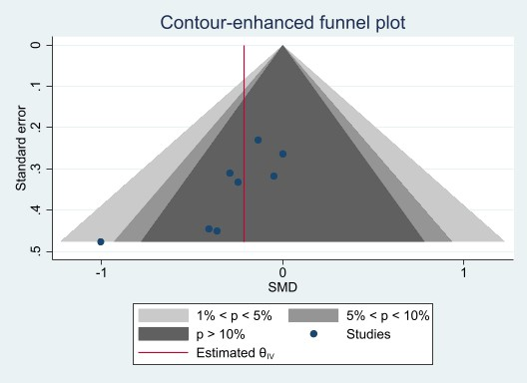
Figure. Funnel plot for SBP
Sensitive analysis

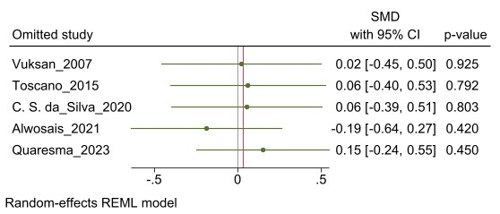
Sensitivity analysis of BMI

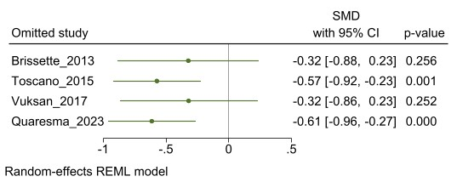
Sensitivity analysis of WC
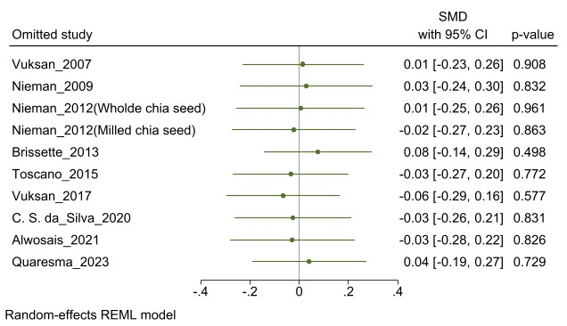
Sensitivity analysis of FBG

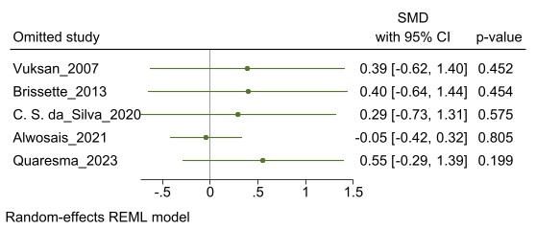
Sensitivity analysis of insulin

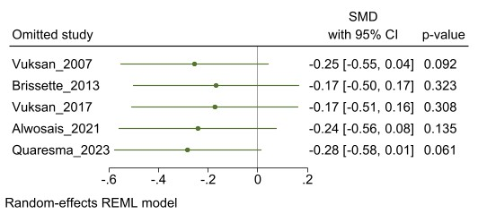
Sensitivity analysis of HbA1C
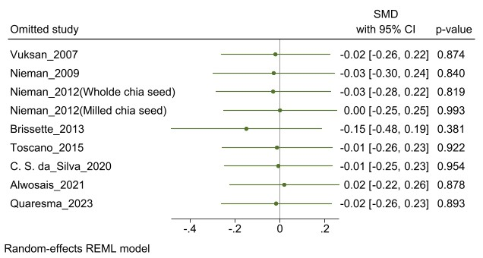
Sensitivity analysis of TC

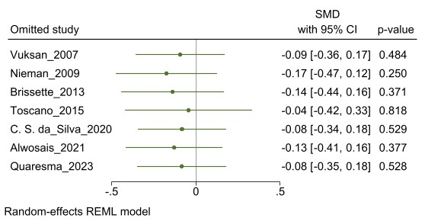
Sensitivity analysis of TG

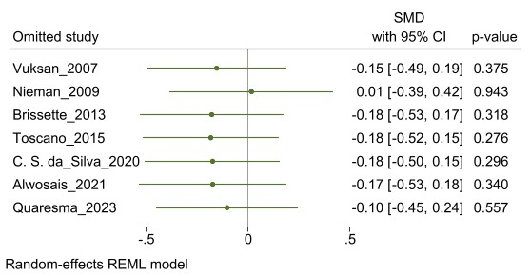
Sensitivity analysis of HDL

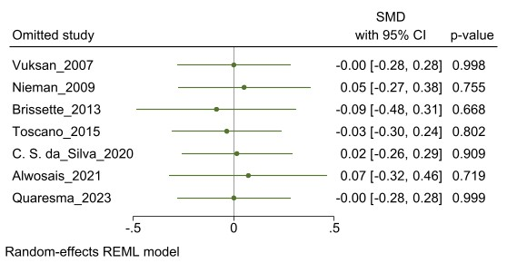
Sensitivity analysis of LDL

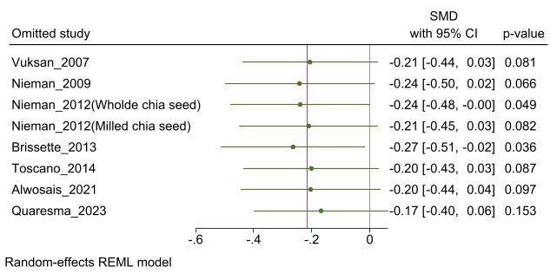
Sensitivity analysis of systolic BP

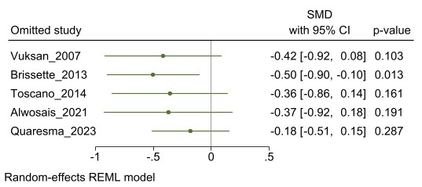
Sensitivity analysis of diastolic BP

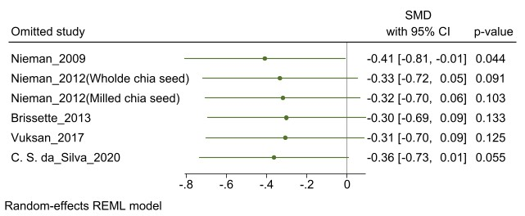
Sensitivity analysis of CRP

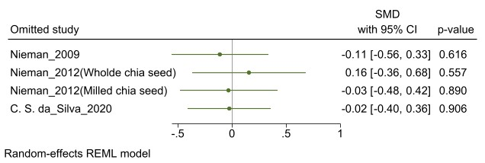
Sensitivity analysis of TNF-a

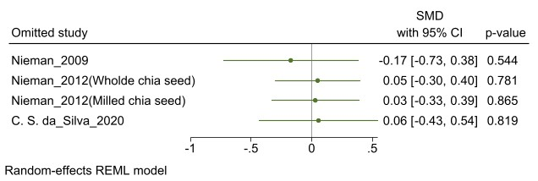
Sensitivity analysis of IL-6

Egger Regression test

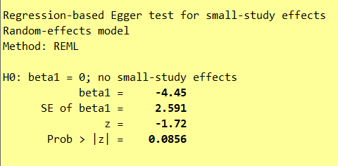
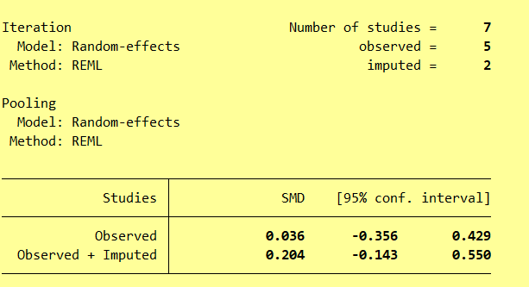
Egger Regression test of BMI

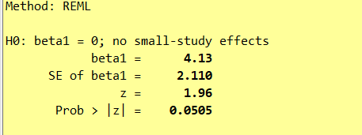
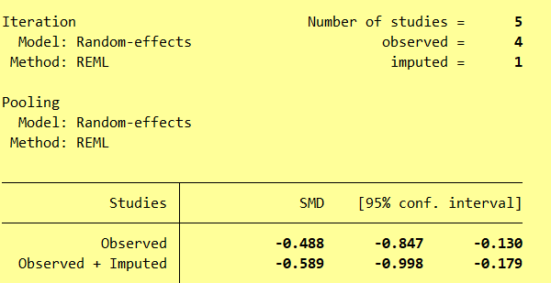
Egger Regression test of WC

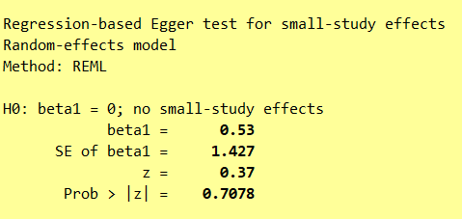
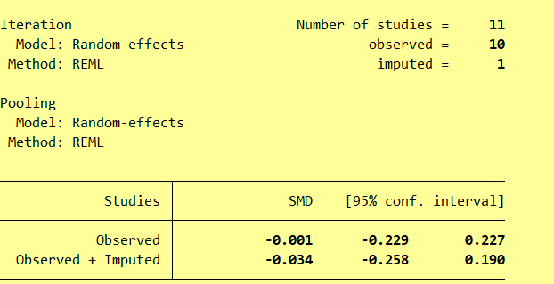
Egger Regression test of FBG

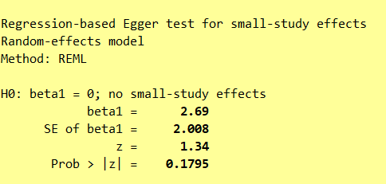
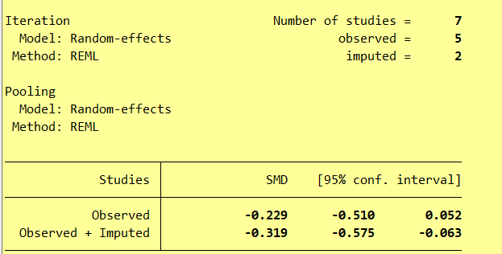
Egger Regression test of HbA1c

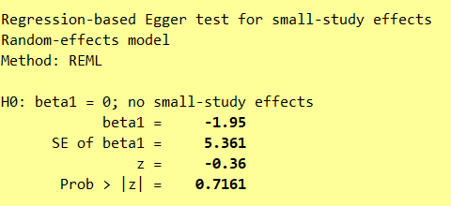
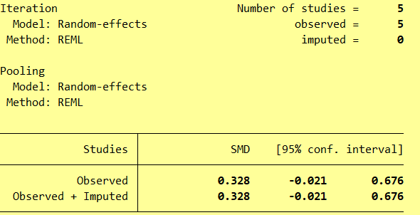
Egger Regression test of Insulin

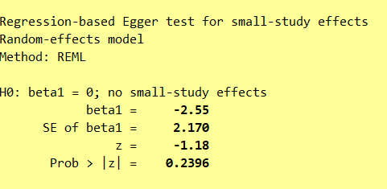

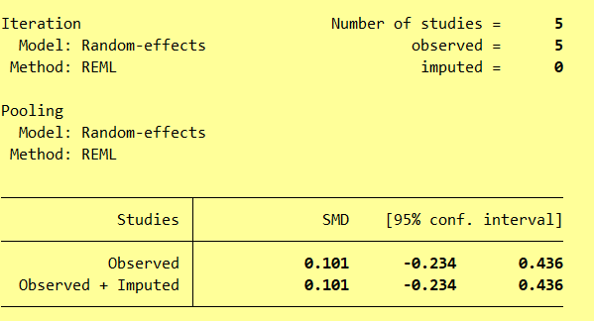
Egger Regression test of TC

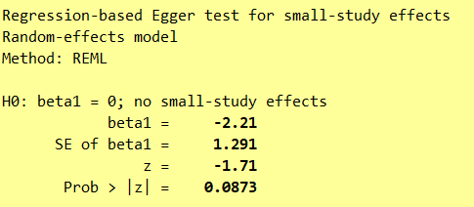
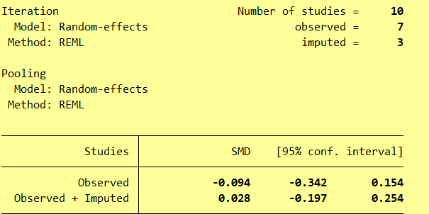
Egger Regression test of TG

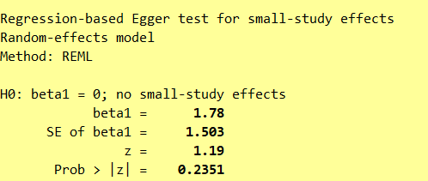

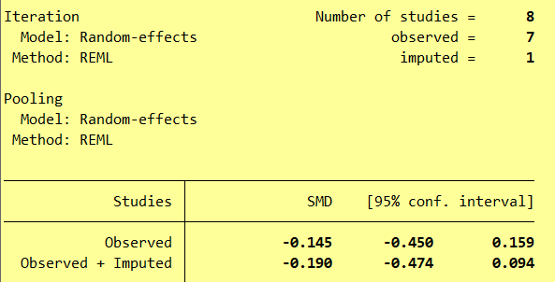
Egger Regression test of LDH

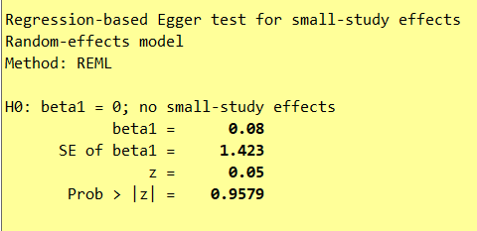

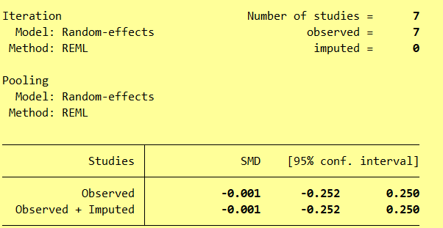
Egger Regression test of LDL

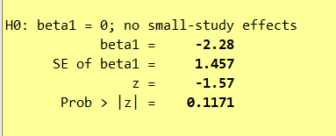
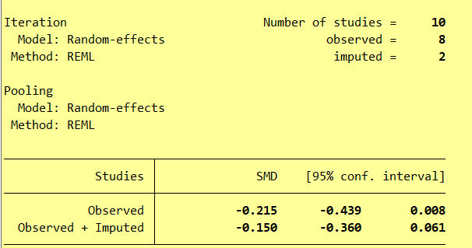
Egger Regression test of systolic BP
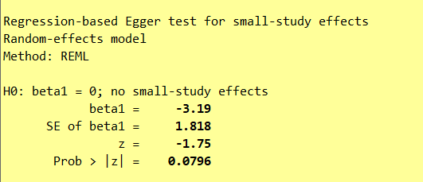
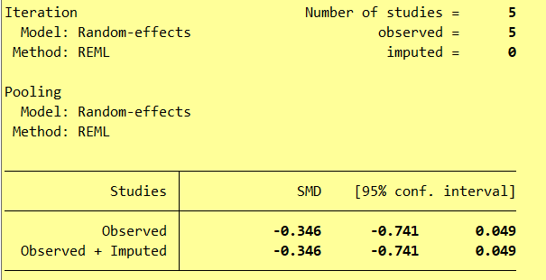
Egger Regression test of diastolic BP

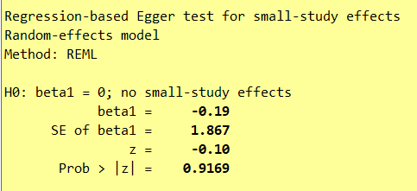
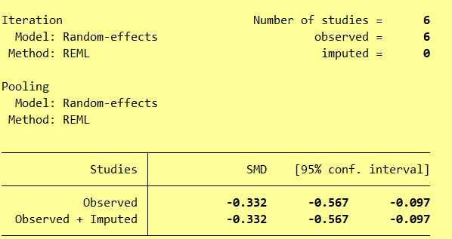
Egger Regression test of CRP

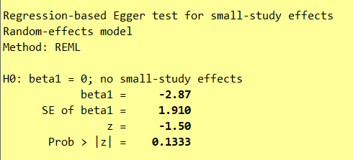

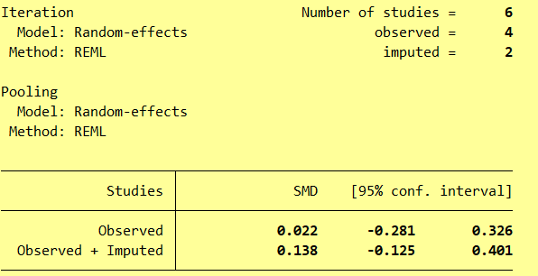
Egger Regression test of IL-6

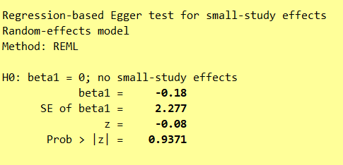

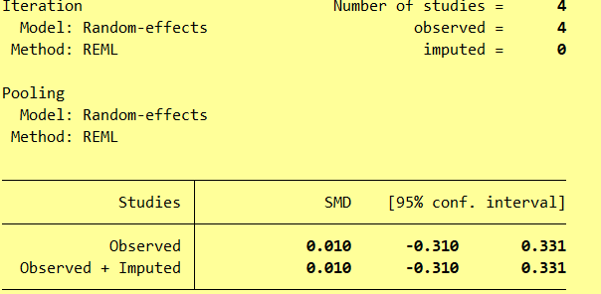
Egger Regression test of TNF-a

