Supplementary tables and figures

The mediating role of obesity in the association between meal-specific dietary patterns and chrono-nutrition components with cardiometabolic risk factors: a structural equation modeling.

Azadeh Lesani, Mehrdad Karimi, Zahra Akbarzade, Kurosh Djafarian, Sakineh Shab-Bidar
Table S1: Factor loadings of food groups identified in principal component analysis (PCA) for dietary patterns (DPs), n = 825 Iranian adults¹.
Code | Food groups | Foods involved | Meal-specific factor loading
Code | Food groups | Foods involved | Breakfast DPs |  | Lunch DPs |  | Dinner DPs
Code | Food groups | Foods involved | oil, egg and cereals | bread, vegetables and cheese | Western | oil, dairy, potato and egg | Western | cereals, oil, poultry, and legume
1 | Bread | White bread, whole grain bread |  | 0.39 | 0.66 |  | 0.44 | -0.32
2 | Cereals And Grains | All pasta and rice, wheat flour, dough, yeast dough, oat, wheat | 0.32 | - 0.54 |  | -0.51 |  | 0.62
3 | Fresh And Dried Fruits | All fruit and fresh fruit juices, All dried fruits
4 | Vegetables | Leafy green vegetables, Broccoli, cauliflower, cabbage, sauerkraut, Mushrooms, peas, corn, sprouts, garlic, onions, fennel, leek, celery, asparagus, bamboo shoots, vegetable mixes |  | 0.356 |  | 0.24 |  | 0.21
5 | Potato | Potatoes and sweet potatoes | 0.28 |  |  | 0.45
6 | Red Meat And Organ Meat | Non-processed meats from: beef, veal, lamb, other red meat, Liver, heart, kidney of cow, goat, lambs and chicken |  |  |  | -0.45
7 | Poultry | Non-processed meats from: chicken, turkey, duck, goose |  | 0.42 | -0.28 |  |  | 0.29
8 | Fish | All fish and shellfish
9 | Processed Meat | Sausages, cured ham, salami |  |  | 0.53 |  | 0.63
10 | Broth | Broth |  |  |  | 0.25 |  | 0.25
11 | Egg | Whole egg, egg whites, yolks | 0.68 |  |  | 0.55 |  | -0.30
12 | Legume | White beans, kidney beans, black beans, other beans, chick peas, lentils | 0.21 |  |  |  |  | 0.30
13 | Nut | All nuts and seeds
14 | Cheese | All cheeses | - 0.66 | 0.23
15 | Milk & Dairy Products | Low and high fat milk, dairy beverages, yogurt |  | - 0.52 | -0.21 | 0.52
16 | Liquid Vegetable Oils | All vegetable oils, Olive oil, olive | 0.82 |  |  | 0.71 | 0.48 | 0.51
17 | Butter | Butter, Animal oil, hydrogenated oil |  | - 0.29 |  | -0.24 |  | -0.3
18 | Pickle | All kind of pickles |  |  |  | 0.33 |  | 0.23
19 | Salty Snacks | Cracker, chips, cheese puff, corn puff
20 | Sugar And Sweets | Honey, syrups, sugar, jams, chocolate, chocolate bars and candies, caramelized fruits and nuts, marzipan, licorice candy, Cakes, cookies, pancakes and waffles |  |  | 0.82 | -0.34 | 0.84 | -0.34
21 | Industrial Beverages And Juices | Carbonated and non-carbonated soft drinks, industrial fruit juice |  |  | 0.84 |  | 0.84
22 | Tea And Herbal Tea | Black tea, and herbal tea |  | 0.29
23 | Coffee | Coffee and coffee substitute drinks
24 | Sauces | Tomato-based sauces, dips and dressings, mayonnaise-based sauces, dessert sauces, other sauces |  |  |  |  | 0.44
25 | Condiments | Curcumin, cinnamon, pepper, vinegar, mustard, herbs, salt, , artificial sweetener
 | Variance of intake explained |  | 15.45 | 11.42 | 9.76 | 15.21 | 14.21 | 9.46

¹ Number of participants consumed the meals (main meals) based on 24 hour dietary recalls.
Factor loadings range from -1 to +1, showing correlations between food groups and patterns. Only loadings above 0.2 or below -0.2 are shown for simplicity.

Table S2 (SEM 1): Model fitness indices for breakfast dietary patterns, chrono-nutrition components associated with cardiometabolic risk factors.

TLI | AGFI | CFI | GFI | RMSEA | χ2.df | df | χ2 | Indices
0.943 | 0.802 | 0.841 | 0.791 | 0.072 | 7.44 | 127 | 891.77 | Conceptual model  Modified model  Acceptable threshold
0.956 | 0.821 | 0.914 | 0.901 | 0.060 | 2.97 | 109 | 324.21 | Conceptual model  Modified model  Acceptable threshold
> 0.90 | > 0.80 | > 0.90 | > 0.90 | < 0.08 | < 3 |  |  | Conceptual model  Modified model  Acceptable threshold
χ2.df, Chi-square test; RMSEA, Root Mean Square Error of Approximation; CFI, Comparative Fit Index; GFI, Goodness-of-Fit Index; AGFI, adjusted GFI; TLI, Tucker-Lewis Index.

Table S3 (SEM 2): Model fitness indices for lunch dietary patterns, chrono-nutrition components associated with cardiometabolic risk factors.

TLI | AGFI | CFI | GFI | RMSEA | χ2.df | df | χ2 | Indices
0.921 | 0.811 | 0.815 | 0.951 | 0.056 | 3.49 | 111 | 383.94 | Conceptual model  Modified model  Acceptable threshold
0.917 | 0.821 | 0.902 | 0.914 | 0.054 | 2.97 | 109 | 302.326 | Conceptual model  Modified model  Acceptable threshold
> 0.90 | > 0.80 | > 0.90 | > 0.90 | < 0.08 | < 3 |  |  | Conceptual model  Modified model  Acceptable threshold
χ2.df, Chi-square test; RMSEA, Root Mean Square Error of Approximation; CFI, Comparative Fit Index; GFI, Goodness-of-Fit Index; AGFI, Adjusted GFI; TLI, Tucker-Lewis Index.

Table S4 (SEM 3): Model fitness indices for dinner dietary patterns, chrono-nutrition components associated with cardiometabolic risk factors.

TLI | AGFI | CFI | GFI | RMSEA | χ2.df | df | χ2 | Indices
0.914 | 0.805 | 0.876 | 0.907 | 0.058 | 3.85 | 110 | 423/133 | Conceptual model  Modified model  Acceptable threshold
0.920 | 0.821 | 0.917 | 0.906 | 0.057 | 2.97 | 108 | 32/321 | Conceptual model  Modified model  Acceptable threshold
> 0.90 | > 0.80 | > 0.90 | > 0.90 | < 0.08 | < 3 |  |  | Conceptual model  Modified model  Acceptable threshold
χ2.df, Chi-square test; RMSEA, Root Mean Square Error of Approximation; CFI, Comparative Fit Index; GFI, Goodness-of-Fit Index; AGFI, Adjusted GFI; TLI, Tucker-Lewis Index.

Table S5 (SEM Final): Model fitness indices for meals-specific dietary patterns, chrono-nutrition components associated with cardiometabolic risk factors.

TLI | AGFI | CFI | GFI | RMSEA | χ2.df | df | χ2 | Indices
0.908 | 0.811 | 0.945 | 0.917 | 0.050 | 3.123 | 177 | 552.781 | Conceptual model  Modified model  Acceptable threshold
0.925 | 0.820 | 0.948 | 0.927 | 0.049 | 2.90 | 175 | 509.210 | Conceptual model  Modified model  Acceptable threshold
> 0.90 | > 0.80 | > 0.90 | > 0.90 | < 0.08 | < 3 |  |  | Conceptual model  Modified model  Acceptable threshold
χ2.df, Chi-square test; RMSEA, Root Mean Square Error of Approximation; CFI, Comparative Fit Index; GFI, Goodness-of-Fit Index; AGFI, adjusted GFI; TLI, Tucker-Lewis Index.

Figure S1. Study Flow Diagram for participant data from the Iranian adults.

Both sex Iranian Participants >= 20 and < 60 years (n =888)

Available individuals with MEQ¹ data = 865

Exclusions
Missing blood samples n = 6
Missing anthropometric data n = 9

Remaining after exclusions missing data n = 850
Exclusion with over-reporting n = 23
Exclusion with underreporting n = 2

Final sample
(n = 825)

¹ MEQ, morning evening questionnaire.

Figure S2. Meal-specific screen plot for the principal component analysis.(n = 825)

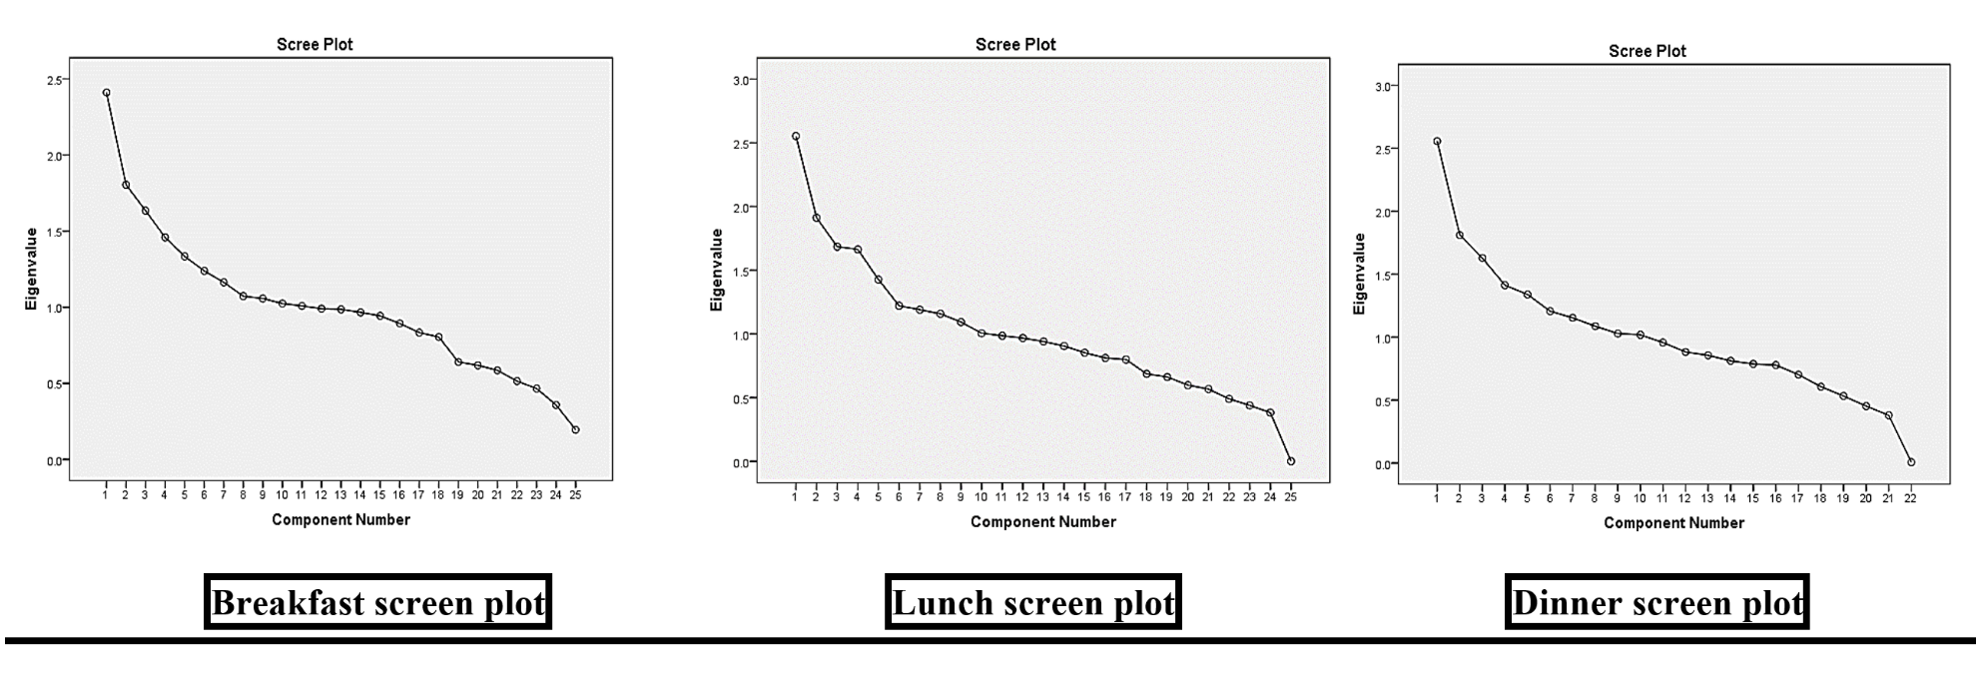

Figure S3. The effect of X on Y (total effect model), the mediation effect model, and decisionmaking tree for mediation analysis in structural equation modeling (SEM).

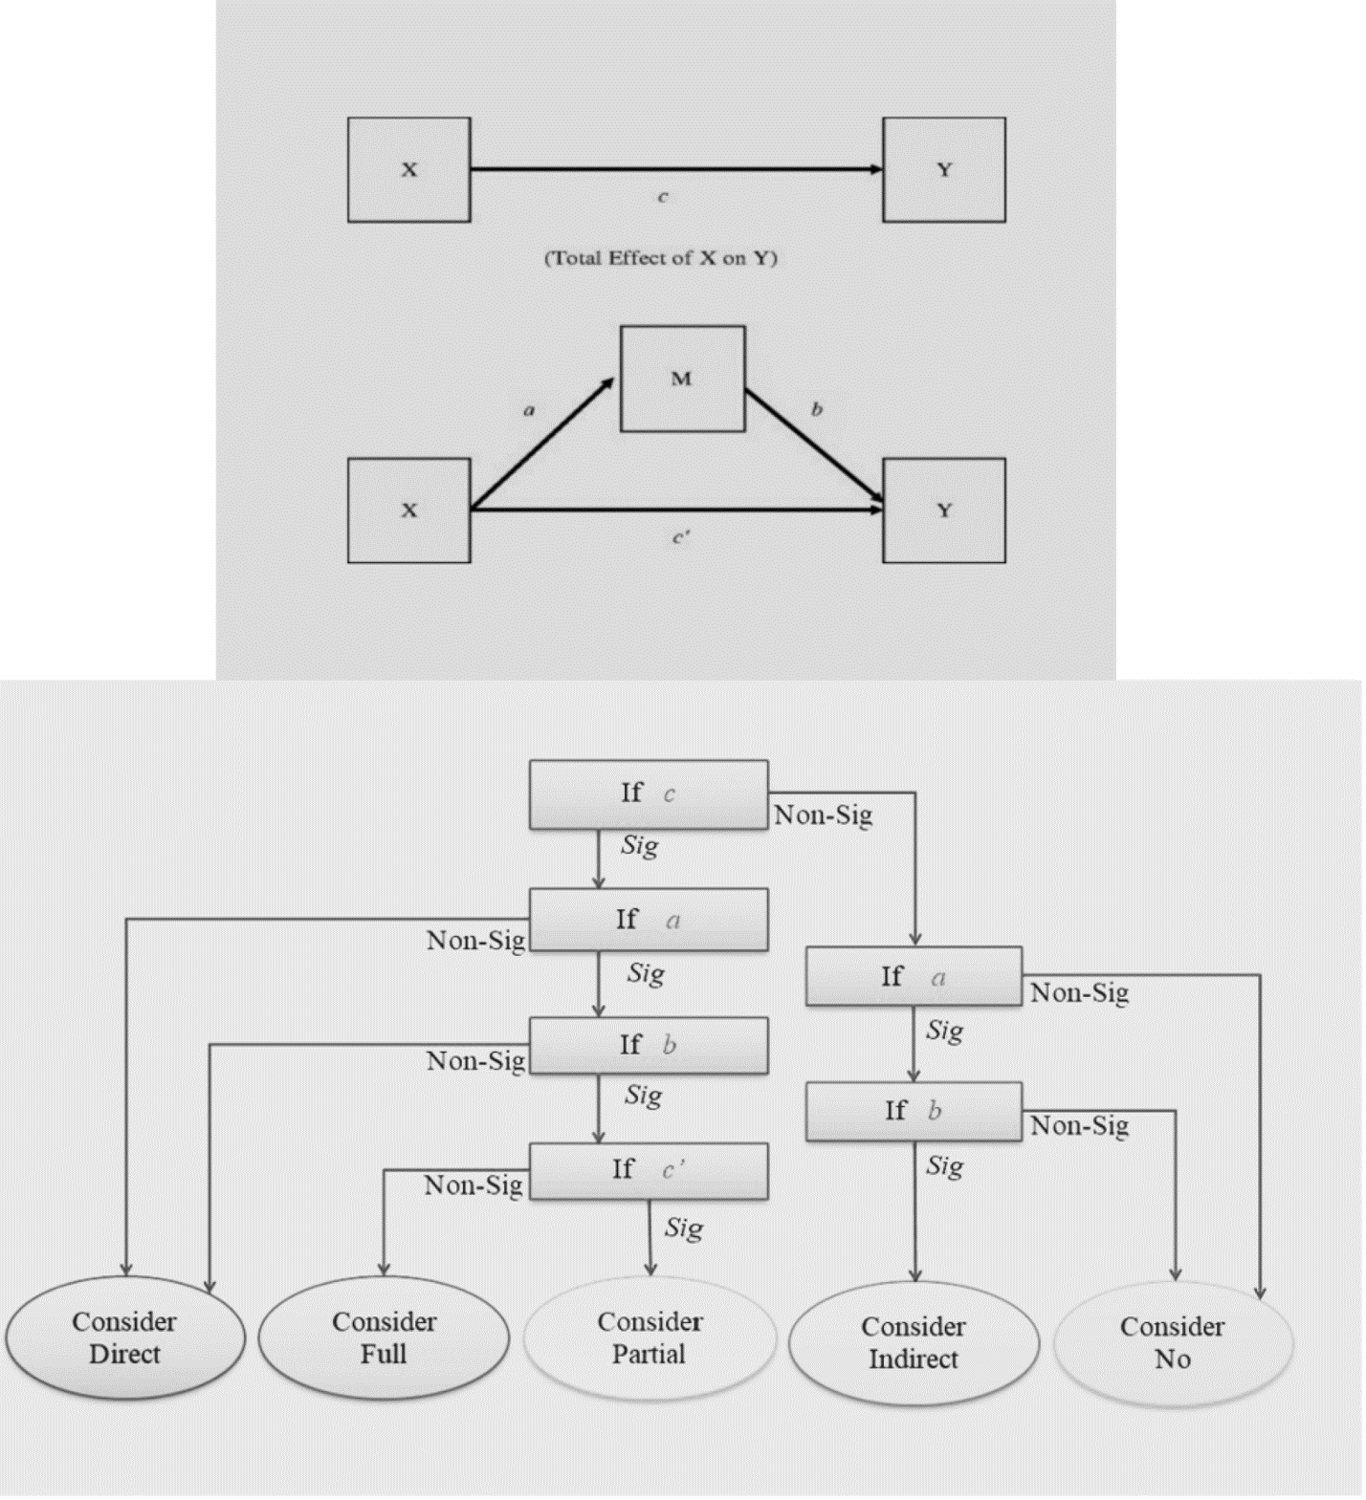
M = mediator
Paths are a, b, c, and c’, ab = indirect effect, c = direct effect, and c’ = total effect.
Figure S4 (SEM 1): Modified structured equation model of breakfast dietary patterns, chrono-nutrition components associated with cardiometabolic risk factors.
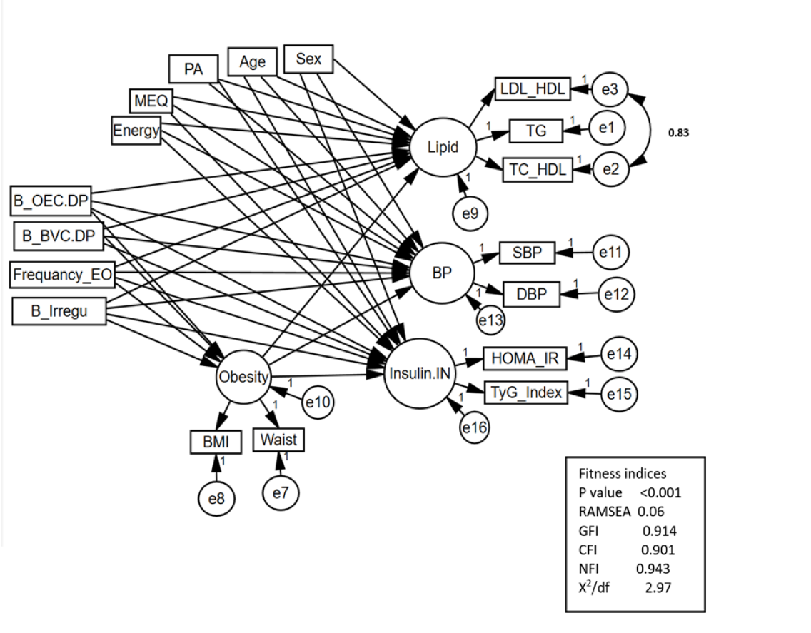

Abbreviations:
B, breakfast; OEC.DP, oil, egg and cereals dietary pattern; BVC.DP, bread vegetable cheese dietary pattern, BMI, Frequency_EO, frequency eating occasion; B_Irregu, breakfast irregularity score; Body Mass Index; SBP, systolic blood pressure; DBP, diastolic blood pressure; Waist, Waist circumference; TG, triglyceride; LDL-C, low-density lipoprotein; HDL-C, high-density lipoprotein HOMA-IR, Homeostatic Model Assessment for Insulin Resistance.

Figure S5 (SEM 2): Modified structured equation model of lunch dietary patterns, chrono-nutrition components associated with cardiometabolic risk factors.
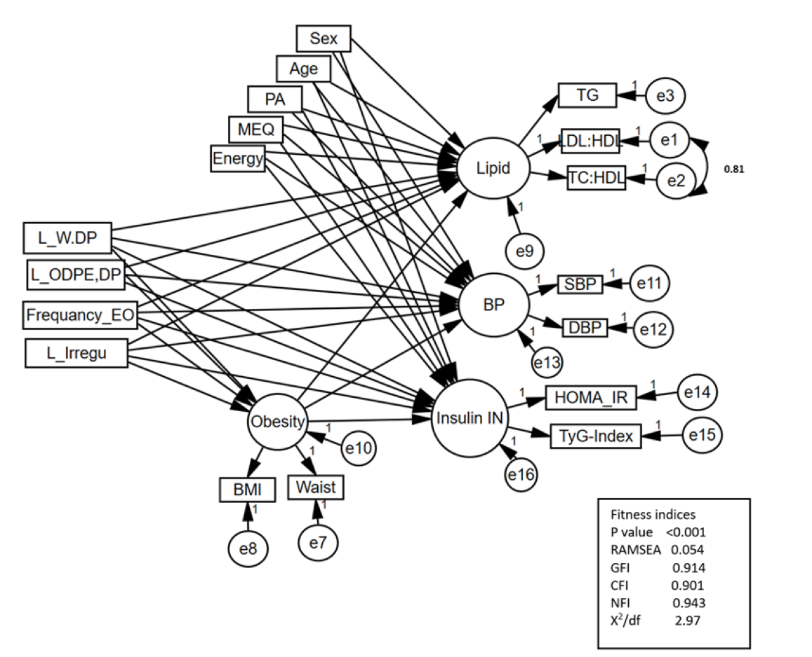

Abbreviations:
L, lunch; W.DP, western dietary pattern; ODPE.DP, oil, dairy, egg and potato dietary pattern, BMI, Frequency_EO, frequency eating occasion; L_Irregu, lunch irregularity score; Body Mass Index; SBP, systolic blood pressure; DBP, diastolic blood pressure; Waist, Waist circumference; TG, triglyceride; LDL-C, low-density lipoprotein; HDL-C, high-density lipoprotein HOMA-IR, Homeostatic Model Assessment for Insulin Resistance.

Figure S6 (SEM 3): Modified structured equation model of dinner dietary patterns, chrono-nutrition components associated with cardiometabolic risk factors.
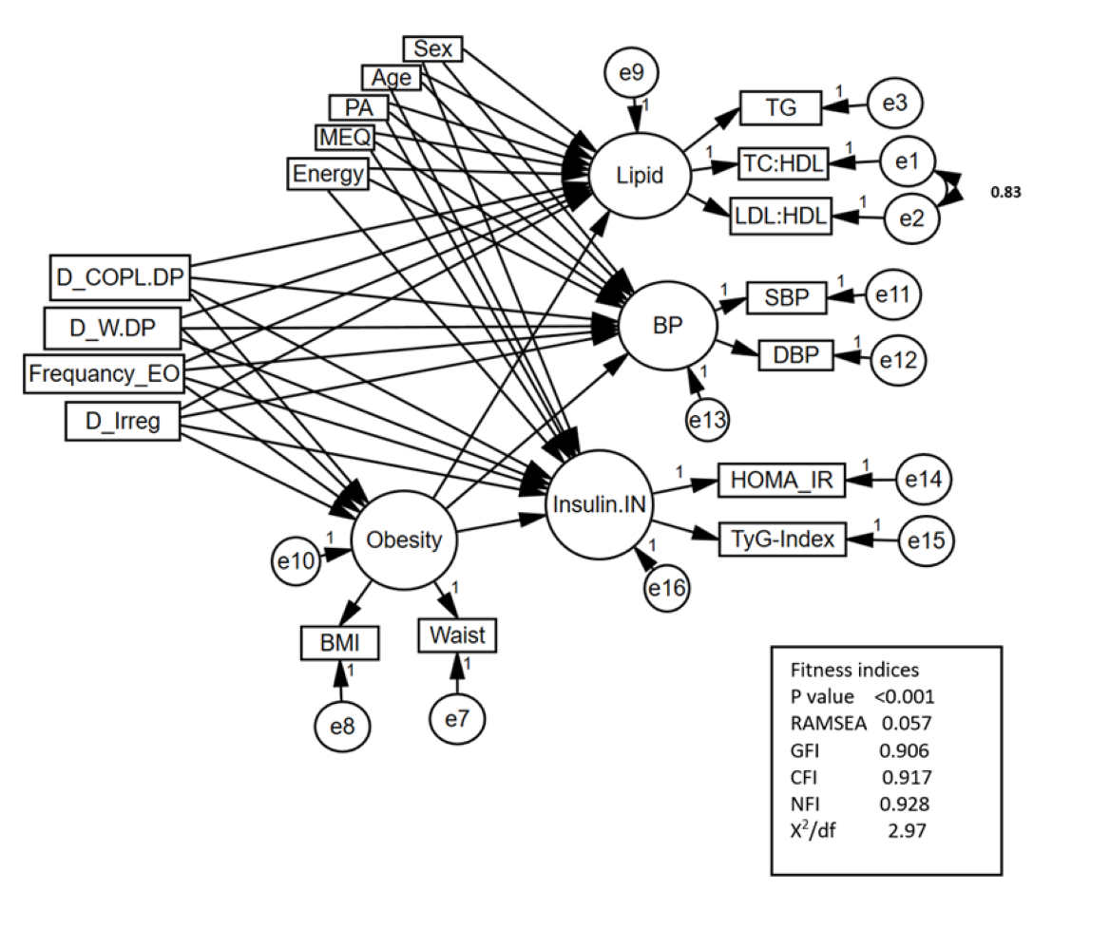
Abbreviations:
D, dinner; W.DP, western dietary pattern; COPL.DP, cereals, oils, poultry and legume dietary pattern, BMI, Frequency_EO, frequency eating occasion; D_Irregu, dinner irregularity score; Body Mass Index; SBP, systolic blood pressure; DBP, diastolic blood pressure; Waist, Waist circumference; TG, triglyceride; LDL-C, low-density lipoprotein; HDL-C, high-density lipoprotein HOMA-IR, Homeostatic Model Assessment for Insulin Resistance.

