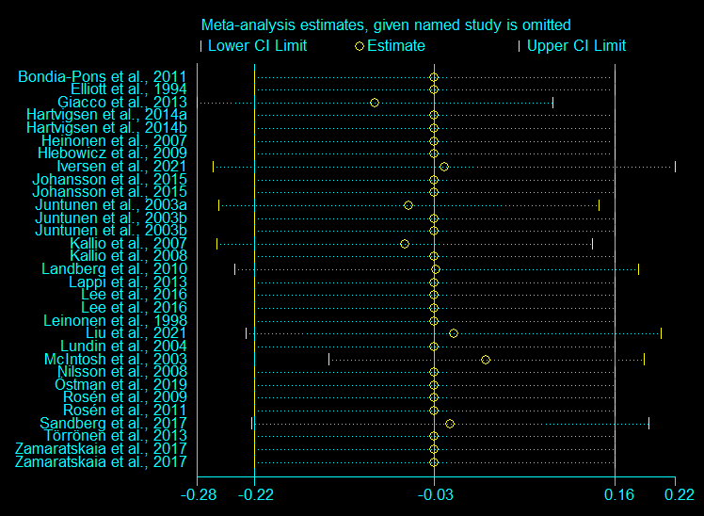

Supplemental Figure 1- Sensitivity analysis of RCTs examining the effect of rye consumption on fasting glucose.

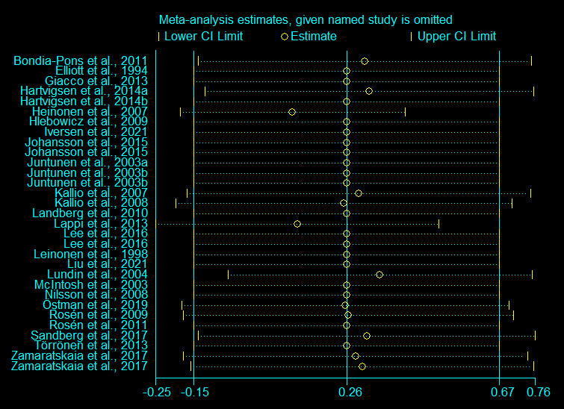

Supplemental Figure 2- Sensitivity analysis of RCTs examining the effect of rye consumption on postprandial glucose.

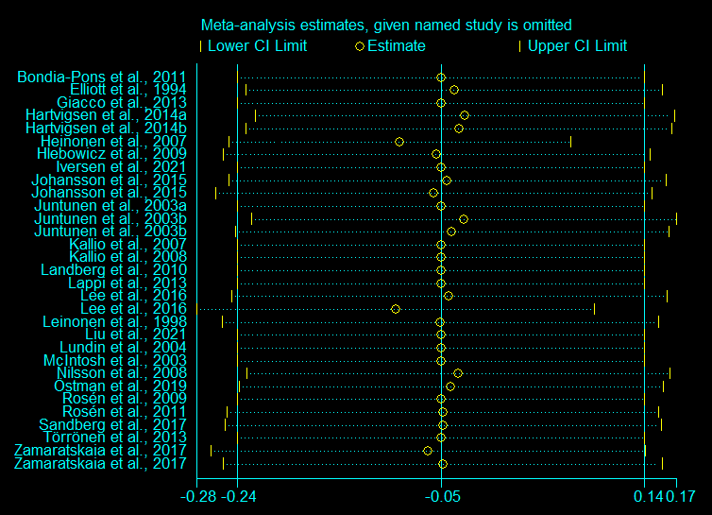

Supplemental Figure 3- Sensitivity analysis of RCTs examining the effect of rye consumption on glucose AUC.

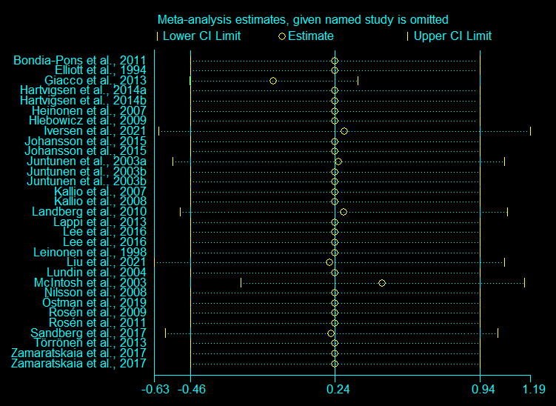

Supplemental Figure 4- Sensitivity analysis of RCTs examining the effect of rye consumption on fasting insulin.

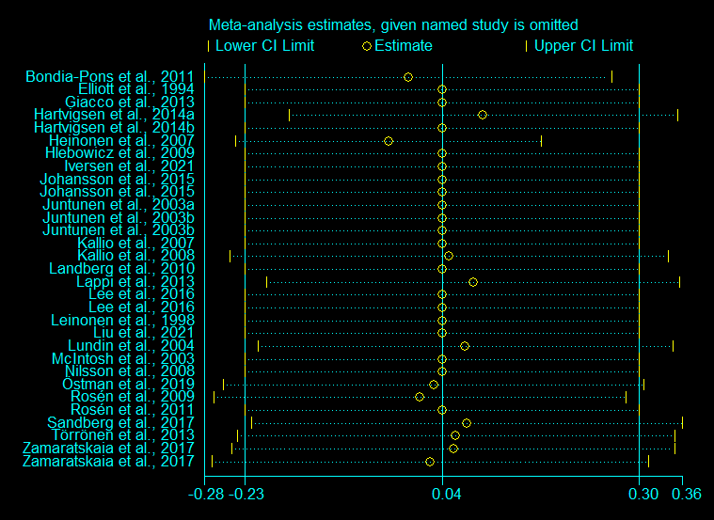

Supplemental Figure 5- Sensitivity analysis of RCTs examining the effect of rye consumption on postprandial insulin.

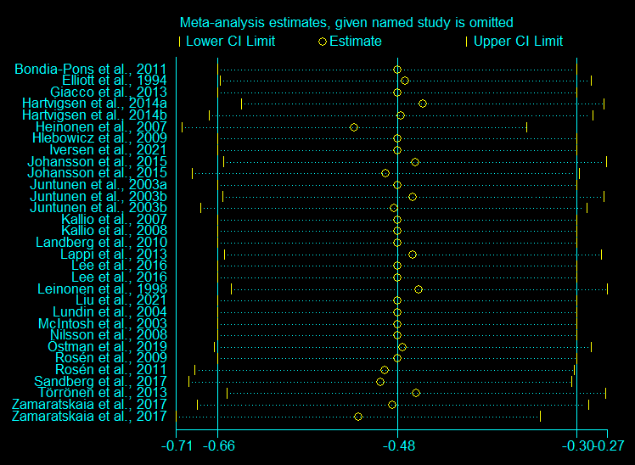

Supplemental Figure 6- Sensitivity analysis of RCTs examining the effect of rye consumption on insulin AUC.

