Clinical Evidence of Sesame (Sesamum indicum L.) Products and its Bioactive Compounds on Anthropometric Measures, Blood Pressure, Glycemic Control, Inflammatory Biomarkers, Lipid Profile, and Oxidative Stress Parameters in Humans: A GRADE-Assessed Systematic Review and Dose-Response Meta-Analysis
Contents
Supplementary Table 1. Search strategy to find potential eligible randomised controlled trials (June 2024) 2
Supplementary Table 2. A summary of excluded articles after full text review 5
Supplementary Figure 1. Forest plot of the effects of sesame supplement on anthropometric measures (a: BF, b: BMI, c: HC, d: WC, e: Weight, f: WHR) 9
Supplementary Figure 2. Forest plot of the effects of sesame supplement on blood pressure (a: DBP, b: SBP) 10
Supplementary Figure 3. Forest plot of the effects of sesame supplement on glycemic profile (a: FBS, b: HbA1c, c: HOMA-IR, d: Serum insulin 11
Supplementary Figure 4. Forest plot of the effects of sesame supplement on inflammatory markers (a: hs-CRP, b: IL-6, c: TNF-α 12
Supplementary Figure 5. Forest plot of the effects of sesame supplement on lipid profile (a: HDL, b: LDL, c: TC, d: TG 13
Supplementary Figure 6. Forest plot of the effects of sesame supplement on oxidative stress parameters (a: MDA, b: TAC 14
Supplementary Figure 7. Random-effects meta-regression plots of the association between sesame dosage (mg/d) and cardiovascular disease outcomes 15
Supplementary Figure 8. Random-effects meta-regression plots of the association between duration of intervention and cardiovascular disease outcomes 16
Supplementary Figure 9. Non-linear dose-response relations between sesame dosage (mg/d) and cardiovascular disease outcomes 17
Supplementary Figure 10. Non-linear dose-response relations between duration of intervention and cardiovascular disease outcomes 18
Supplemental References 19

Supplementary Table 1. Search strategy to find potential eligible randomised controlled trials (June 2024)
Groups | Descriptors
Intervention | Sesame OR Sesam* OR Sesamum OR “Sesame seed*” OR “Sesamum seed*” OR “Sesamum indicum” OR “Sesame indicum” OR “Sesame oil” OR “Sesamum oil” OR Sesamol OR Sesamin OR Sesamolin OR “Sesame lignin*” OR “Sesame supplement*” OR “Sesamin Supplement*” OR “Sesame extract” OR gingili OR tahini OR benni OR benne
Design | Intervention OR “Intervention Study” OR “Intervention Studies” OR “controlled trial” OR random* OR placebo OR “clinical trial” OR Trial OR “randomized controlled trial” OR “randomized clinical trial” OR RCT OR blinded OR “double blind” OR “double blinded” OR trial* OR “Pragmatic Clinical Trial” OR “Cross-Over Studies” OR “Cross-Over” OR “Cross-Over Study” OR parallel OR “parallel study” OR “parallel trial”

PubMed
Number of localized studies: 1,043
 | Descriptors | Number of studies reached
#1 | "Sesamum"[Mesh] OR "Sesame Oil"[Mesh] OR "sesamol" [Supplementary Concept] OR "sesamin" [Supplementary Concept] OR Sesame OR Sesam* OR Sesamum OR "Sesame seed*" OR "Sesamum indicum" OR "Sesame indicum" OR "Sesame oil" OR "Sesamum oil" OR Sesamol OR Sesamin OR Sesamolin OR "Sesame supplement*" OR "Sesamin Supplement*" OR "Sesame extract" OR gingili OR tahini OR benni OR benne | 9,375
#2 | Intervention[Title/Abstract] OR "Intervention Study"[Title/Abstract] OR "Intervention Studies"[Title/Abstract] OR "controlled trial"[Title/Abstract] OR random*[Title/Abstract] OR placebo[Title/Abstract] OR "clinical trial"[Title/Abstract] OR Trial[Title/Abstract] OR "randomized controlled trial"[Title/Abstract] OR "randomized clinical trial"[Title/Abstract] OR RCT[Title/Abstract] OR blinded[Title/Abstract] OR "double blind"[Title/Abstract] OR "double blinded"[Title/Abstract] OR trial*[Title/Abstract] OR "Pragmatic Clinical Trial"[Title/Abstract] OR "Cross-Over Studies"[Title/Abstract] OR "Cross-Over"[Title/Abstract] OR "Cross-Over Study"[Title/Abstract] OR parallel[Title/Abstract] OR "parallel study"[Title/Abstract] OR "parallel trial"[Title/Abstract] OR "Clinical Trial" [Publication Type] OR "Randomized Controlled Trial" [Publication Type] OR "Controlled Clinical Trial" [Publication Type] OR "Random Allocation"[Mesh] OR "Randomized Controlled Trials as Topic"[Mesh] OR "Pragmatic Clinical Trial" [Publication Type] OR "Pragmatic Clinical Trials as Topic"[Mesh] OR "Double-Blind Method"[Mesh] OR "Single-Blind Method"[Mesh] OR "Cross-Over Studies"[Mesh] | 3,674,346
#3 | #1 AND #2 | 1,043

Web of Science
Number of localized studies: 2,946
 | Descriptors | Number of studies reached
#1 | TS=(Sesame OR Sesam* OR Sesamum OR “Sesame seed*” OR “Sesamum seed*” OR “Sesamum indicum” OR “Sesame indicum” OR “Sesame oil” OR “Sesamum oil” OR Sesamol OR Sesamin OR Sesamolin OR “Sesame lignin*” OR “Sesame supplement*” OR “Sesamin Supplement*” OR “Sesame extract” OR gingivi OR tahini OR benin OR berne) | 24,167
#2 | TS=(Intervention OR “Intervention Study” OR “Intervention Studies” OR “controlled trial” OR random* OR placebo OR “clinical trial” OR Trial OR “randomized controlled trial” OR “randomized clinical trial” OR RCT OR blinded OR “double blind” OR “double blinded” OR trial* OR “Pragmatic Clinical Trial” OR “Cross-Over Studies” OR “Cross-Over” OR “Cross-Over Study” OR parallel OR “parallel study” OR “parallel trial”) | 5,576,001
#3 | #1 AND #2 | 2,946

Scopus
Number of localized studies: 2,279
 | Descriptors | Number of studies reached
#1 | TITLE-ABS-KEY (Sesame OR Sesam* OR Sesamum OR “Sesame seed*” OR “Sesamum seed*” OR “Sesamum indicum” OR “Sesame indicum” OR “Sesame oil” OR “Sesamum oil” OR Sesamol OR Sesamin OR Sesamolin OR “Sesame lignin*” OR “Sesame supplement*” OR “Sesamin Supplement*” OR “Sesame extract” OR gingili OR tahini OR benni OR benne) | 22,631
#2 | TITLE-ABS-KEY ( intervention OR "Intervention Study" OR "Intervention Studies" OR "controlled trial" OR random* OR placebo OR "clinical trial" OR trial OR "randomized controlled trial" OR "randomized clinical trial" OR rct OR blinded OR "double blind" OR "double blinded" OR trial* OR "Pragmatic Clinical Trial" OR "Cross-Over Studies" OR "Cross-Over" OR "Cross-Over Study" OR parallel OR "parallel study" OR "parallel trial" ) | 7,928,035
#3 | #1 AND #2 | 2,279

Embase
Number of localized studies: 3664
 | Descriptors | Number of studies reached
#1 | 'sesame'/exp OR 'sesame seed oil'/exp OR 'sesame seed'/exp OR 'sesame extract'/exp OR 'Sesamum'/exp OR 'sesamum indicum extract'/exp OR 'sesamol'/exp OR 'sesamolin'/exp OR 'sesamin'/exp | 6,659
#2 | 'randomized controlled trial'/exp OR 'randomized controlled trial (topic)'/exp OR 'pragmatic trial'/exp OR 'clinical trial'/exp OR 'clinical trial (topic)'/exp OR 'intervention study'/exp OR 'controlled study'/exp OR 'controlled clinical trial'/exp OR 'double blind procedure'/exp OR 'single blind procedure'/exp OR 'crossover procedure'/exp OR 'parallel design'/exp | 11,743,066
#3 | #1 AND #2 | 2,949

Cochrane
Number of localized studies: 638
Limits: TRIALS
 | Descriptors | Number of studies reached
#1 | (Sesame OR Sesam* OR Sesamum OR (Sesame NEXT seed*) OR (Sesamum NEXT seed*) OR (Sesamum NEXT indicum) OR (Sesame NEXT indicum) OR (Sesame NEXT oil) OR (Sesamum NEXT oil) OR Sesamol OR Sesamin OR Sesamolin OR (Sesame NEXT lignin*) OR (Sesame NEXT supplement*) OR (Sesamin NEXT Supplement*) OR (Sesame NEXT extract) OR gingili OR tahini OR benni OR benne):ti,ab,kw | 638

Supplementary Table 2. A summary of excluded articles after full text review
Author, Year (Ref.) | Reason
Hirata1996(1) | Not interested design
Wolde1997(2) | No placebo
Yoon1997(3) | Korean language
Cooney2001(4) | No placebo
Lemcke-Norojarvi2001(5) | No placebo
Frank2004(6) | No placebo
Chen2005(7) | No placebo
Coulman2005(8) | No placebo
Sankar2005(9) | No placebo
Sankar2005(10) | No placebo
Sankar2006(11) | No placebo
Sankar2006(12) | No placebo
Mitra2007(13) | No placebo
Mosallaieepour-Yazdi2008(14) | Persian language
Figueiredo2008(15) | Portuguese language
Coulman2009(16) | No placebo
Kang2009(17) | Not interested design
Wu2009(18) | Not interested design
Sankar2011(19) | No placebo
Sudhakar2011(20) | Not interested intervention
Suwimol2012(21) | No placebo
Alipoor2012(22) | No placebo
Karatzi2012(23) | No placebo
Chiu2013(24) | Not interested intervention
Golzarand2013(25) | Persian language
Karatzi2013(26) | No placebo
Mirmiran2013(27) | No placebo
Namayandeh2013(28) | No placebo
Tomimori2013(29) | Not interested intervention
Haghighian2014(30) | No placebo
Ristic-Medic2014(31) | No placebo
Soare2014(32) | No placebo
Bahadoran2015(33) | No placebo
Takemoto2015(34) | Not interested outcome
Shishehbor2015(35) | Persian language
Seki2015(36) | No full text
Takić2016(37) | Not interested design
Devarajan2016(38) | No placebo
Devarajan2016(39) | No placebo
Saberi2017(40) | Persian language
Aslam2017(41) | No placebo
Silva Barbosa2017(42) | Not interested population
Imai2018(43) | Not interested intervention
Ito2018(44) | Not interested intervention
Amiri2019(45) | No placebo
Farajbakhsh2019(46) | No placebo
Faraji2019(47) | No placebo
Gorbanian2020(48) | Persian language
Haldar2020(49) | No placebo
Mosadegh2020(50) | Persian language
Ramezani-Jolfaie2020(51) | No placebo
Tolouei Azar2020(52) | Persian language
Aghababaei2021(53) | No placebo
Baxevanis2021(54) | No placebo
Moghtaderi2021(55) | No placebo
Raeisi-Dehkordi2021(56) | No placebo
Raeisi-Dehkordi2021(57) | No placebo
Jung2021(58) | Not interested outcome
Amiri2022(59) | No placebo
Atefi2022(60) | No placebo
Baxevanis2022(61) | No placebo
Koonyosying2022(62) | Not interested intervention
Ghoreishi2022(63) | No placebo
Haldar2022(64) | No placebo
Moghtaderi2022(65) | No placebo
Vahedi2022(66) | No placebo
Arshad2022(67) | No placebo
Atefi2022(68) | No placebo
Atefi2023(69) | No placebo
Rasheed2023(70) | No placebo
Praengam2023(71) | Not interested intervention

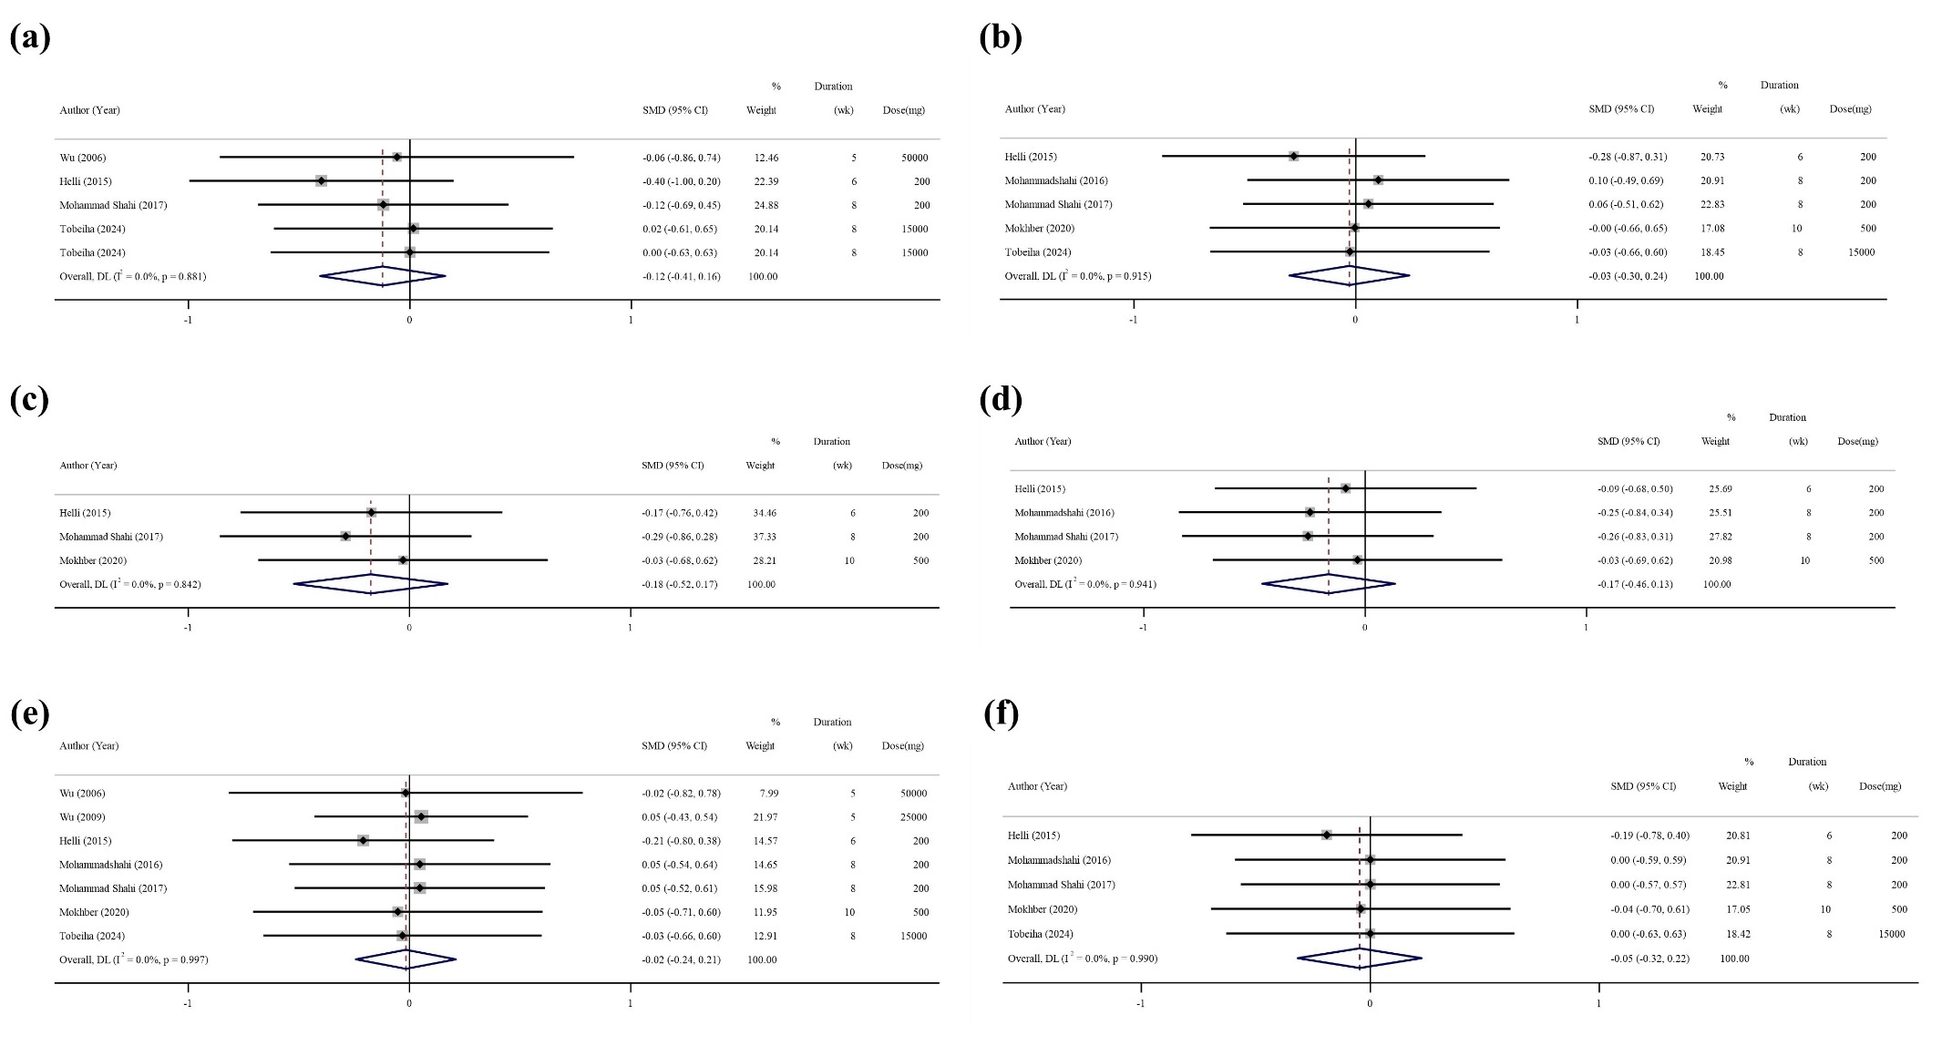

Supplementary Figure 1. Forest plot of the effects of sesame supplement on anthropometric measures (a: BF, b: BMI, c: HC, d: WC, e: Weight, f: WHR)

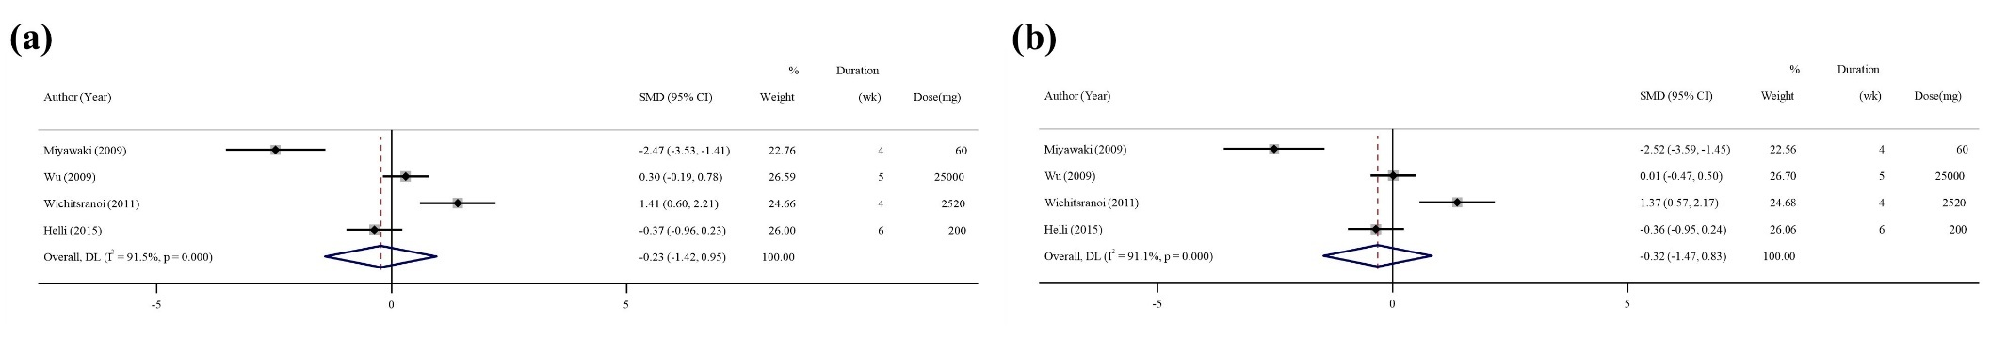

Supplementary Figure 2. Forest plot of the effects of sesame supplement on blood pressure (a: DBP, b: SBP)

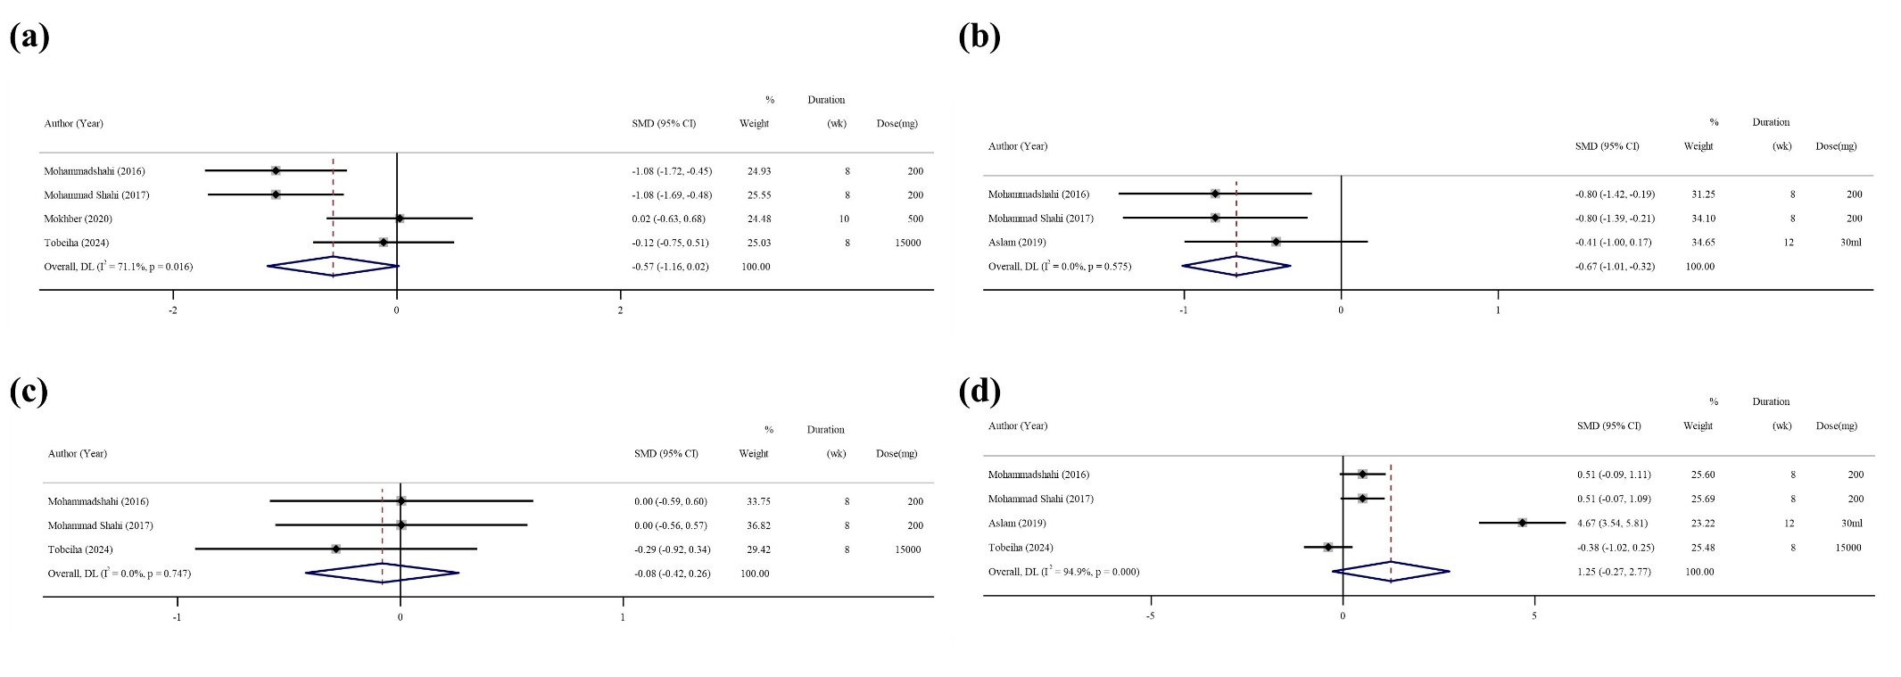

Supplementary Figure 3. Forest plot of the effects of sesame supplement on glycemic profile (a: FBS, b: HbA1c, c: HOMA-IR, d: Serum insulin)

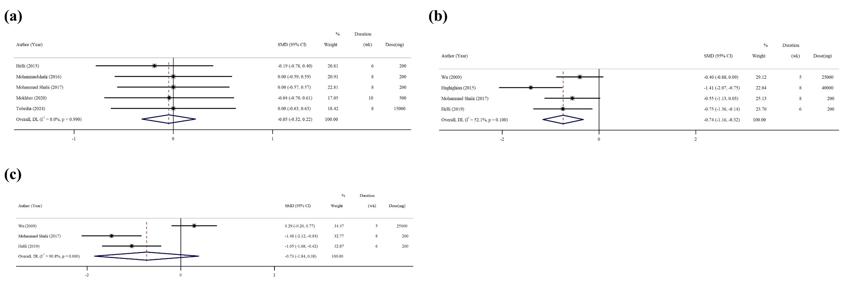

Supplementary Figure 4. Forest plot of the effects of sesame supplement on inflammatory markers (a: hs-CRP, b: IL-6, c: TNF-α)

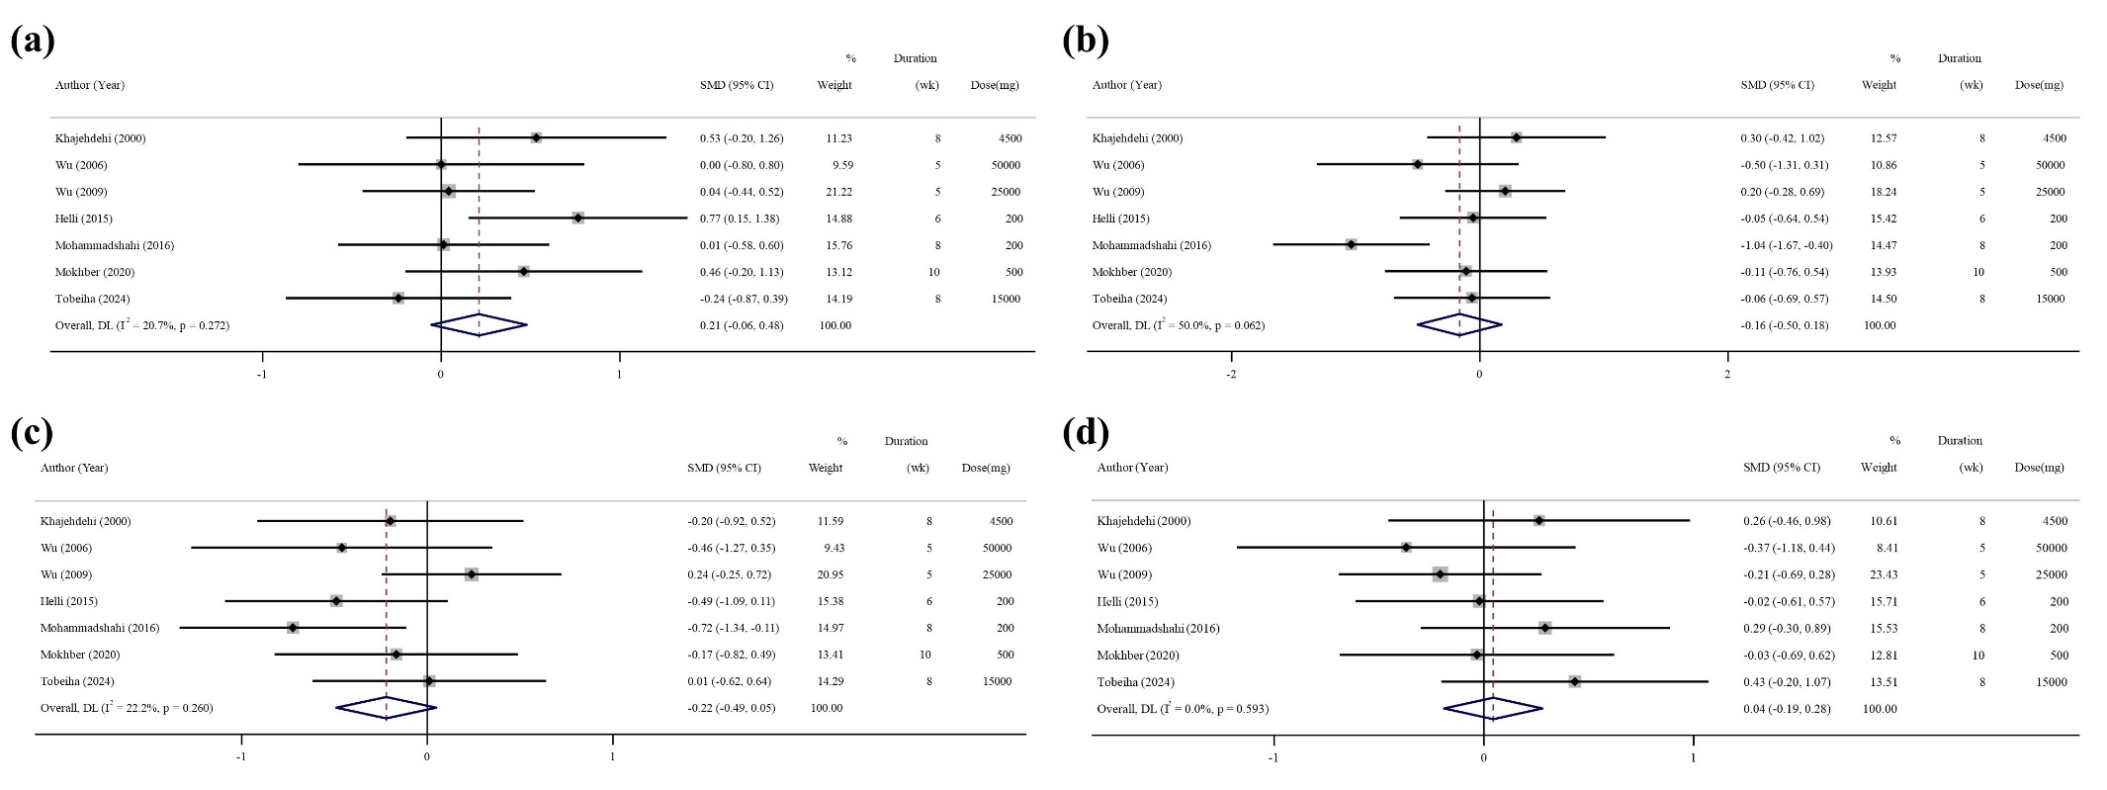

Supplementary Figure 5. Forest plot of the effects of sesame supplement on lipid profile (a: HDL, b: LDL, c: TC, d: TG)

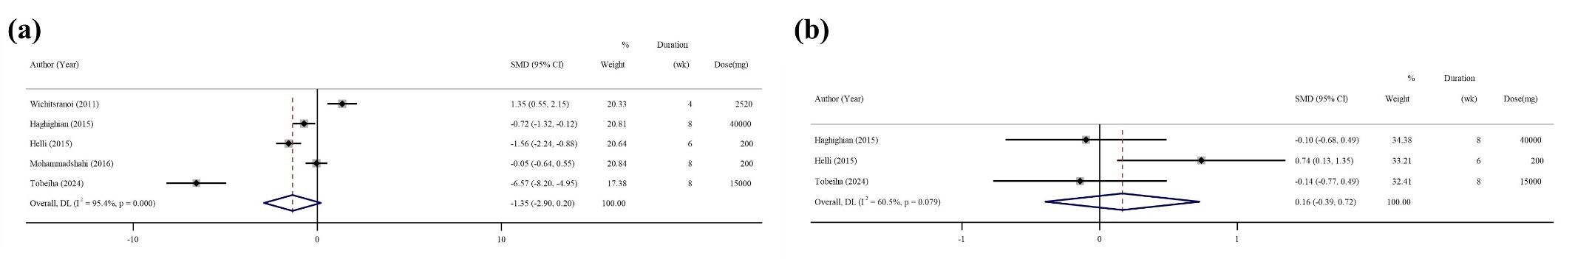

Supplementary Figure 6. Forest plot of the effects of sesame supplement on oxidative stress parameters (a: MDA, b: TAC)

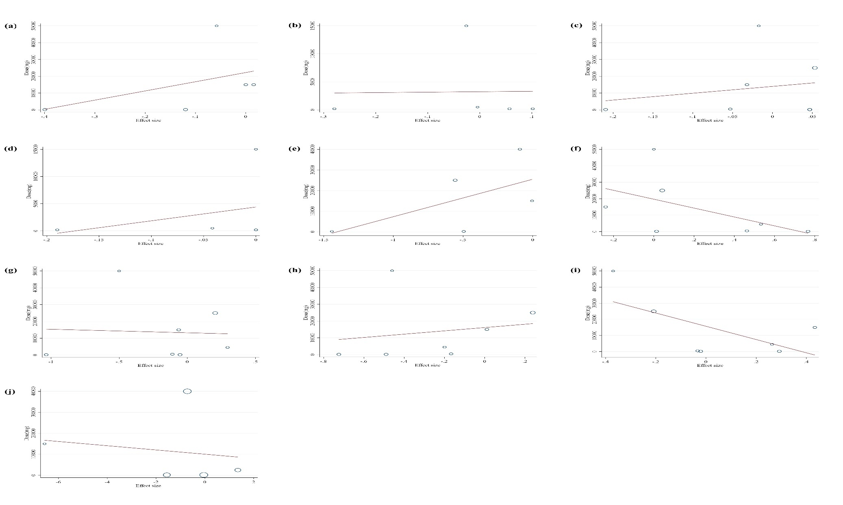
Supplementary Figure 7. Random-effects meta-regression plots of the association between sesame dosage (mg/d) and cardiovascular disease outcomes (a: BF, b: BMI, C: Weight, d: WHR, e: CRP, f: HDL, g: LDL, h: TC, i: TG, j: MDA)
Supplementary Figure 2. Forest plot detailing weighted mean difference and 95% confidence intervals (CIs) for the effect of folic acid supplementation on; A) SBP; and B) DBP.

Supplementary Figure 2. Forest plot of the effects of chia product supplement on anthropometric measures.

Supplementary Figure 4. Forest plot of the effects of chia product supplement on glycemic indices.

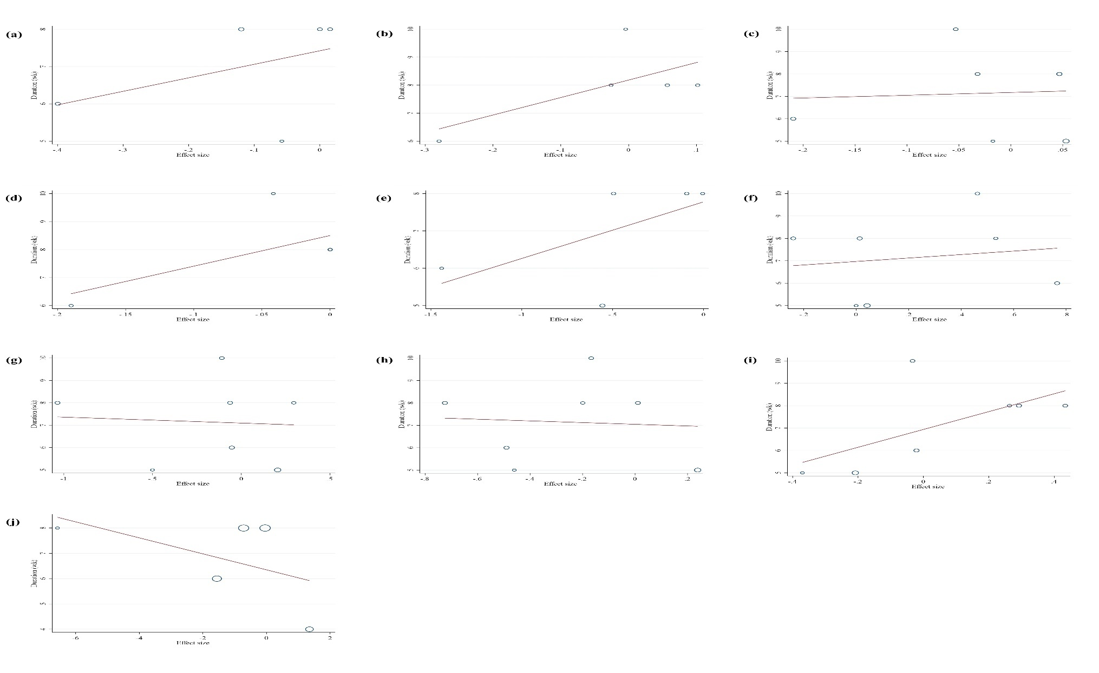
Supplementary Figure 8. Random-effects meta-regression plots of the association between duration of intervention and cardiovascular disease outcomes (a: BF, b: BMI, C: Weight, d: WHR, e: CRP, f: HDL, g: LDL, h: TC, i: TG, j: MDA)
Supplementary Figure 2. Forest plot detailing weighted mean difference and 95% confidence intervals (CIs) for the effect of folic acid supplementation on; A) SBP; and B) DBP.

Supplementary Figure 2. Forest plot of the effects of chia product supplement on anthropometric measures.

Supplementary Figure 4. Forest plot of the effects of chia product supplement on glycemic indices.

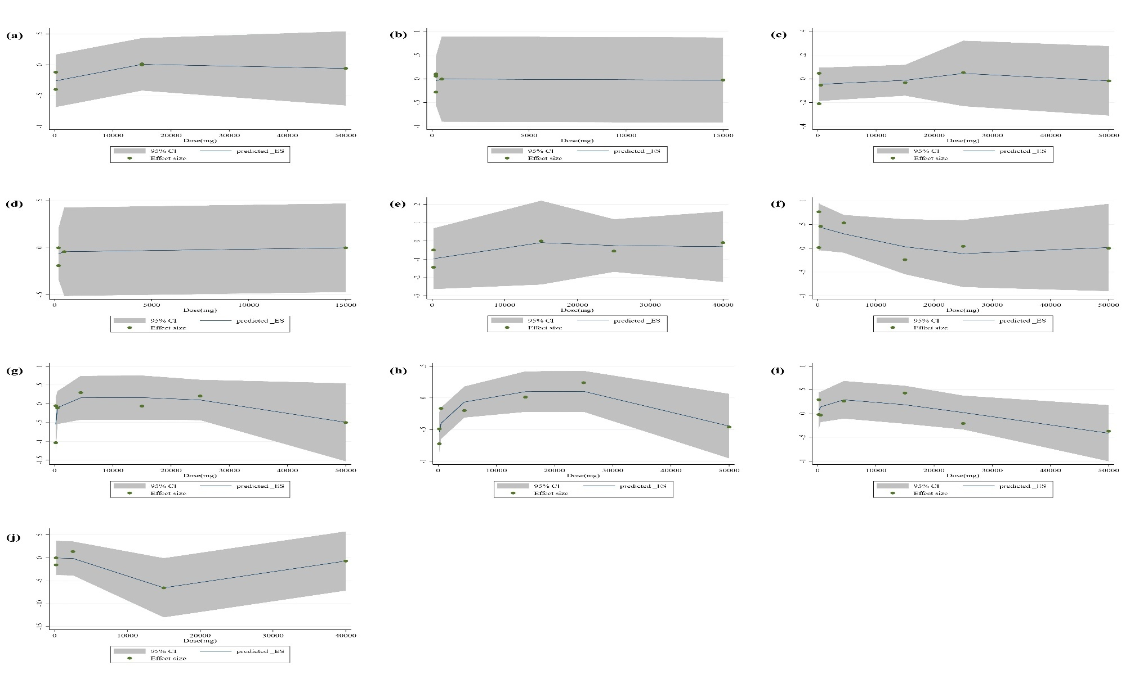
Supplementary Figure 9. Non-linear dose-response relations between sesame dosage (mg/d) and cardiovascular disease outcomes (a: BF, b: BMI, C: Weight, d: WHR, e: CRP, f: HDL, g: LDL, h: TC, i: TG, j: MDA)
Supplementary Figure 2. Forest plot detailing weighted mean difference and 95% confidence intervals (CIs) for the effect of folic acid supplementation on; A) SBP; and B) DBP.

Supplementary Figure 2. Forest plot of the effects of chia product supplement on anthropometric measures.

Supplementary Figure 4. Forest plot of the effects of chia product supplement on glycemic indices.

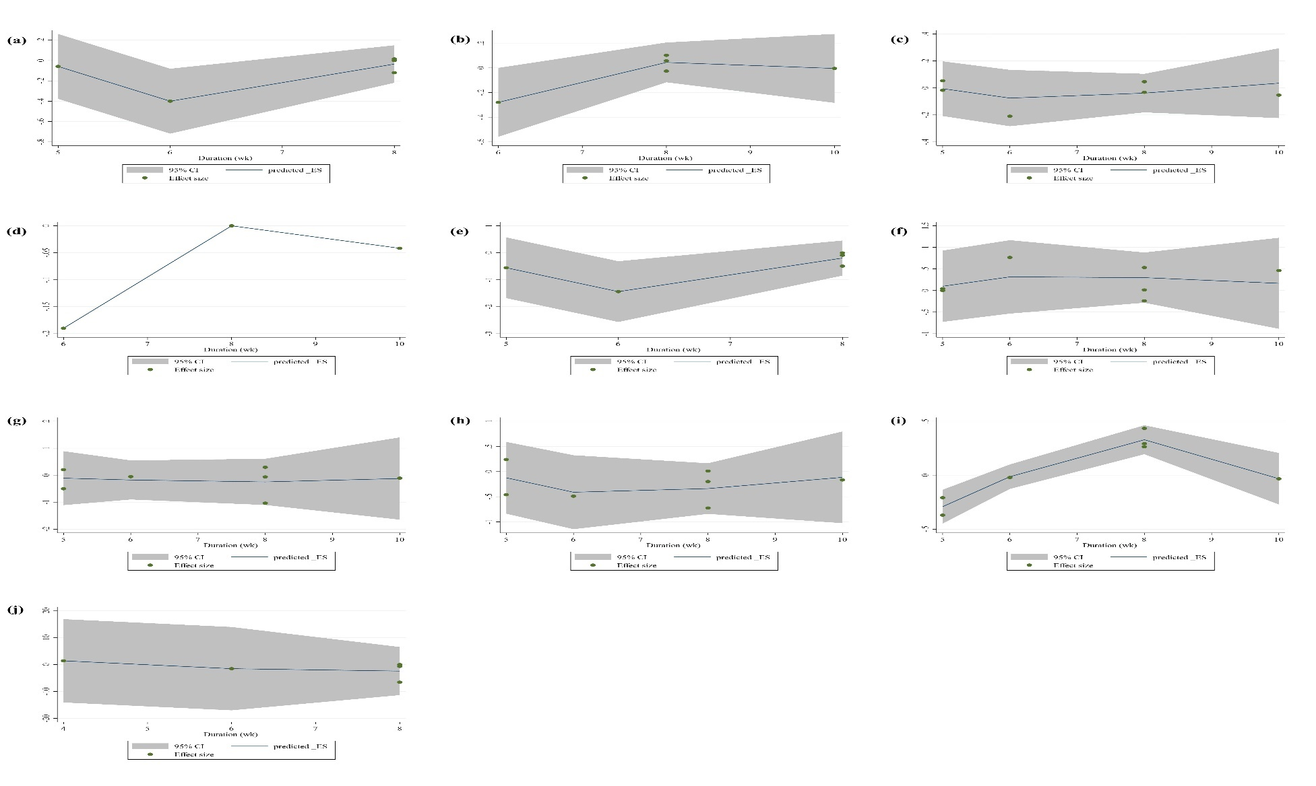
Supplementary Figure 10. Non-linear dose-response relations between duration of intervention and cardiovascular disease outcomes (a: BF, b: BMI, C: Weight, d: WHR, e: CRP, f: HDL, g: LDL, h: TC, i: TG, j: MDA)
Supplementary Figure 2. Forest plot detailing weighted mean difference and 95% confidence intervals (CIs) for the effect of folic acid supplementation on; A) SBP; and B) DBP.

Supplementary Figure 2. Forest plot of the effects of chia product supplement on anthropometric measures.

Supplementary Figure 4. Forest plot of the effects of chia product supplement on glycemic indices.

Supplemental References

1. Hirata F, Fujita K, Ishikura Y, Hosoda K, Ishikawa T, Nakamura H. Hypocholesterolemic effect of sesame lignan in humans. Atherosclerosis. 1996;122(1):135-36.
2. ten Wolde S, Engels F, Miltenburg AM, Kuijpers EA, Struijk-Wielinga GI, Dijkmans BA. Sesame oil in injectable gold: two drugs in one? Br J Rheumatol. 1997;36(9):1012-5.
3. 윤명호, 신준한, 김한수, 탁승제, 최병일. The Effect of Sesamin on Human Serum Lipids.
4. Cooney RV, Custer LJ, Okinaka L, Franke AA. Effects of dietary sesame seeds on plasma tocopherol levels. Nutr Cancer. 2001;39(1):66-71.
5. Lemcke-Norojärvi M, Kamal-Eldin A, Appelqvist LA, Dimberg LH, Ohrvall M, Vessby B. Corn and sesame oils increase serum gamma-tocopherol concentrations in healthy Swedish women. J Nutr. 2001;131(4):1195-201.
6. Frank J, Kamal-Eldin A, Traber MG. Consumption of sesame oil muffins decreases the urinary excretion of gamma-tocopherol metabolites in humans. Ann N Y Acad Sci. 2004;1031:365-7.
7. Chen PR, Chien KL, Su TC, Chang CJ, Liu T-L, Cheng H, et al. Dietary sesame reduces serum cholesterol and enhances antioxidant capacity in hypercholesterolemia. Nutrition research. 2005;25(6):559-67.
8. Coulman KD, Liu Z, Hum WQ, Michaelides J, Thompson LU. Whole sesame seed is as rich a source of mammalian lignan precursors as whole flaxseed. Nutr Cancer. 2005;52(2):156-65.
9. Sankar D, Sambandam G, Rao MR, Pugalendi K. Sesame oil exhibits additive effect on nifedipine and modulates oxidative stress and electrolytes in hypertensive patients. Journal of nutraceuticals, functional & medical foods. 2005;4(3-4):133-45.
10. Sankar D, Sambandam G, Ramakrishna Rao M, Pugalendi KV. Modulation of blood pressure, lipid profiles and redox status in hypertensive patients taking different edible oils. Clin Chim Acta. 2005;355(1-2):97-104.
11. Sankar D, Rao MR, Sambandam G, Pugalendi KV. A pilot study of open label sesame oil in hypertensive diabetics. J Med Food. 2006;9(3):408-12.
12. Sankar D, Rao MR, Sambandam G, Pugalendi K. Effect of sesame oil on diuretics or ß-blockers in the modulation of blood pressure, anthropometry, lipid profile, and redox status. The Yale journal of biology and medicine. 2006;79(1):19.
13. Mitra A. Study on the benefits of sesame oil over coconut oil in patients of insulin resistance syndrome, notably type 2 diabetes and dyslipidaemia. Journal of Human Ecology. 2007;22(1):61-6.
14. Mosallaieepour-Yazdi M, Eghtesadi S, Kaseb F, Afkhami-Ardakani M, Hoseini F. Effects of Sesame Oil on Blood Glucose and Lipid Profile in Type II Diabetic Patients Referring to The Yazd Diabetes Research Center. The Journal of Shahid Sadoughi University of Medical Sciences. 2008;16(2):31-5.
15. Figueiredo AS, Modesto-Filho J. Efeito do uso da farinha desengordurada do Sesamum indicum L nos níveis glicêmicos em diabéticas tipo 2. Revista Brasileira de Farmacognosia. 2008;18:77-83.
16. Coulman KD, Liu Z, Michaelides J, Quan Hum W, Thompson LU. Fatty acids and lignans in unground whole flaxseed and sesame seed are bioavailable but have minimal antioxidant and lipid-lowering effects in postmenopausal women. Mol Nutr Food Res. 2009;53(11):1366-75.
17. Kang S-H, Shin K-O. Effects of Dietary Supplementation with a Compound Composed of Caffeine, Capsaicin, Sesamine, L-Carnitine, Banaba and Lotus on Human Autonomic Nervous System Activity and Lipid Oxidation. Preventive Nutrition and Food Science. 2009;14(3):173-8.
18. Wu JH, Hodgson JM, Clarke MW, Indrawan AP, Barden AE, Puddey IB, et al. Inhibition of 20-hydroxyeicosatetraenoic acid synthesis using specific plant lignans: in vitro and human studies. Hypertension. 2009;54(5):1151-8.
19. Sankar D, Ali A, Sambandam G, Rao R. Sesame oil exhibits synergistic effect with anti-diabetic medication in patients with type 2 diabetes mellitus. Clin Nutr. 2011;30(3):351-8.
20. Sudhakar B, Kalaiarasi P, Al-Numair KS, Chandramohan G, Rao RK, Pugalendi KV. Effect of combination of edible oils on blood pressure, lipid profile, lipid peroxidative markers, antioxidant status, and electrolytes in patients with hypertension on nifedipine treatment. Saudi Med J. 2011;32(4):379-85.
21. Suwimol S, Wiroj J, Kewalin W, Natchapon J, Pathamaporn H, Auranun S. Effects of sesame seeds consumption on serum cholesterol and oxidative status in hypercholesterolemia. Food Public Health. 2012;2(6):193-6.
22. Alipoor B, Haghighian MK, Sadat BE, Asghari M. Effect of sesame seed on lipid profile and redox status in hyperlipidemic patients. Int J Food Sci Nutr. 2012;63(6):674-8.
23. Karatzi K, Stamatelopoulos K, Lykka M, Mantzouratou P, Skalidi S, Manios E, et al. Acute and long-term hemodynamic effects of sesame oil consumption in hypertensive men. J Clin Hypertens (Greenwich). 2012;14(9):630-6.
24. Chiu HF, Chen TY, Tzeng YT, Wang CK. Improvement of liver function in humans using a mixture of schisandra fruit extract and sesamin. Phytother Res. 2013;27(3):368-73.
25. Golzarand M, Bahadoran Z, Hosseinpour-Niazi S, Mirzaee S, Azizi F, Mirmiran P. Effect of Ardeh on components of metabolic syndrome in type 2 diabetic patients: a randomized clinical trial. Iranian Journal of Endocrinology and Metabolism. 2013;15(4):333-9.
26. Karatzi K, Stamatelopoulos K, Lykka M, Mantzouratou P, Skalidi S, Zakopoulos N, et al. Sesame oil consumption exerts a beneficial effect on endothelial function in hypertensive men. European journal of preventive cardiology. 2013;20(2):202-8.
27. Mirmiran P, Bahadoran Z, Golzarand M, Rajab A, Azizi F. Ardeh (Sesamum indicum) could improve serum triglycerides and atherogenic lipid parameters in type 2 diabetic patients: a randomized clinical trial. Arch Iran Med. 2013;16(11):651-6.
28. Namayandeh SM, Kaseb F, Lesan S. Olive and sesame oil effect on lipid profile in hypercholesterolemic patients, which better? Int J Prev Med. 2013;4(9):1059-62.
29. Tomimori N, Tanaka Y, Kitagawa Y, Fujii W, Sakakibara Y, Shibata H. Pharmacokinetics and safety of the sesame lignans, sesamin and episesamin, in healthy subjects. Biopharm Drug Dispos. 2013;34(8):462-73.
30. Khadem Haghighian M, Alipoor B, Eftekhar Sadat B, Malek Mahdavi A, Moghaddam A, Vatankhah AM. Effects of sesame seed supplementation on lipid profile and oxidative stress biomarkers in patients with knee osteoarthritis. Health Promot Perspect. 2014;4(1):90-7.
31. Ristic-Medic D, Perunicic-Pekovic G, Rasic-Milutinovic Z, Takic M, Popovic T, Arsic A, et al. Effects of dietary milled seed mixture on fatty acid status and inflammatory markers in patients on hemodialysis. ScientificWorldJournal. 2014;2014:563576.
32. Soare A, Weiss EP, Holloszy JO, Fontana L. Multiple dietary supplements do not affect metabolic and cardiovascular health. Aging (Albany NY). 2014;6(2):149.
33. Bahadoran Z, Mirmiran P, Hosseinpour-Niazi S, Azizi F. A sesame seeds-based breakfast could attenuate sub-clinical inflammation in type 2 diabetic patients: a randomized controlled trial. Int J Nutr Food Sci. 2015;4(1).
34. Takemoto D, Yasutake Y, Tomimori N, Ono Y, Shibata H, Hayashi J. Sesame lignans and vitamin E supplementation improve subjective statuses and anti-oxidative capacity in healthy humans with feelings of daily fatigue. Global journal of health science. 2015;7(6):1.
35. shishehbor f, hojati n, jahanshahi a, haghighyzadeh mh. Effects of Sesame Seed Consumption on Anthropometric Indices, Lipid Profile and Atherogenic Index of Plasma in Women with Metabolic Syndrome. Iranian Journal of Endocrinology and Metabolism. 2015;17(4):282-91.
36. Seki K, Hasuike-Seo M, Kondo S, Sato N, Suzuki E, Hasumi K. Effects of intake of sesame oil (kadoya pure sesame oil) on the level of serum cholesterol in volunteers with slightly higher serum cholesterol - A randomized, double-blind, parallel-group, placebo-controlled study. Japanese Pharmacology and Therapeutics. 2015;43:687-96.
37. Takić MM. Semenke lana, susama i golice i njihovi ekstrakti, ferulinska kiselina i enterolignani: efekti na lipidni status kod osoba na hemodijalizi, vezivanje za humani serum-albumin in vitro i uticaj na reaktivnost Cys34 tiolne grupe. Универзитет у Београду. 2016.
38. Devarajan S, Singh R, Chatterjee B, Zhang B, Ali A. A blend of sesame oil and rice bran oil lowers blood pressure and improves the lipid profile in mild-to-moderate hypertensive patients. Journal of clinical lipidology. 2016;10(2):339-49.
39. Devarajan S, Chatterjee B, Urata H, Zhang B, Ali A, Singh R, et al. A blend of sesame and rice bran oils lowers hyperglycemia and improves the lipids. The American journal of medicine. 2016;129(7):731-9.
40. Saberi Y, Ghorbanian B, Ansari P. The effect of sesamine and aerobic exercise on plasma levels of total antioxidant capacity and glutathione peroxidase in athlete men. Tehran University of Medical Sciences Journal. 2017;75(7):521-9.
41. Aslam F, Iqbal S, Nasir M, Anjum AA, Swan P, Sweazea K. Evaluation of white sesame seed oil on glucose control and biomarkers of hepatic, cardiac, and renal functions in male Sprague-Dawley rats with chemically induced diabetes. Journal of medicinal food. 2017;20(5):448-57.
42. Barbosa CV, Silva AS, de Oliveira CV, Massa NM, de Sousa YR, da Costa WK, et al. Effects of Sesame (Sesamum indicum L.) Supplementation on Creatine Kinase, Lactate Dehydrogenase, Oxidative Stress Markers, and Aerobic Capacity in Semi-Professional Soccer Players. Front Physiol. 2017;8:196.
43. Imai A, Oda Y, Ito N, Seki S, Nakagawa K, Miyazawa T, et al. Effects of dietary supplementation of astaxanthin and sesamin on daily fatigue: A randomized, double-blind, placebo-controlled, two-way crossover study. Nutrients. 2018;10(3):281.
44. Ito N, Saito H, Seki S, Ueda F, Asada T. Effects of composite supplement containing astaxanthin and sesamin on cognitive functions in people with mild cognitive impairment: A randomized, double-blind, placebo-controlled trial. Journal of Alzheimer's Disease. 2018;62(4):1767-75.
45. Amiri M, Ghaneian MT, Zare-Sakhvidi MJ, Rahmanian M, Nadjarzadeh A, Moghtaderi F, et al. The effect of canola oil compared with sesame and sesame-canola oil on cardio-metabolic biomarkers in patients with type 2 diabetes: Design and research protocol of a randomized, triple-blind, three-way, crossover clinical trial. ARYA atherosclerosis. 2019;15(4):168.
46. Farajbakhsh A, Mazloomi SM, Mazidi M, Rezaie P, Akbarzadeh M, Ahmad SP, et al. Sesame oil and vitamin E co-administration may improve cardiometabolic risk factors in patients with metabolic syndrome: a randomized clinical trial. European Journal of Clinical Nutrition. 2019;73(10):1403-11.
47. Faraji F, Hashemi M, Ghiasabadi A, Davoudian S, Talaie A, Ganji A, et al. Combination therapy with interferon beta-1a and sesame oil in multiple sclerosis. Complementary therapies in medicine. 2019;45:275-9.
48. Gorbanian B, Fakhrpour R, Saberi Y, Dehbashi M. Effect of 10 weeks of aerobic training with sesamin supplementation on non-enzymatic antioxidant. Research in Medicine. 2020;44(4):613-20.
49. Haldar S, Wong LH, Tay SL, Jacoby JJ, He P, Osman F, et al. Two blends of refined rice bran, flaxseed, and sesame seed oils affect the blood lipid profile of chinese adults with borderline hypercholesterolemia to a similar extent as refined olive oil. The Journal of Nutrition. 2020;150(12):3141-51.
50. Mosadegh MM, Modarresi M, Nemayandeh SM, Mirzaei M, Jabinzadeh M, Shahedipour S, et al. Comparison of The Effect of Breads Containing Milled Sesame or Flaxseed on Blood Pressure of Patient in Stage I Hypertension. Journal of Shahid Sadoughi University of Medical Sciences. 2020.
51. Ramezani-Jolfaie N, Aghaei S, Yazd EF, Moradi A, Mozaffari-Khosravi H, Amiri M, et al. The combined effects of cholesteryl ester transfer protein (CETP) TaqIB gene polymorphism and canola, sesame and sesame-canola oils consumption on metabolic response in patients with diabetes and healthy people. Journal of Cardiovascular and Thoracic Research. 2020;12(3):185.
52. Tolouei Azar J, Saberi Y, Tofigi A, Ghorbanian B. Effects of 10 weeks of continuous aerobic training and Sesamin supplementation on serum levels of Interleukin-6 and Interleukin-1 Beta in trained men. Journal of Practical Studies of Biosciences in Sport. 2020;8(16):8-19.
53. Aghababaei Z, Nejatbakhsh F, Mazaheri M, Shirazi M, Feizi A, Bozorgi M, et al. Efficacy of sesame (Sesamum indicum L.) in the management of incomplete abortion: an open-label randomized controlled clinical trial. Complementary Medicine Research. 2021;28(6):501-7.
54. Baxevanis GK, Sakketou E-KI, Tentolouris NK, Karathanos VT, Fragkiadakis GA, Kanellos PT. Tahini consumption improves metabolic and antioxidant status biomarkers in the postprandial state in healthy males. European Food Research and Technology. 2021;247:2721-8.
55. Moghtaderi F, Amiri M, Zimorovat A, Raeisi-Dehkordi H, Rahmanian M, Hosseinzadeh M, et al. The effect of canola, sesame and sesame-canola oils on body fat and composition in adults: a triple-blind, three-way randomised cross-over clinical trial. International Journal of Food Sciences and Nutrition. 2021;72(2):226-35.
56. Raeisi-Dehkordi H, Amiri M, Zimorovat A, Moghtaderi F, Zarei S, Forbes SC, et al. Canola oil compared with sesame and sesame-canola oil on glycaemic control and liver function in patients with type 2 diabetes: A three-way randomized triple-blind cross-over trial. Diabetes Metab Res Rev. 2021;37(5):e3399.
57. Raeisi-Dehkordi H, Amiri M, Moghtaderi F, Zimorovat A, Rahmanian M, Mozaffari-Khosravi H, et al. Effects of sesame, canola and sesame-canola oils on body weight and composition in adults with type 2 diabetes mellitus: a randomized, triple-blind, cross-over clinical trial. J Sci Food Agric. 2021;101(14):6083-92.
58. Jung S-J, Jung E-S, Ha K-C, Baek H-I, Park Y-K, Han S-K, et al. Efficacy and safety of sesame oil cake extract on memory function improvement: A 12-week, randomized, double-blind, placebo-controlled pilot study. Nutrients. 2021;13(8):2606.
59. Amiri M, Raeisi-Dehkordi H, Moghtaderi F, Zimorovat A, Mohyadini M, Salehi-Abargouei A. The effects of sesame, canola, and sesame-canola oils on cardiometabolic markers in patients with type 2 diabetes: a triple-blind three-way randomized crossover clinical trial. Eur J Nutr. 2022;61(7):3499-516.
60. Atefi M, Entezari MH, Vahedi H, Hassanzadeh A. Sesame Oil Ameliorates Alanine Aminotransferase, Aspartate Aminotransferase, and Fatty Liver Grade in Women with Nonalcoholic Fatty Liver Disease Undergoing Low-Calorie Diet: A Randomized Double-Blind Controlled Trial. Int J Clin Pract. 2022;2022:4982080.
61. Baxevanis G, Sakketou E-K, Tentolouris N, Konstantonis G, Karathanos V, Fragkiadakis G, et al. Tahini consumption exhibits beneficial effects in cardiovascular indices and antioxidant biomarkers in healthy males postprandially. Atherosclerosis. 2022;355:6.
62. Koonyosying P, Kusirisin W, Kusirisin P, Kasempitakpong B, Sermpanich N, Tinpovong B, et al. Perilla fruit oil-fortified soybean milk intake alters levels of serum triglycerides and antioxidant status, and influences phagocytotic activity among healthy subjects: a randomized placebo-controlled trial. Nutrients. 2022;14(9):1721.
63. GhoreiShi AS, ChAtrnour G, MAhMoodi M. The effect of sesame seeds on fast blood sugar, haemoglobin A 1C, liver enzymes and lipid profile in patients with type 2 diabetes: a randomised clinical trial. Family Medicine & Primary Care Review. 2022;24(3).
64. Haldar S, Ponnalagu S, Osman F, Tay SL, Wong LH, Jiang YR, et al. Increased Consumption of Unsaturated Fatty Acids Improves Body Composition in a Hypercholesterolemic Chinese Population. Frontiers in Nutrition. 2022;9:869351.
65. Moghtaderi F, Amiri M, Raeisi‐Dehkordi H, Zimorovat A, Mohyadini M, Salehi‐Abargouei A. The effect of sesame, canola, and sesame‐canola oils on cardiometabolic risk factors in overweight adults: a three‐way randomized triple‐blind crossover clinical trial. Phytotherapy Research. 2022;36(2):1043-57.
66. Vahedi H, Atefi M, Entezari MH, Hassanzadeh A. The effect of sesame oil consumption compared to sunflower oil on lipid profile, blood pressure, and anthropometric indices in women with non-alcoholic fatty liver disease: A randomized double-blind controlled trial. Trials. 2022;23(1):1-12.
67. Arshad M, Basharat S, Bashir S, Ashfaq M. THERAPEUTIC EFFECT OF SESAMUM INDICUM L. SUPPLEMENTATION ON BLOOD LIPID PROFILE AMONG MILD TO MODERATE HYPERLIPIDEMIC PATIENTS.
68. Atefi M, Entezari MHH, Vahedi H. The Effects of Sesame Oil on Glycemic Control, Inflammation, and Oxidative Stress in Women with Non-alcoholic Fatty Liver Disease in the Context of a Weight Loss Program: A Parallel, Double-Blind, Randomized Clinical Controlled Trial. 2022.
69. Atefi M, Entezari MH, Vahedi H. The effects of sesame oil consumption on fatigue and mental health status in women with nonalcoholic fatty liver disease: a randomized, double-blinded, controlled trial. Nutrition & Food Science. 2023;53(7):1207-24.
70. Rasheed N, Ahmed A, Nosheen F, Imran A, Islam F, Noreen R, et al. Effectiveness of combined seeds (pumpkin, sunflower, sesame, flaxseed): As adjacent therapy to treat polycystic ovary syndrome in females. Food Science & Nutrition. 2023;11(6):3385-93.
71. Praengam K, Tuntipopipat S, Muangnoi C, Jangwangkorn C, Piamkulvanich O. Efficacy of a dietary supplement derived from five edible plants on telomere length in Thai adults: A randomized, double‐blind, placebo‐controlled trial. Food Science & Nutrition. 2023.

