Supplementary Table 1. Baseline characteristics of participants stratified by incident CAS or not in the Stage I study
Developed carotid atherosclerosis over
follow-up
 | No  (n=466) | Yes  (n=168) | P value
Age(years) | 45.27±8.44 | 50.48±8.28 | <0.001
Male (n, %) | 384(82.40) | 135(80.36) | 0.561
Smoke (n, %) | 149(31.97) | 52(30.95) | 0.847
Hypertension (n, %) | 75(16.09) | 37(22.02) | 0.056
Diabetes (n, %) | 46(9.87) | 32(19.05) | 0.004
BMI (kg/m2) | 26.86±2.58 | 26.80±2.95 | 0.798
SBP (mmHg) | 127.10±14.21 | 131.91±15.43 | <0.001
DBP (mmHg) | 80.26±10.32 | 82.29±11.20 | 0.034
WBCC(×10^9/L) | 5.92±1.43 | 6.05±1.45 | 0.298
Monocyte count(×10^9/L) | 0.41±0.13 | 0.41±0.12 | 0.864
Neutrophil count(×10^9/L) | 3.40±1.08 | 3.46±1.08 | 0.534
FPG (mmol/L) | 5.52±1.25 | 5.76±1.21 | 0.059
HbA1c (%) | 5.60±0.70 | 5.82±0.82 | 0.001
TC (mmol/L) | 5.16±1.03 | 5.39±0.91 | 0.010
TG (mmol/L) | 2.31±1.68 | 2.12±1.42 | 0.199
LDL-C(mmol/L) | 3.21±0.69 | 3.43±0.66 | <0.001
HDL-C(mmol/L) | 1.20±0.26 | 1.19±0.25 | 0.747
Uric acid (mmol/L) | 388.95±84.49 | 382.40±87.94 | 0.395
Values are presented as mean ± standard deviation. BMI, body mass index ; SBP, systolic blood pressure ; DBP, diastolic blood pressure ; WBCC, white blood cell count ; FPG, fasting plasma glucose ; TC, total cholesterol ; TG, triglyceride; LDL-C, low-density lipoprotein cholesterol ; HDL-C, high-density lipoprotein cholesterol ; CAS: carotid atherosclerosis

Supplement Table 2. Baseline characteristics of participants stratified by incident elevated baPWV or not in Stage Ⅱ study
Developed elevated baPWV over
follow-up
 |  | NO  (n=667) | Yes  (n=67) | P value
Age(years) |  | 45.87±8.97 | 55.39±7.61 | <0.001
Male (n, %) |  | 553(82.90) | 56(83.58) | 0.525
Smoke (n, %) |  | 202(30.28) | 26 (38.80) | 0.166
Hypertension (n, %) |  | 95(14.24) | 33(49.25) | <0.001
Diabetes (n, %) |  | 105(15.74) | 19(28.36) | 0.015
BMI (kg/m2) |  | 26.40±2.73 | 26.34±2.75 | 0.861
SBP (mmHg) |  | 126.76±12.99 | 133.06±13.10 | <0.001
DBP (mmHg) |  | 79.75±10.06 | 82.85±9.23 | 0.016
WBCC(×10^9/L) |  | 6.04±1.48 | 5.98±1.25 | 0.776
Monocyte count(×10^9/L) |  | 0.42±0.14 | 0.40±0.11 | 0.457
Neutrophil count(×10^9/L) |  | 3.44±1.06 | 3.54±1.05 | 0.488
FPG (mmol/L) |  | 5.46±1.09 | 5.69±1.15 | 0.095
HbA1c (%) |  | 5.56±0.61 | 5.83±0.81 | 0.001
TC (mmol/L) |  | 5.15±1.02 | 5.10±1.28 | 0.719
TG (mmol/L) |  | 2.15±1.52 | 2.24±2.08 | 0.623
LDL-C(mmol/L) |  | 3.25±0.72 | 3.16±0.84 | 0.360
HDL-C(mmol/L) |  | 1.17±0.23 | 1.17±0.25 | 0.830
Uric acid (mmol/L) |  | 389.02± 80.64 | 383.42± 86.81 | 0.591
Values are presented as mean ± standard deviation. BMI, body mass index ; SBP, systolic blood pressure ; DBP, diastolic blood pressure ; WBCC, white blood cell count ; FPG, fasting plasma glucose ; TC, total cholesterol ; TG, triglyceride; LDL-C, low-density lipoprotein cholesterol ; HDL-C, high-density lipoprotein cholesterol ; baPWV: brachial-ankle pulse wave velocity

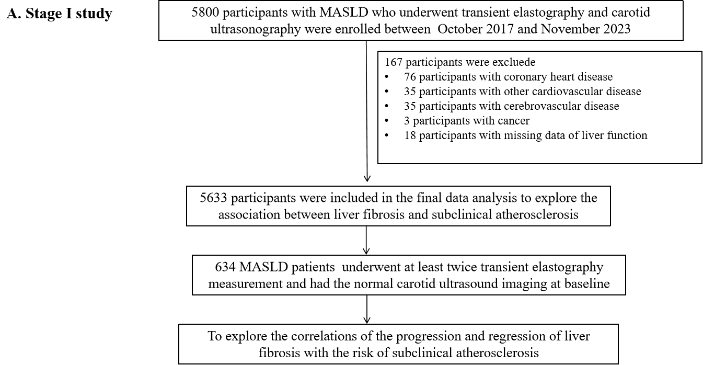
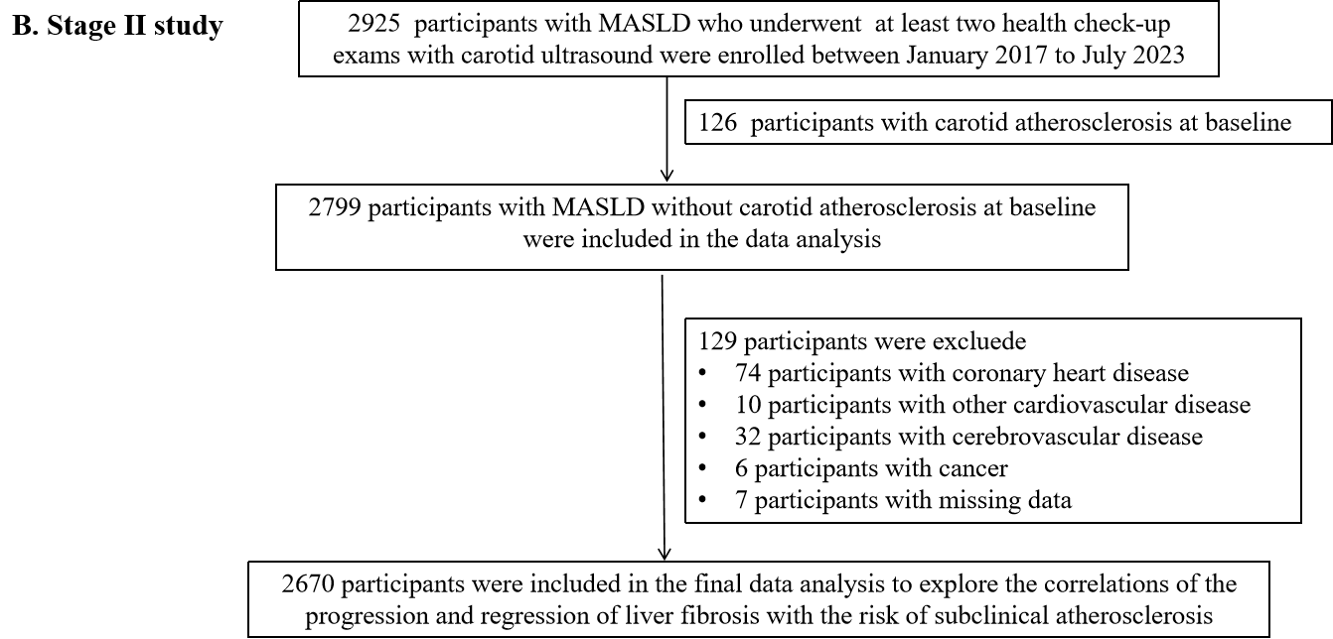

Supplementary Figure 1. The flowchart of the study population. A. Stage I study; B. StageⅡ study

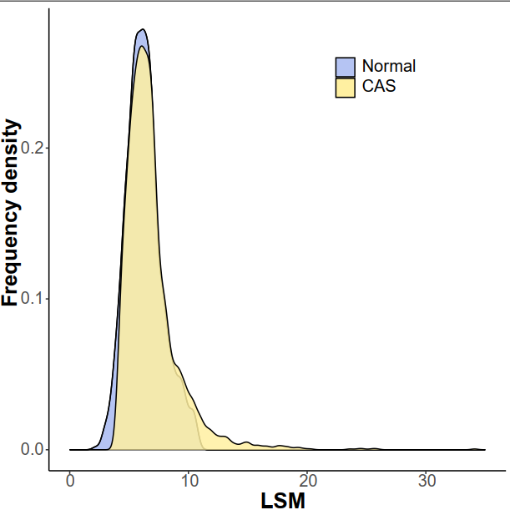
Supplementary Figure 2. The distribution of the values of liver stiffness measurement between participants with carotid atherosclerosis and those without in Stage I study.

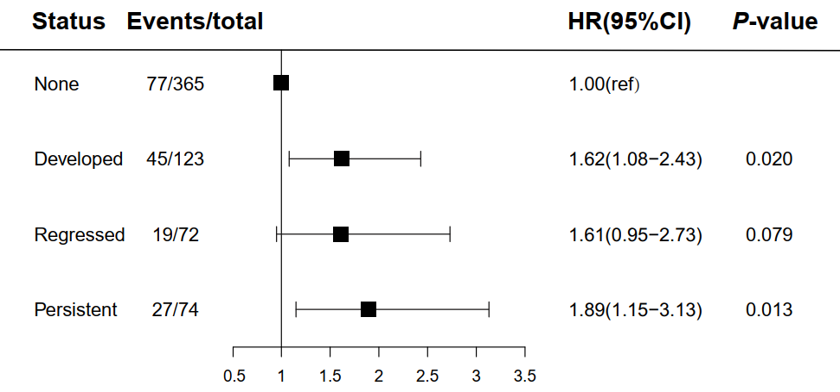
Supplementary Figure 3. Risk of carotid atherosclerosis development according to liver fibrosis status by transient elastography. The model was adjusted for age, sex, smoking, BMI, WBCC, neutrophil count, monocyte count , hypertension, diabetes, dyslipidemia, and serum uric acid

