Low Carbohydrate Diet Intervention(LCD)
Low Fat Diet Intervention(LFD)
East Asian Alternative Diet Model(EAAD)
Korean Food Exchange Model(KFEM)
Medical nutrition therapy(MNT)
Carbohydrate Counting Method(CHO)
Digital Dietary Model(DN)
LGI Dietary Intervention(LGI)
Multifactorial Mediterranean Diet Intervention(EMID)
Soluble Dietary Fiber Intervention(WSDF)
LGI+LGL Dietary Intervention(LGI+LGL)
PCPA dietary intervention(PCPA)
Conventional diabetes dietary intervention(UC)

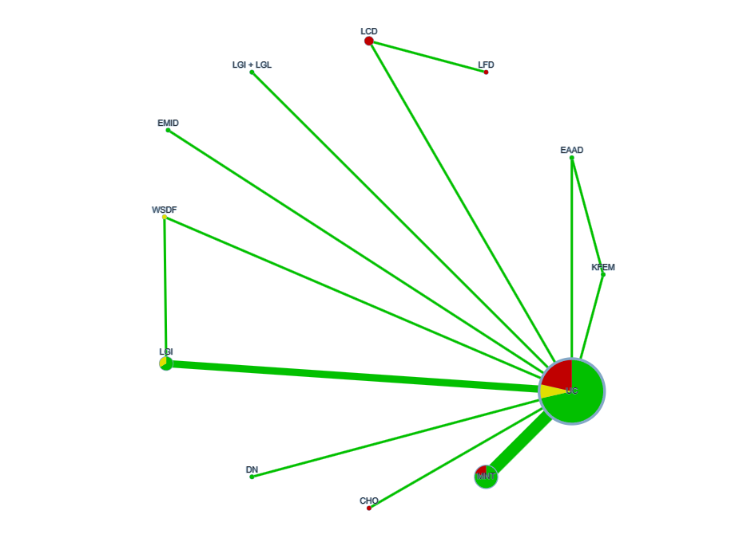
Conventional diabetes dietary intervention(UC)；Korean Food Exchange Model(KFEM)
East Asian Alternative Diet Model(EAAD)；Low Carbohydrate Diet Intervention(LCD)
Low Fat Diet Intervention(LFD)；LGI+LGL Dietary Intervention(LGI+LGL)
Multifactorial Mediterranean Diet Intervention(EMID)
Soluble Dietary Fiber Intervention(WSDF)；LGI Dietary Intervention(LGI)
Digital Dietary Model(DN)；Carbohydrate Counting Method(CHO)
Medical nutrition therapy(MNT)

Figure1 Network meta-analysis evidence network diagram for HbAlc
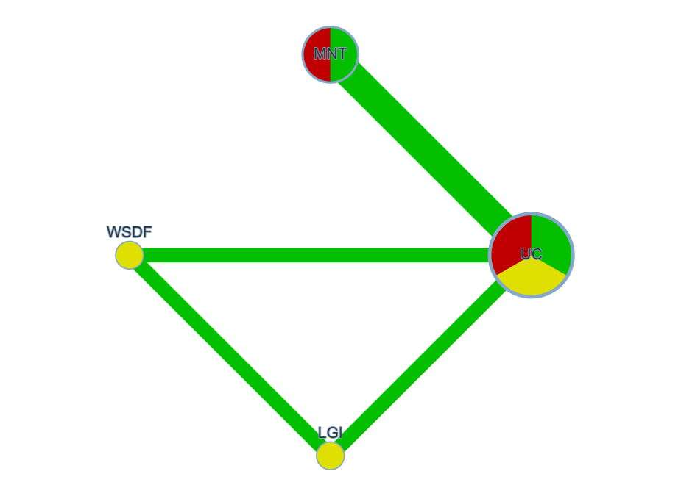
Conventional diabetes dietary intervention(UC)；Medical nutrition therapy(MNT)
Soluble Dietary Fiber Intervention(WSDF)；LGI Dietary Intervention(LGI)

Figure2 Network meta-analysis evidence network diagram for HOMA-IR
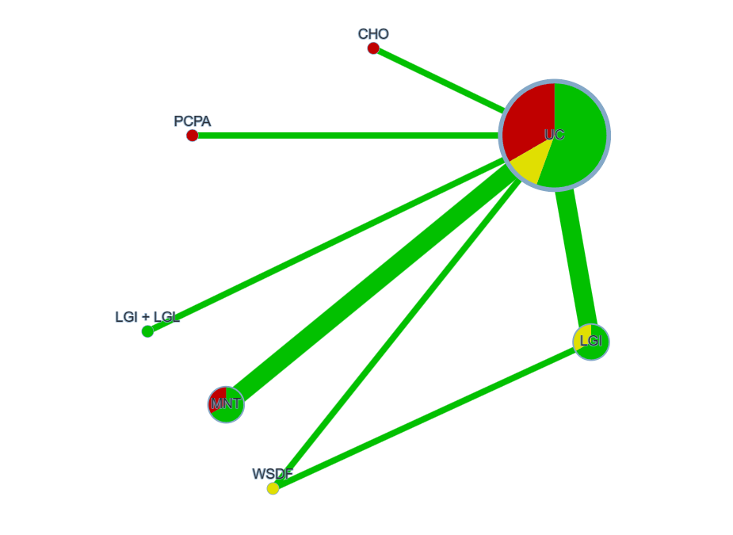
Conventional diabetes dietary intervention(UC)；Carbohydrate Counting Method(CHO)
PCPA dietary intervention(PCPA)；LGI+LGL Dietary Intervention(LGI+LGL)
Medical nutrition therapy(MNT)；Soluble Dietary Fiber Intervention(WSDF)

Figure3 Network meta-analysis evidence network diagram for TC
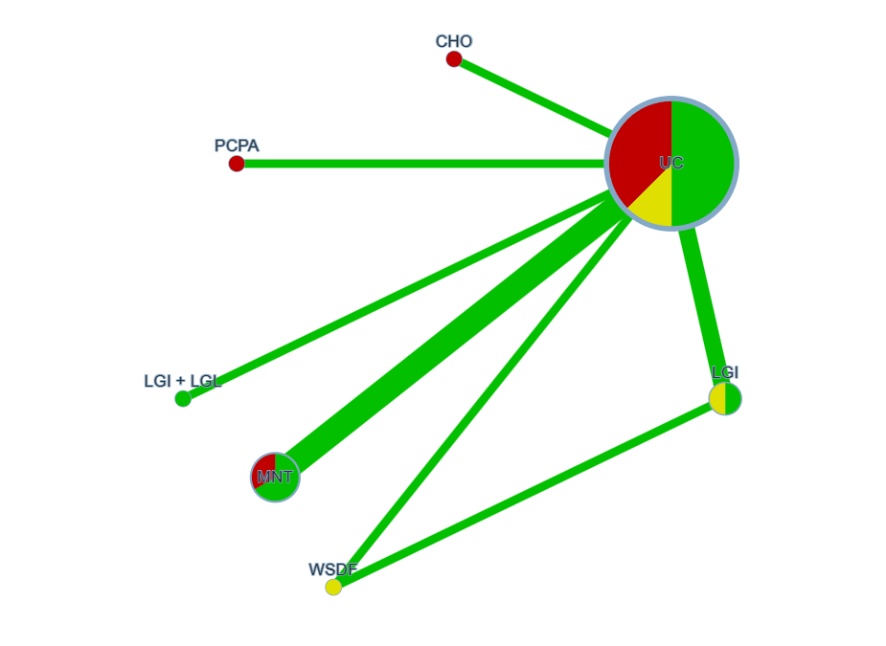
Conventional diabetes dietary intervention(UC)；Carbohydrate Counting Method(CHO)
PCPA dietary intervention(PCPA)；LGI+LGL Dietary Intervention(LGI+LGL)
Medical nutrition therapy(MNT)；Soluble Dietary Fiber Intervention(WSDF)
LGI Dietary Intervention(LGI)

Figure4 Network meta-analysis evidence network diagram for TG
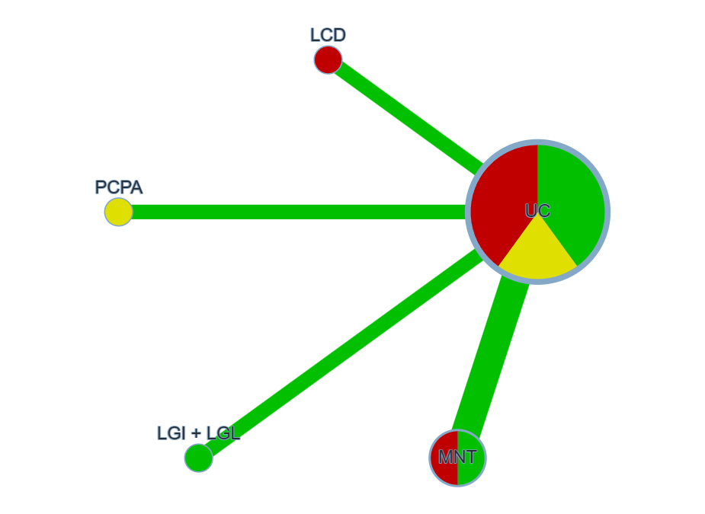
Conventional diabetes dietary intervention(UC)；Low Carbohydrate Diet Intervention(LCD)
PCPA dietary intervention(PCPA)；LGI+LGL Dietary Intervention(LGI+LGL)
Medical nutrition therapy(MNT)

Figure5 Network meta-analysis evidence network diagram for BMI

Table
Stategy for searching literature in Pubmbed database

Serial Number | Search Strategy
#1 | Diet[Mesh]
#2 | Diet, Mediterranean[Mesh]
#3 | ((((((((((((((((((Diet[Text Word]) OR (Diets[Text Word])) OR (Food[Text Word])) OR (dietary[Text Word])) OR (eating pattern[Text Word])) OR (Mediterranean Diet[Text Word])) OR (Diets, Mediterranean[Text Word])) OR (Mediterranean Diets[Text Word])) OR (Diet, Mediterranean[Text Word])) OR (Mediterranean eating pattern[Text Word])) OR (Mediterranean-style diet[Text Word])) OR (medical nutrition intervention[Text Word])) OR (Low glycemic index diet[Text Word])) OR (Energy-restricted diet[Text Word])) OR (Dietary Approaches to Stop Hypertension, DASH[Text Word])) OR (Carbohydrate-restricted diet[Text Word])) OR (Fiber-enriched diet[Text Word])) OR (Low-fat diet[Text Word])) OR (Ethnic diet[Text Word])
#4 | #1 OR #2 OR #3
#5 | Diabetes Mellitus, Type 2[Mesh]
#6 | ((((((((((((((((((((((((((((((((((Diabetes Mellitus, Type 2[Title/Abstract]) OR (Diabetes Mellitus, Noninsulin-Dependent[Title/Abstract])) OR ("type 2 diabetes[Title/Abstract])) OR (diabetes type 2[Title/Abstract])) OR (diabetic[Title/Abstract])) OR (Diabetes Mellitus, Ketosis-Resistant[Title/Abstract])) OR (Diabetes Mellitus, Ketosis Resistant[Title/Abstract])) OR (Ketosis-Resistant Diabetes Mellitus[Title/Abstract])) OR (Diabetes Mellitus, Non Insulin Dependent[Title/Abstract])) OR (Diabetes Mellitus, Non-Insulin-Dependent[Title/Abstract])) OR (Non-Insulin-Dependent Diabetes Mellitus[Title/Abstract])) OR (Diabetes Mellitus, Stable[Title/Abstract])) OR (Stable Diabetes Mellitus[Title/Abstract])) OR (Diabetes Mellitus, Type II[Title/Abstract])) OR (NIDDM[Title/Abstract])) OR (Diabetes Mellitus, Noninsulin Dependent[Title/Abstract])) OR (Diabetes Mellitus, Maturity-Onset[Title/Abstract])) OR (Diabetes Mellitus, Maturity Onset[Title/Abstract])) OR (Maturity-Onset Diabetes Mellitus[Title/Abstract])) OR (Maturity Onset Diabetes Mellitus[Title/Abstract])) OR (MODY[Title/Abstract])) OR (Diabetes Mellitus, Slow-Onset[Title/Abstract])) OR (Diabetes Mellitus, Slow Onset[Title/Abstract])) OR (Slow-Onset Diabetes Mellitus[Title/Abstract])) OR (Type 2 Diabetes Mellitus[Title/Abstract])) OR (Noninsulin-Dependent Diabetes Mellitus[Title/Abstract])) OR (Noninsulin Dependent Diabetes Mellitus[Title/Abstract])) OR (Maturity-Onset Diabetes[Title/Abstract])) OR (Diabetes, Maturity-Onset[Title/Abstract])) OR (Maturity Onset Diabetes[Title/Abstract])) OR (Type 2 Diabetes[Title/Abstract])) OR (Diabetes, Type 2[Title/Abstract])) OR (Diabetes Mellitus, Adult-Onset[Title/Abstract])) OR (Adult-Onset Diabetes Mellitus[Title/Abstract])) OR (Diabetes Mellitus, Adult Onset[Title/Abstract])
#7 | #5 OR #6
#8 | ((((intervention[Title/Abstract]) OR (randomized controlled trial[Title/Abstract])) OR (randomized[Title/Abstract])) OR (RCT[Title/Abstract])) OR (placebo[Title/Abstract])
#9 | #4 AND #7 AND #8

Results of Traditional Meta-Analysis and Heterogeneity Test (SMD, 95%CI)
Outcome Indicator | Number of Included Studies |  | Sample Size |  |  | Heterogeneity Test |  |  | Traditional Meta-Analysis Results
Outcome Indicator | Number of Included Studies | Intervention Comparison | T | C |  | I² | P | Model | SMD | 95%CI | P
FPG | 10 | ②⑥⑦⑧⑨⑫⑬VS① | 494 | 432 |  | 88.3% | 0.000 | Random | -0.75 | (-0.88~-0.61) | 0.000
2hPG | 8 | ②⑥⑧⑨⑫VS① | 329 | 394 |  | 78.5% | 0.000 | Random | -0.62 | (-0.76~-0.47) | 0.000
HbAlc | 12 | ②④⑤⑥⑦⑧⑨⑩⑫VS① | 649 | 646 |  | 80.4% | 0.000 | Random | -0.45 | (-0.45~-0.33) | 0.000
TC | 8 | ⑥⑦⑨⑫⑬VS① | 392 | 405 |  | 93.5% | 0.000 | Random | -0.39 | (-0.54~-0.25) | 0.000
TG | 7 | ⑥⑦⑨⑫⑬VS① | 330 | 326 |  | 82.8% | 0.000 | Random | -0.59 | (-0.75~-0.43) | 0.000
BMI | 5 | ②⑥⑫⑬VS① | 259 | 244 |  | 61.8% | 0.002 | Random | -0.28 | (-0.45~-0.10) | 0.033
Outcome Indicators ①conventional diabetes diet ②low-carb diet ③low-fat diet④East Asian alternative diet⑤Korean food exchange model⑥MNT⑦carbohydrate counting⑧digital dietary patterns ⑨LGI diet⑩multi-factor Mediterranean diet intervention ⑪water-soluble dietary fiber intervention ⑫LGI+LGL⑬PCPA dietary intervention

HbAlc、HOMA-IR、BMI league table (MD, 95% CI)

Items (MD, 95% CI) | Digital Nutrition-Based Dietary Model | Personalized Medical Nutrition Therapy (MNT) | Low-Glycemic Index and Load Intervention | Carbohydrate Counting | Low-Glycemic Index (LGI) Dietary Intervention | Water-Soluble Dietary Fiber Intervention
1.HbAlc league table
Routine Diabetes Dietary Intervention | -1.06 (-2.11,-0.01) | -0.74 (-1.28,-0.19) | - | - | - | -
Korean Food Exchange Model | -1.68 (-3.16,-0.20) | -1.36 (-2.52,-0.19) | - | - | - | -
East Asian Alternative Dietary Model | -2.13 (-3.64,-0.62) | -1.81 (-3.02,-0.60) | -1.79 (-3.31,-0.27) | -1.77 (-3.32,-0.22) | -1.61 (-2.88,-0.33)
2.HOMA-IR league table
Personalized Medical Nutrition Therapy (MNT) | - | - | - | - | -8.04 (-15.07,-1.00)
Routine Diabetes Dietary Intervention | - | - | - | - | -10.13 (-15.96,-4.30) | -6.12 (-12.14,-0.10)
3.BMI league table
Low-Carbohydrate Dietary Intervention | - | - | -2.03 (-3.57,-0.49) | - | - | -
Personalized Medical Nutrition Therapy (MNT) | - | - | -2.41 (-3.88,-0.95) | - | - | -
PCPA Dietary Intervention | - | - | -2.66 (-4.58,-0.74) | - | - | -
Routine Diabetes Dietary Intervention | - | - | -2.73 (-4.03,-1.43) | - | - | -

