Supplementary Table S1. Demographic characteristics of participants for the analysis of association between metabolic vulnerability index and lung function
Total population
(n = 174,949)
Age, years | 56.48 ± 7.98
Townsend deprivation index | -1.63 ± 2.87
Sex, (%)
Men | 81337 (46.49)
Women | 93612 (53.51)
Educational level, (%)
No relevant qualifications | 28065 (16.04)
CSEs or equivalent | 10091 (5.77)
O levels, GCSEs, or equivalent | 39532 (22.60)
A levels, AS levels, or equivalent | 20222 (11.56)
College or university degree | 56219 (32.13)
Others | 20820 (11.90)
Body mass index, (%)
<18.5 kg/m² | 609 (0.35)
18.5 to <25 kg/m² | 57135 (32.66)
25 to <30 kg/m² | 75959 (43.42)
≥30 kg/m² | 41246 (23.58)
Smoking status, (%)
Never | 94805 (54.19)
Past | 63100 (36.07)
Current | 17044 (9.74)
Alcohol drinking, (%)
Never | 5044 (2.88)
Past | 5435 (3.11)
Current | 164470 (94.01)
Family history of chronic lung disease, (%)
No | 149030 (85.18)
Yes | 25919 (14.82)
Air pollution, μg/m³
NO₂ | 26.06 ± 7.34
NO_{X} | 43.16 ± 15.16
PM_{2.5} | 9.95 ± 1.05
PM_{2.5-10} | 16.12 ± 1.89
PM₁₀ | 6.40 ± 0.89
sHDL, μmol/L | 9.82 ± 1.28
GlycA, μmol/L | 808.51 ± 114.67
Isoleucine, μmol/L | 51.01 ± 17.40
Leucine, μmol/L | 104.30 ± 27.70
Valine, μmol/L | 210.67 ± 41.90
Citrate, μmol/L | 65.36 ± 12.60
MVX score | 41.76 ± 15.45
Abbreviations: COPD, Chronic obstructive pulmonary disease; PM_{2.5}, particulate matter with a diameter≤2.5 μm; PM₁₀, particulate matter with a diameter≤10 μm; NO₂, nitrogen dioxide; NO_{X}, nitrogen oxides; GlycA, Glycoprotein Acetyls; sHDL Particle Number of Small High-Density Lipoprotein; MVX, metabolic vulnerability index
Supplementary Table S2. Subgroup analyses on association between metabolic vulnerability index and risk of chronic obstructive pulmonary disease
Subgroup |  | MVX score
Subgroup |  | Q1 | Q2 | Q3 | Q4
Subgroup |  | HR (95% CI) | HR (95% CI) | HR (95% CI) | HR (95% CI)
Age | <60 years | Ref | 1.07 (0.96, 1.20) | 1.30 (1.16, 1.46) | 1.67 (1.49, 1.88)
 | ≥60 years | Ref | 1.12 (1.04, 1.21) | 1.19 (1.10, 1.29) | 1.48 (1.37, 1.61)
Sex | Male | Ref | 1.15 (1.08, 1.23) | 1.24 (1.15, 1.35) | 1.36 (1.24, 1.48)
 | Female | Ref | 1.16 (0.94, 1.43) | 1.49 (1.22, 1.82) | 1.94 (1.59, 2.36)
Townsend deprivation index | Low | Ref | 1.15 (1.01, 1.31) | 1.38 (1.20, 1.58) | 1.73 (1.51, 2.00)
 | Medium | Ref | 1.09 (0.97, 1.22) | 1.25 (1.10, 1.41) | 1.54 (1.37, 1.75)
 | High | Ref | 1.10 (1.00, 1.20) | 1.18 (1.07, 1.30) | 1.49 (1.36, 1.64)
Educational level | College or university degree | Ref | 1.17 (1.01, 1.36) | 1.25 (1.06, 1.47) | 1.73 (1.46, 2.05)
 | Others | Ref | 1.10 (1.03, 1.17) | 1.25 (1.16, 1.34) | 1.56 (1.45, 1.68)
Ethnicity | White | Ref | 1.11 (1.04, 1.18) | 1.24 (1.16, 1.33) | 1.56 (1.46, 1.67)
 | Others | Ref | 1.02 (0.73, 1.42) | 1.10 (0.76, 1.60) | 1.38 (0.94, 2.01)
Body mass index | <25 kg/m² | Ref | 1.14 (1.01, 1.28) | 1.22 (1.07, 1.38) | 1.53 (1.34, 1.74)
 | ≥25 kg/m² | Ref | 1.10 (1.02, 1.18) | 1.25 (1.16, 1.35) | 1.59 (1.47, 1.72)
Smoking status | Never | Ref | 1.09 (0.94, 1.26) | 1.36 (1.17, 1.59) | 1.57 (1.34, 1.84)
 | Past | Ref | 1.13 (1.03, 1.23) | 1.31 (1.19, 1.44) | 1.61 (1.47, 1.78)
 | Current | Ref | 1.06 (0.95, 1.18) | 1.04 (0.93, 1.17) | 1.30 (1.16, 1.45)
Alcohol drinking | Never | Ref | 0.85 (0.59, 1.22) | 0.97 (0.66, 1.43) | 1.22 (0.83, 1.80)
 | Past | Ref | 1.24 (0.97, 1.58) | 1.28 (0.97, 1.68) | 1.55 (1.17, 2.05)
 | Current | Ref | 1.10 (1.03, 1.17) | 1.23 (1.14, 1.31) | 1.52 (1.42, 1.63)
Family history of chronic lung disease | No | Ref | 1.11 (1.04, 1.19) | 1.23 (1.15, 1.33) | 1.51 (1.40, 1.63)
 | Yes | Ref | 1.05 (0.92, 1.20) | 1.17 (1.02, 1.34) | 1.48 (1.29, 1.70)
NO_{X} | Low | Ref | 1.07 (0.98, 1.18) | 1.27 (1.15, 1.41) | 1.44 (1.30, 1.60)
 | High | Ref | 1.12 (1.03, 1.21) | 1.18 (1.08, 1.29) | 1.55 (1.42, 1.69)
NO₂ | Low | Ref | 1.07 (0.98, 1.18) | 1.24 (1.12, 1.36) | 1.45 (1.31, 1.60)
 | High | Ref | 1.12 (1.03, 1.22) | 1.21 (1.11, 1.32) | 1.55 (1.42, 1.69)
PM_{2.5} | Low | Ref | 1.05 (0.95, 1.15) | 1.23 (1.11, 1.36) | 1.40 (1.26, 1.55)
 | High | Ref | 1.14 (1.05, 1.23) | 1.22 (1.12, 1.33) | 1.58 (1.45, 1.73)
PM₁₀ | Low | Ref | 1.05 (0.96, 1.15) | 1.17 (1.06, 1.28) | 1.41 (1.28, 1.55)
 | High | Ref | 1.14 (1.05, 1.24) | 1.27 (1.16, 1.39) | 1.60 (1.46, 1.75)
PM_{2.5-10} | Low | Ref | 1.04 (0.95, 1.14) | 1.18 (1.07, 1.29) | 1.41 (1.28, 1.55)
 | High | Ref | 1.15 (1.06, 1.26) | 1.26 (1.15, 1.38) | 1.60 (1.46, 1.75)
Abbreviations: COPD, Chronic obstructive pulmonary disease; HR, hazard ratio; CI, confidence interval; PM_{2.5}, particulate matter with a diameter≤2.5 μm; PM₁₀, particulate matter with a diameter≤10 μm; NO₂, nitrogen dioxide; NO_{X}, nitrogen oxides; GlycA, Glycoprotein acetyls; sHDL Particle number of small High-Density lipoprotein; MVX, metabolic vulnerability index. Multivariable-adjusted model was adjusted age, sex, townsend deprivation index, ethnicity, educational level, body mass index, smoking status, alcohol drinking, family history of chronic lung disease, NO₂, NO_{X}, PM_{2.5}, PM_{2.5-10}, and PM₁₀.

Supplementary Table S3. Sensitivity analysis for the association between metabolic vulnerability index and risk of chronic obstructive pulmonary disease excluding the first 2 or 5 years of follow-up
 | Crude |  | Age, sex-adjusted model |  | Multivariate adjusted model
 | HR (95% CI) | P-value | HR (95% CI) | P-value | HR (95% CI) | P-value
Excluding the first 2 years of follow-up
Per 1-SD increase in MVX score | 1.22 (1.20, 1.24) | <0.001 | 1.39 (1.36, 1.42) |  | 1.18 (1.16, 1.21) | <0.001
MVX score, quartile
Q1 | Ref |  | Ref |  | Ref
Q2 | 1.07 (1.00, 1.14) | 0.044 | 1.31 (1.22, 1.39) | <0.001 | 1.10 (1.03, 1.17) | 0.004
Q3 | 1.08 (1.01, 1.15) | 0.016 | 1.60 (1.49, 1.71) | <0.001 | 1.23 (1.15, 1.32) | <0.001
Q4 | 1.55 (1.47, 1.65) | <0.001 | 2.39 (2.23, 2.56) | <0.001 | 1.53 (1.43, 1.64) | <0.001
P for trend | <0.001 |  | <0.001 |  | <0.001
Excluding the first 2 years of follow-up
Per 1-SD increase in MVX score | 1.22 (1.19, 1.24) | <0.001 | 1.38 (1.35, 1.41) | <0.001 | 1.18 (1.15, 1.21) | <0.001
MVX score, quartile
Q1 | 1.0 |  | 1.0 |  | 1.0
Q2 | 1.08 (1.01, 1.16) | 0.034 | 1.32 (1.23, 1.42) | <0.001 | 1.11 (1.04, 1.20) | 0.004
Q3 | 1.11 (1.03, 1.19) | 0.004 | 1.63 (1.51, 1.76) | <0.001 | 1.26 (1.16, 1.36) | <0.001
Q4 | 1.56 (1.46, 1.67) | <0.001 | 2.38 (2.21, 2.57) | <0.001 | 1.53 (1.42, 1.66) | <0.001
P for trend | <0.001 |  | <0.001 |  | <0.001
Abbreviations: SD, standard deviation; HR, hazard ratio; CI, confidence interval; MVX, metabolic vulnerability index. Multivariable-adjusted model was adjusted age, sex, townsend deprivation index, ethnicity, educational level, body mass index, smoking status, alcohol drinking, family history of chronic lung disease, NO₂, NO_{X}, PM_{2.5}, PM_{2.5-10}, and PM₁₀.

Supplementary Table S4. Associations of key MVI components with lung function and COPD risk identified by LASSO regression
 | Risk of COPD | FVC, mL | FEV₁, mL
 | Coefficients (β) | Coefficients (β) | Coefficients (β)
sHDL, μmol/L | -0.06035 | 4.85621 | 5.347800
GlycA, μmol/L | 0.00603 | -1.80794 | -1.55881
Isoleucine, μmol/L | 0.002262 | -0.697563 | -0.55173
Leucine, μmol/L | 0.002179 | 0.978850 | 0.60569
Valine, μmol/L | -0.00638 | 0 | 0.27628
Citrate, μmol/L | -0.00630 | 2.75233 | 2.23000
A coefficient of zero indicates the variable was excluded from the model for that specific outcome

Supplementary Table S5. Subgroup analyses on association between metabolic vulnerability index and risk of FVC
Subgroup |  | MVX score
Subgroup |  | Q1 | Q2 | Q3 | Q4
Subgroup |  | β (95% CI) | β (95% CI) | β (95% CI) | β (95% CI)
Age | <60 years | Ref | -85.99 (-97.26, -74.72) | -123.95 (-136.22, -111.68) | -172.74 (-185.86, -159.62)
 | ≥60 years | Ref | -59.53 (-70.06, -49.00) | -89.15 (-100.80, -77.51) | -129.35 (-141.59, -117.10)
Sex | Male | Ref | -90.72 (-103.34, -78.11) | -152.66 (-169.02, -136.30) | -196.53 (-216.80, -176.26)
 | Female | Ref | -31.07 (-47.78, -14.37) | -59.19 (-75.28, -43.10) | -124.40 (-140.56, -108.24)
Townsend deprivation index | Low | Ref | -64.04 (-76.65, -51.43) | -89.53 (-103.51, -75.56) | -114.00 (-128.95, -99.05)
 | Medium | Ref | -67.22 (-80.12, -54.32) | -92.08 (-106.14, -78.01) | -136.43 (-151.34, -121.52)
 | High | Ref | -81.15 (-94.60, -67.69) | -115.75 (-130.41, -101.09) | -155.61 (-170.97, -140.25)
Educational level | College or university degree | Ref | -71.11 (-80.42, -61.80) | -103.05 (-113.15, -92.95) | -143.73 (-154.28, -133.19)
 | Others | Ref | -68.56 (-81.29, -55.84) | -93.86 (-108.09, -79.63) | -127.00 (-142.58, -111.41)
Body mass index | <25 kg/m² | Ref | -74.80 (-87.58, -62.01) | -101.56 (-115.49, -87.62) | -149.38 (-164.37, -134.40)
 | ≥25 kg/m² | Ref | -71.12 (-80.47, -61.78) | -107.31 (-117.55, -97.07) | -151.17 (-161.86, -140.48)
Smoking status | Never | Ref | -59.73 (-69.91, -49.56) | -81.18 (-92.36, -69.99) | -118.70 (-130.55, -106.84)
 | Past | Ref | -78.82 (-90.98, -66.66) | -111.30 (-124.65, -97.94) | -142.83 (-156.97, -128.68)
 | Current | Ref | -72.72 (-99.03, -46.41) | -124.89 (-153.14, -96.64) | -172.54 (-202.05, -143.02)
Alcohol drinking | Never | Ref | -29.54 (-81.56, 22.49) | -66.44 (-122.12, -10.76) | -93.67 (-150.06, -37.29)
 | Past | Ref | -74.13 (-120.55, -27.72) | -81.04 (-134.06, -28.03) | -139.54 (-194.24, -84.85)
 | Current | Ref | -72.13 (-79.81, -64.44) | -101.33 (-109.75, -92.90) | -137.39 (-146.34, -128.44)
Family history of chronic  lung disease | No | Ref | -72.55 (-80.65, -64.46) | -99.33 (-108.23, -90.43) | -134.50 (-143.96, -125.03)
 | Yes | Ref | -63.04 (-82.97, -43.11) | -101.69 (-123.10, -80.27) | -141.85 (-164.04, -119.66)
NO_{X} | Low | Ref | -70.83 (-81.25, -60.42) | -99.13 (-110.56, -87.71) | -130.21 (-142.40, -118.01)
 | High | Ref | -71.18 (-81.96, -60.40) | -99.57 (-111.38, -87.76) | -139.94 (-152.36, -127.53)
NO₂ | Low | Ref | -70.04 (-80.46, -59.62) | -95.63 (-107.08, -84.18) | -125.59 (-137.78, -113.41)
 | High | Ref | -72.07 (-82.85, -61.29) | -102.99 (-114.77, -91.21) | -144.31 (-156.74, -131.88)
PM_{2.5} | Low | Ref | -71.05 (-81.48, -60.62) | -97.59 (-109.05, -86.13) | -128.14 (-140.36, -115.91)
 | High | Ref | -71.01 (-81.78, -60.25) | -101.13 (-112.90, -89.35) | -142.12 (-154.50, -129.73)
PM₁₀ | Low | Ref | -73.51 (-84.12, -62.90) | -99.50 (-111.14, -87.85) | -135.82 (-148.18, -123.46)
 | High | Ref | -69.01 (-79.60, -58.42) | -99.68 (-111.27, -88.09) | -135.13 (-147.39, -122.87)
PM_{2.5-10} | Low | Ref | -73.64 (-84.32, -62.95) | -102.68 (-114.41, -90.96) | -136.56 (-148.99, -124.14)
 | High | Ref | -69.24 (-79.76, -58.73) | -96.73 (-108.25, -85.22) | -134.53 (-146.72, -122.34)
Abbreviations: CI, confidence interval; PM_{2.5}, particulate matter with a diameter≤2.5 μm; PM₁₀, particulate matter with a diameter≤10 μm; NO₂, nitrogen dioxide; NO_{X}, nitrogen oxides; GlycA, Glycoprotein Acetyls; sHDL Particle Number of Small High-Density Lipoprotein; MVX, metabolic vulnerability index. Multivariable-adjusted model was adjusted age, sex, townsend deprivation index, educational level, body mass index, smoking status, alcohol drinking, family history of chronic lung disease, NO₂, NO_{X}, PM_{2.5}, PM_{2.5-10}, and PM₁₀.

Supplementary Table S6. Subgroup analyses on association between metabolic vulnerability index and risk of FEV₁
Subgroup |  | MVX score
Subgroup |  | Q1 | Q2 | Q3 | Q4
Subgroup |  | β (95% CI) | β (95% CI) | β (95% CI) | β (95% CI)
Age | <60 years | Ref | -113.89 (-127.66, -100.12) | -158.85 (-173.83, -143.86) | -215.30 (-231.33, -199.26)
 | ≥60 years | Ref | -82.18 (-95.01, -69.34) | -115.01 (-129.21, -100.81) | -166.98 (-181.91, -152.05)
Sex | Male | Ref | -67.41 (-77.71, -57.11) | -116.42 (-129.78, -103.06) | -152.68 (-169.23, -136.13)
 | Female | Ref | -25.58 (-39.11, -12.06) | -50.97 (-64.00, -37.95) | -101.81 (-114.89, -88.73)
Townsend deprivation index | Low | Ref | -87.40 (-103.00, -71.80) | -120.97 (-138.27, -103.67) | -155.96 (-174.46, -137.46)
 | Medium | Ref | -95.06 (-110.98, -79.13) | -121.34 (-138.70, -103.98) | -174.90 (-193.31, -156.49)
 | High | Ref | -104.87 (-121.21, -88.54) | -144.40 (-162.20, -126.61) | -193.13 (-211.78, -174.48)
Educational level | College or university  degree | Ref | -93.66 (-105.08, -82.24) | -130.69 (-143.08, -118.31) | -181.74 (-194.67, -168.81)
 | Others | Ref | -97.43 (-113.11, -81.75) | -127.64 (-145.18, -110.10) | -169.47 (-188.67, -150.26)
Body mass index | <25 kg/m² | Ref | -101.72 (-117.57, -85.86) | -131.20 (-148.48, -113.91) | -192.80 (-211.39, -174.21)
 | ≥25 kg/m² | Ref | -94.54 (-106.02, -83.07) | -142.20 (-154.77, -129.62) | -204.02 (-217.15, -190.88)
Smoking status | Never | Ref | -92.64 (-105.27, -80.01) | -119.25 (-133.13, -105.36) | -168.86 (-183.59, -154.14)
 | Past | Ref | -97.62 (-112.48, -82.77) | -135.58 (-151.90, -119.27) | -170.13 (-187.41, -152.85)
 | Current | Ref | -89.66 (-121.26, -58.06) | -142.90 (-176.82, -108.97) | -204.02 (-239.47, -168.58)
Alcohol drinking | Never | Ref | -53.80 (-118.00, 10.39) | -106.21 (-174.91, -37.50) | -139.81 (-209.38, -70.23)
 | Past | Ref | -102.38 (-159.15, -45.60) | -120.73 (-185.58, -55.88) | -200.59 (-267.50, -133.69)
 | Current | Ref | -97.14 (-106.58, -87.71) | -130.87 (-141.21, -120.52) | -176.21 (-187.20, -165.21)
Family history of chronic  lung disease | No | Ref | -98.65 (-108.60, -88.70) | -129.65 (-140.59, -118.71) | -173.70 (-185.34, -162.06)
 | Yes | Ref | -81.39 (-105.67, -57.10) | -127.97 (-154.07, -101.88) | -178.98 (-206.02, -151.94)
NO_{X} | Low | Ref | -98.74 (-111.56, -85.92) | -130.35 (-144.42, -116.28) | -174.06 (-189.08, -159.05)
 | High | Ref | -93.09 (-106.30, -79.87) | -127.81 (-142.28, -113.34) | -174.30 (-189.52, -159.09)
NO₂ | Low | Ref | -97.57 (-110.38, -84.77) | -126.06 (-140.14, -111.99) | -168.23 (-183.20, -153.26)
 | High | Ref | -94.32 (-107.55, -81.09) | -131.89 (-146.35, -117.42) | -179.74 (-195.00, -164.49)
PM_{2.5} | Low | Ref | -98.52 (-111.34, -85.70) | -129.30 (-143.38, -115.22) | -172.39 (-187.41, -157.38)
 | High | Ref | -93.40 (-106.62, -80.18) | -128.90 (-143.36, -114.44) | -176.12 (-191.33, -160.91)
PM₁₀ | Low | Ref | -104.07 (-117.12, -91.01) | -133.64 (-147.97, -119.30) | -182.11 (-197.31, -166.90)
 | High | Ref | -88.47 (-101.45, -75.49) | -125.21 (-139.42, -111.01) | -167.36 (-182.38, -152.33)
PM_{2.5-10} | Low | Ref | -101.20 (-114.33, -88.06) | -135.19 (-149.60, -120.78) | -178.45 (-193.72, -163.18)
 | High | Ref | -91.80 (-104.71, -78.90) | -123.93 (-138.06, -109.80) | -171.01 (-185.97, -156.05)
Abbreviations: CI, confidence interval; PM_{2.5}, particulate matter with a diameter≤2.5 μm; PM₁₀, particulate matter with a diameter≤10 μm; NO₂, nitrogen dioxide; NO_{X}, nitrogen oxides; GlycA, Glycoprotein Acetyls; sHDL Particle Number of Small High-Density Lipoprotein; MVX, metabolic vulnerability index. Multivariable-adjusted model was adjusted age, sex, townsend deprivation index, educational level, body mass index, smoking status, alcohol drinking, family history of chronic lung disease, NO₂, NO_{X}, PM_{2.5}, PM_{2.5-10}, and PM₁₀.

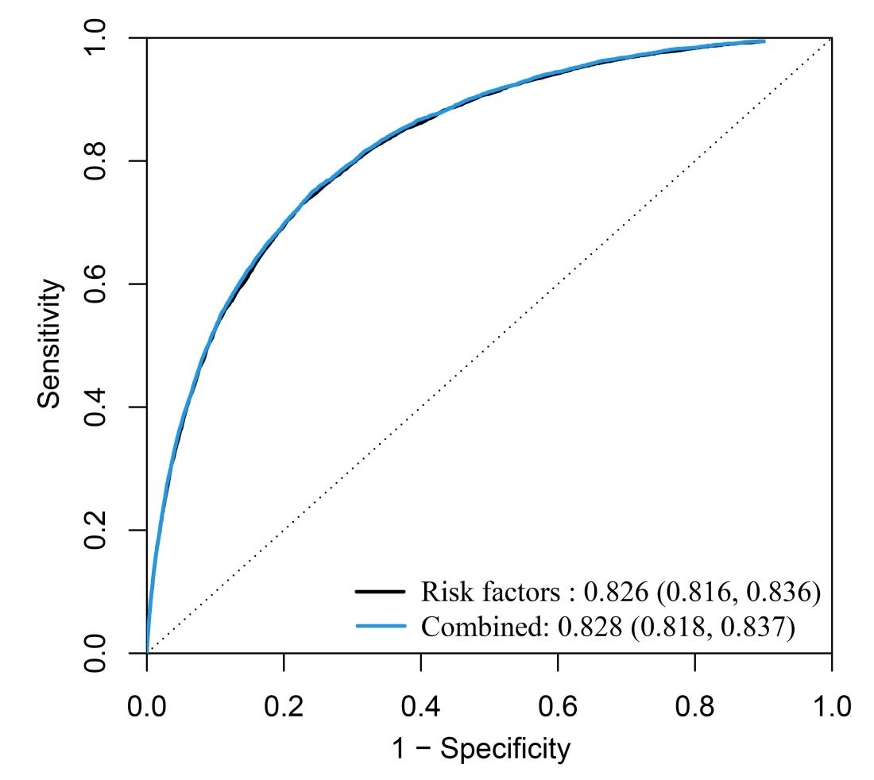
Supplementary Figure S1. ROC analysis of incident COPD prediction model development and predictive value comparison

