Table S1: The risk of bias within individual studies for observational studies by the NOS.
Tamer et al.2011
Study type | Cross-sectional study
Participants | Patients: adult  N: 95 cases, 66 controls  Gender: 4 males/ 91 females case, 2males/ 64 females control  Location: Turkey
Comparison | Comparison: Hypothyroid Patients vs. control  Case: Hypothyroid Patient  Control: Non-hypothyroid subjects
Outcomes | Main study outcome:the risk of vitamin D deficiency  Available outcomes: the risk of vitamin D deficiency
Risk of bias
Bias |  | Authors’ judgment | Support for judgment
Is the case definition  adequate(Selection) |  | 1 | yes, with independent validation
Representativeness of the  cases(Selection) |  | 1 | consecutive or obviously representative series of cases
Selection of Controls(Selection) |  | 0 | hospital controls
Definition of Controls(Selection) |  | 1 | no history of disease (endpoint)
Comparability of cases and controls  on the basis of the design or  analysis(Comparability) |  | 2 | study controls age and gender between case and control
Ascertainment of  exposure(Exposure) |  | 1 | secure record
Same method of ascertainment for  cases and controls(Exposure) |  | 1 | yes
Non-Response rate(Exposure) |  | 0 | not described

Mansournia et al.2013
Study type | Cross-sectional study
Participants | Patients: adult  N: 41 cases, 45 controls  Gender: 7 males/ 34 females case, 12males/ 33 females control  Location: Iran
Comparison | Comparison: Hypothyroid Patients vs. control  Case: Hypothyroid Patient  Control: Non-hypothyroid subjects
Outcomes | Main study outcome:the risk of vitamin D deficiency  Available outcomes: the risk of vitamin D deficiency
Risk of bias
Bias |  | Authors’ judgment | Support for judgment
Is the case definition  adequate(Selection) |  | 1 | yes, with independent validation
Representativeness of the  cases(Selection) |  | 1 | consecutive or obviously representative series of cases
Selection of Controls(Selection) |  | 0 | not described
Definition of Controls(Selection) |  | 1 | no history of disease (endpoint)
Comparability of cases and controls  on the basis of the design or  analysis(Comparability) |  | 2 | study controls age and gender between case and control
Ascertainment of  exposure(Exposure) |  | 1 | secure record
Same method of ascertainment for  cases and controls(Exposure) |  | 1 | Yes
Non-Response rate(Exposure) |  | 0 | not described

Jie Ma et al.2015
Study type | Cross-sectional study
Participants | Patients: adult  N: 70 cases,70 controls  Gender: 19 males/ 51 females case, 21 males/ 49 females control  Location:China
Comparison | Comparison: Hypothyroid Patients vs. control  Case: Hypothyroid Patient  Control: Non-hypothyroid subjects
Outcomes | Main study outcome:the risk of vitamin D deficiency  Available outcomes: the risk of vitamin D deficiency
Risk of bias
Bias |  | Authors’ judgment | Support for judgment
Is the case definition  adequate(Selection) |  | 1 | yes, with independent validation
Representativeness of the  cases(Selection) |  | 1 | consecutive or obviously representative series of cases
Selection of Controls(Selection) |  | 0 | hospital controls
Definition of Controls(Selection) |  | 1 | no history of disease (endpoint)
Comparability of cases and controls  on the basis of the design or  analysis(Comparability) |  | 2 | study controls age and gender between case and control
Ascertainment of  exposure(Exposure) |  | 1 | secure record
Same method of ascertainment for  cases and controls(Exposure) |  | 1 | Yes
Non-Response rate(Exposure) |  | 0 | not described

Dohee et al.2016
Study type | Cross-sectional study
Participants | Patients: adult  N:119 cases,555 controls  Gender:  Location:Korea
Comparison | Comparison: Hypothyroid Patients vs. control  Case: Hypothyroid Patient  Control: Non-hypothyroid subjects
Outcomes | Main study outcome:the risk of vitamin D deficiency  Available outcomes: the risk of vitamin D deficiency
Risk of bias
Bias |  | Authors’ judgment | Support for judgment
Is the case definition  adequate(Selection) |  | 1 | yes, with independent validation
Representativeness of the  cases(Selection) |  | 1 | consecutive or obviously representative series of cases
Selection of Controls(Selection) |  | 0 | hospital controls
Definition of Controls(Selection) |  | 1 | no history of disease (endpoint)
Comparability of cases and controls  on the basis of the design or  analysis(Comparability) |  | 0 | not described
Ascertainment of  exposure(Exposure) |  | 1 | secure record
Same method of ascertainment for  cases and controls(Exposure) |  | 1 | Yes
Non-Response rate(Exposure) |  | 0 | not described

Hoda et al.2019
Study type | Cross-sectional study
Participants | Patients: adult  N:35 cases,35 controls  Gender: 6 males/ 29 females case, 7 males/ 28 females control  Location:Egypt
Comparison | Comparison: Hypothyroid Patients vs. control  Case: Hypothyroid Patient  Control: Non-hypothyroid subjects
Outcomes | Main study outcome:the risk of vitamin D deficiency  Available outcomes: the risk of vitamin D deficiency
Risk of bias
Bias |  | Authors’ judgment | Support for judgment
Is the case definition  adequate(Selection) |  | 1 | yes, with independent validation
Representativeness of the  cases(Selection) |  | 1 | consecutive or obviously representative series of cases
Selection of Controls(Selection) |  | 1 | community controls
Definition of Controls(Selection) |  | 1 | no history of disease (endpoint)
Comparability of cases and controls  on the basis of the design or  analysis(Comparability) |  | 2 | study controls age and gender between case and control
Ascertainment of  exposure(Exposure) |  | 1 | secure record
Same method of ascertainment for  cases and controls(Exposure) |  | 1 | Yes
Non-Response rate(Exposure) |  | 0 | not described

Maja et al.2020
Study type | Cross-sectional study
Participants | Patients: adult  N:50 cases,50 controls  Gender: 16 males/ 134 females  Location:Bosnia and Herzegovina
Comparison | Comparison: Hypothyroid Patients vs. Control  Case: Hypothyroid Patient  Control: Non-hypothyroid subjects
Outcomes | Main study outcome:the risk of vitamin D deficiency  Available outcomes: the risk of vitamin D deficiency
Risk of bias
Bias |  | Authors’ judgment | Support for judgment
Is the case definition  adequate(Selection) |  | 1 | yes, with independent validation
Representativeness of the  cases(Selection) |  | 1 | consecutive or obviously representative series of cases
Selection of Controls(Selection) |  | 1 | community controls
Definition of Controls(Selection) |  | 1 | no history of disease (endpoint)
Comparability of cases and controls  on the basis of the design or  analysis(Comparability) |  | 2 | study controls age and gender between case and control
Ascertainment of  exposure(Exposure) |  | 1 | secure record
Same method of ascertainment for  cases and controls(Exposure) |  | 1 | Yes
Non-Response rate(Exposure) |  | 0 | not described

Nino et al.2021
Study type | Cross-sectional study
Participants | Patients: adult  N:141 cases,1154 controls  Gender:20 males/ 121 females case, 178 males/ 976 females control  Location:Georgia
Comparison | Comparison: Hypothyroid Patients vs. Control  Case: Hypothyroid Patient  Control: Non-hypothyroid subjects
Outcomes | Main study outcome:the risk of vitamin D deficiency  Available outcomes: the risk of vitamin D deficiency
Risk of bias
Bias |  | Authors’ judgment | Support for judgment
Is the case definition  adequate(Selection) |  | 1 | yes, with independent validation
Representativeness of the  cases(Selection) |  | 1 | consecutive or obviously representative series of cases
Selection of Controls(Selection) |  | 1 | community controls
Definition of Controls(Selection) |  | 1 | no history of disease (endpoint)
Comparability of cases and controls  on the basis of the design or  analysis(Comparability) |  | 2 | study controls age and gender between case and control
Ascertainment of  exposure(Exposure) |  | 1 | secure record
Same method of ascertainment for  cases and controls(Exposure) |  | 1 | Yes
Non-Response rate(Exposure) |  | 0 | not described

Cvek et al.2021
Study type | Cross-sectional study
Participants | Patients: adult  N:123 cases,176 controls  Gender:46 males/ 591 females  Location:Croatia
Comparison | Comparison: Hypothyroid Patients vs. Control  Case: Hypothyroid Patient  Control: Non-hypothyroid subjects
Outcomes | Main study outcome:the risk of vitamin D deficiency  Available outcomes: the risk of vitamin D deficiency
Risk of bias
Bias |  | Authors’ judgment | Support for judgment
Is the case definition  adequate(Selection) |  | 1 | yes, with independent validation
Representativeness of the  cases(Selection) |  | 1 | consecutive or obviously representative series of cases
Selection of Controls(Selection) |  | 0 | Hospital controls
Definition of Controls(Selection) |  | 1 | no history of disease (endpoint)
Comparability of cases and controls  on the basis of the design or  analysis(Comparability) |  | 0 | Not described
Ascertainment of  exposure(Exposure) |  | 1 | secure record
Same method of ascertainment for  cases and controls(Exposure) |  | 1 | Yes
Non-Response rate(Exposure) |  | 0 | not described

Gierach et al.2022
Study type | Cross-sectional study
Participants | Patients: adult  N:111 cases,125 controls  Gender:236 females  Location:Poland
Comparison | Comparison: Hypothyroid Patients vs. Control  Case: Hypothyroid Patient  Control: Non-hypothyroid subjects
Outcomes | Main study outcome:the risk of vitamin D deficiency  Available outcomes: the risk of vitamin D deficiency
Risk of bias
Bias |  | Authors’ judgment | Support for judgment
Is the case definition  adequate(Selection) |  | 1 | yes, with independent validation
Representativeness of the  cases(Selection) |  | 1 | consecutive or obviously representative series of case
Selection of Controls(Selection) |  | 1 | community controls
Definition of Controls(Selection) |  | 1 | no history of disease (endpoint)
Comparability of cases and controls  on the basis of the design or  analysis(Comparability) |  | 1 | study only controls age between case and control
Ascertainment of  exposure(Exposure) |  | 1 | secure record
Same method of ascertainment for  cases and controls(Exposure) |  | 1 | Yes
Non-Response rate(Exposure) |  | 0 | not described

Shimmi et al.2023
Study type | Cross-sectional study
Participants | Patients: adult  N:250 cases,250 controls  Gender:500 female  Location:Malaysia
Comparison | Comparison: Hypothyroid Patients vs. Control  Case: Hypothyroid Patient  Control: Non-hypothyroid subjects
Outcomes | Main study outcome:the risk of vitamin D deficiency  Available outcomes: the risk of vitamin D deficiency
Risk of bias
Bias |  | Authors’ judgment | Support for judgment
Is the case definition  adequate(Selection) |  | 1 | yes, with independent validation
Representativeness of the  cases(Selection) |  | 1 | consecutive or obviously representative series of cases
Selection of Controls(Selection) |  | 0 | Hospital controls
Definition of Controls(Selection) |  | 1 | no history of disease (endpoint)
Comparability of cases and controls  on the basis of the design or  analysis(Comparability) |  | 0 | not described
Ascertainment of  exposure(Exposure) |  | 1 | secure record
Same method of ascertainment for  cases and controls(Exposure) |  | 1 | Yes
Non-Response rate(Exposure) |  | 0 | not described

Alqahtani et al.2023
Study type | Cross-sectional study
Participants | Patients: adult  N:1198 cases,1303 controls  Gender:974 males/ 674 females case, 586 males/ 657 females control  Location:Saudi Arabia
Comparison | Comparison: Hypothyroid Patients vs. Control  Case: Hypothyroid Patient  Control: Non-hypothyroid subjects
Outcomes | Main study outcome:the risk of vitamin D deficiency  Available outcomes: the risk of vitamin D deficiency
Risk of bias
Bias |  | Authors’ judgment | Support for judgment
Is the case definition  adequate(Selection) |  | 1 | yes, with independent validation
Representativeness of the  cases(Selection) |  | 1 | consecutive or obviously representative series of cases
Selection of Controls(Selection) |  | 0 | Hospital controls
Definition of Controls(Selection) |  | 1 | no history of disease (endpoint)
Comparability of cases and controls  on the basis of the design or  analysis(Comparability) |  | 0 | not described
Ascertainment of  exposure(Exposure) |  | 1 | secure record
Same method of ascertainment for  cases and controls(Exposure) |  | 1 | Yes
Non-Response rate(Exposure) |  | 0 | not described

Table S2. The Summary of Findings (SoF) of a study on the effects of vitamin D supplementation on thyroid function indicators with GRADE system.
Vitamin D supplementation versus no vitamin D supplementation for thyroid function indicators
Settings: Four of the studies were conducted in Asia, one study in North America
Intervention: Vitamin D supplementation
Comparison: No vitamin D supplementation
Outcomes | SMD (95% CI)¹ | No. of participants(studies) | Quality of the evidence Comments (GRADE)
TSH | -1.76 (-3.23, -0.29) mIU L⁻¹ | 627 (5 RCTs) | ⊕⊕⊕⊝Moderate^{2, 3}
TPO-Ab | -113.11(-141.42, -85.21) U ml⁻¹ | 346 (3 RCTs) | ⊕⊕⊕⊕High³
Abbreviations: SMD: Standard mean difference; CI: Confidence interval; RCT: randomized controlled trial
GRADE Working Group grades of evidence
High quality: We are very confident that the true effect lies close to that of the estimate of the effect
Moderate quality: We are moderately confident in the effect estimate: The true effect is likely to be close to the estimate of the effect, but there is a possibility that it is substantially different
Low quality: Our confidence in the effect estimate is limited: The true effect may be substantially different from the estimate of the effect
Very low quality: We have very little confidence in the effect estimate: The true effect is likely to be substantially different
from the estimate of effect
¹Results for variations of treatments compared with controls
²Inconsistency: Downgraded by one level as a high heterogeneity existed and its source was not completely clear
3Upgraded by one level due to all the results of the included studies were almost identical

Table S3. The Summary of Findings (SoF) of the study of the effect of vitamin D on the risk of hypothyroidism with GRADE system.
The risk of insufficient of vitamin D for the subjects with hypothyroidism compared with normal subjects in risk of insufficient of vitamin D
Settings: Seven of the studies were conducted in Asia, three studies in Europe, one study in Africa
Cases: Subjects with hypothyroidism
Controls: Normal subjects
Outcomes | OR (95% CI) | No. of participants(studies) | Quality of the evidence Comments (GRADE)
The risk of insufficient of vitamin D | 4.06 (1.96, 8.39)¹ | 6158 (11 observational studies) | ⊕⊕⊕⊝Moderate2
Abbreviations: OR: odd ratio; CI: Confidence interval
GRADE Working Group grades of evidence
High quality: We are very confident that the true effect lies close to that of the estimate of the effect
Moderate quality: We are moderately confident in the effect estimate: The true effect is likely to be close to the estimate of the effect, but there is a possibility that it is substantially different
Low quality: Our confidence in the effect estimate is limited: The true effect may be substantially different from the estimate of the effect
Very low quality: We have very little confidence in the effect estimate: The true effect is likely to be substantially different
from the estimate of effect
¹Results for the risk of insufficient of vitamin D for the subjects with hypothyroidism compared with normal subjects in risk of insufficient of vitamin D
2Upgraded by one level due to all the results of the included studies were almost identical
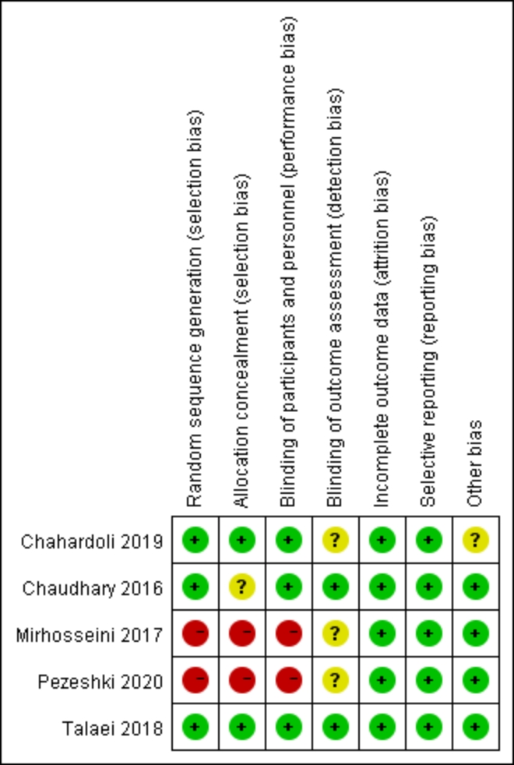
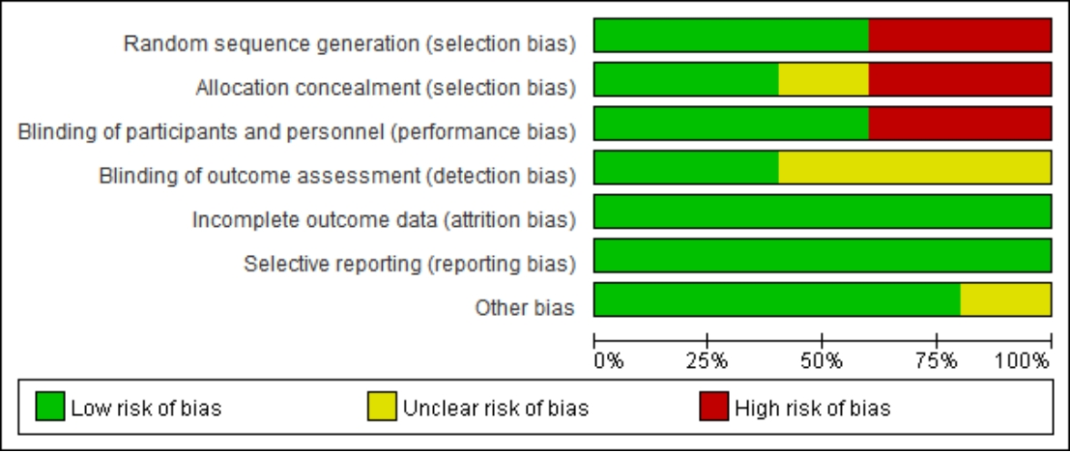Figure S1 The risk of bias within individual studies for RCT studies.
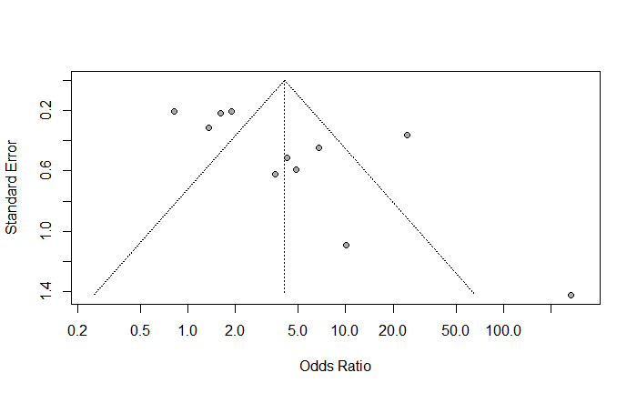Figure S2 Funnel plots for cross-sectional studies.
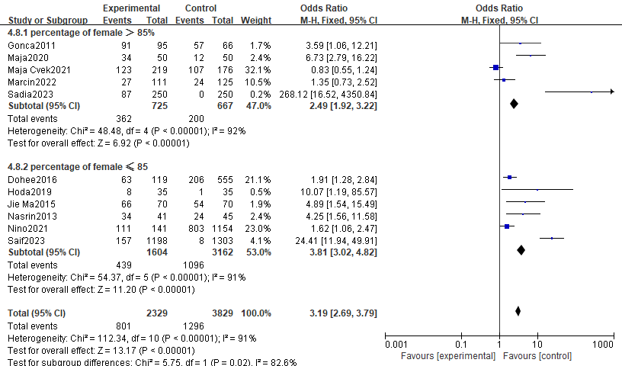
Figure S3 Subgroup analysis of percentage of female > 85%, vs. percentage of female ≤ 85% for the risk of insufficiency of serum vitamin D.
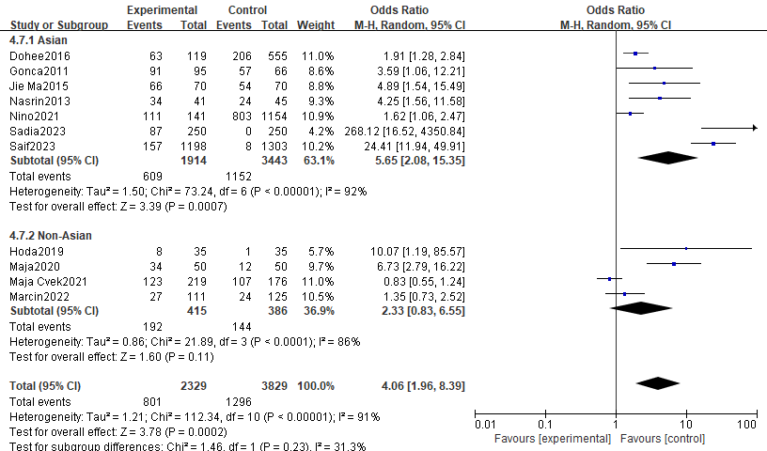
Figure S4 Subgroup analysis of Asia vs. Non-Asia for the risk of insufficiency of serum vitamin D.
Table S4 Meta-regression analyse.
Independent variables | Dependent variables | Coefficient | Standard Error | 95% Lower | 95%  Upper | Z-value | P-value
NOS | VD  deficiency | -0.1573 | 0.3361 | -0.8160 | 0.5014 | -0.4681 | 0.6397
Sample size | VD  deficiency | 0.0004 | 0.0005 | -0.0007 | 0.0015 | 0.7320 | 0.4642
Latitude | VD  deficiency | -1.6905 | 0.5193 | -2.7083 | -0.6728 | -3.2557 | 0.0011

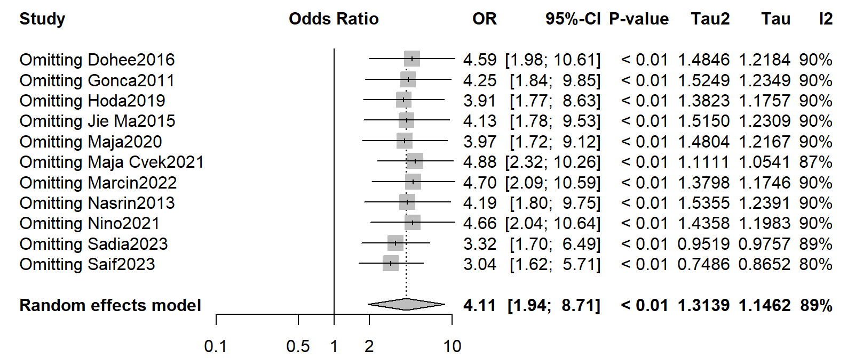Figure S5 Forest plot for sensitivity analysis of observational studies.
Table S5 Full search strategies by database.
Database | Step | Search Terms / Strategy | Number of Results
PubMed | #1 | ("Vitamin D"[Mesh] OR "Cholecalciferol"[Mesh] OR "Ergocalciferols"[Mesh] OR "Vitamin D Deficiency"[Mesh] OR "Vitamin D"[Title/Abstract] OR "Vit D"[Title/Abstract] OR "Cholecalciferol"[Title/Abstract] OR "Ergocalciferol"[Title/Abstract] OR "25-hydroxyvitamin D"[Title/Abstract] OR "25(OH)D"[Title/Abstract] OR "Calcifediol"[Title/Abstract] OR "Calcitriol"[Title/Abstract] OR "Vitamin D2"[Title/Abstract] OR "Vitamin D3"[Title/Abstract] OR "Vitamin D deficiency"[Title/Abstract] OR "Vitamin D insufficiency"[Title/Abstract]) | 79867
PubMed | #2 | ("Hypothyroidism"[Mesh] OR "Hashimoto Disease"[Mesh] OR "Thyroiditis, Autoimmune"[Mesh] OR "Hypothyroidism"[Title/Abstract] OR "Hypothyroid"[Title/Abstract] OR "Underactive thyroid"[Title/Abstract] OR "Hashimoto"[Title/Abstract] OR "Hashimoto's disease"[Title/Abstract] OR "Hashimoto's thyroiditis"[Title/Abstract] OR "Autoimmune thyroiditis"[Title/Abstract] OR "Thyroid insufficiency"[Title/Abstract] OR "Myxedema"[Title/Abstract] OR "Thyroid deficiency"[Title/Abstract]) | 46773
PubMed | #3 | (English[Filter]) | -
PubMed | #4 | (Humans[Filter]) | -
PubMed | #5 | #1 AND #2 AND #3 AND #4 | 297
Embase | #1 | ('vitamin d'/exp OR 'cholecalciferol':ab,ti OR 'vitamin d deficiency':ab,ti OR '25 hydroxyvitamin d':ab,ti OR 'vitamin d2':ab,ti OR 'vitamin d3':ab,ti OR 'calcifediol':ab,ti OR 'calcitriol':ab,ti) | 142387
Embase | #2 | ('hypothyroidism'/exp OR 'underactive thyroid':ab,ti OR 'hashimoto disease':ab,ti OR 'thyroid function':ab,ti OR 'autoimmune thyroiditis':ab,ti OR 'thyroid insufficiency':ab,ti) | 72002
Embase | #3 | [english]/lim | -
Embase | #4 | [human]/lim | -
Embase | #5 | #1 AND #2 AND #3 AND #4 | 796
Cochrane Library | #1 | [mh "Vitamin D"] OR [mh "Cholecalciferol"] OR [mh "Ergocalciferols"] OR [mh "Vitamin D Deficiency"] OR ("Vitamin D"):ti,ab,kw OR (Cholecalciferol):ti,ab,kw OR (Ergocalciferol):ti,ab,kw OR ("25-hydroxyvitamin D"):ti,ab,kw OR (Calcifediol):ti,ab,kw OR (Calcitriol):ti,ab,kw | 12342
Cochrane Library | #2 | [mh "Hypothyroidism"] OR [mh "Hashimoto Disease"] OR [mh "Thyroiditis, Autoimmune"] OR (Hypothyroidism):ti,ab,kw OR ("Underactive thyroid"):ti,ab,kw OR (Hashimoto*):ti,ab,kw OR ("Autoimmune thyroiditis"):ti,ab,kw | 3127
Cochrane Library | #3 | #1 AND #2 | 84
Web of Science | #1 | TS=("Vitamin D" OR "Cholecalciferol" OR "Ergocalciferols" OR "25-hydroxyvitamin D" OR "Vitamin D Deficiency" OR "Vitamin D2" OR "Vitamin D3" OR "Calcifediol" OR "Calcitriol") | 180483
Web of Science | #2 | TS=("Hypothyroidism" OR "Thyroid Dysfunction" OR "Underactive Thyroid" OR "Hashimoto" OR "Autoimmune thyroiditis" OR "Thyroid insufficiency") | 80652
Web of Science | #3 | #1 AND #2 | 106

Section and Topic | Item # | Checklist item | Location where item is reported
TITLE |  |  | 1
Title | 1 | Identify the report as a systematic review. | 1
ABSTRACT |  |  | 2-3
Abstract | 2 | See the PRISMA 2020 for Abstracts checklist. | 2-3
INTRODUCTION |  |  | 3-5
Rationale | 3 | Describe the rationale for the review in the context of existing knowledge. | 3-4
Objectives | 4 | Provide an explicit statement of the objective(s) or question(s) the review addresses. | 5
METHODS |  |  | 6-11
Eligibility criteria | 5 | Specify the inclusion and exclusion criteria for the review and how studies were grouped for the syntheses. | 6
Information sources | 6 | Specify all databases, registers, websites, organisations, reference lists and other sources searched or consulted to identify studies. Specify the date when each source was last searched or consulted. | 6
Search strategy | 7 | Present the full search strategies for all databases, registers and websites, including any filters and limits used. | 6
Selection process | 8 | Specify the methods used to decide whether a study met the inclusion criteria of the review, including how many reviewers screened each record and each report retrieved, whether they worked independently, and if applicable, details of automation tools used in the process. | 7
Data collection process | 9 | Specify the methods used to collect data from reports, including how many reviewers collected data from each report, whether they worked independently, any processes for obtaining or confirming data from study investigators, and if applicable, details of automation tools used in the process. | 6
Data items | 10a | List and define all outcomes for which data were sought. Specify whether all results that were compatible with each outcome domain in each study were sought (e.g. for all measures, time points, analyses), and if not, the methods used to decide which results to collect. | 6-7
Data items | 10b | List and define all other variables for which data were sought (e.g. participant and intervention characteristics, funding sources). Describe any assumptions made about any missing or unclear information. | 6
Study risk of bias assessment | 11 | Specify the methods used to assess risk of bias in the included studies, including details of the tool(s) used, how many reviewers assessed each study and whether they worked independently, and if applicable, details of automation tools used in the process. | 8
Effect measures | 12 | Specify for each outcome the effect measure(s) (e.g. risk ratio, mean difference) used in the synthesis or presentation of results. | 8
Synthesis methods | 13a | Describe the processes used to decide which studies were eligible for each synthesis (e.g. tabulating the study intervention characteristics and comparing against the planned groups for each synthesis (item #5)). | 8
Synthesis methods | 13b | Describe any methods required to prepare the data for presentation or synthesis, such as handling of missing summary statistics, or data conversions. | 9
Synthesis methods | 13c | Describe any methods used to tabulate or visually display results of individual studies and syntheses. | 9
Synthesis methods | 13d | Describe any methods used to synthesize results and provide a rationale for the choice(s). If meta-analysis was performed, describe the model(s), method(s) to identify the presence and extent of statistical heterogeneity, and software package(s) used. | 10
Synthesis methods | 13e | Describe any methods used to explore possible causes of heterogeneity among study results (e.g. subgroup analysis, meta-regression). | 10
Synthesis methods | 13f | Describe any sensitivity analyses conducted to assess robustness of the synthesized results. | 10
Reporting bias assessment | 14 | Describe any methods used to assess risk of bias due to missing results in a synthesis (arising from reporting biases). | 10-11
Certainty assessment | 15 | Describe any methods used to assess certainty (or confidence) in the body of evidence for an outcome. | 7
RESULTS |  |  | 12-22
Study selection | 16a | Describe the results of the search and selection process, from the number of records identified in the search to the number of studies included in the review, ideally using a flow diagram. | 12
Study selection | 16b | Cite studies that might appear to meet the inclusion criteria, but which were excluded, and explain why they were excluded. | 12
Study characteristics | 17 | Cite each included study and present its characteristics. | 12-14
Risk of bias in studies | 18 | Present assessments of risk of bias for each included study. | 12
Results of individual studies | 19 | For all outcomes, present, for each study: (a) summary statistics for each group (where appropriate) and (b) an effect estimate and its precision (e.g. confidence/credible interval), ideally using structured tables or plots. | 12-22
Results of syntheses | 20a | For each synthesis, briefly summarise the characteristics and risk of bias among contributing studies. | 13
Results of syntheses | 20b | Present results of all statistical syntheses conducted. If meta-analysis was done, present for each the summary estimate and its precision (e.g. confidence/credible interval) and measures of statistical heterogeneity. If comparing groups, describe the direction of the effect. | 13
Results of syntheses | 20c | Present results of all investigations of possible causes of heterogeneity among study results. | 14
Results of syntheses | 20d | Present results of all sensitivity analyses conducted to assess the robustness of the synthesized results. | 15-17
Reporting biases | 21 | Present assessments of risk of bias due to missing results (arising from reporting biases) for each synthesis assessed. | 14
Certainty of evidence | 22 | Present assessments of certainty (or confidence) in the body of evidence for each outcome assessed. | 12-22
DISCUSSION |  |  | 22-29
Discussion | 23a | Provide a general interpretation of the results in the context of other evidence. | 22
Discussion | 23b | Discuss any limitations of the evidence included in the review. | 28-29
Discussion | 23c | Discuss any limitations of the review processes used. | 28
Discussion | 23d | Discuss implications of the results for practice, policy, and future research. | 28
OTHER INFORMATION |  |  | 6
Registration and protocol | 24a | Provide registration information for the review, including register name and registration number, or state that the review was not registered. | 6
Registration and protocol | 24b | Indicate where the review protocol can be accessed, or state that a protocol was not prepared. | 6
Registration and protocol | 24c | Describe and explain any amendments to information provided at registration or in the protocol. | 6
Support | 25 | Describe sources of financial or non-financial support for the review, and the role of the funders or sponsors in the review. | 31
Competing interests | 26 | Declare any competing interests of review authors. | 31
Availability of data, code and other materials | 27 | Report which of the following are publicly available and where they can be found: template data collection forms; data extracted from included studies; data used for all analyses; analytic code; any other materials used in the review. | 22

