Supplementary Figure 1. Unsupervised PCA score plots of (A) serum and (B) fecal metabolomic profiles across dietary groups in two-dimensional (2D) and three-dimensional (3D) views
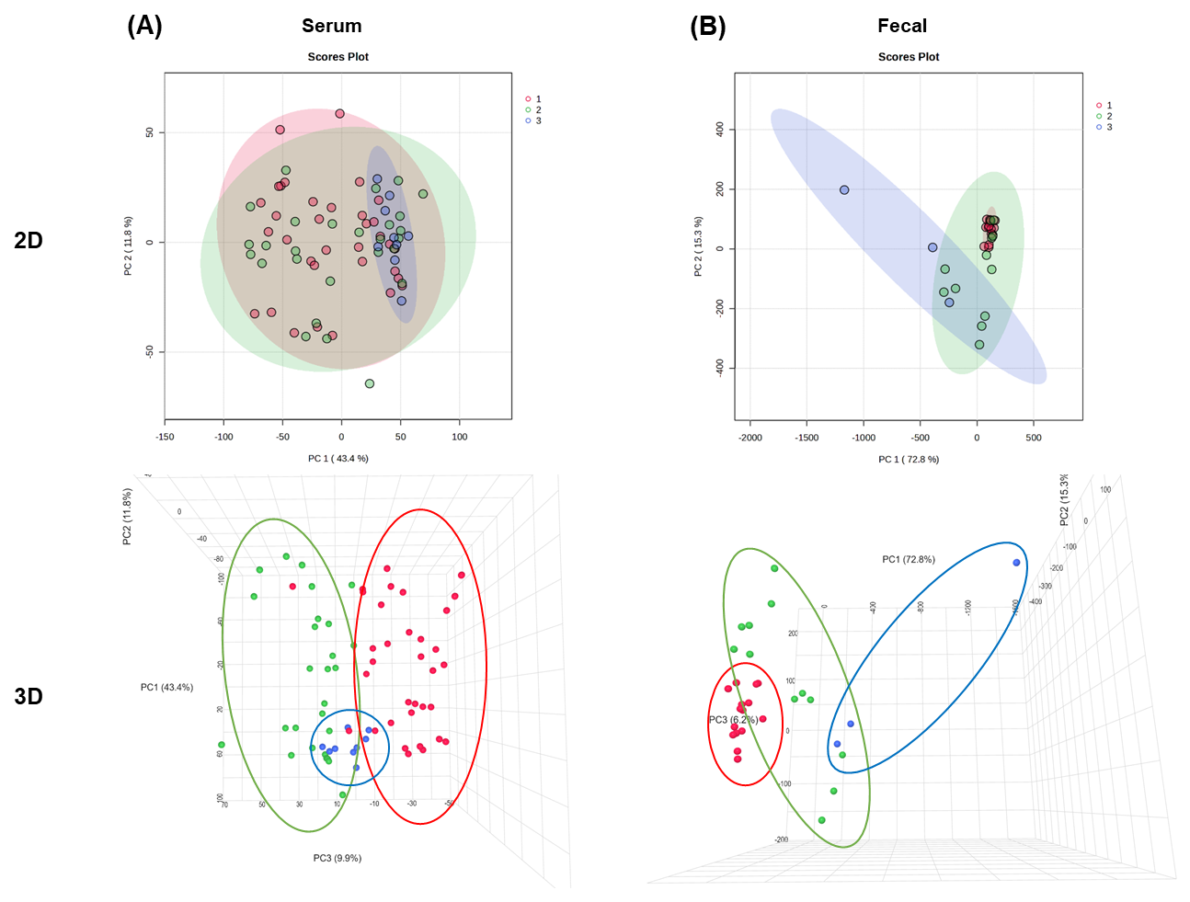

Supplementary Figure S2. Unsupervised hierarchical clustering of individual serum metabolomic profiles across dietary groups
