Table S1. Baseline characteristics of included and analyzable-but-excluded participants
Variables | Total  (n = 16,931) | Included  (n = 2,507) | Excluded  (n = 14,424) | P
Age, years | 59.11 ± 9.77 | 52.74 ± 5.33 | 60.21 ± 9.95 | <0.001
WC, cm | 85.26 ± 10.23 | 85.41 ± 9.66 | 85.23 ± 10.36 | 0.177
Sex, n (%) |  |  |  | 0.102
Male | 8,268 (48.83) | 1,186 (47.31) | 7,082 (49.10)
Female | 8,663 (51.17) | 1,321 (52.69) | 7,342 (50.90)
Marital status, n (%) |  |  |  | <0.001
Married | 13,540 (80.02) | 2,233 (89.07) | 11,307 (78.44)
Other | 3,381 (19.98) | 274 (10.93) | 3,107 (21.56)
Education, n (%) |  |  |  | <0.001
Below elementary | 7,705 (45.52) | 925 (36.90) | 6,780 (47.02)
Elementary | 3,548 (20.96) | 527 (21.02) | 3,021 (20.95)
Above elementary | 5,672 (33.51) | 1,055 (42.08) | 4,617 (32.02)
Residence, n (%) |  |  |  | <0.001
Urban | 3,821 (22.61) | 377 (15.04) | 3,444 (23.93)
Rural | 13,079 (77.39) | 2,129 (84.96) | 10,950 (76.07)
Smoking, n (%) |  |  |  | 0.087
No | 11,411 (70.56) | 1,731 (69.10) | 9,680 (70.82)
Yes | 4,762 (29.44) | 774 (30.90) | 3,988 (29.18)
Drinking, n (%) |  |  |  | <0.001
No | 11,198 (66.70) | 1,596 (63.69) | 9,602 (67.23)
Yes | 5,591 (33.30) | 910 (36.31) | 4,681 (32.77)
Hypertension, n (%) |  |  |  | <0.001
No | 12,299 (73.58) | 1,995 (80.18) | 10,304 (72.42)
Yes | 4,417 (26.42) | 493 (19.82) | 3,924 (27.58)
Diabetes, n (%) |  |  |  | 0.008
No | 15,611 (93.74) | 2,352 (94.95) | 13,259 (93.53)
Yes | 1,042 (6.26) | 125 (5.05) | 917 (6.47)
Cancer, n (%) |  |  |  | 0.362
No | 16,568 (99.06) | 2,475 (99.24) | 14,093 (99.02)
Yes | 158 (0.94) | 19 (0.76) | 139 (0.98)
CKD, n (%) |  |  |  | 0.304
No | 15,737 (94.27) | 2,357 (94.73) | 13,380 (94.19)
Yes | 956 (5.73) | 131 (5.27) | 825 (5.81)
CVD, n (%) |  |  |  | <0.001
No | 14,364 (85.59) | 2,272 (90.84) | 12,092 (84.67)
Yes | 2,419 (14.41) | 229 (9.16) | 2,190 (15.33)
Data are presented as mean ± standard deviation (SD) or number (%), as appropriate
The P-value is based on analysis of variance (ANOVA) or chi-square test
Abbreviations: WC, waist circumference; CKD, chronic kidney disease; CVD, cardiovascular disease

Table S2. Variance inflation factors for the primary model
Variables | VIF
Anemia status transition | 1.018
Age | 1.025
Sex | 1.422
Marital status | 1.019
Education | 1.037
Residence | 1.049
WC | 1.585
Smoking | 1.287
Drinking | 1.179
Hypertension | 1.019
Diabetes | 1.022
Cancer | 1.015
CKD | 1.009
CVD | 1.031
Abbreviations: VIF, variance inflation factor; WC, waist circumference; CKD, chronic kidney disease; CVD, cardiovascular disease

Table S3. Associations of cumulative hemoglobin with low muscle mass and sarcopenia
Variables | Model 1 |  | Model 2 |  | Model 3
Variables | OR (95%CI) | P | OR (95%CI) | P | OR (95%CI) | P
Low muscle mass
Cumulative hemoglobin, per SD | 0.62 (0.55-0.69) | <0.001 | 0.73 (0.64-0.83) | <0.001 | 0.83 (0.72-0.96) | 0.011
Q1 | Ref |  | Ref |  | Ref
Q2 | 0.64 (0.49-0.83) | <0.001 | 0.71 (0.54-0.93) | 0.013 | 0.88 (0.65-1.19) | 0.394
Q3 | 0.43 (0.32-0.57) | <0.001 | 0.55 (0.40-0.75) | <0.001 | 0.69 (0.49-0.97) | 0.033
Q4 | 0.25 (0.18-0.34) | <0.001 | 0.37 (0.25-0.53) | <0.001 | 0.49 (0.33-0.74) | <0.001
P for trend |  | <0.001 |  | <0.001 |  | <0.001
Sarcopenia
Cumulative hemoglobin, per SD | 0.62 (0.53-0.73) | <0.001 | 0.71 (0.59-0.85) | <0.001 | 0.79 (0.66-0.96) | 0.015
Q1 | Ref |  | Ref |  | Ref
Q2 | 0.85 (0.61-1.20) | 0.356 | 0.94 (0.66-1.33) | 0.716 | 1.09 (0.75-1.59) | 0.634
Q3 | 0.43 (0.28-0.64) | <0.001 | 0.52 (0.34-0.82) | 0.004 | 0.65 (0.41-1.04) | 0.070
Q4 | 0.29 (0.19-0.46) | <0.001 | 0.42 (0.25-0.72) | 0.001 | 0.55 (0.32-0.95) | 0.033
P for trend |  | <0.001 |  | <0.001 |  | 0.015
Model 1: Unadjusted
Model 2: Adjusted for Age, Sex, Marital status, Education, Residence
Model 3: Adjusted for Age, Sex, Marital status, Education, Residence, WC, Smoking, Drinking, Hypertension, Diabetes, Cancer, CVD, CKD
Abbreviations: OR, odds ratio; CI, confidence interval; Ref, reference group; WC, waist circumference; CVD, cardiovascular disease; CKD, chronic kidney disease

Table S4. Association of anemia status transition with low muscle mass and sarcopenia in the complete-case analysis
Variables | Model 1 |  | Model 2 |  | Model 3
Variables | OR (95%CI) | P | OR (95%CI) | P | OR (95%CI) | P
Low muscle mass
Persistent non-anemia | Ref |  | Ref |  | Ref
Incident anemia | 1.85 (1.36-2.53) | <0.001 | 1.65 (1.20-2.27) | 0.002 | 1.33 (0.94-1.90) | 0.111
Resolved anemia | 1.64 (1.10-2.44) | 0.015 | 1.65 (1.09-2.48) | 0.017 | 1.60 (1.01-2.53) | 0.044
Persistent anemia | 2.77 (1.84-4.15) | <0.001 | 2.23 (1.47-3.38) | <0.001 | 1.76 (1.11-2.80) | 0.017
Sarcopenia
Persistent non-anemia | Ref |  | Ref |  | Ref
Incident anemia | 1.93 (1.28-2.90) | 0.002 | 1.74 (1.14-2.65) | 0.011 | 1.45 (0.93-2.26) | 0.099
Resolved anemia | 1.79 (1.06-3.02) | 0.029 | 1.90 (1.11-3.26) | 0.019 | 1.74 (0.98-3.07) | 0.057
Persistent anemia | 2.76 (1.66-4.62) | <0.001 | 2.32 (1.36-3.94) | 0.002 | 1.90 (1.09-3.32) | 0.024
Model 1: Unadjusted
Model 2: Adjusted for Age, Sex, Marital status, Education, Residence
Model 3: Adjusted for Age, Sex, Marital status, Education, Residence, WC, Smoking, Drinking, Hypertension, Diabetes, Cancer, CVD, CKD
Abbreviations: OR, odds ratio; CI, confidence interval; Ref, reference group; WC, waist circumference; CVD, cardiovascular disease; CKD, chronic kidney disease

Table S5. Association of anemia status transition with low muscle mass and sarcopenia after excluding participants with chronic disease
Variables | Model 1 |  | Model 2 |  | Model 3
Variables | OR (95%CI) | P | OR (95%CI) | P | OR (95%CI) | P
Low muscle mass
Persistent non-anemia | Ref |  | Ref |  | Ref
Incident anemia | 1.87 (1.34-2.59) | <0.001 | 1.71 (1.21-2.40) | 0.002 | 1.43 (0.98-2.09) | 0.061
Resolved anemia | 1.65 (1.09-2.49) | 0.017 | 1.61 (1.05-2.45) | 0.028 | 1.69 (1.05-2.71) | 0.031
Persistent anemia | 2.66 (1.73-4.09) | <0.001 | 2.18 (1.40-3.39) | <0.001 | 1.66 (1.02-2.71) | 0.043
Sarcopenia
Persistent non-anemia | Ref |  | Ref |  | Ref
Incident anemia | 1.94 (1.26-2.98) | 0.003 | 1.79 (1.15-2.81) | 0.011 | 1.51 (0.95-2.40) | 0.084
Resolved anemia | 1.76 (1.03-3.02) | 0.040 | 1.78 (1.02-3.10) | 0.043 | 1.69 (0.94-3.03) | 0.080
Persistent anemia | 2.90 (1.71-4.94) | <0.001 | 2.53 (1.45-4.40) | 0.001 | 1.99 (1.12-3.55) | 0.020
Model 1: Unadjusted
Model 2: Adjusted for Age, Sex, Marital status, Education, Residence
Model 3: Adjusted for Age, Sex, Marital status, Education, Residence, WC, Smoking, Drinking, Hypertension, Diabetes
Abbreviations: OR, odds ratio; CI, confidence interval; Ref, reference group; WC, waist circumference

Table S6. E-values for the associations of anemia transition with low muscle mass and sarcopenia
Exposure group | OR (95%CI) | E-value for point estimate | E-value for CI limit
Low muscle mass
Incident anemia | 1.36 (0.96-1.92) | 2.06 | 1.00
Resolved anemia | 1.57 (1.00-2.47) | 2.52 | 1.00
Persistent anemia | 1.73 (1.09-2.75) | 2.85 | 1.40
Sarcopenia
Incident anemia | 1.42 (0.92-2.20) | 2.19 | 1.00
Resolved anemia | 1.74 (1.00-3.02) | 2.87 | 1.00
Persistent anemia | 1.85 (1.06-3.24) | 3.10 | 1.31
The E-value for the confidence interval was calculated for the confidence limit closest to the null.
When the 95% confidence interval included the null, the E-value for the confidence interval was set to 1.00.
Adjusted for Age, Sex, Marital status, Education, Residence, WC, Smoking, Drinking, Hypertension, Diabetes, Cancer, CVD, CKD
Abbreviations: OR, odds ratio; CI, confidence interval; WC, waist circumference; CVD, cardiovascular disease; CKD, chronic kidney disease

Figure S1. Proportion of missing values for baseline covariates
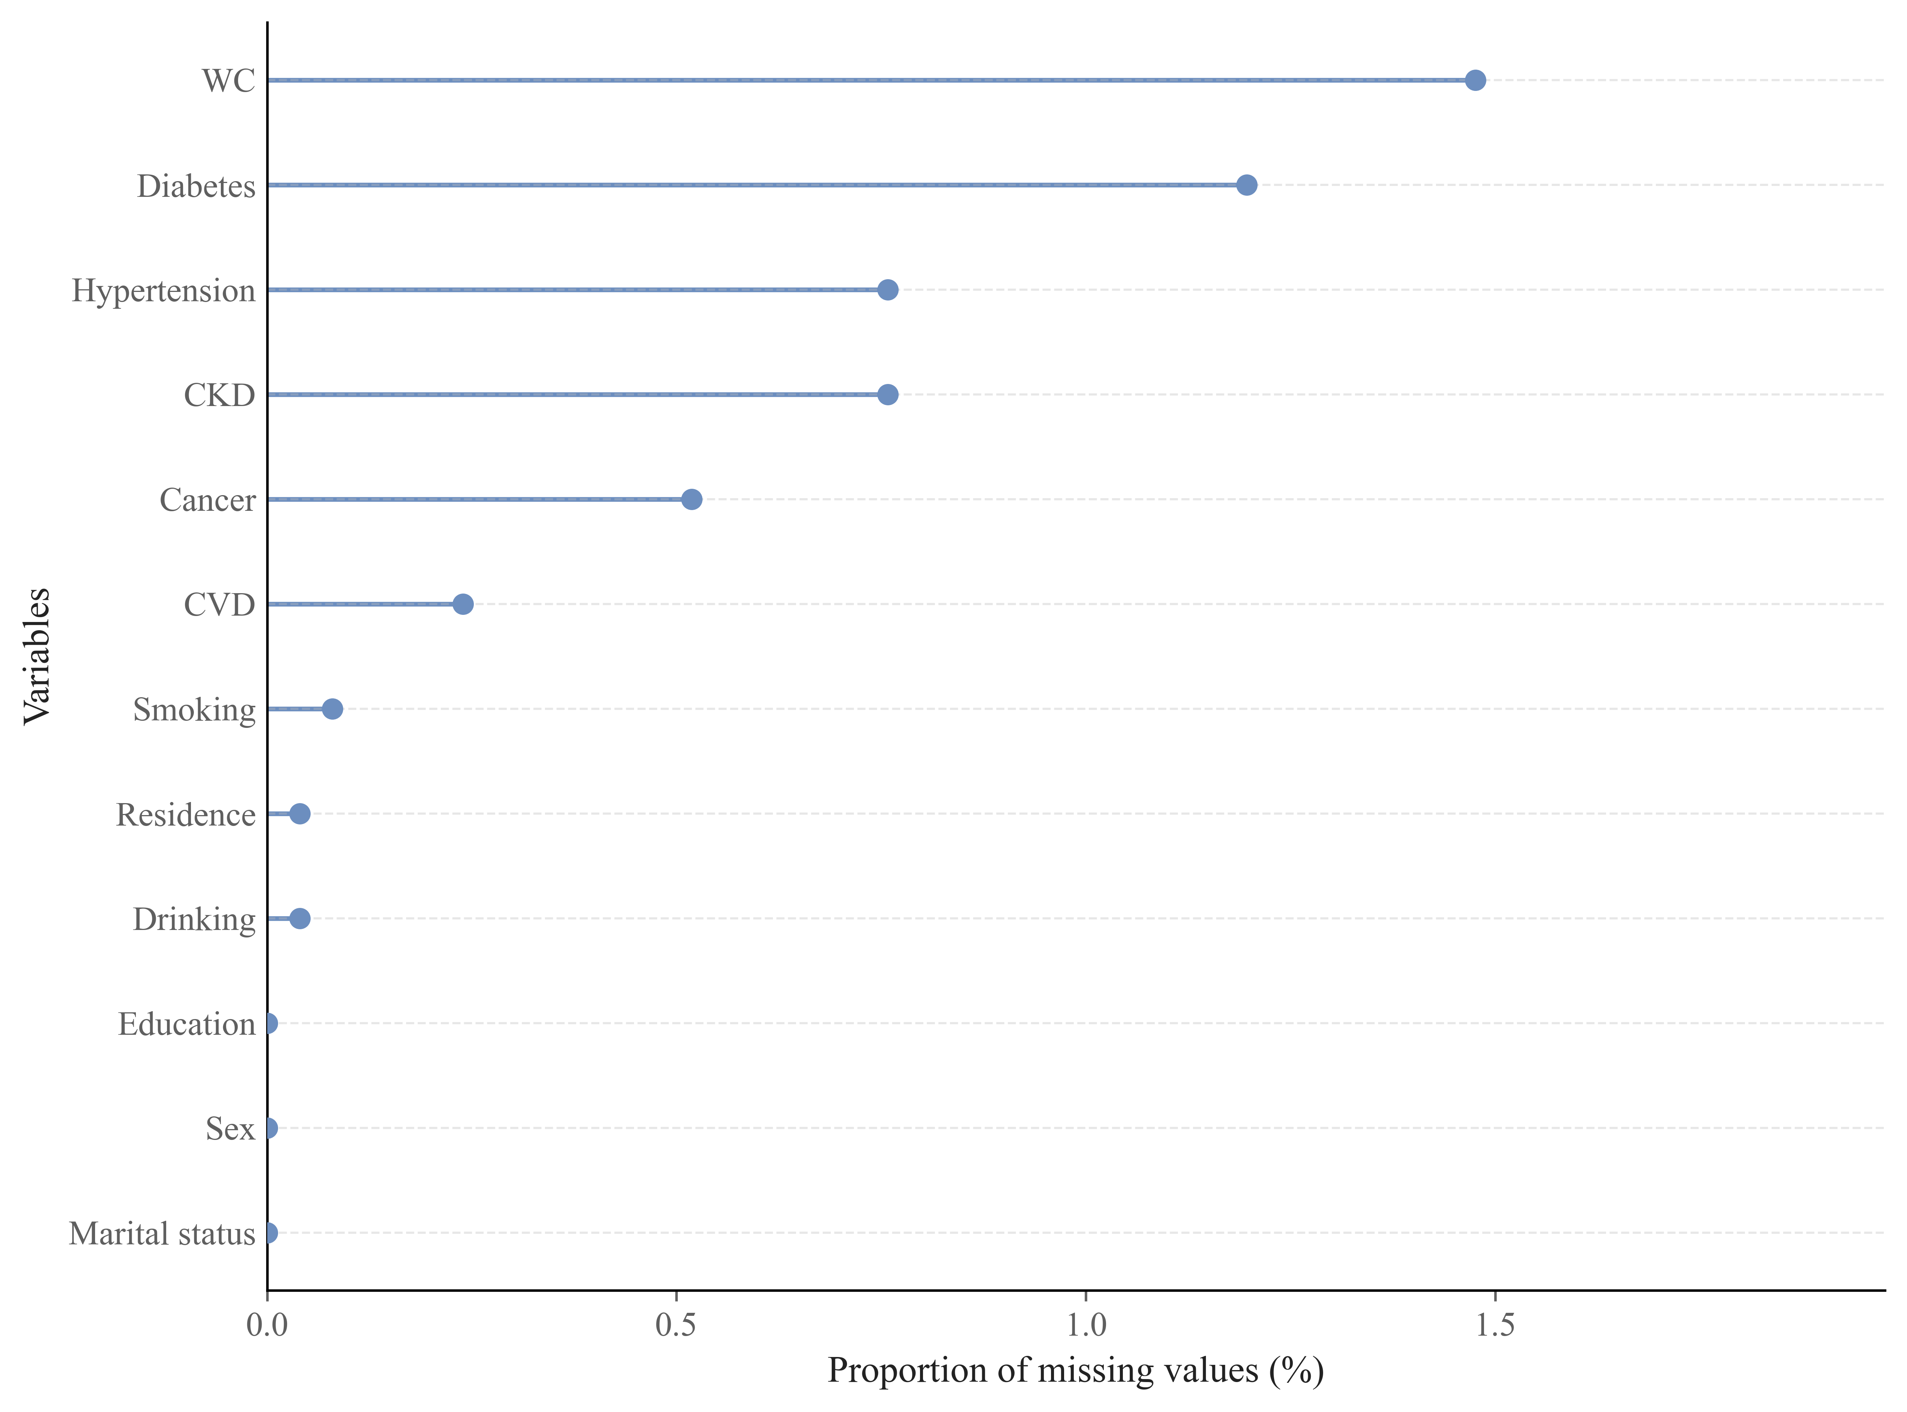

Figure S2. Subgroup analyses of the associations between anemia status transitions and low muscle mass (A) and sarcopenia (B)
