Supplementary Figure S1. Flowchart of participant selection.
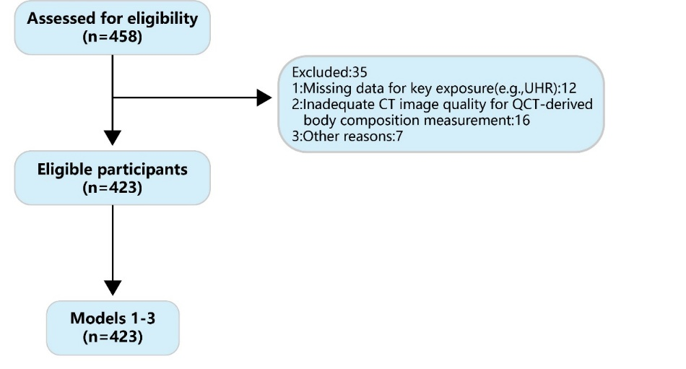
Flow diagram depicting the screening, eligibility, and exclusion process of the study population in accordance with STROBE guidelines. From an initial screening cohort of 458 adult check-up participants, 35 individuals were excluded due to missing key exposure data (e.g., UHR, n = 12), inadequate CT image quality for QCT-derived body composition measurement (n = 16), or other uncollected baseline data (n = 7). A final analytical sample of 423 eligible participants was included across all primary multivariable regression models (Models 1–3).
Abbreviations: CT, computed tomography; QCT, quantitative computed tomography; UHR, uric acid-to-high-density lipoprotein cholesterol ratio; STROBE, Strengthening the Reporting of Observational Studies in Epidemiology.

Supplementary Figure S2. Restricted cubic spline (RCS) curve for the non-linear relationship and threshold analysis between UHR and SMA/VFA ratio.
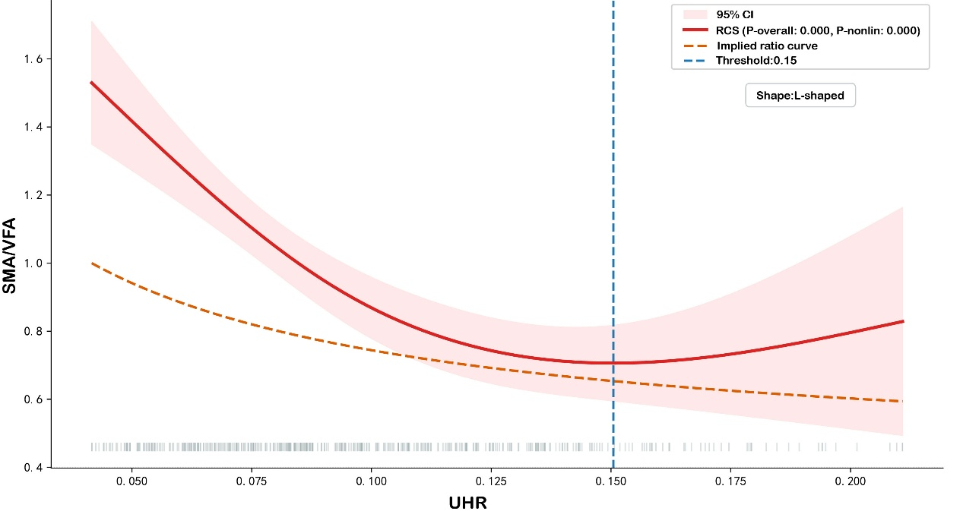
Restricted cubic spline (RCS) curve depicting the non-linear L-shaped association between UHR and the SMA/VFA ratio. The red solid line represents the multivariable-adjusted fitted curve, and the pink shaded area denotes the 95% confidence interval (CI). The brown dashed line shows the implied ratio curve. The vertical blue dashed line indicates the calculated inflection threshold at UHR = 0.15. The gray rug plot along the horizontal axis illustrates the distribution density of UHR data. Significant overall association (P-overall < 0.001) and non-linear response (P-nonlinearity < 0.001) were observed.

Supplementary Figure S3. Directed acyclic graph (DAG) illustrating the hypothesized causal and mediation pathways.
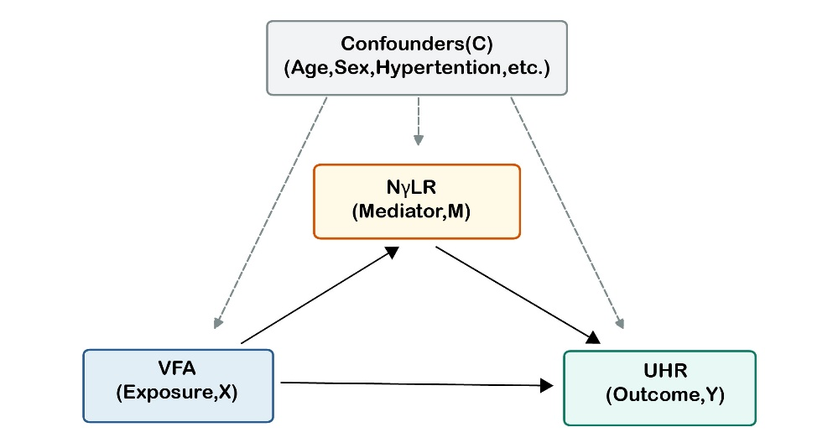
The primary exposure variable ($X$) is visceral fat area (VFA), and the outcome variable ($Y$) is the uric acid-to-high-density lipoprotein cholesterol ratio (UHR). NγLR serves as the hypothesized mediator (M). Solid black arrows denote direct and indirect causal pathways linking exposure, mediator, and outcome. Dashed gray arrows represent potential confounding pathways ($C$) adjusted for in multivariable regression models (including age, sex, and clinical comorbidities such as hypertension, diabetes, and dyslipidemia).

Supplementary Figure S4. Sensitivity analysis evaluating the directionality of the mediation pathway via reverse mediation modeling.
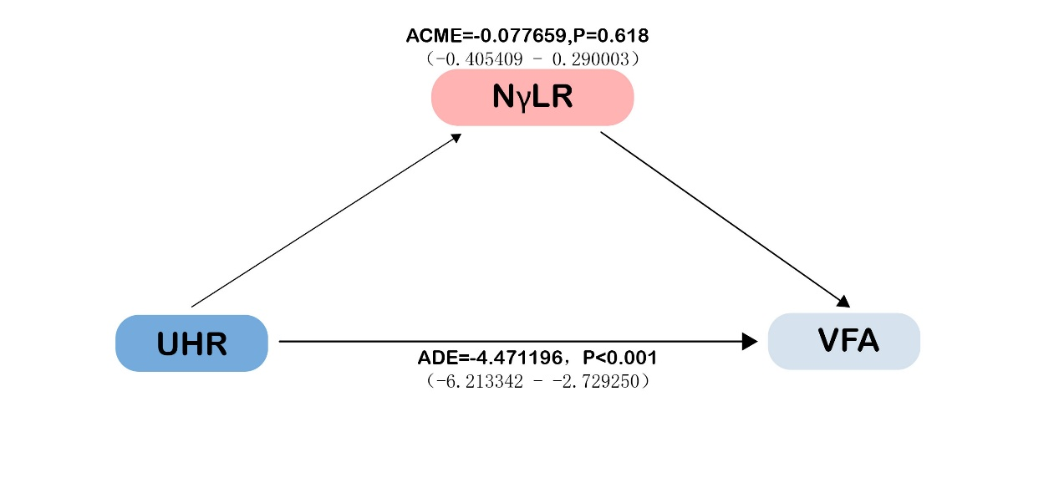
Reverse mediation analysis was performed to test the directionality and robustness of the framework by modeling the pathway from UHR to VFA via $\text{N}γ\text{LR}$ ($\text{UHR}→\text{N}γ\text{LR}→\text{VFA}$). Regression models were adjusted for age, sex and metabolic comorbidities (hypertension, diabetes, and dyslipidemia). Point estimates are presented alongside 95% confidence intervals (CIs).

Supplementary Figure S5. Model residual diagnostic plots for multivariable linear regression analyses.
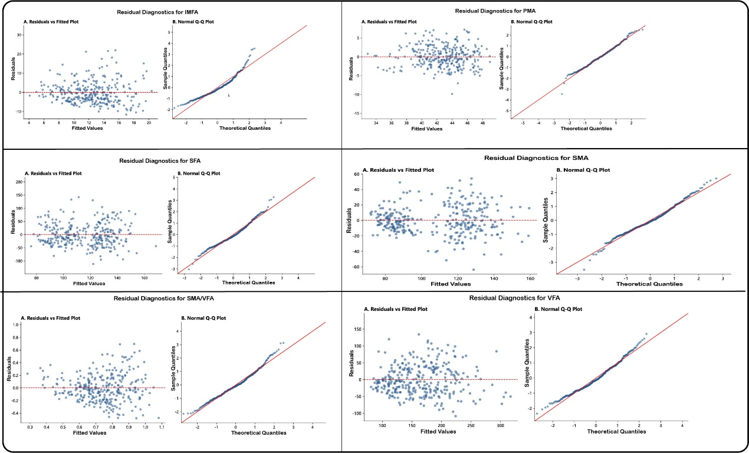

Supplementary Table S1. Subgroup and interaction analyses of the association between UHR and body composition parameters stratified.
Interaction Variable | Dependent Variable (Y) | Independent Variable (X) | Analysis Type | P-value | β | 95% CI
BMI | SFA | UHR | P-value for Interaction Term | >0.05
BMI | VFA | UHR | P-value for Interaction Term | >0.05
BMI | SMA | UHR | P-value for Interaction Term | >0.05
BMI | IMFA | UHR | P-value for Interaction Term | >0.05
BMI | SMA/VFA | UHR | P-value for Interaction Term | >0.05
BMI | PMA | UHR | P-value for Interaction Term | >0.05
Age | SFA | UHR | P-value for Interaction Term | >0.05
Age | VFA | UHR | P-value for Interaction Term | >0.05
Age | SMA | UHR | P-value for Interaction Term | >0.05
Age | IMFA | UHR | P-value for Interaction Term | >0.05
Age | SMA/VFA | UHR | P-value for Interaction Term | >0.05
Age | PMA | UHR | P-value for Interaction Term | >0.05
Sex | SFA | UHR | P-value for Interaction Term | <0.05 | 2.96 | (0.39,5.53)
Sex | SFA | UHR | Subgroup Analysis (Male) | <0.05 | 10.31 | (4.29, 16.32)
Sex | SFA | UHR | Subgroup Analysis (Female) | <0.05 | 13.26 | (4.98, 21.54)
Sex | VFA | UHR | P-value for Interaction Term | <0.05 | 4.46 | (1.25,7.76)
Sex | VFA | UHR | Subgroup Analysis (Male) | <0.05 | 34.92 | (26.77, 43.07)
Sex | VFA | UHR | Subgroup Analysis (Female) | <0.05 | 30.38 | (24.25, 36.50)
Sex | SMA | UHR | P-value for Interaction Term | <0.05 | 3.69 | (1.02,6.44)
Sex | SMA | UHR | Subgroup Analysis (Male) | <0.05 | 9.56 | (6.31, 12.81)
Sex | SMA | UHR | Subgroup Analysis (Female) | <0.05 | 5.79 | (3.49, 8.08)
Sex | IMFA | UHR | P-value for Interaction Term | <0.05 | 0.37 | (0.12,0.62)
Sex | IMFA | UHR | Subgroup Analysis (Male) | <0.05 | 1.20 | (0.41, 1.98)
Sex | IMFA | UHR | Subgroup Analysis (Female) | <0.05 | 1.59 | (0.32, 2.85)
Sex | SMA/VFA | UHR | P-value for Interaction Term | <0.05 | -0.02 | (-0.03,-0.01)
Sex | SMA/VFA | UHR | Subgroup Analysis (Male) | <0.05 | -0.10 | (-0.13, -0.07)
Sex | SMA/VFA | UHR | Subgroup Analysis (Female) | <0.05 | -0.13 | (-0.17, -0.09)
Sex | PMA | UHR | P-value for Interaction Term | >0.05
Dependent variables (Y): SFA (subcutaneous fat area), VFA (visceral fat area), SMA (skeletal muscle area), IMFA (intermuscular adipose fat area), SMA/VFA (skeletal muscle area to visceral fat area ratio), PMA (paraspinal muscle attenuation).
Independent variable (X): UHR (Uric acid to High-density lipoprotein cholesterol Ratio).
Model specifications: Model 1, unadjusted; Model 2, adjusted for age, gender and history of underlying metabolic diseases; Model 3, adjusted for age, gender, BMI and history of underlying metabolic diseases.
Statistical significance: P < 0.05 indicates a statistically significant difference; P > 0.05 indicates no statistically significant difference.
Abbreviations: BMI, body mass index; IMFA, intermuscular adipose fat area; PMA, paraspinal muscle attenuation; SFA, subcutaneous fat area; SMA, skeletal muscle area; UHR, Uric acid to High-density lipoprotein cholesterol Ratio; VFA, visceral fat area.

Supplementary Table S2. Inter-observer measurement reproducibility was evaluated on a randomly selected subset of 30 double-read CT scans (n = 30) using a two-way random-effects intraclass correlation coefficient model for single measures with absolute agreement [ICC (2,1)] along with 95% confidence intervals (CIs).
 | ICC | 95%CI
SFA | 0.88 | (0.80-0.93)
VFA | 0.85 | (0.75-0.91)
SMA | 0.81 | (0.69-0.89)
PMA | 0.70 | (0.52-0.82)
IMFA | 0.69 | (0.51-0.79)
Intra- and inter-observer measurement reproducibility was evaluated on a randomly selected subset of 30 double-read CT scans (n = 30) using a two-way random-effects intraclass correlation coefficient model for single measures with absolute agreement [ICC(2,1)] along with 95% confidence intervals (CIs).

Supplementary Text S1. Statistical software and package versions.
Python (v3.10.12): Data cleaning and management were performed using Pandas (v2.0.3). Baseline group comparisons, partial correlation analyses, and Benjamini-Hochberg (BH) False Discovery Rate (FDR) multiple testing adjustments were conducted using SciPy (v1.11.1). Multivariable linear regression models with HC3 heteroscedasticity-consistent robust standard errors and subgroup interaction analyses (βinteraction) were fitted using statsmodels (v0.14.0).
R (v4.3.1): Restricted cubic spline (RCS) modeling, non-linear ANOVA F-tests, and two-piecewise linear regression threshold identifications were executed using the rms package (v6.7-0). Causal mediation analysis with 5,000 non-parametric bootstrap resamples was performed using the mediation package (v4.5.0).

