Supplementary Material

Associations of Day-to-Day Eating Pattern Variability and Eating Jetlag with Dietary and Lifestyle Insulin Resistance Indices in Iranian women: A cross-sectional study
Azadeh Lesani, Mar Calvo-Malvar, Cain Clark
Figure S1. Flow diagram of participant selection.

759 women
Screened for eligibility

664 women
Assessed for eligibility

48 Excluded
- Missing dietary data (fewer than three 24-hour dietary recalls) (n = 24)
- Missing questionnaire data (sleep or MEQ¹) (n = 11)
- Missing blood sample (n = 13)

626 women
Included in the study
(Main analysis)

27 Excluded in sensitivity analysis
- Over-reporting (n = 12)
- Under-reporting (n = 15)

514 women
Analysed
(Sensitivity analysis)

514 Analysed

¹ MEQ: Morningness-Eveningness Questionnaire.

Figure S2. Study procedures and data collection protocol.
 | Baseline Data Collection | Anthropometry | Dietary Records | Blood tests
Day 1
Random 2nd Day
Random 3rd Day
 | Sociodemographic characteristics.  Medical history. Pharmacological treatments.  Menopausal status.  Smoking status.  Sleep duration.  Physical activity. | Weight and size.  Waist circumference.  Hip circumference. | Day 1: 24-hour dietary intake and eating occasions collected by trained dietitians during a private, in-person interview at the healthcare center.  Days 2–3: Two additional 24-hour dietary recalls conducted by telephone on randomly selected days. | Blood test: Insulin, high-density lipoprotein and triglycerides.

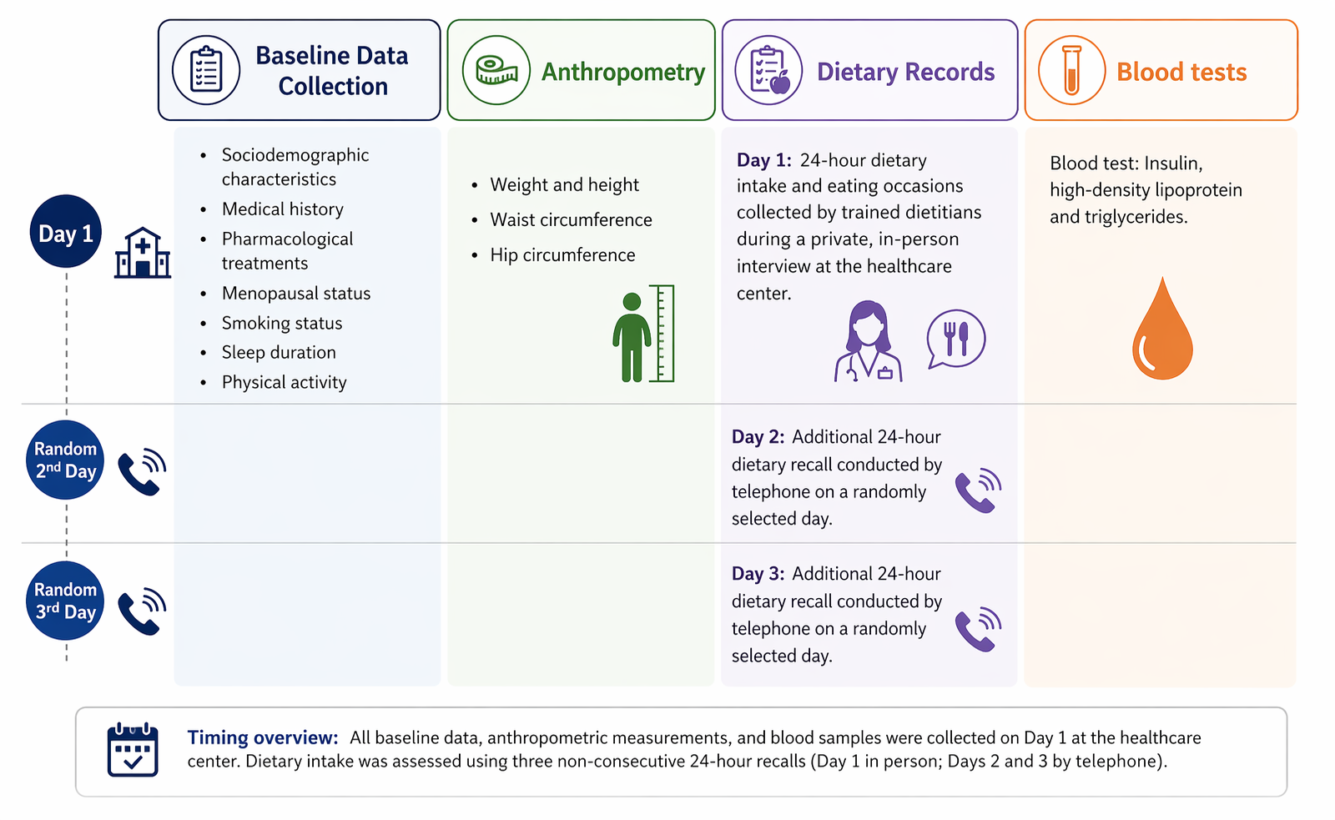
Figure S3. Study procedures.
Figure S4. Directed Acyclic Graph (DAG) accompanying the association in variability in eating patterns and dietary and lifestyle insulinemic indices (DIR and LIR).

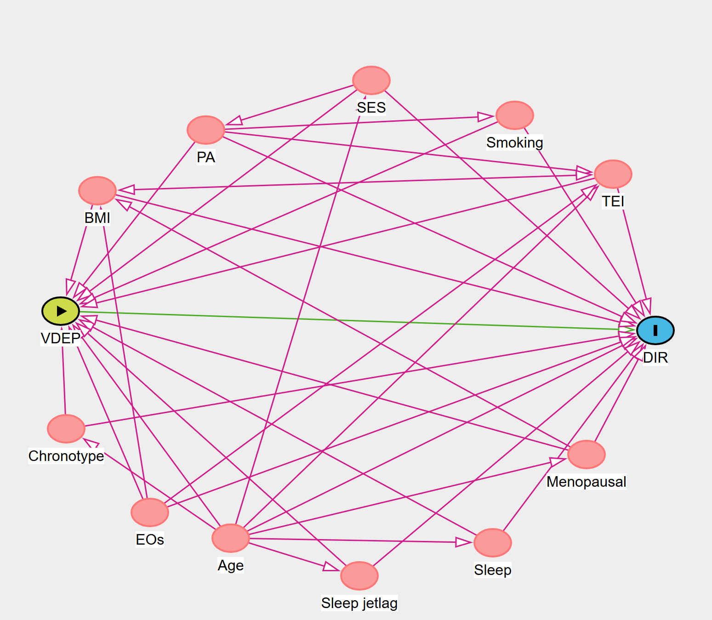 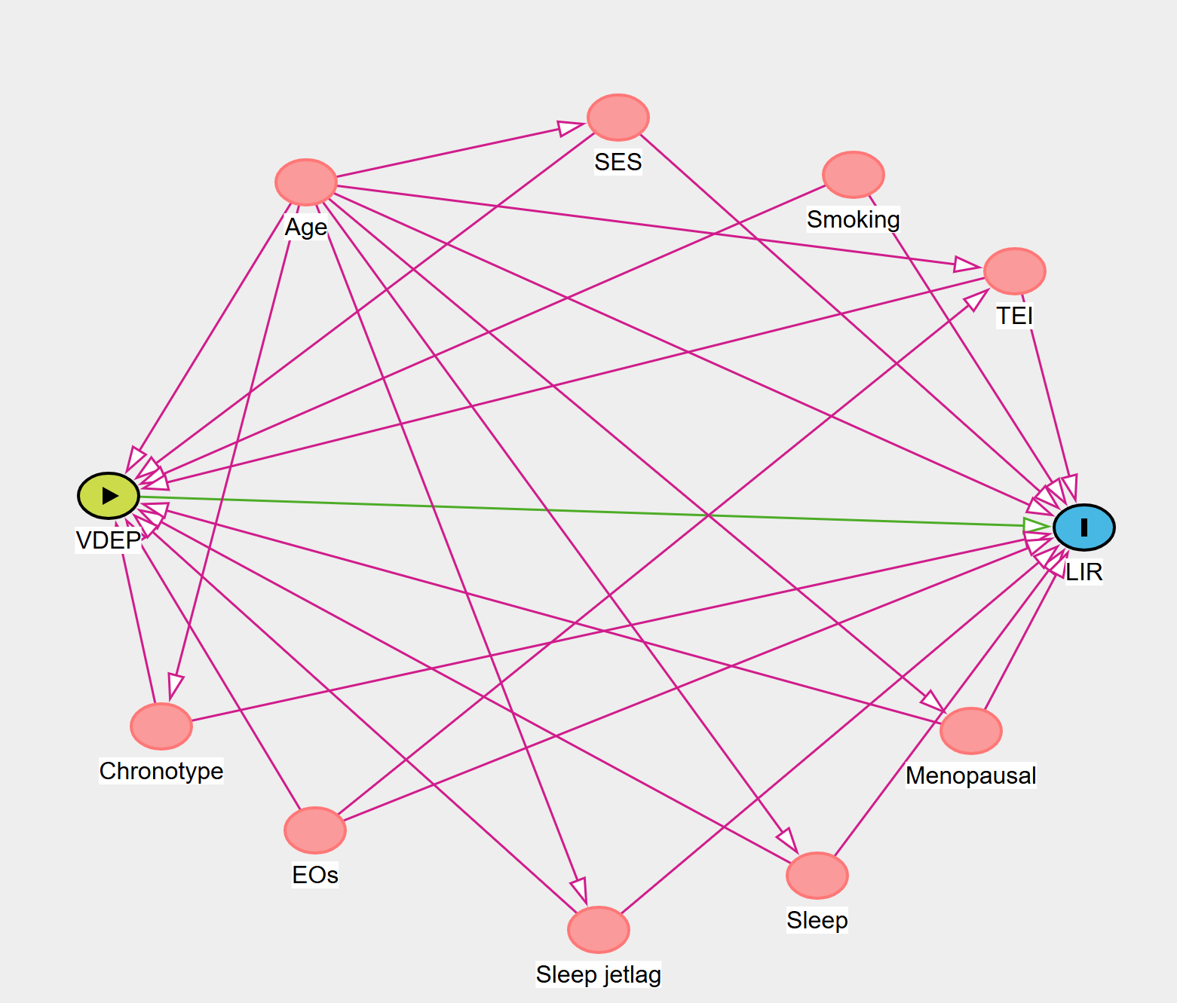
a. b.
Minimal sufficient adjustment sets derived from the DAG:
a. To estimate the total effect of VDEP on DIR, the model was adjusted for age, BMI, total energy intake (TEI), physical activity (PA), socio-economic status (SES), smoking status, menopausal status, diurnal preference (chronotype), total sleep duration, and number of eating occasions (EOs).
b. To estimate the total effect of VDEP on LIR, the model was adjusted for the same variables as model a, except BMI and PA

Abbreviations: BMI, body mass index; DIR, dietary insulinemic index; EOs, eating occasions; LIR, lifestyle insulinemic index; PA, physical activity; SES, socioeconomic status; TEI, total energy intake; VDEP, variability in daily eating patterns.

Table S1. List of 33 food groups used throughout the analyses and mean daily intake (g/day).
No. | Food group | Foods included | Mean ± SD  (g/day)
1 | Refined grains | White bread, pasta rice  wheat flour, dough, yeast dough, oats, wheat | 165.3 ± 51.6
2 | Whole grains | Whole-grain bread, whole-grain pasta, whole-grain cereals | 6.6 ± 3.5
3 | Fruits | Fresh and dried fruits | 105.0 ± 70.9
4 | Green leafy vegetables | Leafy green vegetables | 66.2 ± 50.0
5 | Yellow vegetables | Carrot, red/orange peppers | 8.2 ± 12.4
6 | Cruciferous vegetables | Broccoli, cauliflower, cabbage, sauerkraut | 3.2 ± 9.6
7 | Other vegetables | Tomato, tomato sauce , mushrooms, sprouts, garlic, onions, fennel, leek, celery, asparagus, bamboo shoots, vegetable mixes | 45.2 ± 36.4
8 | Starchy vegetables | Corn, pumpkin, peas, beans | 6.0 ± 7.4
9 | Potatoes | Potatoes and sweet potatoes | 52.8 ± 9.8
10 | Red meat | Non-processed beef, veal, lamb, and other red meats | 70.3 ± 28.2
11 | Poultry | Non-processed, chicken, turkey, duck, goose | 70. 3 ± 28.2
12 | Fish | Fish and shellfish | 3.8 ± 11.9
13 | Processed meat | Sausages, cured ham, salami | 7.2 ± 17.4
14 | Organ meat | Liver, heart, kidney of cow, goat, lamb and chicken | 21.2 ± 12.7
15 | Broth | Traditional Iranian broth | 139.6 ± 95.8
16 | Eggs | Whole eggs, egg whites, yolks | 23.5 ± 21.9
17 | Pickels | Different kinds of pickles and shoor | 64.5 ± 13.8
18 | Legumes | White beans, kidney beans, black beans, other beans, chickpeas, lentils | 28.3 ± 26.7
19 | Low-fat dairy | Low-fat cheese and milk | 37.2 ± 92.4
20 | High-fat dairy | Whole milk, cheese, dairy beverages, yogurt, cream | 6.1 ± 13.2
21 | Doogh | Doogh | 6.9 ± 8.5
22 | Vegetable oils | All vegetable oils | 16.7 ± 7.8
23 | Hydrogenated oil | Animal fat, hydrogenated oil | 3.5 ± 5.1
24 | Butter | Butter | 2.9 ± 3.9
25 | Snacks | Crackers, chips, cheese puffs, corn puffs | 8.9 ± 14.8
26 | Sweets and desserts | Sweets, chocolate, halva, cheese puffs, corn puffs | 63.4 ± 51.9
27 | Fruit juice | All kinds of fruit juices | 24.2 ± 45.4
28 | Tea | Black tea, green tea, herbal tea and fruit infusions | 541.8 ± 184.3
29 | Coffee | Coffee and coffee substitute drinks | 12.6 ± 13.9
30 | Sauces and dressings | Tomato-based sauces, dips, dressings, mayonnaise-based sauces, dessert sauces, and other sauces | 11.8 ± 9.5
31 | Seeds and nuts | All kind of nuts and seeds | 16.2 ± 11.6
32 | Pizza | All kind of pizza | 21.5 ± 5.0
33 | French fries | French fries and chips | 12.3 ± 4.6

Values are presented as the mean daily intake averaged across three 24-hour dietary recalls.

Table S2. Food group classification and standard serving size definitions used for the calculation of dietary and lifestyle insulin resistance indices (DIR and LIR).
No. | Food group | Foods included | Standard serving size
1 | Refined grains | White bread, baguette, lavash, white rice, pasta, noodles | 30 g bread or 79 g cooked rice/pasta
2 | Fish | Fresh fish, canned tuna | 30 g
3 | Doogh | Doogh (yogurt drink) | 490 g
4 | Pickles | Pickled cucumber, mixed pickles, shoor | 122.5 g
5 | Snacks | Sugar, sweets, cookies, cakes, chocolate, honey, jam | 15 g sugar/sweets or 30 g cookies/cake
6 | Lemon juice | Lemon juice | 15 g
7 | Low-fat dairy | Skim milk, low-fat milk, low-fat yogurt | 245 g milk or yogurt
8 | High-fat dairy | Whole milk, cheese, cream, full-fat yogurt | 30 g cheese or 245 g whole milk
9 | Broth | Meat/chicken broth, soup broth | 235 g
10 | Starchy vegetables | Potato, corn, pumpkin, peas, beans | 173 g potato (equivalent)
11 | Red meat | Beef, lamb, ground meat | 30 g
Servings were calculated as grams consumed divided by grams per standard serving size. Food group intakes were energy-adjusted and expressed as servings per 1000 kcal using the following formula:
Servings per 1000 kcal = (number of servings / total daily energy intake [kcal]) × 1000

Table S3. Components and regression coefficients used for the calculation of the lifestyle index for insulin resistance index (LIR) and dietary insulin resistance index (DIR).
Lifestyle insulin resistance index (LIR) |  | Dietary insulin resistance index (DIR)
Directly associated components | β | Directly associated components | β
BMI (kg/m²) | 0.487 | Pickles | 0.085
Refined grains | 0.077 | Refined grains | 0.079
Doogh | 0.061 | Doogh | 0.066
 |  | Lemon juice | 0.063
 |  | Sweetened beverages | 0.059
 |  | Fish | 0.056
Inversely associated components |  | Inversely associated components
Low-fat dairy | − 0.063 | Starchy vegetables | − 0.054
Physical activity (MET-h/week) | − 0.064 | Snacks | − 0.055
Starchy vegetables | − 0.065 | Low-fat dairy | − 0.061
High-fat dairy | − 0.069 | Broth | − 0.061
 |  | Red meat | − 0.067
 |  | High-fat dairy | − 0.073
LIR and DIR scores were calculated as weighted sums of dietary and lifestyle components by multiplying each component by its corresponding regression coefficient (β) and summing the results.

LIR = Σ (β × component value)
DIR = Σ [β × servings per 1000 kcal]

The direction and magnitude of regression coefficients were derived from previously developed and validated indices in Iranian adults (1).
Abbreviations: BMI, body mass index; MET-h/week, metabolic equivalent task-hours per week.

Table S4. Multivariable-adjusted associations of day-to-day eating pattern variability and eating jetlag with dietary insulin resistance index (DIR) in sensitivity analyses (n = 599).

Variables | Model | T1 | T2  β (95% CI) | P value | T3  β (95% CI) | P value | P-interaction Age | P-interaction BMI | P-interaction PA | P-interaction MSFsc
Subjects |  | 201 | 199 |  | 199
Eating jetlag | Crude | Ref. | 0.06 (−0.37, 0.42) | 0.731 | 0.63 (0.17, 1.03) | 0.001
Eating jetlag | Adjusted | Ref. | 0.08 (−0.38, 0.41) | 0.792 | 0.66(0.25, 1.46) | 0.004 | 0.081 | 0.250 | 0.356 | 0.316
SD number of EOs | Crude | Ref. | −0.01 (−0.22, 0.16) | 0.832 | 0.06 (−0.11, 0.23) | 0.543
SD number of EOs | Adjusted | Ref. | −0.02 (−0.31, 0.25) | 0.801 | 0.05 (−0.12, 0.20) | 0.512 | 0.363 | 0.243 | 0.352 | 0.202
SD daily energy intake | Crude | Ref. | 29.32 (−20.93, 80.56) | 0.244 | 60.52 (10.01, 110.65) | 0.01
SD daily energy intake | Adjusted | Ref. | 43.52 (−5.60, 93.15) | 0.081 | 80.90 (31.21, 130.22) | 0.002 | 0.754 | 0.524 | 0.315 | 0.183
SD % energy after 4 p.m. | Crude | Ref. | 0.40 (−0.90, 1.81) | 0.503 | 1.11 (−0.52, 2.54) | 0.135
SD % energy after 4 p.m. | Adjusted | Ref. | 0.32 (−1.10, 1.63) | 0.672 | 0.82 (−0.71, 2.13) | 0.321 | 0.332 | 0.182 | 0.071 | 0.654
SD % energy after 6 p.m. | Crude | Ref. | 2.60 (1.21, 4.21) | 0.001 | 3.22 (1.71, 4.72) | 0.001
SD % energy after 6 p.m. | Adjusted | Ref. | 2.53 (1.10, 4.15) | 0.002 | 3.23 (1.50, 4.72) | 0.002 | 0.141 | 0.251 | 0.172 | 0.665
Generalized linear regression (GLR) models were used to examine the associations between day-to-day eating pattern variability, eating jetlag, and the dietary insulin resistance index (DIR) or lifestyle insulin resistance index (LIR).
Crude models were unadjusted. Adjusted models included age, MSFsc, total energy intake, sleep duration, number of eating occasions, smoking status, education level, BMI, physical activity, menopausal status, and socioeconomic status. In analyses where BMI and physical activity were components of LIR, these covariates were excluded from the model.
Significant p-values are shown in bold.
Abbreviations: DIR, dietary insulin resistance index; SD, standard deviation; h:m, hours:minutes; EOs, eating occasions.

Table S5. Multivariable-adjusted associations of day-to-day eating pattern variability and eating jetlag with lifestyle insulin resistance index (LIR) in sensitivity analyses (n = 599).

Variables | Model | T1 | T2  β (95% CI) | P value | T3  β (95% CI) | P value | P-interaction Age | P-interaction BMI | P-interaction PA | P-interaction MSFsc
Subjects |  | 202 | 201 |  | 196
Eating jetlag | Crude | Ref. | 0.05 (−0.31, 0.36) | 0.204 | 0.72 (0.19, 1.48) | 0.005
Eating jetlag | Adjusted | Ref. | 0.09 (−0.36, 0.41) | 0.383 | 0.46 (0.18, 0.96) | 0.002 | 0.423 | 0.301 | 0.324 | 0.180
SD number of EOs | Crude | Ref. | 0.09 (−0.06, 0.21) | 0.312 | 0.13 (−0.10, 0.68) | 0.302
SD number of EOs | Adjusted | Ref. | 0.09 (−0.05, 0.32) | 0.328 | 0.07 (−0.07, 0.31) | 0.381 | 0.415 | 0.463 | 0.362 | 0.354
SD daily energy intake | Crude | Ref. | 19.9 (−30.11, 70.41) | 0.436 | 53.73 (1.47, 105.42) | 0.042
SD daily energy intake | Adjusted | Ref. | 23.32 (−23.40, 74.61) | 0.324 | 52.12 (0.65, 103.23) | 0.040 | 0.251 | 0.303 | 0.410 | 0.315
SD % energy after 4 p.m. | Crude | Ref. | 1.91 (0.35, 3.91) | 0.011 | 1.74 (0.21, 3.24) | 0.021
SD % energy after 4 p.m. | Adjusted | Ref. | 1.74 (0.23, 3.22) | 0.024 | 1.76 (0.35, 3.21) | 0.012 | 0.003 | 0.231 | 0.632 | 0.402
SD % energy after 6 p.m. | Crude | Ref. | 1.72 (0.12, 3.23) | 0.021 | 2.23 (0.64, 3.82) | 0.006
SD % energy after 6 p.m. | Adjusted | Ref. | 1.63 (0.01, 3.34) | 0.041 | 1.92 (0.43, 3.65) | 0.011 | 0.001 | 0.215 | 0.591 | 0.002
Generalized linear regression (GLR) models were used to examine the associations between day-to-day eating pattern variability, eating jetlag, and the lifestyle insulin resistance index (LIR).
Crude models were unadjusted. Adjusted models included MSFsc, total energy intake, sleep duration, number of eating occasions, smoking status, education level, menopausal status, and socioeconomic status. BMI and physical activity were not included in adjusted models because they are components of the LIR score.
Significant p-values are shown in bold.
Abbreviations: LIR, lifestyle insulin resistance index; SD, standard deviation; EOs, eating occasions; PA, physical activity; MSFsc, sleep-corrected midpoint of sleep on free days.

References

- Mokhtari E, Teymoori F, Farhadnejad H, Mirmiran P, Azizi F. Development and validation of dietary and lifestyle insulinemic indices among Iranian adult population. Nutr Metab (Lond). 2022;19(1):5.

