LC-MS/MS-based in vitro and in vivo investigation of blood-brain barrier integrity by simultaneous quantitation of mannitol and sucrose
Behnam Noorani^{1,4}, Ekram Ahmed Chowdhury^{1,4}, Faleh Alqahtani ², Yeseul Ahn^{1,4}, Dhavalkumar Patel¹, Abraham Al-Ahmad^{1,4}, Reza Mehvar³, Ulrich Bickel^{1,4}

Additional information
Figure S1: Mass spectra of [¹³C₆]mannitol and [²H₈]mannitol
Figure S2: Freeze thaw stability of [¹³C₆] mannitol
Table S1: Inter-run and Intra-run accuracy and precision values of analytes for plasma
Table S2: Inter-run and Intra-run accuracy and precision values of analytes for brain
Table S3: Recoveries of analytes in plasma and brain matrix.

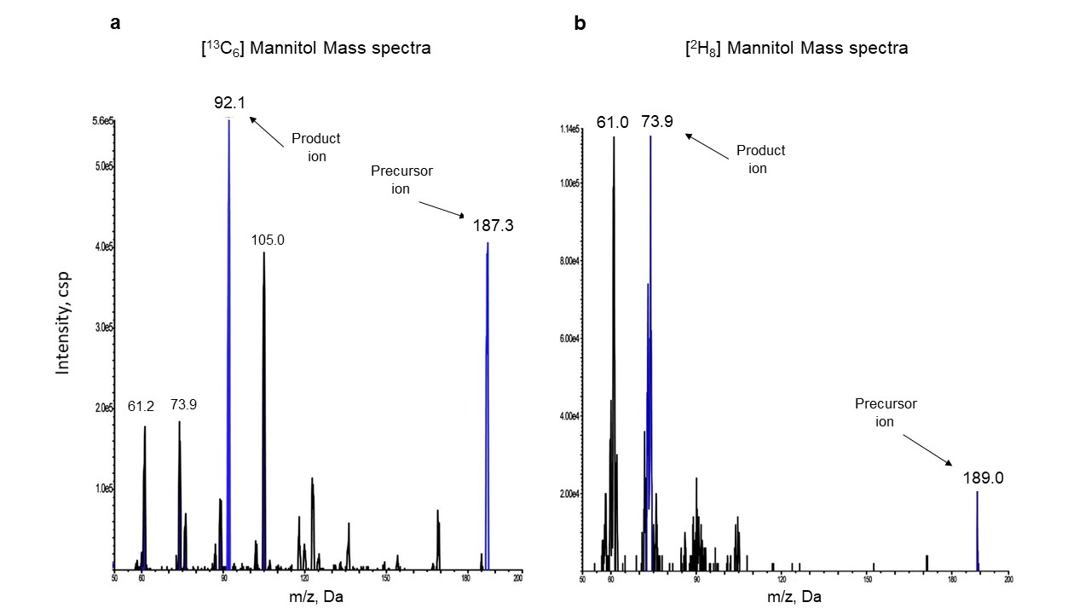
Figure S1: Mass spectra of a) [¹³C₆]mannitol and b) [²H₈]mannitol, demonstrating precursor and product ions considered in the validation. The best m/z transition of stable isotopes of mannitol was selected based on signal to noise ratio and higher sensitivity. The best m/z transition of stable isotopes of mannitol was selected based on signal to noise ratio and higher sensitivity. The transition 187 > 92 of [¹³C₆]mannitol was found to be the best in terms of signal to noise ratio and sensitivity compared to other transitions ( 187>61 and 187> 73). In case of [²H₈]mannitol, the m/z transition of 189> 73 was selected for our study, but the m/z transition of 189 > 61 is also a viable alternative due to the same signal to noise ratio and sensitivity.

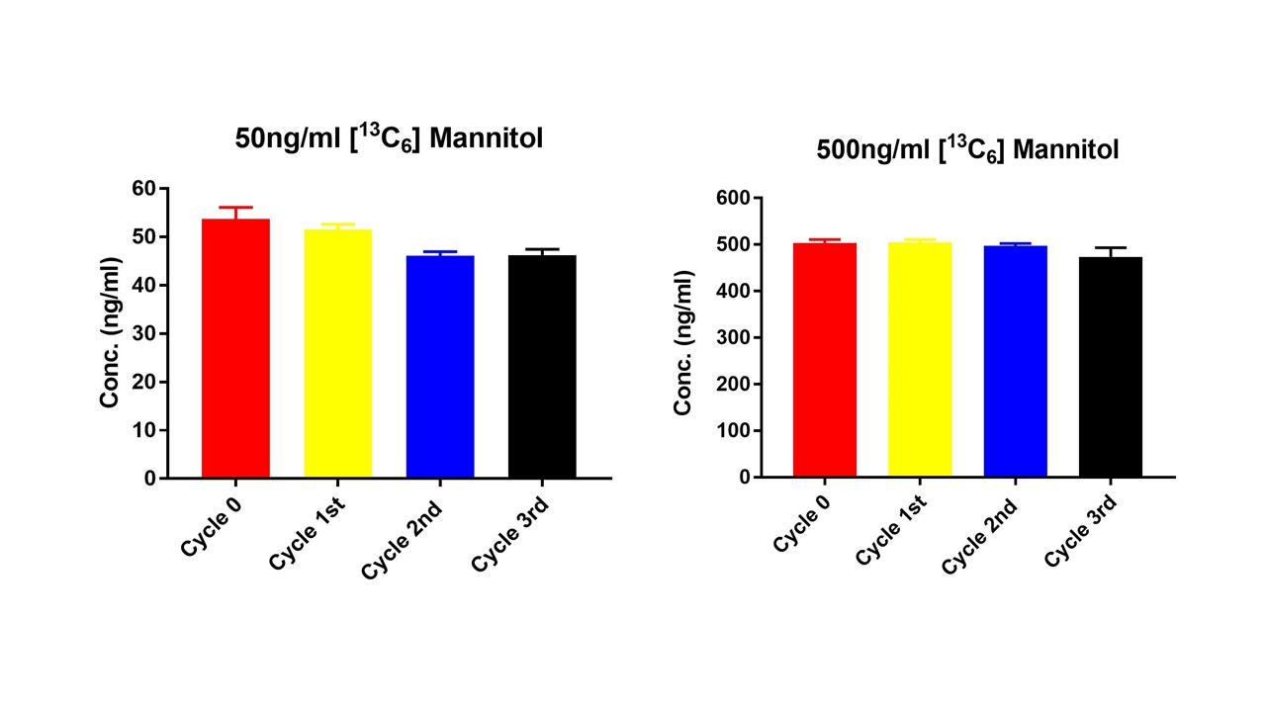
Figure S2: Freeze thaw stability of [¹³C₆] mannitol (n =3). The freeze-thaw stability was performed by subjecting two neat concentrations of analytes (50 and 500 ng/mL) to three freeze/thaw cycles (n=3). Prepared samples were stored at −80 °C and thawed at room temperature for one hour, in order to replicate the experimental conditions. The concentration of the analytes in the neat samples was compared to the standard curve.

Table S1: Inter-run and Intra-run accuracy and precision values of the lowest, middle, and highest concentrations of triple analytes in standard curves for plasma (n=5). The accuracy was calculated as a percentage of measured concentration over nominal concentration. Precision was calculated as a percentage of relative standard deviations (RSD). The acceptable inter and intra-run limits for the accuracy were set at 85–115% for the middle and high concentrations and 80–120% for the low concentration. The standard precision values were 15% (medium and high concentrations) or 20% (low concentration).
Analyte | Added Conc. (ng/ml) | Interday run for plasma |  |  |  | Intra day run of plasma
Analyte | Added Conc. (ng/ml) | Measured Conc.  (ng/ml) | Accuracy (%) | Precision  (RSD %) |  | Measured Conc. (ng/ml) | Accuracy (%) | Precision  (RSD %)
[¹³C₆] Mannitol | 10 | 9.66 | 96.6 | 2.92 |  | 9.67 | 96.7 | 3.23
[¹³C₆] Mannitol | 100 | 101 | 101 | 1.46 |  | 107 | 107 | 1.86
[¹³C₆] Mannitol | 1000 | 938 | 93.8 | 3.34 |  | 982 | 98.2 | 2.83
[¹³C₁₂]sucrose | 10 | 10.1 | 101 | 7.58 |  | 10.7 | 107 | 2.12
[¹³C₁₂]sucrose | 100 | 101 | 101 | 3.34 |  | 99.6 | 99.6 | 2.17
[¹³C₁₂]sucrose | 1000 | 992 | 99.2 | 2.94 |  | 1000 | 100 | 1.99
[13C6]sucrose | 10 | 10.3 | 100 | 5.52 |  | 10.3 | 103 | 2.97
[13C6]sucrose | 100 | 100 | 100 | 2.86 |  | 102 | 102 | 1.73
[13C6]sucrose | 1000 | 987 | 98.7 | 3.32 |  | 1010 | 101 | 1.56

Table S2: Inter-run and Intra-run accuracy and precision values of the lowest, middle, and highest concentrations of triple analytes in standard curves for brain homogenate (n=5)
Analyte | Added Conc. (ng/ml) | Interday run for Brain |  |  |  | Intra day run for Brain
Analyte | Added Conc. (ng/ml) | Measured Conc.  (ng/ml) | Accuracy (%) | Precision  (RSD %) |  | Measured Conc. (ng/ml) | Accuracy (%) | Precision  (RSD %)
[¹³C₆] Mannitol | 5 | 5.00 | 100 | 3.41 |  | 5.20 | 104 | 4.75
[¹³C₆] Mannitol | 50 | 50.5 | 101 | 1.84 |  | 51.1 | 102 | 4.42
[¹³C₆] Mannitol | 400 | 389 | 97.3 | 2.26 |  | 407 | 102 | 1.58
[¹³C₁₂]sucrose | 5 | 4.85 | 97.0 | 2.75 |  | 5.07 | 101 | 3.92
[¹³C₁₂]sucrose | 50 | 51.2 | 102 | 5.08 |  | 52.0 | 104 | 5.33
[¹³C₁₂]sucrose | 400 | 425 | 106 | 4.42 |  | 423 | 106 | 4.24
[13C6]sucrose | 5 | 5.08 | 102 | 8.71 |  | 4.15 | 83.0 | 10.5
[13C6]sucrose | 50 | 49.8 | 99.6 | 4.16 |  | 51.7 | 103 | 5.39
[13C6]sucrose | 400 | 399 | 99.8 | 4.49 |  | 434 | 108 | 4.10

Table S3: Recoveries (mean ± SD) of analytes in a) plasma and b) brain matrix at low, medium and high concentrations(n = 5). Recovery was calculated as the percent of the ratio of peak areas Sample/Reference, where sample refers to the matrix and reference to water (neat sample), respectively.
Added Conc. (ng/ml) | - Analyte (Plasma recovery (%)± SD)
Added Conc. (ng/ml) | [¹³C₆] Mannitol | [¹³C₁₂] sucrose | [¹³C₆] sucrose
10 | 102 ± 3.08 | 96.7 ± 2.25 | 100 ± 3.41
100 | 102 ± 3.72 | 97.3 ± 1.31 | 99.8 ± 1.76
100 | 96.4 ± 2.96 | 99.2 ± 2.57 | 98.8 ± 3.10
Added Conc. (ng/ml) | - Analyte (Brain recovery(%)± SD)
Added Conc. (ng/ml) | [¹³C₆] Mannitol | [¹³C₁₂] sucrose | [¹³C₆] sucrose
5 | 107 ± 5.98 | 101 ± 4.57 | 94.7 ± 1.53
50 | 98.2 ± 4.00 | 102 ± 2.00 | 102 ± 2.66
400 | 94.8 ± 4.12 | 104 ± 4.58 | 103 ± 2.17

