Additional file
Additional file 1: Table S1. Association between all analyzed proteins (expressed in NPX) and groups (iNPH versus C). All 56 analyzed proteins are compared with iNPH and healthy individuals, adjusted for age, sex, and plate.
Protein | log2FC NPH-C | p-value NPH-C |  | q-value NPH-C | p-value Age | p-value Male | p-value Plate
CCL4 | 0.528 (0.225, 0.831) |  | 0.000822 | 0.0356 | 0.0327 | 0.231 | 0.0477
MCP-1 | 0.396 (0.160, 0.632) |  | 0.00127 | 0.0356 | 0.4 | 0.00231 | 0.205
CCL11 | 0.431 (0.160, 0.702) |  | 0.00217 | 0.0405 | 0.0162 | 0.0152 | 0.268
PD-L1 | –0.395 (–0.668, –0.122) |  | 0.00512 | 0.0716 | 0.000202 | 0.886 | 0.0928
FGF-5 | -0.401 (-0.707, -0.094) |  | 0.0109 | 0.122 | 0.000217 | 0.328 | 0.275
TNFSF14 | 0.244 (0.040, 0.449) |  | 0.0199 | 0.186 | 0.306 | 0.626 | 0.404
Beta-NGF | –0.197 (–0.378, –0.015) |  | 0.0343 | 0.218 | 0.000327 | 0.224 | 0.629
IL18 | 0.322 (0.024, 0.619) |  | 0.0347 | 0.218 | 0.149 | 0.0378 | 0.791
CCL3 | 0.331 (0.024, 0.639) |  | 0.0351 | 0.218 | 0.0789 | 0.00431 | 0.0985
CCL19 | –0.516 (–1.008, –0.024) |  | 0.0401 | 0.225 | 0.0408 | 0.00091 | 0.49
MCP-2 | 0.372 (–0.003, 0.747) |  | 0.0518 | 0.245 | 0.147 | 0.0111 | 0.713
Flt3L | 0.210 (–0.005, 0.425) |  | 0.0556 | 0.245 | 0.00401 | 0.031 | 0.666
CCL23 | 0.331 (–0.016, 0.678) |  | 0.0615 | 0.245 | 0.00022 | 0.00589 | 0.387
IL7 | 0.177 (–0.009, 0.364) |  | 0.0622 | 0.245 | 0.00527 | 0.617 | 0.399
DNER | –0.074 (–0.153, 0.005) |  | 0.0656 | 0.245 | 0.00458 | 0.0641 | 0.329
MCP-4 | 0.457 (–0.049, 0.963) |  | 0.0758 | 0.255 | 0.00932 | 0.0316 | 0.427
IL8 | 0.249 (–0.028, 0.525) |  | 0.0773 | 0.255 | 0.173 | 0.122 | 0.803
CCL28 | 0.179 (–0.027, 0.385) |  | 0.0876 | 0.272 | 0.0942 | 0.655 | 0.102
TWEAK | –0.221 (–0.484, 0.043) |  | 0.0997 | 0.289 | 1.83e–05 | 0.788 | 0.318
CXCL11 | 0.389 (–0.084, 0.862) |  | 0.106 | 0.289 | 0.217 | 0.841 | 0.609
CXCL5 | 0.372 (–0.087, 0.832) |  | 0.111 | 0.289 | 0.00823 | 0.179 | 0.526
IL6 | 0.230 (–0.058, 0.519) |  | 0.117 | 0.289 | 0.159 | 0.0092 | 0.36
ADA | –0.243 (–0.550, 0.064) |  | 0.119 | 0.289 | 0.0597 | 0.35 | 0.186
4E-BP1 | 0.283 (–0.105, 0.672) |  | 0.151 | 0.352 | 0.00621 | 0.207 | 0.969
FGF-19 | –0.239 (–0.628, 0.151) |  | 0.226 | 0.499 | 0.00356 | 0.258 | 0.272
TNFB | 0.168 (–0.109, 0.446) |  | 0.232 | 0.499 | 0.0719 | 0.6 | 0.648
CDCP1 | –0.150 (–0.403, 0.103) |  | 0.243 | 0.504 | 0.00409 | 0.894 | 0.497
CD5 | 0.154 (–0.128, 0.436) |  | 0.281 | 0.557 | 0.149 | 0.39 | 0.652
CXCL10 | 0.314 (–0.270, 0.898) |  | 0.288 | 0.557 | 0.277 | 0.318 | 0.817
IL-12B | 0.167 (–0.156, 0.491) |  | 0.307 | 0.574 | 0.122 | 0.514 | 0.983
MMP-1 | 0.289 (–0.298, 0.876) |  | 0.33 | 0.597 | 0.0524 | 0.187 | 0.45
CXCL9 | 0.286 (–0.320, 0.892) |  | 0.351 | 0.599 | 6.94e–05 | 0.306 | 0.636
OPG | 0.137 (–0.154, 0.428) |  | 0.353 | 0.599 | 5.06e–05 | 0.000338 | 0.522
VEGFA | –0.117 (–0.396, 0.161) |  | 0.404 | 0.666 | 0.000585 | 0.341 | 0.22
CXCL1 | 0.130 (–0.202, 0.462) |  | 0.439 | 0.703 | 0.0494 | 0.171 | 0.801
SIRT2 | –0.094 (–0.348, 0.160) |  | 0.462 | 0.719 | 0.00132 | 0.156 | 0.318
HGF | 0.104 (–0.186, 0.395) |  | 0.476 | 0.721 | 0.000143 | 0.487 | 0.849
CSF-1 | –0.067 (–0.271, 0.137) |  | 0.515 | 0.758 | 0.000267 | 0.275 | 0.771
CX3CL1 | –0.099 (–0.408, 0.211) |  | 0.528 | 0.758 | 0.00112 | 0.197 | 0.882
CD40 | –0.075 (–0.338, 0.189) |  | 0.574 | 0.796 | 0.000899 | 0.17 | 0.542
TRAIL | 0.077 (–0.200, 0.353) |  | 0.583 | 0.796 | 0.0324 | 0.323 | 0.69
CD6 | 0.059 (–0.180, 0.299) |  | 0.624 | 0.802 | 0.709 | 0.451 | 0.442
CD8A | 0.096 (–0.310, 0.502) |  | 0.639 | 0.802 | 0.658 | 0.03 | 0.808
TNFRSF9 | –0.061 (–0.334, 0.213) |  | 0.66 | 0.802 | 0.196 | 0.0034 | 0.535
MMP-10 | 0.081 (–0.293, 0.455) |  | 0.668 | 0.802 | 0.0592 | 0.0583 | 0.496
LIF-R | –0.043 (–0.243, 0.157) |  | 0.67 | 0.802 | 0.000574 | 0.12 | 0.433
CD244 | 0.047 (–0.200, 0.294) |  | 0.707 | 0.802 | 0.000123 | 0.00157 | 0.849
CCL25 | 0.045 (–0.203, 0.294) |  | 0.718 | 0.802 | 0.000732 | 5.17e–05 | 0.509
IL-10RB | 0.039 (–0.185, 0.264) |  | 0.729 | 0.802 | 6.78e–05 | 0.0403 | 0.385
CST5 | –0.021 (–0.142, 0.100) |  | 0.73 | 0.802 | 0.289 | 0.0608 | 0.251
uPA | 0.046 (–0.217, 0.309) |  | 0.73 | 0.802 | 0.000391 | 0.347 | 0.699
IL-18R1 | 0.054 (–0.285, 0.392) |  | 0.754 | 0.807 | 0.0345 | 0.684 | 0.964
SCF | –0.042 (–0.321, 0.237) |  | 0.764 | 0.807 | 0.000605 | 0.00804 | 0.961
LAP TGF-beta-1 | –0.019 (–0.433, 0.394) |  | 0.926 | 0.96 | 0.0063 | 0.815 | 0.858
CXCL6 | –0.013 (–0.417, 0.391) |  | 0.95 | 0.967 | 0.0341 | 0.00789 | 0.406
TGF-alpha | –0.004 (–0.214, 0.205) |  | 0.968 | 0.968 | 0.0098 | 0.16 | 0.771

Additional file 1: Figure S1. The four proteins that differ significantly between iNPH and controls.

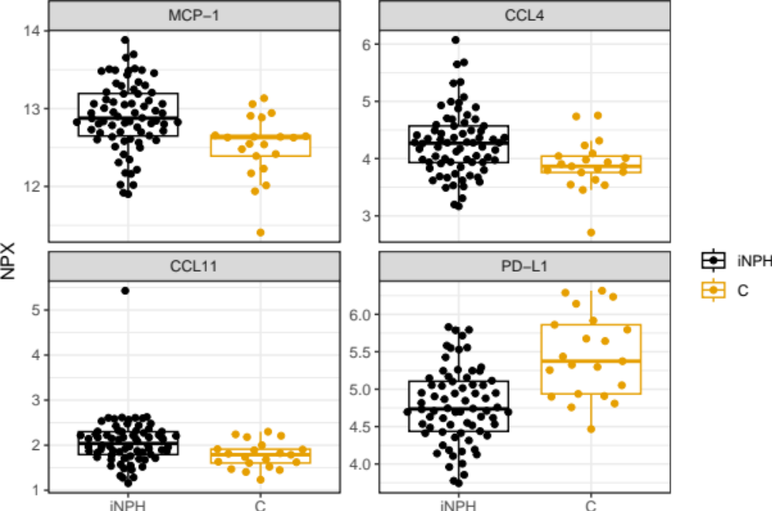

Protein | p.ANOVA | Patient groups | Log₂FC | p-value
CCL11 | 0.181 | NPH-FTD
CCL11 | 0.181 | NPH-AD
CCL11 | 0.181 | NPH-MCI/AD
CCL11 | 0.181 | NPH-MCI
CCL4 | 0.000478 | NPH-FTD | 0.360 (0.701, 0.019) | 0.0389
CCL4 | 0.000478 | NPH-AD | 0.446 (0.722, 0.171) | 0.00169
CCL4 | 0.000478 | NPH-MCI/AD | 0.162 (0.440, –0.116) | 0.252
CCL4 | 0.000478 | NPH-MCI | 0.530 (0.801, 0.259) | 0.000165
MCP-1 | 1.04e–08 | NPH-FTD | 0.310 (0.560, 0.060) | 0.0155
MCP-1 | 1.04e–08 | NPH-AD | 0.563 (0.765, 0.361) | 1.66e-07
MCP-1 | 1.04e–08 | NPH-MCI/AD | 0.487 (0.691, 0.283) | 5.54e–06
MCP-1 | 1.04e–08 | NPH-MCI | 0.467 (0.665, 0.268) | 7.59e–06
PD-L1 | 8.36e–06 | NPH-FTD | –0.388 (–0.106, –0.670) | 0.00743
PD-L1 | 8.36e–06 | NPH-AD | –0.329(–0.101, –0.557) | 0.00494
PD-L1 | 8.36e-06 | NPH-MCI/AD | –0.601 (–0.371, –0.831) | 7.88e–07
PD-L1 | 8.36e–06 | NPH-MCI | –0.129 (0.094, –0.353) | 0.255
Additional file 1: Table S2. Association between the selected proteins and neurodegenerative groups.

Additional file 1: Figure S2. Spearman correlations between the four selected proteins.
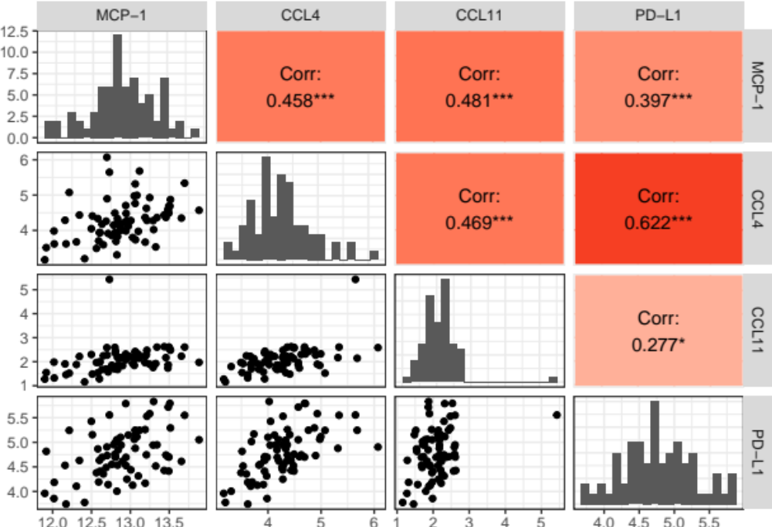

Additional file 1: Figure S3. Spearman correlations between the four selected proteins.
