Supplementary Data

Figure S1: Uncropped results from Western blot of the ZO-1, Occludin, Claudin-1 and actin proteins from Fig. 2D with molecular weight marker (Page ruler prestained protein ladder, 10-180 kDa #11822124).

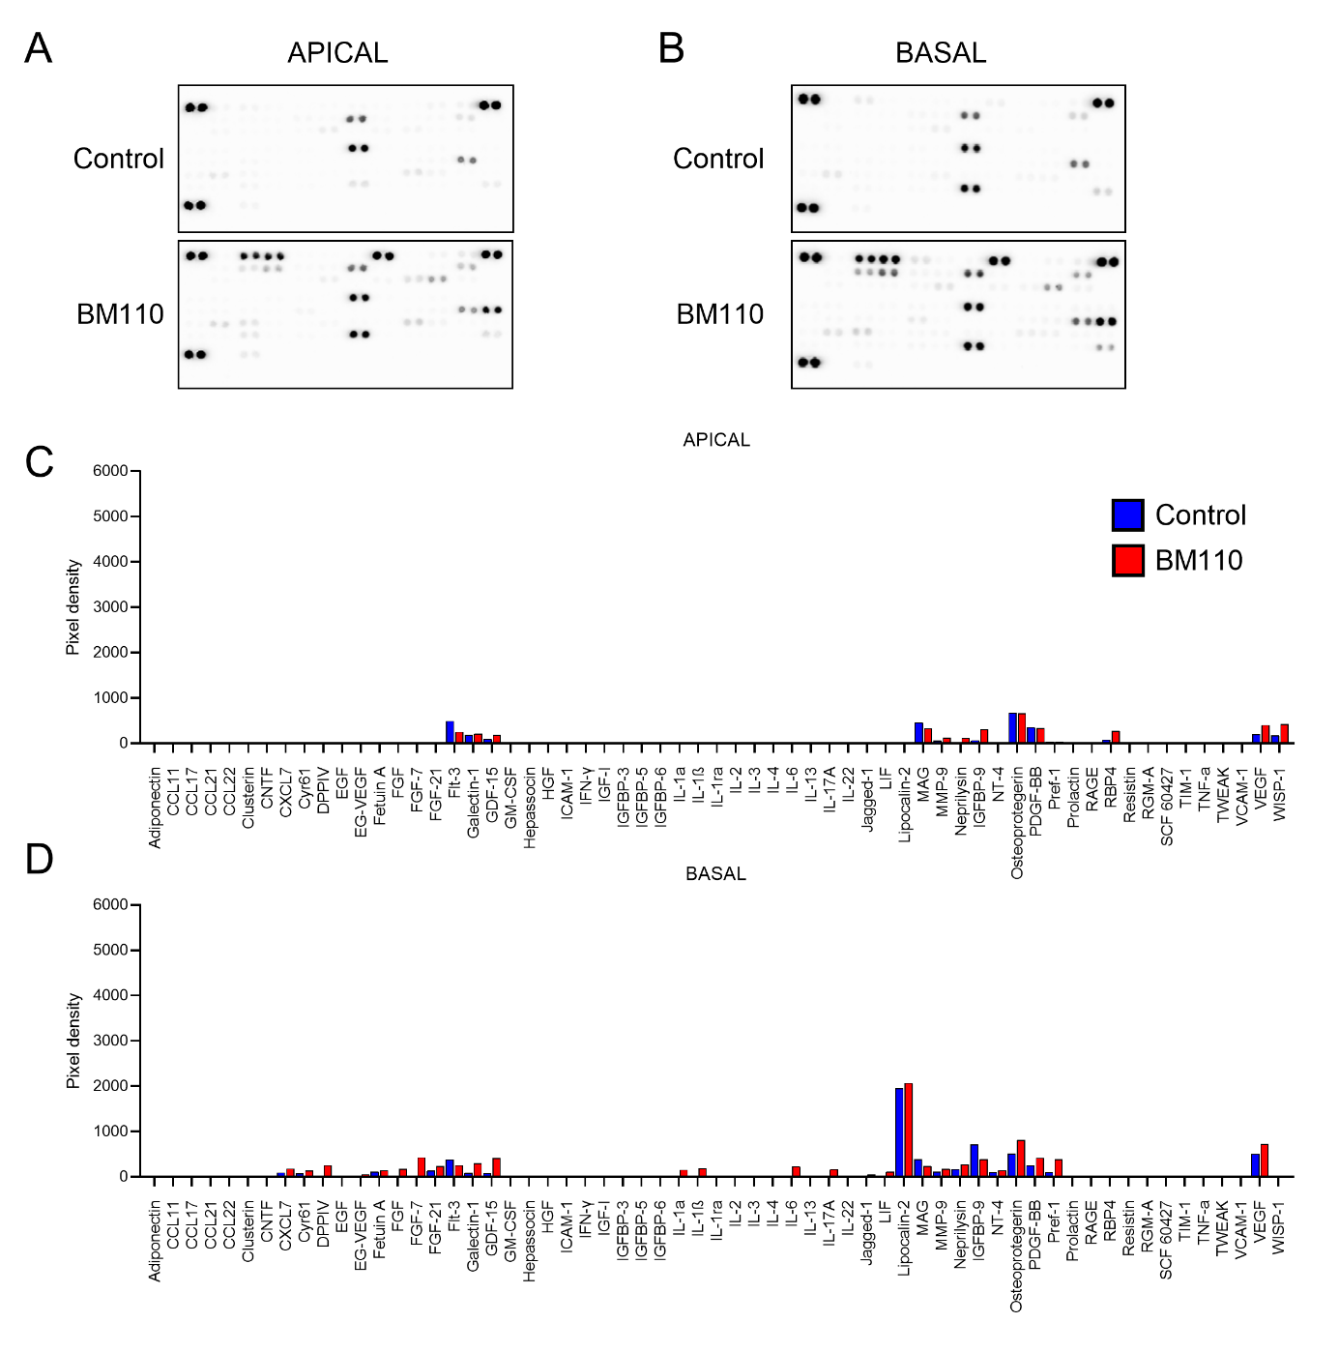
Figure S2: Cytokine array of neonatal primary CPEC following GBS infection.
Apical (A, C) and basal (B, D) culture supernatants from infected primary CPEC were collected and analyzed for the differential expression of 79 secreted cytokines associated with GBS infection. (A, B) Results of the membrane cytokines array and (C, D) pixel intensity quantitative analysis for unchanged molecules.

Supplementary Video S1: Extravascular localisation of a bacterium in the choroid plexus
A three-week old mouse was infected intravenously with a GBS strain (BM110) and then sacrificed by extensive intracardiac perfusion to remove blood from the circulation. Clarified brain slices (500 μm) were immunostained for bacteria (green, GBS), blood vessels (red, CD31), CPEC (blue, TTR). The three-D reconstruction was generated using Imaris-based isosurface rendering of 3D reconstructed confocal z-stack of the choroid plexus. The video shows the volume and surface reconstruction for each fluorescent channel allowing visualization of the extravascular localisation of a bacterium (stromal localisation). Bacteria (green), blood vessels (red), CPEC (blue).
Supplementary Video S2: Bacterial egress from the apical side of CPEC
A three-week old mouse was infected intravenously with a GBS strain (BM110) and then sacrificed by extensive intracardiac perfusion to remove blood from the circulation. Clarified brain slices (500 μm) were immunostained for bacteria (green, GBS), blood vessels (red, CD31), CPEC (blue, TTR). The three-D reconstruction was generated using Imaris-based isosurface rendering of 3D reconstructed confocal z-stack of the choroid plexus. The video shows the release of bacterium from the apical side of CPEC into the ventricular space. Bacteria (green), blood vessels (red), CPEC (blue).
Supplementary Video S3: Presence of bacteria in the ventricular space of choroid plexus
A three-week old mouse was infected intravenously with a GBS strain (BM110) and then sacrificed by extensive intracardiac perfusion to remove blood from the circulation. Clarified brain slices (500 μm) were immunostained for bacteria (green, GBS), blood vessels (red, CD31), CPEC (blue, TTR). The three-D reconstruction was generated using Imaris-based isosurface rendering of 3D reconstructed confocal z-stack of the choroid plexus. The video shows the presence of bacteria in the ventricular space. Bacteria (green), blood vessel (red), CPEC (blue).

