Supplementary Information
Isolation Method of Brain Microvessels from Small Frozen Human Brain Tissue for Blood-Brain Barrier Protein Expression Analysis

Seiryo Ogata^{1,2}, Shingo Ito^{1,3}*, Takeshi Masuda^{1,3,4}, Sumio Ohtsuki^{1,3}

¹Department of Pharmaceutical Microbiology, Graduate School of Pharmaceutical Sciences, Kumamoto University, 5-1 Oe-honmachi, Chuo-ku, Kumamoto 862-0973, Japan
²Department of Environmental Medicine and Molecular Toxicology, Tohoku University Graduate School of Medicine, 2-1 Seiryo-machi, Aoba-ku, Sendai 980-8575, Japan
³Department of Pharmaceutical Microbiology, Faculty of Life Sciences, Kumamoto University, 5-1 Oe-honmachi, Chuo-ku, Kumamoto 862-0973, Japan
⁴Institute for Advanced Biosciences, Keio University, Nipponkoku 403-1, Daihouji, Tsuruoka, Yamagata 997-0017, Japan

*Corresponding author:
Shingo Ito, PhD
Department of Pharmaceutical Microbiology, Faculty of Life Sciences, Kumamoto University, 5-1 Oe-honmachi, Chuo-ku, Kumamoto 862-0973, Japan
TEL: +81-96-371-4323; FAX: +81-96-371-4327; E-mail: ishingo@kumamoto-u.ac.jp

Supplementary tables

Table S1. Methods and brain weights used for brain capillary isolation from the human brain tissues for protein expression analysis.

Author | Brain  condition | Region | Used brain  weight | Homogenize | Density  gradient | Purification
Uchida et al. [13] | Frozen | Cortex | 1.0–3.2 g | Mince, Potter homogenizer | Dextran | Capture on the 45 µm mesh
Uchida et al. [12] | Frozen | Frontal  cortex | 5.23–5.57 g | Mince, Potter homogenizer | Dextran | 210 µm mesh  → glass beads
Zubida et al. [15] | Frozen | Frontal  cortex | 3 g | Mince, Potter homogenizer | Dextran | Capture on the 20 µm mesh
Hartz et al. [14] | Fresh | Frontal  cortex | 10 g | Mince, Potter homogenizer  + Dounce homogenizer | Ficoll | 300 µm mesh → capture on the 30 µm mesh
Wakid et al. [16] | Frozen | Prefrontal cortex | 100 mg | Agitation, Semi-automated dissociation | Sucrose | -

Table S2. Donor information.
Donor no. | Sex | Age  (years) | Race | Brain region | Post mortem  interval (h) | Cause of death
1 | Male | 42 | Caucasian | Frontal cortex | 3 | Electrocution
2 | Male | 40 | Caucasian | Frontal cortex | 3 | Electrocution
3 | Male | 35 | Caucasian | Frontal cortex | 4 | Mechanical asphyxia  during strangulation
4 | Male | 40 | Caucasian | Frontal cortex | 4 | Stab injuries of the chest

Table S3. Peptide probes and MRM transitions of human molecules.
Protein | Amino  acid sequence | Unlabeled peptide (m/z) |  |  |  |  | Labeled peptide (m/z)
 |  | Q1 | Q3-1 | Q3-2 | Q3-3 | Q3-4 | Q1 | Q3-1 | Q3-2 | Q3-3 | Q3-4
ABCB1 (MDR1) | NTTGALTTR | 467.8 | 377.2 | 490.3 | 618.4 | 719.4 | 471.3 | 377.2 | 497.3 | 625.4 | 726.4
ABCG2 (BCRP) | SSLLDVLAAR | 522.8 | 529.3 | 430.3 | 757.5 | 644.4 | 526.3 | 536.4 | 437.3 | 764.5 | 651.4
SLC2A1 (GLUT1) | TFDEIASGFR | 571.8 | 894.4 | 650.4 | 537.3 | 249.1 | 573.8 | 898.4 | 654.4 | 541.3 | 249.1
SLC16A1 (MCT1) | SITVFFK | 421.2 | 201.1 | 441.2 | 540.3 | 641.4 | 426.3 | 201.1 | 451.3 | 550.3 | 651.4
TfR1 | SGVGTALLLK | 479.8 | 244.1 | 658.4 | 715.5 | 407.8 | 483.3 | 244.1 | 665.5 | 722.5 | 411.3
Claudin-5 | EFYDPSVPVSQK | 698.3 | 277.1 | 558.3 | 421.2 | 841.5 | 701.4 | 277.1 | 564.3 | 424.2 | 847.5
Na⁺/K⁺-ATPase | AAVPDAVGK | 414.2 | 374.2 | 685.4 | 242.1 | 586.3 | 417.2 | 380.3 | 691.4 | 242.1 | 592.3
MRM, multiple reaction monitoring; ABCB1, ATP-binding cassette subfamily B member 1; MDR1, multidrug resistance 1; ABCG2, ATP binding cassette subfamily G member 2; BCRP, breast cancer resistance protein; SLC2A1, solute carrier family 2 member 1; GLUT1, glucose transporter protein type 1; SLC16A1, solute carrier family 16 member 1; MCT1, monocarboxylate transporter 1; TfR1, transferrin receptor 1

Table S4. Proteome data of the proteins identified only in the brain microvessel fraction.

Table S5. Proteome data of the proteins identified only in the whole brain lysate fraction.

Table S6. Proteome data of the proteins identified in the both brain microvessel fraction and whole brain lysate fraction.
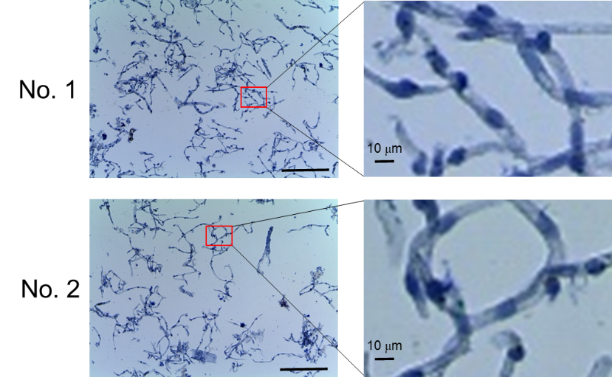
Figure S1. Magnified images of the human brain microvessel.
Magnified images of donor No. 1 and No. 2 shown in Fig. 1B are shown. Scale bar = 250 µm (left images) and 10 µm (right images).

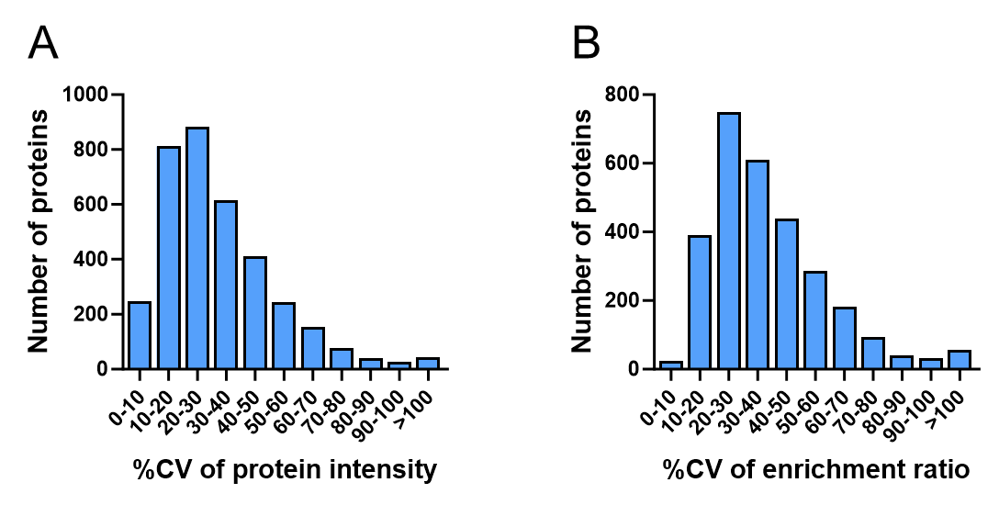

Figure S2. Enrichment and reproducibility of brain capillary isolation from human frozen brain.
(A) Histogram of the coefficient of variance (%CV) of protein intensities of 3548 proteins detected in the brain microvessel fractions (n = 4). (B) Histogram of the %CV of the brain microvessel fraction-whole brain lysate enrichment ratios of 2899 proteins detected in both brain microvessel fractions and whole brain lysates (n = 4).

