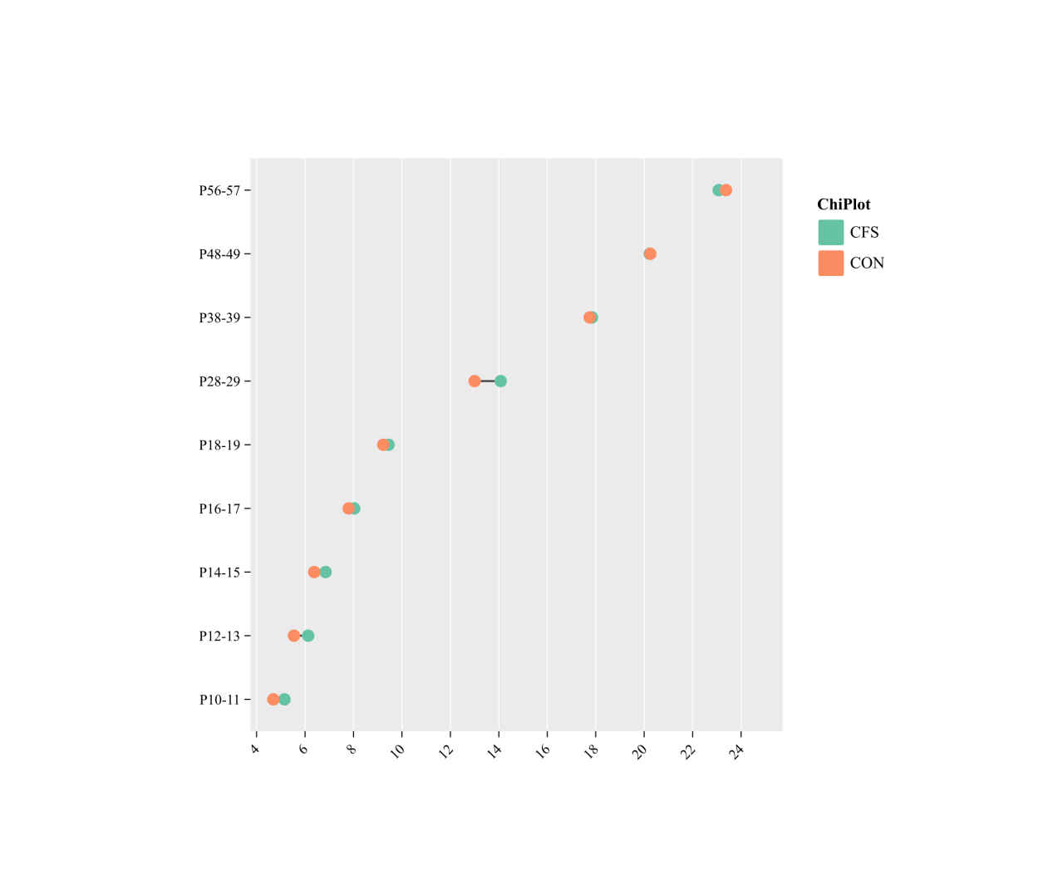

Figure S1.Body weight changes in hot air-induced CFS model and control mice

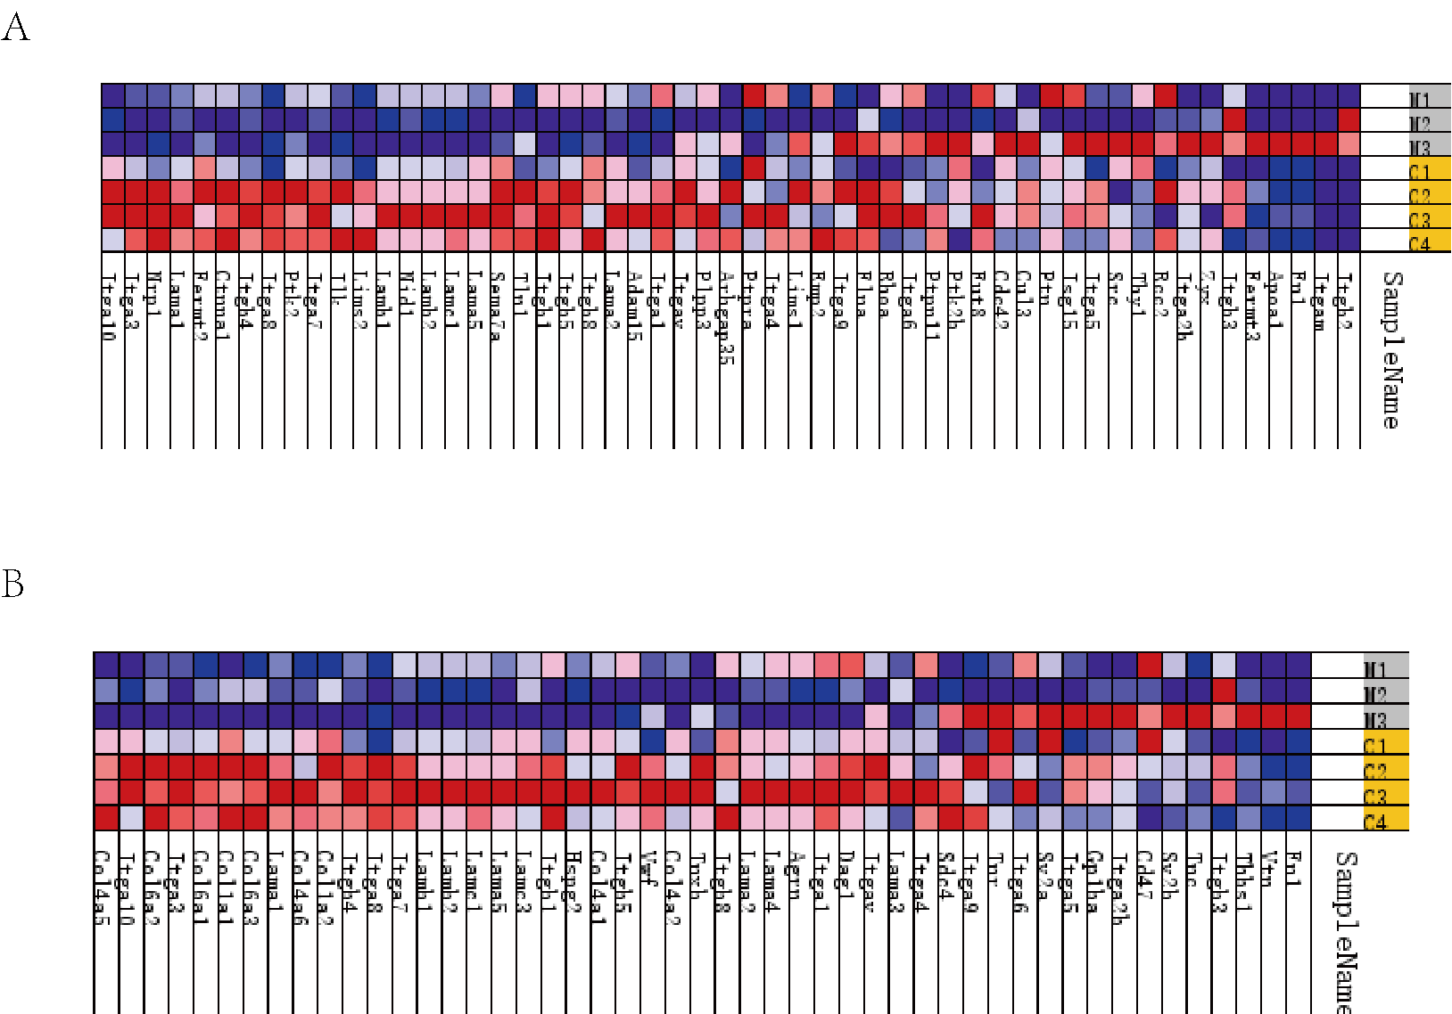
Figure S2 Changes in expression of proteins enriched for ECM-receptor interaction and integrin-mediated signaling pathway
- Expression changes of proteins enriched for integrin-mediated signaling pathway
- Expression changes of proteins enriched for ECM-receptor interaction

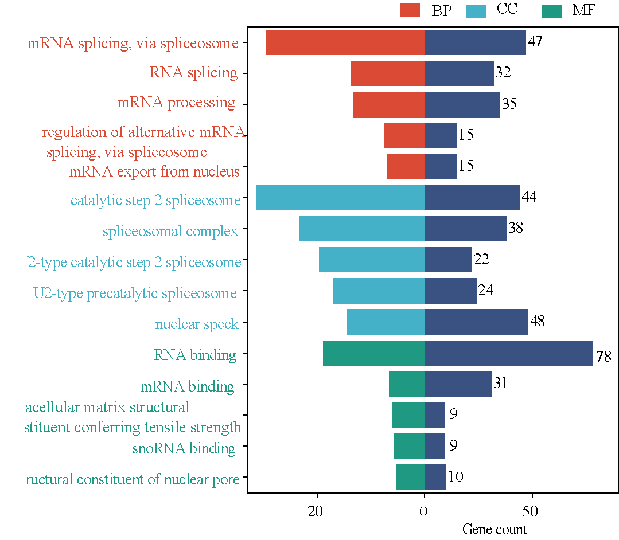
Figure S3 GO analysis of all DEPs in CFS mice

