1. Relationship between GBCA concentration in the fluid estimated from cDSC MRI signal changes and the fluid T1 and T2 values without GBCA used in the conversion

In order to convert GBCA induced fluid signal changes measured in cDSC MRI to GBCA concentration in the fluid, the T1 and T2 values of fluid without GBCA need to be determined (1). For intracranial CSF, literature values are adopted (1). However, the T1 and T2 values of CSF-like fluids in the extracranial olfactory regions (interstitial and lymphatic fluids, nasal glandular and mucosal secretions) can be significantly shorter than those of intracranial CSF. Here, simulations are performed using the cDSC MRI equations derived in our previous work (1) and the imaging parameters applied in the current study to demonstrate the relationship between GBCA concentration in the fluid estimated from cDSC MRI signal changes and the fluid T1 and T2 values used in the conversion.

Figure S1 shows the estimated GBCA concentration ([Gd]) from cDSC signal changes (ΔS/S) as functions of T1 and T2 values of the fluid used in the conversion. Four cDSC ΔS/S levels (-10%, -20%, -30%, -40%) corresponding to the range of cDSC ΔS/S measured in our data were simulated. For a given ΔS/S measured in cDSC MRI, the estimated GBCA concentration increases with the fluid T1 values used in the conversion. This means that if the T1 of CSF-like fluid is shorter than intracranial CSF T1, the GBCA concentration in CSF-like fluid can be overestimated using the current algorithm, which assumes intracranial CSF T1 and T2 for all fluids. The fluid T2 values showed minimal effects on the GBCA concentration estimated from cDSC signal changes.

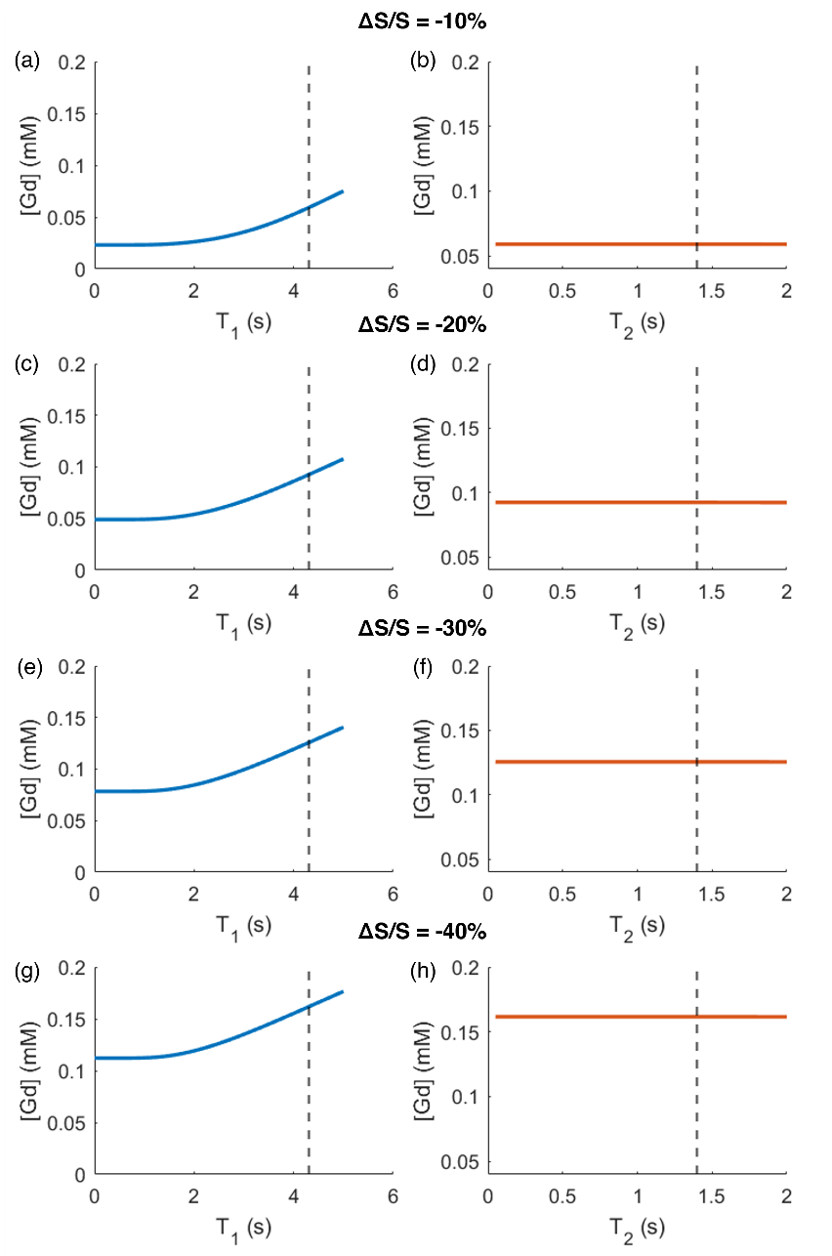
Figure S1: Relationship between the estimated GBCA concentrations ([Gd]) in the fluid from cDSC signal changes (ΔS/S) and T1 and T2 values of the fluid. (a,b) cDSC ΔS/S = -10%; (c,d) cDSC ΔS/S = -20%; (e,f) cDSC ΔS/S = -30%; (g,h) cDSC ΔS/S = -40%. Intracranial CSF T1 = 4310 ms and T2 = 1400 ms at 3T (marked with vertical dashed lines) are adopted from literature (1). The T1 and T2 values of CSF-like fluids in the extracranial regions are expected to be shorter. In (a,c,e,g), the fluid T2 value was fixed at intracranial CSF T2 in the simulations. In (b,d,f,h), the fluid T1 value was fixed at intracranial CSF T1 in the simulations.

2. Relationship between the GBCA induced fluid signal changes in T1-weighted MR images and fluid T1 and T2 values without GBCAs

The T1-weighted Black Blood (T1-BB) MRI sequence was employed as the primary measure in a seminal work from Melin et al (2) investigating CSF efflux to nasal mucosa in humans using intrathecal GBCA based MRI methods. They found significant GBCA enhancement in the olfactory bulb and straight gyrus regions superior to the cribriform plate, but very limited GBCA enhancement in the nasal mucosa regions inferior to the cribriform plate. We hypothesize that, for a given GBCA concentration in the fluid, the GBCA induced signal change in the fluid measured in T1-weighted MR images (ΔS/S) can be substantially influenced by the T1 and T2 values of the fluid without GBCA. Here, Bloch simulations were performed to examine this relationship in a typical T1-BB MRI sequence used on our Philips 3T scanners with the following parameters:
3D turbo spin echo (TSE) readout, TR/TE = 700/35 ms, echo spacing (ES) = 5.0 ms, echo train length (ETL)/TSE factor = 55, flip angle = 80°, voxel = 0.75 mm isotropic, field of view (FOV) = 200×251 mm², 341 slices, sequence duration = 4 minutes 36 seconds.
The imaging parameters are matched with the known parameters in the T1-BB MRI sequence used in Melin et al. (2), which was also performed on a Philips 3T MRI scanner.

Figure S2 shows the GBCA induced fluid signal changes in T1-BB MRI (ΔS/S) as functions of T1 and T2 values of the fluid, respectively. Four GBCA concentration levels ([Gd] = 0.05, 0.1, 0.25, 0.5 mM) corresponding the range of fluid [Gd] measured in Melin et al. (2) were simulated. For a given [Gd] in the fluid, T1-BB ΔS/S increases with the fluid T1. This means that if the T1 of CSF-like fluid is shorter than intracranial CSF T1, the T1-BB ΔS/S measured in CSF-like fluid is expected to be smaller than that in intracranial CSF. The fluid T2 values showed a similar but much smaller effect on T1-BB ΔS/S.
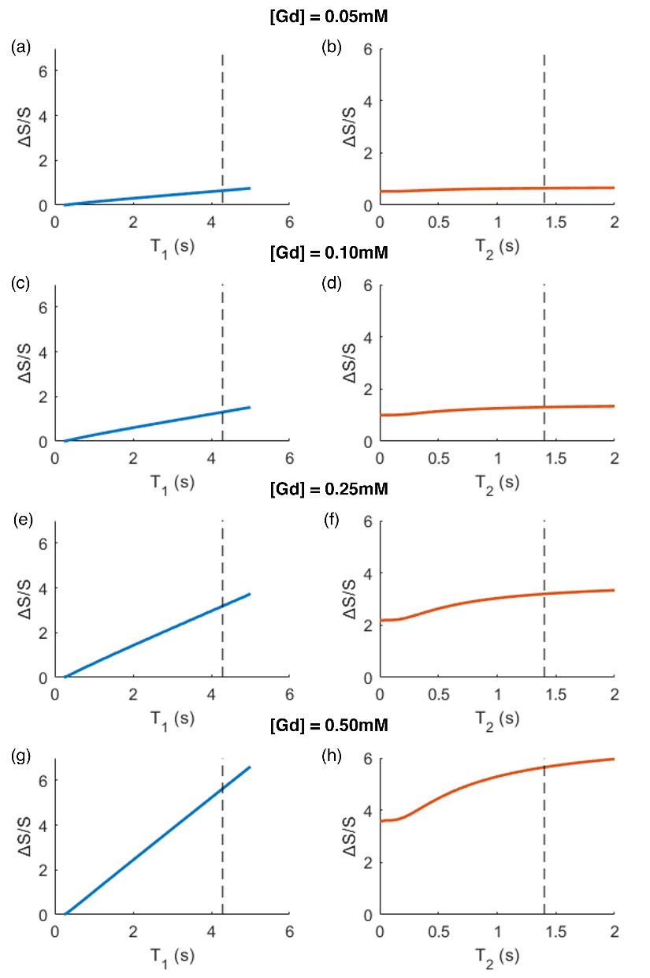

Figure S2: Relationship between the GBCA induced fluid signal changes in T1-BB MRI (ΔS/S, %) and T1 and T2 values of the fluid. (a,b) [Gd] = 0.05 mM; (c,d) [Gd] = 0.1 mM; (e,f) [Gd] = 0.25 mM; (g,h) [Gd] = 0.5 mM. Intracranial CSF T1 = 4310 ms, T2 = 1400 ms at 3T (marked as dotted line) are adopted from literature (1). The T1 and T2 values of CSF-like fluids in the extracranial regions are expected to be shorter. In (a,c,e,g), the fluid T2 value was fixed at intracranial CSF T2 in the simulations. In (b,d,f,h), the fluid T1 value was fixed at intracranial CSF T1 in the simulations.

References
1. Cao D, Kang N, Pillai JJ, Miao X, Paez A, Xu X, et al. Fast whole brain MR imaging of dynamic susceptibility contrast changes in the cerebrospinal fluid (cDSC MRI). Magn Reson Med. 2020;84(6):3256–70.
2. Melin E, Eide PK, Ringstad G. In vivo assessment of cerebrospinal fluid efflux to nasal mucosa in humans. Sci Rep. 2020 Sep 11;10(1):14974.

