SUPPLEMENTARY FIGURES
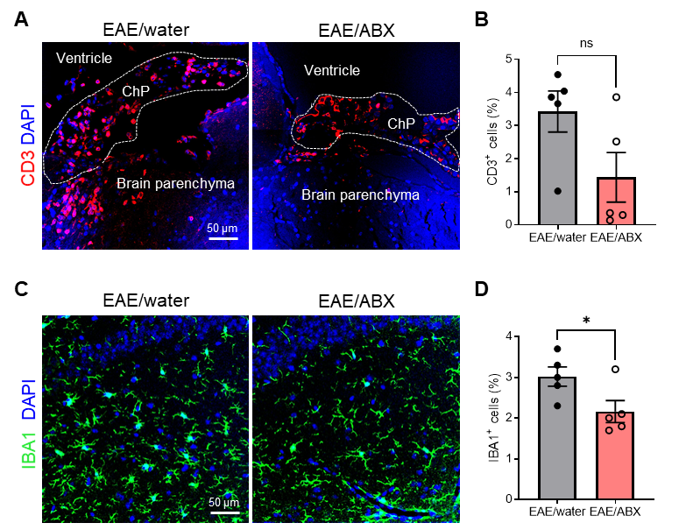
Supplementary Figure S1. CD3⁺ and IBA1⁺ cells in the brain of ABX treated and control treated EAE mice. (A) Representative images of CD3 staining on brain. Scale bar 50 µm. (B) Quantification CD3⁺ cells in brain tissue (n = 5). (C) Representative images of IBA1 staining on brain. Scale bar 50 µm. (D) Quantification IBA1⁺ cells brain tissue (n = 5). Datapoints represent mean ± SEM. Statistical analysis was performed with unpaired t-test (*p < 0.05; ns: not significant). ABX, antibiotics; EAE, experimental autoimmune encephalomyelitis.
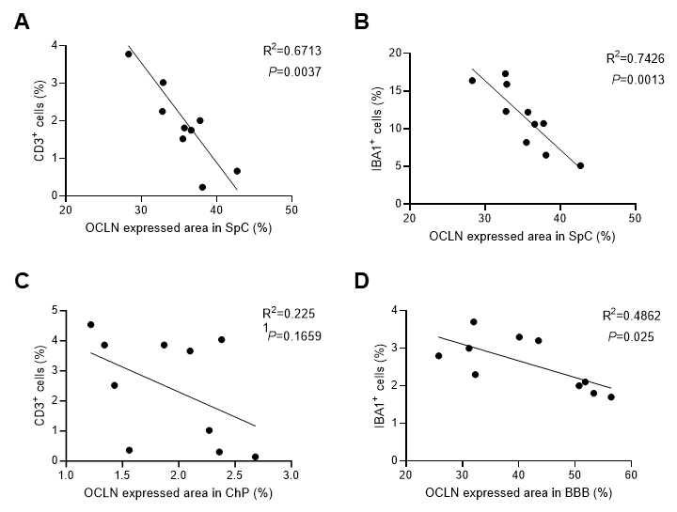
Supplementary Figure S2. Pearson correlation analysis of TJ expression in CNS barriers and immune cell infiltration. (A-B) The relationship between OCLN expression and % CD3⁺ cells of all nuclei (A) and IBA1⁺ cells (B) in spinal cord. (C) The relationship between OCLN expression and % CD3⁺ cells of all nuclei in blood-CSF barrier. (D) The relationship between OCLN expression and IBA1⁺ cells in BBB. OCLN, occludin; SpC, spinal cord; TJ, tight junction.
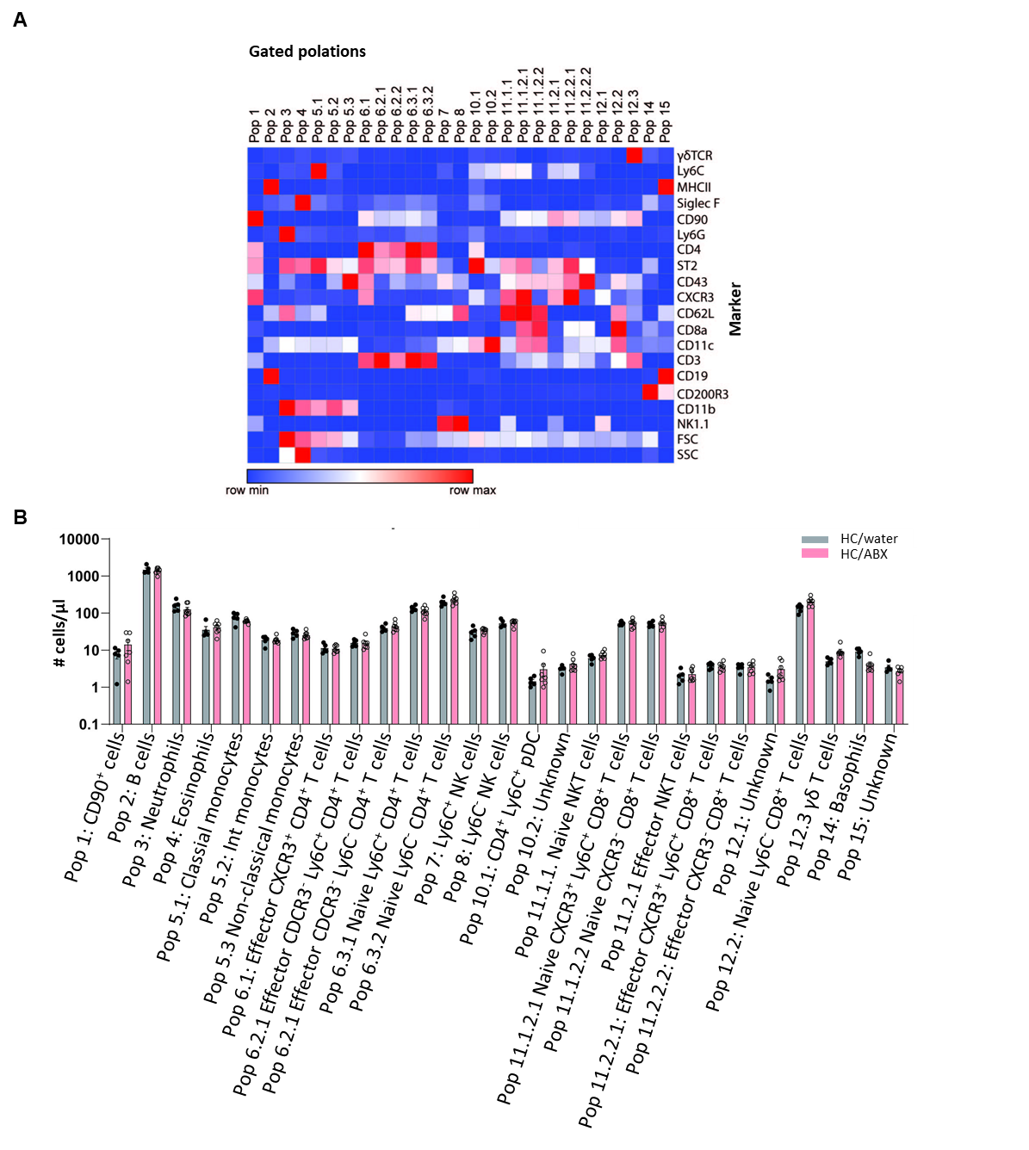
Supplementary Figure S3. Immunophenotyping of the blood from ABX treated and control treated mice. Unsupervised flow cytometry analysis of single CD45⁺ immune cells derived from blood samples of mice receiving antibiotics (ABX) in their drinking water for two weeks compared to those that receiving regular water. (A) Identification of different immune cell population based on marker expression. (B) Absolute number of cells/µl blood for each identified immune cell population. Data presented as mean ± SEM (n = 7/group). Statistical analysis by two-way ANOVA with Tukey post hoc multiple comparison.
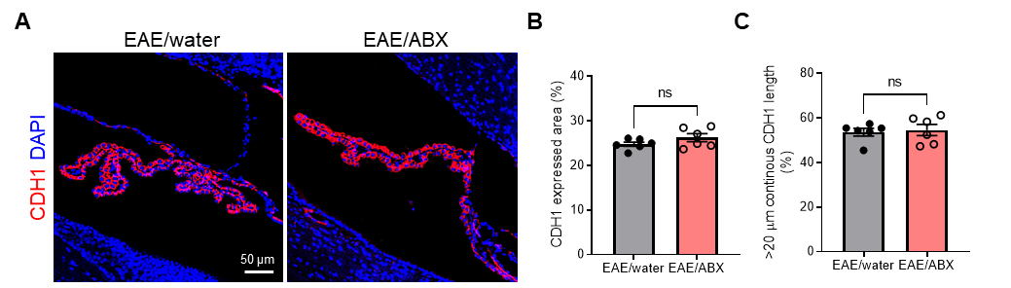Supplementary Figure S4. The impact of gut microbiota on blood-CSF barrier in EAE mice. (A) Representative images of CDH1 staining on ChP. Scale bar 50 µm. (B-C) Quantification CDH1 expressed area (B) and CDH1 continuous length of > 20 µm (C) in ChP (n = 6). Datapoints represent mean ± SEM. Statistical analysis was performed with unpaired t-test (ns: not significant). ABX, antibiotics; EAE, experimental autoimmune encephalomyelitis; OCLN, Occludin; CDH1, E-cadherin.
Supplementary Figure S5. The impact of FMT on blood-CSF barrier in healthy mice. (A) Representative images of CDH1 staining on ChP. Scale bar 50 µm. (B-C) Quantification CDH1 expressed area (B) and CDH1 continuous length of > 20 µm (C) in ChP (n = 4). Datapoints represent mean ± SEM. Statistical analysis was performed with unpaired t-test (ns: not significant). CDH1, E-cadherin; ChP, choroid plexus; CSF, cerebrospinal fluid; FMT, fecal microbiome transplant.
Supplementary Figure S6. The influence of FMT on microbiome composition of the recipient mice. Microbiome composition before (grey dots) and after FMT (pink dots) in EAE recipients which received fecal material from EAE donor mice or Ctr donor mice. EAE, experimental autoimmune encephalomyelitis; FMT, fecal microbiota transfer; Ctr, healthy control.
Supplementary Figure S7. The impact of FMT on blood-CSF barrier in EAE mice. (A) Representative images of CDH1 staining on ChP. Scale bar 50 µm. (B-C) Quantification CDH1 expressed area (B) and CDH1 continuous length of > 20 µm (C) in ChP (n = 6). Datapoints represent mean ± SEM. Statistical analysis was performed with unpaired t-test. CDH1, E-cadherin; ChP, choroid plexus; CSF, cerebrospinal fluid; EAE, experimental autoimmune encephalomyelitis; FMT, fecal microbiome transplant.
Supplementary Figure S8. The impact of gut microbiota on the populations of CD3⁺ and IBA1⁺ cells in the brain and spinal cord of EAE mice receiving a fecal microbiota transplant (FMT) from EAE or Ctr mice. (A-B) Representative images (A) of CD3 staining (red) on brain sections and the corresponding quantification (B) (n = 6). Scale bar represents 50 µm. (C) Pearson correlation analysis of OCLN expression and CD3⁺ cells at the blood-CSF barrier. (D-E) Representative images of IBA1 (green) on brain sections (D) and the corresponding quantification (E) (n = 6). Scale bar represents 50 µm. (F) Pearson correlation analysis of OCLN expression and IBA1⁺ cells at the BBB. (G-H) Representative images (G) of CD3 staining (red) and corresponding quantification of the amount of CD3⁺ cells (H) on spinal cord sections (n = 6). Scale bar represents 50 µm. (I) Pearson correlation analysis of OCLN expression and CD3⁺ cells in spinal cord. (J-K) Representative images (J) of IBA1 staining (green) and corresponding quantification of IBA1 + cells on spinal cord sections (n = 6). Scale bar 50 µm. (L) Pearson correlation analysis of OCLN expression and IBA1⁺ cells in spinal cord. Datapoints represent mean ± SEM. Statistical analysis was performed with unpaired t-test (ns: not significant). BBB, blood-brain barrier; ChP, choroid plexus; EAE, experimental autoimmune encephalomyelitis; Ctr, healthy controls; OCLN, occluding; SpC, spinal cord.
Supplementary Figure S9. The levels SCFA producing bacteria and SCFA in fecal pellets of EAE mice. (A) qPCR analysis of the gut microbiota of healthy control (Ctr) and experimental autoimmune encephalomyelitis mice (EAE) reveal a decrease in relative Firmicutes to Bacteroides ratio in EAE mice compared to Ctr. (B-C) Fecal propionic acid (B) and butyric acid (C). Datapoints represent mean ± SEM. Statistical analysis was performed with unpaired t-test (n = 5; one section per mouse). (*p < 0,05; ns: not significant). EAE, experimental autoimmune encephalomyelitis; Ctr, healthy control; SCFA, short-chain fatty acids.
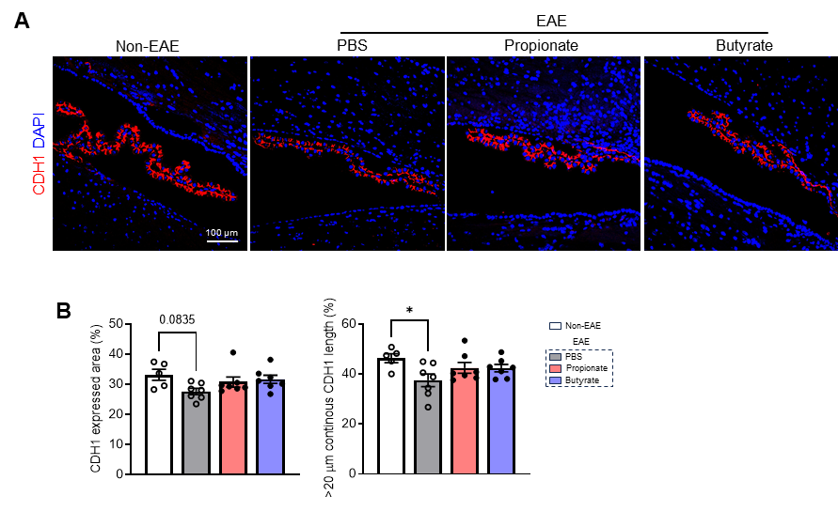
Supplementary Figure S10. The impact of SCFA on blood-CSF barrier in EAE mice. (A) Representative images of CDH1 staining on ChP. Scale bar 50 µm. (B) Quantification CDH1 expressed area (left) and CDH1 continuous length of > 20 µm (right) in ChP (n = 5–7). Datapoints represent mean ± SEM. Statistical analysis was performed with one-way ANOVA followed by Tukey post hoc test. CDH1, E-cadherin; ChP, choroid plexus; CSF, cerebrospinal fluid, EAE, experimental autoimmune encephalomyelitis; SCFA, short-chain fatty acid.
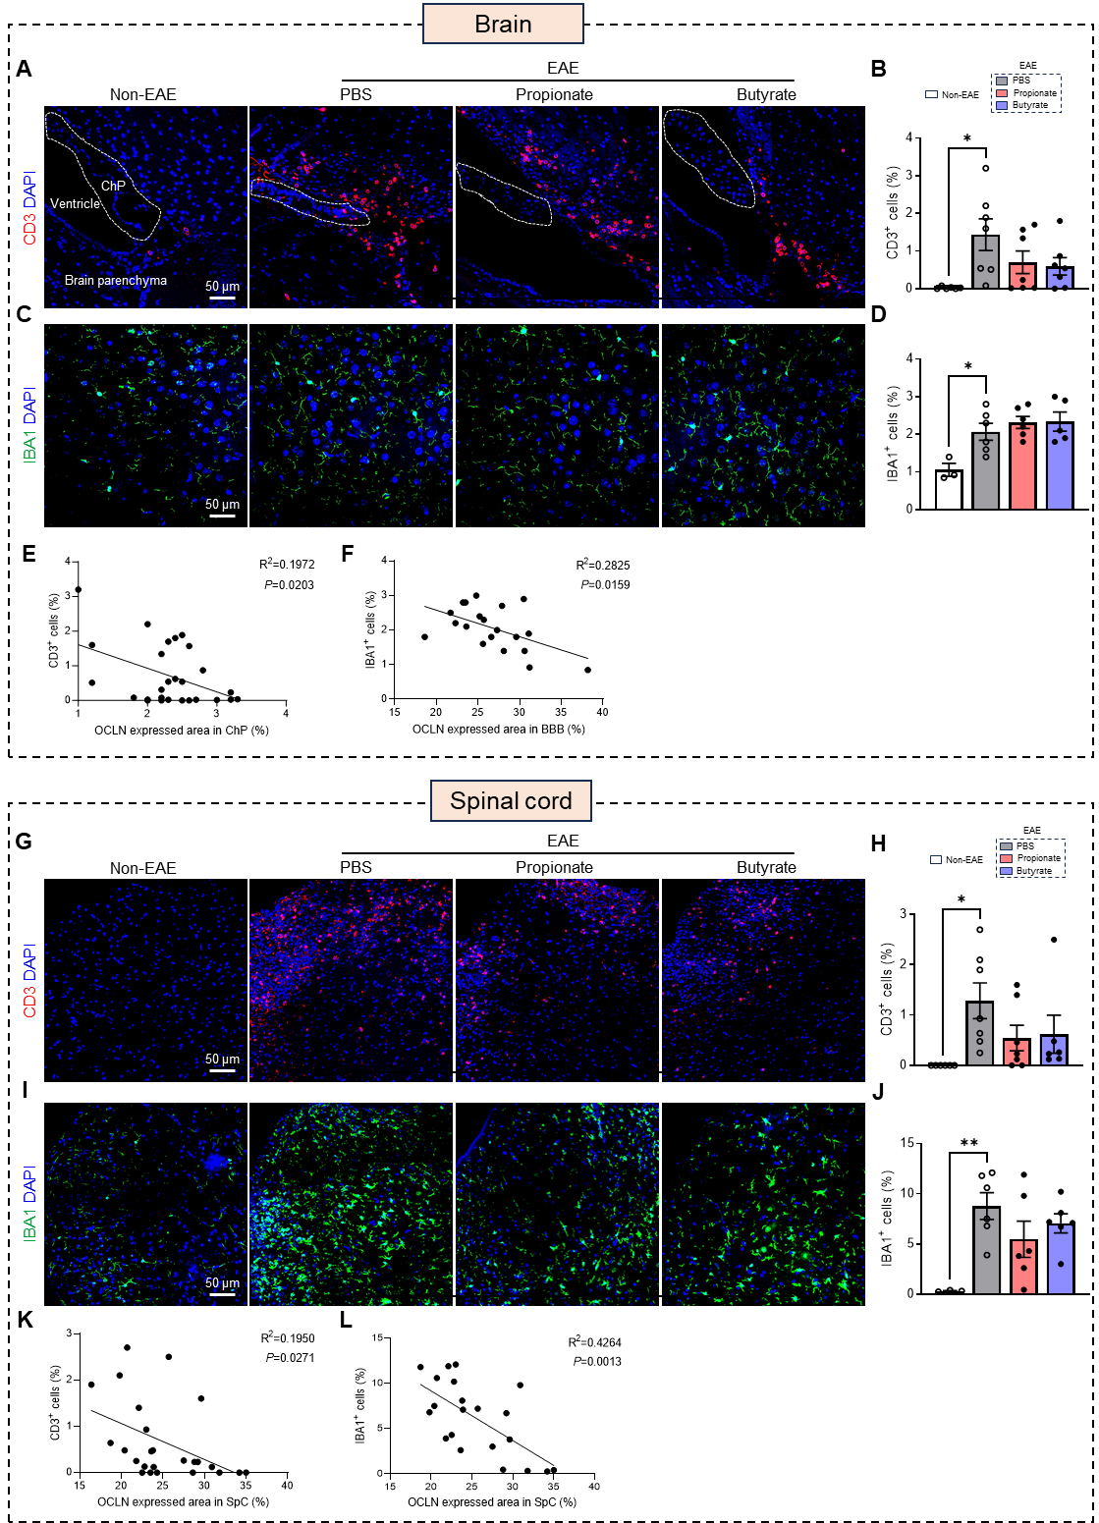
Supplementary Figure S11. The impact of the SCFAs propionate and butyrate on the populations of CD3⁺ and IBA1⁺ cells in the brain and spinal cord of EAE mice. (A-B) Representative images of CD3 (red) staining (A) and quantification (B) of the CD3⁺ cells in brain sections (n = 6–7). Scale bar represents 50 µm. (C-D) Representative images of IBA1 (green) staining (C) and quantification (D) of the amount IBA1⁺ cells in brain sections (n = 3–6). Scale bar represents 50 µm. (E) Pearson correlation analysis of OCLN expression and CD3⁺ cells at the blood-CSF barrier. (F) Pearson correlation analysis of OCLN expression and IBA1⁺ cells at the BBB. (G-H) Representative images (G) of CD3 (red) staining and quantification (H) CD3⁺ cells in spinal cord tissue (n = 6–7) on spinal cord. Scale bar represents 50 µm. (I-J) Representative images (I) of IBA1 (green) staining and quantification (J) of the amount of IBA1⁺ cells in spinal cord tissue (n = 6–7). Scale bar represents 50 µm. (K-L) Pearson correlation analysis of OCLN expression and CD3⁺ cells (K) and IBA1⁺ cells (L) in spinal cord. Datapoints represent mean ± SEM. Statistical analysis was performed with unpaired t-test. EAE, experimental autoimmune encephalomyelitis; Ctr, healthy controls; OCLN, occludin; SpC, spinal cord; SCFA, short-chain fatty acid.
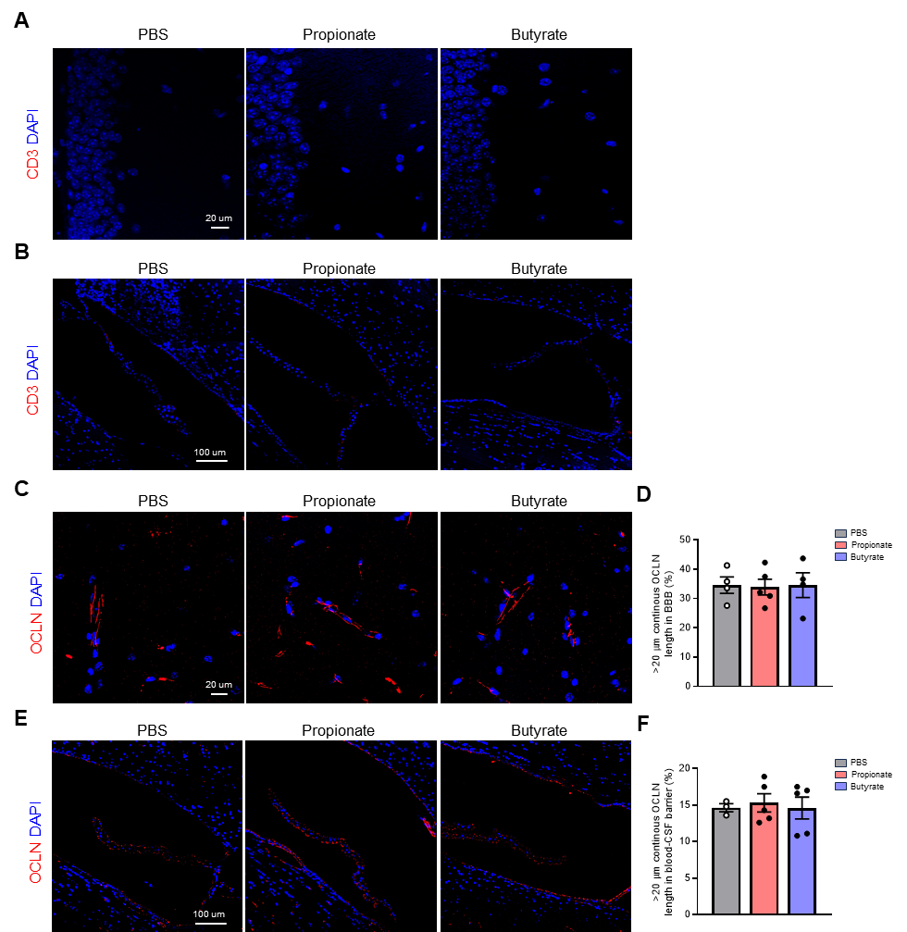
Supplementary Figure S12. The impact of SCFAs on the amount of CD3⁺ cells and the tight junction (TJ)- associated OCLN at the brain barriers in healthy wild type (WT) mice. (A, B, C, E) Representative images of CD3 (A, B; n = 4–5) and OCLN (C, E; n = 3–6) staining at the hippocampus (A, C; scale bar 20 µm) and the lateral ventricle blood-CSF barrier (B, E; scale bar 100 µm) of mice that were supplemented via oral gavage for three consecutive days with PBS, sodium propionate (1 g/kg body weight) or sodium butyrate (1 g/kg body weight). (D, F) The percentage of OCLN continuous length of > 20 µm in the hippocampus (D) and the blood-CSF barrier (F). Datapoints represent mean ± SEM. Statistical analysis was performed with unpaired t-test. CSF, cerebrospinal fluid; OCLN, Occludin; SCFA, short-chain fatty acid.
Supplementary Figure S13. Fecal propionate and butyrate levels are not altered upon fecal microbiota transfer (FMT). (A, C) Fecal propionate levels before the first FMT (pre-FMT) and 6 days after the last FMT (post-FMT) in healthy control (Ctr) recipients which received fecal material from Ctr (A) and EAE (C) donor mice (n = 6). (B, D) Fecal butyrate levels pre- and post-FMT in Ctr recipients which received fecal material from Ctr (B) and EAE (D) donor mice (n = 6). Datapoints represent mean ± SEM. Statistical analysis was performed with a Wilcoxon test. Ctr, healthy control; EAE, experimental autoimmune encephalomyelitis; FMT, fecal microbiota transplantation.

