Supplement

Supplementary table 1. Association between protein and age and sex. Sorted according to lowest p-value (age or female).

Protein Age Female
coefficient 95% CI p coefficient 95% CI p
TWEAK | 0.036 | 0.02, 0.05 | 5.0 × 10⁻⁵ | 0.12 | -0.09, 0.33 | 0.27
PD-L1 | 0.036 | 0.02, 0.05 | 1.5 × 10⁻⁴ | 0.072 | -0.15, 0.30 | 0.53
CDCP1 | 0.030 | 0.01, 0.05 | 2.5 × 10⁻⁴ | 0.013 | -0.18, 0.21 | 0.89
HGF | 0.037 | 0.02, 0.06 | 2.9 × 10⁻⁴ | −0.037 | -0.29, 0.21 | 0.76
OPG | 0.039 | 0.02, 0.06 | 3.1 × 10⁻⁴ | −0.35 | -0.61, -0.10 | 7.6 × 10⁻³
CXCL9 | 0.067 | 0.03, 0.10 | 4.6 × 10⁻⁴ | 0.12 | -0.33, 0.58 | 0.59
CD244 | 0.032 | 0.01, 0.05 | 6.8 × 10⁻⁴ | −0.17 | -0.40, 0.06 | 0.14
Beta-NGF | 0.020 | 0.01, 0.03 | 7.9 × 10⁻⁴ | −0.023 | -0.17, 0.12 | 0.76
IL-10RB | 0.027 | 0.01, 0.04 | 8.0 × 10⁻⁴ | −0.066 | -0.26, 0.13 | 0.50
SIRT2 | 0.027 | 0.01, 0.04 | 8.8 × 10⁻⁴ | −0.086 | -0.28, 0.11 | 0.38
LIF-R | 0.023 | 0.01, 0.04 | 9.3 × 10⁻⁴ | −0.089 | -0.26, 0.08 | 0.29
CSF-1 | 0.023 | 0.01, 0.04 | 1.3 × 10⁻³ | −0.0055 | -0.18, 0.17 | 0.95
uPA | 0.030 | 0.01, 0.05 | 1.4 × 10⁻³ | 0.062 | -0.17, 0.29 | 0.60
SCF | 0.031 | 0.01, 0.05 | 2.0 × 10⁻³ | −0.17 | -0.42, 0.08 | 0.17
VEGFA | 0.031 | 0.01, 0.05 | 2.3 × 10⁻³ | −0.0071 | -0.25, 0.24 | 0.95
CCL23 | 0.040 | 0.01, 0.07 | 3.3 × 10⁻³ | −0.16 | -0.50, 0.17 | 0.34
FGF-5 | 0.032 | 0.01, 0.05 | 3.7 × 10⁻³ | 0.0060 | -0.26, 0.28 | 0.96
CD5 | 0.0074 | -0.01, 0.03 | 0.43 | 0.35 | 0.11, 0.59 | 4.2 × 10⁻³
STAMPB | 0.015 | 0.00, 0.03 | 7.1 × 10⁻³ | 0.013 | -0.13, 0.15 | 0.86
CD40 | 0.025 | 0.01, 0.04 | 9.1 × 10⁻³ | −0.020 | -0.26, 0.22 | 0.87
CX3CL1 | 0.029 | 0.01, 0.05 | 0.010 | −0.018 | -0.30, 0.26 | 0.90
DNER | 0.0073 | 0.00, 0.01 | 0.011 | −0.060 | -0.13, 0.01 | 0.092
TGF-alpha | 0.017 | 0.00, 0.03 | 0.012 | −0.031 | -0.20, 0.14 | 0.72
CXCL5 | 0.043 | 0.01, 0.08 | 0.013 | 0.11 | -0.32, 0.55 | 0.60
CCL25 | 0.022 | 0.00, 0.04 | 0.013 | −0.24 | -0.46, -0.02 | 0.034
FGF-19 | 0.033 | 0.01, 0.06 | 0.018 | −0.041 | -0.39, 0.30 | 0.81
IL7 | 0.015 | 0.00, 0.03 | 0.019 | −0.026 | -0.19, 0.13 | 0.75
Flt3L | 0.018 | 0.00, 0.03 | 0.021 | −0.15 | -0.34, 0.04 | 0.13
CCL19 | 0.041 | 0.01, 0.08 | 0.021 | −0.50 | -0.95, -0.06 | 0.027
LAP TGF-beta-1 | 0.034 | 0.01, 0.06 | 0.022 | 0.22 | -0.15, 0.60 | 0.24
CD6 | 0.0014 | -0.01, 0.02 | 0.86 | 0.23 | 0.03, 0.43 | 0.028
4E-BP1 | 0.032 | 0.00, 0.06 | 0.028 | −0.037 | -0.40, 0.32 | 0.84
ADA | 0.021 | 0.00, 0.04 | 0.032 | −0.12 | -0.37, 0.12 | 0.31
MCP-4 | 0.042 | 0.00, 0.08 | 0.033 | 0.079 | -0.41, 0.56 | 0.75
MCP-1 | 0.0026 | -0.01, 0.02 | 0.75 | −0.23 | -0.44, -0.02 | 0.034
IL6 | −0.0095 | -0.03, 0.01 | 0.36 | −0.27 | -0.53, -0.01 | 0.042
CXCL1 | 0.023 | 0.00, 0.04 | 0.047 | −0.11 | -0.40, 0.17 | 0.42
CCL3 | 0.017 | -0.01, 0.04 | 0.14 | −0.28 | -0.56, 0.00 | 0.053
OSM | 0.013 | -0.00, 0.03 | 0.056 | 0.0034 | -0.17, 0.17 | 0.97
TRAIL | 0.019 | -0.00, 0.04 | 0.064 | 0.10 | -0.16, 0.36 | 0.43
IL-18R1 | 0.022 | -0.00, 0.05 | 0.065 | 0.036 | -0.26, 0.34 | 0.81
CCL4 | 0.020 | -0.00, 0.04 | 0.067 | −0.15 | -0.42, 0.13 | 0.30
CST5 | 0.0057 | -0.00, 0.01 | 0.23 | −0.11 | -0.23, 0.01 | 0.068
CXCL6 | 0.027 | -0.00, 0.06 | 0.069 | −0.19 | -0.57, 0.18 | 0.31
MMP-1 | 0.037 | -0.00, 0.08 | 0.074 | 0.0017 | -0.51, 0.52 | 0.99
CXCL11 | 0.014 | -0.02, 0.05 | 0.38 | 0.36 | -0.04, 0.76 | 0.076
CCL11 | 0.019 | -0.00, 0.04 | 0.081 | −0.080 | -0.35, 0.19 | 0.55
IL8 | 0.015 | -0.00, 0.03 | 0.13 | −0.13 | -0.38, 0.11 | 0.28
MMP-10 | 0.020 | -0.01, 0.05 | 0.14 | −0.17 | -0.51, 0.16 | 0.31
TNFB | 0.011 | -0.01, 0.03 | 0.24 | 0.16 | -0.07, 0.39 | 0.17
CASP-8 | 0.0055 | -0.00, 0.01 | 0.17 | 0.027 | -0.07, 0.13 | 0.59
IL18 | 0.015 | -0.01, 0.04 | 0.18 | −0.090 | -0.37, 0.18 | 0.51
IL-12B | 0.013 | -0.01, 0.03 | 0.25 | 0.18 | -0.10, 0.45 | 0.20
TNFRSF9 | 0.0070 | -0.01, 0.03 | 0.46 | −0.14 | -0.37, 0.10 | 0.26
TNFSF14 | 0.0066 | -0.01, 0.02 | 0.37 | 0.090 | -0.09, 0.28 | 0.33
MCP-2 | 0.012 | -0.01, 0.04 | 0.38 | −0.016 | -0.36, 0.33 | 0.93
CXCL10 | 0.016 | -0.02, 0.06 | 0.44 | 0.10 | -0.41, 0.62 | 0.69
CD8A | −0.0063 | -0.04, 0.02 | 0.66 | −0.13 | -0.49, 0.23 | 0.48
CCL28 | 0.0038 | -0.01, 0.02 | 0.58 | −0.037 | -0.21, 0.14 | 0.68
FGF-21 | −0.00079 | -0.01, 0.01 | 0.88 | −0.018 | -0.14, 0.11 | 0.78

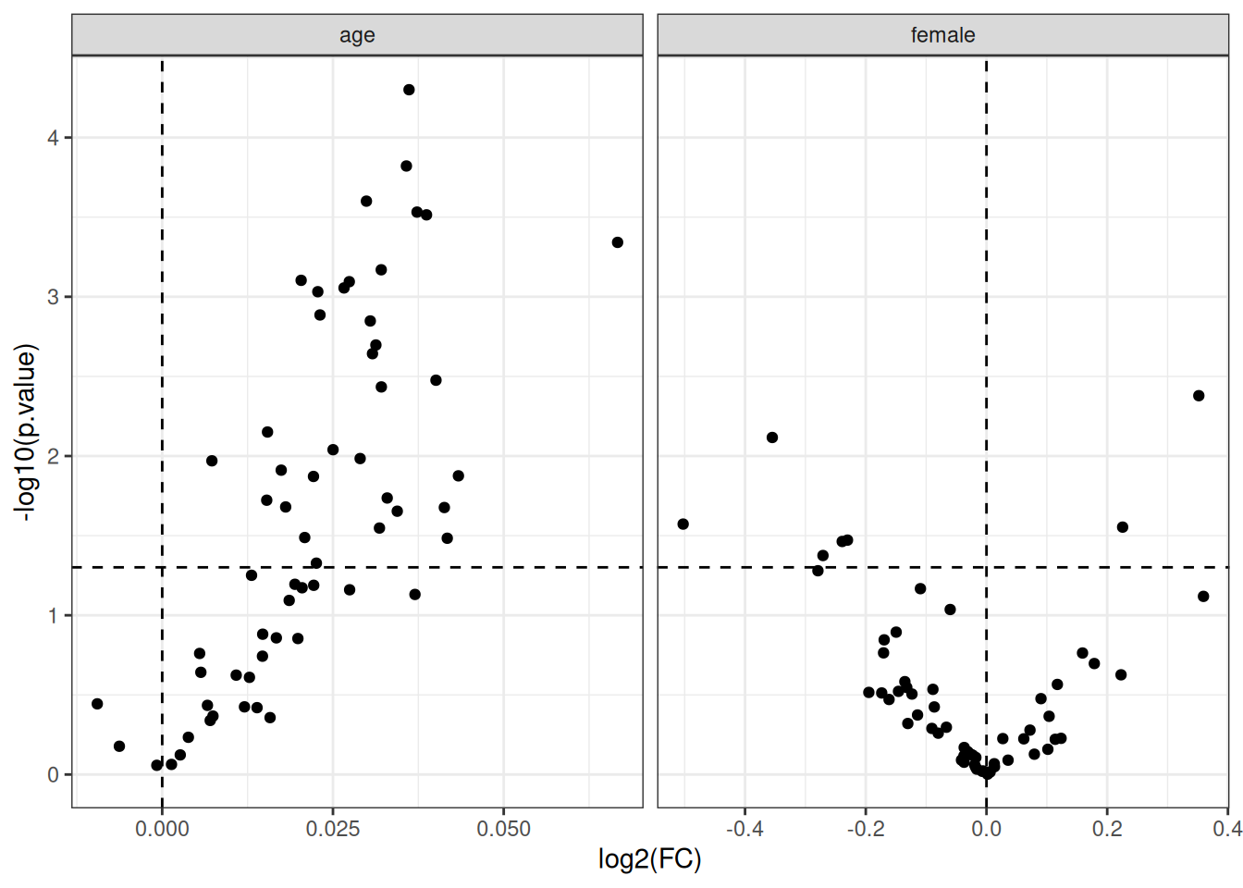

Supplementary figure 1. Volcano plot of association between protein level, age, and sex as computed using linear regression.

Supplementary figure 2. Volcano plot of association between protein level (NPX) and outcome separated in groups (colored) as computed using linear regression. The data is adjusted for age, sex and symptoms of baseline. INPH scale total is all domains without MMSE.

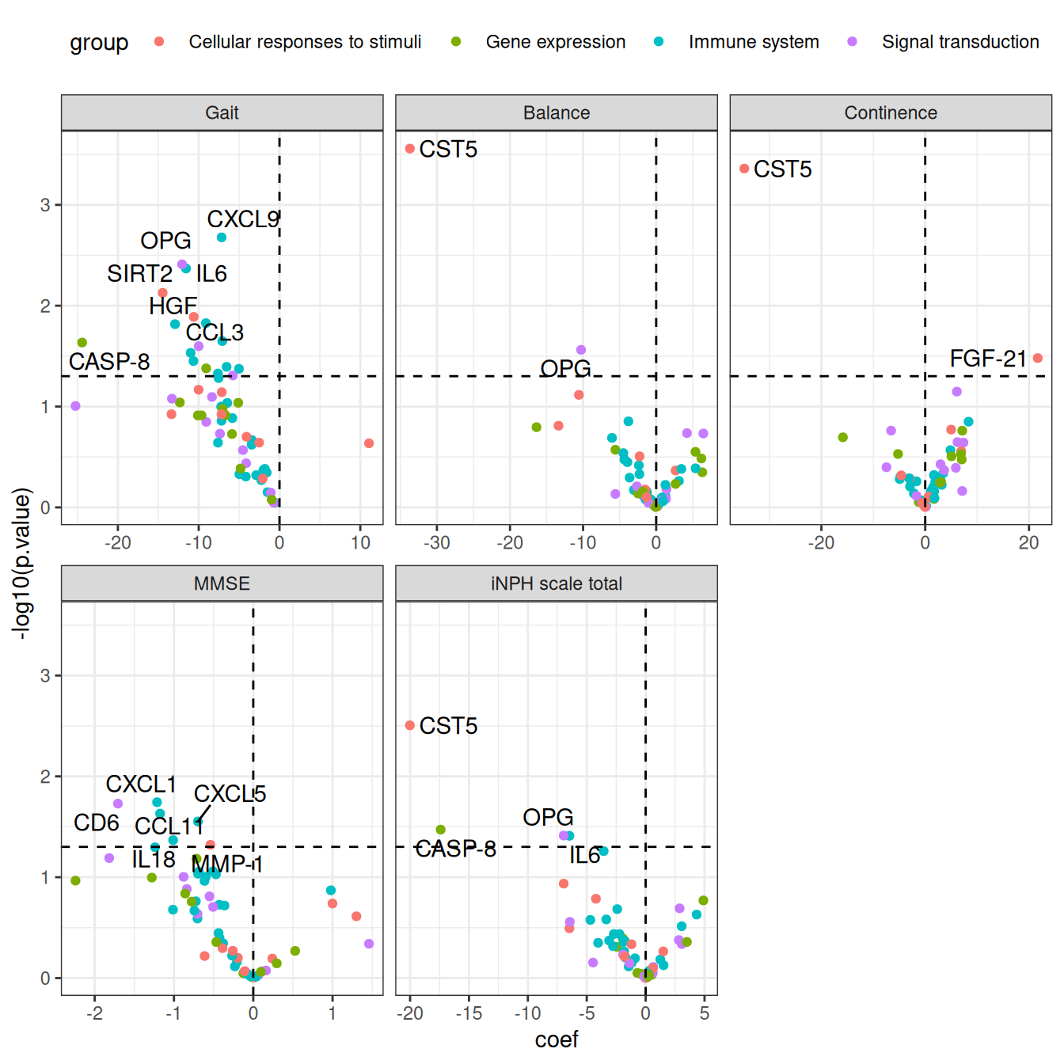

Supplement, table 2. Gene set enrichment analysis (GSEA) of proteins associated with follow up based on gait, balance, continence, MMSE domains and iNPH scale total. iNPH scale total is all domains without MMSE.

pathway | pval | padj | NES | size | Leading Edge
Gait
Cellular responses to stimuli | 0.72 | 0.72 | -0.81 | 11 | SIRT2, HGF, TWEAK, Flt3L, FGF-5, FGF-21, uPA
Gene expression | 0.47 | 0.72 | -1.00 | 13 | SIRT2, CASP-8, TNFRSF9, Beta-NGF,4E-BP1, VEGFA, SCF, LIF-R, TGF-alpha
Immune system | 0.14 | 0.56 | -1.31 | 27 | CXCL9, IL6, CCL3, IL-10RB, MCP-2, TWEAK, MCP-1, CCL23, CCL19, CXCL1, IL18
Signal transduction | 0.57 | 0.72 | -0.93 | 15 | OPG, CD40, TWEAK, CD8A, Flt3L, PD-L1, STAMPB, DNER
Balance
Cellular responses to stimuli | 0.07 | 0.27 | -1.43 | 11 | CST5, SIRT2, FGF-21, MMP-1
Gene expression | 0.75 | 0.75 | -0.80 | 13 | SIRT2, CASP-8, ADA
Immune system | 0.62 | 0.75 | -0.91 | 27 | CXCL9, IL8, CXCL1, IL6, CX3CL1, CCL19, CXCL6, MCP-1
Signal transduction | 0.40 | 0.75 | 1.04 | 15 | CD8A, CD5
Continence
Cellular responses to stimuli | 0.55 | 0.80 | -0.94 | 11 | CST5, SIRT2, FGF-5, TWEAK
Gene expression | 0.60 | 0.80 | 0.91 | 13 | TNFB, TNFSF14, VEGFA, TGF-alpha, LAP TGF-beta-1
Immune system | 0.89 | 0.89 | -0.74 | 27 | CCL28, IL6, IL7, CXCL9, TWEAK, IL-10RB, CCL4, CD244, CX3CL1, CCL3, OSM, IL18, CCL23, CXCL5, CXCL1, CCL19, CXCL11, MCP-1, CXCL6, IL8, MCP-2, IL-18R1, MCP-4, CXCL10, CCL11
Signal transduction | 0.20 | 0.79 | 1.25 | 15 | CD8A, CD5, CD6, Flt3L, LAP TGF-beta-1, CSF-1, TRAIL
MMSE
Cellular responses to stimuli | 0.09 | 0.18 | 1.33 | 11 | SIRT2, FGF-21, FGF-5, Flt3L, TWEAK, uPA, FGF-19, CST5, MMP-10, HGF
Gene expression | 0.62 | 0.62 | −0.91 | 13 | 4E-BP1, TNFSF14, CASP-8, TNFRSF9, LAP TGF-beta-1, SCF
Immune system | 0.08 | 0.18 | −1.36 | 27 | CXCL1, CCL11, CXCL5, IL18, CCL25, CXCL9, MCP-2, CCL23, MCP-4, CXCL11, CXCL6, IL6, CCL19, CXCL10, OSM, IL8, CD244, IL-18R1, CX3CL1
Signal transduction | 0.38 | 0.51 | −1.07 | 15 | CD6, STAMPB, TRAIL, OPG, LAP TGF-beta-1, CD8A, OSM, CD5
iNPH scale total
Cellular responses to stimuli | 0.26 | 0.72 | −1.19 | 11 | CST5, SIRT2, FGF-5, FGF-21, TWEAK, MMP-1, HGF, uPA
Gene expression | 0.82 | 0.82 | −0.73 | 13 | CASP-8, SIRT2
Immune system | 0.36 | 0.72 | −1.08 | 27 | IL6, CXCL9, CCL19, IL18, IL-10RB, CCL23, CX3CL1, TWEAK, CXCL6, MCP-2, IL7, MCP-1, CCL3
Signal transduction | 0.82 | 0.82 | 0.77 | 15 | LAP TGF-beta-1, CD5, CD6, CD8A

MMSE = mini-mental state examination; iNPH scale total = iNPH scale without the cognitive tests; Normalized Enrichment Score (NES) indicates a score for each gene set. A higher NES value reflects stronger enrichment. The gene sets are ranked according to their association with the outcome, with NES > 0 signifying upregulated genes and NES < 0 indicating downregulated genes.

