Supplementary material for the manuscript:

Evaluating Sex as a Biological Variable in In Vitro Blood–Brain Barrier Models: Insights from Primary Mouse Brain Endothelial Cells
Maria Thaysen¹, Line Toft Ørum¹, Alberte Bay Villekjær Pedersen¹, Nana Svane¹, Signe Emilie Dannulat Frazier^{1,2}, Lasse Saaby^{1,3}, Birger Brodin¹, Mie Kristensen¹.
¹Department of Pharmacy, University of Copenhagen, Copenhagen, Denmark
²Cell Therapy Discovery, Novo Nordisk, Måløv Denmark
³Bioneer A/S, Hørsholm, Denmark
Correspondance to Maria Thaysen: mthaysen@sund.ku.dk or Mie Kristensen: mie.kristensen@sund.ku.dk
Key words: Sex difference, primary mouse brain endothelial cells, in vitro models, blood-brain barrier

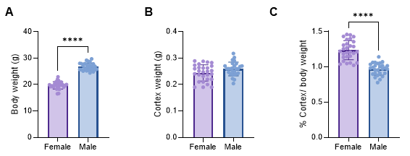
Additional file 1. A Body weight of the mice, B their cortices and C the weight of the cortices as a percentage of the body weight. Significance was tested using unpaired t-test, ****p-value<0.0001 (N=27-28).
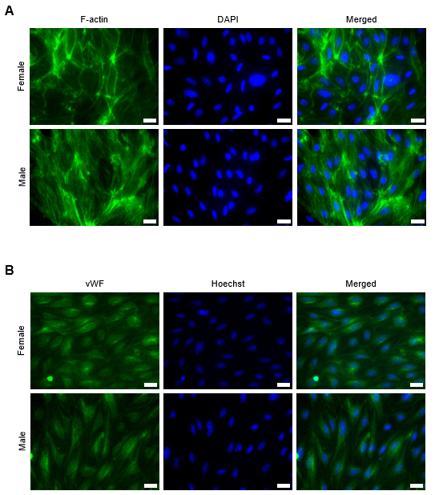
Additional file 2. Representative fluorescence immunostainings of A F-actin and B vWF in female and male PMBECs split by channels. Scale bar is 20 µm.

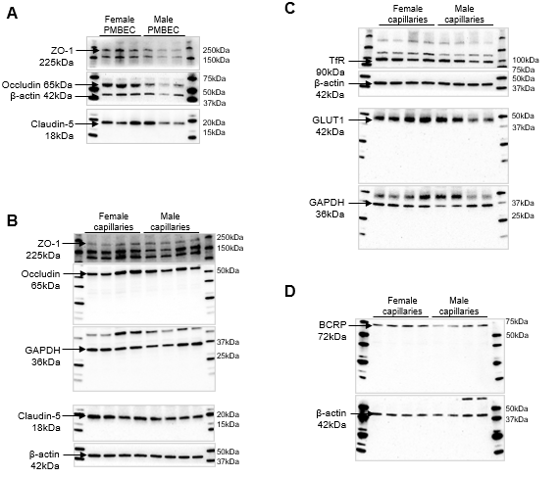
Additional file 3. Full size images of the western blot membranes used for representative images. A Western blots with tight junction proteins from female and male PMBECs. B Western blots with tight junction proteins from female and male capillaries. C Western blots with Transferrin receptor and GLUT1 from female and male capillaries. D Western blot with BCRP from female and male capillaries.

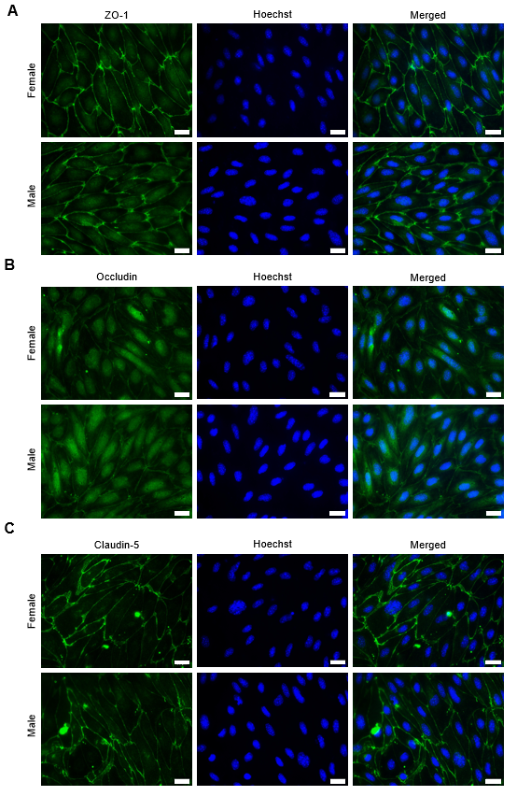
Additional file 4. Representative fluorescence immunostainings of A ZO-1, B occludin and C claudin-5 in female and male PMBECs split by channels. Scale bar is 20 µm.
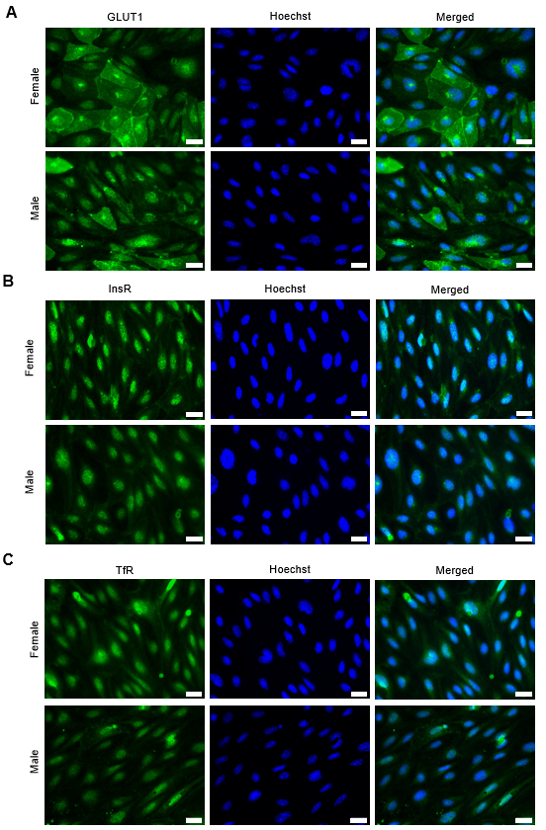
Additional file 5. Representative fluorescence immunostainings of A GLUT1, B Insulin receptor and C transferrin receptor in female and male PMBECs split by channels. Scale bar is 20 µm.
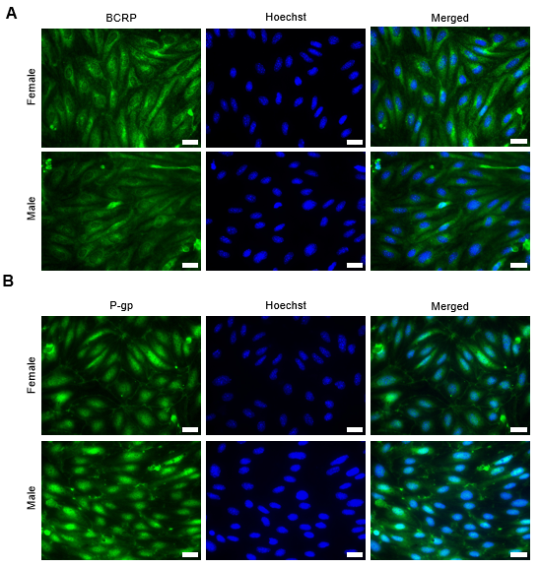
Additional file 6. Representative fluorescence immunostainings of A BCRP and B P-gp in female and male PMBECs split by channels. Scale bar is 20 µm.

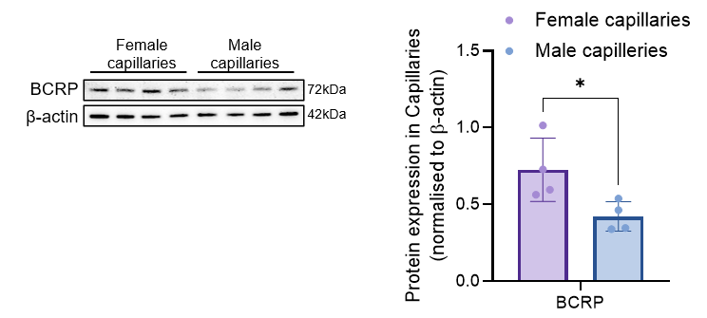
Additional file 7. Replication of experiment in Fig. 4D. Representative images of western blot of female and male capillaries protein lysates. Protein expression of BCRP was quantified and normalized to loading control. Significance tested with Students t-test, *p-value=0.0368 (N=4).

