Additional File 1

Article title:
Effects of HIV and azidothymidine on Alzheimer’s-like pathology and amyloid beta transporters in HIV-infected hu-PBL-NSG mice, brain endothelial amyloid beta uptake and endothelial barrier integrity

Biju Bhargavan, Narendran Annadurai, and Georgette D. Kanmogne*

*Corresponding Author:
Georgette Kanmogne, Ph.D., M.P.H.
Professor, Department of Anesthesiology, University of Nebraska Medical Center
984455 Nebraska Medical Center. Omaha, NE, USA
Email: gkanmogne@unmc.edu

Additional file 1 / data included:

Supplementary methods
Figure S1: Effects of AZT on endothelial cells viability
Figure S2: HIV Tat proteins dysregulate endothelial LRP1 and RAGE expression
Table 1: Blood levels of human (h)CD4+ T-cells and hCD8+ T-cells (mean ± SD) before and after infection

Supplementary Methods
Antibodies
Antibodies to human CD45 (CD45-PE-Cy7, catalog [cat] #304016), CD8 (CD8-APC, cat #344722), and CD3 (CD3-Pacific blue, cat #300330) were purchased from Biolegend (San Diego, CA). Antibodies to human CD4 (CD4-FITC, cat #555346) were from BD Biosciences (San Jose, CA); β-actin (cat #sc8432 from Santa Cruz Biotechnology (Dallas, USA). Antibodies to LRP1 (cat #ab215997), RAGE (cat #ab37647), phospho(p)-Tau(Ser396) (cat #ab32057), pTau(Ser199) (cat #ab4749), NeuN (cat #ab177487), claudin-5 (cat #ab15106), ZO-1 (cat #61–7300), and anti-mouse IgG (HRP) were from Abcam (Cambridge, MA); and antibodies to total Tau (cat #46687) and p-Tau(Thr181) (cat #12885S) from Cell signaling Technologies (Danvers, MA).

FACS analysis
Human (hCD4+, hCD8+, hCD3+, and hCD45+) cells in animals’ blood were quantified by FACS as previously described [3] Briefly, blood (200 μl) samples collected in ethylenediaminetetraacetic acid tubes were centrifuged (543 × g, 8 min at 4°C) and plasma was collected and cryopreserved. Cell pellets were resuspended in 50 μl of FACS buffer (PBS containing 2% fetal bovine serum) and transferred into 5 ml polypropylene round-bottom tubes (BD Falcon, Franklin Lakes, NJ). An antibody cocktail [20 μl containing the following fluorochrome-conjugated human monoclonal antibodies: CD45-PE-Cy7, CD8-APC, CD3-Pacific blue, and CD4-FITC] was added to each sample, mixed, and incubated for 1h on ice in the dark. One ml red blood cells lysis buffer (Roche) was then added to each sample. Samples were incubated for 5 min at room temperature and were centrifuged (377 × g, 5 min at 4°C). Cell pellets were washed two to four times in FACS buffer (2 ml), resuspended in 0.5 ml PBS containing 2% paraformaldehyde, and analyzed using BD LSRII and FACSDiva 8.0 (BD Biosciences).

RNA isolation and quantitative real-time PCR
Total RNA was extracted from cells and brain tissues using the Trizol reagent (Life Technologies-Ambion, Austin, TX) per manufacturer’s instructions. RNA yield and quality were checked using a NanoDrop spectrophotometer (NanoDrop Technologies, Wilmington, DE) and for all samples, absorbance ratios of 260/280 were ≥ 2. Reverse transcription was performed using Verso cDNA synthesis kit (Thermo Fisher) as we previously described [3]; briefly, 1 µg RNA in 11 µl of nuclease-free water was mixed with 4 µl of 5X cDNA synthesis buffer, 2 µl deoxynucleoside triphosphates mix, 1 µl random hexamers, 1 µl reverse transcriptase enhancer and 1 µl Verso enzyme mix. Amplification conditions were: 1 cycle of 42°C for 30 min, followed by 95°C for 2 min. qPCR was performed using the 384-well block of a LightCycler® 480 II (Roche) Real-Time PCR System. For each reaction, 500 ng cDNA in 5 µl nuclease-free water was mixed with 3 µl PCR grade water, 10 µl of 2X LightCycler® 480 Probe master mix, and 1 µl of 20X TaqMan primer-probe mix. Cycling conditions were as follows: 95 °C, 5 min with a ramp rate of 4.8°C/s; followed by 45 cycles of 95°C, 10 s, 4.8°C/s; 60°C, 15 s, 2.5°C/s; and 72°C, 1 s, 4.8°C/s; and hold at 40°C, 10 s, 2°C/s. LRP1 and RAGE mRNA levels were quantified using the delta-CT method as instructed in the LightCycler® 480 software manual and normalized to the sample’s GAPDH levels. All primers were obtained from Applied Biosystems and primers’ IDs were as follows: mouse LRP1 (Mm00464608_m1), RAGE (Mm00449495_m1), NeuN (Mm01248771_m1), Claudin 5 (Mm00727012_s1), and GAPDH (Mm99999915_g1).

Western blot analysis
Each brain tissue sample (5 mg) was transferred into a tube containing 500 µl of ice-cold tissue lysis buffer (T-PERTM tissue protein extraction reagent (Thermo Fisher) and 5 µl of 100X protease and phosphatase inhibitor cocktail, placed on ice and homogenized using a motor and pestle. Homogenized samples were incubated for 30 min on ice, with intermittent vortex (every 5 to 6 min) for 10 s. Samples were centrifuged for 10 min at 18000 × g, 4°C; and each supernatant transferred into a fresh pre-chilled tube and stored at -80°C until use. Total protein levels in each sample were quantified using the bicinchoninic acid assay (Thermo Fisher), and 30 μg protein analyzed by sodium dodecyl sulfate-polyacrylamide gel electrophoresis as previously described [2, 4] using monoclonal antibodies to LRP1, RAGE, Tau, pTau (T181), pTau (S396), pTau (S199), NeuN, claudin-5, ZO-1, and β-actin (each at 1:1000 dilution). To confirm equal loading, protein expression in each sample was normalized to the sample’s β-actin levels; pTau levels were normalized to the sample’s total Tau levels.

HIV-1 p24, Amyloid-β, sLRP1, and sRAGE ELISA
HIV-1 p24 antigen levels in each plasma sample (100 µl) were quantified using Quantikine HIV-1 group-specific antigen (Gag) p24 immunoassay kit (R&D Systems, Minneapolis, MN). Levels of Aβ₄₂ in animals brain tissues (15 or 30 µg) and plasma (10 μl) samples were quantified using the SensoLyte® Anti-Mouse/Rat β-amyloid (1-42) Quantitative ELISA Kit (AnaSpec, Fremont, CA). Levels of soluble (s)LRP1 and sRAGE in animals’ serum samples (10 μl) were quantified using mouse sLRP1 ELISA (MyBioSource, Inc. San Diego, CA) and mouse sRAGE ELISA (Biorbyt Ltd, Cambridge, UK) kits. Levels of Aβ₄₂ in HBMEC culture media (100 μl) and cell lysates (30 µg) were quantified using the human Aβ (1-42) Quantikine ELISA kit (R&D Systems, Bio-Techne, Minneapolis, MN). All procedure were performed per the manufacturer’s protocol. Standard curves generated using reference standards for HIV-1 Gag p24 antigen, mouse sLRP1 and sRAGE, mouse and human Aβ (1-42) provided with each corresponding kit were used to quantify each sample’s p24 antigen, sLRP1 and sRAGE, and Aβ₄₂ levels

Human brain microvascular endothelial cells culture
Primary human brain microvascular endothelial cells (HBMEC) were isolated from brain tissue obtained during surgical removal of epileptogenic cerebral cortex in adult patients, under an Institutional Review Board-approved protocol, as previously described [1, 5]. Routine evaluation by immunostaining for von-Willebrand factor, Ulex europaeus lectin, and CD31 showed that cells were >99% pure. Freshly isolated cells were cultured in collagen-coated flasks or 6-well culture plates using Dulbecco’s Modified Eagle’s Medium/F12 (Life Technologies, Grand Island, NY, USA) containing 10% fetal bovine serum (Atlanta Biologicals, Flowery Branch, GA) supplemented with 10 mmol/l L-glutamine (Life Technologies), 1% heparin (Thermo Fisher Scientific, Pittsburgh, PA), 1% endothelial cell growth supplement (BD Bioscience, San Jose, CA), 1% penicillin-streptomycin (Life Technologies), and 1% fungizone (MP Biomedicals, Solon, OH). Cells at passage 2 to 4 were used in this study.

References
1 Bhargavan B, Kanmogne GD (2018) Differential Mechanisms of Inflammation and Endothelial Dysfunction by HIV-1 Subtype-B and Recombinant CRF02_AG Tat Proteins on Human Brain Microvascular Endothelial Cells: Implications for Viral Neuropathogenesis. Mol Neurobiol 55: 1352-1363 Doi 10.1007/s12035-017-0382-0
2 Bhargavan B, Woollard SM, Kanmogne GD (2016) Toll-like receptor-3 mediates HIV-1 transactivation via NFkappaB and JNK pathways and histone acetylation, but prolonged activation suppresses Tat and HIV-1 replication. Cell Signal 28: 7-22 Doi 10.1016/j.cellsig.2015.11.005
3 Bhargavan B, Woollard SM, McMillan JE, Kanmogne GD (2021) CCR5 antagonist reduces HIV-induced amyloidogenesis, tau pathology, neurodegeneration, and blood-brain barrier alterations in HIV-infected hu-PBL-NSG mice. Mol Neurodegener 16: 78 Doi 10.1186/s13024-021-00500-0
4 Chaudhuri A, Yang B, Gendelman HE, Persidsky Y, Kanmogne GD (2008) STAT1 signaling modulates HIV-1-induced inflammatory responses and leukocyte transmigration across the blood-brain barrier. Blood 111: 2062-2072 Doi 10.1182/blood-2007-05-091207
5 Woollard SM, Li H, Singh S, Yu F, Kanmogne GD (2014) HIV-1 induces cytoskeletal alterations and Rac1 activation during monocyte-blood-brain barrier interactions: modulatory role of CCR5. Retrovirology 11: 20 Doi 10.1186/1742-4690-11-20

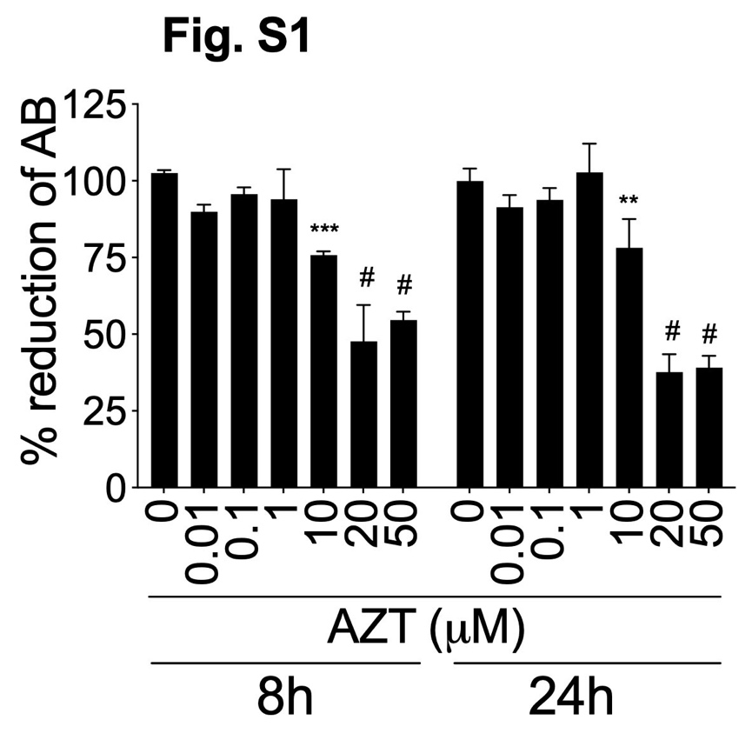

Figure S1. Effects of AZT on endothelial cells viability. Primary HBMEC were treated with AZT (0.01 to 50 µM) and cytotoxicity assessed at 8 and 24 hours by AlamarBlue (AB) assay. **P=0.003; ***P=0.0002; #P<0.0001 compared to untreated controls. Each experimental condition included three technical replicates; error bars represent SD. This is a representative of two independent experiments, using HBMEC (passage 4) from two different donors.

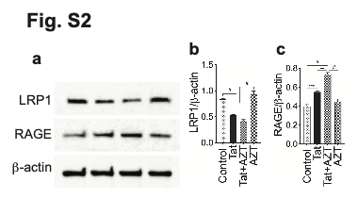

Figure S2. HIV Tat proteins dysregulate endothelial LRP1 and RAGE expression. Primary HBMEC (passage 4) were treated with Tat (100 ng/ml) and/or AZT (1 μM) for 24 hours, and LRP1 (a, b) and RAGE (a, c) expression analyzed by immunoblotting followed by densitometry quantification normalized to samples’ β-actin levels. **P=0.0035; ***P=0.0003; #P<0.0001. Error bars represent SD.

