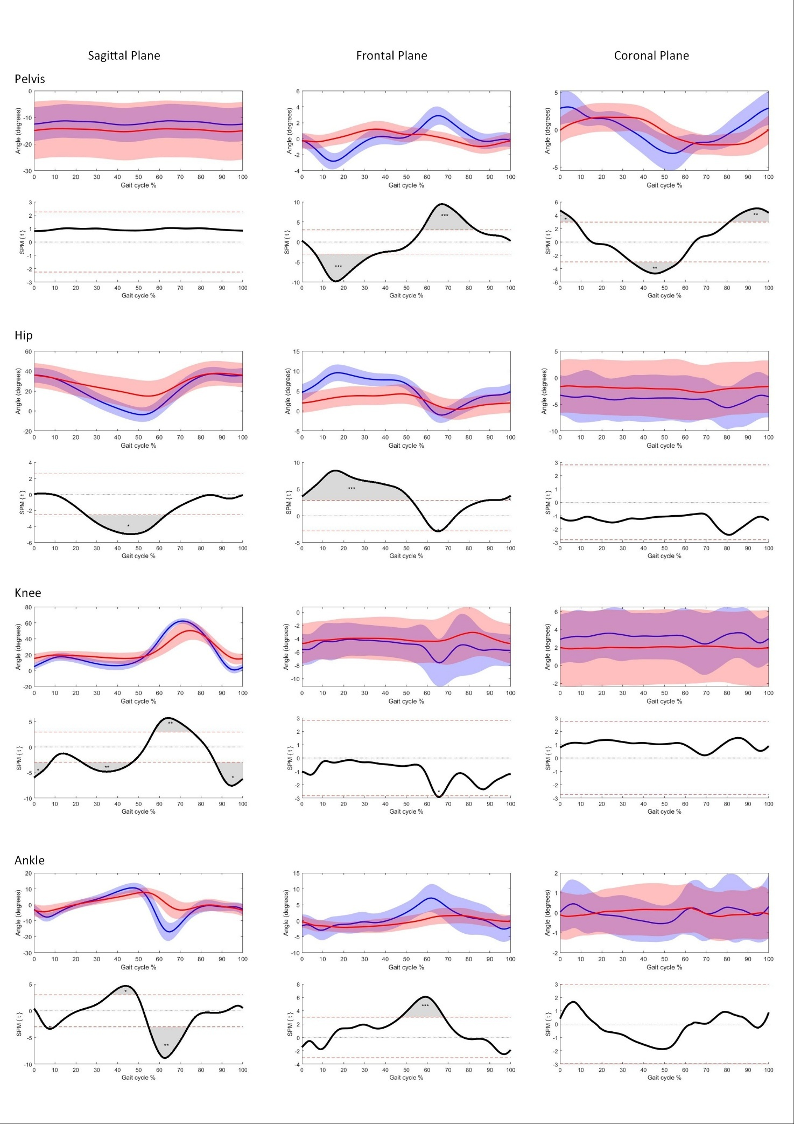
Figure SM2 - Kinematics (joint angles) and SPM hypothesis test results for pelvis (top), hip (2nd from top), knee (2nd from bottom), and ankle (bottom). For each joint, mean joint angle (solid line) and standard deviations (light bands) across the gait cycle are presented in the sagittal (left column), frontal (middle column), and coronal (right column) planes for HC (blue) and iNPH (red). (C) SPM hypothesis testing of the gait profiles. Regions of significant differences between groups are highlight in grey. *p<.05; **p<.01; ***p<.001

