Supplementary Material
Convergent Blood–Brain Barrier Breakdown in Schizophrenia and Autism Spectrum Disorders: A Systematic Review of Preclinical Animal Models

Cristina Morente-Montilla ^{a,b 1}, María Fernández-Guillén ^{a,b 1}, Ana Gómez-Garrido ^{a,b}, Susana García-Cerro ^{a,b}, Amanda Moreno-Mellado ^{a,b}, Matthew Campbell ^{c}, Hermona Soreq ^{d}, David S Greenberg ^{d}, Maria A Deli ^{e}, Benedicto Crespo-Facorro ^{a,b,f,}*, Celia Martín-Cuevas ^{a,b, 2,} *, Maurizio S. Riga ^{a,b, 2}.

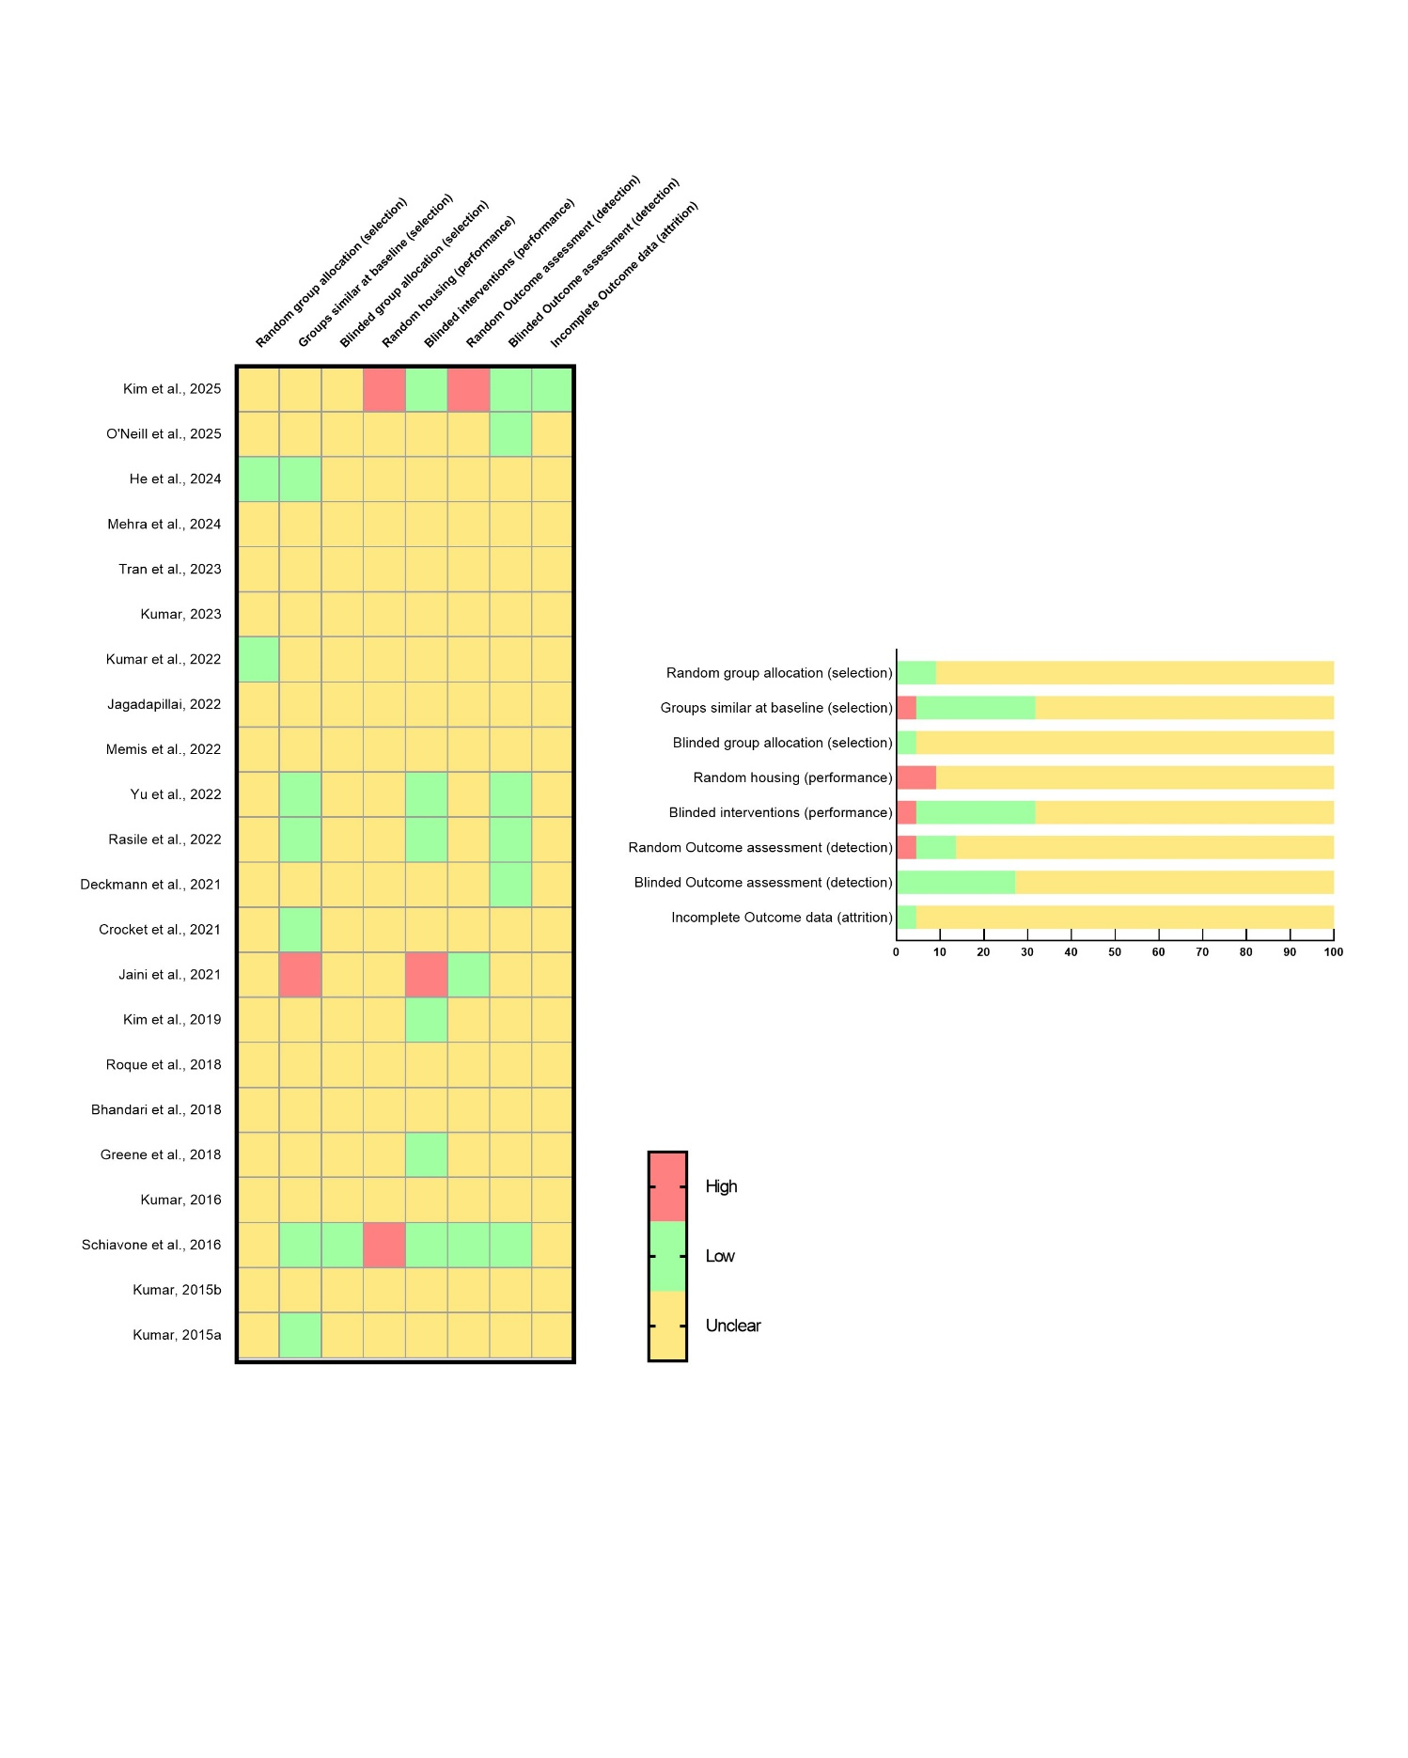

Supplementary Figure S1. Risk of bias summary. Quality assessment of studies was evaluated with the checklist provided by Clarity Group at McMaster University. (green) Low risk of bias, (yellow) Unclear risk of bias, (red) High risk of bias.

