Circulating Sphingosine-1-Phosphate Depletion Is Associated with Endothelial Activation and Altered Brain-Endothelial S1P Pathway Expression in Ischemic Stroke

Lisa T Porschen^{a,b,c}, Frank Matthes^{a,b,c}, Hana Matuskova^{a,b,e,f}, Lino Braadt^{c,d}, Gabor C Petzold^{e,f}, Arne G Lindgren^{g,h} & Anja Meissner^{a,b,c}

ª Department of Experimental Medical Sciences, Lund University, 221 84 Lund, Sweden
^{b} Wallenberg Centre for Molecular Medicine, Lund University, 221 84 Lund, Sweden
^{c} Division of Physiology & Vascular Biology, Institute of Theoretical Medicine, Faculty of Medicine, University of Augsburg, Augsburg, Germany
^{d} Department of Vascular Neurology, University Hospital Bonn, 53127 Bonn, Germany
^{e} German Center for Neurodegenerative Diseases (DZNE), 53127 Bonn, Germany
^{f} Department of Neurology and Clinical Neurophysiology, University Hospital Augsburg, Augsburg, Germany
^{g} Department of Clinical Sciences Lund, Neurology, Lund University, Lund, Sweden
^{h} Department of Neurology, Rehabilitation Medicine, Memory Disorders and Geriatrics, Skåne University Hospital, Lund, Sweden

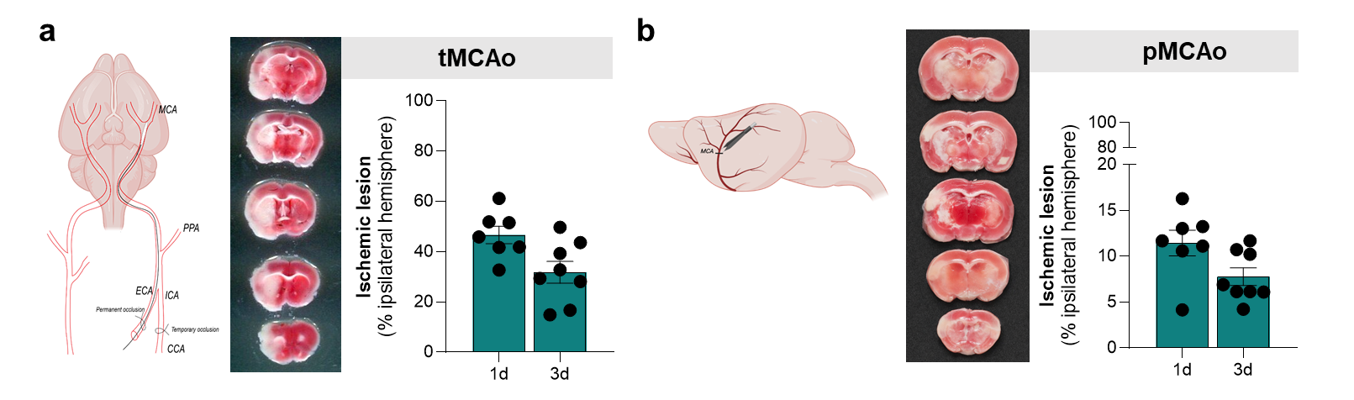

Suppl. Figure 1. Characterization of the experimental stroke models.
(a) Schematic of transient middle cerebral artery occlusion (tMCAo). tMCAo was induced by intraluminal filament occlusion of the MCA for 60 min followed by reperfusion. Representative TTC-stained brain sections and quantification of infarct size at 1- and 3-days post-stroke are shown. (b) Schematic of permanent middle cerebral artery occlusion (pMCAo). pMCAo was induced by permanent electrocoagulation and transection of the MCA. Representative TTC-stained brain sections and quantification of infarct size at 1- and 3-days post-stroke are shown. CCA – common carotid artery, ECA – external carotid artery, ICA – internal carotid artery, MCA – middle cerebral artery, pMCAo – permanent middle cerebral artery occlusion, tMCAo – transient middle cerebral artery occlusion.

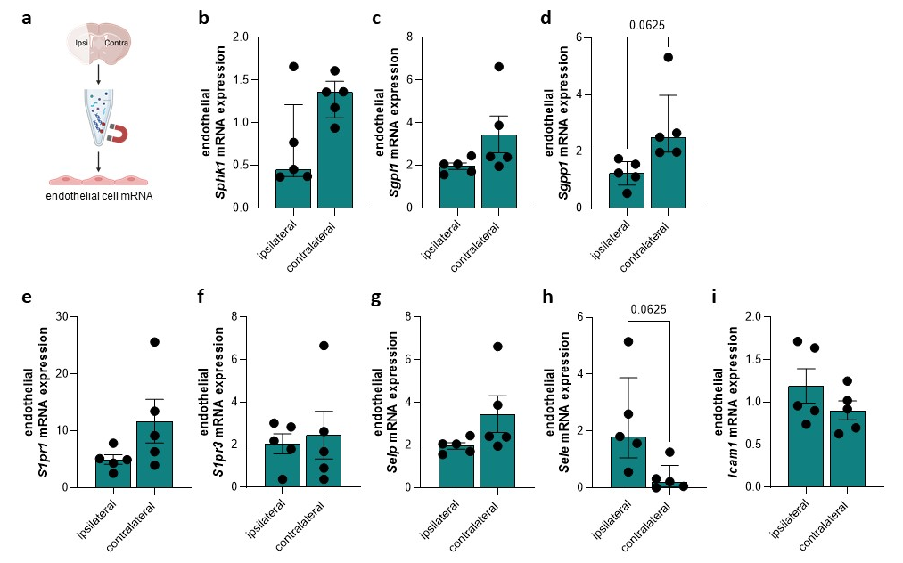

Suppl. Figure 2. Endothelial expression of S1P signaling components 3-days after transient middle cerebral artery occlusion.
(a) Schematic overview of endothelial-specific mRNA isolation using the RiboTag approach from cerebral endothelial cells 3-days after transient middle cerebral artery occlusion (tMCAo).
Endothelial mRNA expression of sphingosine kinase 1 (Sphk1) (b), sphingosine-1-phosphate lyase (Sgpl1) (c), sphingosine-1-phosphate phosphatase 1 (Sgpp1) (d), sphingosine-1-phosphate receptor 1 (S1pr1) (e), and sphingosine-1-phosphate receptor 3 (S1pr3) (f), P-selectin (Selp) (g), E-selectin (Sele) (h) and intercellular adhesion molecule 1 (Icam1) (i) shows no significant differences between the ischemic and contralateral hemispheres. N = 5 for all readouts. Data are presented as mean ± SEM (c, e-g, i) or median ± interquartile range (b, d, h). Contra – contralateral, intercellular adhesion molecule 1 (Icam1), ipsi – ipsilateral, Sele – E-selectin, Selp – P-selectin, S1P – sphingosine-1-phosphate, Sphk – sphingosine kinase, Sgpl – sphingosine lyase, Sgpp – sphingosine phosphatase.

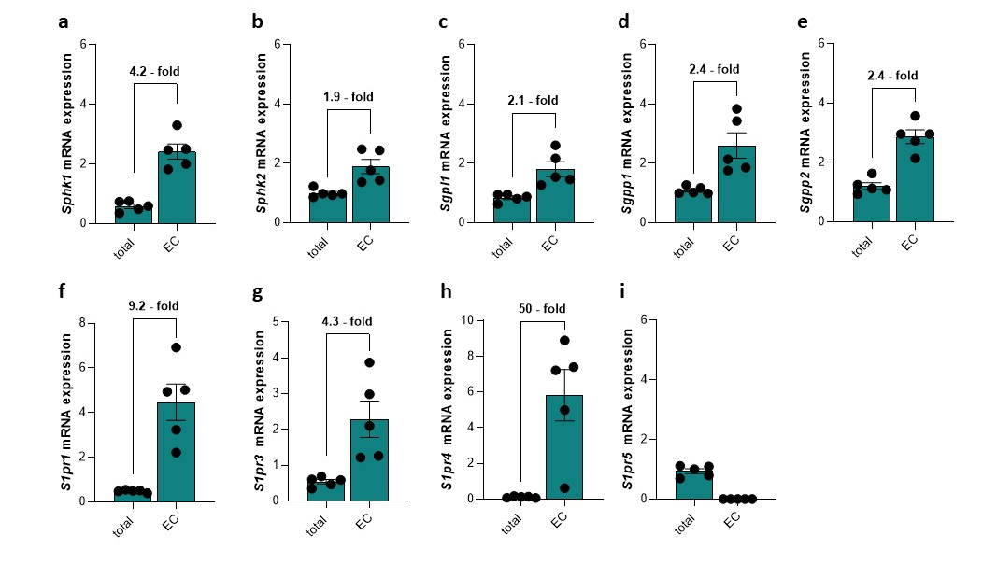
Suppl. Figure 3. Endothelial enrichment of S1P signaling components.
(a–i) Endothelial mRNA isolated from RiboTag mice shows significant enrichment of multiple S1P-signaling components compared with total tissue homogenates, indicating predominant endothelial expression. (j) S1pr5 shows no endothelial enrichment. N = 5 for all readouts. Data are presented as mean ± SEM. EC - endothelial cells; S1P – sphingosine-1-phosphate, S1pr – S1P receptor, Sphk – sphingosine kinase, Sgpl – sphingosine lyase, Sgpp – sphingosine phosphatase.

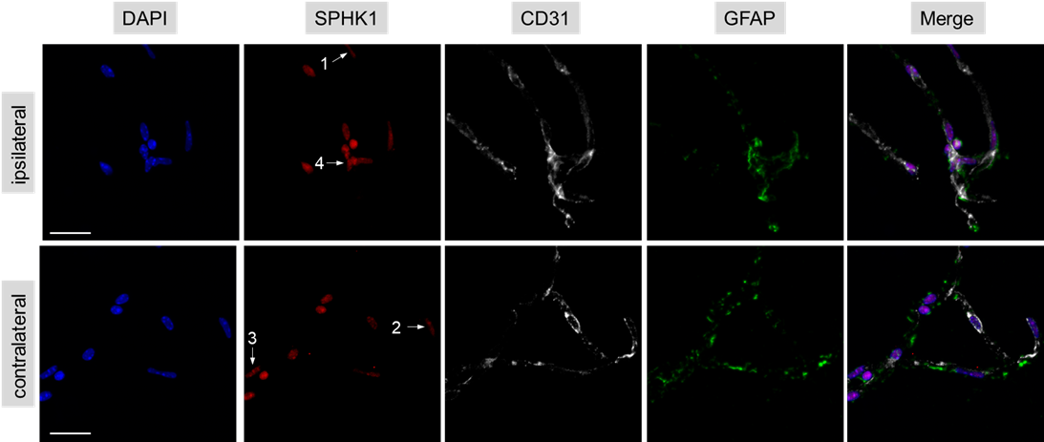

Suppl. Figure 4. Endothelial expression of SPHK1 in isolated cerebral vessels 1-day post-permanent middle cerebral artery occlusion.
Representative immunofluorescence images of cerebral vessels isolated 1-day after permanent middle cerebral artery occlusion (pMCAo) stained for 4′,6-diamidino-2-phenylindole (DAPI), cluster of differentiation 31 (CD31), glial fibrillary acidic protein (GFAP) and sphingosine kinase 1 (SPHK1). Arrows are indicating scoring examples for SPHK1 intensity score (score: 0 = no detectable signal, 1 = low, 2 = moderate, 3 = strong, 4 = very strong). Cluster of differentiation 31 – CD31, GFAP – glial fibrillary acidic protein, Sphk – sphingosine kinase.

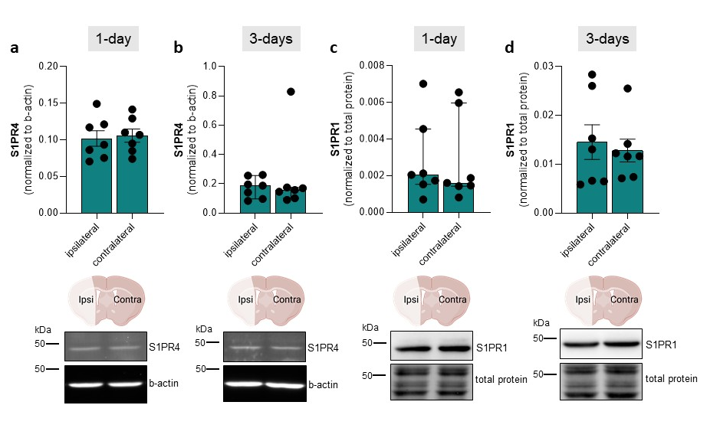

Suppl. Figure 5. S1P receptor protein expression in whole-hemisphere homogenates after permanent ischemic stroke.
Protein expression levels of S1PR4 at 1-day (a) and 3-days (b) after permanent middle cerebral artery occlusion (pMCAo), and S1PR1 at 1-day (c) and 3-days (d) after pMCAo, measured in whole-hemisphere homogenates. Representative immunoblots are shown for each condition. No significant differences were detected between ischemic and contralateral hemispheres at either time point. N = 7 for all readouts. Data are presented as mean ± SEM (a, d) or median ± interquartile range (b, c). Contra – contralateral, ipsi – ipsilateral, S1P – sphingosine-1-phosphate, S1pr – S1P receptor.

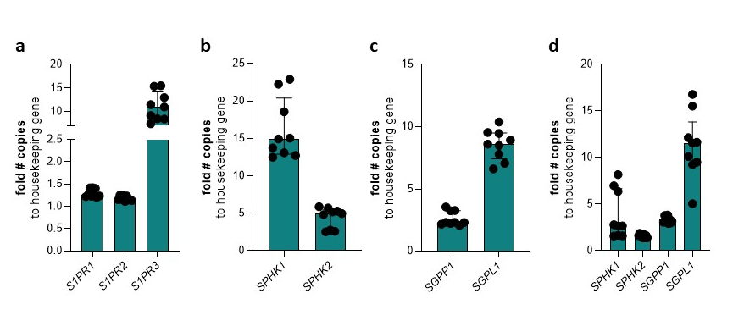

Suppl. Figure 6. Absolute mRNA expression of S1P signaling components in human microvascular brain endothelial cells.
(a) Absolute mRNA expression of sphingosine-1-phosphate receptors (S1PR1–3). (b) Absolute mRNA expression levels of sphingosine kinases (SPHK1 and SPHK2). (c) Absolute mRNA expression of sphingosine-1-phosphate degrading enzymes, including sphingosine-1-phosphate lyase (SGPL1) and sphingosine-1-phosphate phosphatase 1 (SGPP1). (d) Comparative analysis of absolute expression levels of all S1P metabolic enzymes. N = 9 for all readouts. Data are presented as mean ± SEM (d) or median ± interquartile range (a-c). S1P – sphingosine-1-phosphate, S1PR – S1P receptor, SPHK – sphingosine kinase, SGPL – sphingosine lyase, SGPP – sphingosine phosphatase.

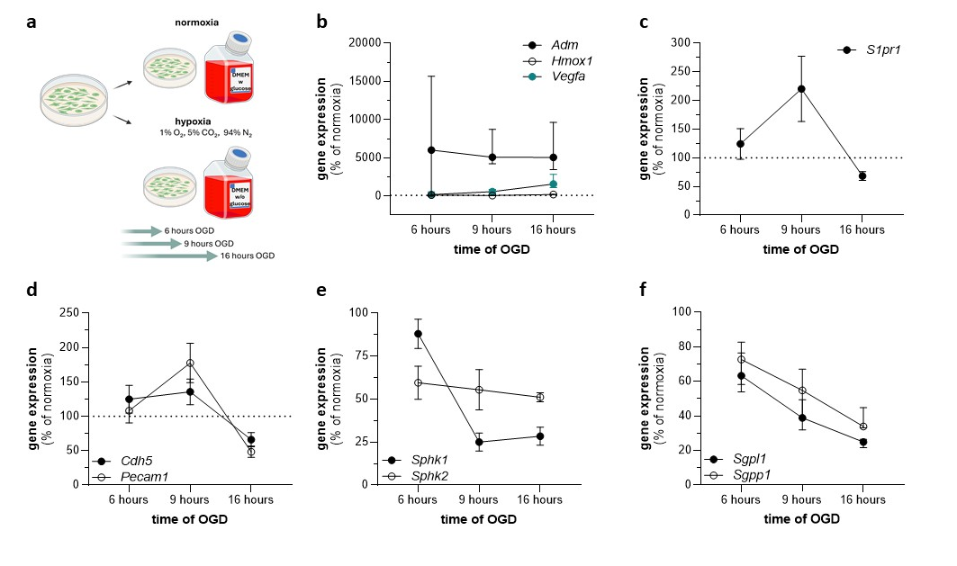

Suppl. Figure 7. Regulation of endothelial gene expression by oxygen-glucose deprivation in murine brain endothelial cells.
(a) Schematic showing experimental design. (b) mRNA expression of hypoxia-responsive genes (Adm, Hmox1, and Vegfa) is increased at all timepoints of oxygen–glucose deprivation (OGD). (c) Expression of sphingosine-1-phosphate receptor (S1pr1) is altered in a duration-dependent manner during OGD. (d) Expression of endothelial markers (Cdh5 and Pecam1) is reduced at 16 hours of OGD. (e) Expression of sphingosine kinases Sphk1 and Sphk2 is reduced with increasing duration of OGD. (f) Expression of the S1P-degrading enzymes Sgpl1 and Sgpp1 progressively decreases with OGD exposure. N = 5-6 for all readouts. Data are presented as percentage of normoxic controls and shown as mean ± SEM (c, d, e) or median ± interquartile range (b, f). Dashed line represents 100 % of normoxia. Adm – Adrenomedullin, Cdh5 – cadherin 5, Hmox1 – heme oxygenase 1, OGD – oxygen glucose deprivation, Pecam1 – platelet endothelial cell adhesion molecule-1, S1P – sphingosine-1-phosphate, S1pr – S1P receptor, Sphk – sphingosine kinase, Sgpl – sphingosine lyase, Sgpp – sphingosine phosphatase, Vegfa – vascular endothelial growth factor A.

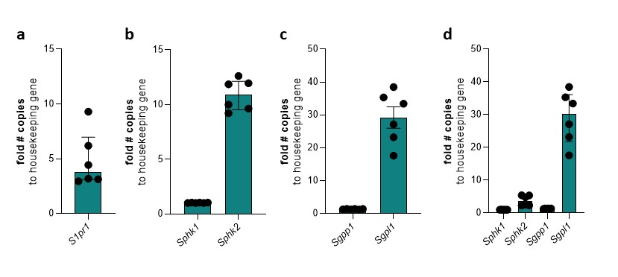

Suppl. Figure 8. Absolute mRNA expression of S1P signaling components in murine brain endothelial cells.
(a) Absolute mRNA expression of sphingosine-1-phosphate receptor (S1pr1). (b) Absolute mRNA expression levels of sphingosine kinases (Sphk1 and Sphk2). (c) Absolute mRNA expression of the degrading enzymes sphingosine-1-phosphate phosphate lyase (Sgpl1) and sphingosine-1-phosphate phosphatase 1 (Sgpp1). (d) Comparative analysis of absolute expression levels of all S1P metabolic enzymes. N = 6 for all readouts. Data are presented as mean ± SEM (c) or median ± interquartile range (a, b, d). S1P – sphingosine-1-phosphate, S1pr – S1P receptor, Sphk – sphingosine kinase, Sgpl – sphingosine lyase, Sgpp – sphingosine phosphatase.

Suppl. Table 1. Key resources table for primer pairs used in qPCR.

- Mouse

Target gene | Forward primer (5´→ 3’) | Reverse primer (5´→ 3’)
Rpl14 | GGCTTTAGTGGATGGACCCT | ATTGATATCCGCCTTCTCCC
Sphk1 | GGTGAATGGGCTAATGGAACG | CTGCTCGTACCCAGCATAGTG
Sphk2 | CACGGCGAGTTTGGTTCCTA | CTTCTGGCTTTGGGCGTAGT
Sgpp1 | GAGCAACTTGCCGCTCTACTA | GGTCGAGATTCCAGATCCAGAA
Sgpp2 | GTTCTCTACGCTGGTGTGTCT | GCAGGGTAGGTCAGAGCAAT
Sgpl1 | GGTGTATGAGCTTATCTTCCAGC | CTGTTGTTCGATCTTACGTCCA
S1pr1 | ATGGTGTCCACTAGCATCCC | CGATGTTCAACTTGCCTGTGTAG
S1pr2 | ACAGTCTCCAAAACCAACCACT | ACTCTGAGTATAAGCCGCCCA
S1pr3 | CAAGCCTAGCGGGAGAGAAA | ACTGCGGGAAGAGTGTTGAA
S1pr4 | CTCGGTCACTCAGCTTCAGG | CAGTCACCATCAGGCAAGGT
S1pr5 | GCCTAGGGCACACGACC | GACACAGGAGAGCGGCTATT
Selp | CATCTGGTTCAGTGCTTTGATCT | ACCCGTGAGTTATTCCATGAGT
Sele | CACGACATGCACGTTTGACT | GGCGCAGATAAGGCTTCACA
Icam1 | CCGTGCCAAGCCCACGCTAC | GCGGAAGCGGACGACTGCAC
Vcam1 | TGCCGAGCTAAATTACACATTG | CCTTGTGGAGGGATGTACAGA
Pecam1 | CCAAAGCCAGTAGCATCATGGTC | GGATGGTGAAGTTGGCTACAGGG
Cdh5 | ATGGCAGGCCCTAACTTTCC | CATTCTGGCGGTTCACGTTG
Vegfa | GGCCTCCGAAACCATGAACT | GTCCACCAGGGTCTCAATCG
Adm | TTCTCGGCTTCTCATCGCAG | TCAGGGTGATGGAAACCAGC
Hmox1 | GAATCGAGCAGAACCAGCCT | CTCAGCATTCTCGGCTTGGA
Ocln | GAAAGGGCAAGAGGACGGAC | CGTCGTCTAGTTCTGCCTGT

- Human

Target gene | Forward primer (5´→ 3’) | Reverse primer (5´→ 3’)
GPI | AGGCTGCTGCCACATAAGGT | CCAAGGCTCCAAGCATGAAT
SPHK1 | AGGCTGAAATCTCCTTCACGC | GTCTCCAGACATGACCACCAG
SPHK2 | CTGTCTGCTCCGAGGACTGC | CAAAGGGATTGACCAATAGAAGC
SGPP1 | CACCGCCATCCCCATTTCTA | AACTAGAGAACACCAGCAGGG
SGPP2 | CCATTGCCTTCACCCTCCTT | CCAGTGTAGAGCCTGCTGAG
SGPL1 | ACTGCTCGCTTCCTCAAGTC | TACTGGGTGGGAACTGCAAC
S1PR1 | TCTGCGGGAAGGGAGTATGT | CGATGGCGAGGAGACTGAA
S1PR2 | CCTTCTCTGGGCAACTTCGT | GGAGAAGTCGTCAAGTGGCA
S1PR3 | TCTACCATCCTGCCCCTCTAC | ACACGCTCACCACAATCACC
S1PR4 | CAACCCCATCATCTACTCCTTCC | AAAGCTGTCCCTTGGCCTC
S1PR5 | TGTATTTATGCAGCGACACCCC | CTTCCCTGACCACCATCACC
VCAM1 | CATCCGAAAGGCCCAGTTGA | TAGAGCACGAGAAGCTCAGGA
PECAM1 | AAGTGGAGTCCAGCCGCATATC | ATGGAGCAGGACAGGTTCAGTC
CDH5 | CGGCGCCAAAAGAGAGATTG | CGTCTCCTGTCTCTGCATCG
VEGFA | AAGGAGGAGGGCAGAATCATC | TCAGGGTACTCCTGGAAGATGT
ADM | CTTCGGAGTTTTGCCATTGCC | CTGGACATCCGCAGTTCCC
HMOX1 | AACTTTCAGAAGGGCCAGGT | CTCCTCCAGGGCCACATAGA

Suppl. Table 2. Plasma sphingosine-1-phosphate (S1P) levels in transient and permanent experimental stroke models.
Plasma S1P concentrations are shown for naïve mice and for sham- and MCAo-operated mice at either 1 or 3 days after transient or permanent middle cerebral artery occlusion. Data are presented as mean ± SEM for the transient model and median ± interquartile range for the permanent model. The same naïve reference group (N = 10) is shown for comparison with both stroke models. P-values are reported for multiple comparison testing using 1-Way ANOVA for the transient model and Kruskal-Wallis for the permanent model; significant post-hoc differences are indicated with * for MCAo and their respective sham groups and with & for 1d sham and naïve comparisons. MCAo – middle cerebral artery occlusion, SEM – standard error of the mean, S1P – sphingosine-1-phosphate.

occlusion type | 1d Sham | 1d MCAo | 3d Sham | 3d MCAo | naïve | P-value
permanent | 592.7 ± 126.4 | 489.1 ± 103.6* | 468.0 ± 65.0 | 440.0 ± 163.2 | 482.5 ± 114.8& | 0.0234
transient | 540.0 ± 58.6 | 370.8 ± 29.7* | 358.4 ± 26.8 | 482.1 ± 54.4 | 461.0 ± 23.8 | 0.0340

Suppl. Table 3. mRNA expression of S1P signaling components in endothelial and total tissue of Cdh5^Cre-ER(T) mice 1-day post stroke.
N = 5 for all readouts. Data are presented as mean $±$ SD. P-values given for paired comparisons. S1P – sphingosine-1-phosphate, S1pr – S1P receptor, Sphk – sphingosine kinase, Sgpl – sphingosine lyase, Sgpp – sphingosine phosphatase.

Target gene | endothelial cells |  |  |  | total tissue
 | ipsilateral | contralateral | P-value | adjusted P-value | ipsilateral | contralateral | P-value | adjusted P-value
S1P generating enzymes
Sphk1 | 0.772 $±$ 0.158 | 2.418 $±$ 0.257 | 0.0079 | 0.0158 | 1.436 $±$ 0.141 | 0.580 $±$ 0.076 | 0.0007 | 0.0028
Sphk2 | 0.834 $±$ 0.094 | 1.898 $±$ 0.239 | 0.0159 | 0.0212 | 0.896 $±$ 0.074 | 0.996 $±$ 0.062 | 0.1209 | 0.1209
S1P degrading enzymes
Sgpl1 | 0.796 $±$ 0.063 | 1.810 $±$ 0.251 | 0.0044 | 0.0088 | 1.174 $±$0.021 | 0.846 $±$ 0.060 | 0.0009 | 0.0054
Sgpp1 | 0.714 $±$ 0.081 | 2.606 $±$ 0.429 | 0.0025 | 0.0075 | 0.904 $±$ 0.039 | 1.092 $±$ 0.056 | 0.0251 | 0.0301
Sgpp2 | 0.592 $±$ 0.267 | 2.872 $±$ 0.230 | 0.0079 | 0.0119 | 0.888 $±$ 0.094 | 1.204 $±$ 0.117 | 0.0692 | 0.0692
S1P receptors
S1pr1 | 0.854 $±$ 0.065 | 1.992 $±$ 0.320 | 0.0127 | 0.0222 | 0.900 $±$ 0.147 | 1.058 $±$ 0.170 | 0.1824 | 0.2128
S1pr2 | - | - | - | - | - | - | - | -
S1pr3 | 0.860 $±$ 0.210 | 2.794 $±$ 0.356 | 0.0038 | 0.0133 | 1.352 $±$ 0.389 | 0.480 $±$ 0.068 | 0.0123 | 0.0222
S1pr4 | 0.860 $±$ 0.127 | 3.070 $±$ 0.149 | 0.0010 | 0.0070 | 1.286 $±$ 0.193 | 1.064 $±$ 0.306 | 0.1409 | 0.1973
S1pr5 | - | - | - |  | 0.943 $±$ 0.095 | 0.936 $±$ 0.084 | 0.9292 | 0.9292

Suppl. Table 4. Regulation of endothelial gene expression by oxygen-glucose deprivation in murine and human brain endothelial cells.
N = 9 for all timepoints. Data are presented as mean $±$ SD. Adm – Adrenomedullin, Cdh5 – cadherin 5, Hmox1 – heme oxygenase 1, OGD – oxygen glucose deprivation, Pecam1 – Platelet Endothelial Cell Adhesion Molecule-1, S1P – sphingosine-1-phosphate, S1pr – S1P receptor, Sphk – sphingosine kinase, Sgpl – sphingosine lyase, Sgpp – sphingosine phosphatase, Vcam1 – Vascular Cell Adhesion Molecule 1, Vegfa – vascular endothelial growth factor A.

Target gene | Human brain endothelial cells
 | normoxia | hypoxia | P-value | adjusted P-value
Hypoxia-responsive genes
6 hours OGD
ADM | 0.228 ± 0.021 | 2.610 ± 0.458 | <0.0001 | <0.000112
HMOX1 | 0.312 ± 0.143 | 1.794 ± 0.659 | <0.0001 | <0.000112
VEGFA | 0.665 ± 0.108 | 1.544 ± 0.216 | <0.0001 | <0.000112
9 hours OGD
ADM | 0.401 ± 0.072 | 1.754 ± 0.329 | <0.0001 | <0.000112
HMOX1 | 0.436 ± 0.236 | 1.339 ± 0.456 | <0.0001 | <0.000112
VEGFA | 0.588 ± 0.110 | 1.559 ± 0.174 | <0.0001 | <0.000112
16 hours OGD
ADM | 0.256 ± 0.086 | 1.812 ± 0.314 | <0.0001 | <0.000112
HMOX1 | 0.675 ± 0.539 | 0.864 ± 0.279 | 0.3498 | 0.3498
VEGFA | 0.485 ± 0.179 | 1.595 ± 0.227 | <0.0001 | <0.000112
S1P receptors
6 hours OGD
S1PR1 | 1.264 ± 0.109 | 0.748 ± 0.154 | <0.0001 | <0.00015
S1PR2 | 1.203 ± 0.126 | 0.769 ± 0.137 | <0.0001 | <0.00015
S1PR3 | 1.034 ± 0.119 | 0.853 ± 0.109 | 0.0007 | 0.00079
9 hours OGD
S1PR1 | 1.323 ± 0.213 | 0.775 ± 0.181 | <0.0001 | <0.00015
S1PR2 | 1.230 ± 0.100 | 0.853 ± 0.060 | <0.0001 | <0.00015
S1PR3 | 1.082 ± 0.080 | 0.891 ± 0.072 | 0.0004 | 0.00051
16 hours OGD
S1PR1 | 1.456 ± 0.313 | 0.699 ± 0.193 | <0.0001 | <0.00015
S1PR2 | 1.044 ± 0.090 | 1.042 ± 0.101 | 0.9623 | 0.9623
S1PR3 | 1.144 ± 0.099 | 0.876 ± 0.139 | <0.0001 | <0.00015
Endothelial markers
6 hours OGD
PECAM1 | 1.045 ± 0.145 | 0.858 ± 0.065 | 0.0004 | 0.00051
CDH5 | 0.986 ± 0.075 | 0.960 ± 0.063 | 0.5987 | 0.5987
VCAM1 | 0.839 ± 0.364 | 1.729 ± 0.283 | <0.0001 | <0.00015
9 hours OGD
PECAM1 | 1.232 ± 0.079 | 0.874 ± 0.099 | <0.0001 | <0.00015
CDH5 | 1.070 ± 0.089 | 0.815 ± 0.083 | <0.0001 | <0.00015
VCAM1 | 0.677 ± 0.162 | 1.643 ± 0.463 | <0.0001 | <0.00015
16 hours OGD
PECAM1 | 1.329 ± 0.117 | 0.737 ± 0.101 | <0.0001 | <0.00015
CDH5 | 1.153 ± 0.095 | 0.707 ± 0.170 | <0.0001 | <0.00015
VCAM1 | 1.408 ± 0.237 | 0.832 ± 0.573 | 0.002 | 0.00225
S1P generating enzymes
6 hours OGD
SPHK1 | 1.173 ± 0.133 | 0.974 ± 0.154 | 0.0009 | 0.00135
SPHK2 | 1.132 ± 0.042 | 0.839 ± 0.091 | <0.0001 | <0.0002
9 hours OGD
SPHK1 | 1.034 ± 0.092 | 0.892 ± 0.035 | 0.0151 | 0.0151
SPHK2 | 1.190 ± 0.087 | 0.789 ± 0.110 | <0.0001 | <0.0002
16 hours OGD
SPHK1 | 1.110 ± 0.139 | 0.950 ± 0.121 | 0.0065 | 0.0078
SPHK2 | 1.208 ± 0.146 | 0.924 ± 0.118 | <0.0001 | <0.0002
S1P degrading enzymes
6 hours OGD
SGPL1 | 1.180 ± 0.124 | 0.780 ± 0.061 | <0.0001 | <0.0001
SGPP1 | 1.231 ± 0.118 | 0.741 ± 0.045 | <0.0001 | <0.0001
9 hours OGD
SGPL1 | 1.090 ± 0.129 | 0.779 ± 0.095 | <0.0001 | <0.0001
SGPP1 | 1.160 ± 0.118 | 0.854 ± 0.027 | <0.0001 | <0.0001
16 hours OGD
SGPL1 | 1.109 ± 0.110 | 0.705 ± 0.141 | <0.0001 | <0.0001
SGPP1 | 1.186 ± 0.137 | 0.911 ± 0.119 | <0.0001 | <0.0001

Suppl. Table 5. Raw and Benjamini-Hochberg-adjusted P values for multi-gene expression analyses.
Raw P-values obtained for target within each predefined experimental panel are shown together with the corresponding Benjamini-Hochberg false discovery rate-adjusted P-values. Multiple-comparison correction was applied within each experimental panel separately.

Target | raw P-value | adjusted P-value
Figure 2
SphK1 | 0.0109 | 0.0263
SphK2 | 0.0272 | 0.0272
Sgpl1 | 0.0181 | 0.0263
Sgpp1 | 0.0210 | 0.0263
Sgpp2 | 0.0031 | 0.0155
Figure 3
S1pr1 | 0.0127 | 0.0169
S1pr3 | 0.0038 | 0.0152
S1pr4 | 0.0110 | 0.0169
S1pr5 | 0.0312 | 0.0312
Figure 4
Ocldn | 0.0625 | 0.0833
Selp | 0.0016 | 0.0032
Sele | 0.0012 | 0.0032
Icam | 0.8929 | 0.8929
Suppl. Figure 2
Sphk1 | 0.1250 | 0.1688
Sgpl1 | 0.1477 | 0.1688
Sgpp1 | 0.0625 | 0.1688
S1pr1 | 0.1271 | 0.1688
S1pr3 | 0.6775 | 0.6775
Selp | 0.1477 | 0.1688
Sele | 0.0625 | 0.1688
Icam | 0.1164 | 0.1688
Suppl. Figure 3 a-e
Sphk1 | 0.0350 | 0.0350
Sphk2 | 0.0294 | 0.0350
Sgpl1 | 0.0251 | 0.0350
Sgpp1 | 0.0251 | 0.0350
Sgpp2 | 0.0006 | 0.0030
Suppl. Figure 3 f-i
S1pr1 | 0.0080 | 0.0160
S1pr3 | 0.0308 | 0.0308
S1pr4 | 0.0163 | 0.0217
S1pr5 | 0.0004 | 0.0016
Suppl. Figure 5
S1PR4 - 1d | 0.6238 | 0.9167
S1PR4 - 3d | 0.9375 | 0.9375
S1PR1- 1d | 0.6875 | 0.9167
S1PR1 - 3d | 0.4309 | 0.9167

