Supplementary Material

Spatiotemporal arising of molecular and functional Blood-Brain Barrier properties in the developing Gallus gallus optic tectum

Jesús Juárez-Balarezo^{1,+}, María Jesús Garrido-Muñoz^{1,+}, Benjamín Reuse¹, Ignacio Casanova-Maldonado¹, Verónica Palma^{1c}.

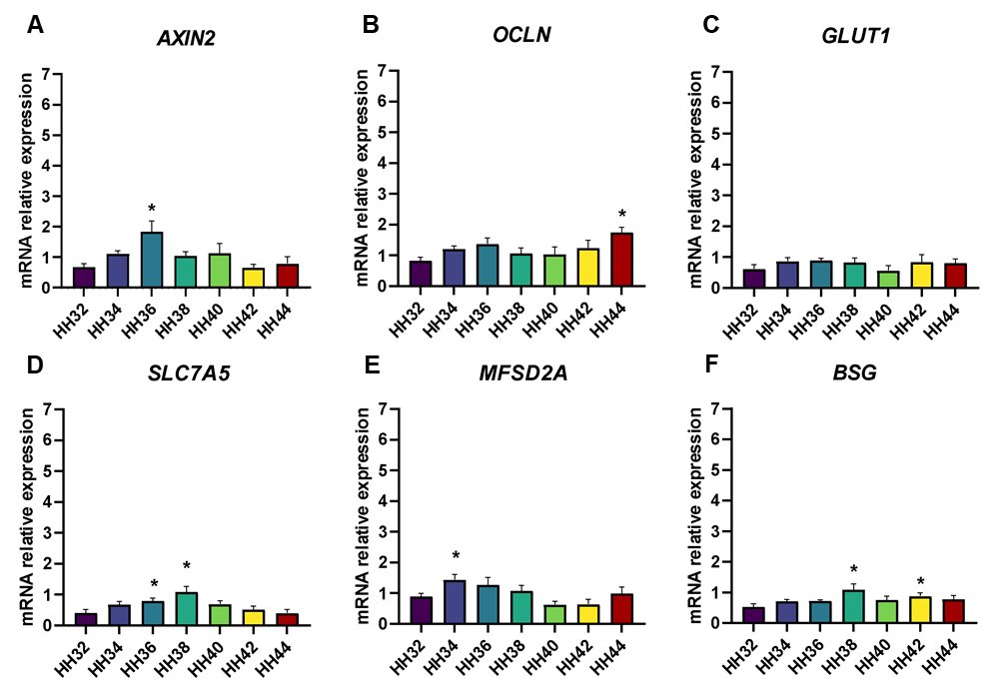Supplementary Figure 1. Transcriptional dynamics of additional BBB-associated genes in the developing Gallus gallus OT. Relative mRNA expression of (A) AXIN2, (B) OCLN, (C) GLUT1, (D) SLC7A5, (E) MFSD2A and (F) BSG in Gallus gallus embryo OT at development stages as indicated. Expression levels were normalized to the reference genes ATCB and AARS1 and calculated relative to HH38. Data are presented as mean ± SEM (n = 5, each in duplicate). ns, not significant; *p < 0.05 (One way ANOVA against HH32).

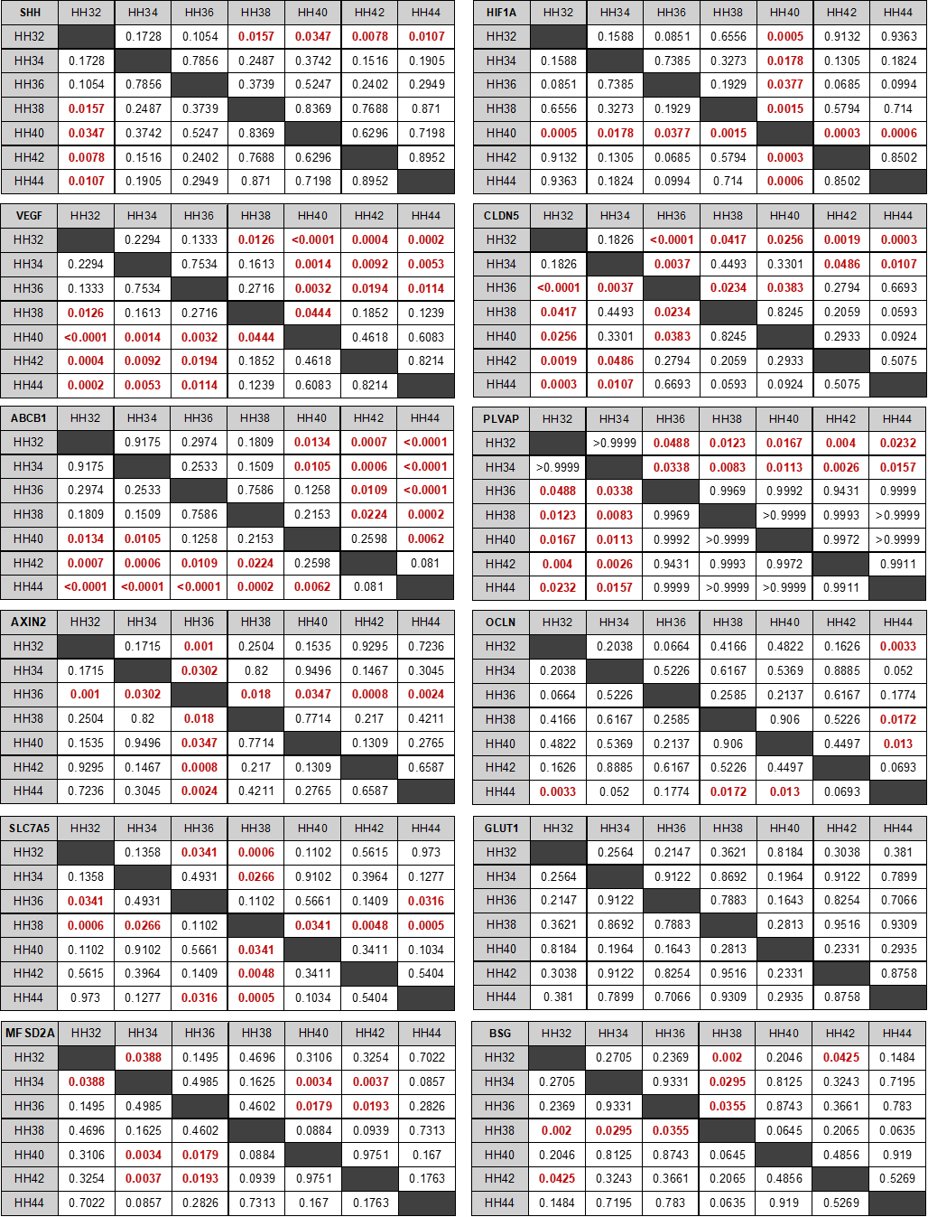Supplementary Figure 2. Multiple comparison analysis of BBB- related genes across experimental development stages. Data are presented as p-value according to One way ANOVA analysis followed by Fisher’s LSD test. Comparisons with p-value < 0.05 are highlighted in red.
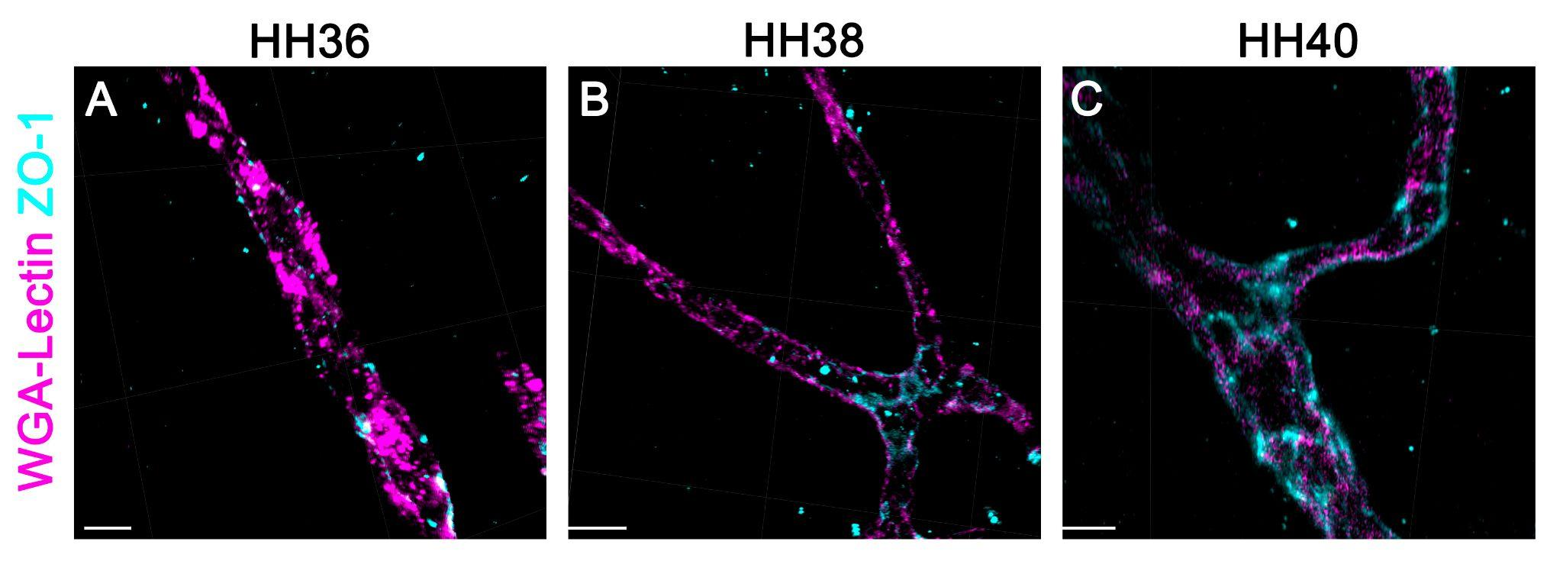

Supplementary Figure 3. Tridimensional reconstruction of ZO-1 distribution across developing OT. Representative 3D images of OT sections labeled for blood vessels (magenta) and ZO-1 (cyan) at HH36 (A), HH38 (B) and HH40 (C) developmental stages. Scale bar = 200 µm.

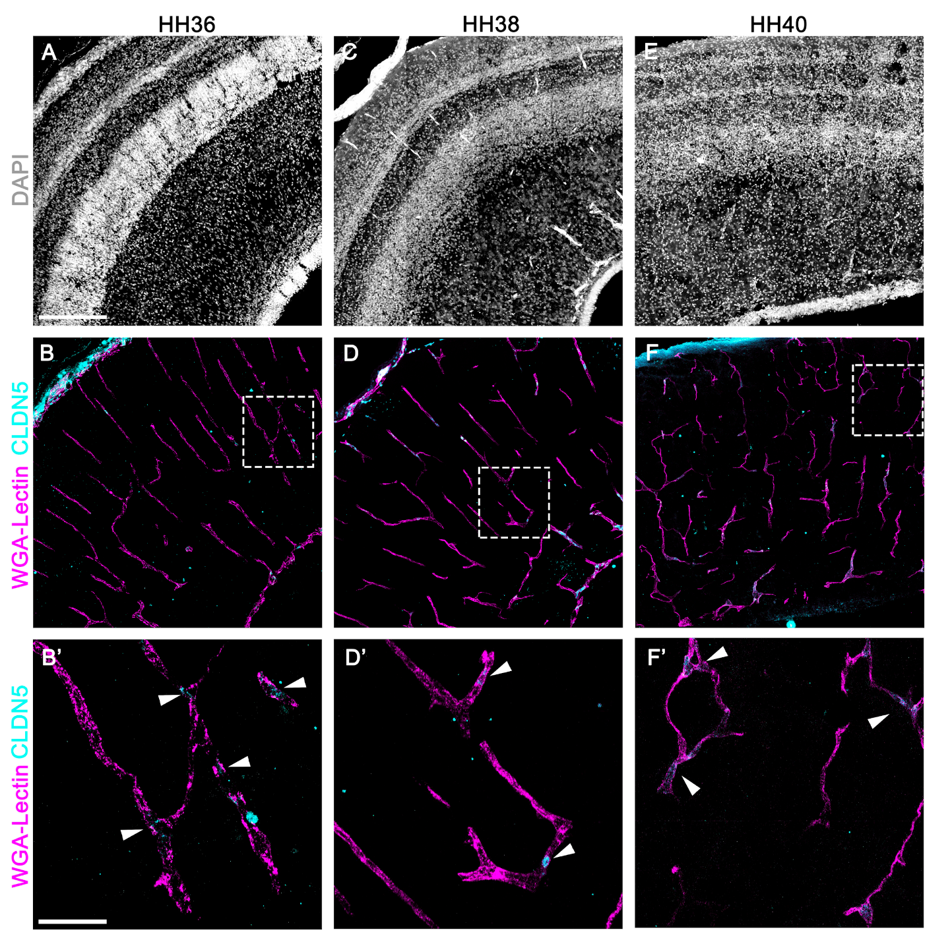
Supplementary Figure 4. Claudin-5 immunoreactivity in developing OT blood vessels. Representative images showing tissue parenchyma (nuclear staining – gray), blood vessels (magenta) and CLDN5 (cyan) at HH36 (A-B’), HH38 (C-D’) and HH40 (E-F’) developmental stages; Scale bar = 200 µm. Magnifications correspond to area delimited in white doted squares; Scale bar = 50 µm. Arrowheads indicate blood vessels regions positive for CLDN5 signal.

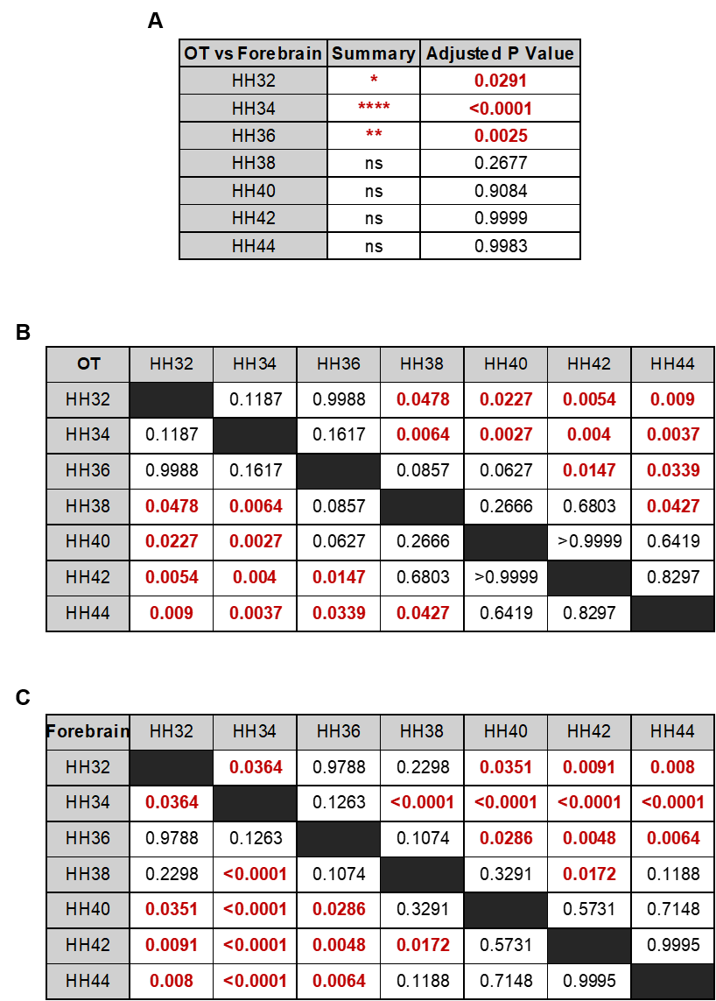

Supplementary Figure 5. Multiple comparison analysis for EB permeability assay. Data presented as p-value according to Two- way RM ANOVA analysis. Comparisons with p-value < 0.05 in red text. (A) Comparison between OT and Forebrain for the same developmental stages. (B) and (C) show comparisons in EB concentration between OT and forebrain for every development stage, separately.

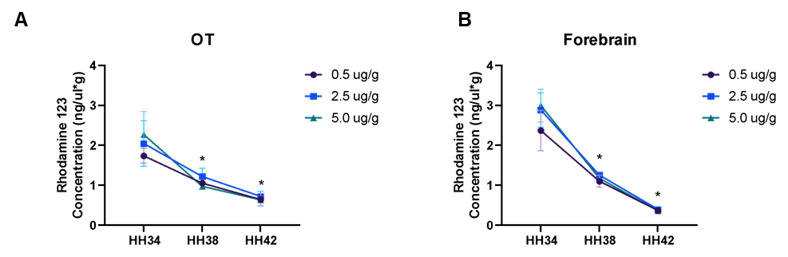

Supplementary Figure 6. Validation of the Rhodamine-123 (R123) assay for assessing P-glycoprotein (P-gp) function. Quantification of R123 tissue concentration (ng/µL*g) in the (A) OT and (B) Forebrain. Across three different injected concentrations, a progressive decrease in R123 accumulation is observed from HH34 to HH42, indicating a developmental increase in functional P-gp efflux activity. Data are presented as mean ± SD (n = 5). Statistical significance was determined using a Two-way RM ANOVA (*p < 0.05)

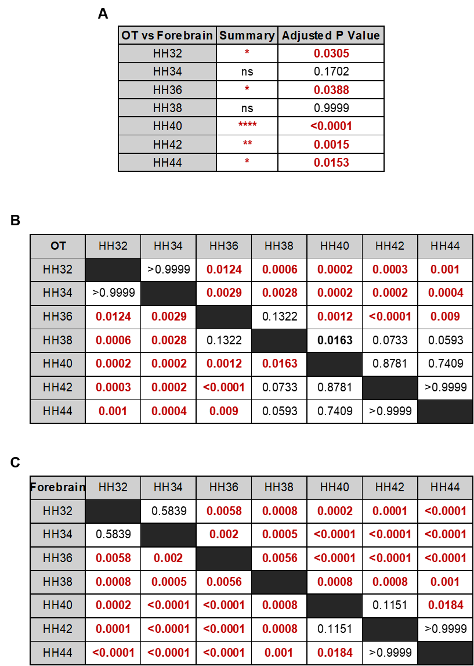
Supplementary Figure 7. Multiple comparison analysis for R123 efflux assay. Data is presented as p-value according to Two way RM ANOVA. Comparisons with p-value < 0.05 in red. (A) Comparison between OT and Forebrain for the same stages. (B) and (C) show comparisons in R123 concentration between OT and Forebrain for every development stage, separately.

Table 1: Primer sequences used for qPCR analysis. List of forward (Fw Sequence) and reverse primers (Rv Sequence) for reference genes and target genes involved in signaling (SHH, HIF1A, VEGF, AXIN2), tight junctions (CLDN5, OCLN), and transport (ABCB1, PLVAP, GLUT1, SLC7A5, MFSD2A, BSG). All sequences are derived from the Gallus gallus genome.
Gene | Species | Fw Sequence 5’-3 | Rv Sequence 5’-3’
AARS1 | Gallus gallus | TCAATCGATGAGACCAGGCG | TGATTTCCTGCGTGGACAGG
ACTB | Gallus gallus | ACCGCAAATGCTTCTAAACCG | TGAGTCAAGCGCCAAAAGAA
SHH | Gallus gallus | CCATCACTCCGAGGAATCGC | CTCCTGATTTCGCTGCCACT
HIF1A | Gallus gallus | TGGGACTCACTCAGTTCGAT | GCTGGTCAGCGTACACTTCA
VEGF | Gallus gallus | CAAGAAAGGCCGGTACAAACCA | TCGACTTGCAACGTGAGTCTGT
AXIN2 | Gallus gallus | ACGTTGGAGAACGGGTACAG | GGGGGATCCCATCTACACTG
CLDN5 | Gallus gallus | ATGCAGTGCAAGGTGTACGA | GATCACGATGCGGGACTTCA
OCLN | Gallus gallus | GGCCTTCGTCATGCTCATCG | GTCCACGGTGCAGTAGTGGT
ABCB1 | Gallus gallus | GCCTCACAAGTAAAAGGAGCAA | CTGCCACTGCAATGATTGGT
PLVAP | Gallus gallus | CCGGAATGCCAACCTGACAC | CCTTCTGATGTCCTCTAGCCTG
GLUT1 | Gallus gallus | GAGCGGCAGCAAGATGACAG | TGGGCTCCTCATATCGGTACA
SLC7A5 | Gallus gallus | AGATTGCAACGGGTGATGTG | GATGATAGCCAGAGGCAGGTT
MFSD2A | Gallus gallus | CTACGCTCAGCCTGGACTTC | TTCTTGTTCTCCCTGCGCTT
BSG | Gallus gallus | GATGCTACAGGTCCGGTGAT | ACCTTCCCCTCGATCGTGTA

