Supplementary Material: Genetics

Supplementary Methods – Genetics

Structural analysis
Structural analysis was performed with UCSF Chimera X [1], essentially as described [2], using the following ribosomal structures: bacterial (8B0X, Resolution: 1.55 Å. Organism: Escherichia coli B) [3], archaeal (9E6Q, Resolution: 1.95 Å. Organism: Pyrobaculum calidifontis JCM 11548) [4], eukaryotic cytoplasmic (8QOI. Resolution: 1.90 Å. Organism: Homo sapiens) [5], mitochondrial (7QI4 and 6ZM5, Resolution: 2.21 Å and 2.89 Å, respectively. Organism: Homo sapiens) [6,7], and chloroplast (6ERI, Resolution: 3.00 Å. Organism: Spinacia oleracea) [8]. The structures were superposed onto the human mitoribosomal structure with the Matchmaker utility of UCSF Chimera X [1], using the large subunit (LSU) rRNA as a reference chain. Hydrogen bonds were identified with the H-bonds utility of UCSF Chimera X with distance and angle tolerances of 0.4 Å and 20°, respectively.

Structural rRNA alignment
Vertebrate MT-RNR2 sequences were retrieved programmatically using a custom Python script. Returned FASTA files were inspected to ensure unique headers, consistent formatting, and absence of control region contamination.

The following organisms were included in the structural alignment:
Organism GenBank Accession
Homo sapiens NC_012920.1
Alligator mississippiensis NC_001922.1
Artibeus jamaicensis NC_002009.1
Balaenoptera musculus NC_001601.1
Balaenoptera physalus NC_001321.1
Bos taurus NC_006853.1
Canis lupus familiaris NC_002008.4
Cebus albifrons NC_002763.1
Ceratotherium simum NC_001808.1
Cyprinus carpio NC_018366.1
Danio rerio NC_002333.2
Dasypus novemcinctus NC_001821.1
Didelphis virginiana NC_001610.1
Equus asinus NC_001788.1
Equus caballus PX583272.1
Erinaceus europaeus NC_002080.2
Felis catus NC_001700.1
Gallus gallus NC_040902.1
Glis glis NC_001892.1
Gorilla gorilla NC_011120.1
Halichoerus grypus NC_001602.1
Hippopotamus amphibius NC_000889.1
Hylobates lar NC_002082.1
Loxodonta africana NC_000934.1
Macaca sylvanus NC_002764.1
Macropus robustus NC_001794.1
Mus musculus NC_012387.1
Nycticebus coucang NC_040292.1
Ornithorhynchus anatinus NC_000891.1
Oryctolagus cuniculus NC_001913.1
Ovis aries NC_001941.1
Pan paniscus NC_001644.1
Pan troglodytes NC_001643.1
Papio hamadryas NC_061413.1
Phoca vitulina NC_001325.1
Pongo abelii NC_002083.1
Pongo pygmaeus NC_001646.1
Rattus norvegicus NC_001665.2
Rhinoceros unicornis NC_001779.1
Sciurus vulgaris NC_002369.1
Sus scrofa NC_039090.1
Talpa europaea NC_002391.1
Tarsius bancanus NC_002811.1
Vicugna pacos NC_002504.1
Xenopus laevis NC_001573.1

Seed construction and structural model generation
Minimal secondary structure seed scaffolds in Stockholm format were generated programmatically using custom scripts. These scaffolds provided only the formal structural framework (balanced paired/unpaired states) required by Infernal (Infernal v1.1.5) cmbuild to create a structure-aware covariance model (CM) [9]. CM indices were produced using Infernal cmpress [9].

Each vertebrate dataset was aligned to its corresponding CM using Infernal’s cmalign. In addition to the native Stockholm output, aligned FASTA (AFA) files were produced using the --dnaout and --outformat afa options [9]. Alignment confidence was assessed using Infernal’s posterior probabilities (PP), truncation warnings, and bit scores. Human sequences consistently achieved bit scores above ~1000 and PP ≈ 0.997, confirming correct seed model construction. Divergent groups (birds, amphibians, fish) displayed lower but structurally coherent scores, consistent with expected mitochondrial rRNA evolutionary divergence. Posterior probabilities were summarized per column (PPmean), per species, and across SS_cons-defined structural motifs (helices and loops). Heatmap visualization confirmed the absence of major misalignments or structure-violating regions. Motif-level consistency further supported correct structural placement across the alignment.

Posterior-probability processing and structural-motif evaluation
Posterior probabilities (PP) were extracted from the Infernal Stockholm files using a custom Python script and converted into numeric values following the Infernal PP scale [9]. Numeric processing was performed in Python using numpy arrays, and summary metrics (per column, per species, and per motif) were derived from these matrices. Structural motifs (helices and loops) were derived from Infernal’s SS_cons annotation using a Python parser that identified contiguous paired and unpaired regions. Structural motifs were mapped to human MT-RNR2 coordinates and to genomic positions (NC_012920.1). Heatmaps were generated with Matplotlib and summary metrics confirmed alignment quality, with high PP across conserved helices and no evidence of structure-violating misalignments.

Visualization
Final Infernal alignments were visualised in Jalview 2.11.5.1 [10] using the aligned FASTA outputs. Column conservation, compensatory base-pair signals, and secondary-structure boundaries were inspected for conformity with CM-derived alignment structure.

Supplementary Results – Genetics

Mitochondrial DNA sequencing identifies a rare homoplasmic MT-RNR2 variant
Given the strict maternal inheritance pattern observed across the pedigree, whole mitochondrial genome sequencing was performed in five affected maternal-line relatives spanning multiple branches of the family. All sequenced individuals fulfilled the biomarker-based diagnostic criteria defined in the main study.

Whole mitochondrial genome sequencing identified multiple sequence variants. The majority represented homoplasmic haplogroup-defining polymorphisms and were excluded from further consideration. Among the remaining private variants, two were homoplasmic synonymous coding variants, one was a control region variant located outside known regulatory binding sites, and one was a heteroplasmic synonymous variant not present in all affected individuals; these variants were not considered further. After systematic filtering based on segregation pattern, predicted functional relevance, and population frequency, a single rare homoplasmic variant remained: MT-RNR2 m.1681G>A; NC_012920.1. This variant was present in all five distantly related affected maternal-line individuals and was homoplasmic in all carriers, with variant allele fractions exceeding 99%.

Population database interrogation demonstrated that m.1681G>A is extremely rare. In the MITOMAP full-length sequence dataset, the variant was observed once among 62,556 sequences (frequency 0.002%, Supplementary Genetics Table 1) [11]. In the gnomAD mitochondrial DNA dataset, m.1681G>A was detected in two individuals among 56,420, both at low heteroplasmy (maximum observed heteroplasmy 0.167; overall allele frequency 3.5 × 10⁻⁵), with no homoplasmic carriers reported [12].

Structural localisation and conservation of m.1681
MT-RNR2 spans the human mitochondrial genome positions 1671–3229 and encodes the 16S mitochondrial (mt) ribosomal RNA of the large ribosomal subunit (LSU). Position m.1681 lies within the 5′ region of this gene (Supplementary Genetics Figure 1A-B). The guanine at position 1681 is highly conserved across species (compare to the bacterial 23S rRNA sequence in Supplementary Genetics Figure 1C-D); MITOMAP reports a mitochondrial conservation score of 95.56% for this nucleotide [11], whereas the universal conservation (NF value = 1,576) is above 90% (Supplementary Genetics Table 1) [13].

Structural annotation shows that m.1681G participates in a canonical base pair with m.1771C in helix H23 of the LSU rRNA (Supplementary Genetics Figure 1A-B). A triple base interaction is formed via a trans sugar–sugar (tSS) interaction between m.1681G and m.1776G (Supplementary Genetics Figure 2A). It seems likely that this conserved triple plays an important role in the stabilization of a compact three-way junction involving helices H3, H4, and H23 of domain I of 16S mt-rRNA (Supplementary Genetics Figure 1E) [14]. The primary structural arrangement of this triple interaction is conserved across ribosomal structures from bacteria, archaea, eukaryotic cytosolic ribosomes, mitochondria, and chloroplasts (Supplementary Genetics Figure 2). Further, no variants have been reported in MITOMAP at either m.1771C or m.1776G [11], in agreement with its functional importance (Supplementary Genetics Table 1). The degree of universal conservation of these positions is similar to that of m.1681 (Supplementary Genetics Table 1).

Bacteria | 80S Human | Chloroplast | Archea | Mitochondria | NF | MLC | Heteroplasmy | MITOMAP freq (FL) | Helix freq
35G | 24G | 34G | 28G | m.1681G | 1,576 | 0.238 | 0.167 | 0.002% | NR
445C | 351C | 457C | 476C | m.1771C | 1,487 | 0.657 | NR | NR | NR
450G | 356G | 462G | 481G | m.1776G | 1,502 | 0.699 | NR | 0% | 0%
Supplementary Genetics Table 1.
NR, not reported. NF, Nucleotide frequency values for large subunit (LSU) rRNA residues have been calculated by using 1045 LSU rRNA sequences from all three phylogenetic domains, Eubacteria, Archaea and Eucarya (including nuclear, mitochondria and chloroplast sequences) [13]. According to the authors, 100% conservation would yield a NF of 2, 90% conservation would result in NFs around 1.5, 60–80% conservation in NFs near 1.0, 40–50% conservation in NFs approaching 0.5 and total lack of conservation in NFs below 0 [15].
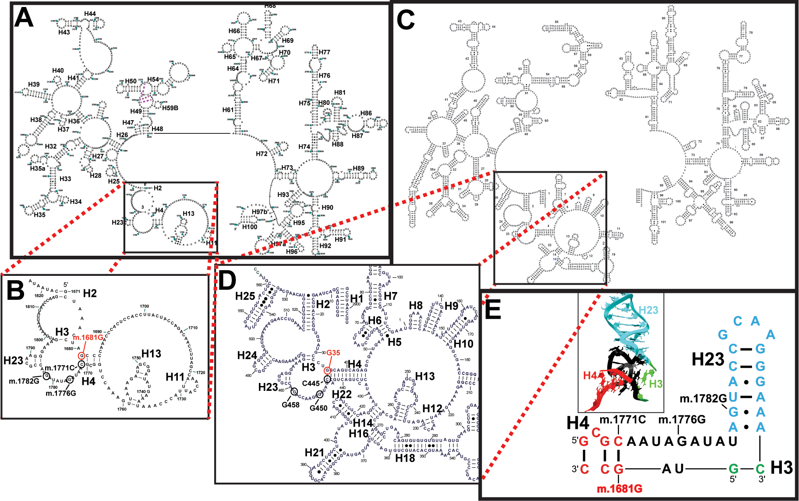
Supplementary Genetics Figure 1: Secondary Structure.
A. Secondary structure of human 16S mt-rRNA. B. Close-up view of the region boxed in A. C. Secondary structure of bacterial 23S rRNA. D. Close-up view of the region boxed in B. The variant site and its heterologous equivalent are indicated in red font in B and D. Other sites of interest are shown in black font. E. Secondary structure of the mitochondrial three-way junction containing helices H3, H4, and H23 [14]. Inset, three-dimensional view of the same region. Helix numbers are indicated in B, D, and E.

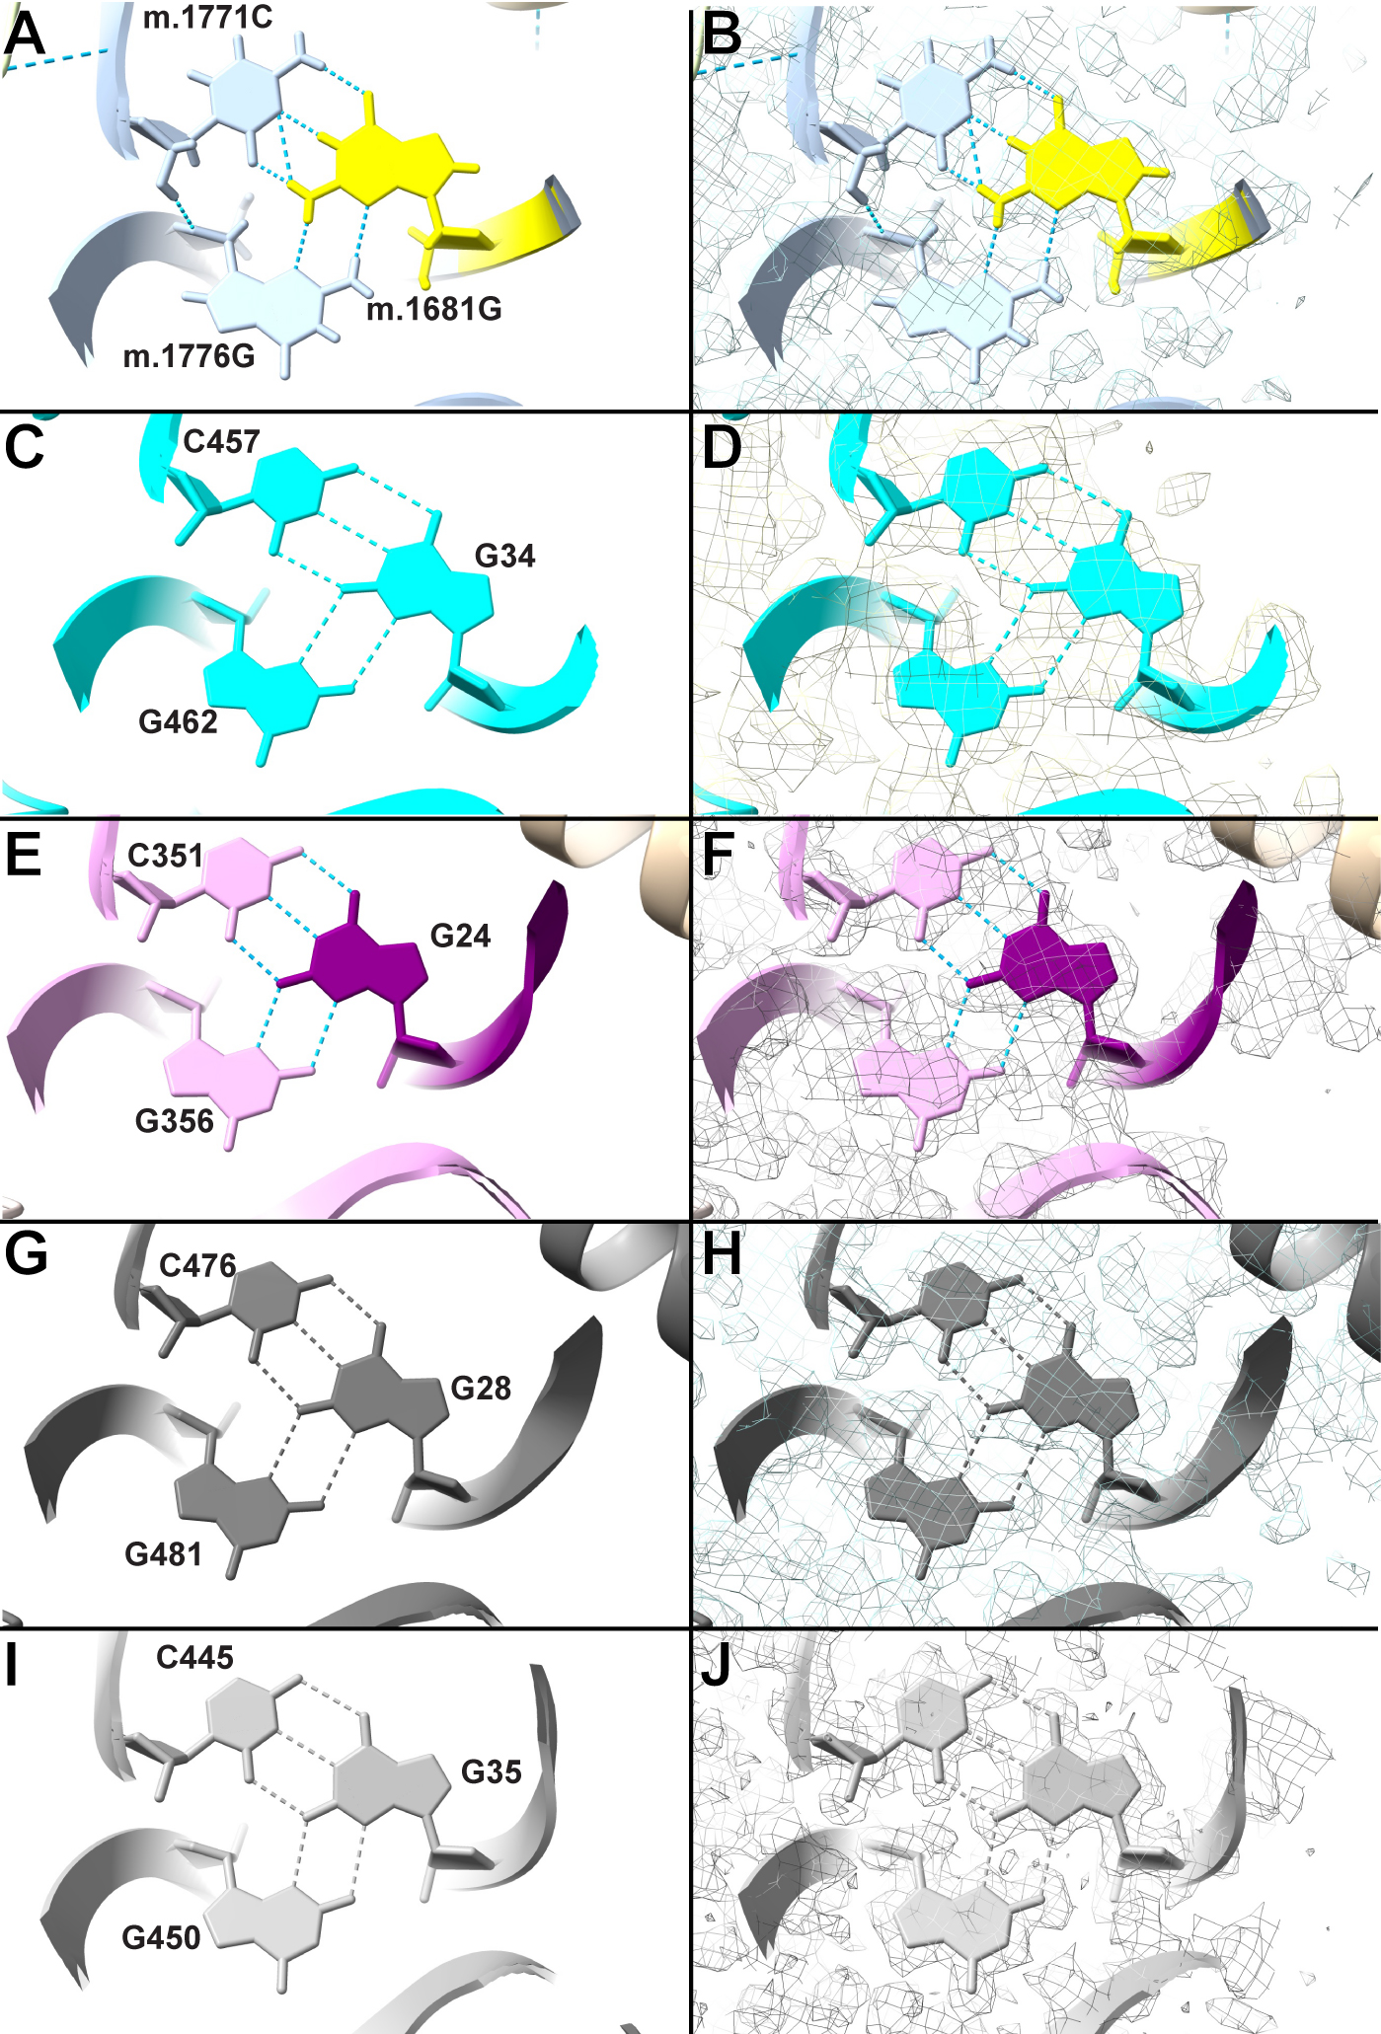
Supplementary Genetics Figure 2. Conservation of the m.1681G:m.1771C●m.1776G triple.
A-B. The triple in human mitochondria. RCSB ID: 7QI4 [7]. C-D. The triple in the chloroplast ribosome. E-F. The triple in the human cytoplasmic ribosome. G-H. The triple in the archaeal ribosome. I-J. The triple in the bacterial ribosome. Position m.1681G is shown in yellow in (A-B). All positions of interest are labeled according to numbering used in structure. UCSF-ChimeraX-determined hydrogen bonds shown as broken, blue lines. Cryo-EM density, black mesh. Rendered with UCSF ChimeraX [1]. Structures used: Bacterial (8B0X, Resolution: 1.55 Å. Organism: Escherichia coli B. 23S rRNA, dark gray [3], archaeal (9E6Q, Resolution: 1.95 Å. Organism: Pyrobaculum calidifontis JCM 11548. 23S rRNA, dim gray [4], eukaryotic cytoplasmic (8QOI. Resolution: 1.90 Å. Organism: Homo sapiens. 5.8S rRNA, purple; 28S rRNA, plum [5] mitochondrial (7QI4, Resolution: 2.21 Å. Organism: Homo sapiens. 16S rRNA [7], and choroplast (6ERI, Resolution: 3.00 Å. 23S rRNA, cyan. Organism: Spinacia oleracea [8] ribosomes. Color names taken from the UCSF ChimeraX palette [1].

Several mitochondrial LSU ribosomal proteins involved in central-body formation (uL4m, bL20m, mL44) and peptide exit-tunnel assembly (uL29m, uL24m) bind in the vicinity of m.1681 [16]. The contacts detected between each of these proteins and the m.1681 region are shown in Supplementary Genetics Table 2: RNA-protein contacts.

Supplementary Genetics Table 2: RNA-protein contacts
rRNA residue | rRNA atom | Amino acid | AA atom | Protein (modern name)
m.1680A | OP1 | Lys 230 | HZ1 | MRPL47 (uL29m)
m.1681G | OP2 | Lys 230 | HZ2 | MRPL47 (uL29m)
m.1682C | OP1 | Arg 222 | HE | MRPL47 (uL29m)
m.1683C | H42 | Asn 225 | OD1 | MRPL47 (uL29m)
m.1684C | HO2′ | Tyr 111 | O | MRPL4 (uL4m)
m.1767G | O6 | Asn 225 | HD21 | MRPL47 (uL29m)
m.1768G | O6 | Lys 229 | HZ2 | MRPL47 (uL29m)
m.1770G | OP1 | Arg 108 | HH21 | MRPL4 (uL4m)
m.1771C | OP1 | Arg 11 | NH1/NH2 | MRPL20 (bL20m)
m.1772A | OP2 | Lys 33 | HZ1 | MRPL44 (mL44)
m.1772A | OP1 | Arg 11 | HH11 | MRPL20 (bL20m)
m.1773A | N1 | Arg 40 | NH1 | MRPL24 (uL24m)
m.1773A | N1 | Arg 40 | NH2 | MRPL24 (uL24m)
m.1773A | OP2 | Val 31 | N | MRPL44 (mL44)
m.1774U | O4’ | Arg 147 | HE | MRPL4 (uL4m)
m.1775A | OP1 | Gly 148 | NH | MRPL4 (uL4m)

In addition, m.1681G>A lies within the 5-base-pair merge window of a validated mitochondrial RNA cleavage boundary cantered at position 1682, identified through population-scale RNA-sequencing analyses [17]. In that study, cleavage sites were defined as local clusters of read termini, with peaks within 5 bp merged as a single biological boundary. Position 1682 represented one of the strongest cleavage signals within MT-RNR2. Variation in cleavage efficiency at this boundary was associated with transcript levels of nine mitochondrial genes (MT-RNR1, MT-RNR2, MT-ND1, MT-ND2, MT-CO2, MT-ATP6, MT-ND4, MT-ND5, and MT-CYB), spanning multiple oxidative phosphorylation complexes.

Together, these results identify MT-RNR2 m.1681G>A as the only rare homoplasmic mitochondrial DNA variant shared across all sequenced affected maternal-line individuals, localised to a highly conserved region of the mitochondrial large ribosomal RNA and adjacent to a validated mitochondrial RNA processing boundary.

Interestingly, an A residue occurs at the position equivalent to m.1681 in Sciurus vulgaris. Structural alignment of 47 vertebrate sequences (Supplementary Genetics Figure 3) shows that the nucleotide equivalent to m.1771 in this species is a T, thereby preserving canonical Watson–Crick pairing with the A residue, while the equivalent of m.1776 remains G. Thus, in this evolutionary context, the triple interaction is maintained through compensatory pairing, in contrast to the A–C mismatch predicted in the human m.1681G>A variant.

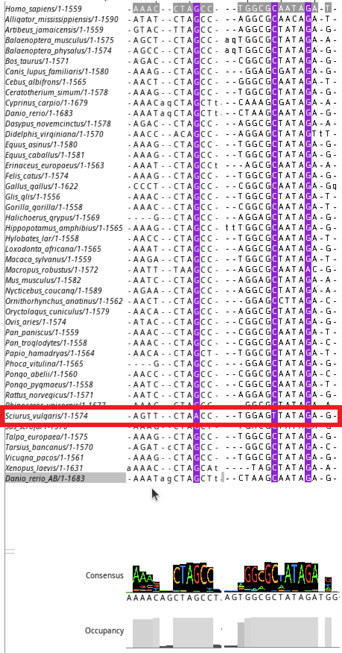
Supplementary Figure 3. Structural alignment of vertebrate 16S mt-rRNA sequences. The alignment was visualized with Jalview [10]. Jalview consensus and occupancy and plots are provided.

Supplementary Discussion – Genetics

1. Overview and scope
The identification of a rare homoplasmic MT-RNR2 m.1681G>A variant in all sequenced affected maternal-line individuals, together with a choroid plexus (ChP)-centred bioenergetic phenotype, raises the question of whether this variant contributes causally to disease. Below, we evaluate genetic, population, structural, and biological evidence bearing on a possible pathogenic role for m.1681G>A, while explicitly acknowledging remaining uncertainties and the need for functional validation.

2. Genetic evidence and inheritance pattern
The pedigree shows strict maternal transmission with essentially complete penetrance among maternal-line descendants and no affected paternal-line relatives across four generations. Within this context, mtDNA sequencing in five distantly related maternal-line individuals spanning multiple branches of the pedigree revealed homoplasmic m.1681G>A in MT-RNR2 in all carriers, with no other rare, homoplasmic non-synonymous mtDNA variants detected. This pattern — strict maternal inheritance, complete concordance of the variant with disease status in all sequenced individuals, and absence of disease in paternal-line relatives — is most consistent with involvement of the mitochondrial genome. High heteroplasmy levels or homoplasmy are generally associated with clinical manifestation of mitochondrial rRNA variants [18], and in adapted ACMG/AMP frameworks for mtDNA, such segregation and inheritance patterns constitute evidence for pathogenicity [19]. However, recent work indicates that some mt-rRNA variants may exert functionally dominant effects [20].

3. Population rarity and conservation
Population database interrogation confirms that m.1681G>A is extremely rare, with no reported homoplasmic carriers in large reference datasets. Together with its high cross-species conservation, this pattern is consistent with evolutionary constraint and argues against the homoplasmic state being selectively neutral.

4. Structural localisation of m.1681 within the mitoribosome
High-resolution cryo-electron microscopy structures of the human mitochondrial large ribosomal subunit place position m.1681 within a compact three-way junction in domain I of the 16S mt-rRNA [14]. At this site, m.1681 participates in a conserved tertiary triple-base interaction, stabilising the relative orientation of the three RNA helices (Supplementary Genetics Figure 1E). This architectural motif is invariant across ribosomes from bacteria, archaea, eukaryotic cytosol, mitochondria, and chloroplasts, indicating strong evolutionary constraint acting on RNA fold and three-dimensional geometry rather than on individual nucleotides in isolation [7,21,22]. The junction lies adjacent to the peptide exit tunnel and forms a densely packed binding platform for multiple mitoribosomal proteins.

5. Structural vulnerability of the m.1681-containing junction
Comparative phylogenetic analyses further underscore the structural constraint at this site. Across the three phylogenetic domains as well as mitochondria and chloroplasts, the nucleotides forming the m.1776G●m.1681G:m.1771C (G●G:C) triple exhibit conservation levels approaching 90%, with the m.1681G:m.1771C base pair conserved in approximately 94% of sequences [13]. Within mitochondrial sequences alone, conservation remains high (~85%), but substitutions typically preserve canonical or near-canonical pairing (A:U 3.9%, U-G 0.9%, A-A 0.9%, U-U 0.9% out of 233 sequences) [13].

An A residue occurs at the position equivalent to m.1681 in S. vulgaris [11]. Alignment of human and S. vulgaris MT-RNR2 sequences indicates that the position corresponding to m.1771 is a T in this species, consistent with preservation of Watson-Crick base pairing between these residues and in agreement with the above trend observed by Gutell and colleagues (Cannone et al., 2002). Structural studies show that A●G tSS base pairs can adopt geometries similar to G●G tSS interactions, albeit typically with a single hydrogen bonds [23,24]. In such configurations, the Watson–Crick face of A remains available for canonical pairing, possible allowing a G●A:U triple isosteric with the normal G●G:C. In the case of the m.1681G>A variant, the Watson-Crick portion of the triple would be substituted by a A-C mismatch. Notably, no A-C juxtapositions were detected at this site [13]. Thus, in S. vulgaris, the presence of A at the m.1681-equivalent position is accompanied by a compensatory substitution at the paired position, preserving canonical Watson–Crick geometry. In contrast, the human m.1681G>A variant introduces an uncompensated A–C mismatch at this structurally constrained site.

Taking all of this into consideration, a G-to-A base change, as in the m.1681G>A variant, would have a twofold weakening effect on the geometry of the triple. First, a single-bond m.1681A●m.1776G tSS interaction would be adopted instead of the double-bond G●G tSS normally present. Second, an A-C mismatch, instead of a three bond Watson:Crick base pair, would be expected between m.1681A and m.1771C. Despite this, the possibility of an m.1681A+•m.1771C wobble, with a protonated A, cannot be excluded [25].

6. Mechanistic hypotheses arising from structural context
6.1 Effects on mitoribosomal assembly
Structural modelling predicts that the m.1681G>A substitution converts the canonical m.1681G:m.1771C base pair into an A:C mismatch and disrupts the associated tertiary interaction with m.1776G. Together, these changes are expected to destabilise both secondary and tertiary RNA interactions within the same compact junction.

The affected three-way junction forms a major binding surface for several mitochondrial large-subunit ribosomal proteins, including MRPL4 (uL4m), MRPL20 (bL20m), MRPL24 (uL24m), MRPL29 (uL29m/MRPL47), and MRPL44 (mL44). Several of these proteins assemble as pre-formed modules that dock onto mt-rRNA during large-subunit biogenesis [16]. Disruption of the local rRNA geometry at m.1681 could therefore impair ribosomal assembly or stability. Pathogenic mutations in MRPL24 and MRPL44 are known to reduce large-subunit levels and mitochondrial translation in human disease, providing precedent for vulnerability of this assembly pathway [26–28]. Pathogenic variants affecting these and related mitoribosomal proteins define a recognised class of mitochondrial disorders characterised by impaired large-subunit assembly, reduced mitochondrial translation, and secondary bioenergetic failure [29].

Detailed inspection of protein–RNA contacts in the vicinity of m.1681 reveals that this nucleotide lies within a cluster of closely spaced electrostatic and hydrogen-bond interactions involving basic residues from several mitoribosomal proteins. Disruption of the local rRNA geometry is therefore predicted to have knock-on effects on protein docking and stability at this site. Importantly, the region surrounding m.1681 is adjacent to the lining of the peptide exit tunnel, a functionally sensitive element of the ribosome in which even subtle perturbations have been shown, in bacterial and mitochondrial systems, to impair translational fidelity, elongation dynamics, and co-translational folding.

Notably, pathogenic or functionally disruptive variants have previously been described in neighbouring structural elements of the same three-way junction, including mutations affecting the H23 loop E motif [30,31]. These variants have been shown to impair mitochondrial translation, induce compensatory mitochondrial biogenesis, and alter cellular bioenergetics in experimental systems. The proximity of m.1681 to this previously implicated structural motif provides precedent for functional vulnerability of this region and supports the notion that even subtle alterations in junction stability can have system-level consequences.

6.2 Effects on translation and exit-tunnel function
The m.1681-containing junction lies immediately adjacent to the peptide exit tunnel. In bacterial systems, mutations affecting the conserved “tentacle” of ribosomal protein L4 — structurally analogous to uL4m — have been shown to impair translational fidelity, elongation dynamics, and cell growth [32,33]. Disruption of contacts between 16S mt-rRNA and exit-tunnel-associated mitoribosomal proteins could therefore plausibly affect mitochondrial translation, even in the absence of gross assembly failure.

6.3 RNA processing at the MT-RNR2 5′ cleavage boundary
In addition to its structural context, m.1681G>A lies within the 5-bp merge window of a validated mitochondrial RNA cleavage boundary centred at position 1682, identified through population-scale RNA-sequencing analyses [17]. Cleavage efficiency at this boundary is associated with transcript levels of nine mitochondrial genes spanning multiple oxidative phosphorylation complexes.

Given that mitochondrial RNA cleavage sites represent short positional windows rather than single nucleotides, the placement of m.1681G>A within this regulatory boundary raises the possibility that the variant could alter rRNA processing efficiency and downstream transcript abundance. Structural disruption of conserved rRNA junctions and altered RNA processing are not mutually exclusive and may act in concert to impair mitoribosomal biogenesis.

6.4 Possible contribution of SHLP3 (exploratory)
MT-RNR2 also contains embedded open reading frames encoding mitochondrial-derived peptides. The open reading frame for Small Humanin-Like Peptide 3 (SHLP3) begins only 26 nucleotides downstream of position 1681 [34]. This raises the possibility that local structural changes induced by m.1681G>A could influence SHLP3 translation or signalling. This hypothesis is exploratory and secondary to the ribosomal mechanisms discussed above and has not been experimentally tested. SHLP3 has been reported to exert cytoprotective and mitochondrial-enhancing effects, including protection against aminoglycoside toxicity in cochlear hair cells [35].

7. Tissue vulnerability and phenotype coherence
MT-RNR2 encodes the 16S rRNA component of the mitochondrial large ribosomal subunit and is essential for mitochondrial protein synthesis. Pathogenic variants in mitochondrial rRNA genes can impair translation of the 13 mtDNA-encoded electron transport chain subunits, leading to oxidative phosphorylation (OXPHOS) deficiency [18]. Disease-causing variants in the companion MT-RNR1 gene, most notably m.1555A>G, are well-established causes of aminoglycoside-induced and nonsyndromic hearing loss [36], demonstrating that mitochondrial rRNA mutations can directly cause human disease.

The ChP epithelium has among the highest mitochondrial densities in the body[37] and depends on continuous ATP generation to support Na⁺/K⁺-ATPase–driven CSF secretion and transporter-mediated solute exchange [38]. ChP pathology, including oncocytic transformation and loss of transporter function, has been reported in established mitochondrial disorders such as Kearns–Sayre syndrome and MELAS [39,40]. The ChP-centred, energy-dependent clearance phenotype observed here — prolonged contrast washout, impaired ATP-dependent trace-element transport, CSF–plasma dissociation of brain-derived proteins, and diffuse “stagnation” on diffusion imaging — is therefore coherent with the expected consequences of a mitochondrial ribosomal defect. Notably, the clinical phenotype independently suggested mitochondrial involvement prior to genetic analysis.

Recent structural and functional studies have demonstrated that mutations in mitochondrial 16S rRNA can exert highly disruptive effects on mitoribosomal assembly and translational fidelity, challenging the previous assumption that mt-rRNA variants are largely benign. Highly disruptive MT-RNR2 variants have been identified in clinical samples and are now considered plausible contributors to human disease, even when extremely rare and previously unreported. Furthermore, modern base-editing experiments confirm that mutations in conserved mt-rRNA positions can directly impair respiratory chain function and cellular bioenergetics, reinforcing the biological plausibility of pathogenic MT-RNR2 variants [30,31,41,42].

8. Challenges, uncertainties, and alternative explanations
Despite these converging lines of evidence, several limitations preclude definitive causal attribution. Functional consequences of m.1681G>A on mitochondrial ribosome assembly, translation, RNA processing, oxidative phosphorylation, or ATP production have not yet been demonstrated in patient-derived systems. Transmitochondrial cybrid experiments and direct metabolic assays in fibroblasts and ChP-like cells will be required to establish molecular causality.

The variant has not previously been reported in association with human disease, and independent replication in other cohorts is currently lacking, consistent with a private familial mutation in a maternally inherited disorder. Although no alternative candidate mtDNA variants were identified in the sequenced individuals, other possibilities — including nuclear variants in linkage disequilibrium, undetected mtDNA structural variants, or more complex nuclear–mitochondrial interactions — cannot be fully excluded. Non-maternal relatives have not yet been sequenced, although the complete absence of disease in paternal-line relatives across four generations provides indirect evidence against these alternatives.

9. Provisional variant classification and future directions
Under current mitochondrial variant interpretation guidelines [19], m.1681G>A fulfils several criteria supporting pathogenicity, including segregation with disease in multiple affected maternal-line individuals, extreme population rarity, localisation to a gene with a well-established role in mitochondrial function, and homoplasmic state in affected carriers. Beyond individual criteria, the alignment of inheritance pattern, tissue-selective vulnerability, bioenergetic phenotype, and structural localisation to a conserved mitoribosomal junction is notable.

In the absence of direct functional validation, we therefore classify MT-RNR2 m.1681G>A as a variant of uncertain significance with multiple converging lines of evidence supporting a pathogenic role, pending experimental confirmation.
Ongoing work includes generation of patient-derived induced pluripotent stem cell lines for ChP-like organoids, transmitochondrial cybrids, direct assessment of oxidative phosphorylation, and targeted RNA-processing assays to evaluate cleavage efficiency at the MT-RNR2 1682 boundary. These studies will determine whether m.1681G>A causes mitochondrial dysfunction sufficient to explain the observed ChP-centred clearance failure.

Taken together, the genetic findings are most consistent with a mitochondrial ribosomal defect acting upstream of the ChP-centred clearance failure described in the main manuscript.

Supplementary References Genetics
1. Pettersen EF, Goddard TD, Huang CC, Meng EC, Couch GS, Croll TI, et al. UCSF ChimeraX: Structure visualization for researchers, educators, and developers. Protein Sci. 2021;30:70–82. https://doi.org/10.1002/pro.3943
2. Elson JL, Smith PM, Vila-Sanjurjo A. Heterologous Inferential Analysis (HIA) as a Method to Understand the Role of Mitochondrial rRNA Mutations in Pathogenesis. In: Weissig V, Edeas M, editors. Mitochondrial Medicine: Volume I, Probing Mitochondrial Function [Internet]. New York, NY: Springer; 2015 [cited 2026 Jan 20]. p. 369–83. https://doi.org/10.1007/978-1-4939-2257-4_32
3. Fromm SA, O’Connor KM, Purdy M, Bhatt PR, Loughran G, Atkins JF, et al. The translating bacterial ribosome at 1.55 Å resolution generated by cryo-EM imaging services. Nat Commun. Nature Publishing Group; 2023;14:1095. https://doi.org/10.1038/s41467-023-36742-3
4. Nissley AJ, Shulgina Y, Kivimae RW, Downing BE, Penev PI, Banfield JF, et al. Structure of an archaeal ribosome reveals a divergent active site and hibernation factor. Nat Microbiol. 2025;10:1940–53. https://doi.org/10.1038/s41564-025-02065-w
5. Holvec S, Barchet C, Lechner A, Fréchin L, De Silva SNT, Hazemann I, et al. The structure of the human 80S ribosome at 1.9 Å resolution reveals the molecular role of chemical modifications and ions in RNA. Nat Struct Mol Biol. 2024;31:1251–64. https://doi.org/10.1038/s41594-024-01274-x
6. Itoh Y, Andréll J, Choi A, Richter U, Maiti P, Best RB, et al. Mechanism of membrane-tethered mitochondrial protein synthesis. Science. 2021;371:846–9. https://doi.org/10.1126/science.abe0763
7. Singh V, Itoh Y, Del’Olio S, Hassan A, Naschberger A, Flygaard RK, et al. Mitoribosome structure with cofactors and modifications reveals mechanism of ligand binding and interactions with L1 stalk. Nat Commun. 2024;15:4272. https://doi.org/10.1038/s41467-024-48163-x
8. Perez Boerema A, Aibara S, Paul B, Tobiasson V, Kimanius D, Forsberg BO, et al. Structure of the chloroplast ribosome with chl-RRF and hibernation-promoting factor. Nat Plants. 2018;4:212–7. https://doi.org/10.1038/s41477-018-0129-6
9. Nawrocki EP, Eddy SR. Infernal 1.1: 100-fold faster RNA homology searches. Bioinformatics. Oxford, England; 2013;29:2933–5. https://doi.org/10.1093/bioinformatics/btt509
10. Waterhouse AM, Procter JB, Martin DMA, Clamp M, Barton GJ. Jalview Version 2—a multiple sequence alignment editor and analysis workbench. Bioinformatics. 2009;25:1189–91. https://doi.org/10.1093/bioinformatics/btp033
11. Ruiz-Pesini E, Lott MT, Procaccio V, Poole JC, Brandon MC, Mishmar D, et al. An enhanced MITOMAP with a global mtDNA mutational phylogeny. Nucleic Acids Res. 2007;35:D823-828. https://doi.org/10.1093/nar/gkl927
12. Laricchia KM, Lake NJ, Watts NA, Shand M, Haessly A, Gauthier L, et al. Mitochondrial DNA variation across 56,434 individuals in gnomAD. Genome Res. 2022;32:569–82. https://doi.org/10.1101/gr.276013.121
13. Cannone JJ, Subramanian S, Schnare MN, Collett JR, D’Souza LM, Du Y, et al. The comparative RNA web (CRW) site: an online database of comparative sequence and structure information for ribosomal, intron, and other RNAs. BMC Bioinformatics. 2002;3:2. https://doi.org/10.1186/1471-2105-3-2
14. Leontis NB, Westhof E. Geometric nomenclature and classification of RNA base pairs. RNA. New York, N.Y.; 2001;7:499–512. https://doi.org/10.1017/s1355838201002515
15. Ortoleva-Donnelly L, Szewczak AA, Gutell RR, Strobel SA. The chemical basis of adenosine conservation throughout the Tetrahymena ribozyme. RNA. New York, N.Y.; 1998;4:498–519. https://doi.org/10.1017/s1355838298980086
16. Lavdovskaia E, Hanitsch E, Linden A, Pašen M, Challa V, Horokhovskyi Y, et al. A roadmap for ribosome assembly in human mitochondria. Nat Struct Mol Biol. Nature Publishing Group; 2024;31:1898–908. https://doi.org/10.1038/s41594-024-01356-w
17. Carbajosa G, Ali AT, Hodgkinson A. Identification of human mitochondrial RNA cleavage sites and candidate RNA processing factors. BMC Biol. 2022;20:168. https://doi.org/10.1186/s12915-022-01373-5
18. Rötig A. Human diseases with impaired mitochondrial protein synthesis. Biochimica et Biophysica Acta (BBA) - Bioenergetics. 2011;1807:1198–205. https://doi.org/10.1016/j.bbabio.2011.06.010
19. McCormick EM, Lott MT, Dulik MC, Shen L, Attimonelli M, Vitale O, et al. Specifications of the ACMG/AMP standards and guidelines for mitochondrial DNA variant interpretation. Human Mutation. 2020;41:2028–57. https://doi.org/10.1002/humu.24107
20. Boscenco S, Tait-Mulder J, Kim M, Tang C, Park T, McNulty F, et al. Functionally dominant hotspot mutations of mitochondrial ribosomal RNA genes in cancer. Nat Genet. Nature Publishing Group; 2025;57:2705–14. https://doi.org/10.1038/s41588-025-02374-0
21. Brown A, Amunts A, Bai X-C, Sugimoto Y, Edwards PC, Murshudov G, et al. Structure of the large ribosomal subunit from human mitochondria. Science. 2014;346:718–22. https://doi.org/10.1126/science.1258026
22. Leontis NB, Westhof E. A common motif organizes the structure of multi-helix loops in 16 S and 23 S ribosomal RNAs. J Mol Biol. 1998;283:571–83. https://doi.org/10.1006/jmbi.1998.2106
23. Lawson CL, Berman HM, Chen L, Vallat B, Zirbel CL. The Nucleic Acid Knowledgebase: a new portal for 3D structural information about nucleic acids. Nucleic Acids Res. 2024;52:D245–54. https://doi.org/10.1093/nar/gkad957
24. Trausch JJ, Batey RT. A disconnect between high-affinity binding and efficient regulation by antifolates and purines in the tetrahydrofolate riboswitch. Chem Biol. 2014;21:205–16. https://doi.org/10.1016/j.chembiol.2013.11.012
25. Pan B, Mitra SN, Sundaralingam M. Structure of a 16-mer RNA duplex r(GCAGACUUAAAUCUGC)2 with wobble C.A+ mismatches. J Mol Biol. 1998;283:977–84. https://doi.org/10.1006/jmbi.1998.2140
26. Carroll CJ, Isohanni P, Pöyhönen R, Euro L, Richter U, Brilhante V, et al. Whole-exome sequencing identifies a mutation in the mitochondrial ribosome protein MRPL44 to underlie mitochondrial infantile cardiomyopathy. J Med Genet. 2013;50:151–9. https://doi.org/10.1136/jmedgenet-2012-101375
27. Di Nottia M, Marchese M, Verrigni D, Mutti CD, Torraco A, Oliva R, et al. A homozygous MRPL24 mutation causes a complex movement disorder and affects the mitoribosome assembly. Neurobiol Dis. 2020;141:104880. https://doi.org/10.1016/j.nbd.2020.104880
28. Horga A, Manole A, Mitchell AL, Bugiardini E, Hargreaves IP, Mowafi W, et al. Uniparental isodisomy of chromosome 2 causing MRPL44-related multisystem mitochondrial disease. Mol Biol Rep. 2021;48:2093–104. https://doi.org/10.1007/s11033-021-06188-1
29. Antolínez-Fernández Á, Esteban-Ramos P, Fernández-Moreno MÁ, Clemente P. Molecular pathways in mitochondrial disorders due to a defective mitochondrial protein synthesis. Front Cell Dev Biol [Internet]. Frontiers; 2024 [cited 2026 Jan 20];12. https://doi.org/10.3389/fcell.2024.1410245
30. Elson JL, Smith PM, Greaves LC, Lightowlers RN, Chrzanowska-Lightowlers ZMA, Taylor RW, et al. The presence of highly disruptive 16S rRNA mutations in clinical samples indicates a wider role for mutations of the mitochondrial ribosome in human disease. Mitochondrion. 2015;25:17–27. https://doi.org/10.1016/j.mito.2015.08.004
31. Vila-Sanjurjo A, Mallo N, Elson JL, Smith PM, Blakely EL, Taylor RW. Structural analysis of mitochondrial rRNA gene variants identified in patients with deafness. Front Physiol. 2023;14:1163496. https://doi.org/10.3389/fphys.2023.1163496
32. O’Connor M, Gregory ST, Dahlberg AE. Multiple defects in translation associated with altered ribosomal protein L4. Nucleic Acids Res. 2004;32:5750–6. https://doi.org/10.1093/nar/gkh913
33. Zaman S, Fitzpatrick M, Lindahl L, Zengel J. Novel mutations in ribosomal proteins L4 and L22 that confer erythromycin resistance in Escherichia coli. Mol Microbiol. 2007;66:1039–50. https://doi.org/10.1111/j.1365-2958.2007.05975.x
34. Cobb LJ, Lee C, Xiao J, Yen K, Wong RG, Nakamura HK, et al. Naturally occurring mitochondrial-derived peptides are age-dependent regulators of apoptosis, insulin sensitivity, and inflammatory markers. Aging. 2016;8:796–809. https://doi.org/10.18632/aging.100943
35. Lu Y, Bartoszek EM, Cortada M, Bodmer D, Levano Huaman S. Mitochondrial-derived peptides, HNG and SHLP3, protect cochlear hair cells against gentamicin. Cell Death Discov. Nature Publishing Group; 2024;10:445. https://doi.org/10.1038/s41420-024-02215-9
36. Prezant TR, Agapian JV, Bohlman MC, Bu X, Oztas S, Qiu WQ, et al. Mitochondrial ribosomal RNA mutation associated with both antibiotic-induced and non-syndromic deafness. Nat Genet. 1993;4:289–94. https://doi.org/10.1038/ng0793-289
37. Cornford EM, Varesi JB, Hyman S, Damian RT, Raleigh MJ. Mitochondrial content of choroid plexus epithelium. Exp Brain Res. 1997;116:399–405. https://doi.org/10.1007/pl00005768
38. Damkier HH, Brown PD, Praetorius J. Cerebrospinal Fluid Secretion by the Choroid Plexus. Physiological Reviews. American Physiological Society; 2013;93:1847–92. https://doi.org/10.1152/physrev.00004.2013
39. Ohama E, Ikuta F. Involvement of choroid plexus in mitochondrial encephalomyopathy (MELAS). Acta Neuropathol. 1987;75:1–7. https://doi.org/10.1007/BF00686785
40. Tanji K, Schon EA, DiMauro S, Bonilla E. Kearns-sayre syndrome: oncocytic transformation of choroid plexus epithelium. J Neurol Sci. 2000;178:29–36. https://doi.org/10.1016/s0022-510x(00)00354-3
41. Boscenco S, Tait-Mulder J, Kim M, Tang C, Park T, McNulty F, et al. Functionally dominant hotspot mutations of mitochondrial ribosomal RNA genes in cancer. Nat Genet. 2025;57:2705–14. https://doi.org/10.1038/s41588-025-02374-0
42. Connor TM, Hoer S, Mallett A, Gale DP, Gomez-Duran A, Posse V, et al. Mutations in mitochondrial DNA causing tubulointerstitial kidney disease. Larsson N-G, editor. PLoS Genet. 2017;13:e1006620. https://doi.org/10.1371/journal.pgen.1006620

