Supplementary Materials

Comparison of Water Exchange Rate in Young and Older Adults with Diffusion-Weighted and Multi-Echo Arterial Spin Labeling MRI

Figure S1: Axial view at four different slices of time of exchange (Tex) maps with Gaussian smoothing at five different isotropic kernel sizes for one healthy young participant. The use of kernel size of 10mm minimizes the number of negative Tex (neg) values across slices while preserving desired contrast.

Figure S2: Axial view at four different slices of time of exchange (Tex) maps with Gaussian smoothing at five different isotropic kernel sizes for one healthy older participant. The use of kernel size of 10mm minimizes the number of negative Tex (neg) values across slices while preserving desired contrast.

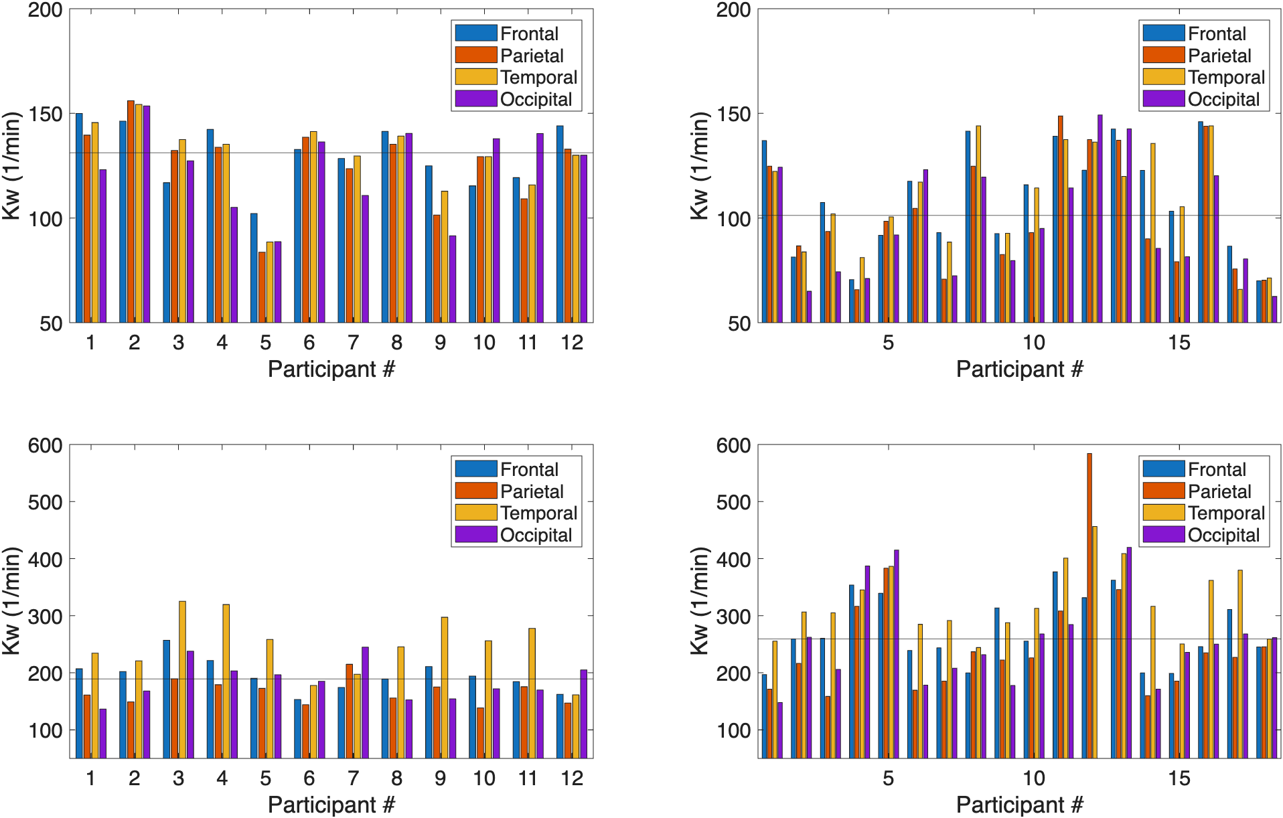
Figure S3: (A)-(B) Individual average Kw values in the four major brain lobes for diffusion-weighted (DW) ASL between young and older participants. (C)-(D) The same individual average Kw values for multi-echo (ME) ASL. The horizontal lines in these plots represent the median Kw for each cohort and sequence. For the young cohort, the median line for DW ASL is located at 131.2min⁻¹ while for ME ASL, it is located at 189.3min⁻¹. For the older cohort, the median line for DW ASL is located at 101.2min⁻¹ while for ME ASL, it is located at 259.3min⁻¹.

Figure S4: Regional t-statistics between young and older Kw cortical maps for diffusion-weighted (DW) and multi-echo (ME) ASL. The direction of change between young and old is opposite between the two sequences. Regions where the absolute t-statistics magnitude exceeds 3 are pointed out with standardized brain structure acronyms.

Table S1: Uncorrected t-test of average Kw values between older and young participants in 35 FreeSurfer gray matter cortical regions for the left hemisphere.

Table S2: Uncorrected t-test of average Kw values between older and young participants in 35 FreeSurfer gray matter cortical regions for the right hemisphere.

