Additional file 1

15 nm Ag | 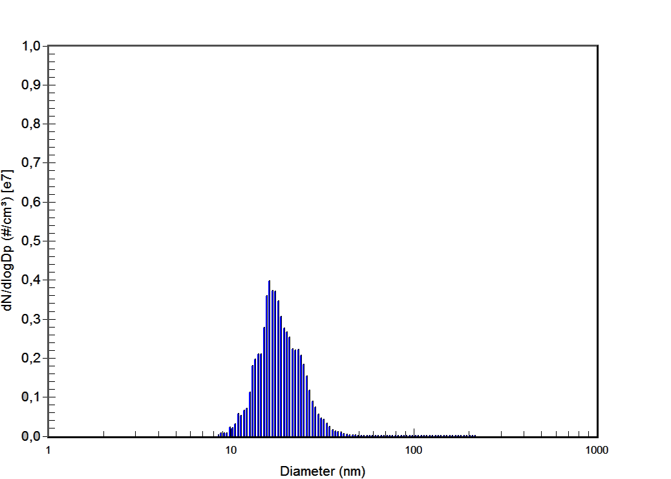
410 nm Ag | 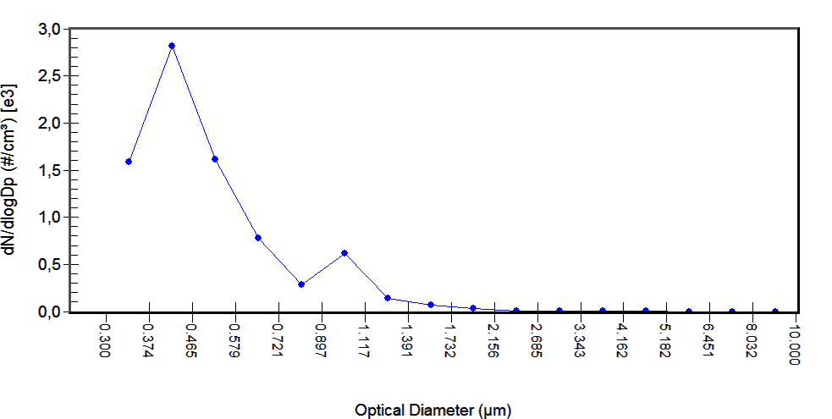

Figure S1. SMPS and OPS particle size distribution (left) and CPC particle number concentration (right) of 15 nm and 410 nm silver particles.

