Supporting Information
Figure S1. Transmission electron microscopy (TEM) and field emission-type scanning electron microscopy (FE-SEM) image of NiO NPs. (A) TEM. (B) FE-SEM.

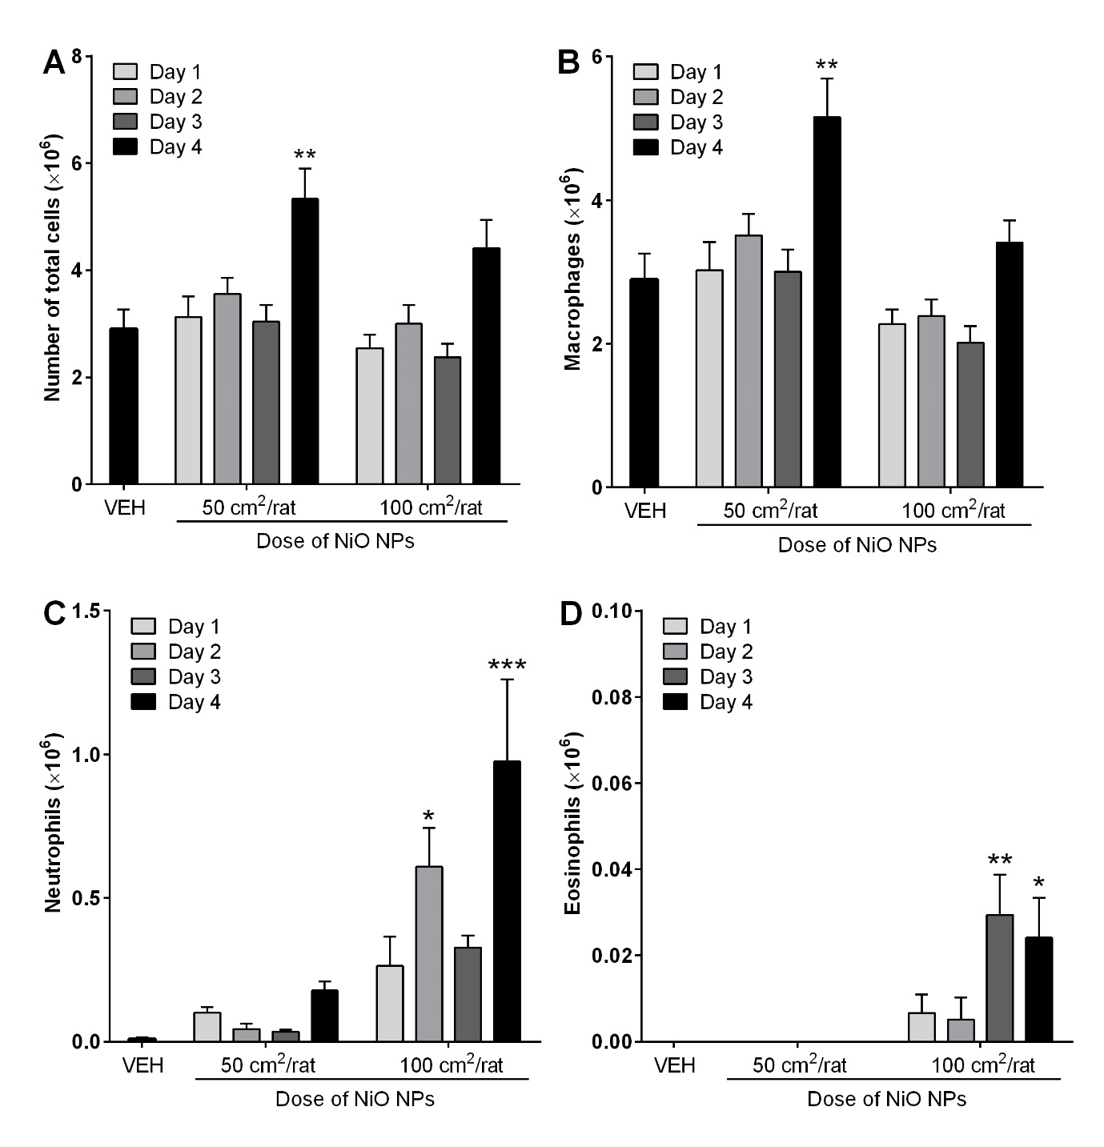
Figure S2. Cytological analysis of BALF after intratracheal instillation of NiO NPs. NiO NPs were instilled at 50 and 100 cm²/rat and cytological evaluation was performed at 1, 2, 3, and 4 days after instillation. (A), Number of total cells. (B) Number of macrophages. (C) Number of neutrophils. (D) Number of eosinophils. Mean ± SEM (n=4). One-way ANOVA test was applied for comparison between NiO NPs and vehicle control (VEH) with statistical significance indicated by *p<0.05, **p<0.01, and ***p<0.001.

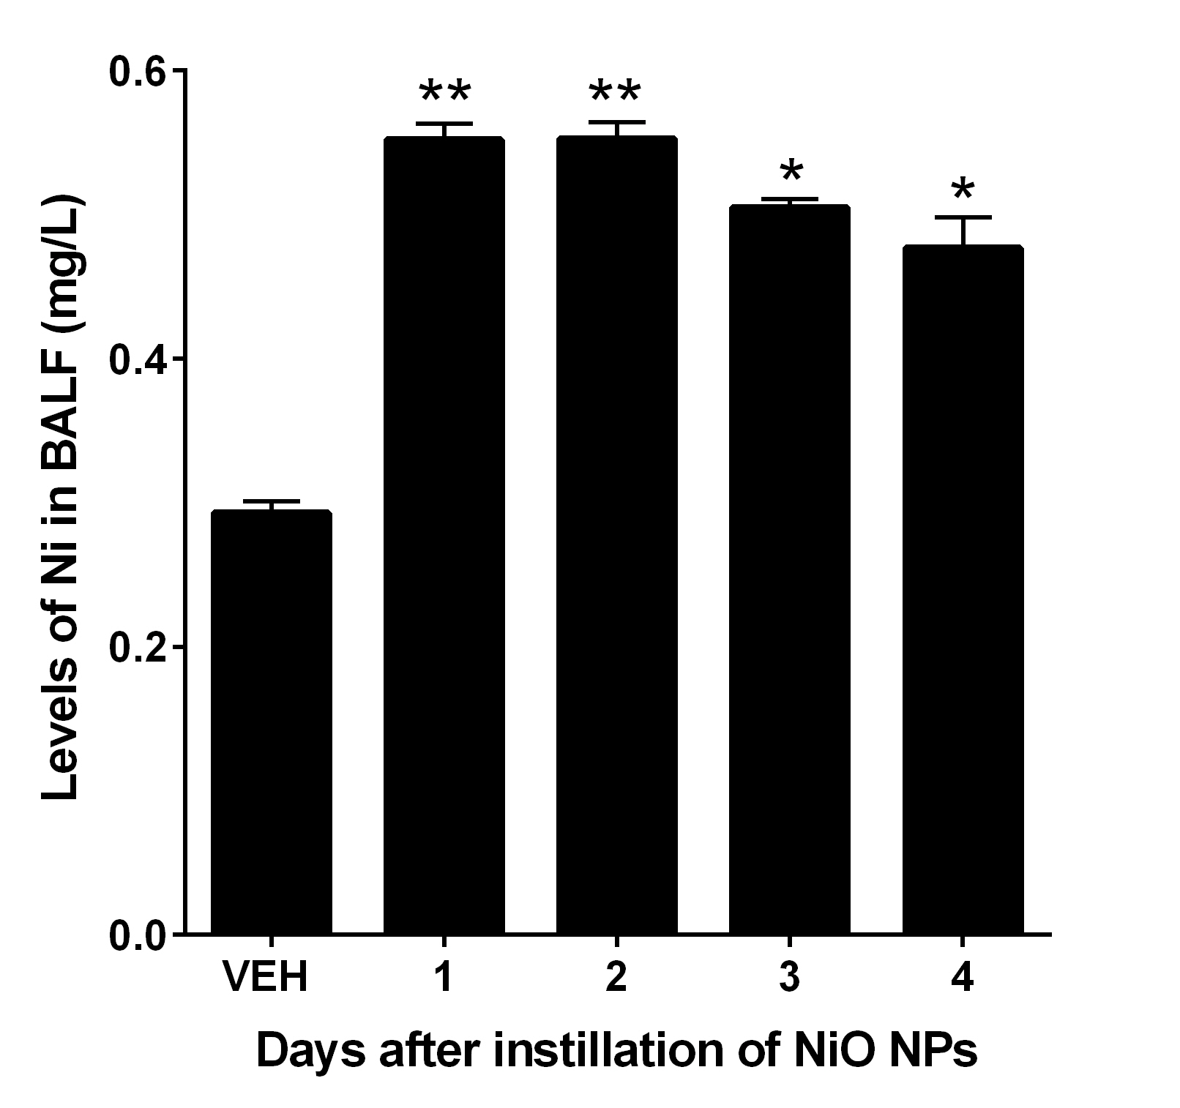
Figure S3. The levels of nickel (Ni) in BALF at 1, 2, 3, and 4 days after intratracheal instillation of NiO NPs at 200 cm²/rat. Mean ± SEM (n=4). One-way ANOVA test was applied for comparison between NiO NPs and vehicle control (VEH) with statistical significance indicated by *p<0.05 and **p<0.01.

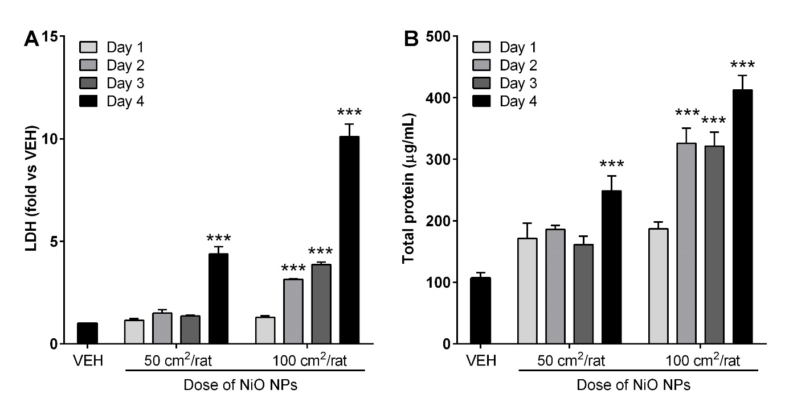
Figure S4. Levels of lactate dehydrogenase (LDH) and total protein in BALF treated with NiO NPs. NiO NPs were instilled at 50 and 100 cm²/rat and the levels of LDH and total protein were measured at 1, 2, 3, and 4 days after instillation. (A), Levels of LDH. (B), Levels of total protein. Mean ± SEM (n=4). One-way ANOVA test was applied for comparison between NiO NPs and vehicle control (VEH) with statistical significance indicated by ***p<0.001.

