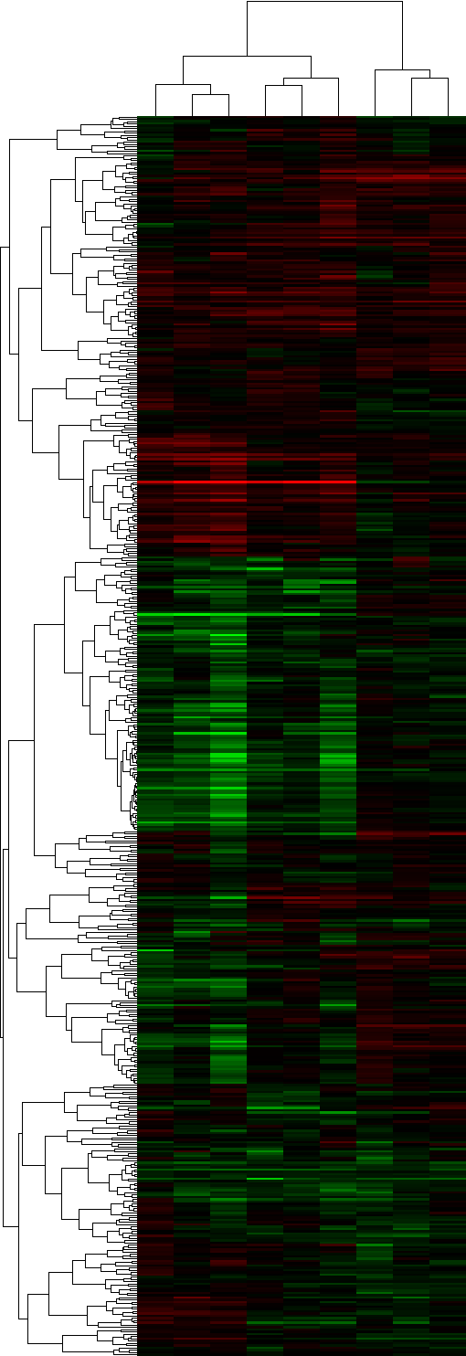
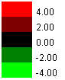
Total: 60
Total: 140
Total: 200
Insoluble: 60
Insoluble: 140
Insoluble: 200
Soluble: 140
Soluble: 60
Soluble: 200

Figure S1. Vuong et al., 2017

