Supplementary material
Figures
Figure S1. Levels of pro-inflammatory mediators in cell supernatants in vitro (adapted from [13]).
Figure S2. Levels of proteins, LDH (cytotoxicity) and intracellular ROS (oxidative stress) in BALF.
Figure S3. Examples of critical effect doses (CED) and dose intervals (CEDL/BMDL and CEDU/BMDU) determined using benchmark dose response modeling.
Figure S4. Size distribution of the NMs in water suspensions used to expose rats.
Figure S5. Initial lung burden in vivo assessed by ICP-MS 3h after instillation (n=2).

Tables
Table S1. Doses deposited in vitro in submerged conditions in function of nominal concentrations in suspensions (First published in [13] ).
Table S2. LOAELs (in µg/cm²) determined in vitro with the pro-inflammatory effects for each exposure method used (First published in [13]).
Table S3. Dose intervals (in µg/10⁶ macrophages) determined for each NM and each methodology.
Table S4. Dose intervals normalized by primary surface areas (in cm²/10⁶ macrophages) for each NM and each methodology.
Table S5. Dose intervals normalized by agglomerate surface areas (in cm²/10⁶ macrophages) for each NM and methodology.
Table S6. Characterization of mass deposited in vitro on cells after 3h exposure at the ALI to aerosols of NMs (Adapted from [13]).

Tables of results
Table S7. Total number of cells in bronchoalveolar lavage fluids in vivo.
Table S8. Number of macrophages in bronchoalveolar lavage fluids in vivo.
Table S9. Number of neutrophils in bronchoalveolar lavage fluids in vivo.
Table S10. IL-1β secretion in bronchoalveolar lavage fluids in vivo.
Table S11. IL-6 secretion in bronchoalveolar lavage fluids in vivo.
Table S12. KC-GRO secretion in bronchoalveolar lavage fluids in vivo.
Table S13. TNF-α secretion in bronchoalveolar lavage fluids in vivo.

References
Figures
Figure S1. Levels of pro-inflammatory mediators in cell supernatants in vitro (adapted from [13]).
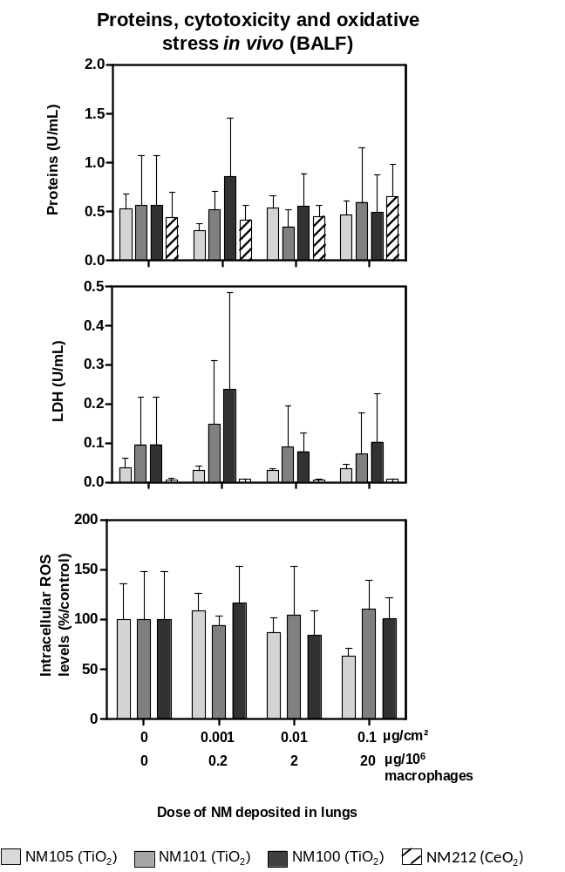

Figure S2. Levels of proteins, LDH (cytotoxicity) and intracellular ROS (oxidative stress) in BALF.
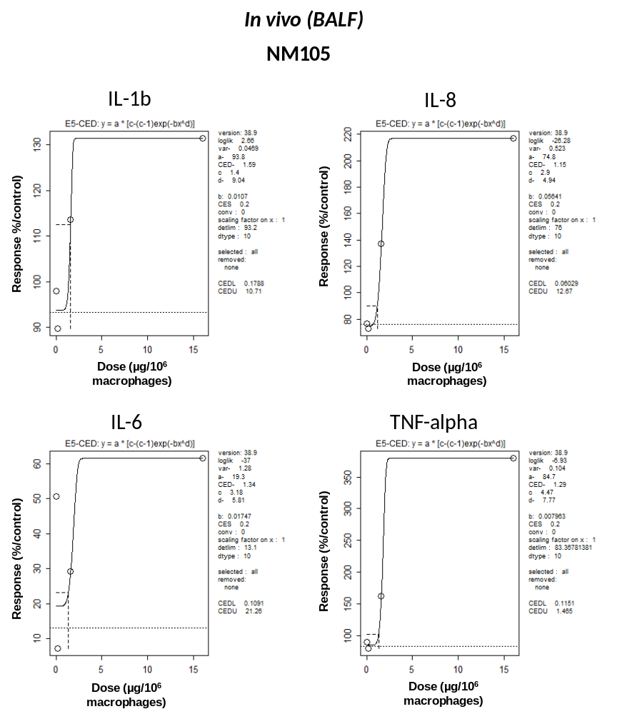
Figure S3. Examples of critical effect doses (CED) and dose intervals (CEDL and CEDU) determined using benchmark dose response modeling.

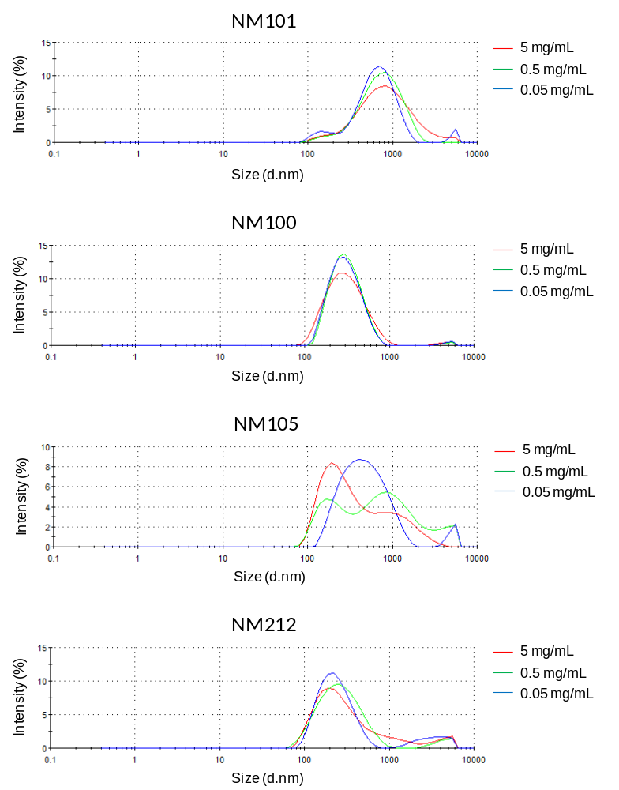
Figure S4. Size distribution of the NMs in water suspensions used to expose rats.

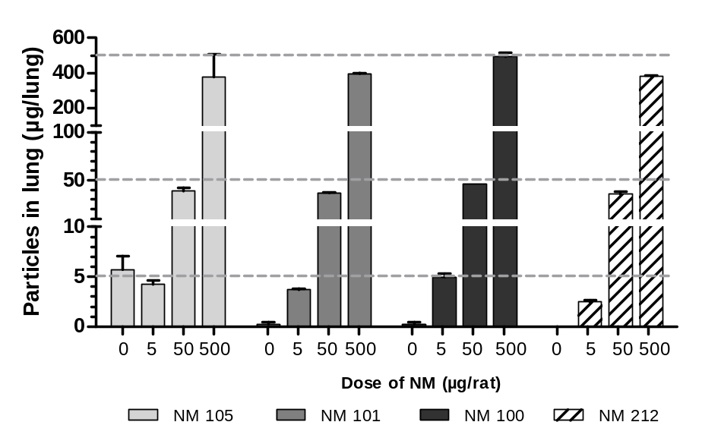
Figure S5. Initial lung burden in vivo assessed by ICP-MS 3h after instillation (n=2).

Tables

Table S1. Doses deposited in vitro in submerged conditions in function of nominal concentrations in suspensions (First published in [13]).
 |  | 24h deposition in plates |  |  |  | 3h deposition in inserts
TiO₂ NM105 | Nominal dose (µg/mL) | 10 | 50 | 100 | 200 | 54.5 | 163.5 | 544.9
TiO₂ NM105 | Nominal dose (µg/cm²) | 2.5 | 12.5 | 25 | 50 | 11.7 | 35.0 | 116.7
TiO₂ NM105 | Estimated dose using the ISDD model (µg/cm²) | 0.7 | 3.6 | 7.1 | 14.3 | 1 | 3 | 10
TiO₂ NM101 | Nominal dose (µg/mL) | 4 | 10 | 50 | 100 | 23.4 | 70.1 | 233.5
TiO₂ NM101 | Nominal dose (µg/cm²) | 1 | 2.5 | 12.5 | 25 | 5.0 | 15.0 | 50.0
TiO₂ NM101 | Estimated dose using the ISDD model (µg/cm²) | 1.0 | 2.5 | 12.5 | 25.0 | 1 | 3 | 10
TiO₂ NM100 | Nominal dose (µg/mL) | 4 | 10 | 50 | 100 | 34.3 | 102.9 | 343.1
TiO₂ NM100 | Nominal dose (µg/cm²) | 1 | 2.5 | 12.5 | 25 | 7.3 | 22.0 | 73.5
TiO₂ NM100 | Estimated dose using the ISDD model (µg/cm²) | 0.7 | 1.8 | 8.8 | 17.5 | 1 | 3 | 10
CeO₂ NM212 | Nominal dose (µg/mL) | 10 | 50 | 100 | 200 | 42.5 | 127.4 | 424.5
CeO₂ NM212 | Nominal dose (µg/cm²) | 2.5 | 12.5 | 25 | 50 | 9.1 | 27.3 | 90.9
CeO₂ NM212 | Estimated dose using the ISDD model (µg/cm²) | 0.9 | 4.7 | 9.5 | 18.9 | 1 | 3 | 10
Tested doses about (µg/cm²) |  | 1 | 3 | 10 | 20 | 1 | 3 | 10

Table S2. LOAELs (in µg/cm²) determined in vitro with the pro-inflammatory effects for each exposure method used (First published in [13]).
 | IL-1β |  |  | IL-6 |  |  | IL-8 |  |  | TNF-α
 | ALIª | Subm insert^{b} | Subm  plate^{c} | ALIª | Subm insert^{b} | Subm  plate^{c} | ALIª | Subm insert^{b} | Subm  plate^{c} | ALIª | Subm insert^{b} | Subm  plate^{c}
NM105 | 1 | 3 | 10 | 1 | 1 | 3 | 10 | 1 | 1 | 3 | 10 | 1
NM101 | 1 | 10 | 10 | 1 | 1 | 10 | 10 | 1 | 1 | 10 | 10 | 1
NM100 | Ø | Ø | Ø | 3 | Ø | Ø | Ø | 3 | Ø | Ø | Ø | 3
NM212 | 3 | Ø | Ø | 3 | 3 | Ø | Ø | 3 | 3 | Ø | Ø | 3
ªExposure at the air-liquid interface (ALI) in insert for 24h. Final deposited within 3h.
^{b}Exposure in submerged conditions in inserts for 24h. Final dose deposited within 3h.
^{c}Exposure in submerged conditions in plates. Final dose deposited within 24h.
Ø No effects measured at the tested doses

Table S3. Dose intervals (in µg/10⁶ macrophages) determined for each NM and each methodology.
 | Cytokines | NM105 |  |  | NM101 |  |  | NM100 |  |  | NM212
 | Cytokines | Dose interval |  |  | Dose interval |  |  | Dose interval |  |  | Dose interval
 | Cytokines | BMDL | BMDU | Median | BMDL | BMDU | Median | BMDL | BMDU | Median | BMDL | BMDU | Median
In vitro,  suspension  (24h) | IL-1β | 3.83 | 475.94 | 185.23  -  447.98 | 21.19 | 114.01 | 112.93  -  254.43 | 427.32 | 1303.4 | 438.55  -  1047.6 | 2.5197 | 410.28 | 17.21  -  566.71
In vitro,  suspension  (24h) | IL-6 | 180.05 | 444.26 | 185.23  -  447.98 | 194.47 | 418.63 | 112.93  -  254.43 | ND | ND | 438.55  -  1047.6 | ND | ND | 17.21  -  566.71
In vitro,  suspension  (24h) | IL-8 | ND | ND | 185.23  -  447.98 | ND | ND | 112.93  -  254.43 | ND | ND | 438.55  -  1047.6 | ND | ND | 17.21  -  566.71
In vitro,  suspension  (24h) | TNF- α | 190.4 | 448.0 | 185.23  -  447.98 | 112.9 | 254.4 | 112.93  -  254.43 | 449.8 | 791.8 | 438.55  -  1047.6 | 31.9 | 723.13 | 17.21  -  566.71
In vitro,  suspension  (3h + 21h) | IL-1β | 7.22 | 37.63 | 4.30  -  25.20 | 10.085 | 110.38 | 13.37  -  103.42 | 57.994 | 888.95 | 57.99  -  929.20 | 57.99 | 915.3 | 56.21  -  876.70
In vitro,  suspension  (3h + 21h) | IL-6 | 3.38 | 22.65 | 4.30  -  25.20 | 21.43 | 136.47 | 13.37  -  103.42 | ND | ND | 57.99  -  929.20 | 38.48 | 839.14 | 56.21  -  876.70
In vitro,  suspension  (3h + 21h) | IL-8 | 1.86 | 18.58 | 4.30  -  25.20 | 14.041 | 62.361 | 13.37  -  103.42 | 55.996 | 969.44 | 57.99  -  929.20 | 57.181 | 161.06 | 56.21  -  876.70
In vitro,  suspension  (3h + 21h) | TNF- α | 5.2 | 27.8 | 4.30  -  25.20 | 12.7 | 96.5 | 13.37  -  103.42 | 63.9 | 883.0 | 57.99  -  929.20 | 55.23 | 914.25 | 56.21  -  876.70
ALI  (3h + 21h) | IL-1β | 0.85 | 13.36 | 1.01  -  13.64 | 1.02 | 12.41 | 1.64  -  13.43 | 0.092 | 15.14 | 0.75  -  15.05 | 10.47 | 43.57 | 14.69  -  45.28
ALI  (3h + 21h) | IL-6 | 0.61 | 13.53 | 1.01  -  13.64 | 1.48 | 12.86 | 1.64  -  13.43 | 0.195 | 14.647 | 0.75  -  15.05 | 14.69 | 45.28 | 14.69  -  45.28
ALI  (3h + 21h) | IL-8 | 1.31 | 13.78 | 1.01  -  13.64 | 18.89 | 198.27 | 1.64  -  13.43 | 1.30 | 14.96 | 0.75  -  15.05 | ND | ND | 14.69  -  45.28
ALI  (3h + 21h) | TNF- α | 1.17 | 13.75 | 1.01  -  13.64 | 1.81 | 14.00 | 1.64  -  13.43 | 3.96 | 16.12 | 0.75  -  15.05 | ND | ND | 14.69  -  45.28
In vivo | IL-1β | 0.18 | 10.71 | 0.11  -  12.06 | ND | ND | 0.35  -  13.45 | ND | ND | ND | ND | ND | 0.00  -  11.85
In vivo | IL-6 | 0.11 | 22.26 | 0.11  -  12.06 | 0.71 | 13.77 | 0.35  -  13.45 | ND | ND | ND | 0.00 | 3.10 | 0.00  -  11.85
In vivo | IL-8 | 0.03 | 13.40 | 0.11  -  12.06 | ND | ND | 0.35  -  13.45 | ND | ND | ND | 0.52 | 13.07 | 0.00  -  11.85
In vivo | TNF- α | 0.12 | 1.46 | 0.11  -  12.06 | 0.00 | 13.14 | 0.35  -  13.45 | ND | ND | ND | 0.00 | 11.85 | 0.00  -  11.85
BMDL: Benchmark Dose Lower confidence limit
BMDU: Benchmark Dose Upper confidence limit
Median: Median BMDL and BMDU values calculated by pooling the four cytokines, to have a dose-interval for a general pro-inflammatory response

Table S4. Dose intervals normalized by primary surface areas (in cm²/10⁶ macrophages) for each NM and methodology.
 | Cytokines | NM105 |  |  | NM101 |  |  | NM100 |  |  | NM212
 | Cytokines | Dose interval |  |  | Dose interval |  |  | Dose interval |  |  | Dose interval
 | Cytokines | BMDL | BMDU | Median | BMDL | BMDU | Median | BMDL | BMDU | Median | BMDL | BMDU | Median
In vitro,  suspension  (24h) | IL-1β | 1.77 | 219.41 | 85.39  -  206.52 | 66.96 | 360.27 | 356.86  -  804.00 | 42.73 | 130.34 | 43.86  -  104.76 | 0.68 | 110.78 | 4.65  -  153.01
In vitro,  suspension  (24h) | IL-6 | 83.00 | 204.80 | 85.39  -  206.52 | 614.53 | 1322.87 | 356.86  -  804.00 | ND | ND | 43.86  -  104.76 | ND | ND | 4.65  -  153.01
In vitro,  suspension  (24h) | IL-8 | ND | ND | 85.39  -  206.52 | ND | ND | 356.86  -  804.00 | ND | ND | 43.86  -  104.76 | ND | ND | 4.65  -  153.01
In vitro,  suspension  (24h) | TNF- α | 87.77 | 206.53 | 85.39  -  206.52 | 356.76 | 803.90 | 356.86  -  804.00 | 44.98 | 79.18 | 43.86  -  104.76 | 8.61 | 195.25 | 4.65  -  153.01
In vitro,  suspension  (3h + 21h) | IL-1β | 3.33 | 17.35 | 1.98  -  11.62 | 31.87 | 348.80 | 42.26  -  326.82 | 5.80 | 88.90 | 5.80  -  92.92 | 15.66 | 247.13 | 15.18  -  236.71
In vitro,  suspension  (3h + 21h) | IL-6 | 1.56 | 10.44 | 1.98  -  11.62 | 67.72 | 431.25 | 42.26  -  326.82 | ND | ND | 5.80  -  92.92 | 10.39 | 226.57 | 15.18  -  236.71
In vitro,  suspension  (3h + 21h) | IL-8 | 0.86 | 8.57 | 1.98  -  11.62 | 44.37 | 197.06 | 42.26  -  326.82 | 5.60 | 96.94 | 5.80  -  92.92 | 15.44 | 43.49 | 15.18  -  236.71
In vitro,  suspension  (3h + 21h) | TNF- α | 2.40 | 12.82 | 1.98  -  11.62 | 40.13 | 304.94 | 42.26  -  326.82 | 6.39 | 88.30 | 5.80  -  92.92 | 14.91 | 246.85 | 15.18  -  236.71
ALI  (3h + 21h) | IL-1β | 0.39 | 6.16 | 0.47  -  6.29 | 3.22 | 39.22 | 5.20  -  42.44 | 0.01 | 1.51 | 0.07  -  1.51 | 2.83 | 11.76 | 3.97  -  12.23
ALI  (3h + 21h) | IL-6 | 0.28 | 6.24 | 0.47  -  6.29 | 4.68 | 40.64 | 5.20  -  42.44 | 0.02 | 1.46 | 0.07  -  1.51 | 3.97 | 12.23 | 3.97  -  12.23
ALI  (3h + 21h) | IL-8 | 0.60 | 6.35 | 0.47  -  6.29 | 59.69 | 626.53 | 5.20  -  42.44 | 0.13 | 1.50 | 0.07  -  1.51 | ND | ND | 3.97  -  12.23
ALI  (3h + 21h) | TNF- α | 0.54 | 6.34 | 0.47  -  6.29 | 5.72 | 44.24 | 5.20  -  42.44 | 0.40 | 1.61 | 0.07  -  1.51 | ND | ND | 3.97  -  12.23
In vivo | IL-1β | 0.08 | 4.94 | 0.05  -  5.56 | ND | ND | 1.12  -  42.51 | ND | ND | ND | ND | ND | 0.00  -  3.20
In vivo | IL-6 | 0.05 | 10.26 | 0.05  -  5.56 | 2.24 | 43.51 | 1.12  -  42.51 | ND | ND | ND | 0.00 | 0.84 | 0.00  -  3.20
In vivo | IL-8 | 0.01 | 6.18 | 0.05  -  5.56 | ND | ND | 1.12  -  42.51 | ND | ND | ND | 0.14 | 3.53 | 0.00  -  3.20
In vivo | TNF- α | 0.06 | 0.67 | 0.05  -  5.56 | 0.00 | 41.52 | 1.12  -  42.51 | ND | ND | ND | 0.00 | 3.20 | 0.00  -  3.20
BMDL: Benchmark Dose Lower confidence limit
BMDU: Benchmark Dose Upper confidence limit
Median: Median BMDL and BMDU values calculated by pooling the four cytokines, to have a dose-interval for a general pro-inflammatory response

Table S5. Dose intervals normalized by agglomerate surface areas (in cm²/10⁶ macrophages) for each NM and methodology.
 | Cytokines | NM105 |  |  | NM101 |  |  | NM100 |  |  | NM212
 | Cytokines | Dose interval |  |  | Dose interval |  |  | Dose interval |  |  | Dose interval
 | Cytokines | BMDL | BMDU | Median | BMDL | BMDU | Median | BMDL | BMDU | Median | BMDL | BMDU | Median
In vitro,  suspension  (24h) | IL-1β | 0.52 | 64.44 | 25.08  -  60.65 | 1.43 | 7.69 | 7.62  -  17.16 | 50.36 | 153.62 | 51.69  -  123.47 | 0.32 | 51.40 | 2.16  -  70.99
In vitro,  suspension  (24h) | IL-6 | 24.38 | 60.15 | 25.08  -  60.65 | 13.12 | 28.23 | 7.62  -  17.16 | ND | ND | 51.69  -  123.47 | ND | ND | 2.16  -  70.99
In vitro,  suspension  (24h) | IL-8 | ND | ND | 25.08  -  60.65 | ND | ND | 7.62  -  17.16 | ND | ND | 51.69  -  123.47 | ND | ND | 2.16  -  70.99
In vitro,  suspension  (24h) | TNF- α | 25.78 | 60.65 | 25.08  -  60.65 | 7.61 | 17.16 | 7.62  -  17.16 | 53.01 | 93.32 | 51.69  -  123.47 | 4.00 | 90.59 | 2.16  -  70.99
In vitro,  suspension  (3h + 21h) | IL-1β | 0.98 | 5.09 | 0.58  -  3.41 | 0.68 | 7.44 | 0.90  -  6.97 | 6.84 | 104.77 | 6.84  -  109.51 | 7.26 | 114.66 | 7.04  -  109.82
In vitro,  suspension  (3h + 21h) | IL-6 | 0.46 | 3.07 | 0.58  -  3.41 | 1.45 | 9.20 | 0.90  -  6.97 | ND | ND | 6.84  -  109.51 | 4.82 | 105.12 | 7.04  -  109.82
In vitro,  suspension  (3h + 21h) | IL-8 | 0.25 | 2.52 | 0.58  -  3.41 | 0.95 | 4.21 | 0.90  -  6.97 | 6.60 | 114.26 | 6.84  -  109.51 | 7.16 | 20.18 | 7.04  -  109.82
In vitro,  suspension  (3h + 21h) | TNF- α | 0.70 | 3.76 | 0.58  -  3.41 | 0.86 | 6.51 | 0.90  -  6.97 | 7.53 | 104.07 | 6.84  -  109.51 | 6.92 | 114.53 | 7.04  -  109.82
ALI  (3h + 21h) | IL-1β | 0.30 | 4.77 | 0.36  -  4.87 | 0.85 | 10.34 | 1.37  -  11.19 | 0.03 | 4.73 | 0.23  -  4.70 | 2.86 | 11.88 | 4.01  -  12.35
ALI  (3h + 21h) | IL-6 | 0.22 | 4.83 | 0.36  -  4.87 | 1.23 | 10.72 | 1.37  -  11.19 | 0.06 | 4.58 | 0.23  -  4.70 | 4.01 | 12.35 | 4.01  -  12.35
ALI  (3h + 21h) | IL-8 | 0.47 | 4.92 | 0.36  -  4.87 | 15.74 | 165.23 | 1.37  -  11.19 | 0.41 | 4.68 | 0.23  -  4.70 | ND | ND | 4.01  -  12.35
ALI  (3h + 21h) | TNF- α | 0.42 | 4.91 | 0.36  -  4.87 | 1.51 | 11.67 | 1.37  -  11.19 | 1.24 | 5.04 | 0.23  -  4.70 | ND | ND | 4.01  -  12.35
In vivo | IL-1β | 0.02 | 1.45 | 0.02  -  1.63 | ND | ND | 0.02  -  0.91 | ND | ND | ND | ND | ND | 0.00  -  1.48
In vivo | IL-6 | 0.01 | 3.01 | 0.02  -  1.63 | 0.05 | 0.93 | 0.02  -  0.91 | ND | ND | ND | 0.00 | 0.39 | 0.00  -  1.48
In vivo | IL-8 | 0.00 | 1.81 | 0.02  -  1.63 | ND | ND | 0.02  -  0.91 | ND | ND | ND | 0.07 | 1.64 | 0.00  -  1.48
In vivo | TNF- α | 0.02 | 0.20 | 0.02  -  1.63 | 0.00 | 0.89 | 0.02  -  0.91 | ND | ND | ND | 0.00 | 1.48 | 0.00  -  1.48

Table S6. Characterization of mass deposited in vitro on cells after 3h exposure at the ALI to aerosols of NMs (Adapted from [13]).
Nebulizer (PALAS, AGK 2000) | TiO₂ NM105 |  |  | TiO₂ NM101 |  |  |  | TiO₂ NM100 |  |  | CeO₂ NM212
Suspension concentration (g/L) | 1 | 5 | 10 |  | 1 | 5 | 10 | 1 | 5 | 10 | 1 | 5 | 10
Deposited mass^{d}(µg/cm² in 3h) (n=4-7) (ICP-MS) | 0.06±  0.01 | 0.66±  0.12 | 2.68  ±  0.6 |  | 0.22  ±  0.03 | 1.51  ±  0.11 | 3.15  ±  0.44 | 0.11  ±  0.01 | 0.50  ±  0.12 | 2.85  ±  0.30 | 0.22  ±  0.02 | 1.54  ±  0.08 | 3.26  ±  0.68

Tables of results
Table S7. Total number of cells in bronchoalveolar lavage fluids in vivo.
Total cells  (x 10⁶) | NM105 |  |  | NM101 |  |  | NM100 |  |  | NM212
Dose (µg) | Mean | SD | n | Mean | SD | n | Mean | SD | n | Mean | SD | n
0 | 8,116667 | 2,469143 | 6 | 8,320 | 1,104681 | 6 | 8,320 | 1,104681 | 6 | 6,758333 | 0,8873649 | 6
5 | 11,94167 | 7,829394 | 6 | 7,606667 | 1,515449 | 6 | 7,041667 | 1,81863 | 6 | 7,378333 | 2,405497 | 6
50 | 10,125 | 3,014424 | 6 | 8,580 | 2,256333 | 6 | 9,500 | 3,018609 | 6 | 7,758334 | 1,546744 | 6
500 | 13,40833 | 7,89116 | 6 | 6,480 | 1,718232 | 6 | 8,866667 | 2,73636 | 6 | 6,595 | 1,546205 | 6

Table S8. Number of macrophages in bronchoalveolar lavage fluids in vivo.
Macrophages  (x 10⁶) | NM105 |  |  | NM101 |  |  | NM100 |  |  | NM212
Dose (µg) | Mean | SD | n | Mean | SD | n | Mean | SD | n | Mean | SD | n
0 | 7,906667 | 2,405815 | 6 | 8,088333 | 1,261942 | 6 | 8,088333 | 1,261942 | 6 | 6,400 | 0,7920605 | 6
5 | 11,80167 | 7,818852 | 6 | 6,755 | 1,747624 | 6 | 7,083333 | 1,690535 | 6 | 7,245 | 2,231123 | 6
50 | 9,778334 | 2,919284 | 6 | 9,286667 | 3,087139 | 6 | 8,116667 | 2,073438 | 6 | 7,330 | 1,470687 | 6
500 | 12,45333 | 7,389264 | 6 | 8,585 | 2,852155 | 6 | 5,630 | 1,935407 | 6 | 5,946667 | 1,534675 | 6

Table S9. Number of neutrophils in bronchoalveolar lavage fluids in vivo.
Neutrophils  (x 10⁶) | NM105 |  |  | NM101 |  |  | NM100 |  |  | NM212
Dose (µg) | Mean | SD | n | Mean | SD | n | Mean | SD | n | Mean | SD | n
0 | 2,533333 | 1,834848 | 6 | 0,650 | 0,5504543 | 6 | 0,650 | 0,5504543 | 6 | 5,000 | 6,131884 | 6
5 | 1,383333 | 1,937438 | 6 | 6,950 | 7,524294 | 6 | 3,550 | 3,894997 | 6 | 1,333333 | 2,160247 | 6
50 | 3,100 | 2,565151 | 6 | 4,850 | 3,924666 | 6 | 2,250 | 3,318283 | 6 | 5,166667 | 2,316607 | 6
500 | 6,766666 | 3,631896 | 6 | 13,33333 | 12,72143 | 6 | 3,633333 | 2,063654 | 6 | 9,833333 | 4,833908 | 6

Table S10. IL-1β secretion in bronchoalveolar lavage fluids in vivo.
IL-1β (pg/mL) | NM105 |  |  | NM101 |  |  | NM100 |  |  | NM212
Dose (µg) | Mean | SD | n | Mean | SD | n | Mean | SD | n | Mean | SD | n
0 | 8,884489 | 1,849256 | 6 | 9,138938 | 4,634266 | 6 | 9,138938 | 4,634266 | 6 | 5,91275 | 2,010868 | 6
5 | 8,277813 | 2,307245 | 6 | 11,53626 | 5,389348 | 6 | 10,98688 | 6,011103 | 6 | 9,572947 | 4,58724 | 6
50 | 10,45812 | 2,844312 | 6 | 9,932984 | 3,694911 | 6 | 6,774626 | 2,236386 | 6 | 6,11853 | 0,7779508 | 6
500 | 11,85874 | 2,137961 | 6 | 13,254 | 11,96707 | 6 | 6,882884 | 2,226868 | 6 | 9,275265 | 2,540267 | 6

Table S11. IL-6 secretion in bronchoalveolar lavage fluids in vivo.
IL-6  (pg/mL) | NM105 |  |  | NM101 |  |  | NM100 |  |  | NM212
Dose (µg) | Mean | SD | n | Mean | SD | n | Mean | SD | n | Mean | SD | n
0 | 641,9868 | 1090,115 | 6 | 201,9327 | 409,2815 | 6 | 201,9327 | 409,2815 | 6 | 247,1255 | 251,5747 | 6
5 | 83,94656 | 123,9007 | 6 | 1561,140 | 2454,902 | 6 | 1728,992 | 2213,854 | 6 | 646,437 | 1215,112 | 6
50 | 299,6054 | 373,0139 | 6 | 102,3409 | 130,1647 | 6 | 247,705 | 340,396 | 6 | 575,3152 | 452,0587 | 6
500 | 494,0656 | 372,196 | 6 | 2547,297 | 5762,785 | 6 | 124,1872 | 177,432 | 6 | 2057,351 | 1911,255 | 6

Table S12. KC-GRO secretion in bronchoalveolar lavage fluids in vivo.
KC-GRO  (pg/mL) | NM105 |  |  | NM101 |  |  | NM100 |  |  | NM212
Dose (µg) | Mean | SD | n | Mean | SD | n | Mean | SD | n | Mean | SD | n
0 | 154,921 | 130,2589 | 6 | 436,0563 | 849,0498 | 6 | 436,0563 | 849,0498 | 6 | 612,267 | 769,132 | 6
5 | 117,6946 | 33,43017 | 6 | 505,3957 | 611,5626 | 6 | 525,504 | 449,3068 | 6 | 245,1932 | 185,7892 | 6
50 | 357,3673 | 484,7474 | 6 | 101,2313 | 68,70238 | 6 | 238,2058 | 235,6528 | 6 | 255,8444 | 96,38566 | 6
500 | 514,3612 | 597,0824 | 6 | 584,2678 | 709,4099 | 6 | 259,6591 | 309,2401 | 6 | 1358,297 | 933,4235 | 6

Table S13. TNF-α secretion in bronchoalveolar lavage fluids in vivo.
TNF-α  (pg/mL) | NM105 |  |  | NM101 |  |  | NM100 |  |  | NM212
Dose (µg) | Mean | SD | n | Mean | SD | n | Mean | SD | n | Mean | SD | n
0 | 1,704346 | 0,8449346 | 6 | 1,903974 | 2,234239 | 6 | 1,903974 | 2,234239 | 6 | 2,425805 | 1,646873 | 6
5 | 1,420876 | 0,4093659 | 6 | 2,528478 | 2,363132 | 6 | 2,463016 | 1,448268 | 6 | 3,038258 | 2,296852 | 6
50 | 2,914879 | 0,9622893 | 6 | 2,734777 | 2,081956 | 6 | 1,390201 | 0,7100273 | 6 | 5,076797 | 5,844111 | 6
500 | 6,758596 | 2,074849 | 6 | 6,386044 | 4,192086 | 6 | 1,478584 | 0,8414167 | 6 | 8,041635 | 3,607172 | 6

Reference
13. Loret T, Peyret E, Dubreuil M, Aguerre-Chariol O, Bressot C, le Bihan O, et al. Air-liquid interface exposure to aerosols of poorly soluble nanomaterials induces different biological activation levels compared to exposure to suspensions. Part Fibre Toxicol. 2016;13(1):58.

