SUPPLEMENTARY DATA

Table S1. Primer sequences
Gene | Primer Sequence
SLC15A1 (Forward) | 5’-CTTCGATGCTGTGCTGTACC-3’
SLC15A1 (Reverse) | 5’-GGCCAAGTGTCACCATCTCT-3’
SI (Forward) | 5’-TGGTGGCACTGTTATCCGAC-3’
SI (Reverse) | 5’-GACCACCACGGACATGTAGG-3’
ALPI (Forward) | 5’-GTCCATCCTGTACGGCAATG-3’
ALPI (Reverse) | 5’-ACATGCGCTACGAAGCTCTG-3’
CLDN2 (Forward) | 5’-TACTCACCACTGGTGCCTGA-3’
CLDN2 (Reverse) | 5’-GAGAGCTCCTTGTGGCAAGA-3’
OCLN (Forward) | 5’-ACAGACTACACAACTGGCGG-3’
OCLN (Reverse) | 5’-GCAGCAGCCATGTACTCTTC-3’
ZO1 (Forward) | 5’-GAGAGGTGTTCCGTGTTGTG-3’
ZO1 (Reverse) | 5’-GCTGCGAAGACCTCTGAATC-3’
Actin (Forward) | 5’-GCATGGAGTCCTGTGGCATC-3’
Actin (Reverse) | 5’-CCACACGGAGTACTTGCGCT- 3’

Table S2. Interconversion of the used concentrations. The relationships between µg/mL and µg/cm² are indicated
TiO₂NPs Concentrations
µg/mL | 12.5 | 25 | 50 | 100 | 150 | 350
µg/cm² | 5.58 | 11.16 | 22.32 | 44.64 | 66.96 | 156.26

FIGURE LEGEND

Figure S1. Monolayer confirmation of the intestinal in vitro model, Caco-2/HT29. Transversal cuts of the Caco-2/HT29 barrier stained in Alcian Blue (A and C). Transversal cuts of Caco-2 monocultures (B and D) stained in Hematoxylin and Eosin.

Figure S2. Dynamic light scattering characterization of the NP’s over the incubation time. Hydrodynamic size for TiO₂NPs-S (A), TiO₂NPs-R (B), and TiO₂NPs-W (C), suspended in DMEM cell culture medium at concentrations ranging from 12.5 to 350 μg/mL. Bars that do not share any letter are significantly different according to the one-way ANOVA with a Tukey's post-test (P<0.05). Data is represented as mean ± SD.

Figure S3. Three-dimensional confocal image of the Caco-2/HT29 co-culture exposed to 150 μg/mL of TiO₂NPs-Wires. Cell nuclei (blue) were stained with Hoechst and mucus (red) stained with WGA. NPs were visualized by reflection and marked with a green mask. NPs-cell nucleus interactions are indicated with white circles. Images were processed with the Imaris 7.2.1 software.

Figure S4. Confocal images of the reflected NPs found in the collected basolateral medium after exposing the Caco-2/HT29 co-culture barrier to 150 µg/mL of TiO₂NPs.

.

Figure S1.
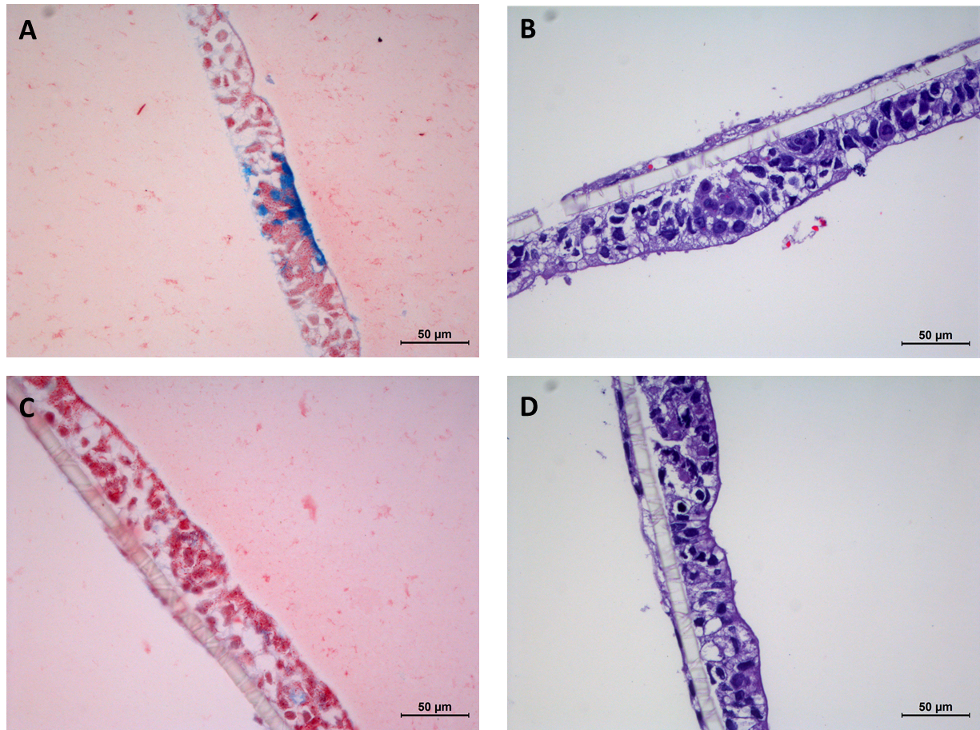

Figure S2.

Figure S3.

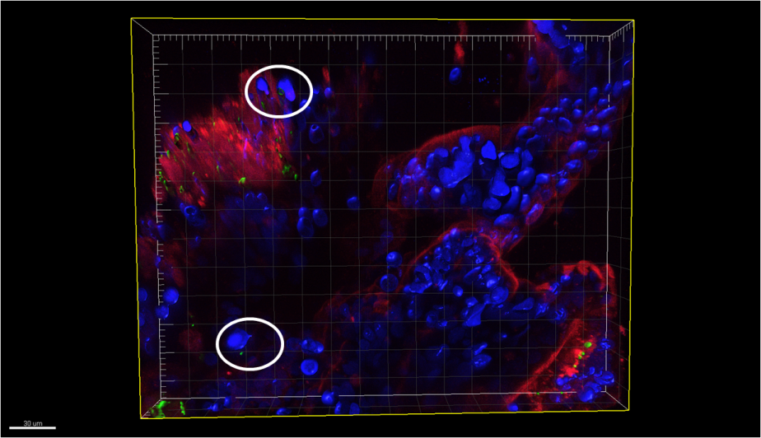

Figure S4.

