Supporting information
Iron oxide nanoparticles induce reversible endothelial-to-mesenchymal transition in vascular endothelial cells at acutely non-cytotoxic concentrations
Tao Wen^{1#}, Lifan Du^{1#}, Bo Chen², Doudou Yan¹, Aiyun Yang¹, Jian Liu¹, Ning Gu³, Jie Meng^{1*}, Haiyan Xu^{1*}
- Institute of Basic Medical Sciences, Chinese Academy of Medical Sciences & Peking Union Medical College, Beijing 100005, China
- Materials Science and Devices Institute, Suzhou University of science and technology, Suzhou, 215009, China
- State Key Laboratory of Bioelectronics, Jiangsu Key Laboratory for Biomaterials and Devices, School of Biological Science and Medical Engineering, Southeast University, Nanjing 210096, China

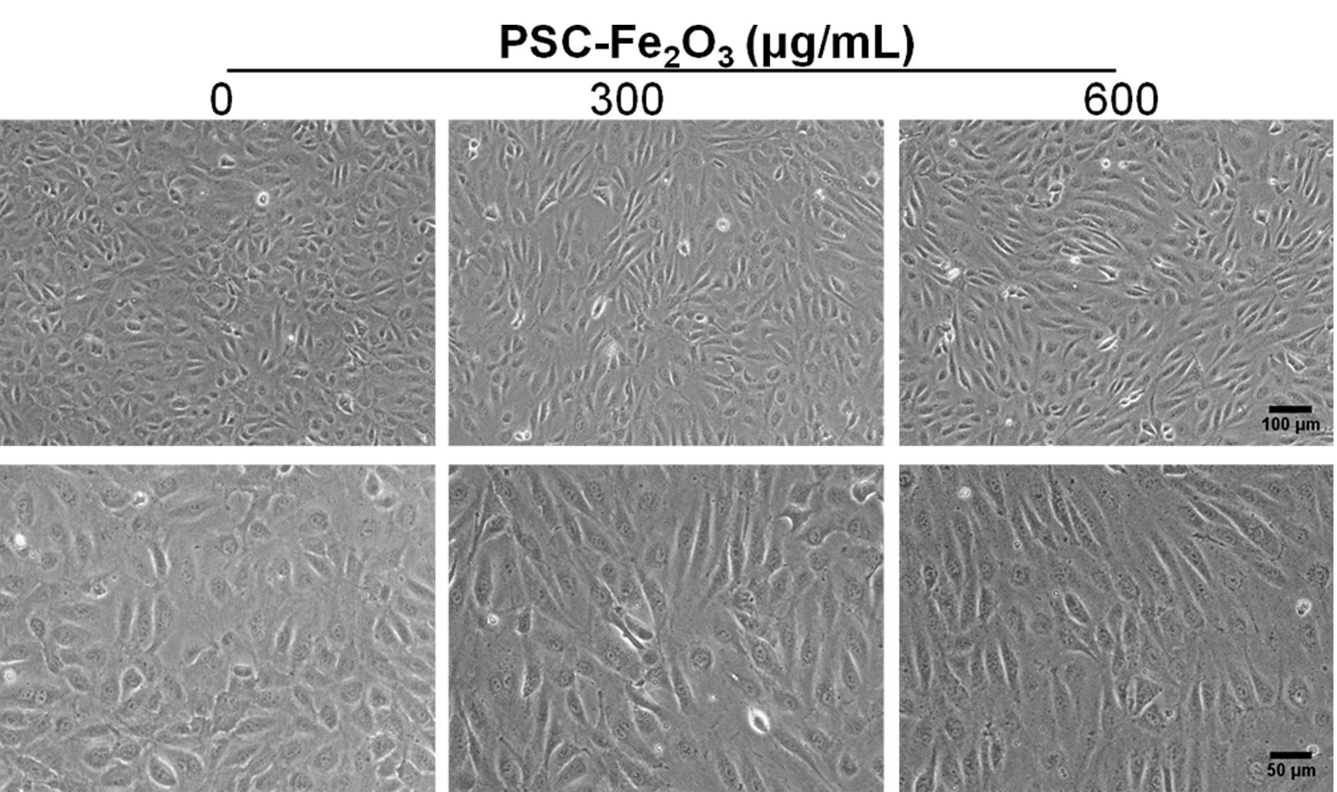
Figure S1 Representative morphology of low density of HUVECs treated with 300 and 600 μg/mL PSC-Fe₂O₃.
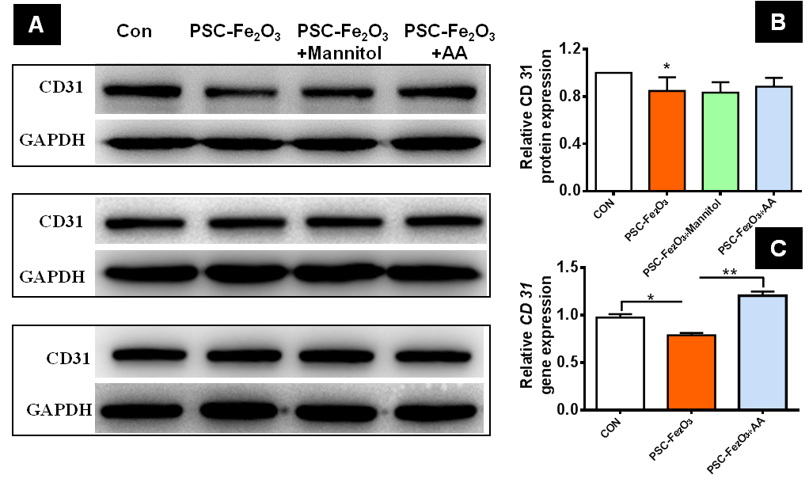
Figure S2 PSC-Fe₂O₃ inhibited CD31 protein and gene expression, which was rescued by antioxidants. (A) Three replications of CD31 immunoblots. (B) Quantification of CD31 expression for HUVECs with different treatments. (C) Gene expression of CD31 for endothelial cell with different treatments. Data are mean ± SD, one-way ANOVA with LSD-t, ** p < 0.01.

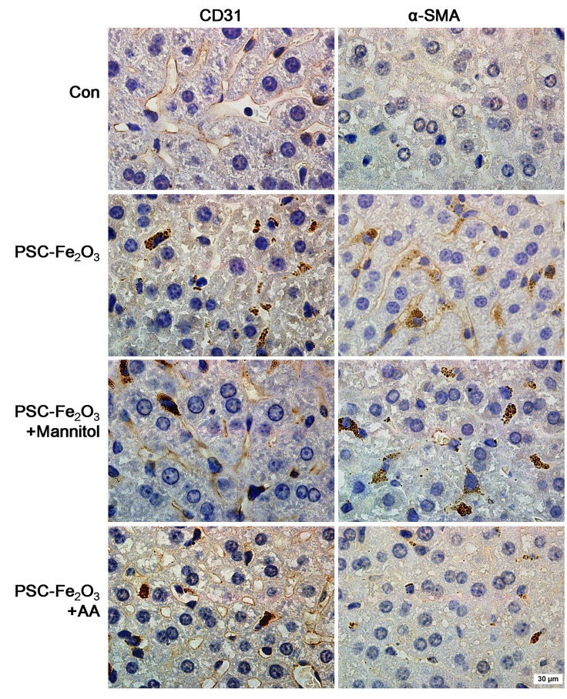
Figure S3. Representative of liver sections stained for mesenchymal markers α-SMA, and the endothelial markers CD31.
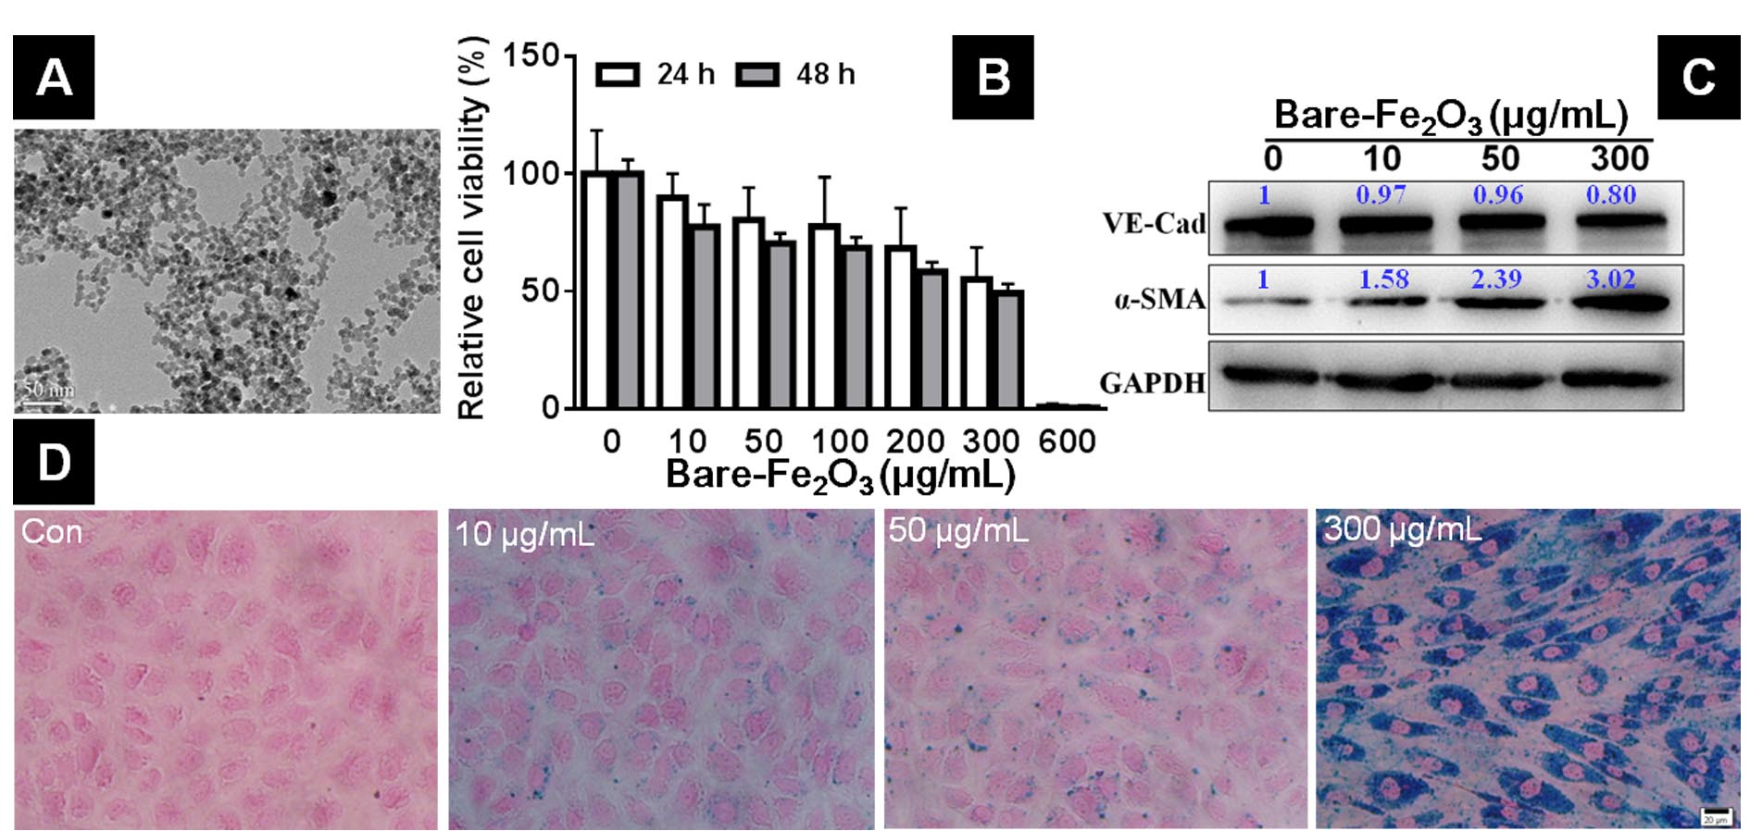
Figure S4 Effects of bare Fe₂O₃ nanoparticles (bare-Fe₂O₃) on HUVECs. (A) TEM image for bare-Fe₂O₃. (B) Cell viability of HUVECs treated with different concentrations of bare-Fe₂O₃ for 24 h or 48 h. (C) Representative immunoblots of VE-Cadherin and α-SMA of HUVECs treated with 0, 10, 50 and 300 μg/mL of bare-Fe₂O₃ for 48 h. (D) Microscope observation of HUVEC cells treated with different concentrations of bare-Fe₂O₃ after Prussian blue staining.

