Supplement 1. Schematic of exposure system for generating AuNPs, AgNPs, and AuNP+AgNP co-exposure for nose only exposure chambers.
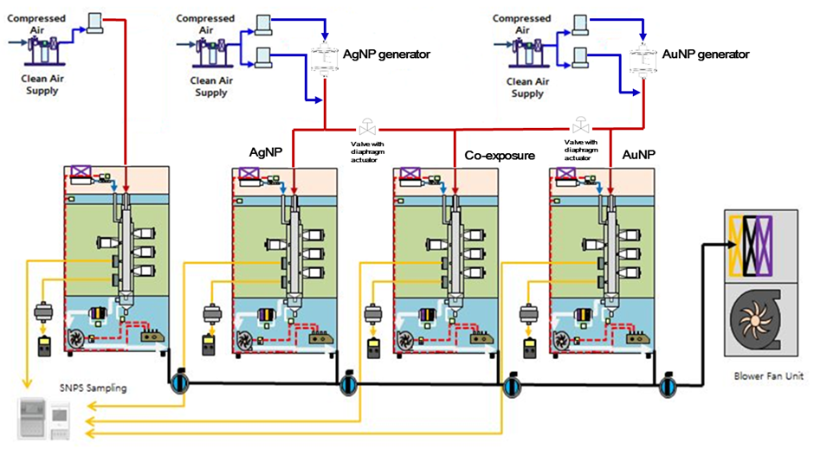

Supplement 2. Spiked standard curve and recovery detection for Au and Ag in lung tissue. Range of Au, 2 – 100 ng/g ; range of Ag, 0.2 – 5 ng/g.

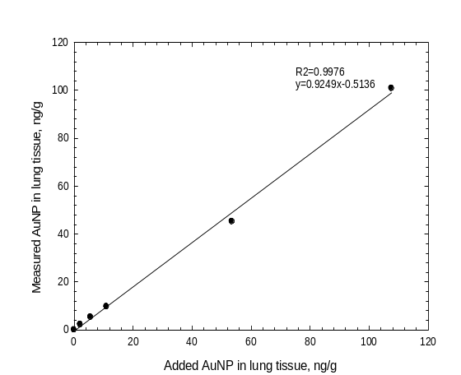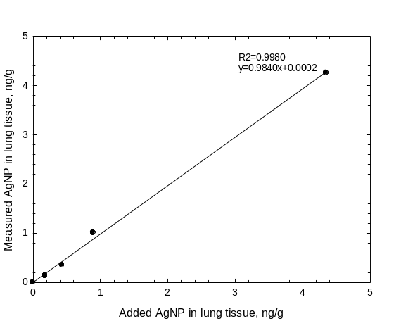
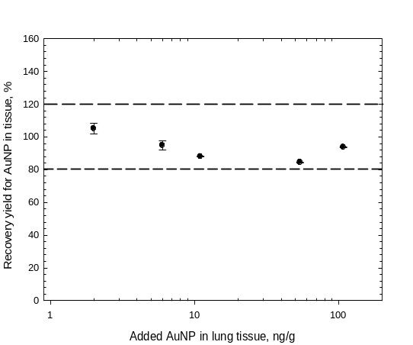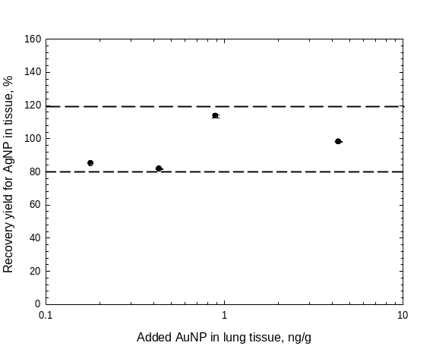
Supplement 3. Particle distribution in exposure chambers based on DMAS and FE-TEM; (A), CMD and GSD using DMAS during exposure period; (B), Particle diameter using DMAS; (C), CMD and GSD for AgNPs using FE-TEM; (D), CMD and GSD for AuNPs using FE-TEM; (E) CMD and GSD for AgNP+AuNP co-exposure using FE-TEM.
(A) CMD and GSD using DMAS during the 28-day exposure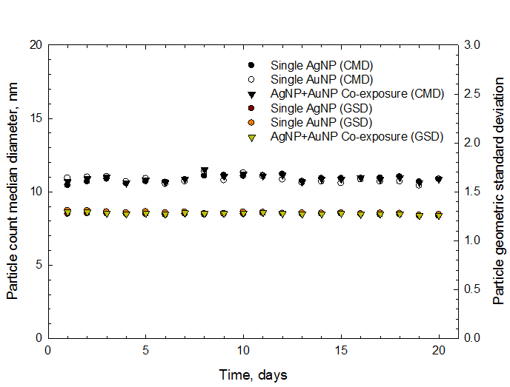 | (B) Size distribution using DMAS  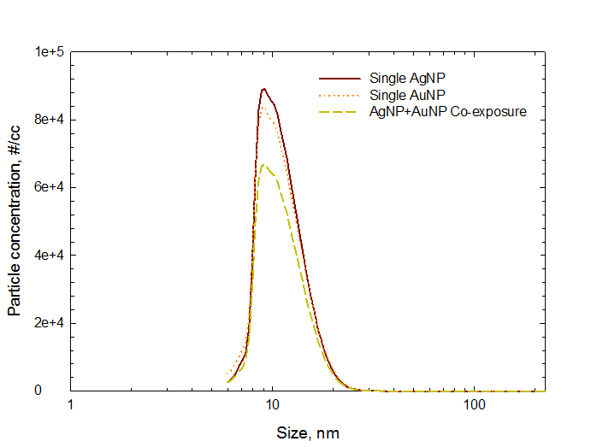
(C) Single AgNP using FE-TEM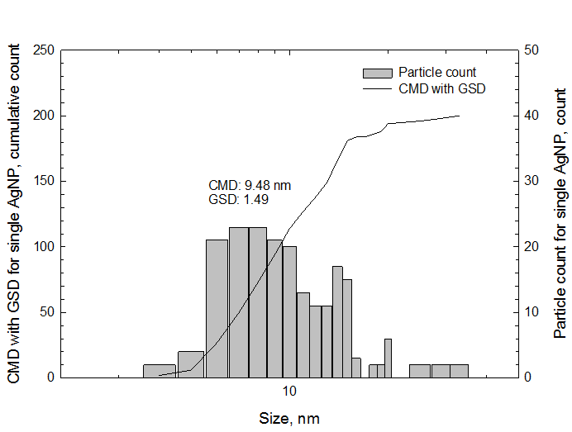 | (D) Single AuNP using FE-TEM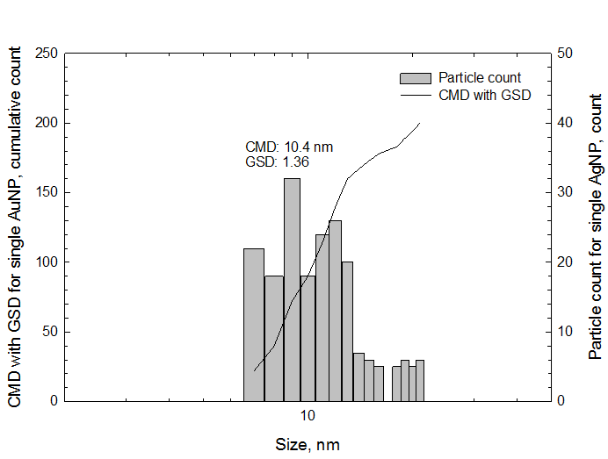
(E) Co-exposure AgNP with AuNP using FE-TEM
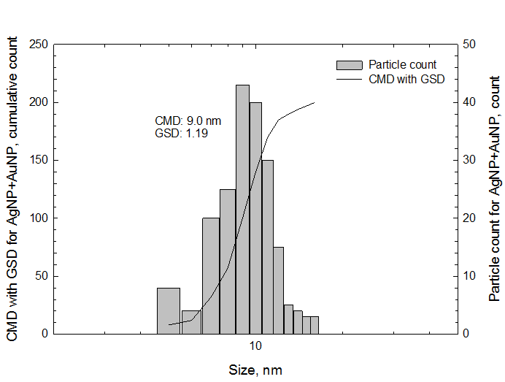

Supplement 4. The particle mass concentration of single of AgNP and AuNP using by DMAS.
The particle mass concentrations were calculated based on DMAS data of number concentration and average of diameter and particle density following under formula.

A. Mass of one nanoparticle = density x volume of one nanoparticle
- Ag: 10.49 x 10⁻¹² ng/nm³ x 670.30 nm³ = 7.0283 x 10⁻⁹ ng
- Au: 19.32 x 10⁻¹² ng/nm³ x 662.92 nm³ = 12.80761 x 10⁻⁹ ng
- Density: 10.49 g/cc of Ag; 19.32 g/cc of Au
- Volume of one nanoparticle: $(\frac{4}{3} π r^{3})$
- Average of diameter (based on DMAS): 10.86 nm of Ag (r = 5.43 nm); 10.82 nm of Au (r=5.41 nm)

B. Particle number concentration (based on DMAS)
- Ag: 1.44 x 10⁶ #/cc
- Au: 1.38 x 10⁶ #/cc

C. Particle mass concentration = mass of one particle x particle number concentration
- Ag: 7.0283 x 10⁻⁹ ng x 1.44 x 10⁶ #/cm³ = 10.121 µg/m³
- Au: 12.80761 x 10⁻⁹ ng x 1.38 x 10⁶ #cm³ = 17.675 µg/m³

Supplement 5. Deposition and retention of Au
 | µg/g of lung tissue^{A} | Whole lung weight^{B} (g) | µg^{C} (whole lung)
E-1 | 0.454 ± 0.022 | 1.024 ± 0.032 | 0.466 ± 0.034
PEO-1 | 7.352 ± 0.496 | 1.211 ± 0.029 | 8.930 ± 0.742
PEO-7 | 6.551 ± 0.588 | 1.218 ± 0.070 | 8.048 ± 1.308
PEO-28 | 5.930 ± 0.587 | 1.194 ± 0.052 | 7.010 ± 0.578

Supplement 6. Deposition and retention of Au in case of co-exposure with AgNPs
 | µg/g of lung tissue^{A} | Whole lung weight^{B} (g) | µg^{C} (whole lung)
E-1 | 0.296 ± 0.010 | 1.055 ± 0.026 | 0.313 ± 0.018
PEO-1 | 3.129 ± 0.060 | 1.153 ± 0.040 | 3.607 ± 0.133
PEO-7 | 2.645 ± 0.185 | 1.189 ± 0.037 | 3.137 ± 0.220
PEO-28 | 2.095 ± 0.180 | 1.173 ± 0.028 | 2.458 ± 0.224

Supplement 7. Deposition and retention of Ag
 | µg/g of lung tissue^{A} | Whole lung weight^{B} (g) | µg^{C} (whole lung)
E-1 | 0.045 ± 0.001 | 1.055 ± 0.009 | 0.047 ± 0.005
PEO-1 | 0.122 ± 0.014 | 1.065 ± 0.028 | 0.129 ± 0.015
PEO-7 | 0.072 ± 0.007 | 1.261 ± 0.038 | 0.090 ± 0.008
PEO-28 | 0.047 ± 0.010 | 1.260 ± 0.030 | 0.058 ± 0.011

Supplement 8. Deposition and retention of Ag in case of co-exposure with AuNPs
 | µg/g of lung tissue^{A} | Whole lung weight^{B} (g) | µg^{C} (whole lung)
E-1 | 0.021 ± 0.001 | 1.055 ± 0.026 | 0.023 ± 0.001
PEO-1 | 0.119 ± 0.007 | 1.153 ± 0.040 | 0.137 ± 0.006
PEO-7 | 0.061 ± 0.008 | 1.189 ± 0.037 | 0.072 ± 0.009
PEO-28 | 0.032 ± 0.004 | 1.173 ± 0.028 | 0.037 ± 0.005
E1, after 1 day of exposure, PEO-1, after 28 days of exposure; PEO-7, after 7 days of recovery; PEO-28, after 28 days of recovery;
A= ng/g lung tissue analyzed by ICP-MS
B= whole lung weight
C= amount of deposition in whole lung =AxB= ng/g x g = ng

