Supplementary Material

Airborne particulate matters induce thrombopoiesis from megakaryocytes through regulating mitochondrial oxidative phosphorylation

Xiaoting Jin^{1,2}, Hongyan Yu², Baoqiang Wang², Zhendong Sun^{1,3}, Ze Zhang², Qian S Liu¹, Yuxin Zheng², Qunfang Zhou^{1,3,4,5,*}, and Guibin Jiang^{1,3,4}

¹State Key Laboratory of Environmental Chemistry and Ecotoxicology, Research Center for Eco-Environmental Sciences, Chinese Academy of Sciences, Beijing, 100085, P. R. China.
²China School of Public Health, Qingdao University, Qingdao 266071, P. R. China.
³School of Environment, Hangzhou Institute for Advanced Study, University of Chinese Academy of Sciences, Hangzhou, 310000, P. R. China.
⁴College of Resources and Environment, University of Chinese Academy of Sciences, Beijing, 100049, P. R. China.
⁵Institute of Environment and Health, Jianghan University, Wuhan 430056, P. R. China.

* Corresponding Author:
Dr. Qunfang Zhou, State Key Laboratory of Environmental Chemistry and Ecotoxicology, Research Center for Eco-Environmental Sciences, Chinese Academy of Sciences, Beijing 100085, P. R. China.
Email: zhouqf@rcees.ac.cn

Supplementary materials and methods
Sampling and characterization of airborne fine particles
The airborne fine particulate matter (PM) including PM₁ and PM_{2.5} were collected using an inorganic quartz filter (QFF) and organic polypropylene filter (PPF) during the heating season in Beijing. The details about the sampling process and PM preparation were provided in a previous study.[1] The morphologies of four kinds of PM samples (i.e. QFF-PM_{2.5}, QFF-PM₁, PPF-PM_{2.5}, and PPF-PM₁) were analyzed by transmission electron microscopy (TEM) (JEOL, 2100F, Japan). The hydrodynamic diameters of all fine particles suspended in Milli-Q water were evaluated by a Zeta Sizer Nano ZS (Malvern Nano ZS, Nalvem, UK).
Alamar Blue assay
To screen the non-cytotoxic exposure levels of QFF-PM_{2.5}, the megakaryocytic cells with the density of 10,000 cells/well were seeded in the 96-well plates and cultured for 12 h. The cells were subsequently treated with 0, 0.05, 0.1, 0.5, 1, 5, 10 and 50 μg/mL PMs for 48 hours (h). When the exposure procedure was terminated, the cells were observed and photographed using an inverted microscope (Olympus IX73, Japan). In each well, 10 μL of 100 μM celltiter-blue reagent (Sigma Aldrich, USA) was added to each well, mixed and incubated for another 2 h, and the fluorescence was recorded at 530 nm/590 nm (λ_{ex}/λ_{em}) using a microplate reader (Thermo Fisher Scientific, USA).
To analyze the growth of megakaryocytic cells under the exposure stress of QFF-PM_{2.5}, the cells were plated on the 96-well plates at the density of 2000 cells/well. After 12-h incubation, the cell medium was replaced by 100 μL of cell medium containing 5% FBS, and the cells were treated with various concentrations of airborne fine particles (0, 10, 50 and 100 ng/mL) for 0, 3, 6, 9, and 12 d, respectively, and six parallel wells were set for each condition. The cell viability was measured using the alamarBlue assay described above.
Assay for ROS level
The megakaryocytic cells were seeded in 6-well plates at the densities of 30,000 cells/well, and treated with 10, 50, and 100 ng/mL QFF-PM_{2.5} for 12 d. The negative control and QFF-ctr groups were designed in parallel. After exposure, the cells were digested by trypsin, centrifuged at 1200 rpm for 5 min, suspended in 1 mL of serum-free medium containing 10 μM DCFH-DA (Invitrogen, USA), incubated in the dark for 20 min under a gentle upside down mixing at 5 min intervals. The cells were subsequently washed with serum-free medium twice, resuspended in 500 μL of PBS, and submitted to the analysis of intracellular ROS using a flow cytometer (Novocyte 1040, ACEA Biosciences, USA) under λ_{ex}/λ_{em} of 488 nm/525 nm.
Tests for the effects of QFF-PM₁, PPF-PM_{2.5}, and PPF-PM₁
The megakaryocytic cells were treated with a series of concentrations of PPF-PM_{2.5}, QFF-PM₁ and PPF-PM₁ (10, 50, and 100 ng/mL) for consecutive 12 d and submitted to the assays including WGA staining, DNA ploidy, CD33 and CD41a expressions following the similar protocols to those used for QFF-PM_{2.5}.

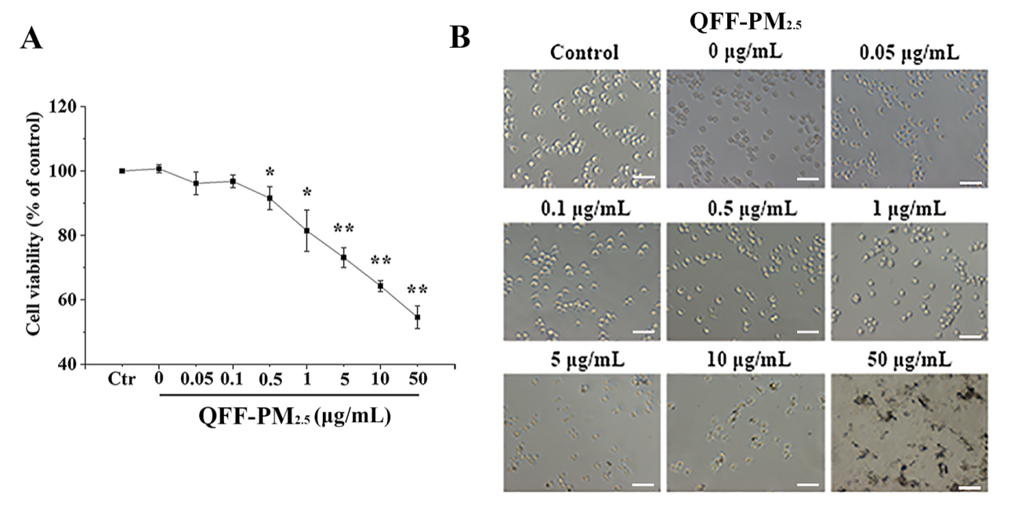
Fig. S1. The effect of QFF-PM_{2.5} exposure on cell viabilities of megakaryocytes. (A) The relative cell viabilities of megakaryocytes under a series of concentrations of QFF-PM_{2.5} treatment. *p < 0.05, or **p < 0.01 versus the negative control. (B) The morphological alterations of megakaryocytes caused by QFF-PM_{2.5} stimulation. The exposure time lasted for 48 h. The scale bar represents 100 μm.

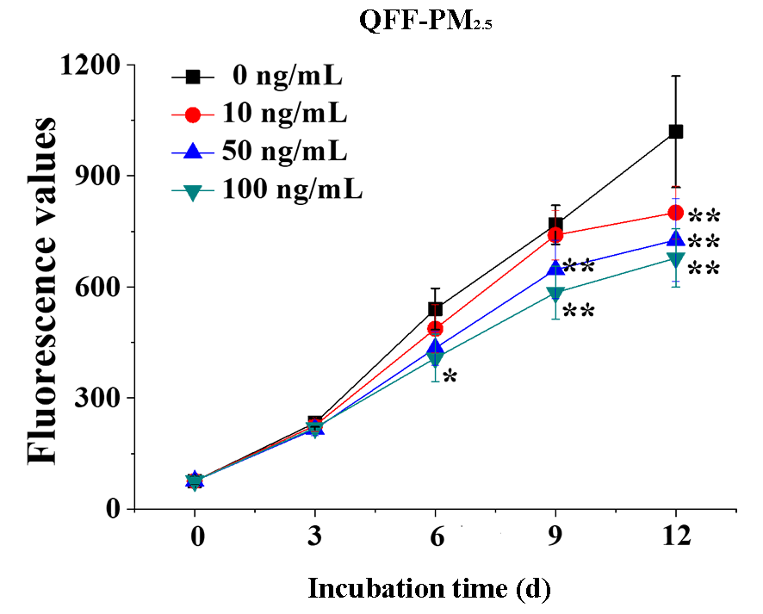
Fig. S2. Growth curves of megakaryocytes upon QFF-PM_{2.5} exposure. *p < 0.05, or **p < 0.01 versus the control group.

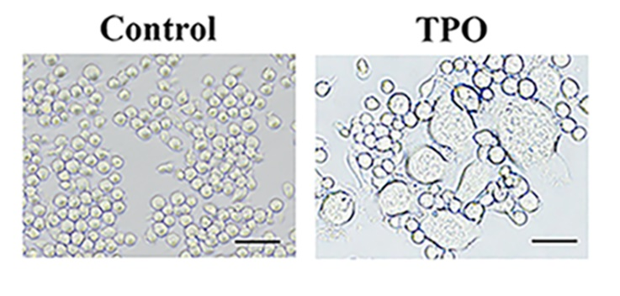
Fig. S3. The morphological alteration of megakaryocytes upon TPO treatment. The concentration of the positive control (TPO) is 1 ng/mL. Scale bars equal to 50 μm.

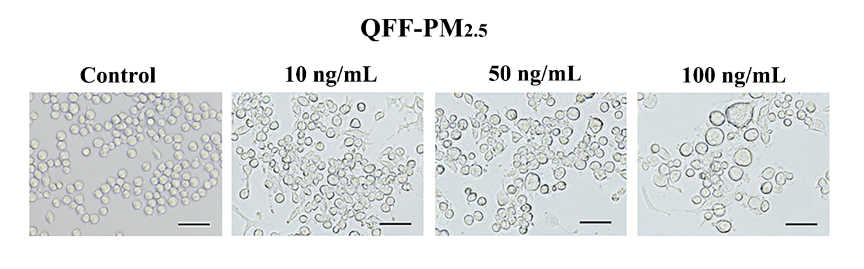
Fig. S4. The morphological alteration of megakaryocytes upon QFF-PM_{2.5} treatment. Scale bars equal to 50 μm.

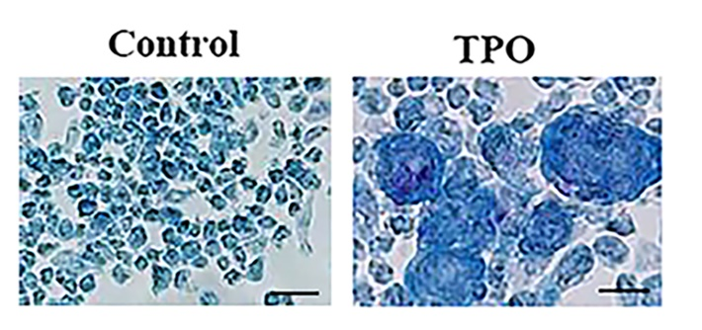
Fig. S5. Giemsa staining assay for TPO-induced morphological alteration in megakaryocytes. Scale bars equal to 50 μm.

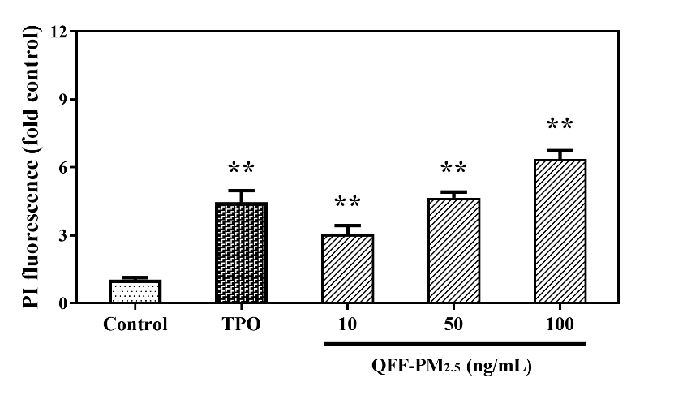
Fig. S6. The contents of DNA in megakaryocytes upon QFF-PM_{2.5} treatment. TPO (1 ng/mL) was used as a positive control. *p < 0.05, or **p < 0.01 versus the control group.

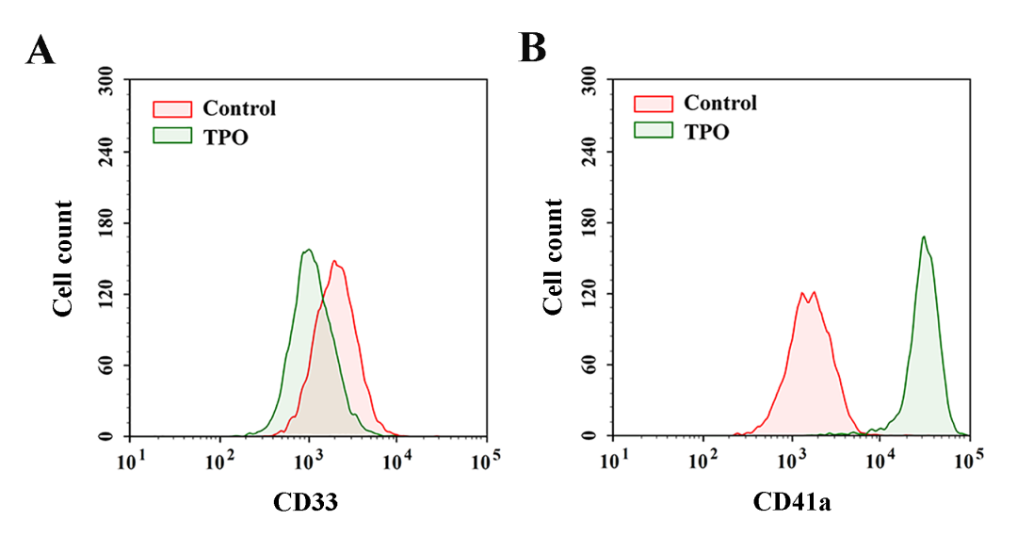
Fig. S7. The levels of CD33 and CD41a in megakaryocytes are stimulated by TPO. (A) CD33-expressed cell population. (B) CD41a-expressed cell population. The exposure was performed using 1 ng/mL TPO for 12 d.

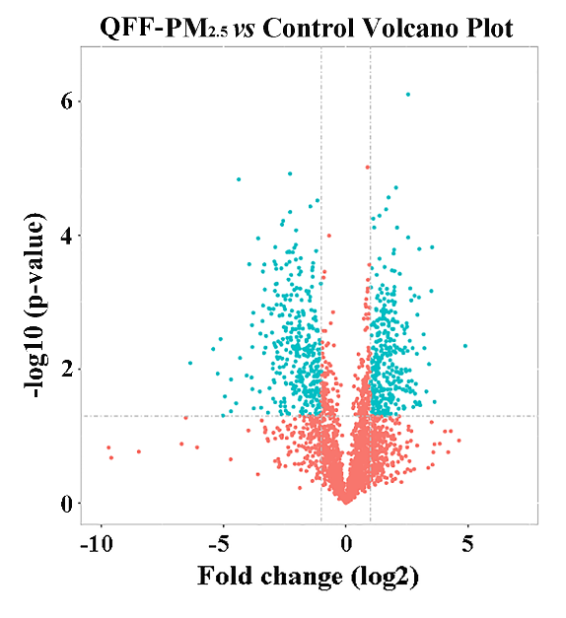
Fig. S8. Volcano plot for the distribution of differentially expressed proteins. Each point represented on protein, and those in blue indicated the proteins that displayed both |log₂ ratio| ≥ 1 and p-value < 0.05.

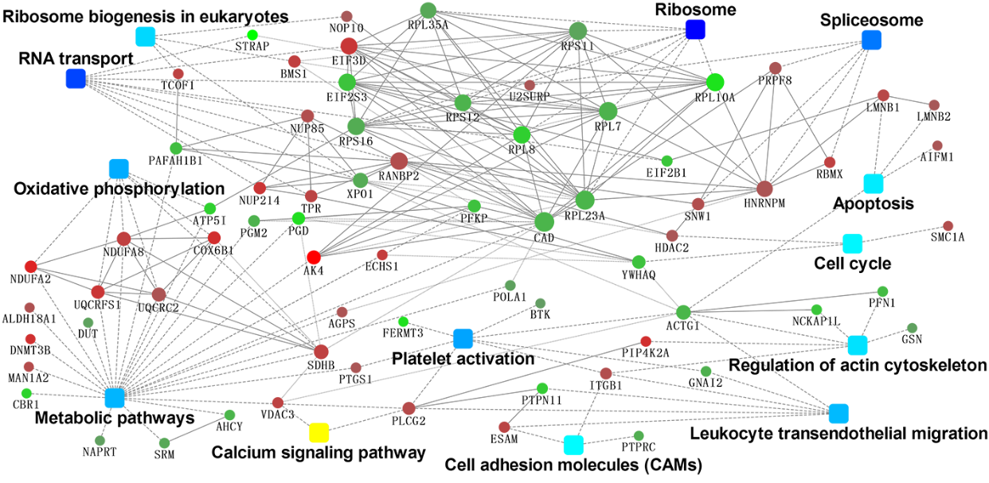
Fig. S9. The crosstalk of critical differentially-expressed proteins involved pathways using protein-protein interaction network (PPI). The proteins (indicated by circles) are enriched in the pathways (indicated by squares). Each protein profile is represented in a different color.

Fig. S10. The effects of QFF-PM_{2.5} exposure on the protein expressions of mitochondrial respiratory chain complex I-V in megakaryocytes. **p < 0.01 versus the controls.

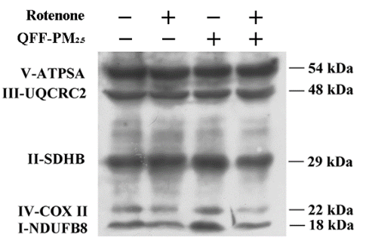
Fig. S11. The antagonistic effect of rotenone on QFF-PM_{2.5} influenced mitochondrial oxidative phosphorylation in megakaryocytes. The exposure concentrations of QFF-PM_{2.5} and rotenone were 100 ng/mL and 15 nM, respectively, and the exposure lasted for 12 d.

Fig. S12. QFF-PM_{2.5} induced ROS generation. (A) Intracellular ROS generation using flow cytometry analysis. (B) Quantitative analysis of ROS generation in different treatments. **p < 0.01 versus QFF-ctr control. (C) The effect of rotenone on QFF-PM_{2.5} induced ROS generation in megakaryocytes. (D) Quantitative analysis for the inhibition effect of rotenone on QFF-PM_{2.5} induced ROS generation. The exposure concentrations of QFF-PM_{2.5} and rotenone were 100 ng/mL and 15 nM, respectively, and the exposure lasted for 12 d. **p < 0.01 versus the control or QFF-PM_{2.5} exposure groups.
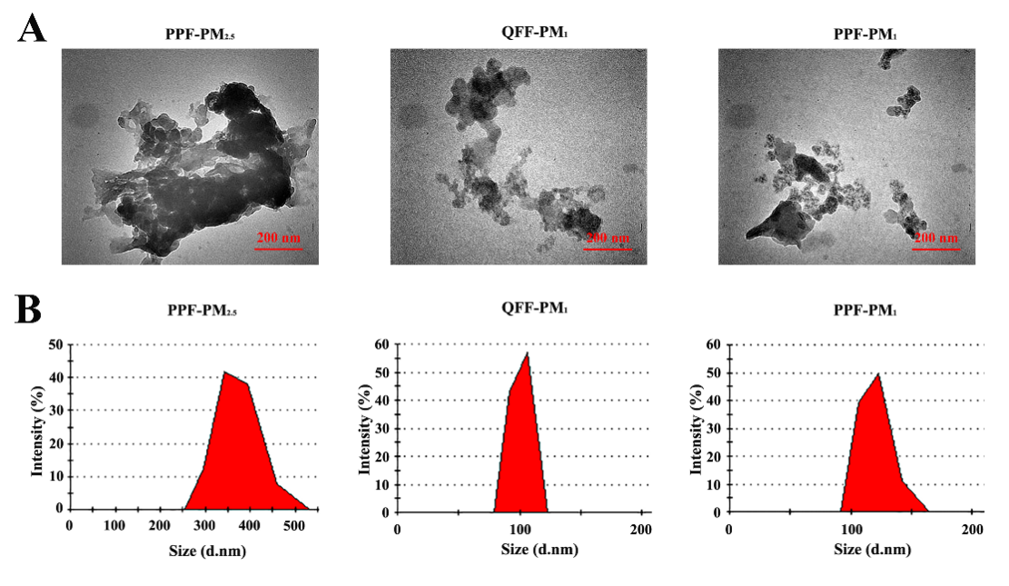
Fig. S13. Characterization of airborne fine particles. (A) Representative TEM images of PPF-PM_{2.5}, QFF-PM₁, and PPF-PM₁. (B) Hydrodynamic diameters of PPF-PM_{2.5}, QFF-PM₁, and PPF-PM₁ in Milli-Q water.
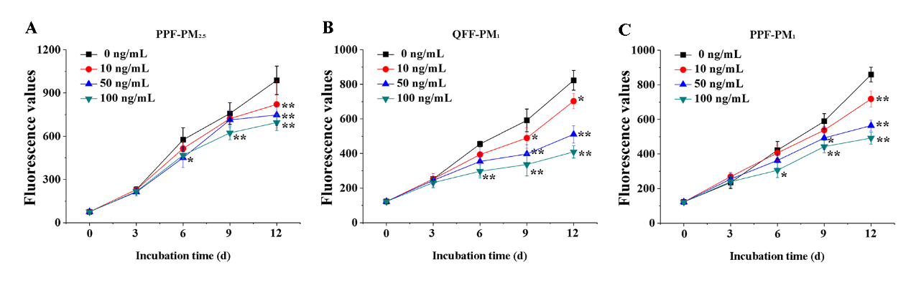
Fig. S14. Growth curves of megakaryocytes in different PM exposure groups. (A) PPF-PM_{2.5}, (B) QFF-PM₁ and (C) PPF-PM₁. *p < 0.05, or **p < 0.01 versus the corresponding controls.

Fig. S15. The effects of different PM samples on thrombopoiesis from megakaryocytes. (A) The images for different PM-treated megakaryocytes with wheat germ agglutinin (WGA) staining. The exposure concentrations were 0, 10, 50, and 100 ng/mL for PM samples, and the duration was 12 d. The green arrows denote the budding cells. Scale bar equals to 15 μm. (B) Quantitative analysis of thrombopoiesis by counting the budding cell numbers in different groups (n = 4). *p < 0.05, or **p < 0.01 versus the control. PPF-Ctr was evaluated as PM-free PPF filter control.
Fig. S16. The effects of different PMs on DNA ploidy in megakaryocytes. (A) The DNA contents quantified by PI staining in different groups. **p < 0.01 versus the control. (B) Flow cytometry analysis of DNA ploidy change in megakaryocytes treated with different concentrations of QFF-PM₁. M1, M2, M3, and M4 refer to the 2 N, 4 N, 8 N, and 16 N ploidy, respectively. (C) The quantitative analysis of DNA ploidy changes in megakaryocytes treated with different PM samples (n = 4). *p < 0.05, or **p < 0.01 versus the corresponding controls.

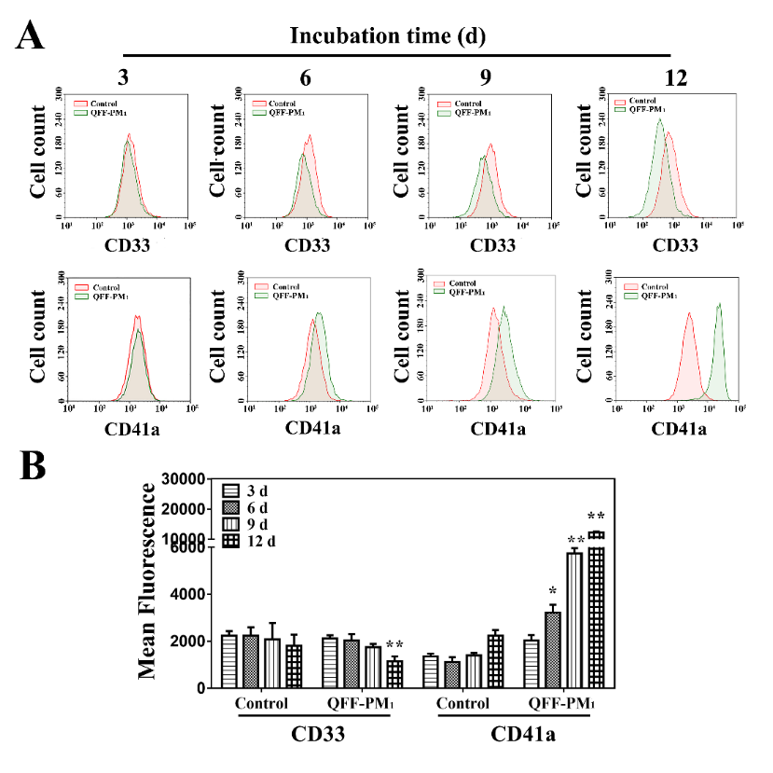
Fig. S17. The effect of QFF-PM₁ treatment on expressions of CD33 and CD41a in megakaryocytes. (A) Time courses for the expressions of CD33 and CD41a in megakaryocytes. The exposure concentration of QFF-PM₁ was 100 ng/mL. (B) The quantitative analysis of CD33 and CD41a expressions in megakaryocytes. *p < 0.05, and **p < 0.01 versus the corresponding controls.

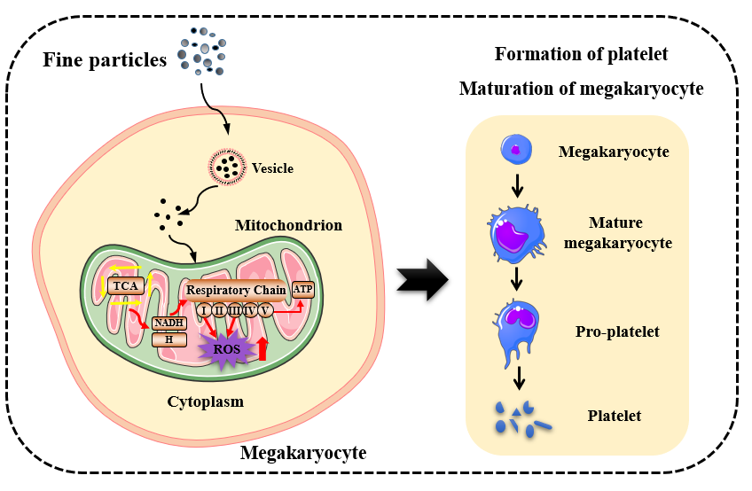
Fig. S18. The illustration of thrombopoiesis upon PM exposure and the underlying mechanism.
Table S1. The numbers of differentially expressed proteins in megakaryocytes (p value < 0.05 and |log₂ ratio| ≥ 1).
Protein Number | All test proteins | Interacting proteins | Differentially expressed proteins | Up-regulation | Down-regulation
PM_{2.5} vs Control | 5017 | 3962 | 695 | 337 | 358

Table S2. The differentially expressed proteins correlated with megakaryocyte differentiation.
NO. | Protein ID | Protein name | Gene name | MW [kDa] | Fold change | p-  value
1 | P27144 | Adenylate kinase 4, mitochondrial | AK4 | 25.268 | 10.579 | 0.008
2 | Q5VTL8 | Pre-mRNA-splicing factor 38B | PRPF38B | 64.467 | 6.107 | 0.010
3 | O43678 | NADH dehydrogenase [ubiquinone] | NDUFA2 | 10.921 | 5.578 | 0.021
4 | P14854 | Cytochrome C oxidase subunit 6B1 | COX6B1 | 10.192 | 4.520 | 0.015
5 | P48426 | Phosphatidylinositol 5-phosphate 4-kinase type-2 alpha | PIP4K2A | 46.224 | 4.475 | 0.039
6 | Q9UBC3 | DNA (cytosine-5)-methyltransferase 3B | DNMT3B | 95.750 | 4.407 | 0.013
7 | Q96J01 | THO complex subunit 3 | THOC3 | 38.771 | 4.269 | 0.000
8 | X6RAL5 | Histone deacetylase complex subunit | SAP18 | 19.526 | 3.974 | 0.000
9 | P35658 | Nuclear pore complex protein Nup214 | NUP214 | 213.620 | 3.963 | 0.004
10 | P47985 | Mitochondrial cytochrome b-c1 complex subunit | UQCRFS1 | 29.668 | 3.917 | 0.001
11 | O15371 | Eukaryotic translation initiation factor 3 subunit D | EIF3D | 63.972 | 3.818 | 0.026
12 | O94906 | Pre-mRNA-processing factor 6 | PRPF6 | 106.920 | 3.745 | 0.028
13 | P30084 | Enoyl-CoA hydratase, mitochondrial | ECHS1 | 31.387 | 3.510 | 0.005
14 | Q14692 | Ribosome biogenesis protein BMS1 homolog | BMS1 | 145.810 | 3.279 | 0.003
15 | P51970 | NADH dehydrogenase [ubiquinone] 1 alpha subunit 8 | NDUFA8 | 20.105 | 3.253 | 0.002
16 | P38159 | RNA-binding motif protein, X chromosome | RBMX | 42.331 | 3.216 | 0.011
17 | P21912 | Mitochondrial succinate dehydrogenase [ubiquinone] iron-sulfur subunit | SDHB | 31.629 | 3.193 | 0.049
18 | Q13428 | Treacle protein | TCOF1 | 152.100 | 3.123 | 0.004
19 | Q9Y277 | Voltage-dependent anion-selective channel protein 3 | VDAC3 | 30.658 | 3.100 | 0.041
20 | P12270 | Nucleoprotein TPR | TPR | 267.290 | 2.998 | 0.000
21 | Q96AP7 | Endothelial cell-selective adhesion molecule | ESAM | 41.176 | 2.941 | 0.020
22 | P20700 | Lamin-B1 | LMNB1 | 66.408 | 2.824 | 0.001
23 | P16885 | Phosphoinositide phospholipase C | PLCG2 | 147.870 | 2.663 | 0.047
24 | O60476 | Mannosyl-oligosaccharide 1,2-alpha-mannosidase IB | MAN1A2 | 73.003 | 2.617 | 0.046
25 | P49792 | E3 SUMO-protein ligase RanBP2 | RANBP2 | 358.200 | 2.551 | 0.004
26 | P05556 | Integrin beta-1 | ITGB1 | 88.414 | 2.523 | 0.037
27 | Q9BW27 | Nuclear pore complex protein Nup85 | NUP85 | 75.019 | 2.496 | 0.008
28 | G8JLG1 | Structural maintenance of chromosomes protein | SMC1A | 140.86 | 2.495 | 0.009
29 | G3V3A4 | SNW domain-containing protein 1 | SNW1 | 65.391 | 2.466 | 0.002
30 | P54886 | Delta-1-pyrroline-5-carboxylate synthase | ALDH18A1 | 87.301 | 2.371 | 0.005
31 | Q9P013 | Spliceosome-associated protein CWC15 homolog | CWC15 | 26.624 | 2.369 | 0.005
32 | P52272 | Heterogeneous nuclear ribonucleoprotein M | HNRNPM | 77.515 | 2.264 | 0.014
33 | O00116 | Alkyldihydroxyacetonephosphate synthase, peroxisomal | AGPS | 72.911 | 2.256 | 0.049
34 | P22695 | Mitochondrial cytochrome b-c1 complex subunit 2 | UQCRC2 | 48.442 | 2.246 | 0.032
35 | Q92769 | Histone deacetylase 2 | HDAC2 | 55.364 | 2.187 | 0.027
36 | O15042 | U2 snRNP-associated SURP motif-containing protein | U2SURP | 118.290 | 2.187 | 0.007
37 | P23219 | Prostaglandin G/H synthase 1 | PTGS1 | 68.686 | 2.185 | 0.024
38 | O95831 | Apoptosis-inducing factor 1, mitochondrial | AIFM1 | 66.900 | 2.177 | 0.000
39 | Q6P2Q9 | Pre-mRNA-processing-splicing factor 8 | PRPF8 | 273.600 | 2.168 | 0.009
40 | Q03252 | Lamin-B2 | LMNB2 | 69.948 | 2.074 | 0.003
41 | Q9NPE3 | H/ACA ribonucleoprotein complex subunit 3 | NOP10 | 7.706 | 2.055 | 0.016
42 | Q06187 | Tyrosine-protein kinase BTK | BTK | 76.280 | 0.488 | 0.015
43 | Q00610 | Clathrin heavy chain | CLTC | 192.060 | 0.472 | 0.025
44 | Q6XQN6 | Nicotinate phosphoribosyltransferase | NAPRT | 57.578 | 0.461 | 0.015
45 | P06396 | Gelsolin | GSN | 82.525 | 0.450 | 0.015
46 | A6NMQ1 | DNA polymerase;DNA polymerase alpha catalytic subunit | POLA1 | 166.460 | 0.442 | 0.029
47 | P33316 | Deoxyuridine 5-triphosphate nucleotidohydrolase, mitochondrial | DUT | 26.563 | 0.434 | 0.028
48 | P23396 | 40S ribosomal protein S3 | RPS3 | 26.688 | 0.413 | 0.012
49 | P62280 | 40S ribosomal protein S11 | RPS11 | 18.431 | 0.405 | 0.017
50 | P62424 | 60S ribosomal protein L7a | RPL7A | 29.995 | 0.391 | 0.000
51 | P19623 | Spermidine synthase | SRM | 33.824 | 0.376 | 0.031
52 | P18077 | 60S ribosomal protein L35a | RPL35A | 12.538 | 0.373 | 0.031
53 | Q9Y6A5 | Transforming acidic coiled-coil-containing protein 3 | TACC3 | 90.359 | 0.368 | 0.022
54 | O14980 | Exportin-1 | XPO1 | 123.380 | 0.350 | 0.003
55 | P62249 | 40S ribosomal protein S16 | RPS16 | 16.445 | 0.339 | 0.006
56 | P08575 | Receptor-type tyrosine-protein phosphatase C | PTPRC | 147.480 | 0.326 | 0.005
57 | P62269 | 40S ribosomal protein S18 | RPS18 | 17.718 | 0.322 | 0.005
58 | P04899 | Guanine nucleotide-binding protein G(i) subunit alpha-2 | GNAI2 | 40.450 | 0.308 | 0.011
59 | P18124 | 60S ribosomal protein L7 | RPL7 | 29.225 | 0.292 | 0.043
60 | Q96G03 | Phosphoglucomutase-2 | PGM2 | 68.283 | 0.292 | 0.011
61 | P25398 | 40S ribosomal protein S12 | RPS12 | 14.515 | 0.286 | 0.013
62 | F8VPD4 | CAD protein | CAD | 236.02 | 0.274 | 0.001
63 | P23526 | Adenosylhomocysteinase | AHCY | 47.716 | 0.273 | 0.011
64 | P62750 | 60S ribosomal protein L23a | RPL23A | 17.695 | 0.271 | 0.002
65 | P63261 | Actin, cytoplasmic 2 | ACTG1 | 41.792 | 0.267 | 0.002
66 | P42224 | Signal transducer and activator of transcription 1-alpha/beta | STAT1 | 87.334 | 0.265 | 0.000
67 | Q13131 | 5-AMP-activated protein kinase catalytic subunit alpha-1 | PRKAA1 | 64.009 | 0.265 | 0.005
68 | P07737 | Profilin-1 | PFN1 | 15.054 | 0.235 | 0.019
69 | P43034 | Platelet-activating factor acetylhydrolase IB subunit alpha | PAFAH1B1 | 46.637 | 0.217 | 0.001
70 | Q01813 | ATP-dependent 6-phosphofructokinase, platelet type | PFKP | 85.595 | 0.202 | 0.000
71 | P27348 | 14-3-3 protein theta | YWHAQ | 27.764 | 0.200 | 0.000
72 | P41091 | Eukaryotic translation initiation factor 2 subunit 3 | EIF2S3 | 51.109 | 0.194 | 0.002
73 | P62851 | 40S ribosomal protein S25 | RPS25 | 13.742 | 0.181 | 0.001
74 | P55160 | Nck-associated protein 1-like | NCKAP1L | 128.15 | 0.178 | 0.036
75 | Q14232 | Translation initiation factor eIF-2B subunit alpha | EIF2B1 | 33.712 | 0.178 | 0.001
76 | Q06124 | Tyrosine-protein phosphatase non-receptor type 11 | PTPN11 | 68.436 | 0.157 | 0.043
77 | P62917 | 60S ribosomal protein L8 | RPL8 | 28.024 | 0.143 | 0.006
78 | P56385 | ATP synthase subunit e, mitochondrial | ATP5I | 7.933 | 0.141 | 0.001
79 | P16152 | Carbonyl reductase [NADPH] 1 | CBR1 | 30.375 | 0.129 | 0.014
80 | P52209 | 6-phosphogluconate dehydrogenase, decarboxylating | PGD | 53.139 | 0.100 | 0.000
81 | P62277 | 40S ribosomal protein S13 | RPS13 | 17.222 | 0.098 | 0.006
82 | Q86UX7 | Fermitin family homolog 3 | FERMT3 | 75.952 | 0.095 | 0.000
83 | P62906 | 60S ribosomal protein L10a | RPL10A | 24.831 | 0.089 | 0.003
84 | Q9Y3F4 | Serine-threonine kinase receptor-associated protein | STRAP | 38.438 | 0.045 | 0.032

Table S3. Statistical analysis of the influencing factors for PM-induced thrombopoiesis.
Factor | DF | SS | MS | F Value | p value
Exposure concentration (EC) | 2 | 27666.889 | 13833.444 | 297.138 | 0.000001
Filter type (FT) | 1 | 61.361 | 61.361 | 1.318 | 0.262262
PM size | 1 | 1144.694 | 1144.694 | 24.588 | 0.000046
EC*PM size | 2 | 633.556 | 316.778 | 6.804 | 0.004561
EC*FS*PM size | 5 | 53.139 | 10.628 | 0.228 | 0.946505
Note: Three-way ANOVA method was used. DF, degree of freedom. SS, the variation from different variables. MS, the mean square from different variables.

Table S4. The influence of PM sampling filter type on thrombopoiesis.
PM | Exposure concentration  (ng/mL) | Filter type |  | p value
PM | Exposure concentration  (ng/mL) | QFF | PPF | p value
PM₁ | 10 | 5.67 ± 1.70 | 3.33 ± 2.05 | 0.9999
PM₁ | 50 | 34.33 ± 7.76 | 31.33 ± 6.65 | 0.9999
PM₁ | 100 | 74.00 ± 9.27 | 71.33 ± 5.31 | 0.9999
PM_{2.5} | 10 | 2.33 ± 1.25 | 0.33 ± 0.47 | 0.9999
PM_{2.5} | 50 | 9.33 ± 3.68 | 10.67 ± 3.30 | 0.9999
PM_{2.5} | 100 | 68.33 ± 10.78 | 61.33 ± 2.05 | 0.9773
Note: The Tukey method was used to analyze the effect of sampling filter type on thrombopoiesis given the same PM size and exposure dose.

Table S5. The influence of PM size on thrombopoiesis.
Filter type | Exposure dose (ng/mL) | PM |  |  | p value
Filter type | Exposure dose (ng/mL) | PM₁ | PM_{2.5} |  | p value
QFF | 10 | 5.67 ± 2.08 |  | 2.33 ± 1.53 | 1.0000
QFF | 50 | 34.33 ± 9.50 |  | 9.33 ± 4.51** | 0.0067
QFF | 100 | 74.00 ± 11.36 |  | 68.33 ± 13.20 | 0.9956
PPF | 10 | 3.33 ± 2.52 |  | 0.33 ± 0.58 | 1.0000
PPF | 50 | 31.33 ± 8.14 |  | 10.67 ± 4.04* | 0.0399
PPF | 100 | 71.33 ± 6.51 |  | 61.33 ± 2.52 | 0.8056
Note: The Tukey method was used to analyze the effect of PM size on thrombopoiesis given the same PM exposure dose and sampling filter. *p < 0.05, or **p < 0.01.

Table S6. Statistical analysis for the effect of PM size on PM-promoted megakaryocytic maturation.
Index | PM |  | p value
Index | QFF-PM₁ | QFF-PM_{2.5} | p value
Total DNA | 8.59 ± 0.52 | 6.38 ± 0.29** | 0.0063
2N | 34.33 ± 5.68 | 37.11 ± 5.24 | 0.5670
4N | 37.46 ± 6.54 | 34.18 ± 4.61 | 0.5169
8N | 8.69 ± 1.06 | 7.65 ± 1.23 | 0.3295
16N | 0.55 ± 0.096 | 0.42 ± 0.075 | 0.1383
CD33 | 1144 ± 213.45 | 1096 ± 143.11 | 0.7625
CD41a | 12254 ± 312.54 | 11287 ± 469.87* | 0.0412
Note: One-way ANOVA method was used to statistically analyze the differences of total DNA (indicated by PI fluorescence), cell percentages of 2N, 4N, 8N, 6N and the expression of CD33 and CD41a (indicated by the corresponding fluorescence intensities) between PM₁ and PM_{2.5} exposure groups. **p < 0.01 or *p < 0.05.

Table S7. Pair primer sequences for quantitative polymerase chain reaction (qPCR) analysis.
Gene | Primer | Sequence (5’→3’)
NDUFA2 | Forward | AGGGCGTCAGGGACTTCATT
 | Reverse | CTCTTGGCCAAATGCGTAGC
NDUFA8 | Forward | GCCGCTGGGAAGAGAAAGAT
 | Reverse | CTGCTGTTTGCGACAGTGAC
SDHB | Forward | ATGTGGCCCCATGGTATTGG
 | Reverse | TGGTGTCAATCCTTCGGGTG
UQCRFS1 | Forward | CCGCCGCCTTGAAGTTTTAG
 | Reverse | AACTGGGTGACGGCATTCTT
UQCRC2 | Forward | TCAATGTCACCACAGCACCA
 | Reverse | ATTAGCCAAGGCATTCCGGT
COX6B1 | Forward | TACAAGACCGCCCCTTTTGA
 | Reverse | TATCGCCTCCTTTAGCGGTC
GAPDH | Forward | ATCTTCCAGGAGCGAGATCC
 | Reverse | CTGCAAATGAGCCCCAGCCT

Reference
1. Jin X, Ma Q, Sun Z, Yang X, Zhou Q, Qu G, et al. Airborne fine particles induce hematological effects through regulating the crosstalk of the kallikrein-kinin, complement, and coagulation systems. Environ Sci Technol. 2019;53 5:2840-51. http://dx.doi.org/10.1021/acs.est.8b05817 https://www.ncbi.nlm.nih.gov/pubmed/30742439.

