SUPPLEMENTARY MATERIAL
Additional file 1.

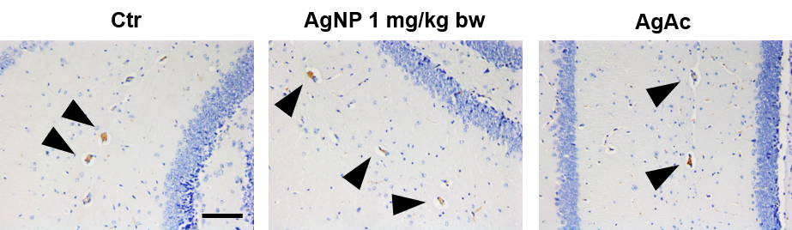
Figure S1. Brain, hippocampus, immunohistochemistry for albumin. Immunostaining of albumin in control (Ctr), AgNP 1 mg/kg bw and AgAc treated mice at the EoT, 200x (Scale bar 100 µm). Immunostained albumin within blood vessels (arrowheads). No signs of albumin extravasation were observed in treated mice.

