Gut microbiome and plasma metabolome changes in rats after oral gavage of nanoparticles - sensitive indicators of possible adverse health effects

Robert Landsiedel^{1#}, Daniela Hahn^{2#}, Rainer Ossig², Sabrina Ritz², Lydia Sauer², Roland Buesen¹, Sascha Rehm^{3,4}, Wendel Wohlleben⁵, Sibylle Groeters¹, Volker Strauss¹, Saskia Sperber¹, Haleluya Wami⁶, Ulrich Dobrindt⁶, Karola Prior⁷, Dag Harmsen⁷, Bennard van Ravenzwaay^{1#}, Juergen Schnekenburger^{2#}

# Equally contributing first and senior authors, respectively

¹ Experimental Toxicology and Ecology, BASF SE, 67056 Ludwigshafen am Rhein, Germany
² Biomedical Technology Center of the Medical Faculty, University of Muenster, 48149 Muenster, Germany

³ HB Technologies AG, 72076 Tuebingen, Germany

⁴ Medical Data Integration Center, University Tuebingen, 72072 Tuebingen, Germany
⁵ Polymer Physics, BASF SE, 67056 Ludwigshafen am Rhein, Germany
⁶ Institute of Hygiene, University of Muenster, 48149 Muenster, Germany
⁷ Department of Periodontology and Operative Dentistry, University Hospital Muenster, 48149 Muenster, Germany

Corresponding author: Dr. Juergen Schnekenburger,
Biomedical Technology Center of the Medical Faculty
University of Muenster
Mendelstrasse 17
48149 Muenster, Germany
Telephone: +49(0)2518352534
Email: schnekenburger@uni-muenster.de

Supplementary Information
Changes in the composition of intestinal microbes in male Wistar rats after a 25-day gavage with the vehicle
The differences in the microbiota composition of untreated rats at day 0 compared to vehicle treated controls at day 25 were further analyzed at the taxonomic level of phyla and classes (Fig. S3). In the untreated control (UC), Bacteroidota and Firmicutes were detected as the two predominant phyla, which account for nearly 91% of the total microbiome with an average ratio of approx. 1:1 Firmicutes:Bacteroidota. The third largest phylum identified was the Verrucomicrobia contributing a fraction of 6.2% to the total quantity, followed by Proteobacteria (1.9%). All other identified phyla were below 1% among which Actinobacteriota (0.2%) and Patescibacteria (0.2%) were the most prominent (Fig. S3a, Table S5).
After the 25-day gavage of the vehicle PBS + BSA (VC), we observed distinct alterations in the gut microbial communities (Fig. S3). The level of Bacteroidota decreased from 47.7 % to 23.5% accompanied by an increase of Firmicutes from 43.1% to 57.5%, which led to a shift in the ratio of Firmicutes:Bacteroidetes towards 2.5:1. Most strikingly, the level of Proteobacteria increased from 1.9% towards 16.8% in the vehicle-treated animals. In contrast, the relative abundance of Verrucomicrobiota decreased from 6.2% towards 1.3% (Fig. S3a, for further details see Table S5).
At the level of classes, the described changes were dominated by a decrease of Bacteroidia from 47.7% in UC towards 23.5% in VC and an increase of the class Bacilli from 6.4% to 22.6%. Moreover, a fundamental enrichment of the class Gammaproteobacteria (from 0.2% in UC to 16.7% in VC) seems to be responsible for the observed change of phylum Proteobacteria. (Fig. S3b, for further details see Table S6).
As for the vehicle control, we observed a similar differentiation of microbiota also between each of the NP-treated groups and the UC group (Fig. S2a). Since for all rats of each study group, the cage conditions and daily intake of food and water were similar, the sexual maturation during the 25-day gavage or the treatment with vehicle can be the possible cause for the observed differentiation of the microbial profiles from UC. Recently, Han et al. studied the impact of 4-epi-oxytetracycline in normal saline on the gut microbiota in a 28-day oral study using Wistar rats. Comparable to the data presented here, they found a Firmicutes:Bacteroidota ratio of 2.2:1 (55% Firmicutes, 25% Bacteroidota) in control male rats after 28 days. Different from our study, they collected the feces once every four days. They also reported progressive changes in the gut microbiota from day 0 to day 28 in their control group.^{[1]} With regard to these results, the differences we found between the untreated controls (collected at day 0 of the study) and the vehicle-treated controls (collected at day 25 of the study) were most probably determined by animal aging and development rather than by effects of the treatment. At the same time, also the inter-animal variations within treatment groups were enhanced during this 25-day aging period (Fig. S2a). Similar aging effects, i.e. an increase in the Firmicutes:Bacteroidetes ratio from birth to adulthood has been previously reported also for the human gut microbiota.^{[2]} In order to avoid an inclusion of these possible aging effects in our analysis, only those data obtained for the vehicle-treated animals after day 25 were used as relevant controls for the nanoparticle-treated animals throughout the study.

Supplementary Tables
Table S1: Body weight
 | Male animals
Day | VC | SiO₂ | Ag
0 | 164 | 167 | 169
7 | 204 | 211 | 207
14 | 239 | 248 | 249
21 | 265 | 275 | 277
28 | 286 | 295 | 296

SiO₂, Ag nanoparticles and vehicle control (VC) were applied daily for 28 days; body weight (g), expressed as mean of test group (N = 5), data shown for SiO₂ NP had already been published by Buesen et al. 2014 (denominated “SiO₂ naked” in that publication).^{[3]}

Table S2: Hematology: Red blood cell and coagulation parameters
 | VC | SiO₂ | Ag | Historical control range ª
RBC; tera/L | 7.94 | 8.27 | 8.40* | 7.59-8.60
HGB; mmol/L | 8.9 | 8.8 | 9.0 | 8.6-9.5
HCT; L/L | 0.432 | 0.425 | 0.440 | 0.384-0.432
MCV; fL | 54.5 | 51.4 | 52.4 | 48.1-53.3
MCH; fmol | 1.12 | 1.07 | 1.07 | 1.06-1.19
MCHC; mmol/L | 20.58 | 20.81 | 20.41* | 20.43-23.73
RET; % | 2.2 | 2.1 | 1.7* | 1.4-3.1
PLT; giga/L | 836 | 792 | 911 | 791-1,025
HQT; sec | 37.1 | 33.9 | 34.9 | 33.3-39.6

Data were determined on day 29 and expressed as mean of test group (N = 5), data shown for SiO₂ nanoparticles had already been published by Buesen et al. 2014. (denominated “SiO₂ naked” in that publication)^{[3]} RBC red blood cells, HGB hemoglobin, HCT hematocrit, MCV mean corpuscular volume, MCH mean corpuscular hemoglobin, MCHC mean corpuscular hemoglobin concentration, RET reticulocytes, PLT platelets, HQT prothrombin time (Heptatoquick® test), Units giga/L = 10⁹/liter; tera/L = 10¹²/liter; fL = fentoliter; mmol/L = millimole/liter; fmol = femtomole; L/L = liter/liter; sec = seconds Significance, as compared to the control group: * p ≤ 0.5; ** p ≤ 0.1 a Historical control range (N = 37), unpublished in-house data

Table S3: Hematology: White blood cell parameters
 | VC | SiO₂ | Ag | Historical control range ª
WBC; giga/L | 6.30 | 5.86 | 5.86 | 4.38-7.90
LUC; giga/L | 0.04 | 0.05 | 0.03 | 0.01-0.05
LUC; % | 0.6 | 1.0 | 0.5 | 0.3-0.8
Neut.; % | 12.8 | 16.6 | 15.5 | 9.4-16.6
Lymph.; % | 83.0 | 78.7 | 79.6 | 79.1-87.0
Mono.; % | 1.7 | 2.4 | 2.3 | 0.9-2.5
Eos.; % | 1.5 | 1.0* | 1.7 | 1.1-2.8
Baso.; % | 0.4 | 0.3 | 0.4 | 0.0-0.9

Data were determined on day 29 and expressed as mean of test group (N=5), data shown for SiO₂ had already been published by Buesen et al. 2014 (denominated “SiO₂ naked” in that publication).^{[3]} WBC white blood cells, LUC large unstained cells, Neut. polymorphonuclear neutrophils, Lymph. lymphocytes, Mono. monocytes, Eos. eosinophils, Baso. Basophils, Units: giga/L = 10⁹/liter, Significance, as compared to the control group: * p ≤ 0.5, a Historical control range (N = 37), unpublished in-house data

Table S4: Clinical chemistry in blood samples
 | VC | SiO₂ | Ag | Historical control range ª
ALT; µkat/L | 0.80 | 0.76 | 0.77 | 0.53-0.89
AST; µkat/L | 1.99 | 2.10 | 1.86 | 1.46-2.42
AP; µkat/L | 2.35 | 1.99 | 2.68 | 1.50-2.80
gGT; nkat/L | 0 | 0 | 0 | 0-13
TP; g/L | 60.20 | 62.34 | 61.02 | 59.09-65.07
Alb; g/L | 37.53 | 38.20 | 38.00 | 35.28-38.41
Glob; g/L | 22.67 | 24.13 | 23.02 | 22.15-28.70
Na; mmol/L | 141.8 | 140.5 | 141.4 | 139.1-146.0
K; mmol/L | 4.45 | 4.52 | 4.58 | 4.29-4.91
Cl; mmol/L | 101.7 | 100.4 | 101.6 | 99.2-104.0
INP; mmol/L | 2.15 | 2.01 | 2.24 | 1.88-2.39
Ca; mmol/L | 2.53 | 2.53 | 2.57 | 2.42-2.70
Urea; mmol/L | 5.77 | 6.23 | 6.36 | 4.69-7.67
Crea; µmol/L | 45.1 | 47.5 | 46.3 | 43.9-52.5
TBIL; µmol/L | 1.40 | 1.38 | 1.29 | 1.46-2.63
Hapt.; ng/mL | 234.02 | 413.56* | 287.83 | 265.2-1,074.0
α2m; ng/mL | 11.08 | 14.29 | 12.72 | 8.92-33.77

Enzymes, substrates, electrolytes, acute phase proteins were determined on day 29, expressed as mean of test group (N=5), data shown for SiO₂ nanoparticles had already been published by Buesen et al. 2014 (denominated “SiO₂ naked” in that publication).^{[3]} a: unpublished in-house data, Significance, as compared to the control group: p ≤ 0.5 is indicated with *, ALT = alanine aminotransferase; AST = aspartate aminotransferase; AP = alkaline phosphatase; gGT = gamma glutamyl transferase; TP = total protein; Alb. = albumin; Glob. = globulins; Na = sodium; K = potassium; Cl = chloride; Hapt. = haptoglobin; α2m = α2-macroglobin. Units: µkat/L = microkatal per liter; nkat/L = nanokatal per liter; ng/mL = nanogram per milliliter; g/L = gram per liter; mmol/L = millimole per liter

Table S5: Relative abundance of bacterial phyla (≥ 0.1% in at least one group) in the feces of male Wistar rats
UC: untreated control animals at day 0, VC: 25 days vehicle-treated animals.
Mean values expressed as % of the total gut microbiota. Values are shown for phyla with relative abundance ≥ 0.1% in at least one group.

Table S6: Relative abundance of bacterial classes (≥ 0.1% in at least one group) in the feces of male Wistar rats
UC: untreated control animals at day 0, VC: 25 days vehicle-treated animals.
Mean values expressed as % of the total gut microbiota. Values are shown for classes with relative abundance ≥ 0.1% in at least one group.

Table S7: Relative abundance of bacterial phyla (≥ 0.1% in at least one group) in the feces of male Wistar rats
VC
mean
mean
p-value
mean
p-value
Actinobacteriota
0.34%
0.42%
0.232
0.16%
0.059
Bacteroidota
23.46%
30.35%
0.087
25.23%
0.377
Firmicutes
57.45%
60.80%
0.174
69.56%
0.008 *
Patescibacteria
0.16%
0.12%
0.232
0.01%
0.005 *
Proteobacteria
16.83%
7.82%
0.125
1.32%
0.038 *
Verrucomicrobiota
1.26%
0.04%
0.174
2.38%
0.087
Phylum
Ag
SiO₂

VC: vehicle-treated controls, Ag: Ag NP-treated animals, SiO₂: SiO₂ NP-treated animals. Mean values expressed as % of the total gut microbiota, N = 5 for each treatment group, asterisks mark significant changes, p-values were obtained by using the Mann-Whitney-U-test.

Table S8: Relative abundance of bacterial classes (≥ 0.1%) in the feces of male Wistar rats
VC
mean
mean
p-value
mean
p-value
Actinobacteriota: Actinobacteria
0.09%
0.11%
0.301
0.06%
0.125
Actinobacteriota: Coriobacteriia
0.25%
0.32%
0.302
0.10%
0.024 *
Bacteroidota: Bacteroidia
23.46%
30.35%
0.087
25.23%
0.377
Firmicutes: Bacilli
22.58%
18.02%
0.174
17.02%
0.174
Firmicutes: Clostridia
34.87%
42.77%
0.125
52.54%
0.038 *
Patescibacteria: Saccharimonadia
0.16%
0.12%
0.232
0.01%
0.005 *
Proteobacteria: Alphaproteobacteria
0.09%
0.16%
0.377
0.10%
0.377
Proteobacteria: Gammaproteobacteria
16.74%
7.66%
0.125
1.23%
0.059
Verrucomicrobiota: Verrucomicrobiae
1.26%
0.04%
0.174
2.38%
0.087
Class
Ag
SiO₂

VC: vehicle-treated controls, Ag: Ag NP-treated animals, SiO₂: SiO₂ NP-treated animals. Mean values expressed as % of the total gut microbiota, N = 5 for each treatment group, asterisks mark significant changes, p-values were obtained by using the Mann-Whitney-U-test.

Table S9: Relative abundance of bacterial order (≥ 0.1% in at least one group) in the feces of male Wistar rats
VC
mean
mean
p-value
mean
p-value
Coriobacteriia: Coriobacteriales
0.25%
0.32%
0.301
0.10%
0.024*
Bacteroidia: Bacteroidales
23.03%
29.90%
0.059
25.06%
0.301
Bacilli: Bacillales
0.21%
0.56%
0.377
0.27%
0.458
Bacilli: Erysipelotrichales
1.45%
2.95%
0.008*
0.69%
0.024*
Bacilli: Lactobacillales
19.48%
12.77%
0.087
15.31%
0.232
Bacilli: RF39
0.31%
1.05%
0.301
0.68%
0.087
Bacilli: Staphylococcales
1.12%
0.65%
0.458
0.02%
0.014*
Clostridia: Christensenellales
1.00%
0.25%
0.087
1.50%
0.301
Clostridia: Clostridia_UCG-014
6.72%
10.71%
0.087
3.94%
0.059
Clostridia: Clostridia_vadinBB60
_group
0.31%
0.54%
0.059
0.47%
0.232
Clostridia: Clostridiales
0.51%
0.85%
0.174
0.08%
0.232
Clostridia: Lachnospirales
10.07%
8.80%
0.301
18.53%
0.038*
Clostridia: Monoglobales
0.13%
0.08%
0.301
0.20%
0.174
Clostridia: Oscillospirales
13.20%
18.88%
0.005*
26.64%
0.038*
Clostridia: Peptococcales
0.02%
0.03%
0.125
0.16%
0.005*
Clostridia: Peptostreptococcales
-Tissierellales
2.75%
2.36%
0.232
0.89%
0.005*
Saccharimonadia: Saccharimonadales
0.16%
0.12%
0.232
0.01%
0.005*
Alphaproteobacteria: Rhodospirillales
0.08%
0.16%
0.301
0.08%
0.301
Gammaproteobacteria: Enterobacterales
16.71%
7.62%
0.125
1.17%
0.059
Verrucomicrobiae: Verrucomicrobiales
1.26%
0.04%
0.174
2.38%
0.087
Order
Ag
SiO₂

VC: vehicle-treated controls, Ag: Ag NP-treated animals, SiO₂: SiO₂ NP-treated animals.
Mean values expressed as % of the total gut microbiota, N = 5 for each treatment group, asterisks mark significant changes, p-values were obtained by using the Mann-Whitney-U-test.

Table S10: Relative abundance of bacterial family (≥ 0.1 % in at least one group) in the feces of male Wistar rats
VC
mean
mean
p-value
mean
p-value
Coriobacteriales: Eggerthellaceae
0.23%
0.24%
0.458
0.09%
0.024*
Bacteroidales: Bacteroidaceae
4.60%
6.85%
0.087
6.58%
0.059
Bacteroidales: Muribaculaceae
14.63%
15.63%
0.301
12.45%
0.174
Bacteroidales: Prevotellaceae
1.94%
5.62%
0.024*
4.52%
0.014*
Bacteroidales: Tannerellaceae
1.87%
1.80%
0.301
1.50%
0.232
Bacillales: Bacillaceae
0.13%
0.13%
0.623
0.16%
0.699
Bacillales: Planococcaceae
0.07%
0.44%
0.699
0.11%
0.301
Erysipelotrichales: Erysipelatoclostridiaceae
0.09%
0.86%
0.008*
0.37%
0.014*
Erysipelotrichales: Erysipelotrichaceae
1.36%
2.09%
0.087
0.32%
0.008*
Lactobacillales: Enterococcaceae
2.09%
2.19%
0.059
0.40%
0.038*
Lactobacillales: Lactobacillaceae
17.35%
10.55%
0.125
14.87%
0.301
RF39: RF39
0.31%
1.05%
0.301
0.68%
0.087
Staphylococcales: Staphylococcaceae
1.12%
0.65%
0.458
0.02%
0.014*
Christensenellales: Christensenellaceae
1.00%
0.25%
0.087
1.50%
0.301
Clostridia_UCG-014: Clostridia_UCG-014
6.72%
10.71%
0.087
3.94%
0.059
Clostridia_vadinBB60_group:
Clostridia_vadinBB60_group
0.31%
0.54%
0.059
0.47%
0.232
Clostridiales: Clostridiaceae
0.51%
0.85%
0.174
0.08%
0.232
Lachnospirales: Lachnospiraceae
10.06%
8.77%
0.301
18.47%
0.038*
Monoglobales: Monoglobaceae
0.13%
0.08%
0.301
0.20%
0.174
Oscillospirales: Butyricicoccaceae
0.08%
0.07%
0.301
0.23%
0.005*
Oscillospirales: Oscillospiraceae
5.80%
7.89%
0.125
11.17%
0.038*
Oscillospirales: Ruminococcaceae
6.36%
9.04%
0.038*
13.38%
0.008*
Oscillospirales: UCG-010
0.45%
0.59%
0.377
0.51%
0.301
Oscillospirales: [Eubacterium]_
coprostanoligenes_group
0.43%
1.18%
0.174
1.31%
0.008*
Peptococcales: Peptococcaceae
0.02%
0.03%
0.125
0.16%
0.005*
Peptostreptococcales
-Tissierellales: Anaerovoracaceae
0.87%
0.78%
0.301
0.43%
0.232
Peptostreptococcales
-Tissierellales: Peptostreptococcaceae
1.88%
1.57%
0.301
0.46%
0.024*
Saccharimonadales: Saccharimonadaceae
0.16%
0.12%
0.232
0.01%
0.005*
Enterobacterales: Enterobacteriaceae
0.73%
1.45%
0.087
0.02%
0.059
Enterobacterales: Morganellaceae
15.10%
4.68%
0.087
1.12%
0.059
Verrucomicrobiales: Akkermansiaceae
1.26%
0.04%
0.174
2.38%
0.087
Family
Ag
SiO₂

VC: vehicle-treated controls, Ag: Ag NP-treated animals, SiO₂: SiO₂ NP-treated animals. Asterisks mark significant changes, p-values were obtained by using the Mann-Whitney-U-test, N = 5 for each treatment group.

Table S11: Relative abundance of bacterial genera (≥ 1% in at least one group) in the gut microbiota of male Wistar rats
VC
mean
mean
p-value
mean
p-value
Bacteroidaceae:
Bacteroides
4.60%
6.85%
0.087
6.58%
0.059
Muribaculaceae:
Muribaculaceae
14.31%
15.13%
0.377
11.80%
0.087
Erysipelotrichaceae:
Turicibacter
1.11%
1.84%
0.087
0.15%
0.008*
Enterococcaceae:
Enterococcus
2.09%
2.19%
0.059
0.40%
0.038*
Lactobacillaceae:
Lactobacillus
17.35%
10.54%
0.125
14.86%
0.301
RF39: RF
39
0.31%
1.05%
0.301
0.68%
0.087
Staphylococcaceae:
Staphylococcus
1.12%
0.65%
0.458
0.02%
0.014*
Christensenellaceae:
Christensenellaceae
0.98%
0.22%
0.059
1.47%
0.301
Clostridia_UCG-014:
Clostridia_UCG
-
014
6.72%
10.71%
0.087
3.94%
0.059
Lachnospiraceae:
Lachnospiraceae
_NK4A136_group
2.06%
0.87%
0.458
2.84%
0.232
Oscillospiraceae:
NK4A214_group
1.22%
1.46%
0.301
1.42%
0.232
Oscillospiraceae:
UCG-005
0.67%
1.85%
0.038*
1.10%
0.087
Ruminococcaceae:
Incertae_Sedis
1.40%
1.73%
0.458
0.77%
0.059
Ruminococcaceae:
Ruminococcus
0.66%
0.57%
0.377
1.32%
0.087
Ruminococcaceae:
[Eubacterium]_siraeum_group
0.26%
0.23%
0.125
2.42%
0.008*
[Eubacterium]_coprostanoligenes_group:
[Eubacterium]_
coprostanoligenes_group
0.43%
1.18%
0.174
1.31%
0.008*
Peptostreptococcaceae:
Romboutsia
1.86%
1.55%
0.301
0.46%
0.024*
Morganellaceae:
Morganella
1.53%
1.29%
0.301
0.20%
0.059
Morganellaceae:
Proteus
13.55%
3.39%
0.087
0.92%
0.059
Akkermansiaceae:
Akkermansia
1.26%
0.04%
0.174
2.38%
0.087
Genus
Ag
SiO₂

VC: vehicle-treated controls, Ag: Ag NP-treated animals, SiO₂: SiO₂ NP-treated animals. Mean values expressed as % of the total gut microbiota, N = 5 for each treatment group, asterisks mark significant changes, p-values were obtained by using the Mann-Whitney-U-test.

Table S12: Individual sample and median values for the relative abundance of selected most abundant bacterial genera (≥ 1% in at least one group) in the gut microbiota of male Wistar rats
VC: vehicle-treated controls, Ag50: Ag NP-treated animals, SiO₂: SiO₂ NP-treated animals.
Median values expressed as % of the total gut microbiota, N = 5 for each treatment group. Sample numbers 1 to 5 refer to the individual animals of each test group, respectively. These data are displayed as scatter plots in Fig. 2 of the Results and Discussion section.

Table S13: Overall comparison of plasma metabolite changes in male Wistar rats after 28 days of treatment with Ag NP or SiO₂ NP and changes observed after treatments with different antibiotics.

Oral treatment with SiO₂ nanoparticles (SiO₂ naked), or Ag nanoparticles (Ag50 EO) or different antibiotics as indicated. Statistically significant changes (Welch test; p < 0.2) are coloured in red, representing increase or yellow, representing decrease, N = 5. In parts, the data shown for the different antibiotics were already published ^{[4, 5, 6, 7]}.

Table S14: Physicochemical characterization of the test substances (adapted from: Hellack et al., 2012; Wohlleben et al., 2013 [8, 9]).
Property | Method | Units | SiO₂ | Ag
Form of delivery |  | weight% | Suspension (40%) | Suspension (25%)
Intended surface functionalisation | Educts in synthesis | Qualitative | None | EO
Particle morphology | LM / SEM | Qualitative | uniform, globular | irregular, globular
Crystallinity | XRD | Qualitative | amorphous | cubic, face-centered
Primary particle size (number mean) | TEM | nm | 15 | 7
Primary particle size distribution | TEM | nm | 5 – 50 | 2 – 85
Particle size (H₂O) | DLS D₅₀ (H₂O) | nm | 40 | 40
Particle size (mass) / dispersability (H₂O) | AUC D₅₀ (H₂O) / AAN | nm / qualitative | 19 / 1 | 34 / 1
Particle size (mass) / dispersability in DMEM/FCS | AUC  (D₅₀ / AAN) | nm / qualitative | 420 / 28 | 38 / 1
Particle size (mass) / dispersability in PBS+BSA (pH value: 7.4) | AUC (NP diameter / non-adsorbed albumin) | nm / % | 15 / non-ads. albumin: 42% | not determined
Surface composition | XPS /  supported by SIMS | Atom-% /  qualitative | Si: 29; O: 66; C: 4  (C-C, C-H, C-O, C=O); Na: 1 | C: 63; O: 23.5; Ag: 13.5 / impurities: organic C_{x}H_{y}O₂
Iso-electric point | Electrophoretic mobility titration | pH | <1 | 2.5
Zeta-potential at pH 7.4 | Zetasizer | mV | -39 | -20
Surface reactivity * | ESR / CPH spin trap | Relative to D₂O | 4 / p-f s: 0.88 | not available
Formation of OH radicals [10] * | ESR / DMPO spin trap | Relative to D₂O | 11 / p-f s: 6.3 | not available
*: Surface reactivity and formation of reactive oxygen species ^{[10]} were determined relative to the ‘reference material’ deuterium oxide (D₂O; ²H₂O). Assuming a 30% variability of the methodology, only measurements >1.3 are considered relevant. Of note, this value should only serve as a guiding principle, and not as an absolute value.
AAN: average agglomeration number; derived from the ratio of the volume-based median particle size to the average equivalent spherical volume derived from the BET gas adsorption.
ROS: reactive oxygen species, p-f s: particle-free supernatant.

Table S15: Altered plasma metabolite pathways in Ag NP or SiO₂ NP-treated rats and their functional relationship with the gut microbiota.
Metabolite | Trend SiO₂ | Trend Ag | Related Pathways | Source | Microbially mediated conversions | Impact of the gut microbiome
Phenylalanine (Phe) | ~ | ↓* | Phenylalanine & Tyrosine metabolism | dietary and microbial (e.g. Morganella, Bacillus, Echerichia,^{[11]}) | Phenylacetic acid, P-cresol, Phenylethylamine (PEA), e.g. by Morganella morganii ^{[11]} | Triggering of host physiological responses, Fine-tuning of host physiology via Production of Phe, agonist for G-protein coupled receptors, and PEA, a dopamine receptor antagonist [11]
Proline (Pro) | ~ | ↑* | Arginine and Proline metabolism | dietary from L-glutamate, microbial from 1-Pyrroline-5 carboxylic acid (P5C)^{[12]} | Metabolization of Hyp, a derivative of Pro (e.g. Clostridium)[12] | Hyp metabolism may affect Pro availability of the host and may impact host stress and apoptosis ^{[12, 13]}
Tryptophan (Trp) | ~ | ↑* | Serotonine pathway, Kynurenine pathway, Indole pathway | from dietary proteins | Production of Indole derivatives (e.g. IAA, IAld, IA) by various genera, e.g. Akkermansia, Lactobacillus, Peptostreptococus, Eubacterium, Bifidobacterium ^{[14, 15, 16]} | Host gut metabolic interaction, maintenance of Trp homeostasis (altered Trp homeostasis associated with neurologic and psychologic disorders and chronic inflammation ^{[17]}
Indole-3-acetic acid* | ↓* | ↓* | Indole pathway | 100% microbiota-derived from dietary Tryptophan via Indole-3 acetamide by various genera, e.g. Akkermansia, Lactobacillus, Peptostreptococus, Eubacterium, Bifidobacterium | Reduction to Indole-3 aldehyde (IAld), ligand of the arylhydrocarbon receptor (AHR) ^{[14, 18]} | Driving mucosal immune responses, maintenance of intestinal homeostasis, epithelial surveillance, intraepithelial lymphocyte maintenance ^{[14, 18, 19]}
trans-4-Hydroxyproline (Hyp) | ↓** | ~ | Hyp metabolism | Hydroxylation of Proline (posttranlational modification) | Metabolization of Hyp to P5C and Proline, chemical reversion of Proline hydroxylation (e.g. Clostridium ^{[12]} | Hyp metabolism may affect Pro availability of the host and may impact host stress and apoptosis [12, 13]
Hexoses-2 | ↑* | ↑* | Carbohydrate metabolism | dietary from plant fibers, microbial from pentoses via pentose phosphate pathway (Prevotella copri) [20] | Fermentation to Lactate, Succinate or SCFAs (Acetate, Propionate, Butyrate), Hydrogen and Carbondioxide ^{[21]} | Provisioning of energy and carbon source to the host ^{[20]}
dihomo-γ-Linolenic acid (C20:cis[8,11,14]3) (DGLA) | ~ | ↑* | γ-Linoleic acid metabolism | Elongation product of dietary γ-Linoleic acid mediated by host and gut microbiota | Elongation of γ-Linoleic acid to dihomo-γ-Linoleic acid ^{[22]} | Co-Production of DGLA, precursor of arachidonic acid (inflammatory) and bioactive eicosanoids (anti-inflammatory) ^{[23]}, Interaction with host lipid homeostasis [22]
Phosphatidylcholine No 02 (PC) | ↓* | ↓' | Phosphatidylcholine-Choline metabolic pathway | dietary | Breakdown of PC to trimethyl-amine (TMA), which is oxidized by hepatic flavin-containing mono-oxygenases to TMAO ^{[24]} | Gut microbiota metabolism of PC promotes cardiovascular disease via TMAO, a cardiovascular risk factor ^{[24, 25]}
Sphingomyelin (d18:2,C18:0) (SM) | ↓' | ↓* | Sphingolipid Metabolic pathway | dietary or synthesis via ER-produced Ceramide and transfer of phosphocholine from PC [26], microbial, e.g. Bacteroides [27] | SM from Bacteroides form membrane functional units for signaling ^{[27]} | SM has protective properties against gut dysbiosis and inflammation ^{[28]}, positive impact on bacterial survival under stress ^{[27]}
Malate | ↓* | ~ | Energy metabolism | dietary, from Fumarate (TCA cycle), Oxalacetate (Malate-Aspartate shuttle) | Synthesis of Propionate (e.g. Bacteroidetes) or Succinate (e.g. Prevotella and Ruminococcus) via Succinate pathway ^{[21, 29]} | Energy supply, Impact on lipogenesis and carcinogenesis ^{[30]}
3,4-Dihydroxyphenylglycol (DOPEG) | ~ | ↓** | Catecholamine metabolism | Deamination of norepinephrine and epinephrine produces a reactive aldehyde that is reduced to form DHPG ^{[31]} | Production of norepinephrine (e.g. Proteus vulgaris) ^{[32]} | Modulation of neurotransmission, communication along the gut-brain axis ^{[32]}
4-Hydroxy-3-methoxyphenylglycol (HMPG) | ↓' | ↓* | Catecholamine metabolism | Intermediate aldehyde of norepinephrine metabolism is reduced to HMPG ^{[33]} | Production of norepinephrine (e.g. Proteus vulgaris) ^{[32]} | Modulation of neurotransmission, communication along the gut-brain axis ^{[32]}
Epinephrine | ↓* | ~ | Catecholamine metabolism | produced from norepinephrine via Phenylethanolamine N-Methyltransferase | Production of norepinephrine (e.g. Proteus vulgaris) ^{[32]} | Modulation of neurotransmission, communication along the gut-brain axis ^{[32]}
Metanephrine | ↓* | ~ | Catecholamine metabolism | produced from Epinephrine via catechol-o-methyltransferase | Production of norepinephrine (e.g. Proteus vulgaris) ^{[32]} | Modulation of neurotransmission, communication along the gut-brain axis ^{[32]}
Allantoin | ~ | ↑* | Purine Catabolism | degradation product of uric acid | unknown | unknown
Pseudouridine | ↑* | ~ | Posttranscriptional Modification (Pseudourinylation) | Isomerization of uridines, widely distributed in naturally occuring RNAs ^{[34]} | unknown | unknown
Pantothenic acid | ↓* | ~ | Biosynthesis of Pantothenic acid pathway | dietary, microbial de novo synthesis from 2-Dihydro-pantoate and ß-Alanine (100% of the phylum Bacterioidetes, 95% of the phylum Proteobacteria) ^{[35]} | host-gut microbiota Co-production of Coenzyme A, intestinal conversion of Coenzyme A to pantothenic acid (Proteobacteria, Bacterioidetes) ^{[35, 36]} | impact on cell metabolism, growth, cell differentiation ^{[36]}
Threonic acid | ↓* | ~ | Carbohydrate metabolism | dietary, microbial, degradation product of ascorbic acid ^{[37]} | host-gut microbiota co-production of threonic acid ^{[37]} | maintenance of gut barrier integrity, contribution to energy metabolism, Protection from intestinal inflammation ^{[38]}
↑: upregulated, ↓: downregulated, ~: not significantly altered; ': p < 0.2, *: p < 0.05, **: p < 0.01, N=5

Supplementary Figures
a
b
Fig. S1 Alpha diversity of the gut microbiota in male Wistar rats before (untreated) and after exposure to vehicle, Ag NP (Ag50) or SiO₂NP (SiO₂), shown as Shannon-Wiener index (a) or Inverse Simpson index (b). UC: untreated control, VC: vehicle control, Ag50: Ag NP-treated rats, SiO₂: SiO₂ NP-treated rats. Values are means ± SD, N = 5 for treatment groups. Alpha diversity was calculated ASV-based and evaluated by Student‘s t-test No significant differences were noted between nanoparticle-treated rats and the vehicle controls (p < 0.05).

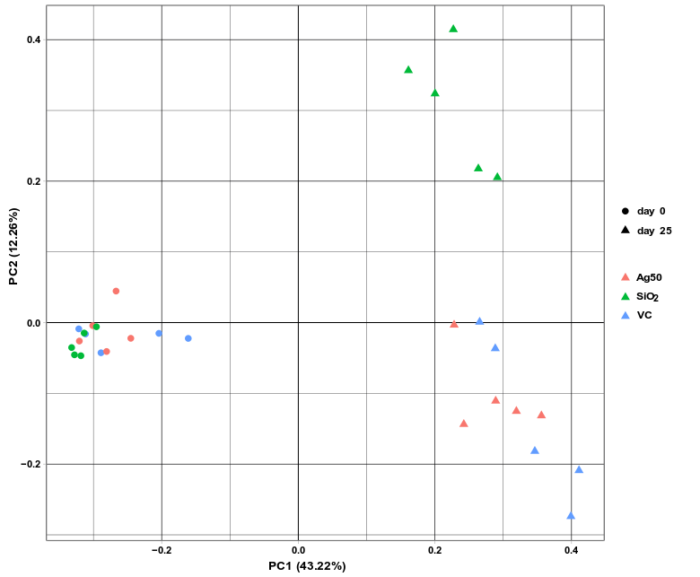
a

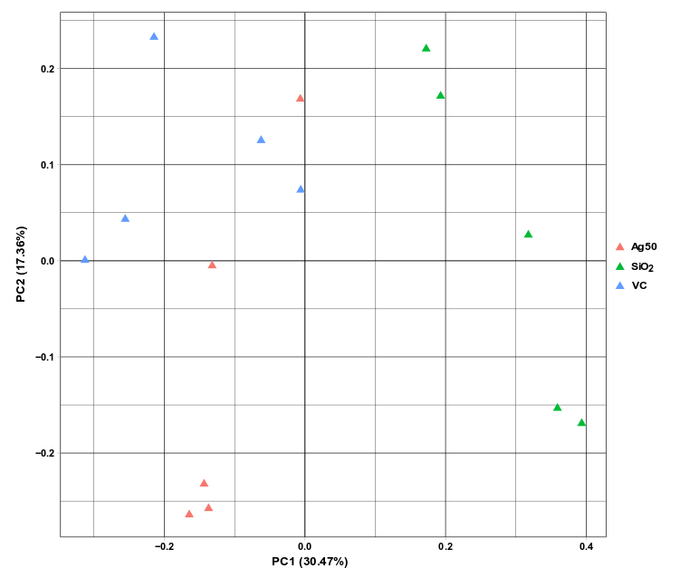
b
Fig. S2 Beta-diversity of gut microbiota visualized as PCoA plots. Beta-diversity illustrated for samples of untreated male Wistar rats (at day 0) compared to the same animals after 25 days of gavage treatment with vehicle, Ag NP or SiO₂ NP (a), or samples from male Wistar rats after 25 days of gavage treatment only to compare treatments with vehicle, Ag NP and SiO₂ NP (b). VC: vehicle control, Ag50: Ag NP, SiO₂: SiO₂ NP. Bray-Curtis distance values were calculated using ASV data of the indicated samples, collected at day 0 and/or at day 25 after treatment.

a
b
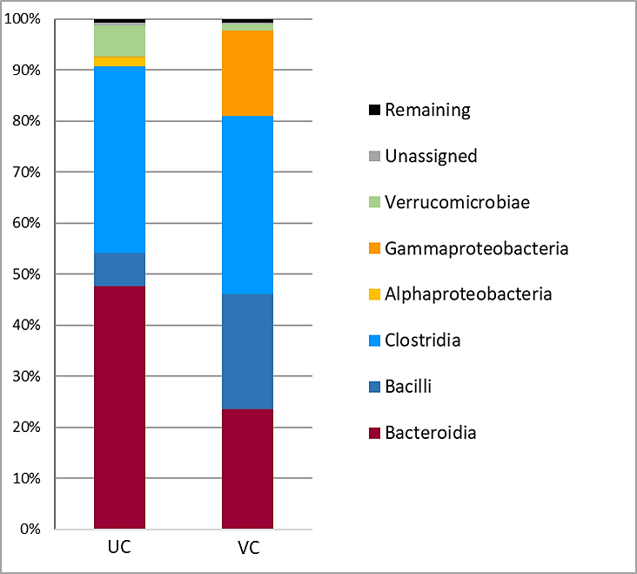
Fig. S3 Relative abundance of bacterial phyla (a) and classes (b) in the gut microbiota (≥ 1%) of male Wistar rats before (untreated) and after a 25-day gavage of PBS + BSA (vehicle). UC: Untreated control, mean values of the gut microbiota composition in feces collected at day 0 before the beginning of the experiment, VC: Vehicle control, mean values of the gut microbiota composition from feces of five animals after gavage with the vehicle PBS + BSA, collected at day 25.

Fig. S4 Scatter plots obtained for selected most abundant genera after exposure to either Ag or SiO₂ NP (median relative abundance was ≥ 1% in at least one group). VC: vehicle control; Ag50: Ag NP; SiO₂: SiO₂ NP, N = 5, p-values were obtained by using the Mann-Whitney-U-test.

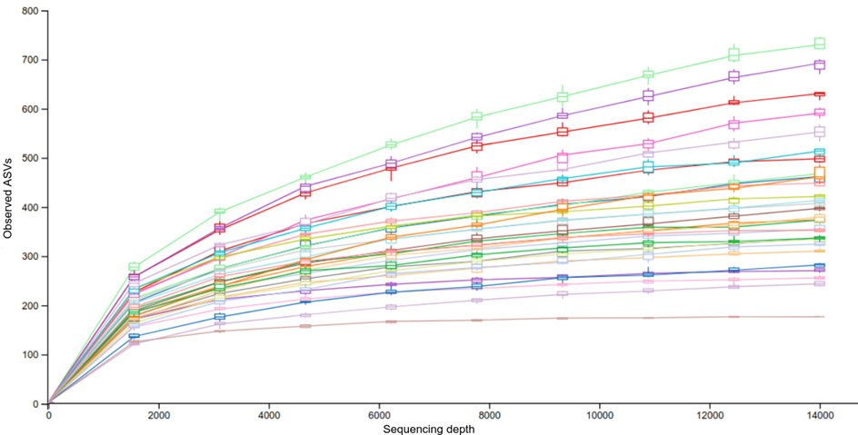
Fig. S5 Rarefaction curves of all animals used for the analyses (samples of untreated rats at day 0; vehicle controls, Ag NP and SiO₂NP-treated samples at day 25, respectively). Different colors display the different individual samples. The box plots represent the distribution of the observed ASVs for each sample at each even sampling depth.

References

1. Han H, Xiao H, Zhang K, Lu Z. Impact of 4-epi-oxytetracycline on the gut microbiota and blood metabolomics of Wistar rats. Sci Rep. 2016;6:23141; doi: 10.1038/srep23141. http://www.ncbi.nlm.nih.gov/pubmed/26976662.
2. Mariat D, Firmesse O, Levenez F, Guimaraes V, Sokol H, Dore J, et al. The Firmicutes/Bacteroidetes ratio of the human microbiota changes with age. BMC Microbiol. 2009;9:123; doi: 10.1186/1471-2180-9-123. http://www.ncbi.nlm.nih.gov/pubmed/19508720.
3. Buesen R, Landsiedel R, Sauer UG, Wohlleben W, Groeters S, Strauss V, et al. Effects of SiO(2), ZrO(2), and BaSO(4) nanomaterials with or without surface functionalization upon 28-day oral exposure to rats. Arch Toxicol. 2014;88 10:1881-906; doi: 10.1007/s00204-014-1337-0. http://www.ncbi.nlm.nih.gov/pubmed/25164825.
4. Behr C, Kamp H, Fabian E, Krennrich G, Mellert W, Peter E, et al. Gut microbiome-related metabolic changes in plasma of antibiotic-treated rats. Arch Toxicol. 2017;91 10:3439-54; doi: 10.1007/s00204-017-1949-2. https://www.ncbi.nlm.nih.gov/pubmed/28337503.
5. Behr C, Ramirez-Hincapie S, Cameron HJ, Strauss V, Walk T, Herold M, et al. Impact of lincosamides antibiotics on the composition of the rat gut microbiota and the metabolite profile of plasma and feces. Toxicol Lett. 2018;296:139-51; doi: 10.1016/j.toxlet.2018.08.002. https://www.ncbi.nlm.nih.gov/pubmed/30102961.
6. Behr C, Slopianka M, Haake V, Strauss V, Sperber S, Kamp H, et al. Analysis of metabolome changes in the bile acid pool in feces and plasma of antibiotic-treated rats. Toxicol Appl Pharmacol. 2019;363:79-87; doi: 10.1016/j.taap.2018.11.012. https://www.ncbi.nlm.nih.gov/pubmed/30502395.
7. Behr C, Sperber S, Jiang X, Strauss V, Kamp H, Walk T, et al. Microbiome-related metabolite changes in gut tissue, cecum content and feces of rats treated with antibiotics. Toxicol Appl Pharmacol. 2018;355:198-210; doi: 10.1016/j.taap.2018.06.028. https://www.ncbi.nlm.nih.gov/pubmed/30008377.
8. Hellack B, Hülser T, Izak E, Kuhlbusch T, Meyer F, Spree M, et al: Characterization report for all nanoGEM materials. 2012.
9. Wohlleben W, Ma-Hock L, Boyko V, Cox G, Egenolf H, Freiberger H, et al. Nanospecific Guidance in REACH: A Comparative Physical-Chemical Characterization of 15 Materials with Methodical Correlations. J Ceram Sci Technol. 2013;4 2:93-104; doi: 10.4416/Jcst2012-00045. <Go to ISI>://WOS:000209199600006.
10. Scher JU, Sczesnak A, Longman RS, Segata N, Ubeda C, Bielski C, et al. Expansion of intestinal Prevotella copri correlates with enhanced susceptibility to arthritis. Elife. 2013;2:e01202; doi: 10.7554/eLife.01202. http://www.ncbi.nlm.nih.gov/pubmed/24192039.
11. Pandey S, Maharana J, Shukla AK. The Gut Feeling: GPCRs Enlighten the Way. Cell Host Microbe. 2019;26 2:160-2; doi: 10.1016/j.chom.2019.07.018. https://www.ncbi.nlm.nih.gov/pubmed/31415748.
12. Levin BJ, Huang YY, Peck SC, Wei Y, Martinez-Del Campo A, Marks JA, et al. A prominent glycyl radical enzyme in human gut microbiomes metabolizes trans-4-hydroxy-l-proline. Science. 2017;355 6325; doi: 10.1126/science.aai8386. https://www.ncbi.nlm.nih.gov/pubmed/28183913.
13. Phang JM, Liu W, Zabirnyk O. Proline metabolism and microenvironmental stress. Annu Rev Nutr. 2010;30:441-63; doi: 10.1146/annurev.nutr.012809.104638. https://www.ncbi.nlm.nih.gov/pubmed/20415579.
14. Roager HM, Licht TR. Microbial tryptophan catabolites in health and disease. Nat Commun. 2018;9 1:3294; doi: 10.1038/s41467-018-05470-4. https://www.ncbi.nlm.nih.gov/pubmed/30120222.
15. Lamas B, Richard ML, Leducq V, Pham HP, Michel ML, Da Costa G, et al. CARD9 impacts colitis by altering gut microbiota metabolism of tryptophan into aryl hydrocarbon receptor ligands. Nat Med. 2016;22 6:598-605; doi: 10.1038/nm.4102. https://www.ncbi.nlm.nih.gov/pubmed/27158904.
16. van Beek AA, Hugenholtz F, Meijer B, Sovran B, Perdijk O, Vermeij WP, et al. Frontline Science: Tryptophan restriction arrests B cell development and enhances microbial diversity in WT and prematurely aging Ercc1(-/Delta7) mice. J Leukoc Biol. 2017;101 4:811-21; doi: 10.1189/jlb.1HI0216-062RR. https://www.ncbi.nlm.nih.gov/pubmed/27418353.
17. Comai S, Bertazzo A, Brughera M, Crotti S. Tryptophan in health and disease. Adv Clin Chem. 2020;95:165-218; doi: 10.1016/bs.acc.2019.08.005. https://www.ncbi.nlm.nih.gov/pubmed/32122523.
18. Lamas B, Martins Breyner N, Houdeau E. Impacts of foodborne inorganic nanoparticles on the gut microbiota-immune axis: potential consequences for host health. Part Fibre Toxicol. 2020;17 1:19; doi: 10.1186/s12989-020-00349-z. https://www.ncbi.nlm.nih.gov/pubmed/32487227.
19. Lavelle A, Sokol H. Gut microbiota-derived metabolites as key actors in inflammatory bowel disease. Nat Rev Gastroenterol Hepatol. 2020;17 4:223-37; doi: 10.1038/s41575-019-0258-z. https://www.ncbi.nlm.nih.gov/pubmed/32076145.
20. Basen M, Kurrer SE. A close look at pentose metabolism of gut bacteria. FEBS J. 2021;288 6:1804-8; doi: 10.1111/febs.15575. https://www.ncbi.nlm.nih.gov/pubmed/33063458.
21. Reichardt N, Duncan SH, Young P, Belenguer A, McWilliam Leitch C, Scott KP, et al. Phylogenetic distribution of three pathways for propionate production within the human gut microbiota. ISME J. 2014;8 6:1323-35; doi: 10.1038/ismej.2014.14. https://www.ncbi.nlm.nih.gov/pubmed/24553467.
22. Kindt A, Liebisch G, Clavel T, Haller D, Hormannsperger G, Yoon H, et al. The gut microbiota promotes hepatic fatty acid desaturation and elongation in mice. Nat Commun. 2018;9 1:3760; doi: 10.1038/s41467-018-05767-4. https://www.ncbi.nlm.nih.gov/pubmed/30218046.
23. Whelan J. The health implications of changing linoleic acid intakes. Prostaglandins Leukot Essent Fatty Acids. 2008;79 3-5:165-7; doi: 10.1016/j.plefa.2008.09.013. https://www.ncbi.nlm.nih.gov/pubmed/18990554.
24. Stremmel W, Schmidt KV, Schuhmann V, Kratzer F, Garbade SF, Langhans CD, et al. Blood Trimethylamine-N-Oxide Originates from Microbiota Mediated Breakdown of Phosphatidylcholine and Absorption from Small Intestine. PLoS One. 2017;12 1:e0170742; doi: 10.1371/journal.pone.0170742. https://www.ncbi.nlm.nih.gov/pubmed/28129384.
25. Wang Z, Klipfell E, Bennett BJ, Koeth R, Levison BS, Dugar B, et al. Gut flora metabolism of phosphatidylcholine promotes cardiovascular disease. Nature. 2011;472 7341:57-63; doi: 10.1038/nature09922. https://www.ncbi.nlm.nih.gov/pubmed/21475195.
26. Pralhada Rao R, Vaidyanathan N, Rengasamy M, Mammen Oommen A, Somaiya N, Jagannath MR. Sphingolipid metabolic pathway: an overview of major roles played in human diseases. J Lipids. 2013;2013:178910; doi: 10.1155/2013/178910. https://www.ncbi.nlm.nih.gov/pubmed/23984075.
27. An D, Na C, Bielawski J, Hannun YA, Kasper DL. Membrane sphingolipids as essential molecular signals for Bacteroides survival in the intestine. Proc Natl Acad Sci U S A. 2011;108 Suppl 1:4666-71; doi: 10.1073/pnas.1001501107. https://www.ncbi.nlm.nih.gov/pubmed/20855611.
28. Norris GH, Milard M, Michalski MC, Blesso CN. Protective properties of milk sphingomyelin against dysfunctional lipid metabolism, gut dysbiosis, and inflammation. J Nutr Biochem. 2019;73:108224; doi: 10.1016/j.jnutbio.2019.108224. https://www.ncbi.nlm.nih.gov/pubmed/31654895.
29. Louis P, Flint HJ. Formation of propionate and butyrate by the human colonic microbiota. Environ Microbiol. 2017;19 1:29-41; doi: 10.1111/1462-2920.13589. https://www.ncbi.nlm.nih.gov/pubmed/27928878.
30. Hosseini E, Grootaert C, Verstraete W, Van de Wiele T. Propionate as a health-promoting microbial metabolite in the human gut. Nutr Rev. 2011;69 5:245-58; doi: 10.1111/j.1753-4887.2011.00388.x. https://www.ncbi.nlm.nih.gov/pubmed/21521227.
31. Eisenhofer G, Kopin IJ, Goldstein DS. Catecholamine metabolism: a contemporary view with implications for physiology and medicine. Pharmacol Rev. 2004;56 3:331-49; doi: 10.1124/pr.56.3.1. https://www.ncbi.nlm.nih.gov/pubmed/15317907.
32. Strandwitz P. Neurotransmitter modulation by the gut microbiota. Brain Res. 2018;1693 Pt B:128-33; doi: 10.1016/j.brainres.2018.03.015. https://www.ncbi.nlm.nih.gov/pubmed/29903615.
33. Mardh G, Dingley AL, Auld DS, Vallee BL. Human class II (pi) alcohol dehydrogenase has a redox-specific function in norepinephrine metabolism. Proc Natl Acad Sci U S A. 1986;83 23:8908-12; doi: 10.1073/pnas.83.23.8908. https://www.ncbi.nlm.nih.gov/pubmed/3466164.
34. Charette M, Gray MW. Pseudouridine in RNA: what, where, how, and why. IUBMB Life. 2000;49 5:341-51; doi: 10.1080/152165400410182. https://www.ncbi.nlm.nih.gov/pubmed/10902565.
35. Magnusdottir S, Ravcheev D, de Crecy-Lagard V, Thiele I. Systematic genome assessment of B-vitamin biosynthesis suggests co-operation among gut microbes. Front Genet. 2015;6:148; doi: 10.3389/fgene.2015.00148. https://www.ncbi.nlm.nih.gov/pubmed/25941533.
36. Gominak SC. Vitamin D deficiency changes the intestinal microbiome reducing B vitamin production in the gut. The resulting lack of pantothenic acid adversely affects the immune system, producing a "pro-inflammatory" state associated with atherosclerosis and autoimmunity. Med Hypotheses. 2016;94:103-7; doi: 10.1016/j.mehy.2016.07.007. https://www.ncbi.nlm.nih.gov/pubmed/27515213.
37. Zheng X, Xie G, Zhao A, Zhao L, Yao C, Chiu NH, et al. The footprints of gut microbial-mammalian co-metabolism. J Proteome Res. 2011;10 12:5512-22; doi: 10.1021/pr2007945. https://www.ncbi.nlm.nih.gov/pubmed/21970572.
38. Sun L, Jia H, Li J, Yu M, Yang Y, Tian D, et al. Cecal Gut Microbiota and Metabolites Might Contribute to the Severity of Acute Myocardial Ischemia by Impacting the Intestinal Permeability, Oxidative Stress, and Energy Metabolism. Front Microbiol. 2019;10:1745; doi: 10.3389/fmicb.2019.01745. https://www.ncbi.nlm.nih.gov/pubmed/31428065.

