Supporting Information

Ultrasmall Iron Oxide Nanoparticles Cause Significant Toxicity by Specifically Inducing Acute Oxidative Stress to Multiple Organs

Lin Wu¹, Wen Wen^{1,2}, Xiaofeng Wang^{1,2}, Danhua Huang^{1,2}, Jin Cao², Xueyong Qi², and Song Shen^{2,*}

¹ Affiliated Hospital of Jiangsu University, Zhenjiang 212001, China
² School of Pharmaceutical Science, Jiangsu University, Zhenjiang 212013, China
E-mail addresses: jsdx.shensong@163.com (S. Shen),

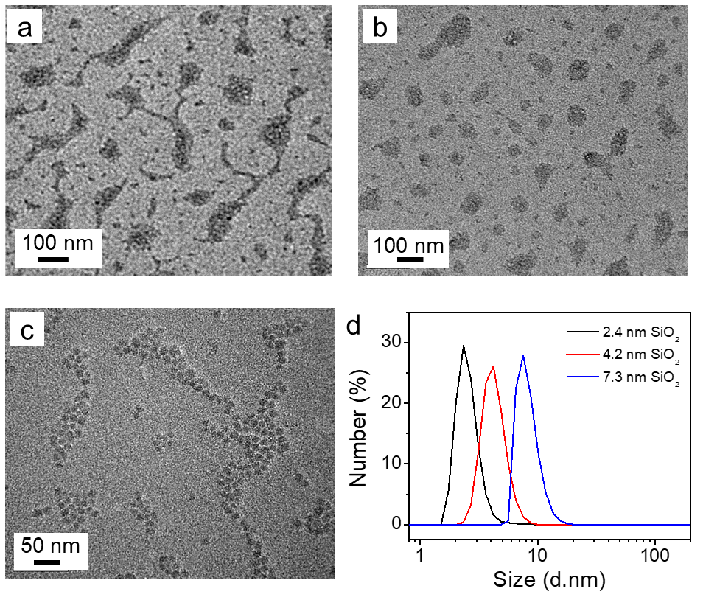
Figure S1. TEM images of SiO₂ NPs with size of a) 2.4 nm, b) 4.2 nm, c) 7.3 nm. d) particle size distribution of the SiO₂ NPs.

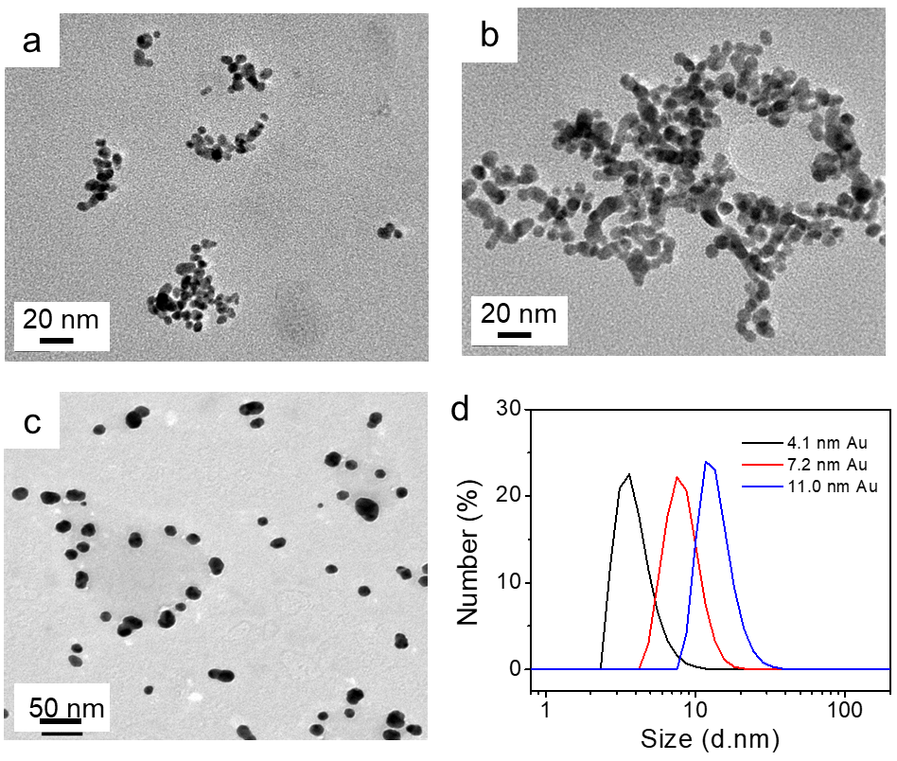
Figure S2. TEM images of Au NPs with size of a) 4.1 nm, b) 7.2 nm, c) 11.0 nm. d) particle size distribution of the Au NPs.

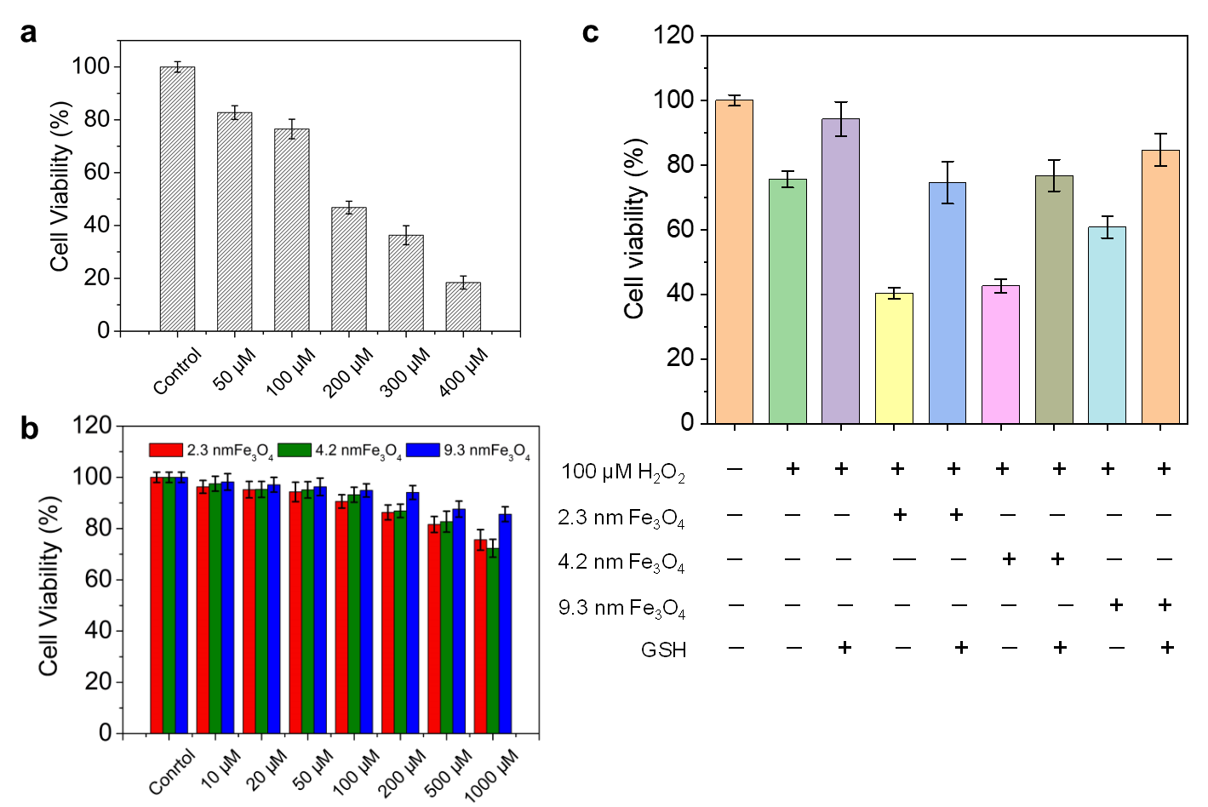
Figure S3. a) Toxicity of different concentrations of H₂O₂ solution to MCF-7 cells. b) Cell viability of MCF-7 incubated with different-sized Fe₃O₄ NPs at different concentrations. c) The cytotoxicity of Fe₃O₄ NPs (1000 μg/mL) to MCF-7 cells in the presence and absence of H₂O₂ and GSH.

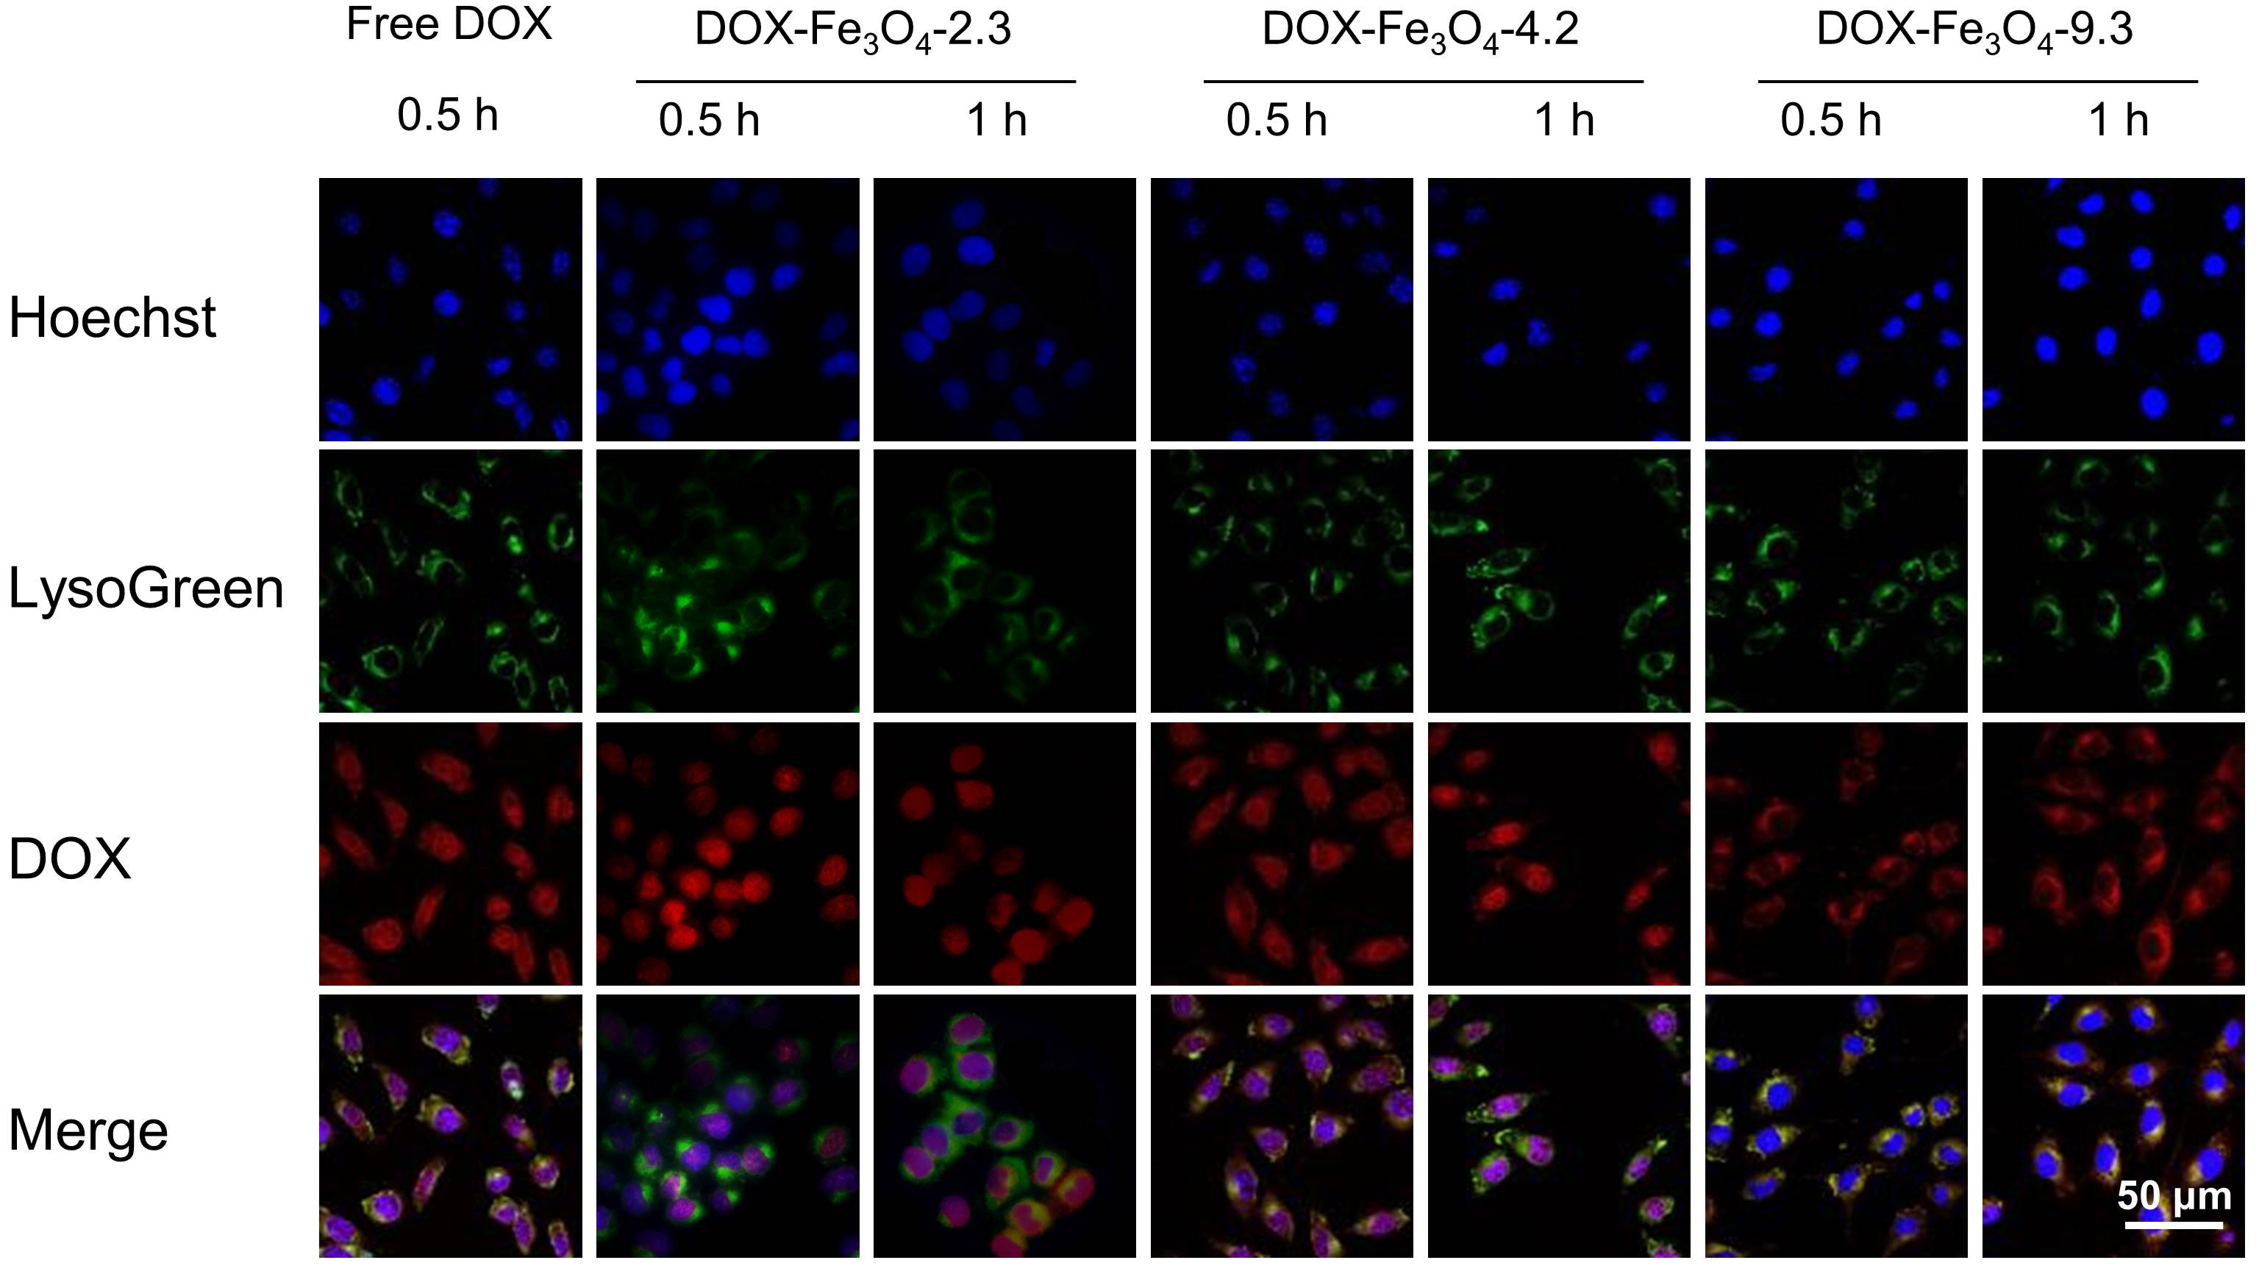
Figure S4. Cellular uptake of different size of Fe₃O₄ NPs with different incubation time. Red: DOX fluorescence. Blue: Hoechst 33342 staining of nuclei. Green: LysoGreen staining of lysosomes.

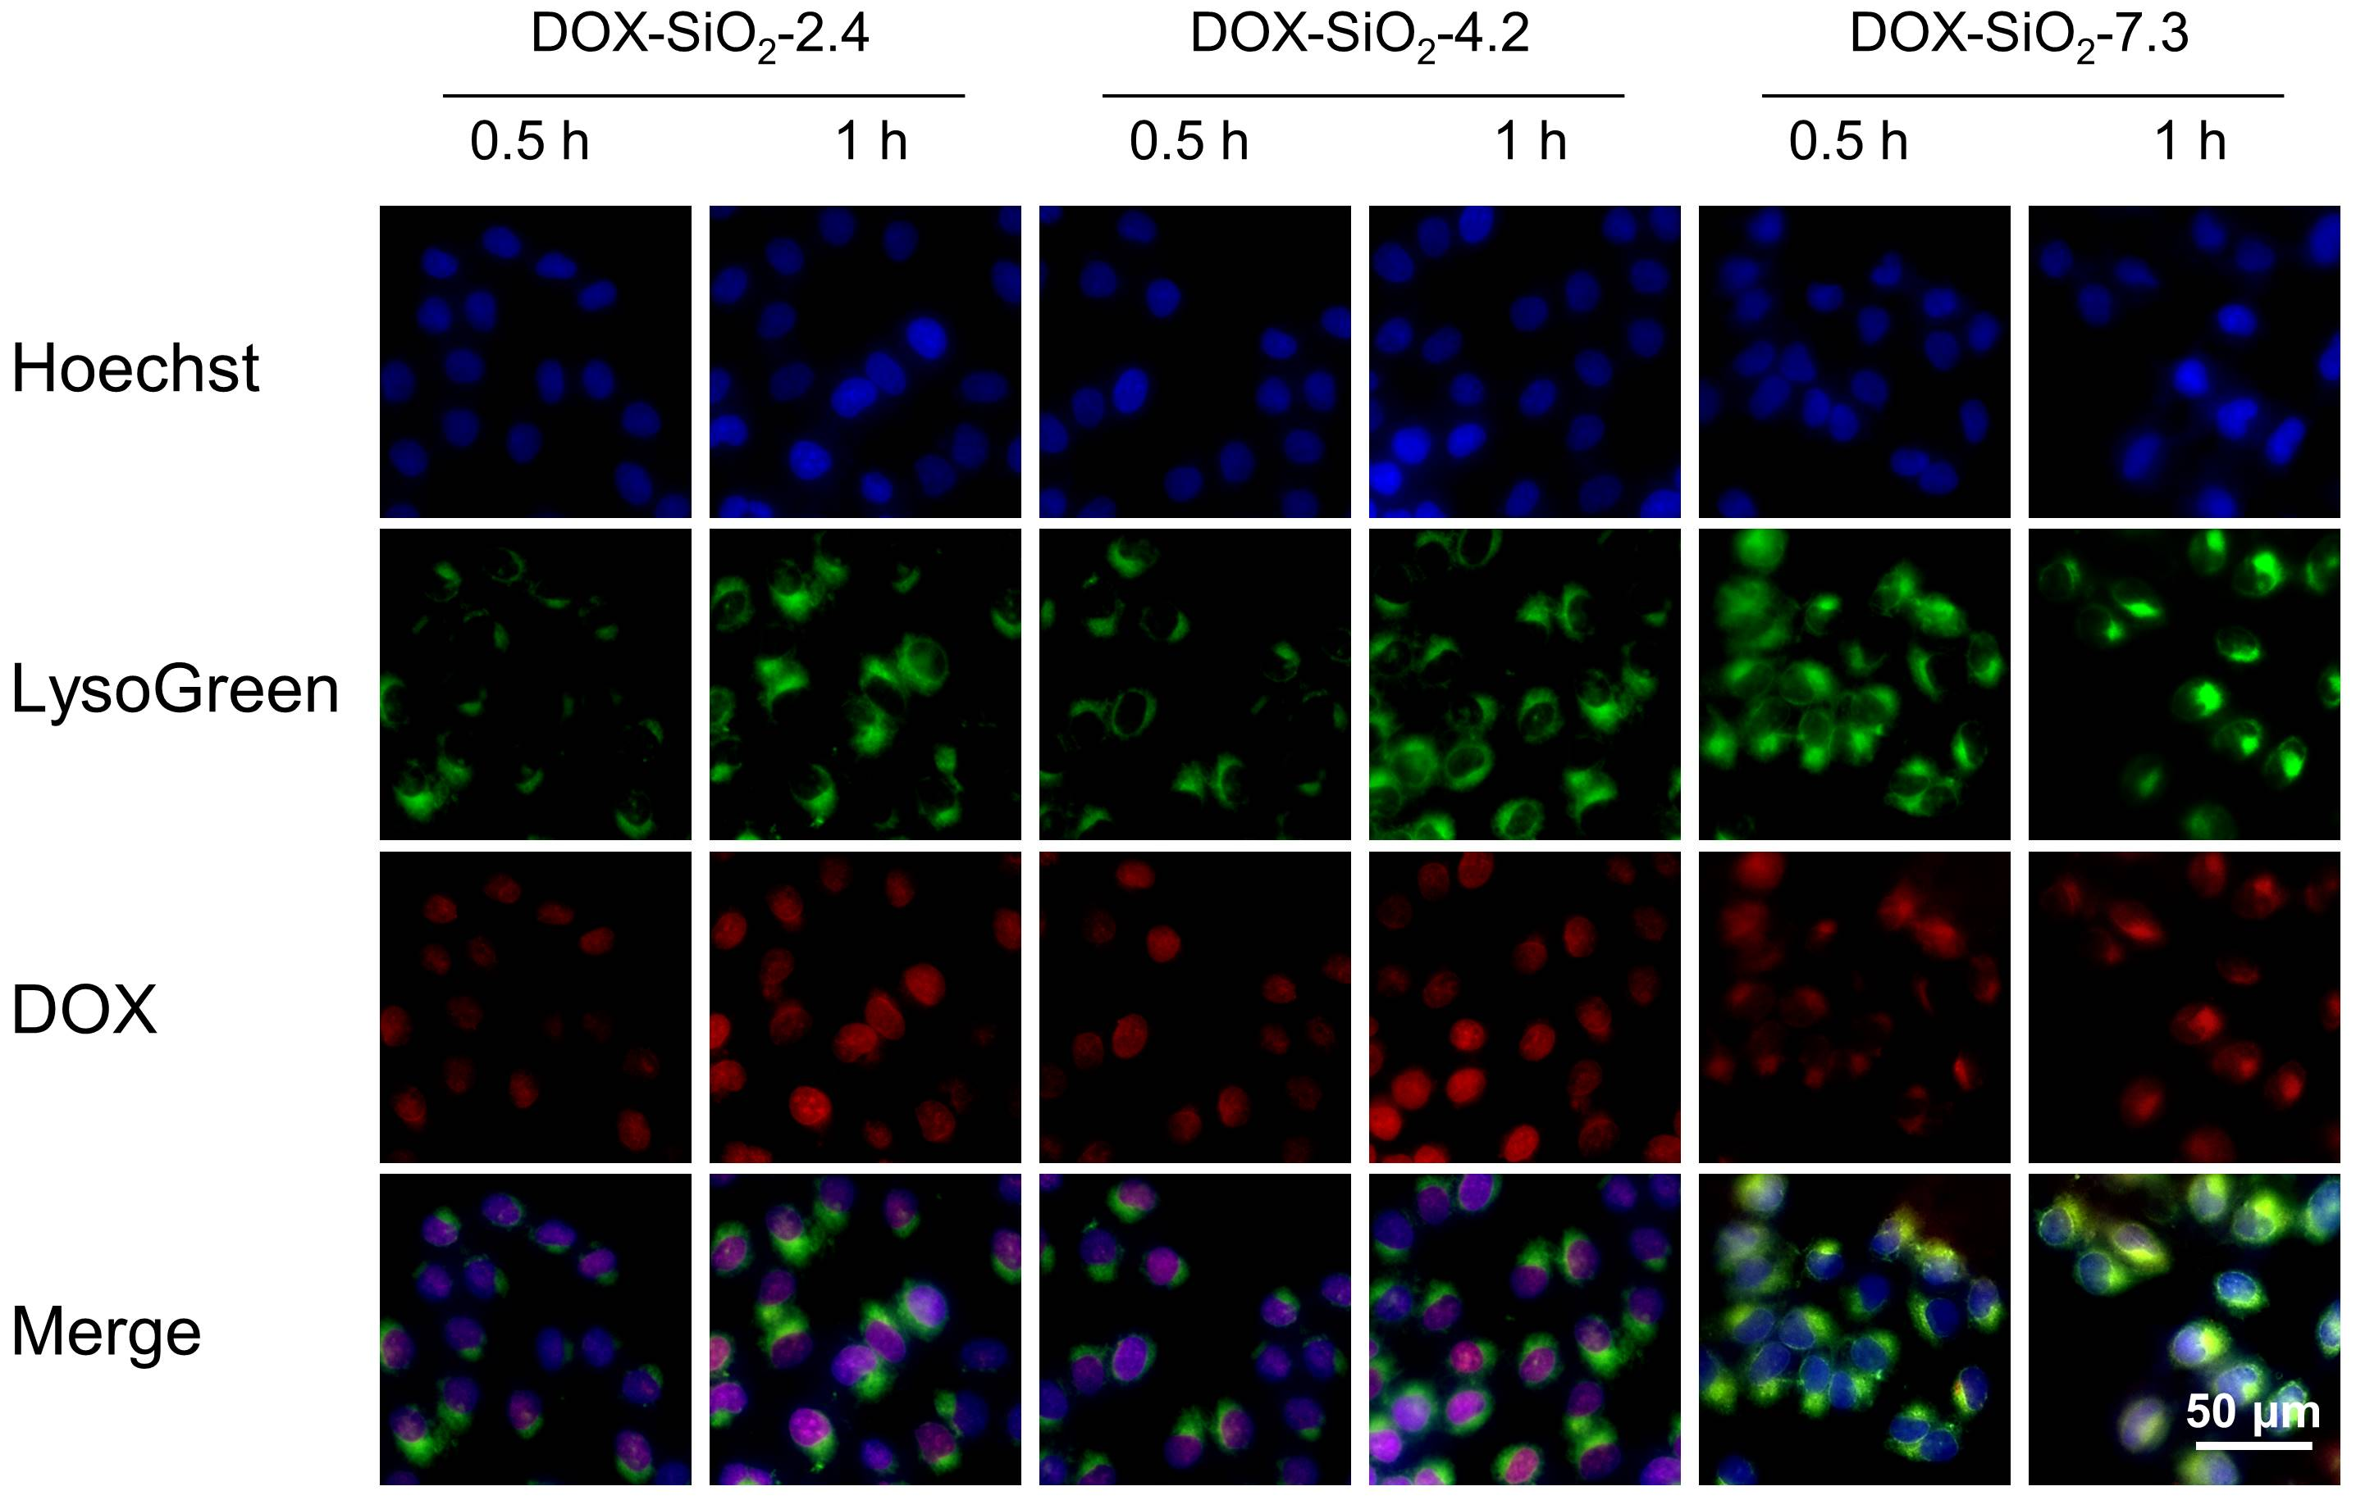
Figure S5. Cellular uptake of different size of SiO₂ NPs with different incubation time. Red: DOX fluorescence. Blue: Hoechst 33342 staining of nuclei. Green: LysoGreen staining of lysosomes.

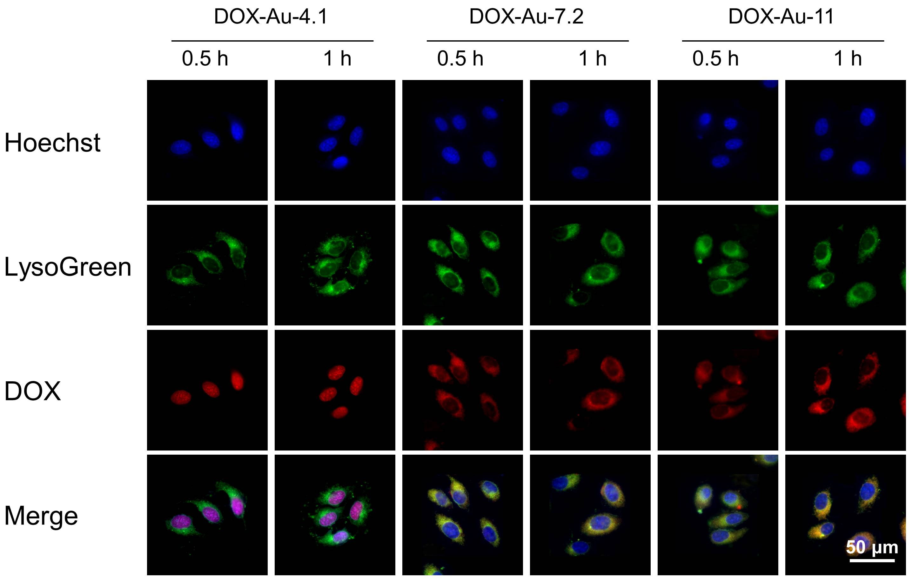
Figure S6. Cellular uptake of different sizes of Au NPs with different incubation time. Red: DOX fluorescence. Blue: Hoechst 33342 staining of nuclei. Green: LysoGreen staining of lysosomes.

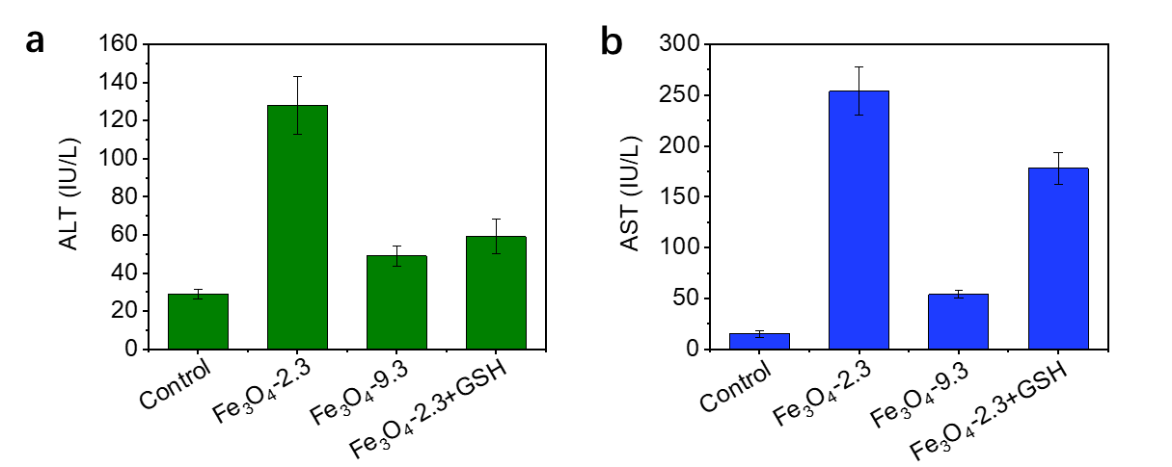
Figure S7. The levels of ALT (a) and AST(b) after treatments of Fe₃O₄-2.3, Fe₃O₄-9.3, and Fe₃O₄-2.3+GSH.

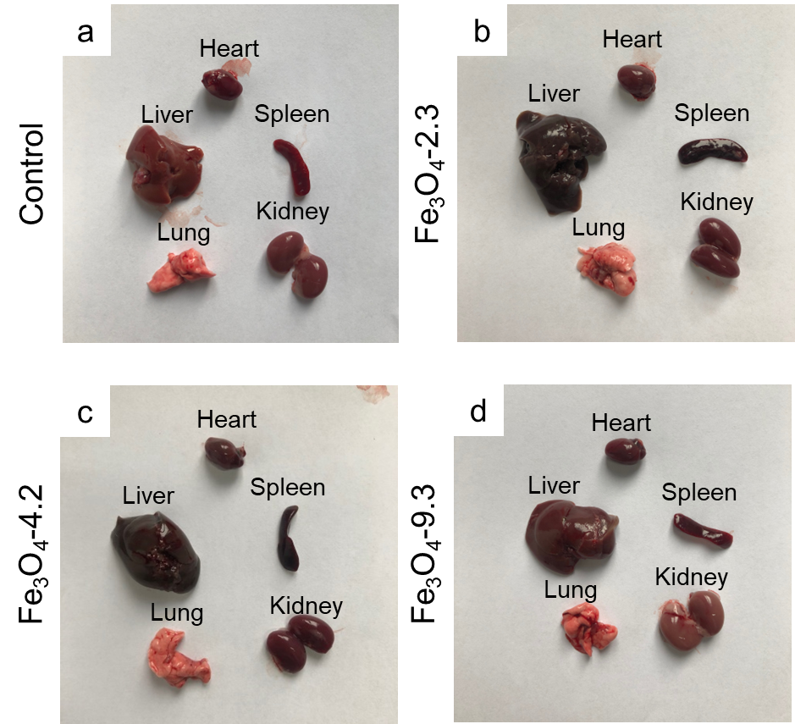
Figure S8. Biodistribution of different sizes of Fe₃O₄ NPs. Digital images of the major organs collected from mice injected with Fe₃O₄ nanoparticles for 24 h.

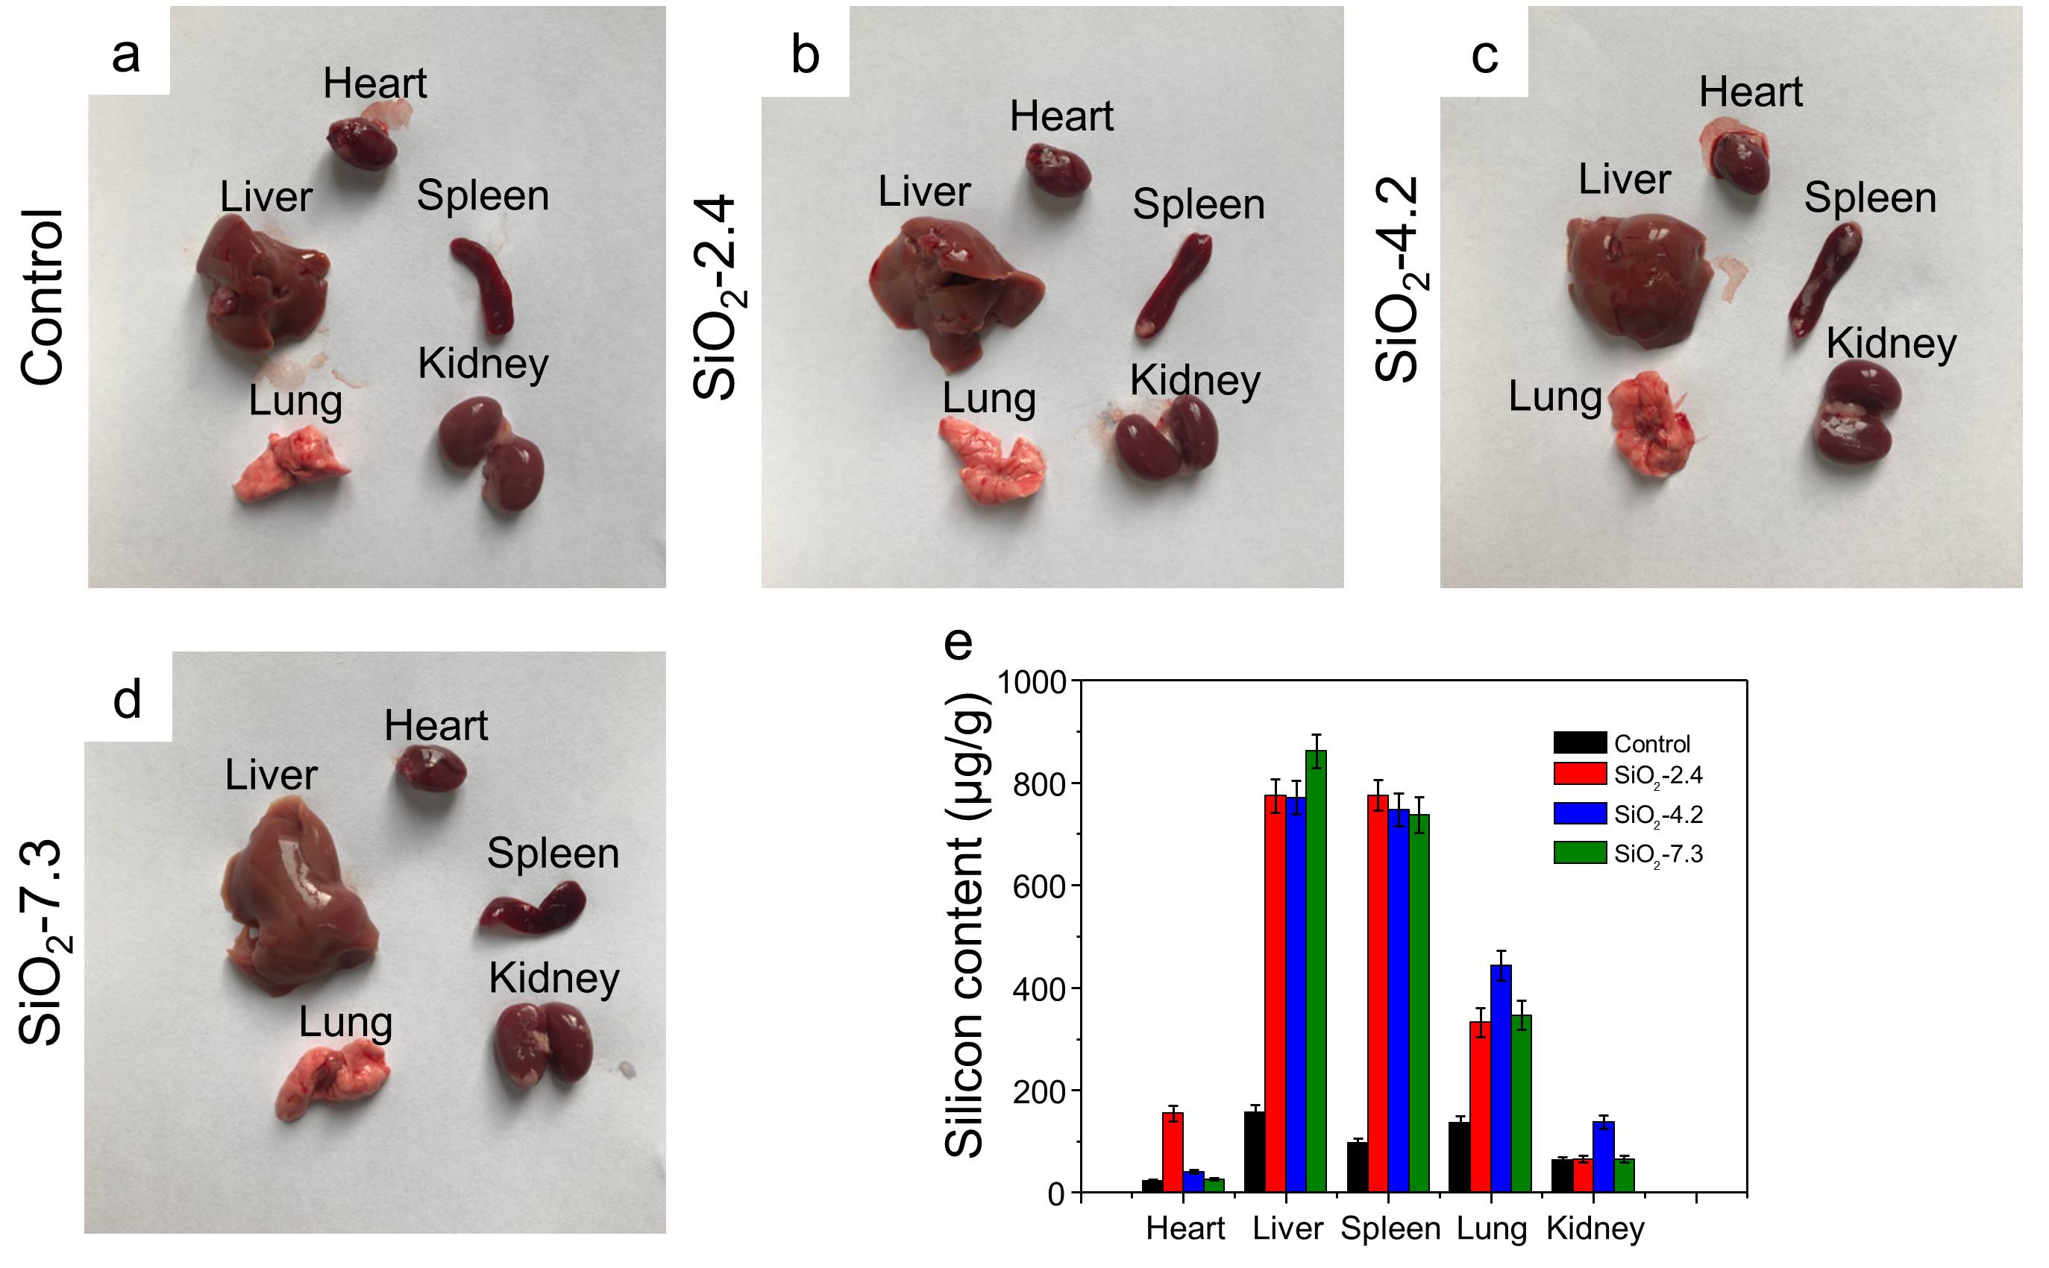
Figure S9. Biodistribution of different sizes of SiO₂ NPs. Digital images of the major organs collected from mice injected with SiO₂ nanoparticles for 24 h and quantitative determination of silicon in different organs obtained by ICP-AES (n=3).

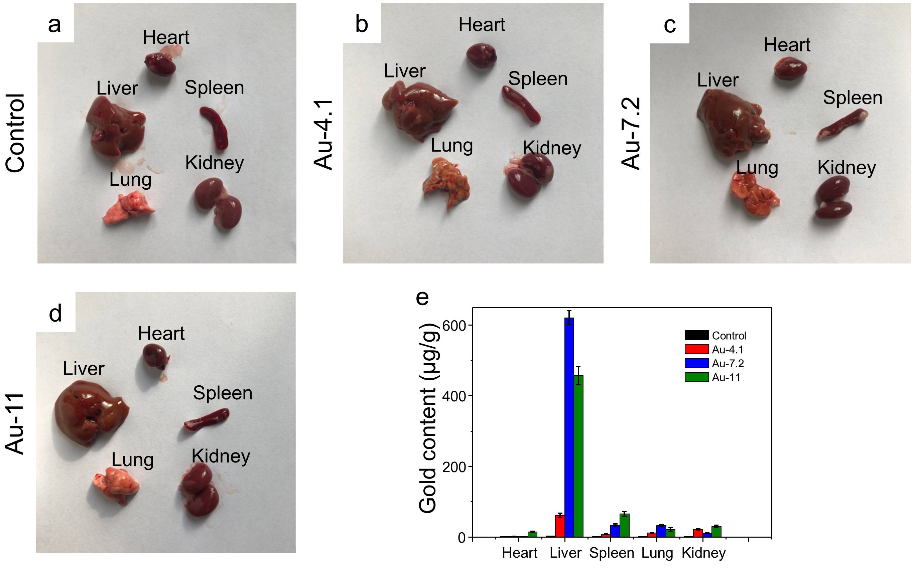
Figure S10. Biodistribution of different sizes of Au NPs. Digital images of the major organs collected from mice injected with Au nanoparticles for 24 h and quantitative determination of gold in different organs obtained by ICP-AES (n=3).

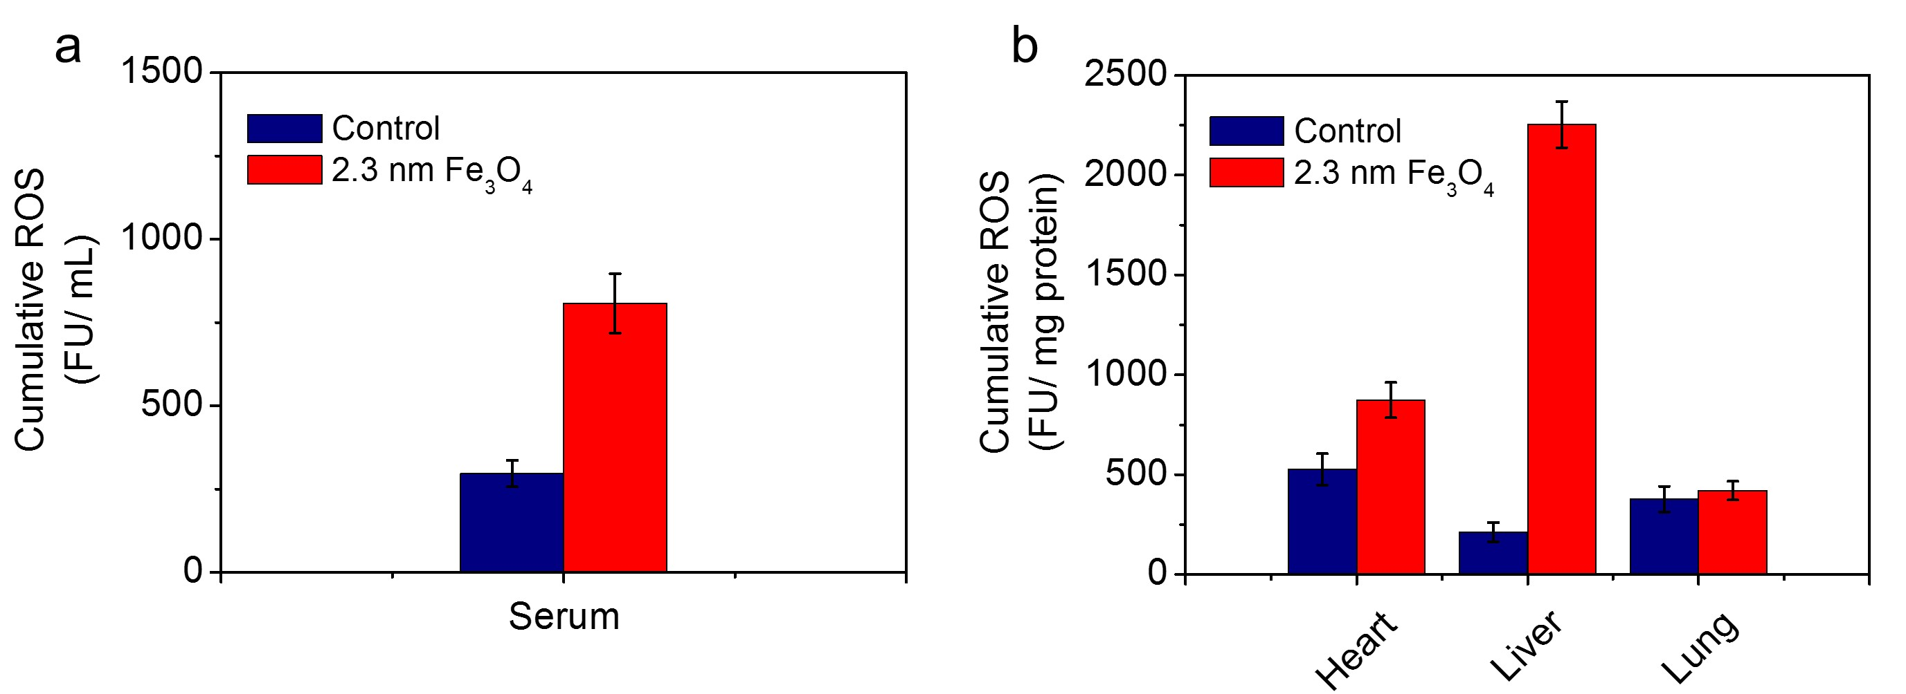
Figure S11. ROS in serum (a) and organs (b) after intravenous injection of 2.3 nm Fe₃O₄ NPs (50 mg/kg) for 3 consecutive days.

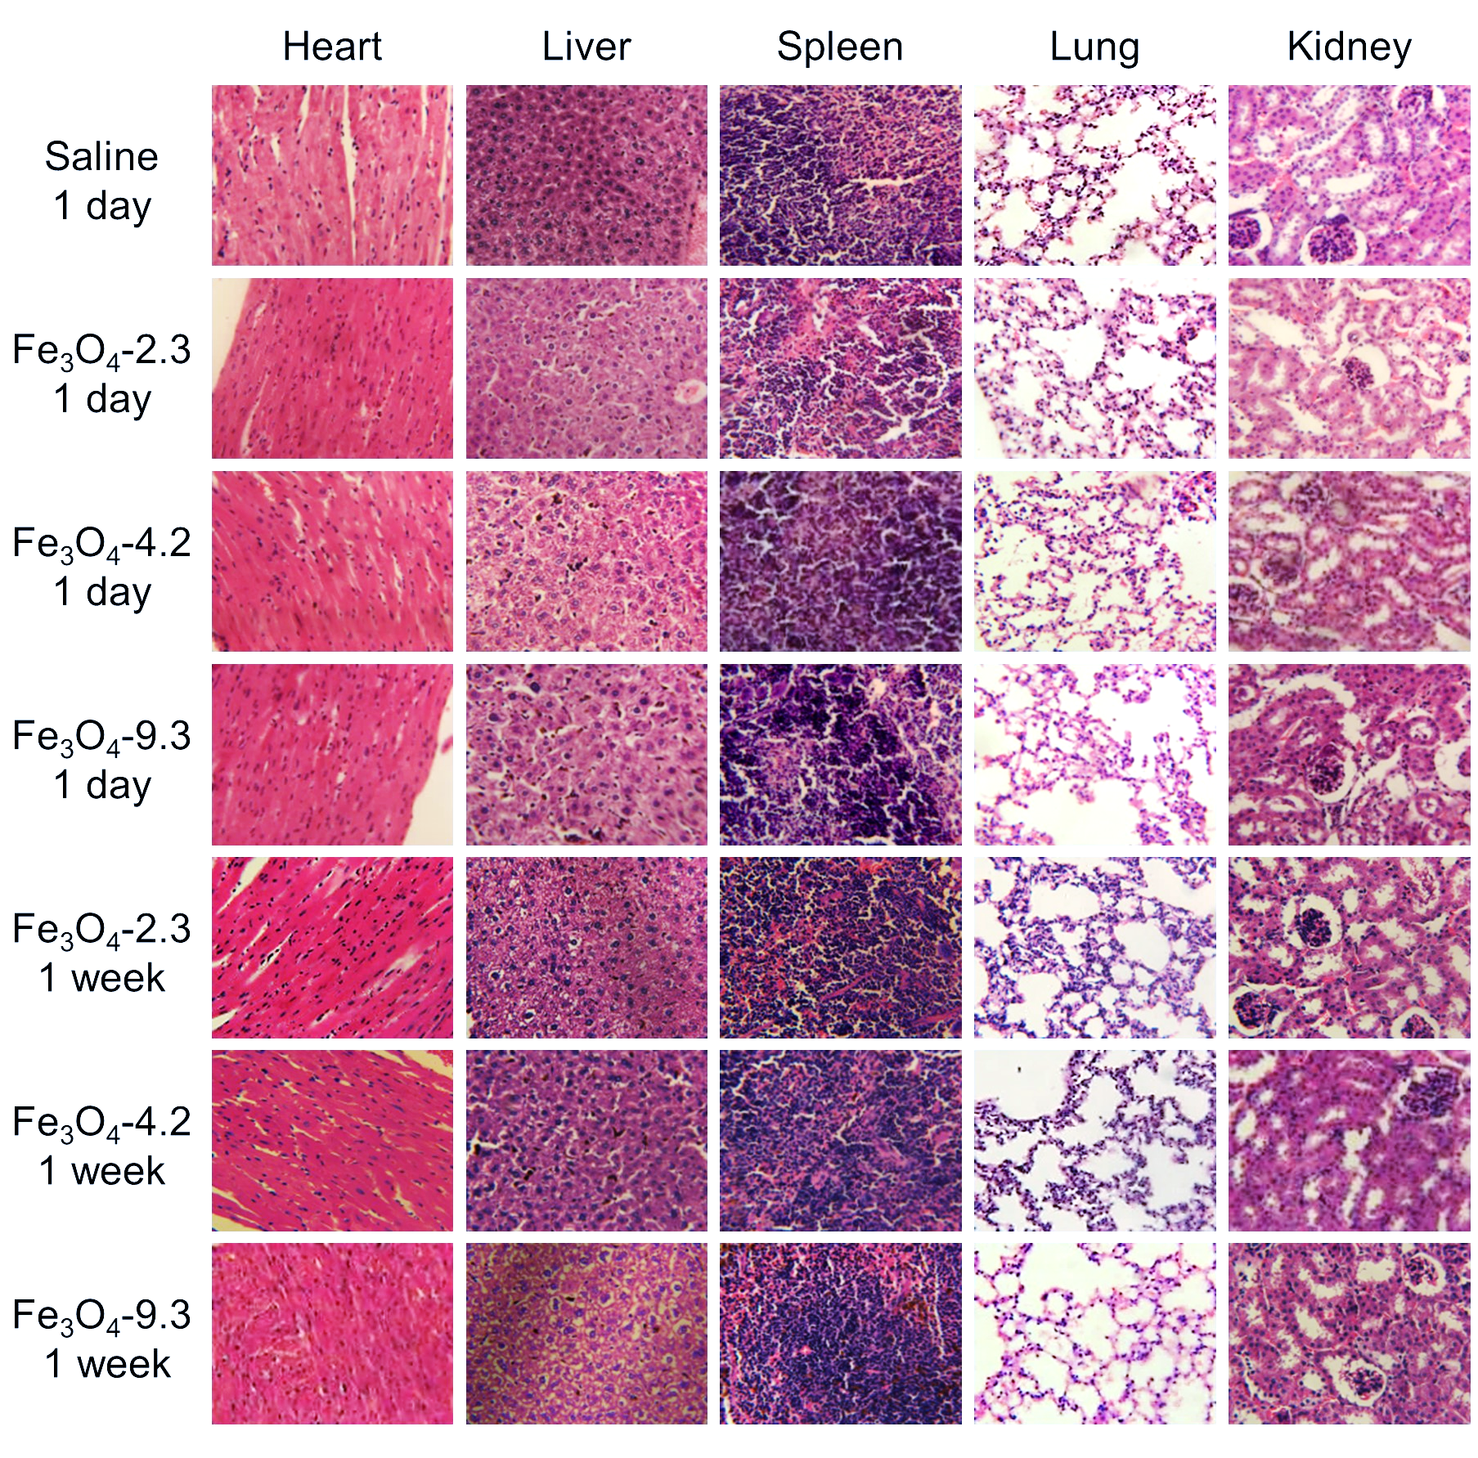
Figure S12. H&E stained images of heart, liver, spleen, lung and kidney collected from Fe₃O₄-injected and saline-injected mice after injection for 1 day and 1 week.

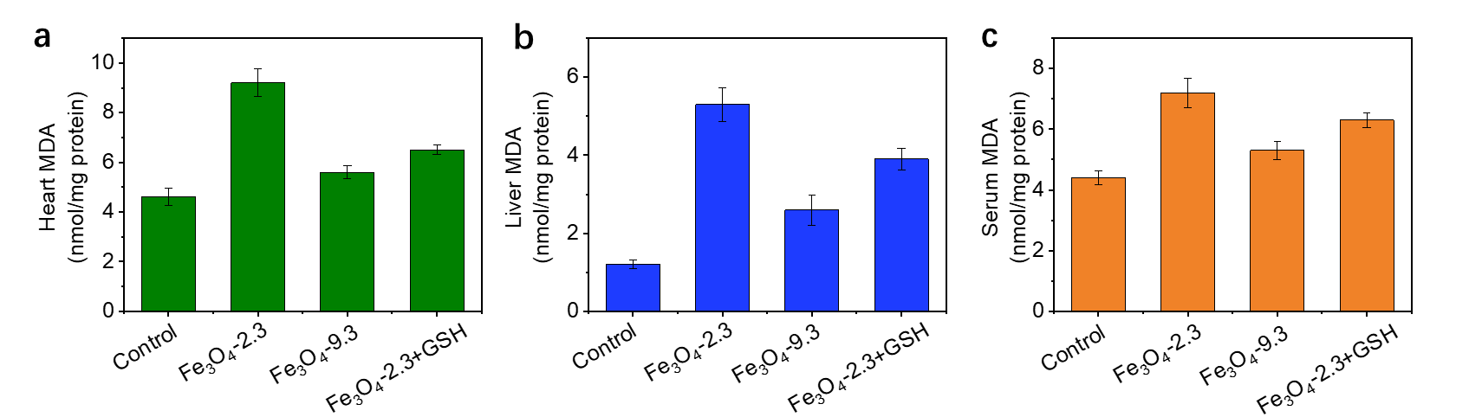
Figure S13. The malondialdehyde (MDA) levels in heart (a), liver (b) and serum (c) of the mice after the treatments of Fe₃O₄-2.3, Fe₃O₄-9.3 NPs and Fe₃O₄-2.3+GSH.

Table S1. The surviving rate of mice after injection with Fe₃O₄-2.3 or Fe₃O₄-2.3+GSH.
 | Number of dead mice | Number of live mice
Fe₃O₄-2.3, with single injection | 5 | 0
Fe₃O₄-2.3, with 4 injections | 1 | 4
Fe₃O₄-2.3+GSH | 2 | 3

