Additional File 9
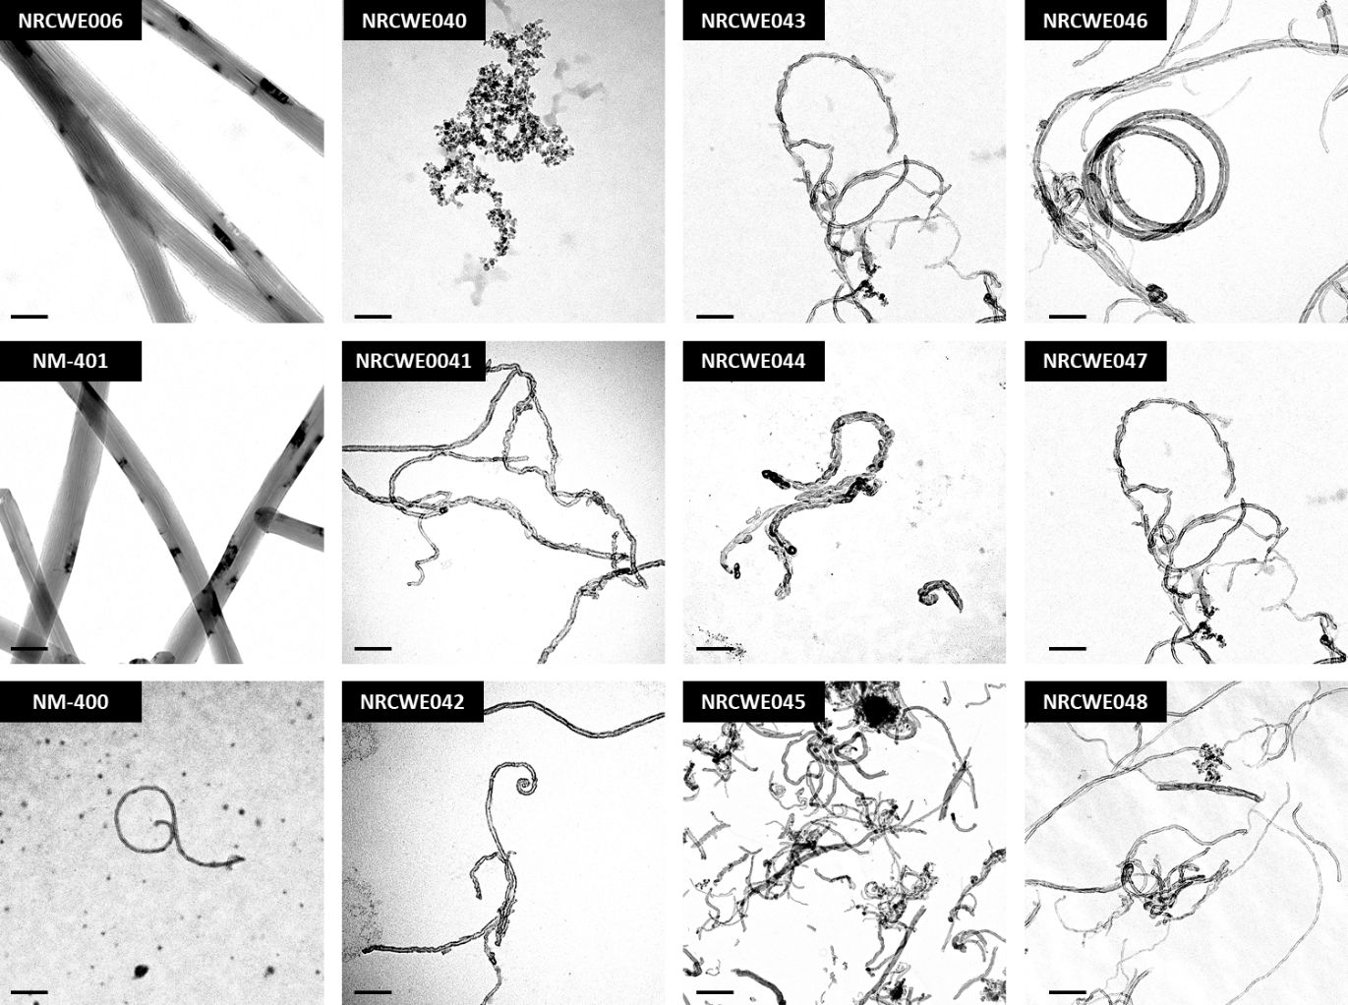
Figure S3: Transmission Electron microscope images of MWCNT panel. Scale bar = 100µm. MWCNT were dispersed in 70% ethanol and dispersed by ultrasonication prior to mounting on TEM grids.

