Additional information 2

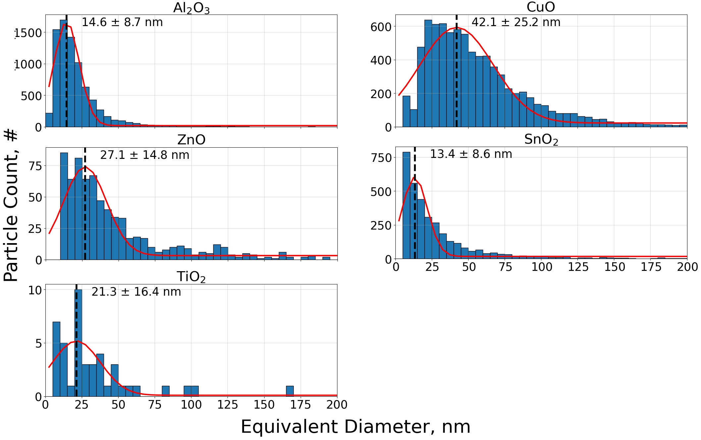
Figure S1. Particle equivalent circular diameter distributions from TEM measurements on five metal oxide samples. Samples were taken from the particle suspension in exposure vehicle. The distributions were fitted with a normal distribution, as seen in red, in order to get the mean size and standard deviation of the particle mode.

