Additional information 5
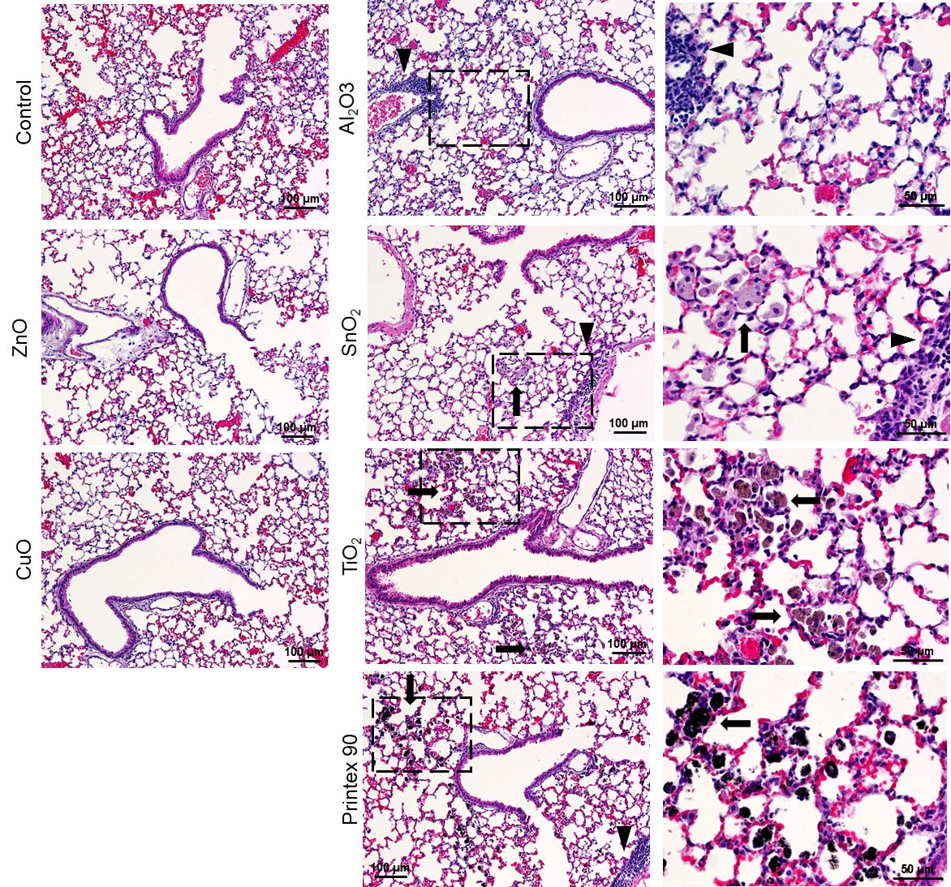

Figure S3. Mouse lung histopathology 28 days post-exposure to vehicle control, ZnO, CuO, Al₂O₃, SnO₂, TiO₂ and Printex 90. Macrophage aggregates in the alveolar region (arrows) and perivascular lymphocytic infiltration (arrowheads). Brightfield microscopy and H&E stain applies to all.

