Supplementary material

Type 1 diabetes and diet-induced obesity predispose C57BL/6J mice to PM_{2.5}-induced lung injury: a comparative study

Shen Chen^{#1}, Miao Li^{#1}, Rui Zhang^{#1}, Lizhu Ye¹, Yue Jiang¹, Xinhang Jiang¹, Hui Peng¹, Ziwei Wang¹, Zhanyu Guo¹, Liping Chen¹, Rong Zhang², Yujie Niu², Michael Aschner³, Daochuan Li¹, Wen Chen^{*1}

¹Guangdong Provincial Key Laboratory of Food, Nutrition and Health, Department of Toxicology, School of Public Health, Sun Yat-sen University, Guangzhou 510080, China.
²Department of Toxicology, School of Public Health, Hebei Medical University, Shijiazhuang, 050017, China.
³Department of Molecular Pharmacology, Albert Einstein College of Medicine, Forchheimer 209, 1300 Morris Park Avenue, Bronx, NY, 10461, USA.

#These authors contributed equally: Shen Chen, Miao Li, Rui Zhang.
*Correspondence and requests for materials should be addressed to Wen Chen, Email: chenwen@mail.sysu.edu.cn.
Supplementary figures
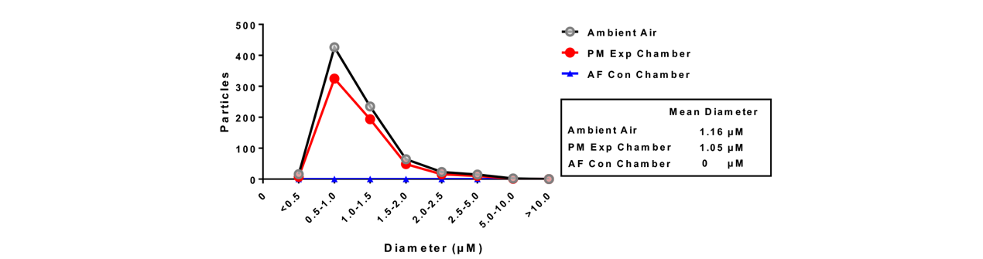
Figure S1. The distribution of PM size.
The distribution of particle diameters in PM samples from ambient air (black line with grey circles), the PM exposure chambers (blue line with blue triangles), and the AF control chambers (red line with red circles) were compared. In contrast to no particles detected in samples from AF control chambers, samples from ambient air and the PM exposure chambers were comparable in particle size, ranging from 0.5 to 1.5 micrometers.

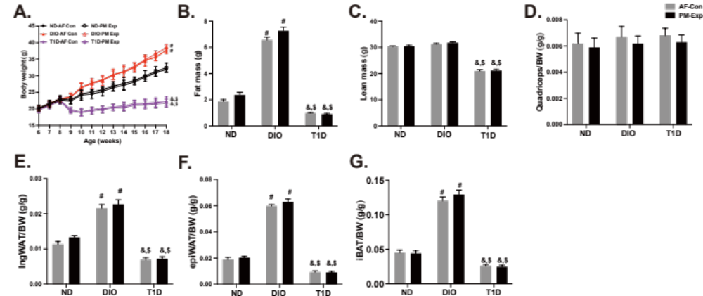
Figure S2. Body composition analysis.
The dynamic changes in body weight (A), fat mass (B), lean mass (C), quadriceps (D), inguinal white adipose tissues (ingWAT) (E), epididymal white adipose tissues (epiWAT) (F), and interscapular brown adipose tissues (iBAT) (G) from age 8 weeks to 18 weeks in different mouse models (n = 10). The data are presented as mean ± SEM. *P < 0.05 (PM vs. AF). #P < 0.05 (DIO vs. ND). &P < 0.05 (T1D vs. ND). $P < 0.05 (T1D vs. DIO).
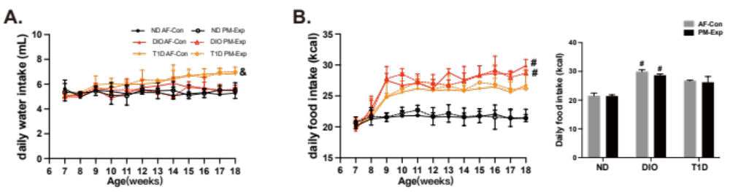
Figure S3. The average daily water consumption and food intake.
A. The weekly changes in the average daily water consumption. B. The weekly changes in the average daily food intake (left), and the average daily food intake at the 18-week of age (right). n = 10. The data are presented as mean ± SEM. *P < 0.05 (PM vs. AF). #P < 0.05 (DIO vs. ND). &P < 0.05 (T1D vs. ND). $P < 0.05 (T1D vs. DIO).
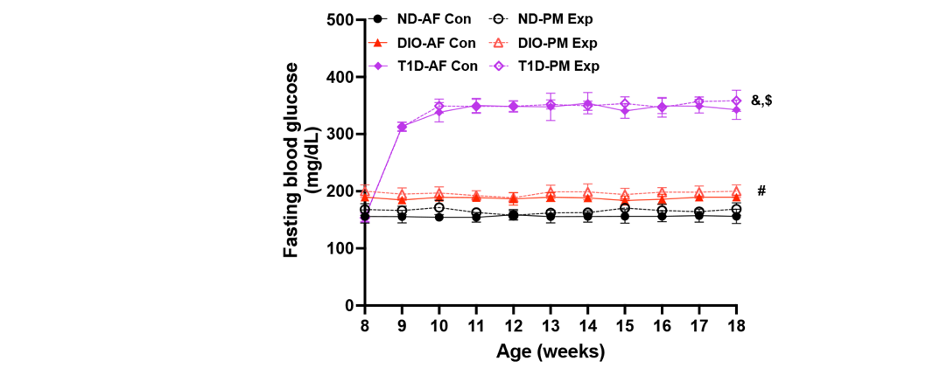
Figure S4. Dynamic changes in fasting blood glucose levels in different mouse models from 8 to 18 weeks of age.
After five consecutive injections of STZ, T1D mice began to present markedly elevated fasting blood glucose levels. DIO mice that were fed a 45% high-fat diet for 10 weeks had slightly higher glucose than mice fed with the ND regimen (n = 10). The data are presented as mean ± SEM. *P < 0.05 (PM vs. AF). #P < 0.05 (DIO vs. ND). &P < 0.05 (T1D vs. ND). $P < 0.05 (T1D vs. DIO).

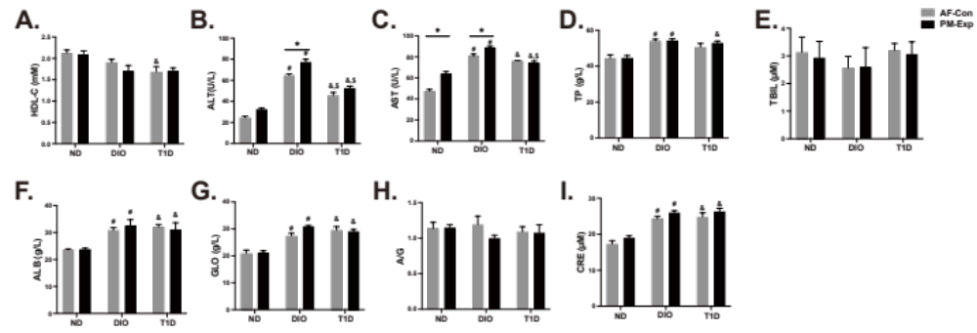Figure S5. Plasma biochemical analysis in different mouse models upon PM exposure.
The biochemical analysis was conducted in ND-fed (control), DIO, and T1D mice following 4-week PM exposure. A. Low-density lipoprotein cholesterol (LDL-C). B. Alanine transaminase (ALT). C. Aspartate transaminase (AST). D. Total protein (TP). E. Total bilirubin (TBIL). F. Albumin (ALB). G. Globulin (GLO). H. Albumin/Globulin (A/G). I. Creatinine (CRE). n = 3. The data are presented as mean ± SEM. *P < 0.05 (PM vs. AF). #P < 0.05 (DIO vs. ND). &P < 0.05 (T1D vs. ND). $P < 0.05 (T1D vs. DIO).
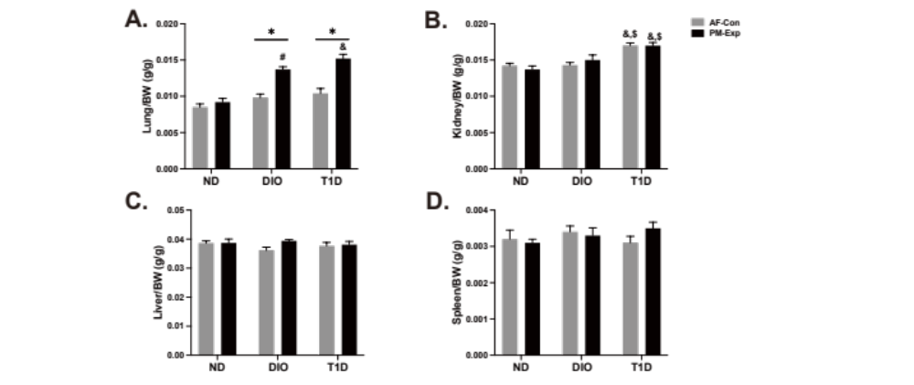Figure S6. Organ coefficients in different mouse models upon PM exposure.
Organ coefficients were calculated in ND-fed, DIO, and T1D mice upon 4-week PM exposure. A. Lung coefficient. B. Kidney coefficient. C. Liver coefficient. D. Spleen coefficient. n = 10. The data are presented as mean ± SEM. *P < 0.05 (PM vs. AF). #P < 0.05 (DIO vs. ND). &P < 0.05 (T1D vs. ND). $P < 0.05 (T1D vs. DIO).
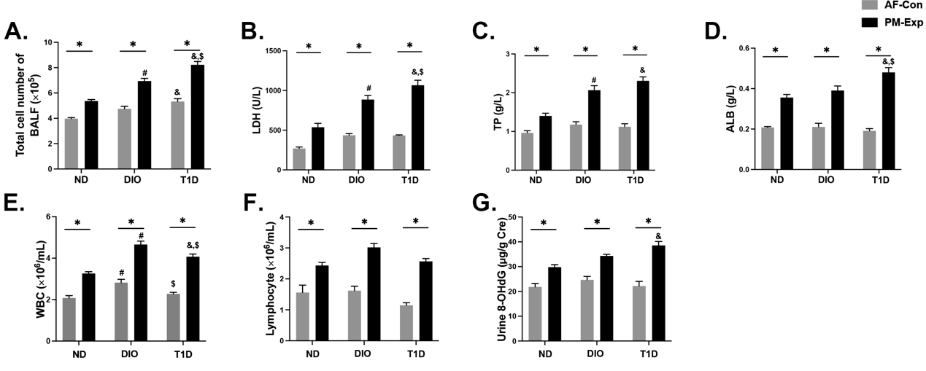
Figure S7. The state of T1D and DIO led to enhanced lung injury and systemic toxicity upon PM exposure.
A. Count of total cell number in BALF. The contents of lactase hydrogenase (B), total protein (C), and albumin (D) in BALF. Cell differential analysis showed the quantitative relationship between the count of WBCs (E) and lymphocytes (F). The content of urine 8-OHdG (G). n = 5. The data are presented as mean ± SEM. *P < 0.05 (PM vs. AF). #P < 0.05 (DIO vs. ND). &P < 0.05 (T1D vs. ND). $P < 0.05 (T1D vs. DIO).
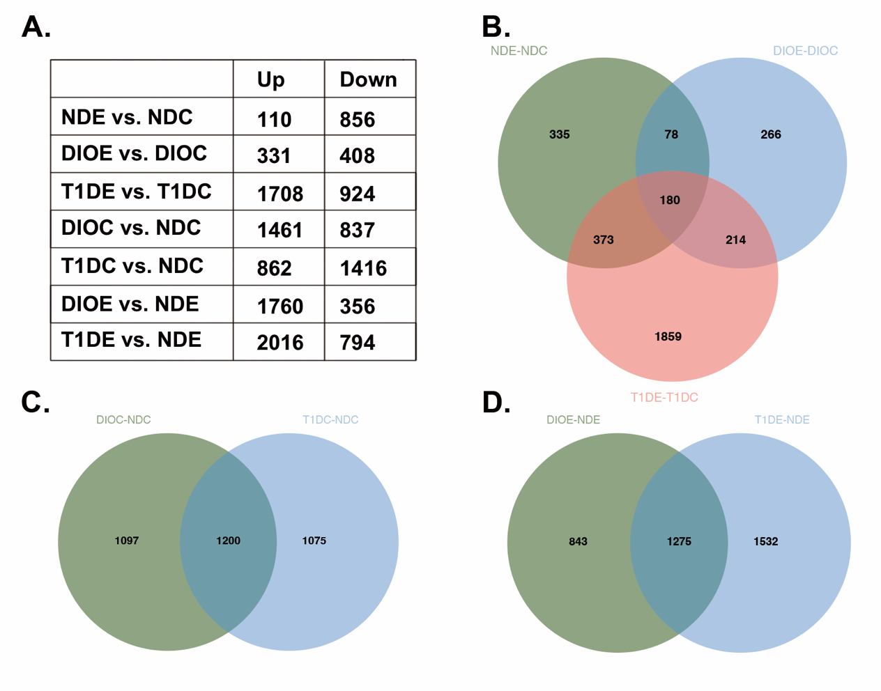Figure S8. Multiple comparisons between differentially expressed genes (DEGs) in lung tissues.
A. The table presents the number of DEGs (up- or down-regulated ), which were subjected to multiple comparisons. The Venn plots display the relationship among DEGs from multiple comparisons, including DEG _{NDE vs. NDC}, DEG _{T1DE vs. T1DC}, and DEG _{DIOC vs. NDC} (B), DEG _{DIOC vs. NDC} and DEG _{T1DC vs. NDC} (C), and DEGinvolved _{DIOE vs. NDE} and DEG _{T1DE vs. NDE} (D). n = 3. The threshold was set as the fold change (FC) value greater than 1.5 times, and the adjusted P-value less than 0.05.

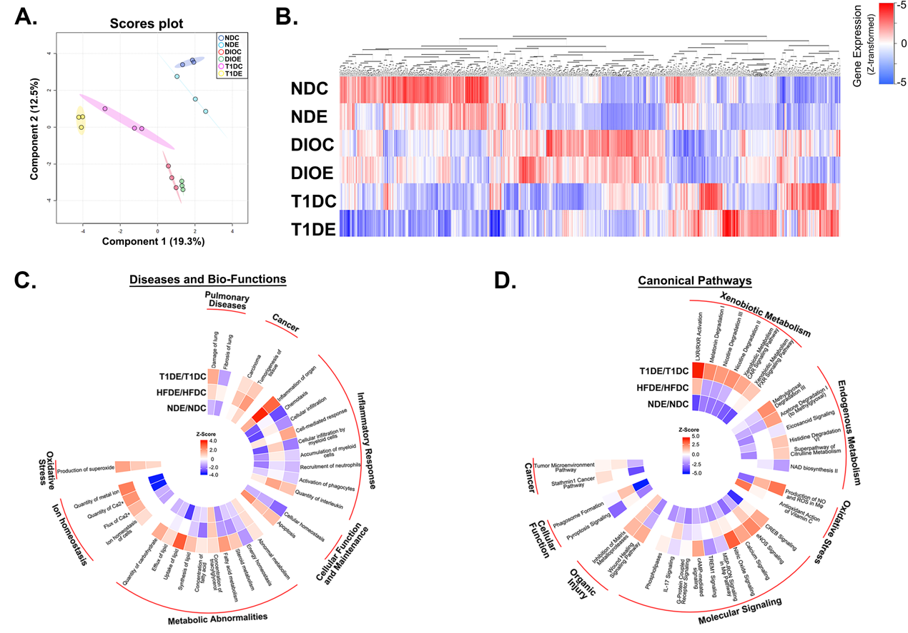
Figure S9. Perturbations of pathways in the lungs of DIO and T1D mice exposed to PM.
PLS-DA (A) and HCA (B) displayed overall discrimination among different groups. Lung DEGs obtained between PM exposure and control groups in DIO or T1D mouse model were introduced into IPA software for Disease and Biological Function analysis (C) and Canonical Pathway analysis (D), shown as the Circo heatmaps consisting of the top 30 enriched pathways.
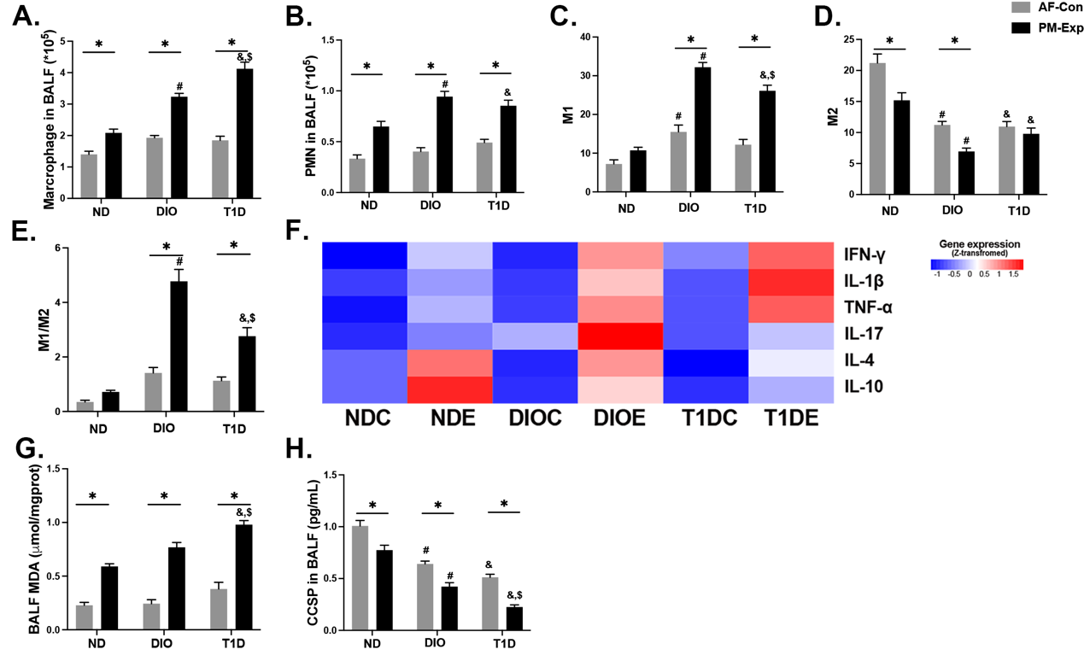Figure S10. Key molecular events enhanced in the lungs of DIO and T1D mice upon PM exposure.
Cell counts of macrophages (A) and polymorphonuclear cells (PMNs) (B) in BALF. Proportions of M1 (F4/80⁺/CD11b⁺/CD11c⁺/CD206⁻) macrophages (C), M2 (F4/80⁺/CD11b⁺/CD11c⁻/CD206⁺) macrophages (D), and M1/M2 ratio (E) derived from flow cytometry analysis. F. The heatmap derived from cytokines levels (IFN-γ, IL-1β, TNF-α, IL-17, IL-4, and IL-10) in BALF. G. Detection of MDA in BALF. H. The content of CCSP cytokine in BALF. n = 5. The data are presented as mean ± SEM. *P < 0.05 (PM vs. AF). #P < 0.05 (DIO vs. ND). &P < 0.05 (T1D vs. ND). $P < 0.05 (T1D vs. DIO).
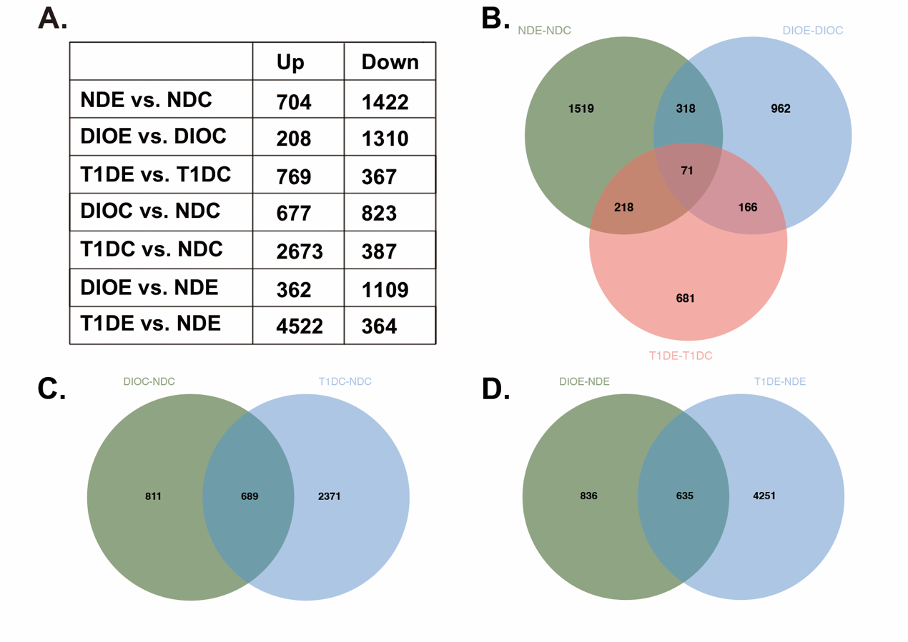Figure S11. The multiple comparisons among differentially expressed genes (DEGs) from liver tissues.
A. The table presents all liver DEGs for multiple comparisons. The Venn plots display the relationship among DEGs from multiple comparisons, including DEG _{NDE vs. NDC}, DEG _{T1DE vs. T1DC}, and DEG _{DIOC vs. NDC} (B), DEG _{DIOC vs. NDC} and DEG _{T1DC vs. NDC} (C), and DEG _{DIOE vs. NDE} and DEG _{T1DE vs. NDE} (D). n = 3. The threshold was set as the fold change (FC) value greater than 1.5 times, and the adjusted P-value less than 0.05.

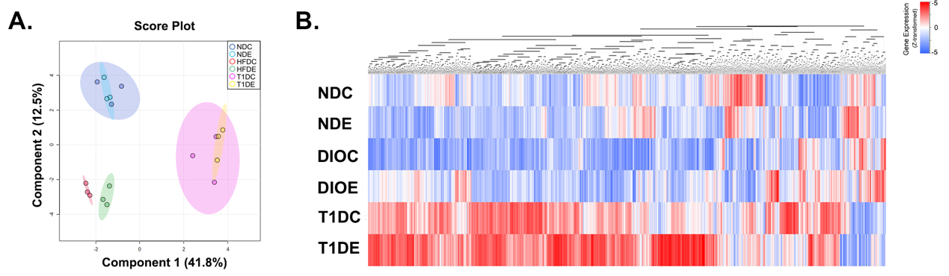Figure S12. Differences in liver transcriptome profiles among DIO, T1D, and ND mice upon PM exposure.
A. Partial Least-Squares Discriminant Analysis (PLS-DA). B. Hierarchical cluster analysis (HCA). n = 3.
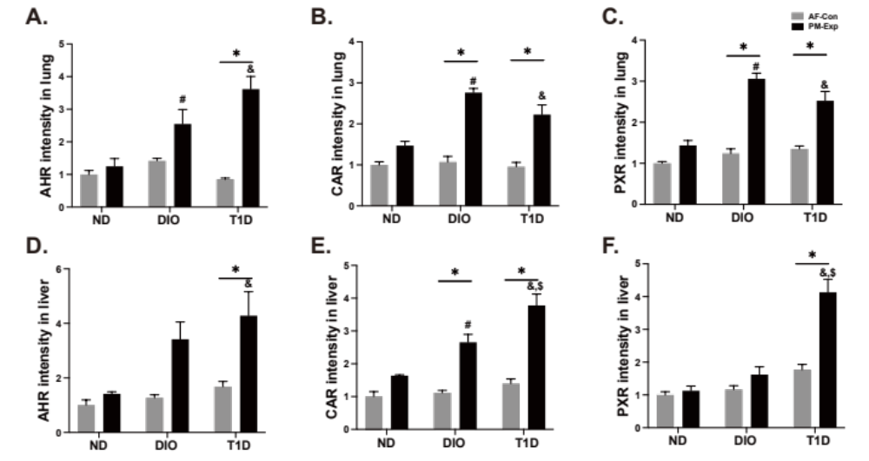Figure S13. The quantification of protein expression from the images of protein bands.
Aryl hydrocarbon receptor (AHR) in the lung (A) and liver (D). Constitutive androstane receptor (CAR) in the lung (B) and the liver (E). Pregnane X receptor (PXR) in the lung (C) and liver (F). n = 3. The data are presented as mean ± SEM. *P < 0.05 (PM vs. AF). #P < 0.05 (DIO vs. ND). &P < 0.05 (T1D vs. ND). $P < 0.05 (T1D vs. DIO).
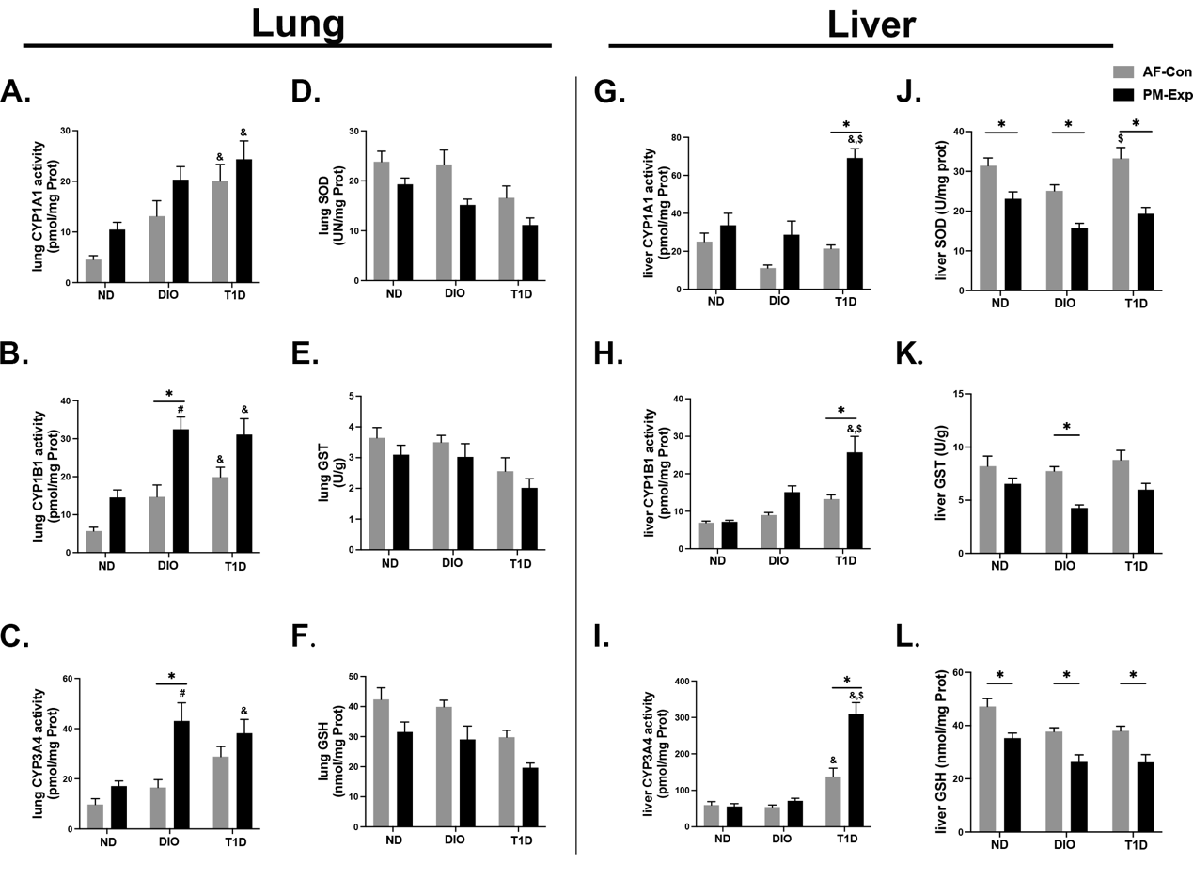
Figure S14. Enzyme activities differentially altered in the lungs and livers of DIO and T1D mice upon PM exposure.
Enzymatic activities of three subtypes of CYP450s, including CYP1A1 (A, G), CYP1B1 (B, H), and CYP3A4 (C, I) were quantified in lung and liver tissues, respectively. Detoxification ability indicated by SOD (D, J), GST (E, K), and GSH (F, L) was examined in mouse lungs and livers. n = 5. The data are presented as mean ± SEM. *P < 0.05 (PM vs. AF). #P < 0.05 (DIO vs. ND). &P < 0.05 (T1D vs. ND). $P < 0.05 (T1D vs. DIO).
Figure S15. The blotting images of AHR, CAR, and PXR in mouse lungs.
Figure S16. The blotting images of AHR, CAR, and PXR in mouse livers.

Supplementary tables
Table S1. Energy proportions of macronutrients (kcal%) in D12451 and AIN-93G diets
 | D12451 | AIN-93G
Protein | 20 | 18
Carbohydrate | 35 | 66
Fat | 45 | 16
Total | 100 | 100

Table S2. The detailed information about the formulation of D12450 diets (4.7 Kcal/g)
Class description | Ingredients | Contents (grams)
Protein | Casein, Lactic, 30 Mesh | 200.00
Protein | Cystine, L | 3.00
Carbohydrate | Sucrose, Fine Granulated | 176.80
Carbohydrate | Lodex 10 | 100.00
Carbohydrate | Starch, Corn | 72.80
Fiber | Solka Floc, FCC200 | 50.00
Fat | Lard | 177.50
Fat | Soybean Oil, USP | 25.00
Mineral | S10026B | 50.00
Vitamine | Choline Bitartrate | 2.00
Vitamine | V10001C | 1.00
Dye | Dye, Red FD&C #40, Alum. Lake 35-42% | 0.05
Total: 858.15

Table S3. The detailed information about the formulation of AIN93G purified diets (3.92 Kcal/g)
Class description | Ingredients | Contents (grams)
Carbohydrate | Corn Starch | 397.50
Protein | Casein | 200.00
Carbohydrate | Maltodextrin | 132.00
Carbohydrate | Sucrose | 100.00
Fat | Soybean Oil | 70.00
Fiber | Cellulose | 50.00
Mineral | Mineral MixAIN-93G-MX | 35.00
Vitamin | Vitamin MixAIN-93-VM | 10.00
Protein | L-Cystine | 3.00
Vitamin | Choline Bitartrate | 2.50
Total: 1000.00

Table S4. The meteorological conditions in the AF control and PM exposure cages
 | Temperature  (℃) | Humidity  （%） | Ventilation frequency  （/h) | Air-flow rate  （m/s) | Noise  （dB）
AF Control | 20.2±2.4 | 45.1±1.1% | 18-20 | 0.17 | 35-40
PM Exposure | 21.5±3.1 | 46.3±2.1% | 18-20 | 0.17 | 35-40

Table S5. Primers for qRT-PCR
Gene | Forward (5’-3’) | Reverse (5’-3’)
Representative components in molecular pathways (Lung)
Tlr1 | GCTGGTGTTAGGAGATGCTTAT | GACGGACACATCCAGAAGAAA
Tlr13 | CAGAGGCCATTAGTGACATACC | CCAGAGCAGACAGATTGGTAAA
Trem1 | GTCCAGTTTATCCTCTGCTCTTG | CACAGGTCACAGTCCCTTATTG
Gpr35 | TCCCTTCACTTCTCCTTCCT | AGGCCTCAGGAAACTTACAATC
Gpr87 | ATGACCCTGACATTCCCATTC | CAGCCCAAGAAACACGATAGA
Grk1 | GACTTCTCCGTGGACTACTTTG | TGCTTCAGCTCCTTGTTCTC
Grk4 | CCTGATCCTCAGGCCATTTATT | GGTATCCAGGTTGACTCCTTTC
Cacng1 | CGATCTGGTCTGGTCATCTTTAG | GTTCGTATCATGGCGGAGAA
Chrna1 | GTCAGACCAGGAGTCCAATAAC | CGATGAGACACACCAGCATAA
Mapk10 | CTGGCTTCTCTCAGTCAGTTATC | CTATGCTCCATGACCAAGTCTC
Mapk13 | TCGGAGCTTCCATGATTTCTAC | GTACACCAAGTACTGGACCTTATC
Cebpb | CTTGATGCAATCCGGATCAAAC | CCCGCAGGAACATCTTTAAGT
Cebpd | GCAGCTCCCAGAACACTAAA | TCTGTAAAGCTTCAGCCAGTATC
Nlrp10 | TGAAAGAACCAGCCCTTACC | GACTTCACACCACAGGAGATAC
Il1b | ATGGGCAACCACTTACCTATTT | GTTCTAGAGAGTGCTGCCTAATG
Il1r2 | CTGATAGTCCCGTGCAAAGT | GGGTAAGCAGCCGAGATAAA
Il6 | GTCTGTAGCTCATTCTGCTCTG | GAAGGCAACTGGATGGAAGT
Tnf | CTACCTTGTTGCCTCCTCTTT | GAGCAGAGGTTCAGTGATGTAG
Cxcl5 | TGAACTCCCTGCTTTGATGAG | CCGATAGTGTGACAGATAGGAAAG
Cxcl13 | CTCGTGCCAAATGGTTACAAAG | CTTCAGGCAGCTCTTCTCTTAC
Ifng | CTCTTCCTCATGGCTGTTTCT | TTCTTCCACATCTATGCCACTT
Ido1 | GCTTCTTCCTCGTCTCTCTATTG | CTTTCAGGTCTTGACGCTCTAC
Ido2 | CCCTCAGACTTCCTCACTTAATC | GCTGCTCACGGTAACTCTTTA
Tdo2 | CATCGTGTGGTGGTCATCTT | CTGATGCTGGAGACAGGTATTC
Trp53 | CAGTCTACTTCCCGCCATAAA | GTCTCAGCCCTGAAGTCATAAG
Cdkn1a | GTTCCTTGCCACTTCTTACCT | TCATCCTAGCTGGCCTTAGA
Cdkn2a | CATGTTGTTGAGGCTAGAGAGG | CACCGTAGTTGAGCAGAAGAG
Col4a1 | CTGCTCTGCGTGGAGTATTT | AGGATGAAGGAGGCTAACAAAG
Col9a2 | AGCCAGGACAGAGCCTATTA | CTCCCTCACTGAACTTGTCTTC
Bax | GTGGTTGCCCTCTTCTACTTT | CAGCCCATGATGGTTCTGAT
Xenobiotic metabolizing enzymes and transporters (Lung)
Aldh1l1 | GAGGAAGCTGGTGGAGTATTG | ACGGTTGGCTGAAAGAAGAA
Aldh3a1 | CACTTCCAGCGGGTCATAAA | TAGGATGGTGGGAGCTATGT
Aldh3b2 | TGGGCAGATCTGGTGACTAA | CCACCCTCTAGGTATGGATGAA
Cat | CACACACACACACATGCAATAC | TTCTGAGTGGGCCATCTTTATC
Ces1b | CTGGGCTTCTCTTGCTCTTT | CTGGTGTACTTTCCCAGGATTT
Ces2e | GCTGATGGCCTCTAAGGATTT | GGCAGGGTCTTTCTGGTTATT
Ces3a | GCCTGTCTGCTCCTGATATTT | GGATGCCCAGGAAGACATTTA
Cyp1a1 | GTGAGCAAGGAGGCTAACTATC | GGCTACTGACACGACCAAATA
Cyp1a2 | GTCTTCCTCTTCTTAGCCATCC | GCTTCATGGTCAACCCATAGT
Cyp1b1 | TGGCCCTTTCCTCCTATCT | ACTGACACAACCTGCGTATC
Cyp2a5 | GAGGAGATTGATCGGGTGATTG | CATGGATTACAGCCTCCGTATAG
Cyp2e1 | GAAGTCTCTGGTTGACCCTAAG | AGGTCTCATGAACGAGGAATG
Cyp3a11 | ACCACCAGTAGCACACTTTC | CCAGGTATTCCATCTCCATCAC
Fmo6 | CACATCCTTCCTCCGGAATATC | CTTTCCTGAGAGGGCCATTTA
Maoa | GAAGAGAAGAACTGGTGTGAGG | CGAATCACCCTTCCATACAGAG
Nqo1 | GAGAAGAGCCCTGATTGTACTG | ACCTCCCATCCTCTCTTCTT
Sod3 | GAACTTCACCAGAGGGAAAGAG | CAGTAGCAAGCCGTAGAACAA
Nos2 | TCTCCCTTTCCTCCCTTCTT | CTTCAGTCAGGAGGTTGAGTTT
Gclc | CATCGACCTGACCATCGATAAG | AGGGTGAGTGGGTCTCTAATAA
Gsta2 | GAAGAGCCATGGACAAGACTAC | GTCAGAAGGCTGGCATCAA
Gsta4 | GCTGCAGGCATTTAAGACAAG | GTCCTGACCACCTCAACATAG
Sult1a1 | GATGCCCACTATGCCAAGATAA | CTTGCCTTGGTTCCCAGTATAG
Sult1d1 | CAGTTCACTGTAGCCCAGTATG | CCAACTCTCCCTAGATCTCTGA
Ugt1a1 | TGGACGGACTGCCTTTAATC | CAGCTAGGAGCATACTGGAATC
Ugt2b1 | CTGGTGTGGCCTACAGAATAC | TGAGGATGGAAGCAGAAGATATG
Abcc2 | GTGAACAGCATTCGGAAGAAAG | CAGGGTTGGAGTTAGGTGTAAG
Abcc3 | GATAGCAGAGACAGGCAATGT | ACCATACAGGAGGCAGATAGA
Slc18b1 | GGCTACGAGGTACCCTTTATTT | TTCCCTGGATCGGACTCATA
Slc43a3 | GGGAGGAATCCTGTTCCTTATC | TGCTGAGGAGGAGTCAAATG
Slc4a4 | CTCAAGAAAGGAGCAGGGTATC | GAGCCATGAGGGAGCATATAAC
Representative components in molecular pathways (Liver)
Atf3 | CTCCTGGGTCACTGGTATTTG | CCGATGGCAGAGGTGTTTAT
Atf4 | CCACTCCAGAGCATTCCTTTAG | CTCCTTTACACATGGAGGGATTAG
Cybb | ATGAGTTCCACACCTTCCTTC | GGCTTGAGACAACCTGGTATTA
Fos | GAATCCGAAGGGAACGGAATAA | TCTCCGCTTGGAGTGTATCT
Cebpd | GCAGCTCCCAGAACACTAAA | TCTGTAAAGCTTCAGCCAGTATC
Mafk | TTGGGCCTTCTTGTCCTTATC | ACACACAGGAACACAGACATTA
Map2k6 | GGATACGGGCCACAGTTAATAG | GTAGAAGGTCACGGTGAATGG
Map4k3 | GTACGTGGCTGTATGTGATGAA | CCGGTAAGTTGTGGGAGTAAAG
Mapk7 | GTGAGGCTTGGCTTGAGTTA | GTAGAGTCTCCTGGTCCTGTTA
Nfe2l2 | CTCCGTGGAGTCTTCCATTTAC | GCACTATCTAGCTCCTCCATTTC
Stat3 | GCCACGTTGGTGTTTCATAATC | TTCGAAGGTTGTGCTGATAGAG
Id1 | AGGTGAACGTCCTGCTCTA | GATCTCCACCTTGCTCACTTT
Traf2 | CAGCCTTCTACACAAGCAGATA | CCACGAAGAAGAGAGACAGATG
Hspa1b | TGGTGCTGACGAAGATGAAG | CGCTGAGAGTCGTTGAAGTAG
Hspa8 | CCCTTCATGGTGGTGAATGA | GACACTTCCTCTGGGTAGAAAC
Il1a | GCTTGAGTCGGCAAAGAAATC | GAGAGATGGTCAATGGCAGAA
Il1b | ATGGGCAACCACTTACCTATTT | GTTCTAGAGAGTGCTGCCTAATG
Il1r1 | AGGTGGAGGACTCAGGATATT | CCAGGGTCATTCTCTAACACAG
Ccl2 | CTCGGACTGTGATGCCTTAAT | TGGATCCACACCTTGCATTTA
Casp1 | TACACGTCTTGCCCTCATTATC | CTCCAGCAGCAACTTCATTTC
Cdkn1a | GTTCCTTGCCACTTCTTACCT | TCATCCTAGCTGGCCTTAGA
Bax | GTGGTTGCCCTCTTCTACTTT | CAGCCCATGATGGTTCTGAT
Bcl2 | GAGCAGGTGCCTACAAGAAA | CTTTGTCCTCTGACTGGGTATG
Gadd45b | CCTGGTCACGAACTGTCATAC | GGTTATTGCCTCTGCTCTCTT
Gadd45g | TCCGCCAAAGTCCTGAATG | CGCCTGAATCAACGTGAAATG
Xenobiotic metabolizing enzymes and transporters (Liver)
Aldh2 | CTGGACCAGTGTGTGCTTATT | CCTTGGACTTGACCTGCTTATC
Ces1g | CATGGAGGTGGACTTGTGATAG | GGCGATACTGAATGACCACTAC
Cyp1a1 | GTGAGCAAGGAGGCTAACTATC | GGCTACTGACACGACCAAATA
Cyp1a2 | GTCTTCCTCTTCTTAGCCATCC | GCTTCATGGTCAACCCATAGT
Cyp2e1 | GAAGTCTCTGGTTGACCCTAAG | AGGTCTCATGAACGAGGAATG
Cyp2a5 | GAGGAGATTGATCGGGTGATTG | CATGGATTACAGCCTCCGTATAG
Cyp3a11 | ACCACCAGTAGCACACTTTC | CCAGGTATTCCATCTCCATCAC
Fos | GAATCCGAAGGGAACGGAATAA | TCTCCGCTTGGAGTGTATCT
Nqo1 | GAGAAGAGCCCTGATTGTACTG | ACCTCCCATCCTCTCTTCTT
Gclc | CATCGACCTGACCATCGATAAG | AGGGTGAGTGGGTCTCTAATAA
Gsta1 | GTGAGCTGAGTGGAGAAGAAG | CCGGGCATTGAAGTAGTGAA
Gstm1 | CTCACGCTTCCTAGAATTACCC | CAGGCTGGCACTCAAGTATT
Gstm2 | AAGCCTCAGCTACCCACTAT | CAACCACTAACAGGAAGGAAGG
Gstm3 | GAGGATCCGTGTGGATACTTTG | GAACTCTGGCTTCTGCTTCT
Gstm5 | CCCACAGCGTCCAGTATAAA | CCAGTAACCCAGAACCATAGAC
Gstp1 | GAGACCTCACCCTTTACCAATC | CCCATCATTCACCATATCCATCT
Gstt3 | GAGTGGAGGGAAAGAAAGTGAA | GAGGAACGGAACCCAGTAAAG
Mgst3 | GTACAGCACAGATCCTGAGAAC | GTAAACACCTCCCACCGTTAG
Sult1a1 | GATGCCCACTATGCCAAGATAA | CTTGCCTTGGTTCCCAGTATAG
Sult1b1 | ACTATGCTCCCTGGCTATCT | CCAGCCTGGTCTACACTATTTC
Sult1d1 | CAGTTCACTGTAGCCCAGTATG | CCAACTCTCCCTAGATCTCTGA
Sult2a8 | TCTCTCCTTCCCATCCAACTA | TAGCCTGACACAAGAACATCTC
Ugt1a1 | TGGACGGACTGCCTTTAATC | CAGCTAGGAGCATACTGGAATC
Ugt1a9 | CCTCTTTAGCCCAGTGTCTATTT | GGCAGTTGATCCCACCAATA
Abcc3 | GATAGCAGAGACAGGCAATGT | ACCATACAGGAGGCAGATAGA
Abce1 | GAAGTCCAGCAGATCCCTAAAG | GCCAGAGTGTCTTCCTCAATTA
Abcd1 | CTCTCGGATCACATGAAGGAAG | GTCTTCAGGGAATGCAGGTAA
Slc1a2 | TCTGTCTCTGTCTCTCCCTTT | CTGGTTCCTGGAGTTAGTGTATG
Slc2a2 | CTTACAGTCACACCAGCATACA | AGACAGAGACCAGAGCATAGT
Slc2a1 | AAGACTGCTGCTCAGATCTATTC | GGAGATAGGAGAGTGGCTGATA

