RESEARCH
A Nano-QSTR model to predict nano-cytotoxicity: an approach using human lung cells data
João Meneses¹, Michael González-Durruthy¹, Eli Fernandez-de Gortari¹, Alla P. Toropova², Andrey A. Toropov², Ernesto Alfaro-Moreno¹(*)
¹ NanoSafety Group, International Iberian Nanotechnology Laboratory, 4715-330 Braga, Portugal
² Instituto di Ricerche Farmacologiche Mario Negri IRCCS, Via Mario Negri 2, 20156 Milano, Italy
* Correspondence: ernesto.alfaro@inl.int

Supplementary Information
Additional File 2
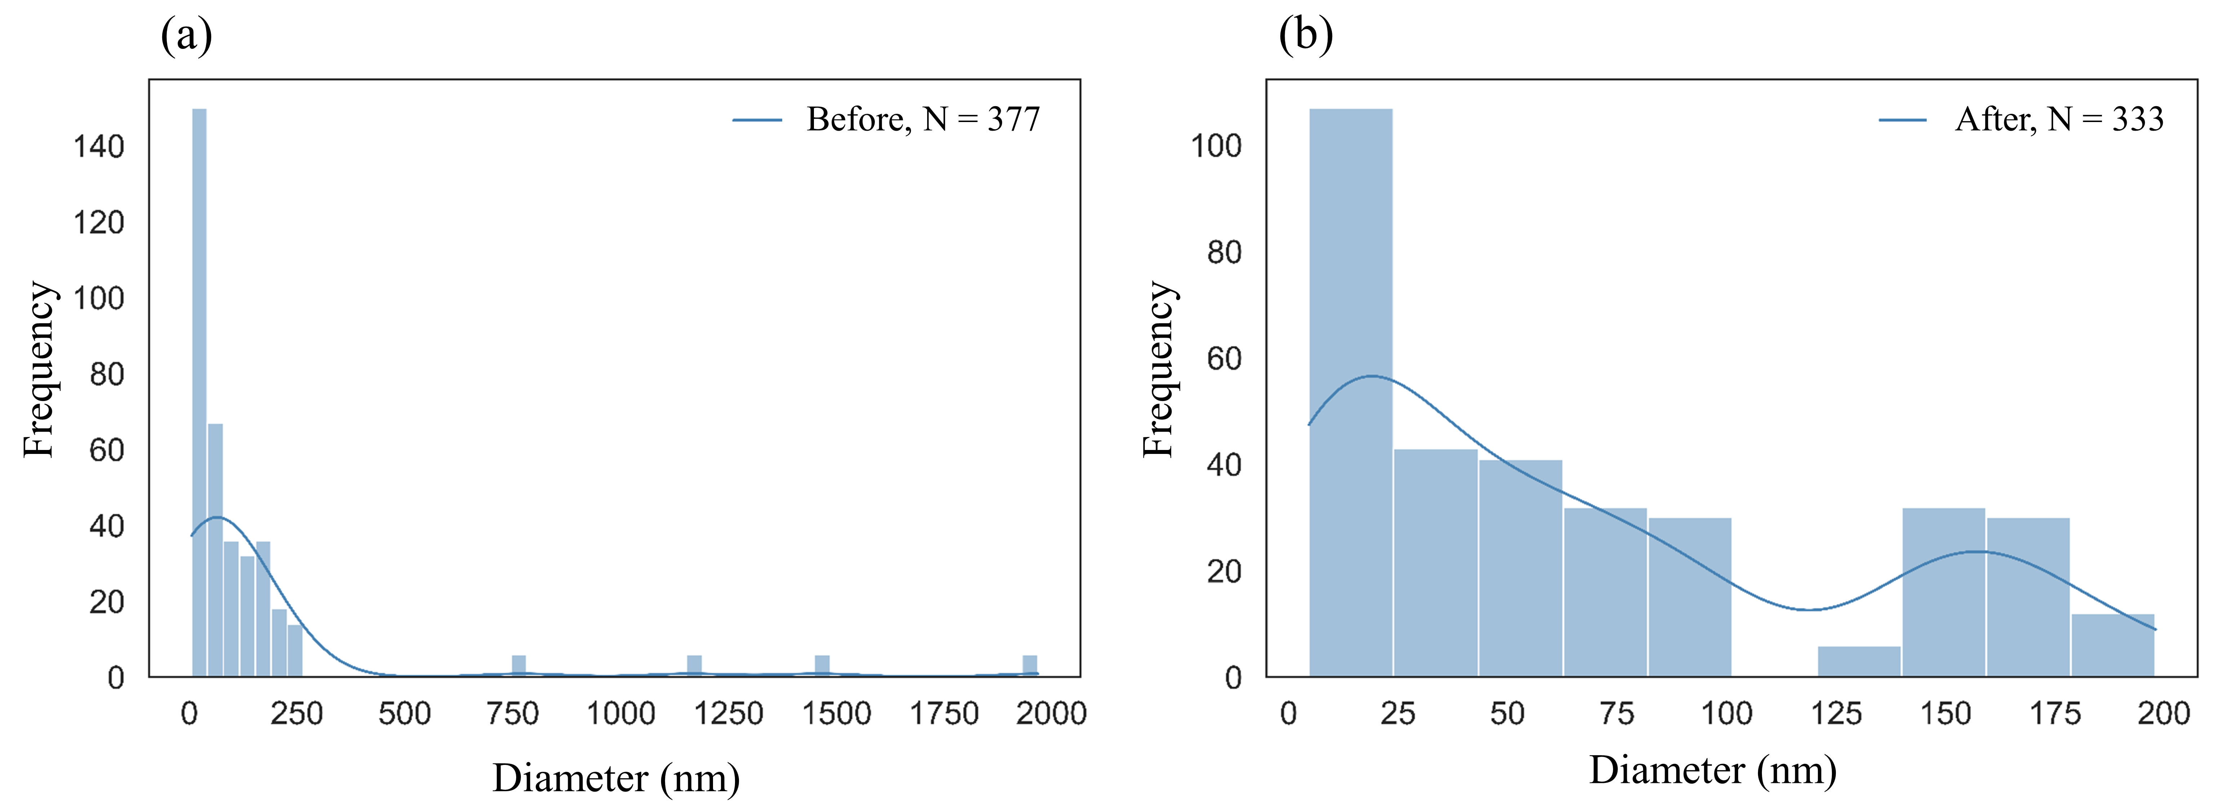
Figure S1 ENMs diameter (nm) frequency distribution (a) before and (b) after the filtering step.
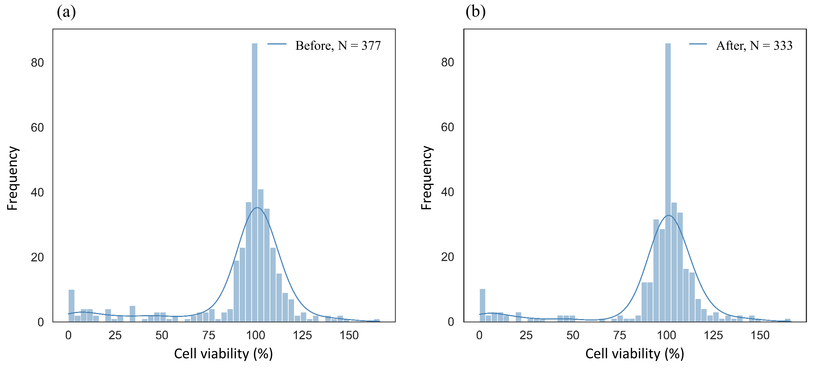
Figure S2 Cell viability (%) frequency distribution (a) before and (b) after the filtering step.
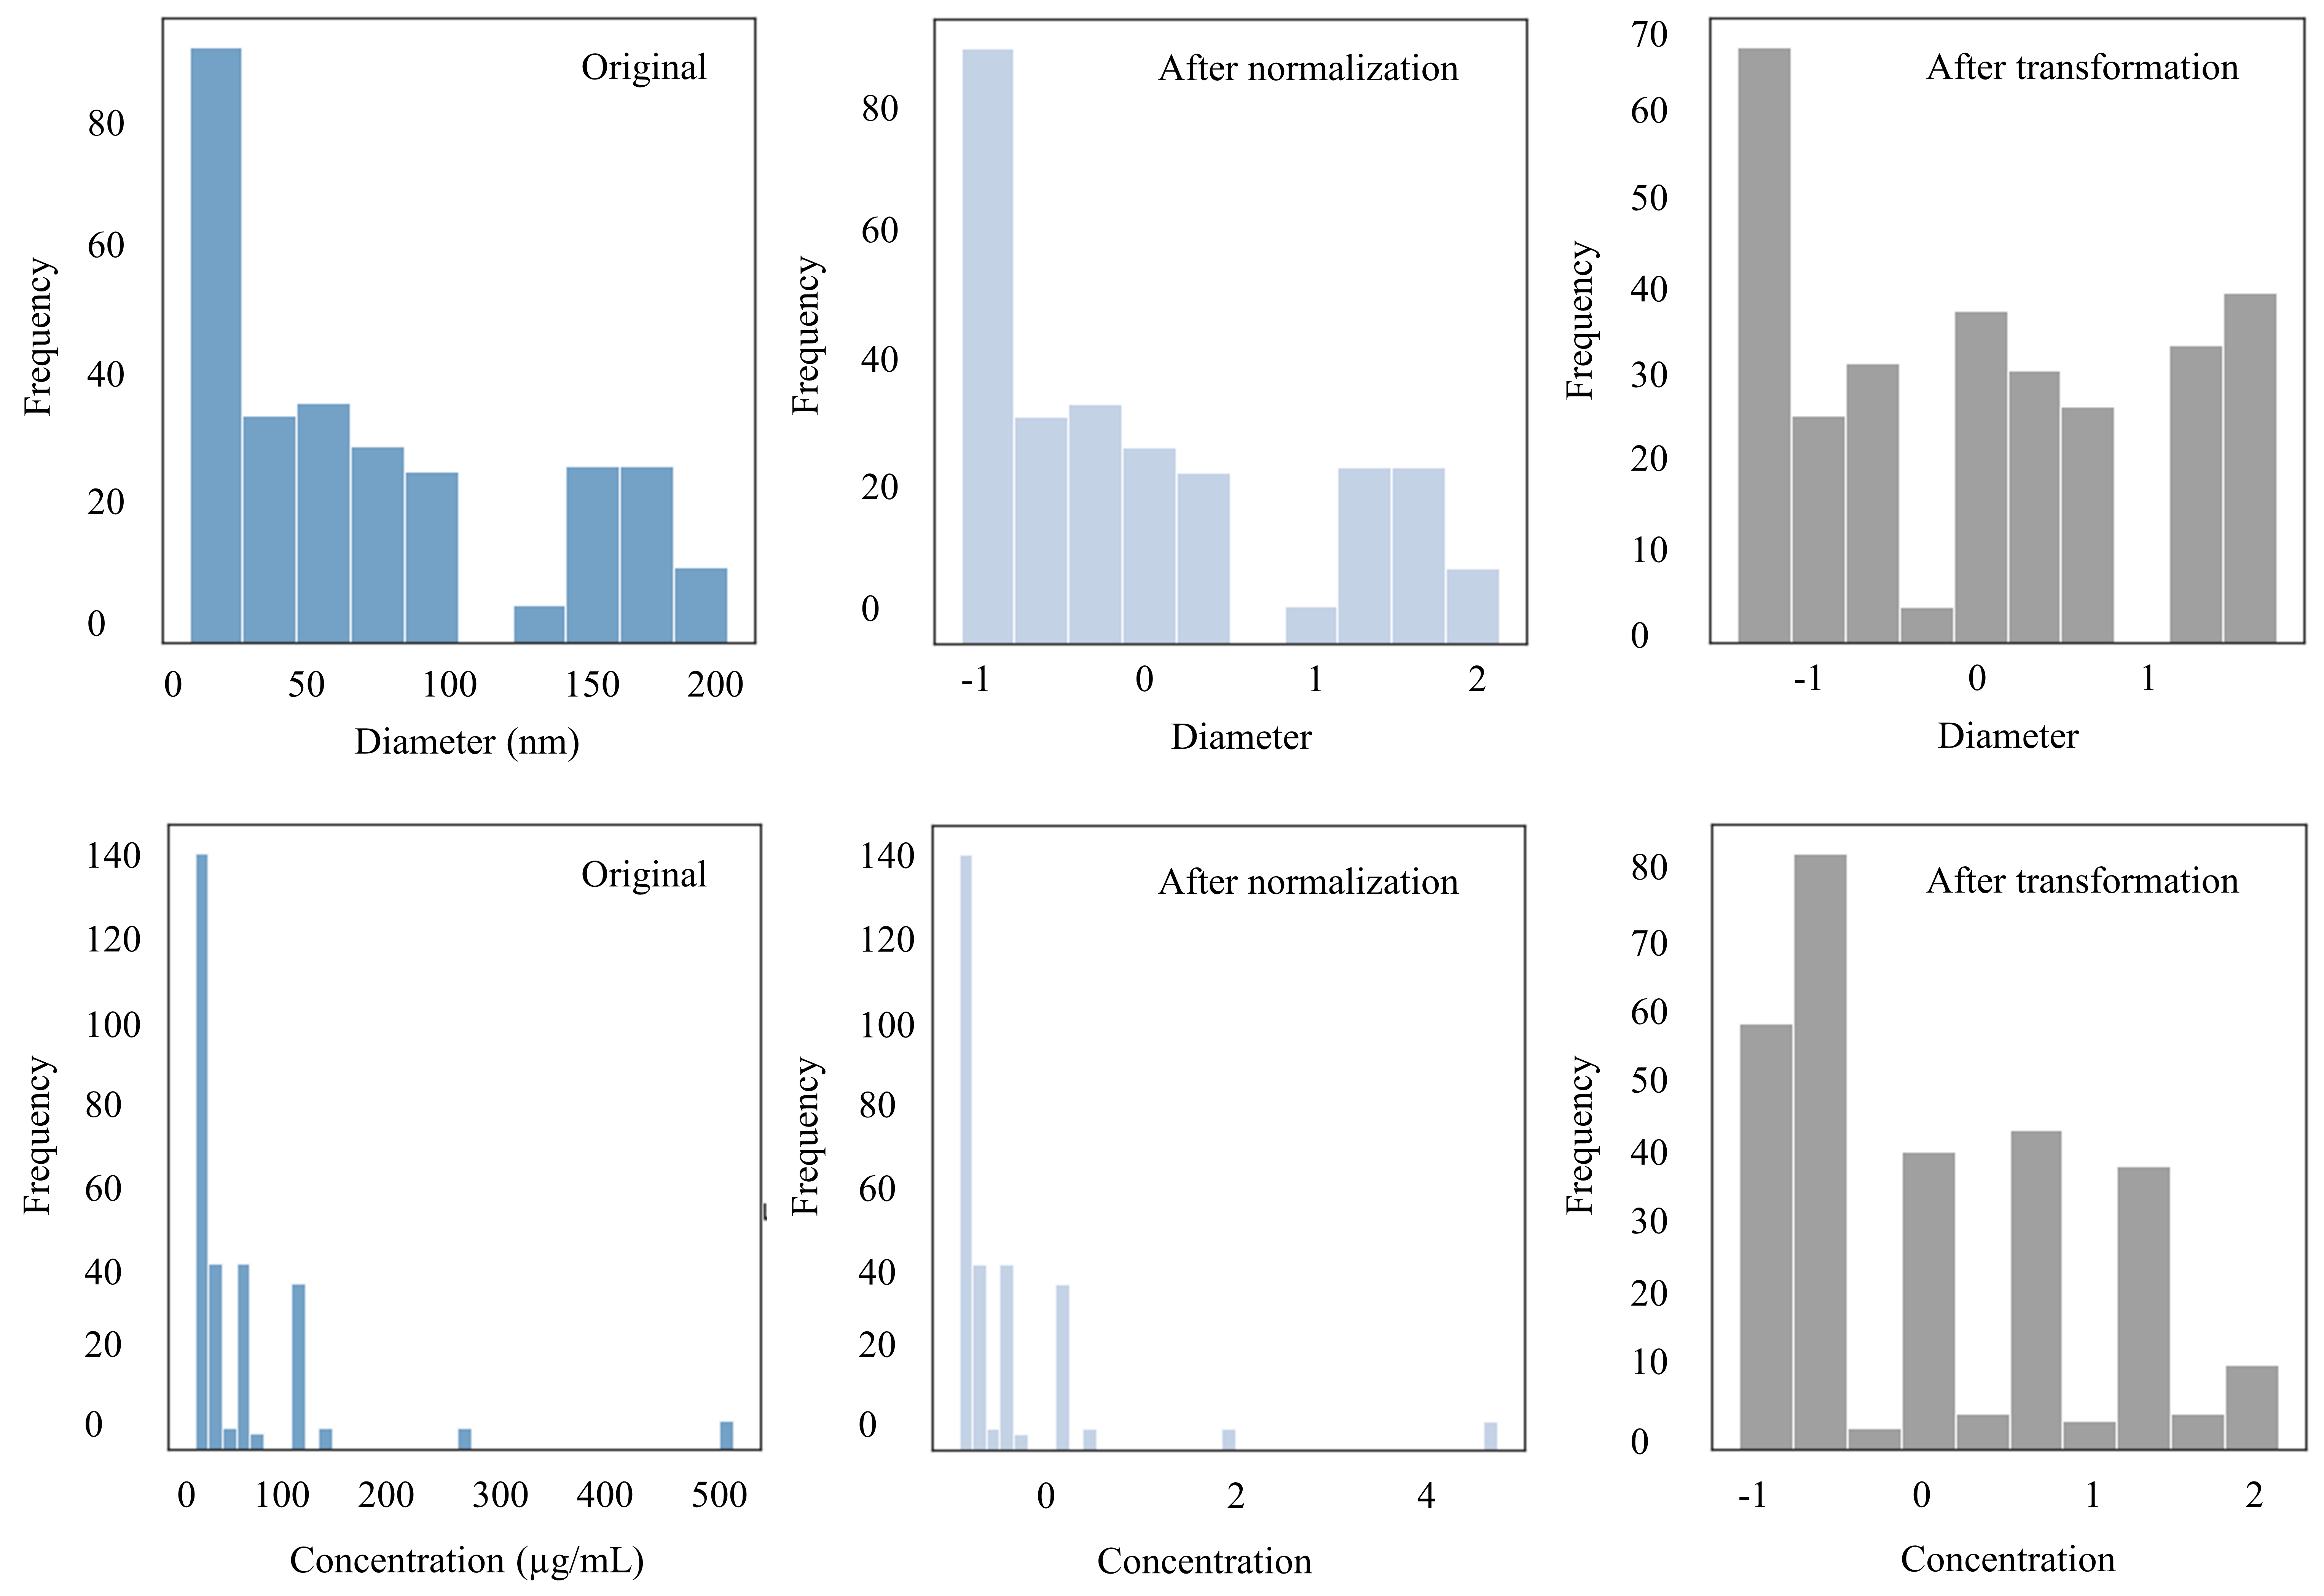
Figure S3 General representation of data normalization and transformation pre-processing steps for ENMs diameter and concentration.
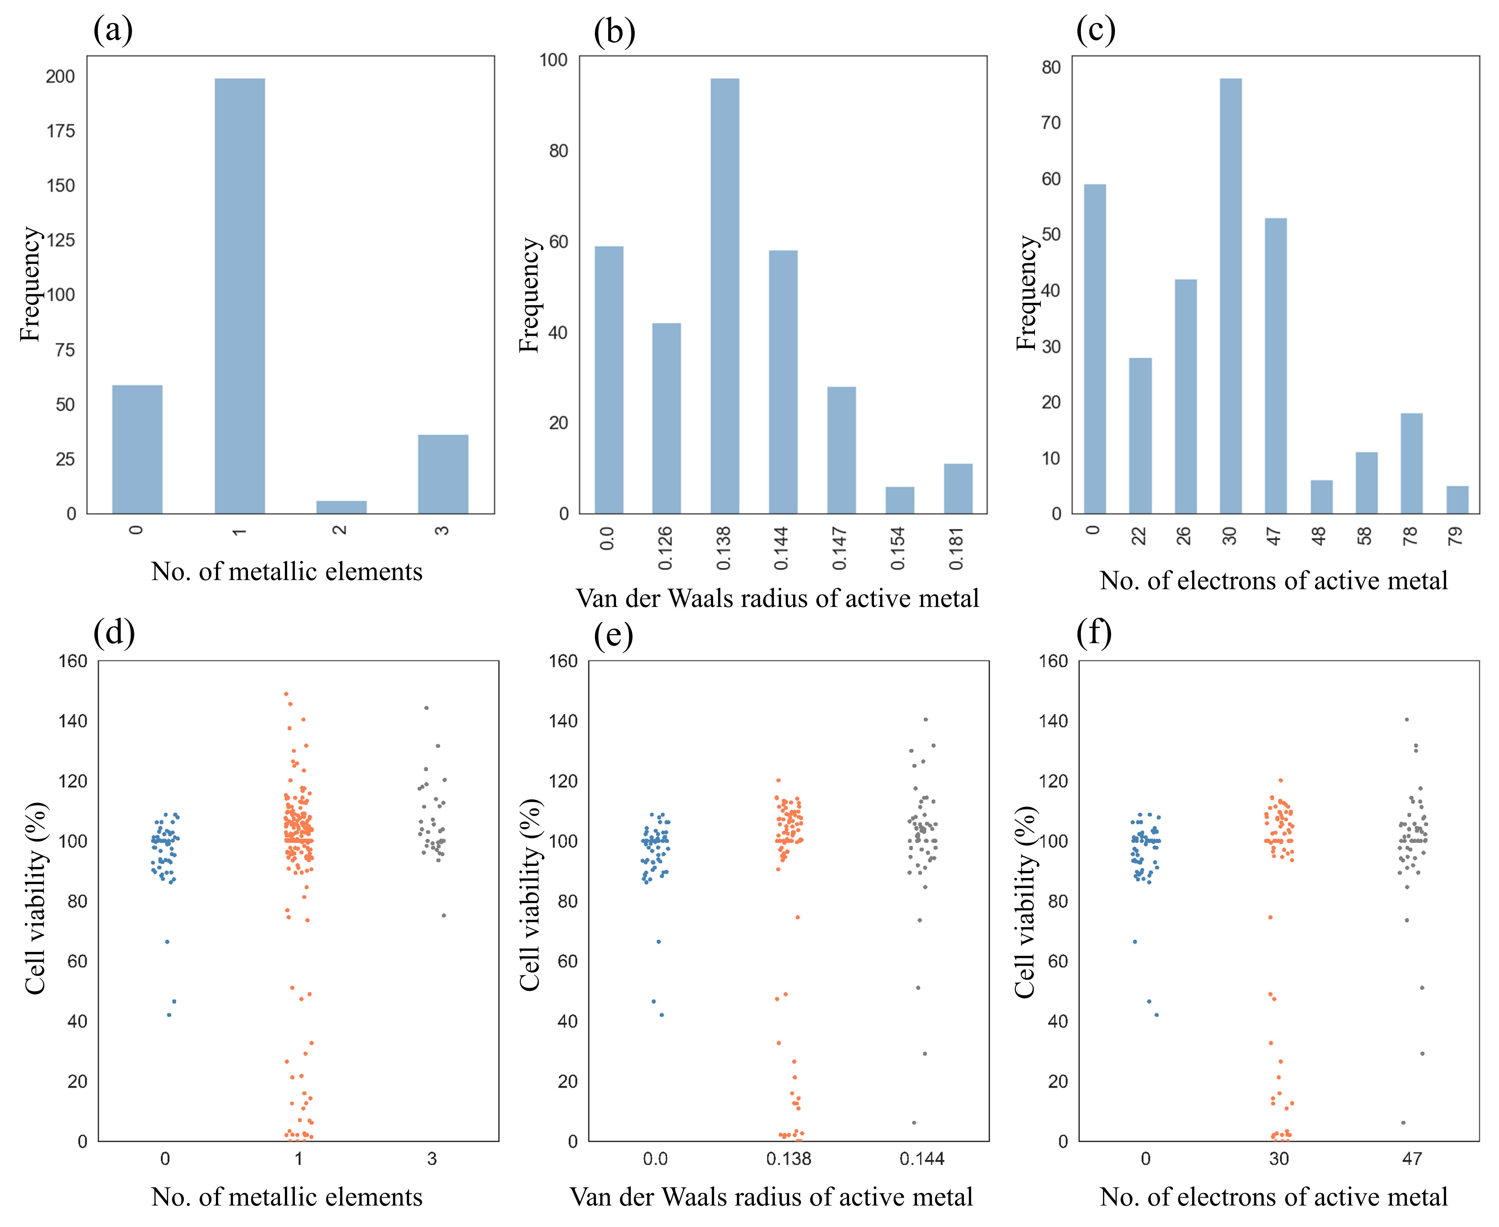
Figure S4 Dataset overview. (a), (b), and (c) Diversity of a set of nano-descriptors obtained from the Elemental descriptor calculator; (e), (f), and (g) Cell Viability (%) variation trend with representative examples of each nano-descriptor.
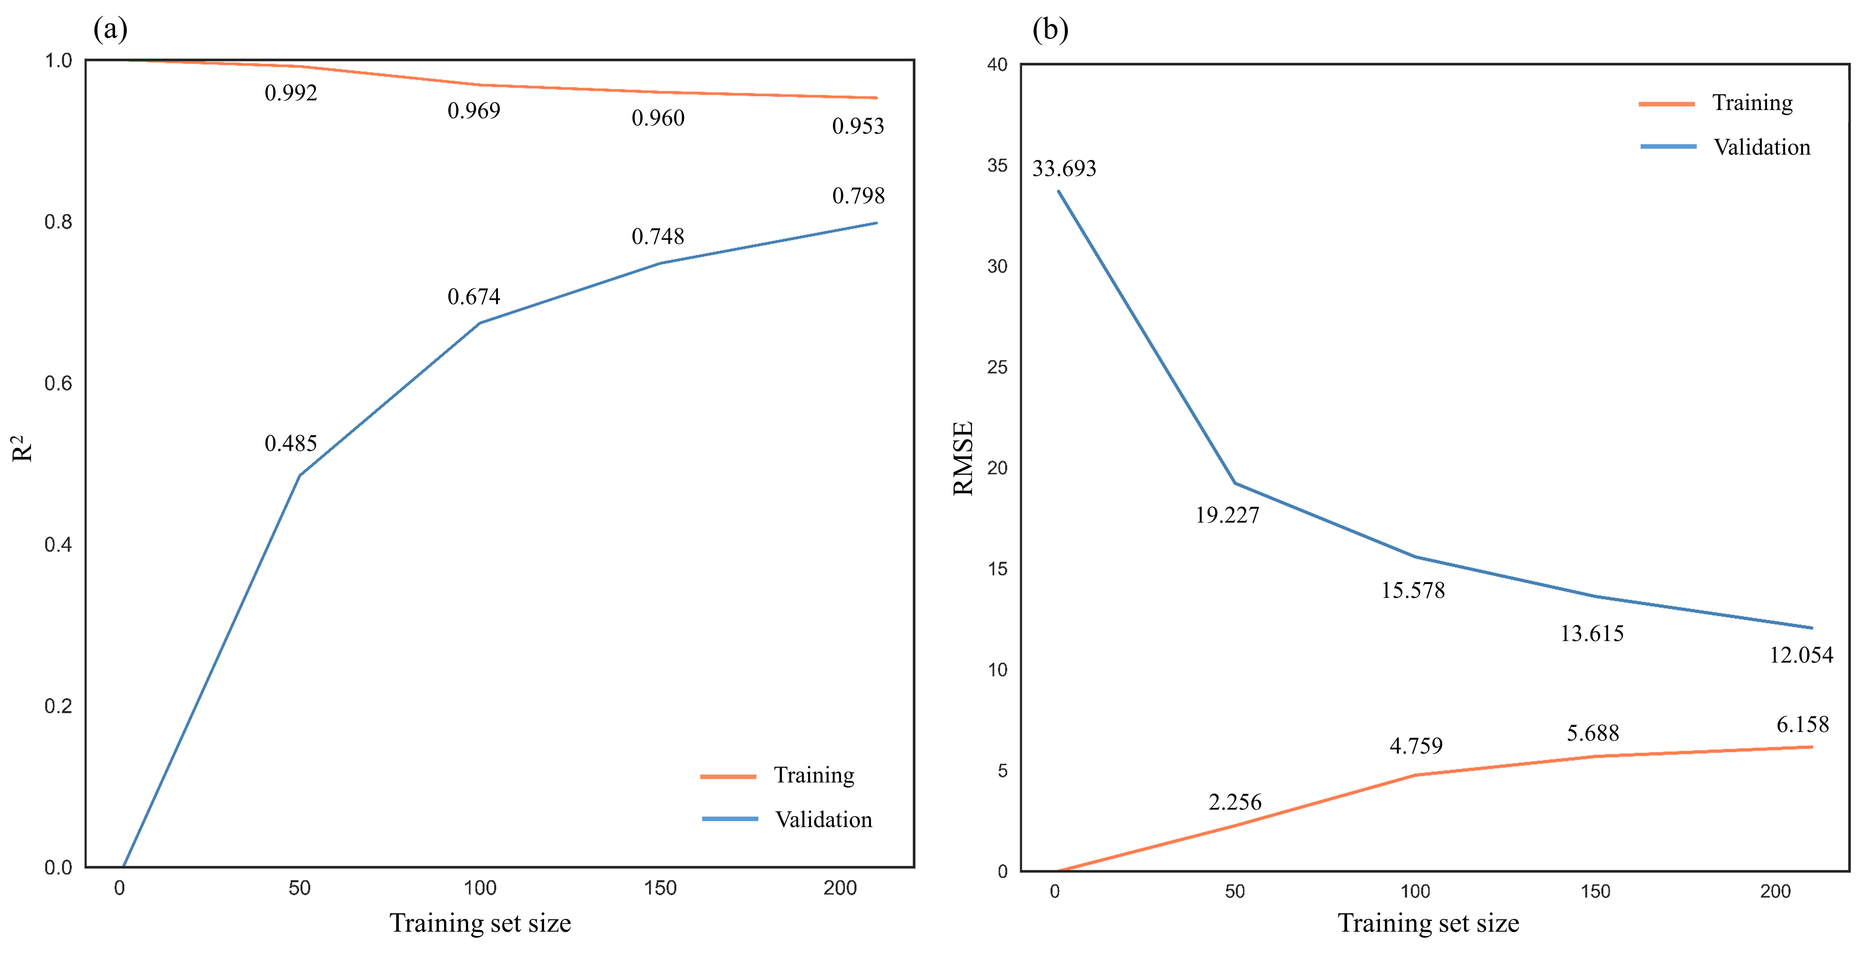
Figure S5 Learning curves for ET nano-QSTR model for training and validation sets according to (a) determination coefficient (R2) and (b) root-mean-square error (RMSE).
Table S1 ET nano-QSTR model performance for training, validation, test, and unseen sets assuming data normalization by ENMs surface area.
Model | Subset | R² | R²_{ext} | Q²_{LOO} | Q²_{F1} | Q²_{F2} | RMSE | MAE | CCC
ET | Training | 0.957 | - | - | - | - | 5.869 | 3.200 | 0.977
ET | Validation | 0.725 | - | 0.726 | - | - | 14.329 | 8.361 | 0.844
ET | Test | - | 0.761 | - | 0.760 | 0.760 | 13.391 | 7.331 | 0.869
ET | Unseen | - | 0.917 | - | 0.921 | 0.918 | 4.625 | 3.316 | 0.957
ET: extra-trees regressor; R²: determination coefficient (R²_{ext} for external validation); Q: determination coefficient based-metrics (Q²_{LOO} for internal validation; Q²_{F1} and Q²_{F2} for external validation); RMSE: root-mean-square error; MAE: mean absolute error; CCC: coefficient of concordance.

