Additional file 1: Figures and Tables

Diesel exhaust particle (DEP)-induced glucose intolerance is driven by an
intestinal innate immune response and NLRP3 activation in mice

Authors: Angela J. T. Bosch¹, Theresa V. Rohm¹, Shefaa AlAsfoor¹, Andy J. Y. Low¹, Zora Baumann¹, Neena Parayil¹, Faiza Noreen^{1,3}, Julien Roux^{1,3}, Daniel T. Meier¹, Claudia Cavelti-Weder^{1,4,5*}

Affiliations:
¹Department of Biomedicine, University of Basel, 4031 Basel, Switzerland.
²Swiss Institute of Bioinformatics, 4031 Basel, Switzerland.
³Clinic of Endocrinology, Diabetes and Metabolism, University Hospital Basel, 4031 Basel, Switzerland.
⁴Department of Endocrinology, Diabetology and Clinical Nutrition, University Hospital Zurich (USZ) and University of Zurich (UZH), Zurich, Switzerland.

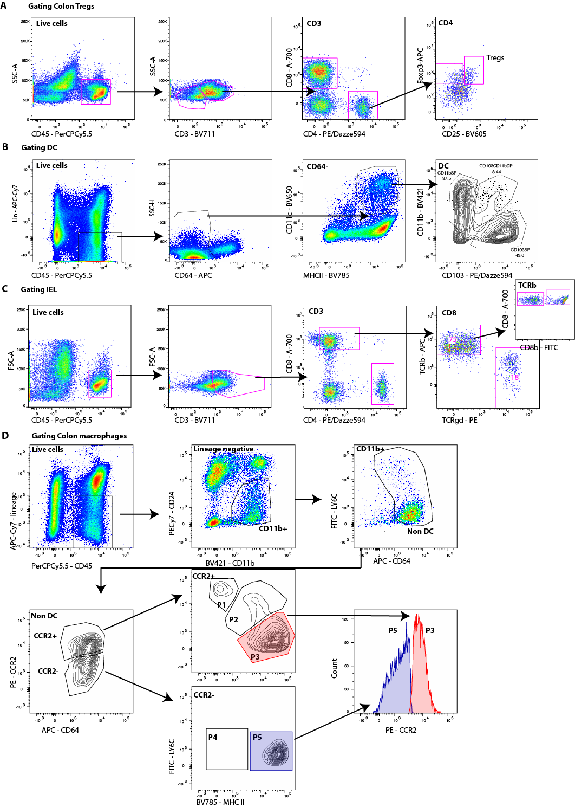
Additional file 1: Figure S1: Gating strategy of colon immune cells. All gating strategies included a gate for lymphocytes, followed by doublet exclusion and exclusion of dead cells A T-cells were defined as CD45⁺/CD3⁺ and either CD8⁺ or CD4⁺, the latter ones were further analyzed for regulatory T cells defined as Foxp3⁺ and CD25⁺. B Colon DC were defined as positive for CD45 and negative for lineage markers (lineage cocktail included CD3, CD19, GR1.1 and NK1.1), as well as negative for the expression of CD64. The remaining cells were gated for MHCII and CD11c to identify DC. For determination of subgroups DC were gated for CD103 and CD11b. C For intraepithelial lymphocyte (IELs) assessment CD45⁺ cells were gated for CD3⁺ cells and further divided into CD4⁺ and CD8⁺ T-cells, CD8⁺ T-cells were further gated for expression of TCRαβ, TCRγδ, CD8αα, and CD8αβ. D To identify colon macrophages, cells isolated from the lamina propria were first gated for the expression of CD45 and the absence of lineage markers (lineage cocktail included CD3, CD19, GR1.1 and NK1.1). The cells were further gated for CD11b and absence of CD24 expression. In a subsequent gate, cells that were double negative for Ly6C and CD64 were excluded, and the remaining cells were further gated for the expression of CCR2. CCR2+ colon macrophages were defined as inflammatory macrophages, this subset could be further divided into 3 different subpopulations P1-P3, where the expression of Ly6C is lost and MHCII expression acquired. The CCR2- population was defined as anti-inflammatory colon macrophages with two subpopulations P4 and P5. In respect to the expression of Ly6C and MHCII P3 and P5 could not be separated, however the two populations clearly differ in their CCR2 expression.

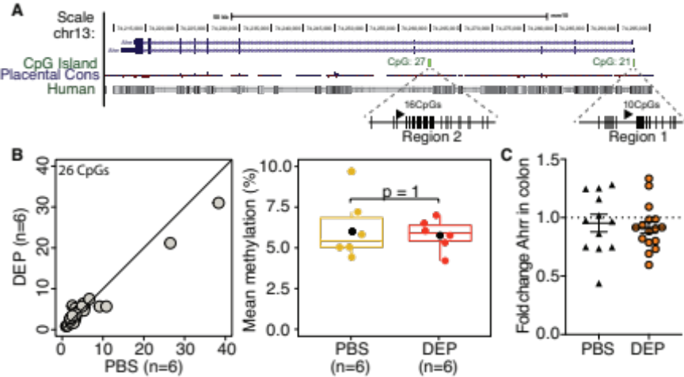
Additional file 1: Figure S2: Ahrr methylation and gene expression are unchanged upon diesel exposure. A The UCSC browser view showing Ahrr. In green is CpG island track. Primers were designed to detect methylation levels at both CpG islands in Ahrr gene. Schematic shows two sequencing regions, identifying methylation status of 26CpGs (Region 1: 10CpGs; Region 2: 16CpGs) with Ahrr sequencing primer positions (arrows), CpGs analyzed (black vertical lines), CpGs not analyzed (grey vertical lines). B Left: scatter plot showing mean methylation levels for each CpG in PBS (controls, n=6) and DEP exposed mice (n=6). Each circle represents one CpG. Right: boxplots of the resultant methylation levels on all 26CpGs per mouse. Shown are median (line) and mean (black circle). C Ahrr gene expression in colon of mice exposed for 9 months with PBS or DEP. A,B represent one experiment, C pooled data from two independent experiments. Data are presented as mean±SEM and compared by a two-tailed, unpaired with Mann-Whitney U test.

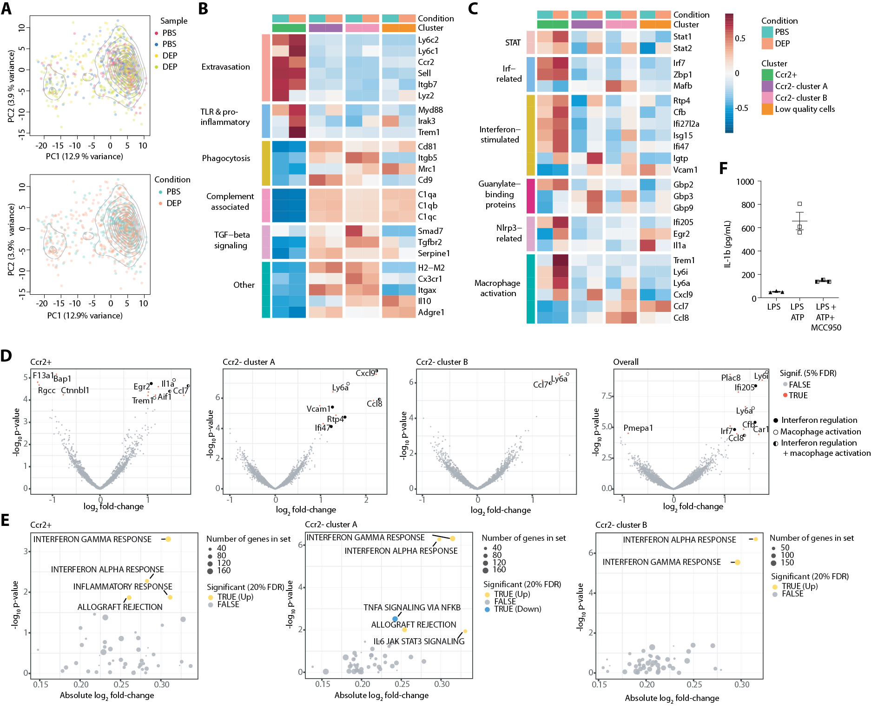

Additional file 1: Figure S3: Differences in genes expression in mice exposed to diesel. A Principal component analysis of colon macrophages showing Ccr2⁺ and Ccr2⁻ subpopulations (colors represent different clusters; contour lines indicate cell density) for each sample and per condition (diesel exhaust particles (DEP), phosphate-buffered saline (PBS)). B Functionally defined subsets of selected marker genes up- or downregulated during differentiation from Ccr2⁺ to Ccr2⁻ colon macrophages of mice exposed to DEP or PBS. C Heatmap of averaged expression of selected genes from interferon regulation, inflammasome regulation, and macrophage activation in mice exposed to DEP or PBS across clusters and conditions. D Volcano plots for the differential expression analysis of FACS sorted colon macrophages from mice exposed to DEP or PBS, from an analysis stratified into the different clusters. Significant genes at an FDR of 5% are shown in red and labelled; non-significant genes are shown in grey. Closed circles indicate genes related to interferon regulation, open circles genes related to macrophage activation, half-open circles to both. E Effects of Diesel on MSigDB Hallmark Pathways in Ccr2⁺ and Ccr2⁻ Colon Macrophages. MSigDB Hallmark pathways that were up- (yellow) or down-regulated (blue) in colon macrophages upon exposure to diesel, from an analysis stratified into Ccr2⁺ and Ccr2⁻ clusters. Data were obtained from one experiment with a group size of 2 animals per group. F Protein expression of IL-1β in the supernatant of peritoneal macrophages isolated from wild-type mice in vitro stimulated with LPS±ATP±the NLRP3-inhibitor MCC950. DEP: diesel exhaust particles, PBS: phosphate-buffered saline (control).

Additional file 1: Tables
REAGENT or RESOURCE | SOURCE | IDENTIFIER
Antibodies
Anti-mouse CD16/32 (93) | Biolegend | Cat#101321; RRID: AB_2103871
Anti-mouse CD11c (N418) BV650 | Biolegend | Cat#117339; RRID: AB_2562414
Anti-mouse CD11c (N418) PE-Cy7 | Biolegend | Cat#117318; RRID: AB_493568
Anti-mouse CD11b (M1/70) BV421 | Biolegend | Cat#101236; RRID: AB_11203704
Anti-mouse CD45 (30-F11) PerCP-Cy5.5 | Biolegend | Cat#103131; RRID: AB_893344
Anti-mouse I-A/I-E (M5/114.15.2) BV785 | Biolegend | Cat#107645; RRID: AB_2565977
Anti-mouse Ly6C (HK1.4) FITC | Biolegend | Cat#128005; RRID: AB_1186134
Anti-mouse CCR2 (475301) PE | R&D Systems | Cat#FAB5538P; RRID: AB_10718414
Anti-mouse CD103 (2E7) PE-Dazzle594 | Biolegend | Cat#121430; RRID: AB_2566493
Anti-mouse CD24 (M1/69) PE-Cy7 | Biolegend | Cat#101821; RRID: AB_756047
Anti-mouse CD64 (X54-5/7.1) APC | Biolegend | Cat#139306; RRID: AB_11219391
Anti-mouse CD3 (145-2C11) APC-Cy7 | Biolegend | Cat#100330; RRID: AB_1877170;
Anti-mouse Nk1.1 (PK136) APC-Cy7 | Biolegend | Cat#108723; RRID: AB_830870
Anti-mouse CD19 (6D5) APC-Cy7 | Biolegend | Cat#115530; RRID: AB_830707
Anti-mouse Siglec F (E50-2440) BV510 | BD Biosciences | Cat#740158; RRID: AB_2739911
Anti-mouse F4/80 (BM8) PE | Biolegend | Cat#123110; RRID: AB_893486
Anti-mouse CD206 (C068C2) A647 | Biolegend | Cat#141712; RRID: AB_10900420
Anti-mouse CD3 (17A2) BV711 | Biolegend | Cat#100241; RRID:AB_2563945
Anti-mouse TCRβ (H57-597) APC | Biolegend | Cat#109211;RRID:AB_313434
Anti-mouse TCRγδ (GL3) PE | Biolegend | Cat#118107; RRID:AB_313831
Anti-mouse CD8a (53-6.7) A700 | Biolegend | Cat#100729;RRID:AB_493702
Anti-mouse CD8b (YTS156.7.7) FITC | Biolegend | Cat#126605; RRID:AB_961293
Anti-mouse CD4 (GK1.5) PE-Dazzle 594 | Biolegend | Cat#100456; RRID:AB_2565845
Anti-mouse CD25 (PC61) BV605 | Biolegend | Cat#102035; RRID:AB_11126977
Anti-mouse Foxp3 (FJK-16s) APC | Thermo Fisher Scientific | Cat#17-5773-82; RRID:AB_469457
Anti-mouse Rorγ (Q31-378) BV786 | BD Biosciences | Cat#564723; RRID:AB_273891
anti-GATA3 (TWAJ) A488 | Thermo Fisher Scientific | Cat#52-9966-43; RRID:AB_2574493
Chemicals, Peptides, and Recombinant Proteins
Diesel exhaust particles (DEP) | National Institute of Standards and Technologies/Sigma | Cat# NIST1650B
Collagenase IV | Worthington | Cat# LS004189
Collagenase VIII | Sigma-Aldrich | Cat# C2139
DNase 1 | Roche | Cat# 11284932001
Percoll | GE Healthcare | Cat# GE17-0891-01
PLX5622 (CFS1R inhibitor) | Plexxikon | MTA
anti-IL-1β (01BSUR) | Novartis | MTA
Critical Commercial Assays
Mouse/rat insulin kit | MesoScale Diagnostics | Cat#K152BZC
V-Plex custom mouse cytokine proinflammatory panel 1 mouse TNF-α, mouse IL-6 and mouse IL-1β | MesoScale Diagnostics | Cat#K15048
Foxp3 staining Kit | Thermo Fisher Scientific | Cat# 00-5523-00
NucleoSpin RNA kit | Macherey Nagel | Cat# 740955
RNeasy Plus Universal Mini kit | Qiagen | Cat# 73404
GoScriptTM | Promega | Cat# A5003
GoTaq qPCR Master Mix | Promega | Cat# A4472919
Deposited Data
scRNA-seq Data | This paper | GSE133406
Experimental Models: Organisms/Strains
Mouse, C57BL/6NCrl | Charles River laboratories | RRID:IMSR_CRL:027
Mouse, B6.129S4-Ccr2^{tm1Ifc}/J | The Jackson laboratory | RRID:IMSR_JAX:004999
Mouse: C57BL/6J | University of Basel | RRID:IMSR_JAX:000664
Mouse, B6.129S6-Rag2^{tm1Fwa} | Taconic biosciences | RRID:IMSR_TAC:RAGN12
Mouse, B6-Nlrp3<tm1Tsc>/N | Prof M. Donath, University of Basel | N/A
Oligonucleotides
Primers for qPCR -> Suppl. Table 2 | Microsynth | N/A
Software and Algorithms
Flow jo (version 9.9 or higher) | Becton Dickinson & Company (BD) | https://flowjo.com
BD FACS Diva (version 8.0.1) | Becton Dickinson & Company (BD) | https://www.bdbiosciences.com/en-us/instruments/research-instruments/research-software/flow-cytometry-acquisition/facsdiva-software
Prism 8 | GraphPad Software, LLc. | https://www.graphpad.com
R version 3.6 | The R Foundation | https://www.r-project.org

Additional file 1: Table S1. Reagent and resource table.

Gene | Forward Primer | Reverse Primer
Housekeeping genes
B2m | 5′ TTCTGGTGCTTGTCTCACTGA | 5′ CAGTATGTTCGGCTTCCCATTC
Ppia | 5′ GAGCTGTTTGCAGACAAAGTTC | 5′ CCCTGGCACATGAATCCTGG
Inflammation markers
Tnf | 5′ ACTGAACTTCGGGGTGATCG | 5′ TGAGGGTCTGGGCCATAGAA
Il6 | 5′ GGATACCACTCCCAACAGACCT | 5′ GCCATTGCACAACTCTTTTCTC
Il1b | 5′ GCAACTGTTCCTGAACTCAACT | 5′ ATCTTTTGGGGTCCGTCAACT
Cxcl1 (KC) | 5′ CTGGGATTCACCTCAAGAACATC | 5′ CAGGGTCAAGGCAAGCCTC
Il10 | 5′ AGGCGCTGTCATCGATTTCTC | 5′ GCCTTGTAGACACCTTGGTCTT
Il18 | 5′TCTTGCGTCAACTTCAAGGA | 5′GTGAAGTCGGCCAAAGTTGT
Il22 | 5′TTG AGG TGT CCA ACT TCC AGC A | 5′AGC CGG ACG TCT GTG TTG TTA
Tgfb1 | 5′CTCTCCACCTGCAAGACCAT | 5′CGAGCCTTAGTTTGGACAGG
Tgfb2 | 5′GAAATACGCCCAAGATCGAA | 5′TGTCACCGTGATTTTCGTGT
Ifng | 5′GTCTCTTCTTGGATATCTGGAGGAACT | 5′GTAGTAATCAGGTGTGATTCAATGACGC
Il17 | 5′ATC AGG ACG CGC AAA CAT GA | 5′TTG GAC ACG CTG AGC TTT GA
Immune cells
Cd68 | 5′ GCAGCACAGTGGACATTCAT | 5′ AGAGAAACATGGCCC GAAGT
Adgre1 (Emr1) | 5′ GCC CAG GAGTGGAATGTCAA | 5′ CAGACACTCATCAACATCTGCG
Ly6c1 | 5’GCA GTG CTA CGA GTG CTA TGG | 5’ACT GAC GGG TCT TTA GTT TCC TT
Beta-cell identity
Pdx1 | 5′CCC CAG TTT ACA AGC TCG CT | 5′CTC GGT TCC ATT CGG GAA AGG
Foxo1 | 5′GTA CGC CGA CCT CAT CAC CA | 5′TGC TGT CGC CCT TAT CCT TG
Ins2 | 5′CCC TGC TGG CCC TGC TCT T | 5′AGG TCT GAA GGT CAC CTG CT
Additional file 1: Table S2. Primers sequences used for quantitative real time-PCR.
Gene | Primer | Sequence (5’-3’)
Ahrr | Forward1 | TGGGATTTGGTTTTAGATTAGAGAAG
 | Reverse1 | GCCCCCGCCCGAACACCCTATCCAAACACTCAAAC
 | Forward-nested1 | GTTTTAGATTAGAGAAGGAAAGTTTTAT
 | Sequencing-S1 | GAAGGAAAGTTTTATTTTAGT
 | Forward2 | AGTTTAAGTTGAGTTTTTGGGAT
 | Reverse2 | GCCCCCGCCCGAATCTAAACCCCTAACCAATTTACC
 | Sequencing-S2 | GTTGAGTTTTTGGGATTT
Universal primer |  | Biotin-GCCCCCGCCCG

Additional file 1: Table S3. Pyrosequencing primer sequences. Sequence underlined represents the 11-base tag.

