Supplementary Figure 1.
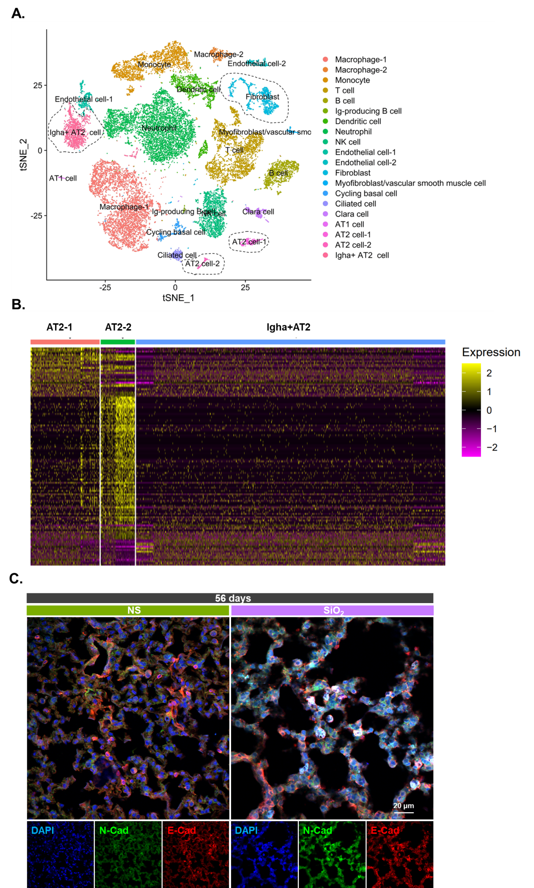
Supplementary Figure 1. Fractionation basis of alveolar type II epithelial cells
A. scRNA-Seq clustering and definitions. The cell type for each cluster was annotated according to canonical cell markers in CellMarker.
B. Heat map representing the expression of distinct RNAs that identify three groups of AT2 cell subtypes.
C. Immunohistochemical staining showing that E-Cad and N-Cad were expressed in lung tissue, scale bar: 20 μm.

Supplementary Figure 2.
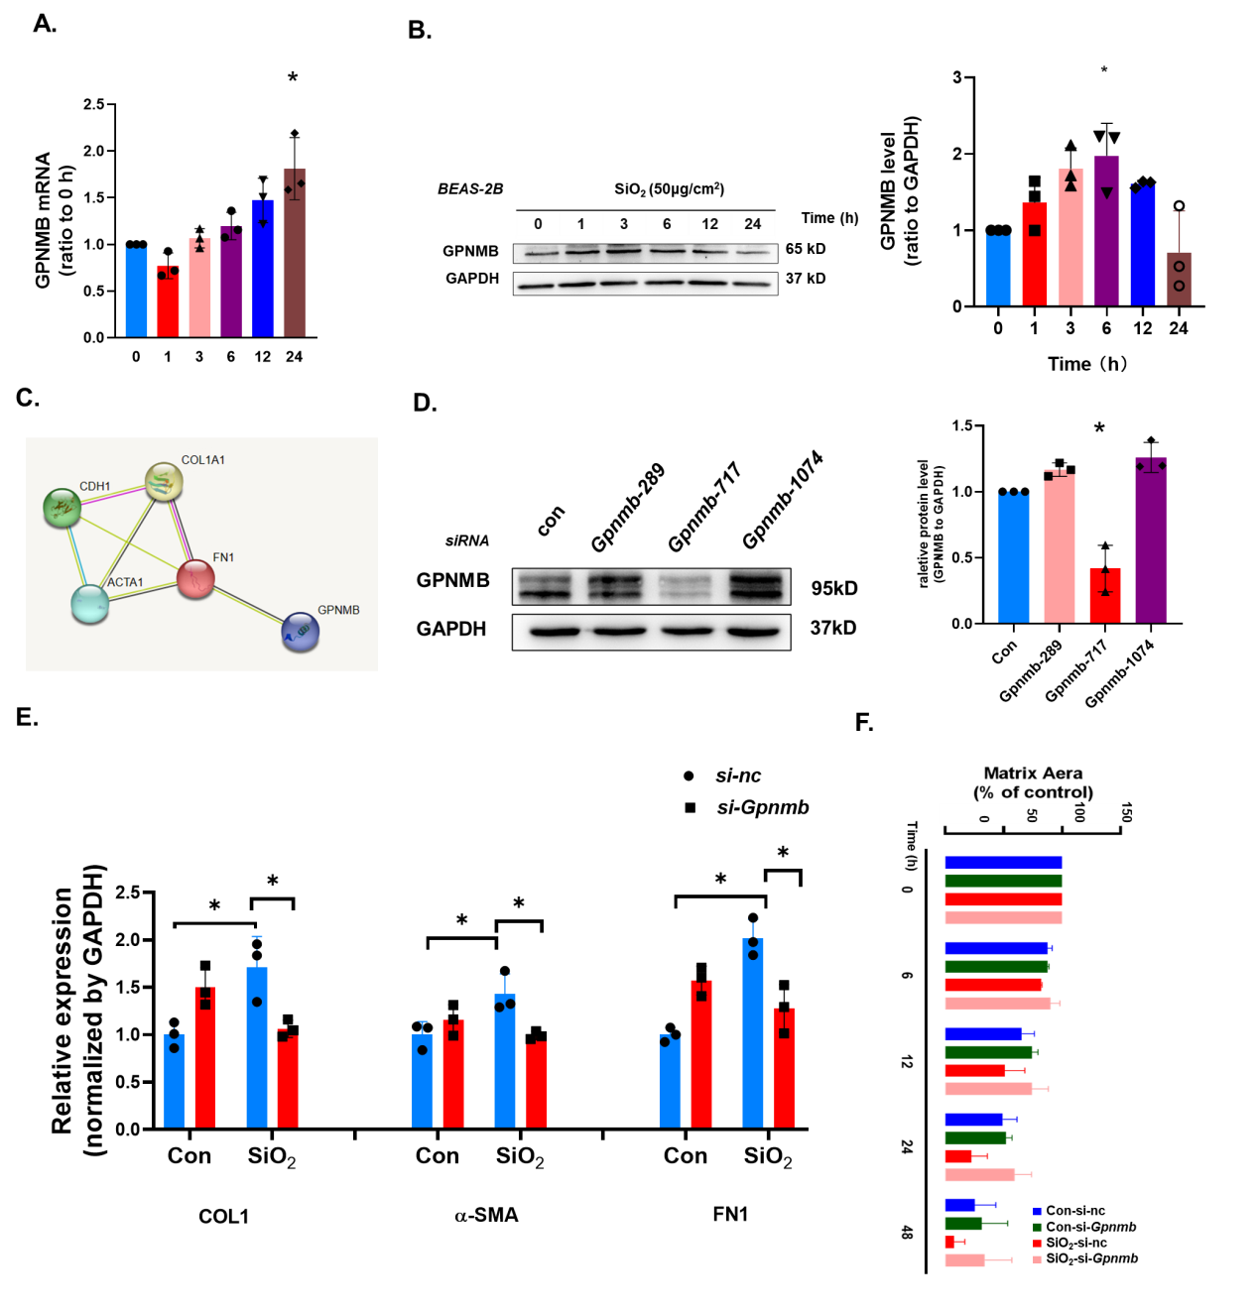
Supplementary Figure 2. Experimental evidence of the EMT-related phenomena of MLE-12 cells
A. GPNMB expression was elevated over time in MLE-12 cells, with significant differences in expression between 24 h and 0 h (*P < 0.05).
B. Representative western blot results showing that the elevated GPNMB expression in alveolar type II epithelial cells can activate EMT through the upregulation of GPNMB cells; #P < 0.05 indicates significant differences in expression between 6 h and 0 h (*P < 0.05).
C. Interaction map showing interactions between proteins enriched in GPNMB and interstitial marker protein.
D. Western blot showing that the knockdown efficiency of Gpnmb-177 using one-way ANOVA suggested a statistically significant difference.
D. *P < 0.05 indicates that the SiO₂-treated si-nc group had higher protein levels than the control group and that the model was successfully established; #P < 0.05 indicates that si-Gpnmb reversed the SiO₂-induced elevated protein levels of COL1, α-SMA, and FN1 after SiO₂ treatment.
E. *P < 0.05 indicates that the cell migration rate was higher in the si-nc group than in the control group after SiO₂ treatment and that the model was successfully established; #P < 0.05 indicates that the cell migration rate was lower in the si-Gpnmb group than in the si-nc group after SiO₂ treatment.
F. *P < 0.05 indicates that the cell migration rate in the si-nc group was higher than that in the control group after SiO₂ treatment and that the model was successfully established; #P < 0.05 indicates that the cell migration rate was lower in the si-Gpnmb group than in the si-nc group after SiO₂ treatment.

Supplementary Figure 3.
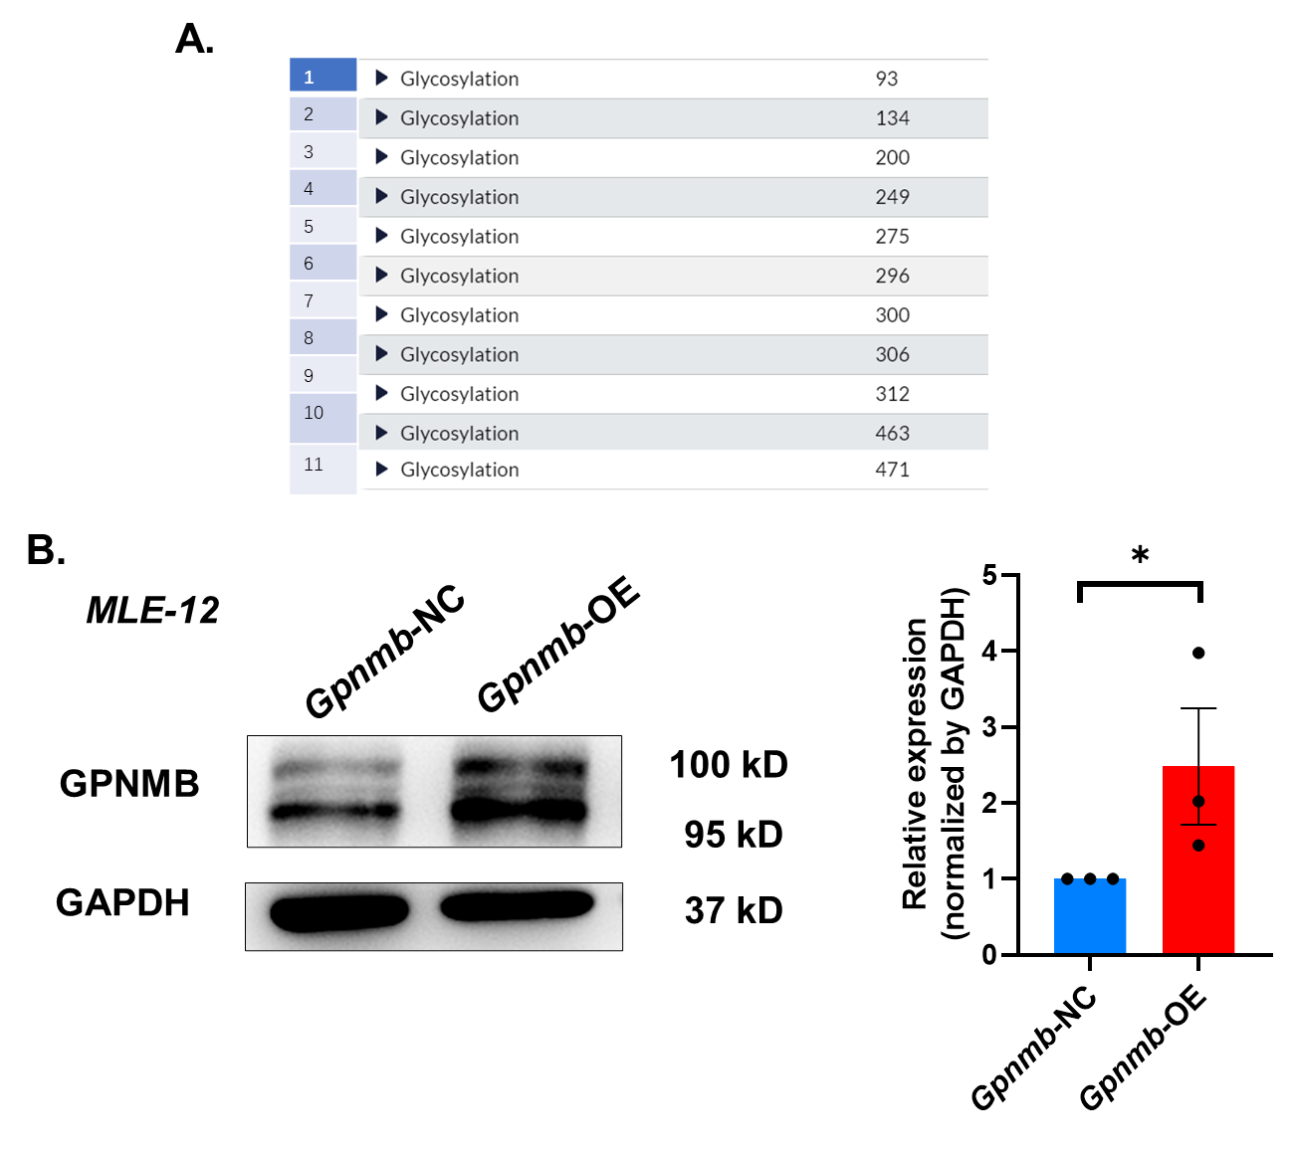
Supplementary Figure 3. The glycosylation level of GPNMB
A. Eleven GPNMB glycosylation sites.
B. Western blot showing the successful establishment of Gpnmb overexpressing cell lines; *P < 0.05 indicates statistically significant differences.

Supplementary Figure 4.
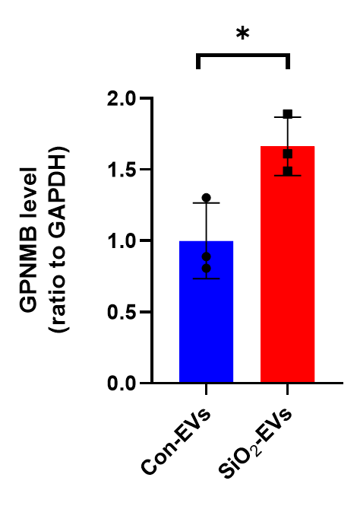
Supplementary Figure 4. Identification of GPNMB expression in EVs
*P < 0.05 indicates that the level of GPNMB protein was higher in the SiO₂ group than in the control group.

Supplementary Figure 5.
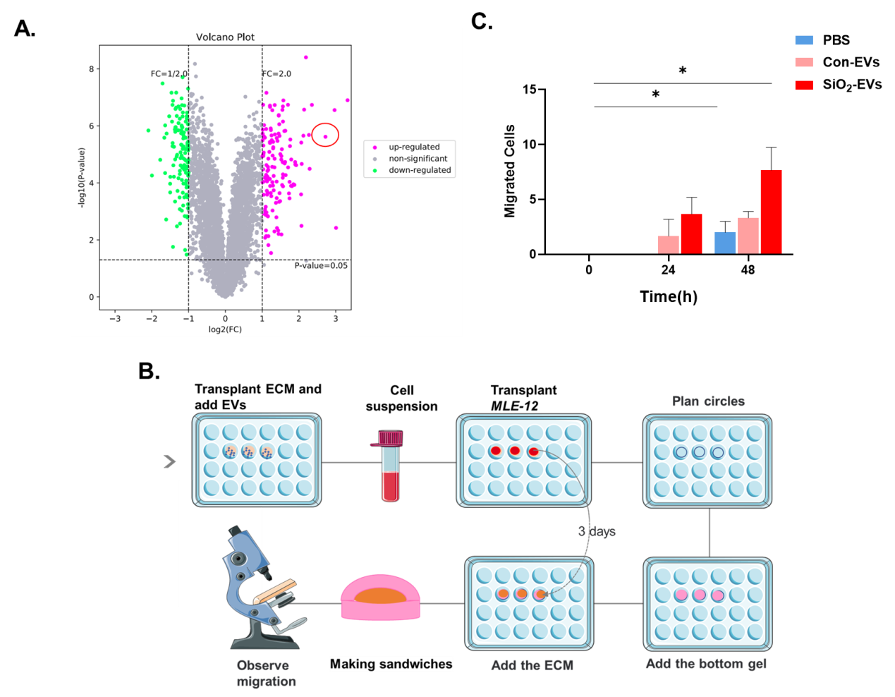
Supplementary Figure 5. Process of EVs adhesion to the ECM.
A. According to the ECM proteomics results, 270 proteins showed differential expression in the ECM derived from the lung tissue of silicosis mice.
B. Schematic diagram of the nested matrix model method.
C. Number of cells migrating at different time points; *P < 0.05 shows a statistically significant difference at 48 h compared to 0 h.

