Additional file 6

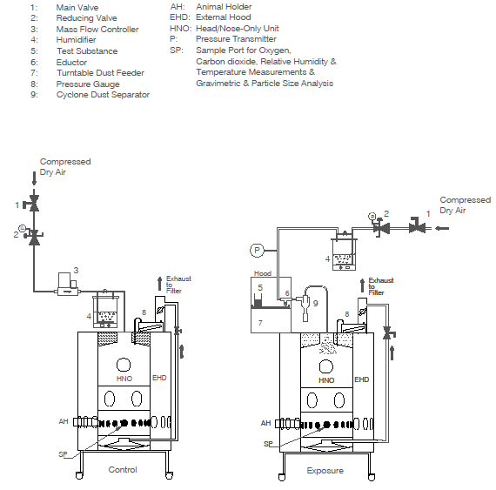
Figure S1 Drawing of test atmosphere generation set-up

